OAT Writing Intervention

Week One

Narrative

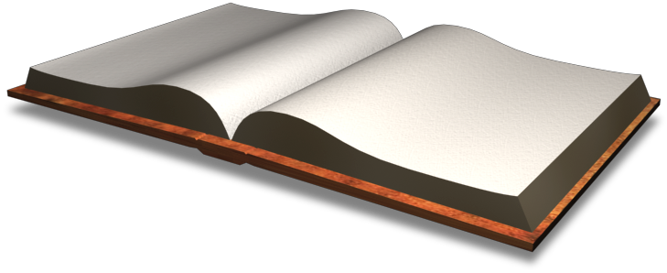

Features of a Narrative

A fictional narrative is an invented (pretend) story that you create in your head. Fictional narratives are not true.

A personal narrative is story that you wrote about something that has happened to you or something that really could have happened to you.

Features of a Fictional Narrative
- A fictional narrative is a pretend (made up) story.
- A fictional narrative usually has a problem that characters in the story need to resolve.

Features of the Personal Experience Narrative
- A personal experience narrative is usually told from the 1st person point of view (“I”).
- A personal experience narrative focuses on an event that could have happened, or really happened to you.

Name ________________________

Writing Prompt: Write about a character who goes to a school fair and plays different games that have different probabilities. Some of the games are fair games and others are unfair. List two possible games and explain why they are fair/unfair using your knowledge of probability. Use two different games as examples.

Type Game | Probability of Winning (explain) | Fair or Unfair

________________________________________________________________________________________________________________________________________________________________________________________________________________________________________________________________________________________________________________________________________________________________________________________________________________________________________________________________________________________________________________________________________________________________________________________________________________________________________________________________________________________________________________________________________________________________________________________________________________________________________________________________________________________________________________________________________________________________________________________________________________________________________________________________________________________________________________________________________________________________________________________________________________________________________________________________________________________________________________________________________________________________________________________________________________________________________________________________________________________________________________________________________________________________________________________________________________________________________________________________________________________________________________________________________________________________________________________________
Checklist:

- I used narrative format ( I, he/she.)
- My story has a beginning, middle, and end.
- I used interesting words.
- I addressed the prompt---(stayed on topic.)

- I used correct punctuation and capitalization.

