Index to Questions

Question Number | Source | BM | GLI | Description
9 | OAT March 05 | C | PFA 8.1 | This multiple-choice question asks students to identify the equation that generalizes the relationship between the number of doughnuts purchased and the total cost.
10 | OAT March 05 | F | PFA 8.9 | This multiple-choice question asks students to solve an equation.
11 | OAT March 05 | H | PFA 8.10 | This short-answer question asks students to use a system of equations to represent and analyze a problem situation.
28 | OAT March 05 | F, G | PFA 8.9, PFA 8.12 | This multiple-choice question asks students to find the  zeros for the quadratic equation y = x2 – 9.
31 | OAT March 05 | A | PFA 8.2 | This short-answer question asks students to write a rule for the pattern and use the rule to identify the number of x‘s in the 50th term.
33 | OAT March 05 | C | PFA 8.1 | This multiple-choice question asks students to match the graph to data in a table.
42 | OAT March 05 | B | PFA 8.3 | This multiple-choice question asks students to identify the graph that represents a linear relationship.
43 | OAT March 05 | J | PFA 8.13 | This multiple-choice question asks students to find the slope of the line segment.
3 | OAT March 06 | B | PFA 8.3 | This multiple-choice question asks students to identify the equation that represents a nonlinear function.
25 | OAT March 06 | J | PFA 8.13 | This multiple-choice question asks students to find the slope of a line that passes through two points.
32 | OAT March 06 | E | PFA 8.6 | This multiple-choice question asks students to determine the meaning of the y-intercept as it relates to the problem situation.
42 | OAT March 06 | E | PFA 8.6 | This multiple-choice question asks students to select a statement that describes the change in the graph of the given equation if the constant is changed.
5 | OAT May 07 | D | PFA 8.8 | This multiple-choice question asks students to identify the equation that represents the given problem situation.
19 | OAT May 07 | I | PFA 8.14 | This multiple-choice question asks students to identify the equation that represents a direct variation.
Question Number | Source | BM | GLI | Description
30 | OAT May 07 | J | PFA 8.13 | This multiple-choice question asks students to find the distance between two points on a coordinate plane.
38 | OAT May 07 | A | PFA 8.2 | This multiple-choice question asks students to identify the expression that represents the sequence provided in the problem.
44 | OAT May 07 | C | PFA 8.1 | This multiple-choice question asks students to describe the relationship between the values in the table provided.
10 | OAT May 08 | B | PFA 8.3 | This multiple-choice question asks students to identify a linear function from the information given in a table.
27 | OAT May 08 | C | PFA 8.1 | This multiple-choice question asks students to explain the meaning of 1.2 in the given equation.
34 | OAT May 08 | H | PFA 8.10 | This multiple-choice question asks students to identify the solution to the system of two linear equations with two variables.
42 | OAT May 08 | G | PFA 8.12 | This multiple-choice question asks students to determine solutions of quadratic equation by using its graph.
44 | OAT May 08 | B | PFA 8.3 | This multiple-choice question asks students to identify the equation that represents a linear function.

BACK TO INDEX

Benchmark: C | Translate information from one representation (words, table, graph or equation) to another representation of a relation or function.
GLI: PFA 8.1 | Relate the various representations of a relationship; i.e., relate a table to graph, description and symbolic form.

Multiple Choice Question:

9. The table shows the relationship between the number of doughnuts (d), and the total cost (c) in dollars for an order of doughnuts.
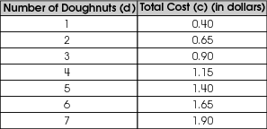
Which equation shows the total cost for an order of doughnuts?
- c = 0.15d +.25
- c = 0.25d +.15
- c = 0.28d
- c = 0.40d

Commentary:
This multiple-choice question asks students to identify the equation that generalizes the relationship between the number of doughnuts purchased and the total cost. Students need to use the values in the table to determine that there is a 15 cent fee and a charge of 25 cents for each doughnut purchased, c = 0.25d+.15 (answer choice B). Answer choice A reverses the fee and the cost per doughnut. Answer choice C is the result of averaging the first doughnut and the increase of the next four doughnuts. Answer choice D considers only the cost of the first doughnut.

The level of complexity for this question is Moderate Complexity. The task requires students to use an equation to represent the situation described in the table.

Performance Data:
The percent of public school students selecting answer choice B for question 9 on the March 2005 Grade 8 Achievement Test was 48%.

Keywords: algebra, equation, pattern

BACK TO INDEX

Benchmark: F | Solve and graph linear equations and inequalities.
GLI: PFA 8.9 | Solve linear equations and inequalities graphically, symbolically and using technology.

Multiple Choice Question:
10. Which is the value of x when $\frac{x}{3}$+ 5 = 15 ?
- x = 30
- x = 40
- x = 50
- x = 60

Commentary:
This multiple-choice question asks students to solve an equation. The students may solve the equation $\frac{x}{3}$+ 5 = 15 by subtracting 5 from both side of the equation and then multiply both side by 3, resulting in x = 30 (answer choice A). Answer choices B, C and D are obtained by not following the correct order for solving the equation or by adding 5 instead of subtracting.

The level of complexity for this question is Low Complexity. The task requires students to solve an equation for a given variable.

Performance Data:
The percent of public school students selecting answer choice A for question 10 on the March 2005 Grade 8 Achievement Test was 86%.

Keywords: algebra, solve equations

BACK TO INDEX

Benchmark: H | Solve systems of linear equations involving two variables graphically and symbolically.
GLI: PFA 8.10 | Solve 2 by 2 systems of linear equations graphically and by simple substitution.

Mathematical Processes
Benchmark: E | Use a variety of mathematical representations flexibly and appropriately to organize, record and communicate mathematical ideas.

Short Answer Question:

11. Will plans to buy at least 10, and possibly more, new CDs and is trying to decide between two different CD offers.

CD-Land charges $40 to become a member of a frequent buyers club and $9 for each CD you buy.

MUSICVILLE has no membership fee and charges $12 for each CD you buy.

In your Answer Document, create and label a double line graph that shows the cost of 1 to 20 CDs for each of the two offers. Explain how Will can use this graph to decide which offer to accept.

Commentary:
This short-answer question asks students to use a system of equations to represent and analyze a problem situation. Students need to create and label a line graph that represents each of the situations described in the question. DC-Land can be represented by the graph of the equation y = 9x + 40 and MUSICVILLE can be represented by the graph of the equation y = 12x. Students also need to explain how the graphs can be used to select one of the offers. The response earning the maximum number of points (2 points) provides the appropriate line graphs and a clear explanation of how Will can use the graph to make a decision.

The complexity of this question is Moderate Complexity. The task requires students to interpret a visual representation and provide an explanation.
Performance Data:
The percent of public school students earning each score point for question 11 on the March 2005 Grade 8 Achievement Test:

Percent at Each Score Point
0 | 1 | 2
73% | 16% | 6%

Scoring Guidelines:
Points | Student Response
2 | Sample Correct Responses:  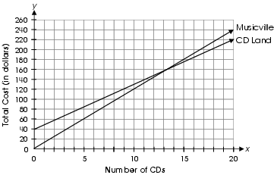  If Will wants to buy only 10 CDs, he should go to Musicville, because 10 CDs will cost him $120 there and $130 at CD-Land. If Will wants to buy more than 13 CDs, he should go to CD-Land.  I can use the graph to identify where the two plans cost the same by seeing where the lines cross.  When one plan costs more or less than the other for a given number of CDs by looking at which line is below the other line.

Points | Student Response
2 | 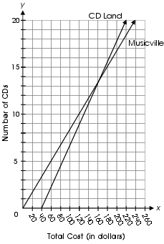  If Will wants to buy only 10 CDs, he should go to Musicville, because 10 CDs will cost him $120 there and $130 at CD-Land. If Will wants to buy more than 13 CDs, he should go to CD-Land.  The focus of this task is to draw a double line graph and draw conclusions from this graph. A correct response will include a graph representing the cost of 1-20 CD’s for two situations, then draw accurate conclusions from the graph. The response will include an accurate graph with two lines. CD-Land is represented by the line y = 9x + 40 and Musicville is represented by the line y = 12x. (Although the equations of the lines do not need to be identified.) The student explains that the Musicville plan is better for 10 CDs, but the CD-Land plan is better for more than 13 CDs or provides an appropriate explanation for how to use the graph.
1 | The response provides partial evidence of drawing a double line graph and drawing conclusions from this graph; however, the graph and/or conclusions may be incomplete or slightly flawed.  For example, the response may:  - Show lines that are graphed correctly, but states that CD-Land is the better value no matter how many CDs Will buys.  - Show one line that is graphed incorrectly, and the conclusion is based on the incorrect graph.  - Show a correct graph but does not explain how Will can use the graph to decide which offer to accept.  Show the two lines graphed correctly on two separate grids.

Scoring Guidelines:
Points | Student Response
0 | The response provides inadequate evidence of drawing a double line graph and drawing conclusions from this graph. The response provides an explanation with major flaws and errors of reasoning.  For example, the response may:  - Restate the information provided in the item.  - Be blank or provide irrelevant information.  - No graph given.

Keywords: algebra, system of equations, line graph

BACK TO INDEX

Benchmark: F | Solve and graph linear equations and inequalities.
Benchmark: G | Solve quadratic equations with real roots by graphing, formula and factoring.
GLI: PFA 8.9, PFA 8.12 | PFA 8.9: Solve linear equations and inequalities graphically, symbolically and using technology.  PFA 8.12: Solve simple quadratic equations graphically; e.g., y = x2 – 16.

Multiple Choice Question:

28. The graph of y = x² – 9 is shown.
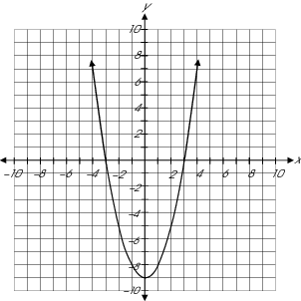
For what values of x does x² – 9 = 0?

- x = 2 and x = -2
- x = 3 and x = -3
- x = 4.5 and x = 0
- x = -9 and x = 0

Commentary:
This multiple-choice question asks students to find the zeros for the quadratic equation
y = x² – 9. Students may approach this question graphically or symbolically. Students may use the graph to identify the x-intercepts or student may solve the equation x² – 9 = 0 symbolically. Answer choice B is the correct answer for the zeros of the equation y = x² – 9. The other answer choices are the result of miscalculations or misinterpretations of the question.

The level of complexity for this question is Moderate Complexity. The task requires retrieving information from a graph.

Performance Data:
The percent of public school students selecting answer choice B for question 28 on the March 2005 Grade 8 Achievement Test was 56%.

Keywords: algebra, quadratic equations, zeros

BACK TO INDEX

Benchmark: A | Generalize and explain patterns and sequences in order to find the next term and the nth term.
GLI: PFA 8.2 | Generalize patterns and sequences by describing how to find the nth term.

Mathematical Processes
Benchmark: A | Formulate a problem or mathematical model in response to a specific need or situation, determine information required to solve the problem, choose method for obtaining this information, and set limits for acceptable solution.

Short Answer Question:
31. The first four steps in a pattern are shown:

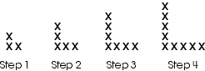

In your Answer Document, write an equation or a rule that can be used to find the number of x ’s in any step of the pattern. Use your equation or rule to find the number of the x ’s for step 50.

Commentary:
This short-answer question asks students to write a rule for the pattern and use the rule to identify the number of x ‘s in the 50th term. Students may approach this question in several ways, such as a visual analysis and creating tables. Students need to identify the growth pattern from one step to the next and account for the x common to both legs. A response earning the maximum number of points (2 points) provides a rule for the pattern and the number of x’s in the 50th term.

The level of complexity for this question is Moderate Complexity. The task requires students to generalize a pattern and use the rule to extend the pattern.

Performance Data:
The percent of public school students earning each score point for question 31 on the March 2005 Grade 8 Achievement Test:

Percent at Each Score Point
0 | 1 | 2
65% | 12% | 16%

Scoring Guidelines:
Points | Student Response
2 | Sample Correct Responses:  Number of x’s = 2 × step + 1  Number of x’s (step 50) = 2 × 50 + 1  = 100 + 1  = 101  x = 3 + 2( n – 1) x = number of x’s and n = step number  x = 3 + 2 (50 – 1)  = 3 + 98  = 101  To find the number of x’s, multiply the step number by 2 and then add 1.  x = 3 + 2( n – 1) x = number of x’s and n = step number  50 x 2 = 100 100 + 1 = 101  There would be 101 x’s for step 50.  The focus of this task is to generalize a pattern and create an equation or rule that can be used to find the n th term. Response includes a clear and complete equation or rule that will result in the correct number of x’s for any step in the pattern. The equation or rule must result in a correct answer for all steps, including step 1. The response also provides evidence to verify or show that the equation or rule does result in a correct answer (101 x’s) when used to find the number of x’s in step 50 (101 x’s); e.g., substitutes 50 into the equation and/or starts with 50 and performs the actions defined in the rule.  Note: There are a variety of equivalent equations and rules that may be used to generalize the pattern and can be used to find the number of x’s for any step in the pattern.
1 | The response provides partial evidence of generalizing or explaining the pattern; however, the solution may be incomplete or slightly flawed; e.g., may include an equation or rule that can be used to describe, but not generalize, the pattern or an error is made when using an accurate equation or rule to find the number of x’s for step 50.  For example, the response may:  - Provide an incomplete equation or rule that describes how to extend the pattern to find additional steps or an equation or rule that will not work for step 1; e.g., “add 2 to each step” or “the steps are consecutive odd numbers” or “x = 2 times the previous step + 1” (does not work for step 1). The response shows how to use the incomplete equation or description to accurately extend the pattern and identifies 101 x’s for step 50.  - State an accurate equation or rule; however, includes an incorrect answer for the number of x’s for step 50 due to a computation error in using the equation or rule.

Points | Student Response
1 | - Identify an accurate equation or rule and does not attempt or complete the process for finding the number of x’s for step 50; e.g., substitutes 50 into the equation with no other work or writes “101”, or another number, with no evidence of using the stated equation or rule.  - Determine the number of x’s for step 50 (101 x’s) with supporting work that clearly communicates an accurate generalization of the pattern and complete steps that can be used to find the number of x’s for any step, but does not clearly or specifically state a general equation or rule; e.g., number of x’s in step 50 = 2 times 50 + 1 = 101 x’s.
0 | The response provides inadequate evidence of using an equation or rule to generalize and explain a pattern. It may include no equation or rule or a highly flawed equation or rule that yields an incorrect number of x’s for many steps in the pattern; e.g., x’s = 3 times the step number. Finding the number of x’s for step 50 using a highly flawed equation or rule is insufficient to earn one point; e.g., showing work indicating 3 times 50 is 150 based on the example of a highly flawed equation/rule does not demonstrate minimal understanding of generalizing or explaining a pattern.  For example, the response may:  - Include the number 101, with no equation, rule or other evidence of generalizing the pattern; e.g., show no work or only extends the pattern by drawing x’s.  - Show some work; however, the work shown has very limited or no connection to components of the task; e.g., includes a partial rule, equation and/or work showing little or no understanding of the task; e.g., “the L’s gets bigger each time”, “the answer is an odd number”, step 50 = step 4 plus 46.  - Recopy information provided in the item with no work.  - Provide unrelated statements or work.  - Be blank.

Keywords: patterns, rule

BACK TO INDEX

Benchmark: C | Translate information from one representation (words, table, graph or equation) to another representation of a relation or function.
GLI: PFA 8.1 | Relate the various representations of a relationship; i.e., relate a table to graph, description and symbolic form.

Multiple Choice Question:

33. The graph of an equation is shown on the coordinate plane.

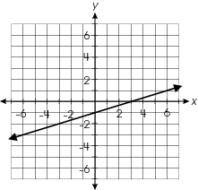

Which table of values represents coordinate points that lie on the line?

A. | 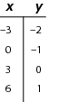 | B. | 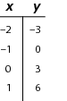
C. | 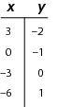 | D. | 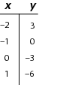

Commentary:
This multiple-choice question asks students to match the graph to data in a table. Students need to compare points on the graph to the data in the table. One way is to identify the x- and y-intercepts. Answer choice A is the only table that contains the coordinates (0, -1) and (3, 0) which are the x- and y-intercepts on the graph. The tables for the other answer choices contain points that reflect misunderstandings about reading a graph.

The level of complexity for this question is Moderate Complexity. The task requires students to retrieve and compare information form a graph and table.

Performance Data:
The percent of public school students selecting answer choice A for question 33 on the March 2005 Grade 8 Achievement Test was 61%.

Keywords: algebra, graph, table

BACK TO INDEX

Benchmark: B | Identify and classify functions as linear or nonlinear, and contrast their properties using tables, graphs or equations.
GLI: PFA 8.3 | Identify functions as linear or nonlinear based on information given in a table, graph or equation.

Multiple Choice Question:

42. Which graph represents a linear relationship?

A. | 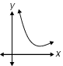 | B. | 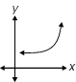
C. | 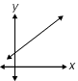 | D. | 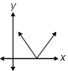

Commentary:
This multiple-choice question asks students to identify the graph that represents a linear relationship. Students need to recall the characteristics of a linear relationship: a constant rate of change without a change in direction (a single straight line). Answer choice C is a single straight line and represents a linear relationship. Answer choices A and B are both curves and not linear. Answer choice D contains a constant rate of change; however, the graph is not a single straight line.

The level of complexity for this question is Low Complexity. The task requires students to recognize an example of a concept.

Performance Data:
The percent of public school students selecting answer choice C for question 42 on the March 2005 Grade 8 Achievement Test was 58%.

Keywords: algebra, graph, linear relationship

BACK TO INDEX

Benchmark: J | Describe and interpret rates of change from graphical and numerical data.
GLI: PFA 8.13 | Compute and interpret slope, midpoint and distance given a set of ordered pairs.

Multiple Choice Question:

43. The line segment $\overline{\text{AB}}$ is shown on the coordinate system.

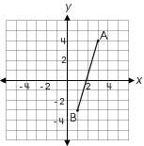

What is the slope of$\overline{\text{AB}}$?

A. $\frac{2}{7}$
B. $−\frac{7}{2}$
C. $−\frac{2}{7}$
D. $\frac{7}{2}$

Commentary:
This multiple-choice question asks students to find the slope of the line segment. Students can use several different methods to find the slope. One method is to use the concept of $\frac{\text{Rise}}{\text{Run}}$. Starting at point B, students can count the number of units the graph rises (7 units up) and the number of units the graph runs (2 units to the right) to move to point A. Both the rise and the run are positive, so the slope would be$\frac{7}{2}$, answer choice D. Answer choices A and C reverse the rise and run, and answer choices B and C indicate a negative slope.

The level of complexity for this question is Moderate Complexity. The task requires students to determine how to find the slope of the line.

Performance Data:
The percent of public school students selecting answer choice D for question 43 on the March 2005 Grade 8 Achievement Test was 34%.

Keywords: algebra, slope

BACK TO INDEX

Benchmark: B | Identify and classify functions as linear or nonlinear, and contrast their properties using tables, graphs or equations.
GLI: PFA 8.3 | Identify functions as linear or nonlinear based on information given in a table, graph or equation.

Multiple Choice Question:

3. Which equation represents a nonlinear function?
A. y = x
B. y = 2 x
C. y = x²
D. y = x + 2

Commentary:
This multiple-choice question asks students to identify the equation that represents a nonlinear function. A nonlinear function is one where the values for x change at a constant rate, but the values for y do not change at a constant rate, where the graph of the function is not a straight line. Answer choice C does represent not a linear function. Answer choices A, B and D are linear functions.

The complexity level of this question is Low Complexity. The question requires recognizing an example of a concept.

Performance Data:
The percent of public school students selecting answer choice C for question 3 on the March 2006 Grade 8 Achievement Test was 47%.

Keywords: algebra, function, equation

BACK TO INDEX

Benchmark: J | Describe and interpret rates of change from graphical and numerical data.
GLI: PFA 8.13 | Compute and interpret slope, midpoint and distance given a set of ordered pairs.

Multiple Choice Question:

25. What is the slope of the line containing the points 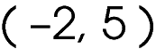 and 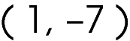?
A. - 4
B. - 2
C. 2
D. 4

Commentary:
This multiple-choice question asks students to find the slope of a line that passes through two points. Student may use one of several methods to find the slope of the line through a set of points. One method is to graph the two points on a coordinate grid and then find the slope, $\frac{\text{Rise}}{\text{Run}}$between the two points.
Rise
Run

A second method is to find the change in the vertical distance and divide it by the change in the horizontal distances:

$\left(\frac{y_{2} − y_{1}}{x_{2} − x_{1}}\right)$ or $\left(\frac{−7 − 5}{1 − \left(−2\right)}\right)$= $\frac{−\text{12}}{3} = −4$.

Therefore, answer choice A is correct.
Answer choices B, C and D are incorrect because the student may have incorrectly calculated the slope of the line.

The complexity level of this question is Moderate Complexity. The question requires students to find the slope between two points.

Performance Data:
The percent of public school students selecting answer choice A for question 25 on the March 2006 Grade 8 Achievement Test was 43%.

Keywords: algebra, slope

BACK TO INDEX

Benchmark: E | Analyze and compare functions and their graphs using attributes, such as rates of change, intercepts and zeros.
GLI: PFA 8.6 | Describe the relationship between the graph of a line and its equation, including being able to explain the meaning of slope as a constant rate of change and y-intercept in real-world problems.

Multiple Choice Question:

32. The graph shows the change in the amount of water in an uncovered beaker over several days.
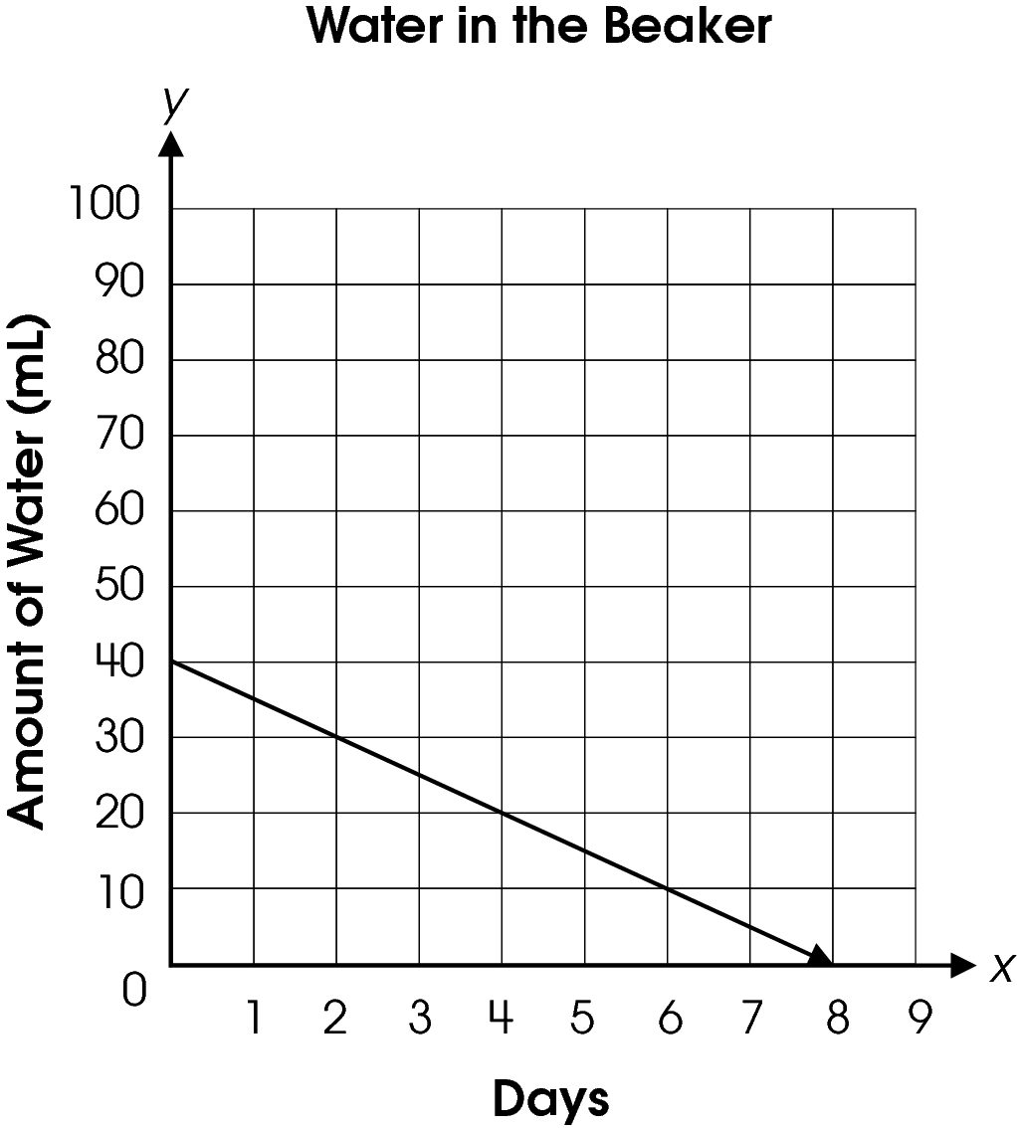
What information does the y -intercept provide?

A. The amount of water in the beaker decreased by 40 mL.
B. The water was gone by the eighth day.
C. The change in the amount of water over time has a negative slope.
D. The water level started at 40 mL.

Commentary:
This multiple-choice question asks students to determine the meaning of the y-intercept as it relates to the problem situation. Students should know that the y-intercept is the point where the graph intersects the y-axis. For this line the y-intercept is at the order pair (0, 40). The y-intercept implies that at 0 days there are 40 milliliters in the beaker. The correct answer choice is D. Answer choice A is incorrect because 40 mL is the change in the amount of water after 8 days. Answer choice B is incorrect because it is describing the x-intercept, and answer choice C is incorrect because it is describing the slope of the line.

The complexity level of this question is Moderate Complexity. The question requires the interpretation of a visual representation.

Performance Data:
The percent of public school students selecting answer choice D for question 32 on the March 2006 Grade 8 Achievement Test was 50%.

Keywords: algebra, y-intercept

BACK TO INDEX

Benchmark: E | Analyze and compare functions and their graphs using attributes, such as rates of change, intercepts and zeros.
GLI: PFA 8.6 | Describe the relationship between the graph of a line and its equation, including being able to explain the meaning of slope as a constant rate of change and y-intercept in real-world problems.

Multiple Choice Question:

42. The graph represents the equation y = x + 3.
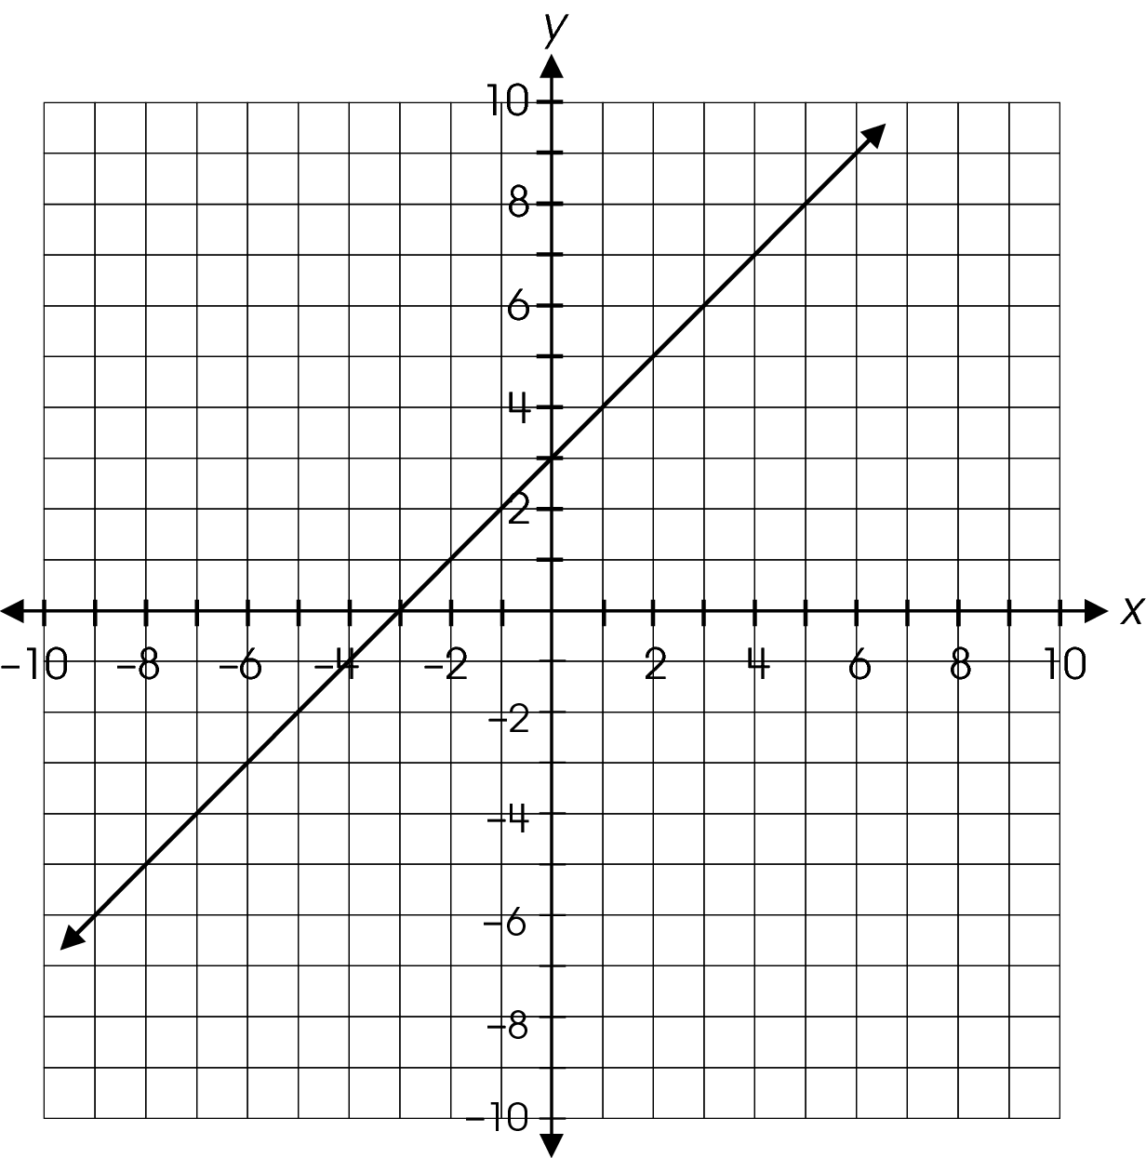
How would the graph change if the constant were changed from 3 to 5?
A. The line will shift up 2 units.
B. The line will shift down 2 units.
C. The line will be steeper.
D. The line will change direction.

Commentary:
This multiple-choice question asks students to select a statement that describes the change in the graph of the given equation if the constant is changed. Students should know that when the constant is changed, the y-intercept of the equation is changed. In this situation the y-intercept is changed from 3 to 5. Therefore, the graph of the equation is moved from crossing the y-axis at 3 up two units to cross at 5, answer choice A. Answer choice B is incorrect, because it states that the line would shift down instead of up. Answer choices C and D are incorrect because they address the slope of the line instead of the y-intercept.

The complexity level of this question is High Complexity. This question requires students to analyze the differences between representations.

Performance Data:
The percent of public school students selecting answer choice A for question 42 on the March 2006 Grade 8 Achievement Test was 48%.

Keywords: algebra, equation

BACK TO INDEX

Benchmark: D | Use algebraic representations, such as tables, graphs, expressions, functions and inequalities, to model and solve problem situations.
GLI: PFA 8.8 | Write, simplify and evaluate algebraic expressions (including formulas) to generalize situations and solve problems.

Multiple Choice Question:

5. The County Fair charges a $3 entrance fee. The cost of each ride is $2.
Which equation represents the cost (y) of getting into the fair and going on x number of rides?
A. y = 3 + 2 + x
B. y = (3 + 2)x
C. y = 3 + 2x
D. y = 3x + 2

Commentary:
This multiple-choice question asks students to identify the equation that represents the given problem situation. Students need to analyze the problem situation to determine the fixed cost and the varying cost. The entrance fee for the fair is a one time cost; therefore, it is a fixed cost. The cost for each ride is $2. Because the total cost is dependent on the number of rides taken, the number of rides is a varying aspect to the situation. Students must now write the situation in symbolic form. One method is to use words first and then convert the sentence to symbolic form. For example:

Total cost is equal to the entrance fee plus $2 times the number of times on a ride.
y = total cost
x = number of times on a ride
y = 3 + 2x

Answer choice C is correct.
The equations in answer choices A, B and D do not represent the situation and are incorrect.

The complexity level of this question is Low Complexity. This question requires students to recognize an equivalent representation.

Performance Data:
The percent of public school students selecting answer choice C for question 5 on the May 2007 Grade 8 Achievement Test was 72 %.

Keywords: algebra, equation, algebraic, representation

BACK TO INDEX

Benchmark: I | Model and solve problems situations involving direct and inverse variations.
GLI: PFA 8.14 | Differentiate and explain types of changes in mathematical relationships, such as linear vs. nonlinear, continuous vs. non-continuous, direct variation vs. inverse variation.

Multiple Choice Question:

19. Which equation represents a direct variation?

A. $y = 5x$
B. $y = \frac{5}{x}$
C. $y = 5$
D. $y = 5 − x$

Commentary:
This multiple-choice question asks students to identify the equation that represents a direct variation. Students need to know that an equation of direct variation is written in the form y = kx and that the graph of this equation must pass through the origin. The equation y = 5x, answer choice A, is an example of a direct variation.
Answer choices B, C, and D are incorrect. Answer choice B is an example of an inverse variation. The graph of the equation in Answer choices C and D do not pass through the origin and are not in the form y = kx.

The complexity level of this question is Low Complexity. The question requires students to recognize an example of a concept.

Performance Data:
The percent of public school students selecting answer choice A for question 19 on the May 2007 Grade 8 Achievement Test was 32%.

Keywords: algebra, equation, direct variation

BACK TO INDEX

Benchmark: J | Describe and interpret rates of change from graphical and numerical data.
GLI: PFA 8.13 | Compute and interpret slope, midpoint and distance given a set of ordered pairs.

Multiple Choice Question:

30. Two points (–1, 1) and (3, –2) are graphed on a coordinate plane.
What is the shortest distance between the points?

A. 3
B. 4
C. 5
D. 7

Commentary:
This multiple-choice question asks students to find the distance between two points on a coordinate plane. Students can use one of several methods to find the distance between the two points, (-1, 1) and (3, -2), as provided in the question. One method is to use the Distance formula that is provided on the reference sheet. Students should substitute the values for the x and y coordinates of the two points into the formula and simplify.

$$\begin{aligned}d = \sqrt{(x_{2} − x_{1})^{2} + (y_{2} − y_{1})^{2}} \\ d = \sqrt{(3 − (−1))^{2} + (−2 − 1)^{2}} \\ d = \sqrt{(4)^{2} + (−3)^{2}} \\ d = \sqrt{\text{16} + 9} \\ d = \sqrt{\text{25}} \\ d = 5\end{aligned}$$

Answer choice C is correct.
Students who selected answer choice A may have only found the vertical distance between the two points and those who selected B may have found the horizontal distance between the two points. Answer choice D is the result of a computational error in simplifying the radical with squared numbers.

The complexity level of this question is Moderate Complexity. The question requires students to bring together skills and knowledge from various domains.

Performance Data:
The percent of public school students selecting answer choice C for question 30 on the May 2007 Grade 8 Achievement Test was 23%.

Keywords: algebra, distance formula, coordinate plane, distance

BACK TO INDEX

Benchmark: A | Generalize and explain patterns and sequences in order to find the next term and the nth term.
GLI: PFA 8.2 | Generalize patterns and sequences by describing how to find the nth term.

Multiple Choice Question:

38. Which expression represents the nth term in the sequence 1, 3, 5, 7, 9, n . . . ?

A. n – 2
B. 2n² – 1
C. 2n –1
D. 2^{n} –1

Commentary:
This multiple-choice question asks students to identify the expression that represents the sequence provided in the problem. Student may use one of several methods for determining the expression to represent the sequence. Students may start by observing that each value in the sequence increases by 2. Students can use the following steps to determine the coefficient of n.

Term (n) | Action | Value | Difference from the given value in sequence
1 | Multiply by 2 | 2 | 1
2 | Multiply by 2 | 4 | 1
3 | Multiply by 2 | 6 | 1
n | Multiply by 2 | 2n

The results obtained by multiplying by 2 is one more that the values in the given sequence. Therefore, students need to subtract 1 from the expression, 2n, and test the new expression 2n - 1 again.

Term (n) | Action | Value | Difference from the given value in sequence
1 | Multiply by 2 and subtract 1 | 1 | 0
2 | Multiply by 2 and subtract 1 | 3 | 0
3 | Multiply by 2 and subtract 1 | 5 | 0
4 | Multiply by 2 and subtract 1 | 7 | 0
5 | Multiply by 2 and subtract 1 | 9 | 0
n | Multiply by 2 and subtract 1 | 2n - 1

The expression 2n -1, answer choice C, is correct.

Students selecting answers choices A, B or D may have made an error in determining the expression or in checking if that expression worked for all values in the sequence.

The complexity level of this question is High Complexity. This task requires students to generalize a pattern with an expression.

Performance Data:
The percent of public school students selecting answer choice C for question 38 on the May 2007 Grade 8 Achievement Test was 34%.

Keywords: algebra, sequence, expression, pattern

BACK TO INDEX

Benchmark: C | Translate information from one representation (words, table, graph or equation) to another representation of a relation or function.
GLI: PFA 8.1 | Relate the various representations of a relationship; i.e., relate a table to graph, description and symbolic form.

Multiple Choice Question:

- The table shows the relationship between the number of minutes and the cost of a phone call.
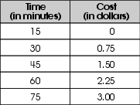
Which describes the relationship between the number of minutes and the cost of a phone call?
A. The cost of a phone call is $0.15 per minute after the first 25 minutes.
B. The cost of a phone call is $0.03 per minute.
C. The cost of a phone call is $0.05 per minute after the first 15 minutes.
D. The cost of a phone call is $1.00 per 25 minutes.

Commentary:
This multiple-choice question asks students to describe the relationship between the values in the table provided. To answer this question, students need to analyze the data given in the table. For the first 15 minutes of the phone call, there is no charge. For the next 15 minutes there is a 0.75 charge or a charge of .05 cents for every minute. In each of the next 15 minute periods the cost increases by another 0.75 cents or by $0.05 for every minute. Answer choice C, “The cost of a phone call is $0.05 per minute after the first 15 minutes” is correct.
Answer choices A, B and D are the result of an error in analyzing the information in the chart.

The complexity level of this question is Moderate Complexity. This question requires students to retrieve information from a table and use it to solve a problem.

Performance Data:
The percent of public school students selecting answer choice C for question 44 on the May 2007 Grade 8 Achievement Test was 46%.

Keywords: algebra, table, relationship

BACK TO INDEX

Benchmark: B | Identify and classify functions as linear or nonlinear and contrast their properties using tables, graphs or equations.
GLI: PFA 8.3 | Identify functions as linear or nonlinear based on information given in a table, graph or equation.

Multiple Choice Question:

10. Which table of values represents a linear function?

A.
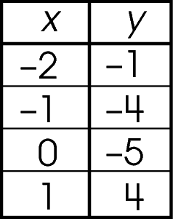

B.
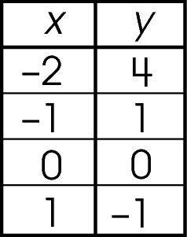

C.
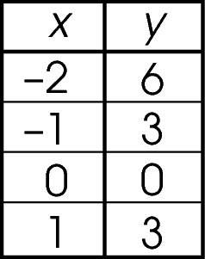

D.
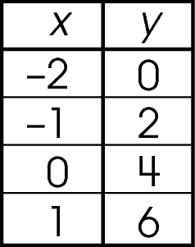
Commentary:
This multiple-choice question asks students to identify a linear function from the information given in a table. A linear function is the one where the slope, a difference of any two y – values over the difference of their corresponding x – values remains the same.
Using data from the table in answer choice D students can calculate the slope as the difference of any two y – values they pick from the table over the difference of their corresponding x – values.
For example, the slope = $\frac{2−0}{−1−(−2)}$= $\frac{2}{1}$ = 2; the slope = $\frac{4−2}{0−(−1)}$= $\frac{2}{1}$ = 2,
or the slope = $\frac{6−0}{1−(−2)}$= $\frac{6}{3}$ = 2. Since the slope remains the same, answer choice D is correct.

All other answer choices are incorrect because the difference of any two y – values over the difference of their corresponding x – values does not remain the same.

The complexity level of this question is Moderate Complexity. This question requires students to select different representation of a mathematics concept.

Performance Data:
The percent of public school students selecting answer choice D for question 10 on the May 2008 Grade 8 Achievement Test was 51%.

Keywords: algebra, linear function, table

BACK TO INDEX

Benchmark: C | Translate information from one representation (words, table, graph or equation) to another representation of a relation or function.
GLI: PFA 8.1 | Relate the various representations of a relationship; i.e., relate a table to graph, description and symbolic form.

Multiple Choice Question:

27. According to the Woodlawn Park Zoo in Seattle, Washington, the average height in inches (h) of a baby giraffe during its first week can be described by the equation h = 72 + 1.2d, where d is the number of days since it was born.
Which statement explains the meaning of the 1.2 in the equation?

A. The giraffe's growth after 1.2 days.
B. The giraffe grows 1.2 inches a day.
C. The giraffe is this tall after 1.2 weeks.
D. The giraffe's initial height is 1.2 inches.

Commentary:
This multiple-choice question asks students to explain the meaning of 1.2 in the given equation.
To answer this question, students need to understand that the equation h = 72 + 1.2d in words means that the average height in inches of a baby giraffe equals 72 plus 1.2 times the number of days since it was born. So, every time d increases by 1 day, the height of the baby giraffe increases 1.2 inches. Therefore, 1.2 represents the rate of change or how much the giraffe grows each day, answer choice B.

Answer choices A, C and D are the result of errors in analyzing the equation.

The complexity level of this question is Low Complexity. This question requires students to retrieve information from an equation.

Performance Data:
The percent of public school students selecting answer choice B for question 27 on the May 2008 Grade 8 Achievement Test was 64%.

Keywords: algebra, equation, relationship

BACK TO INDEX

Benchmark: H | Solve systems of linear equations involving two variables graphically and symbolically.
GLI: PFA 8.10 | Solve 2 by 2 systems of linear equations graphically and by simple substitution.

Multiple Choice Question:

34. A system of linear equations is shown.
y = 2x – 4
y = x− 1
Which is the solution to this system of equations?

A. x = −3, y = −4
B. x = −1, y = −2
C. x = 2, y = 0
D. x = 3, y = 2

Commentary:
This multiple-choice question asks students to identify the solution to the system of two linear equations with two variables. One method students can use to find the solution to the system is the substitution method. Since the right sides of both given equations equal y, the second equation can be substituted into the y of the first equation and then solved
2x – 4 = x – 1
2x – x = 4 – 1
x = 3
The next step is to substitute 3 for x in one of the original equations.
For instance:
y = 3 – 1 = 2

Another method student can use to find the solution to the system of two linear equations with two variables is by graphing two lines and then identifying their points of intersection. Since a solution of a system of two linear equations with two variables is solution common to both equations, it is also a point common to the graphs of both equations. Both lines have to be graphed on a single set of axes.

y = 2x – 4
x | y
0 | -4
1 | -2
2 | 0

y = x – 1
x | y
0 | -1
1 | 0
2 | 1

The two lines appear to intersect at the point (3, 2). Students can check their answer by replacing x with 3 and y with 2 in both equations.
Answer choice D is correct.

All other x and y values will make only one equation in the system a true statement and it will make answer choices A, B and C incorrect.

The complexity level of this question is Low Complexity. This question requires students to perform a specified procedure.

Performance Data:
The percent of public school students selecting answer choice D for question 34 on the May 2008 Grade 8 Achievement Test was 43%.

Keywords: system of linear equations, solution of equation, substitution

BACK TO INDEX

Benchmark: G | Solve quadratic equations with real roots by graphing, formula and factoring
GLI: PFA 8.12 | Solve simple quadratic equations graphically; e.g., y = x2 – 16.

Multiple Choice Question:

42.
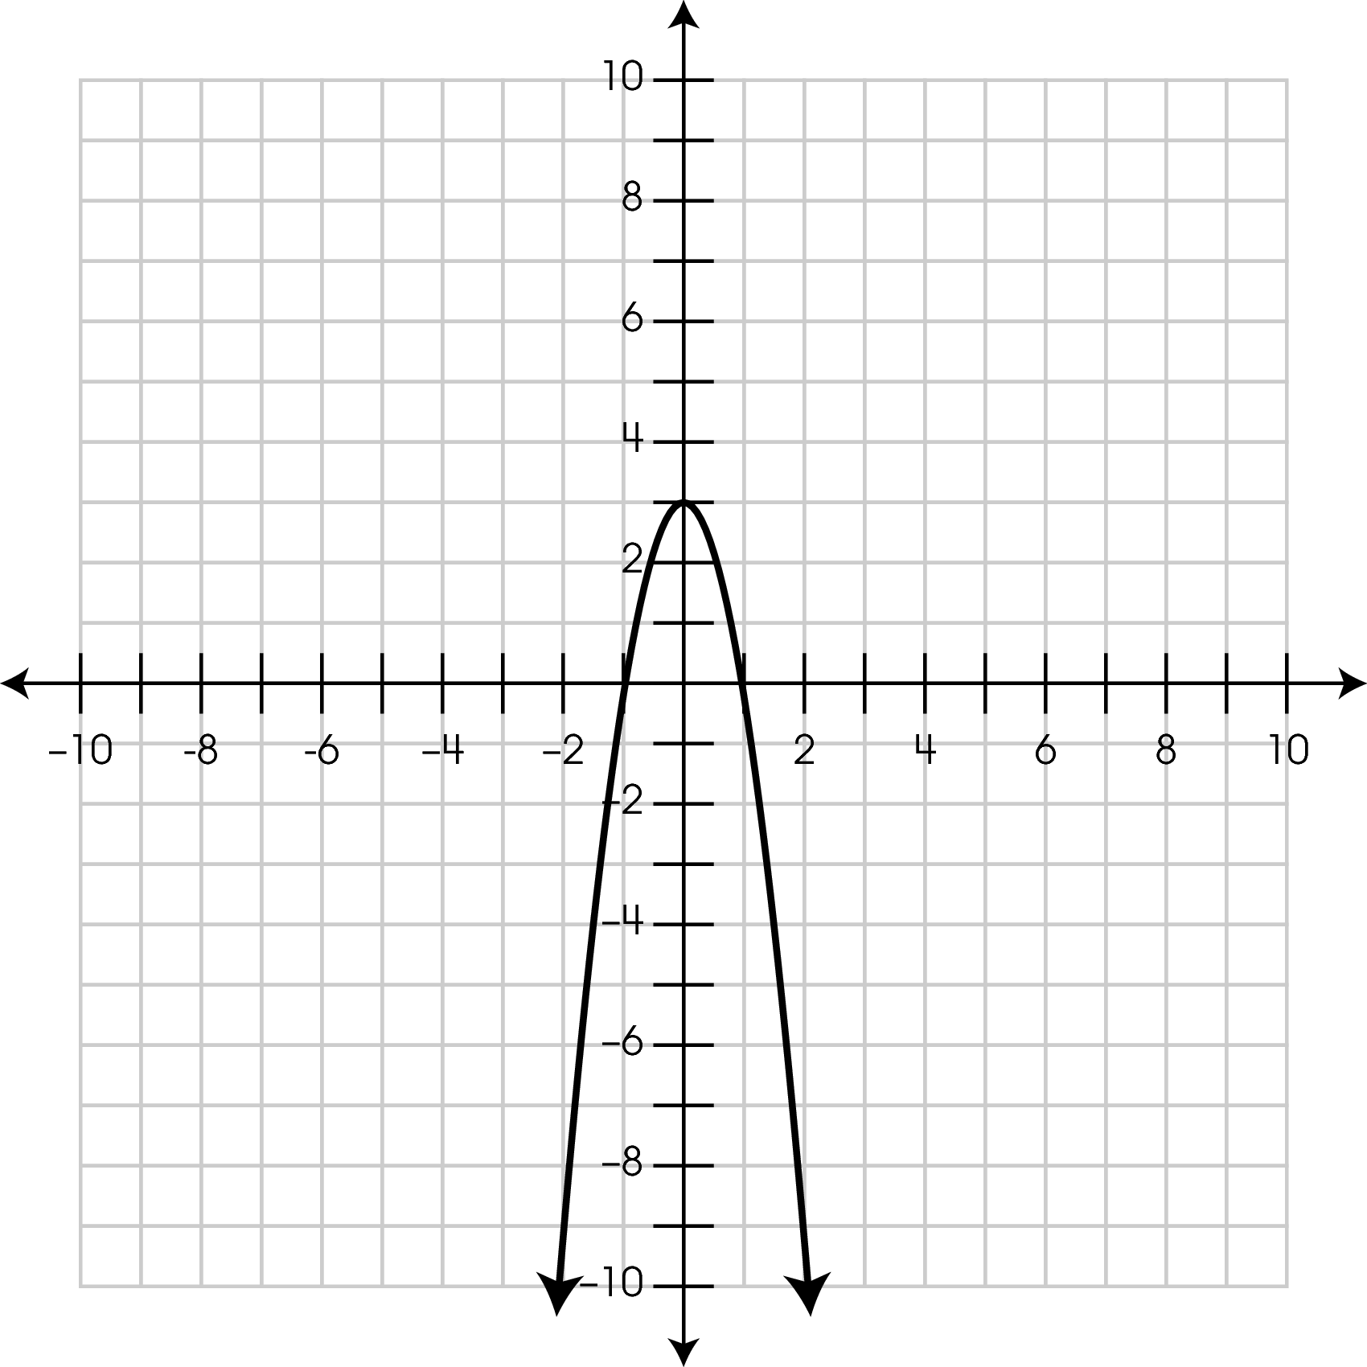
What are the solutions to 0 = -3x² + 3 ?

- 1 and -1
- 3 and -3
- 3 and 1
- 3 and -1
Commentary:
This multiple-choice question asks students to determine solutions of quadratic equation by using its graph. The solutions of quadratic equation are the points where the graph intersects the x-axis. These points are 1 and -1. Therefore, the correct answer choice is A.

Students who selected answer choice B thought that the solutions are the numbers that appear in the given equation. Students who selected answer choice C thought that the solutions are the y-intercept (point where the graph intersects the y-axis) and the positive x-intercept (point where the graph intersects the x-axis). Students who selected answer choice D may have thought that the solutions are the y-intercept and the negative x-intercept.

The complexity level of this question is Moderate Complexity. This question requires students to retrieve information from a graph.

Performance Data:
The percent of public school students selecting answer choice A for question 42 on the May 2008 Grade 8 Achievement Test was 43%.

Keywords: algebra, graph, solutions of quadratic equation, x – intercept, y – intercept

BACK TO INDEX

Benchmark: B | Identify and classify functions as linear or nonlinear, and contrast their properties using tables, graphs or equations.
GLI: PFA 8.3 | Identify functions as linear or nonlinear based on information given in a table, graph or equation.

Multiple Choice Question:

44. Which is a linear function?
A. y = x²+4
B. y = $\frac{3}{5x}$
C. y = 4x³
D. y = $\frac{1}{2}$x

Commentary:
This multiple-choice question asks students to identify the equation that represents a linear function. To solve the problem students should be able to distinguish an equation of linear function from other types of functions. An equation representing a linear function is a linear equation that contains one or two variables with no variable having an exponent other than 1 and that can be written in the form y = mx + b. In this form m is the slope, b is the y – intercept of the line and x and y are variables.
Answer choice D, y = $\frac{1}{2}$x, is correct because the exponents of the variables x and y are one and it can be written in the form y = $\frac{1}{2}$x + 0, where m = $\frac{1}{2}$ and b = 0.

Answer choice A is the equation of quadratic function that has an exponent 2 with a variable x.

Answer choice B is the equation of rational function that has an exponent (-1) with a variable x because x appears in denominator of the fraction.

Answer choice C is the equation of exponential function that has an exponent 3 with a variable x.

The complexity level of this question is Moderate Complexity. This question requires students to compare and select a mathematical statement.

Performance Data:
The percent of public school students selecting answer choice D for question 44 on the May 2008 Grade 8 Achievement Test was 38%.

Keywords: algebra, function, linear function

BACK TO INDEX

