Index to Questions

Question Number | Source | BM | GLI | Description
3 | OAT March 05 | B | PFA 7.1 | This multiple-choice question asks students to describe  the relationship between two variables.
7 | OAT March 05 | K | PRA 7.5 | This multiple-choice question asks students to identify the graph of a linear equation.
11 | OAT March 05 | J | PFA 7.8 | This short-answer question asks students to use a formula to solve a problem.
15 | OAT March 05 | D | PFA 7.9 | This multiple-choice question asks students to recognize the equation that could represent a given situation.
25 | OAT March 05 | G | PFA 7.7 | This multiple-choice question asks students to determine which expression is equivalent to the given expression.
29 | OAT March 05 | F | PFA 7.5 | This multiple-choice question asks students to select the  graph which represents the given situation.
34 | OAT March 05 | E | PFA 7.3 | This multiple-choice question asks students to select the pattern which is non-linear.
40 | OAT March 05 | L | PFA 7.10 | This multiple-choice question asks students to describe the effect on one variable when the other variable changes.
45 | OAT March 05 | B | PFA 7.2 | This multiple-choice question asks students to describe how to find the next term in a sequence of numbers.
9 | OAT March 06 | J | PFA 7.8 | This multiple-choice question asks students to find the cost of shipping an 8 pound package using a given equation.
18 | OAT March 06 | G | PFA 7.7 | This multiple-choice question asks students to simplify an algebraic expression.
38 | OAT March 06 | K | PFA 7.6 | This multiple-choice question asks students to identify the graph that represents the solution set of the given inequality.
8 | OAT May 07 | L | PFA 7.10 | This multiple-choice question asks students to determine the effect of decreasing the value of y on the value of x in a given equation.
11 | OAT May 07 | B | PFA 7.1 | This extended-response question asks students to complete the table given a problem situation.
Question Number | Source | BM | GLI | Description
17 | OAT May 07 | K | PFA 7.5 | This multiple-choice question asks students to identify the ordered pairs for the x- and y- intercepts of the given equation.
32 | OAT May 08 | L | PFA 7.10 | This multiple-choice question asks students to determine the effect of decreasing the value of y on the value of x in the relationship shown by the graph on a coordinate grid.
35 | OAT May 08 | H | PFA 7.4 | This multiple-choice question asks students to select the equation representing a given model.
39 | OAT May 08 | B | PFA 7.1 | This multiple-choice question asks students to select the equation that represents the relationship given in a table.
44 | OAT May 08 | F | PFA 7.5 | This multiple-choice question asks students to identify the equation of the line shown on a coordinate plane.

BACK TO INDEX

Benchmark: B | Represent, analyze and generalize a variety of patterns and functions with tables, graphs, words and symbolic rules.
GLI: PFA 7.1 | Represent and analyze patterns, rules and functions with words, tables, graphs and simple variable expressions.

Multiple Choice Question:

3. This table shows the cost of renting a certain number of videos.

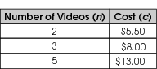

Which rule describes the relationship between the cost (c), in dollars, and the number of videos (n) rented?

- c = 2 n + 3
- c = 2.5 n + 0.5
- c = 2.25 n + 1
- c = 2 n + 2

ID: 1062; Version: 5

Commentary:
This multiple-choice question asks students to describe the relationship between two variables. Students are asked to select an equation which describes the relationship between the cost and the number of videos rented, which is given in a table. The relationship must be true for each number of videos given in the table. The relationship is described correctly in answer choice B, c = 2.5n + 0.5, where c is the cost in dollars and n is the number of videos rented. Students can verify the description by substituting the number of videos from the table in the equation to find the cost. For example, c = 2.5  3 + 0.5 for 3 videos. The cost is 7.5 + 0.5, which is 8, the cost in the table. Answer choices A, C and D are incorrect because the description is true for only one of the data points in the table.

The level of complexity for this question is Moderate Complexity. This task requires students to represent a situation mathematically.

Performance Data:
The percent of public school students selecting answer choice B for question 3 on the March 2005 Grade 7 Achievement Test was 48%.
Keywords: algebra, generalize patterns, variables

BACK TO INDEX

Benchmark: K | Graph linear equations and inequalities.
GLI: PFA 7.5 | Represent linear equations by plotting points in the coordinate plane.

Multiple Choice Question:

7. Which graph represents y = 2x + 1?

A. | 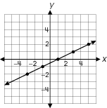 | B.
C. | 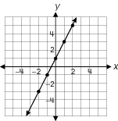 | D.

ID: 2847; Version: 15

Commentary:
This multiple-choice question asks students to identify the graph of a linear equation. Using the points on the line of the graph is one way of determining if the graph represents the equation. All of the points must satisfy the equation. This is determined by substituting each of the x -and y- coordinates of the points on the line in the equation. All of the points on the line of the graph in answer choice C satisfy the equation. Some of the points on the line of the graphs in answer choices A, B and D fail to satisfy the equation.

The level of complexity for this question is Moderate Complexity. The task requires selecting and using different representations.

Performance Data:
The percent of public school students selecting answer choice C for question 7 on the March 2005 Grade 7 Achievement Test was 31%.

Keywords: function, linear equation, graph

BACK TO INDEX

Benchmark: J | Use formulas in problem-solving situations.
GLI: PFA 7.8 | Use formulas in problem-solving situations.

Mathematical Processes
Benchmark: J | Communicate mathematical thinking to others and analyze the mathematical thinking and strategies of others.
GLI: PFA ??? | ?????

Short Answer Question:

11. Sal is hosting a party for 50 people. He will have people sit at a long line of tables. Each table can seat 4 people, plus one person can sit at each end of the line of tables, as shown.
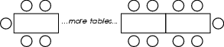
Sal uses this formula to find the number of people (p) who can sit at any number of tables (t).
p = 4t + 2
In your Answer Document, use the formula to find the number of tables he will need to seat 50 people. Show all steps you use to find the answer.

Commentary:
This short-answer question asks students to use a formula to solve a problem. Students can use a guess-and-check method or an algebraic approach to solve this problem. A response earning the maximum number of points (2 points) includes substituting the given values in the formula and showing steps to find the number of tables (t) needed to seat 50 people. For example,

p = 4t + 2
50 = 4t + 2
48 = 4t
12 = t

Twelve tables are needed to seat 50 people.

The level of complexity for this question is Moderate Complexity. The task requires retrieving information and using it to solve a problem requiring multiple steps.

Performance Data:
The percent of public school students earning each score point for question 11 on the March 2005 Grade 7 Achievement Test:
Percent at Each Score Point
0 | 1 | 2
44% | 21% | 32%

Scoring Guidelines:
Points | Student Response
2 | Sample Correct Responses:  - Twelve tables are needed.  p = 4t + 2  50 = 4t + 2  -2 - 2  48 = 4t  $\frac{\text{48}}{4}$ = $\frac{4t}{4}$  t = 12  - Sal needs 12 tables.  50 = 4t + 2 subtract two from each side  48 = 4t divide each side by 4  12 = t  NOTE: Response may show evidence of using guess-and-check method with identification (circle, underline, etc.) of the correct answer, e.g., “Sal needs 12 tables.”  The focus of the task is using a formula to solve a problem. The response includes a method of solving the given formula and appropriate steps resulting in the correct solution.
1 | The response provides partial evidence of using a formula to solve a problem; however, the solution is incomplete or slightly flawed.  For example, the response may:  - Substitute 50 in for t and solve for p  p = 4t + 2  p = (4  50) + 2  p = 200 + 2  p = 202  - Misunderstand multiplication and uses inverse operation of subtraction  4t + 2 = 50  50 – 2 = 48  4t = 48  48 – 4 = t  44 = t  - Add 2 instead of subtracting  - 4 t + 2 = 50, 4 t = 52, $\frac{\text{52}}{4}$= 13. t = 13  - State 12 tables without using the formula.
0 | The response provides inadequate evidence of using a formula to solve a problem. The response provides major flaws in reasoning or irrelevant information.  For example, the response may:  - State that he needs 50 tables.  - Be blank or make unrelated statements.  - Copy information from the stem.

Keywords: algebra, formula

BACK TO INDEX

Benchmark: D | Use symbolic algebra to represent and explain mathematical relationships.
GLI: PFA 7.9 | Recognize a variety of uses for variables; e.g., placeholder for an unknown quantity in an equation, generalization for a pattern, formula.

Mathematical Processes
Benchmark: H | Use representations to organize and communicate mathematical thinking and problem solutions.

Multiple Choice Question:

15. Kwame bought three rose bushes and two maple trees. Each rose bush costs $15. Kwame spent a total of $67. Let t represent the cost of one maple tree.
Which equation is one way to represent this situation?
- 2t + 3(15) = 67
- 2t + 3t = 67
- 2t + 3t = 67t
- 3t + 2(15) = 67

ID: 2783; Version: 19

Commentary:
This multiple-choice question asks students to recognize the equation that could represent a given situation. Information is provided about the cost of each rose bush ($15) and the total cost, but not the cost of each maple tree. Answer choice A, 2t + 3(15) = 67, reflects buying two maple trees (t) and three rose bushes at $15 each for a total of $67. Although answer choices B and C reflect buying two maple trees, they do not use the given cost of $15 for the rose bushes. Answer choice D shows buying two rose bushes at $15 each instead of three rose bushes.

The level of complexity of this question is Moderate Complexity. The task requires students to represent a situation mathematically.

Performance Data:
The percent of public school students selecting answer choice A for question 15 on the March 2005 Grade 7 Achievement Test was 67%.

Keywords: algebra, equation

BACK TO INDEX

Benchmark: G | Write, simplify and evaluate algebraic expressions.
GLI: PFA 7.7 | Justify that two forms of an algebraic expression are equivalent, and recognize when an expression is simplified; e.g., 4m = m + m + m + m or a · 5 + 4 = 5a + 4.

Multiple Choice Question:

25. Which expression is equivalent to 5(a + a + b)?
A. 15ab
B. 10a + b
C. 5a + 5b
D. 10a + 5b

ID: 1118; Version: 20

Commentary:
This multiple-choice question asks students to determine which expression is equivalent to the given expression. Students may model the problem by writing 5 sets of a + a + b and combining like terms or students may use the distributive property and combine like terms. Answer choice D is the correct answer. Answer choices A, B and C are the result of not combining like terms appropriately.

The level of complexity for this question is Moderate Complexity. The task requires students to represent a mathematical expression in more than one way.

Performance Data:
The percent of public school students selecting answer choice D for question 25 on the March 2005 Grade 7 Achievement Test was 30%.

Keywords: algebra, simplify algebraic expressions

BACK TO INDEX

Benchmark: F | Use representations, such as tables, graphs and equations, to model situations and to solve problems, especially those that involve linear relationships.
GLI: PFA 7.5 | Represent linear equations by plotting points in the coordinate plane.

Multiple Choice Question:

29. Tanisha earns $10 an hour at her job.
Which graph represents the amount of money that Tanisha will earn for any number of hours?
A. | 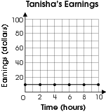 | B. | 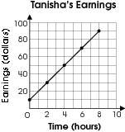
C. | 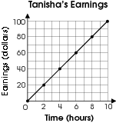 | D. | 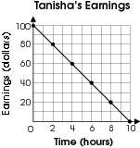

ID: 2320; Version: 5

Commentary:
This multiple-choice question asks students to select the graph which represents the given situation. Students should look for the graph which shows the relationship of earning $10 every hour. Answer choice C shows this relationship. Answer choice A shows earning only $10 for the entire job, regardless of the number of hours. Answer choice B shows earning more than $10 an hour, whereas answer choice D shows losing money as the number of hours increases.

The level of complexity for this question is Moderate Complexity. The task requires students to interpret visual representations.
Performance Data:
The percent of public school students selecting answer choice C for question 29 on the March 2005 Grade 7 Achievement Test was 61%.

Keywords: functions, graphs

BACK TO INDEX

Benchmark: E | Use rules and variables to describe patterns, functions and other relationships.
GLI: PFA 7.3 | Recognize and explain when numerical patterns are linear or nonlinear progressions; e.g., 1,3,5,7... is linear and 1,3,4,8,16... is nonlinear.

Multiple Choice Question:

34. Which pattern is non-linear?
A. –4, 2, 8, 14, 20, . . .
B. 2, 4, 8, 16, 32, . . .
C. 3, 6, 9, 12, 15, . . .
D. 5, 9, 13, 17, 21, . . .

Commentary:
This multiple-choice question asks students to select the pattern which is non-linear. In linear patterns, the numbers in the sequence change at a constant rate. Students should look for the pattern in which the numbers do not change at a constant rate, e.g., do not have the same amount added each time. The rate of change in answer choice B is not constant. The rate of change from the first term to the second term is not the same as from the second term to the third term, etc. The patterns in answer choices A, C and D are linear (A increases by 6, C increases by 3, and D increases by 4).

The level of complexity for this question is Moderate Complexity. The task requires students to compare patterns.
Performance Data:
The percent of public school students selecting answer choice B for question 34 on the March 2005 Grade 7 Achievement Test was 29%.

Keywords: patterns, non-linear

BACK TO INDEX

Benchmark: L | Analyze functional relationships, and explain how a change in one quantity results in a change in the other.
GLI: PFA 7.10 | Analyze linear and simple nonlinear relationships to explain how a change in one variable results in the change of another.

Multiple Choice Question:

40. The relationship between x and y is y = –2 x + 7.
How does the value of y change when x increases from 0 to 3?
- y decreases by 6
- y decreases by 3
- y increases by 5
- y increases by 7

Commentary:
This multiple-choice question asks students to describe the effect on one variable when the other variable changes. Students can determine the effect by creating and analyzing a table. For example, substitute 0, 1, 2 and 3 into the equation y = 2x + 7 to examine the changes in the y values.

x | y
0 | 7
1 | 5
2 | 3
3 | 1

The table shows that the values of y decreased from 7 to 1, so y decreased by 6 (answer choice A). Answer choice B states the range for the x values. Answer choices C and D show the y value increasing.

The level of complexity for this question is High Complexity. The task requires students to reason deductively.

Performance Data:
The percent of public school students selecting answer choice A for question on the March 2005 Grade 7 Achievement Test was 28%.

Keywords: algebra, functional relationships

BACK TO INDEX

Benchmark: B | Represent, analyze and generalize a variety of patterns and functions with tables, graphs, words and symbolic rules.
GLI: PFA 7.2 | Generalize patterns by describing in words how to find the next term.

Multiple Choice Question:

45. A sequence of numbers is shown.
0, 4, 12, 28, . . .
Which describes how to find the next term?
- Add 8 to the previous term.
- Add 16 to the previous term.
- Add 4 to the previous term and then multiply the result by 3.
- Add 2 to the previous term and then multiply the result by 2.

Commentary:
This multiple-choice question asks students to describe how to find the next term in a sequence of numbers. One strategy is to apply the rule in each answer choice to determine if the rule applies to each term. The rule in answer choice D applies to each term in the sequence. The rules in answer choices A, B and C do not apply to each term.

The level of complexity for this question is Moderate Complexity. The task requires students to compare statements to determine a rule for a sequence of numbers.

Performance Data:
The percent of public school students selecting answer choice D for question 45 on the March 2005 Grade 7 Achievement Test was 50%.

Keywords: patterns, rules

BACK TO INDEX

Benchmark: J | Use formulas in problem-solving situations.
GLI: PFA 7.8 | Use formulas in problem-solving situations.

Multiple Choice Question:

9. A shipping company uses a formula to determine the cost for shipping a package:
c = 2.79 + 0.38p,
where c is the cost of shipping and p is the number of pounds.
What is the cost of shipping a package that weighs 8 pounds?
A. $2.79
B. $3.04
C. $5.21
D. $5.83

Commentary:
This multiple-choice question asks students to find the cost of shipping an 8 pound package using a given equation. To find the cost students need to know how to substitute a value in an equation and solve for a variable. In this equation the p can be replaced with 8 and then the equation can be simplified:
c = 2.79 + 0.38p
= 2.79 + 0.38 • 8
= 2.79 + 3.04
= 5.83
the cost will be $5.83, answer choice D. Answer choices A, B and C are incorrect and may be the result of a computational error or not completely simplifying the equation.

The complexity level of this question is Moderate Complexity. This question asks students to solve a problem requiring multiple steps.

Performance Data:
The percent of public school students selecting answer choice D for question 9 on the March 2006 Grade 7 Achievement Test was 60%.

Keywords: algebra, equation

BACK TO INDEX

Benchmark: G | Write, simplify and evaluate algebraic expressions.
GLI: PFA 7.7 | Justify that two forms of an algebraic expression are equivalent, and recognize when an expression is simplified; e.g., 4m = m + m + m + m or a · 5 + 4 = 5a + 4.

Multiple Choice Question:

18. Simplify: 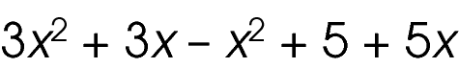
A. 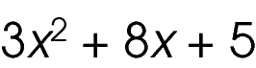
B. 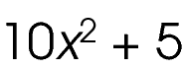
C. 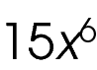
D. 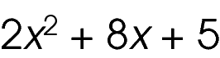

Commentary:
This multiple-choice question asks students to simplify an algebraic expression. To simplify this expression student should have an understanding of combining like terms (terms with the same variables raised to exactly the same powers are called like terms). The student could simplify this expression by combining 3x² and - x², and then combining 3x and 5x.
3x² + 3x - x² + 5 + 5x = 3x² - x² + 3x + 5x + 5
= 2x² + 8x + 5
The correct answer choice is D. Answer choices A, B and C are the result of an incorrect computation or error in combining like terms.

The complexity level of this question is Low Complexity. This question asks students to recognize an equivalent representation.

Performance Data:
The percent of public school students selecting answer choice D for question 18 on the March 2006 Grade 7 Achievement Test was 22%.

Keywords: algebra, expression, like terms

BACK TO INDEX

Benchmark: K | Graph linear equations and inequalities.
GLI: PFA 7.6 | Represent inequalities on a number line or a coordinate plane.

Multiple Choice Question:

38. Which graph represents –2  x  2?
A. 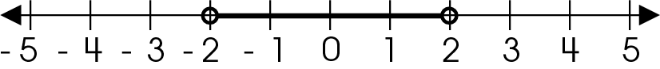
B. 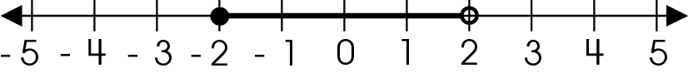
C. 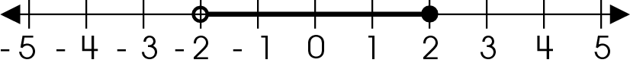
D. 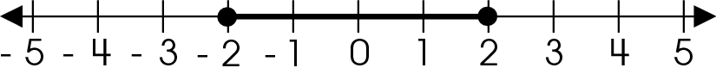

Commentary:
This multiple-choice question asks students to identify the graph that represents the solution set of the given inequality. To solve this question students need to understand that they have to identify the intersection of the two inequalities x  -2 and x  2. Because of the greater than or equal to signs used for both inequalities, the numbers 2 and -2 must be included in the solution set for the given inequalities. Therefore, both endpoints of the interval must be included or closed, eliminating answer choices A, B and C. Answer choice D is correct.

The complexity level of this question is Low Complexity. This question require student to identify an equivalent representation.

Performance Data:
The percent of public school students selecting answer choice D for question 38 on the March 2006 Grade 7 Achievement Test was 36%.

Keywords: algebra, inequalities, graph

BACK TO INDEX

Benchmark: L | Analyze functional relationships, and explain how a change in one quantity results in a change in the other.
GLI: PFA 7.10 | Analyze linear and simple nonlinear relationships to explain how a change in one variable results in the change of another.

Multiple Choice Question:

8. For y = –7x – 4, as the value of y decreases, what happens to the value of x?

- The value of x increases.
- The value of x decreases.
- The value of x stays the same.
- The value of x increases and decreases.

Commentary:
This multiple-choice question asks students to determine the effect of decreasing the value of y on the value of x in a given equation. One method students can use for determining the effect of y on x is to substitute decreasing values for y in the equation y = -7x – 4 and examine how it affects the values of x. For example:

3 = -7x -4 0 = -7x – 4 -4 = -7x - 4
7 = -7x 4 = -7x 0 = -7x
-1 = x $−\frac{4}{7}$ = x 0 = x

For the equation y = -7x – 4, as y decreases x increases, answer choice A.
Answer choices B, C and D may be the result of computational errors in solving the equation for x, and therefore are incorrect.

The complexity level of this question is High Complexity. The question requires students to solve a problem that has multiple steps and multiple decision points.

Performance Data:
The percent of public school students selecting answer choice A for question 8 on the May 2007 Grade 7 Achievement Test was 36 %.

Keywords: algebra, equation

BACK TO INDEX

Benchmark: B | Represent, analyze and generalize a variety of patterns and functions with tables, graphs, words and symbolic rules.
GLI: PFA 7.1 | Represent and analyze patterns, rules and functions with words, tables, graphs and simple variable expressions.

Extended Response Question:

11. Julius has created a number pattern. The first number in his pattern is 1. Then, he says, “the next number in my pattern can always be determined by multiplying the previous number by 2 and then adding 3.”
In your Answer Document, copy and complete the table showing the first six numbers in Julius’ number pattern.
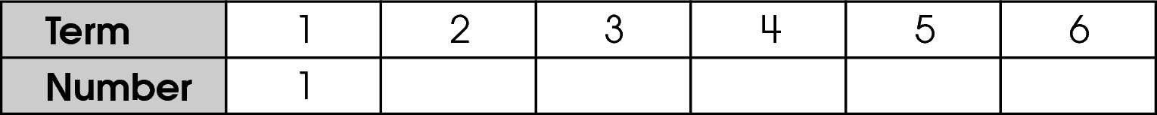
Use the table to decide if Julius’ number pattern changes at a constant rate and explain how you know.
Julius claims that 100 cannot be a number in his pattern. Explain whether Julius’ claim is valid and how you know.

Commentary:
This extended-response question asks students to complete the table given a problem situation. Student must also determine if the pattern is changing at a constant rate and if the number 100 can be a number in the pattern. A response earning the maximum number of point (4 points) provides a completed table, states that the pattern is not changing at a constant rate and that 100 can not be a number in the pattern. Students must use the first number in the pattern (1) and then multiply it by 2 and then add 3 to obtain the number for the next term. Students must continue this process to complete the table.

1• 2 + 3 = 5
5• 2 + 3 = 13
13• 2 + 3 = 29
29• 2 + 3 = 61
61• 2 + 3 = 125

Term | 1 | 2 | 3 | 4 | 5 | 6
Number | 1 | 5 | 13 | 29 | 61 | 125

To analyze this pattern, students can subtract two sets of adjacent terms to determine if the pattern increases at a constant rate.
As the patterns goes from the 5th to the 6th term, the number goes from 61 to 125, skipping 100.

The complexity level of this question is Moderate Complexity. This task requires students to retrieve information from a table and use it to solve a problem with multiple steps.

Performance Data:
The percent of public school students earning each score point for question 11 on the May 2007 Grade 7 Achievement Test:

Percent at Each Score Point
0 | 1 | 2 | 3 | 4
25% | 12% | 22% | 31% | 10%

Scoring Guidelines:
Sample Correct Responses:
- 2(1) + 3 = 5
2(5) + 3 = 13
2(13) + 3 = 29
2(29) + 3 = 61
2(61) + 3 = 125
Term | 1 | 2 | 3 | 4 | 5 | 6
Number | 1 | 5 | 13 | 29 | 61 | 125

AND
The numbers do not increase the same amount each time.
AND
Julius’ claim is correct because 100 is an even number and all the numbers in the pattern are odd numbers. There are no terms between 5 and 6 that would give 100.

Points | Student Response
4 point text | The focus of the task is representing and analyzing patterns, rules and functions with words, tables, graphs and simple variable expressions. The response provides an accurate table showing the first six numbers in Julius’ number pattern. The response provides an adequate explanation as to whether the number pattern changes at a constant rate. The response also provides an adequate explanation on whether Julius’ claim that 100 cannot be a number in his pattern is valid.
3 point text | The response provides clear evidence of representing and analyzing patterns, rules and functions with words, tables, graphs and simple variable expressions; however, the solution is slightly flawed.  For example, the response may:  - Provide a table with a minor calculation error and two adequate explanations.  - Provide a correct table and one correct explanation.  - Provide two correct explanations, using correct numbers from the table, but does not include a table.
2 point text | The response provides partial evidence of representing and analyzing patterns, rules and functions with words, tables, graphs and simple variable expressions; however, the solution is incomplete or flawed.  For example, the response may:  - Provide a correct table showing the first six numbers in Julius’ number pattern.  - Provide two correct explanations, but does not include a table.
1 point text | The response provides minimal evidence of representing and analyzing patterns, rules and functions with words, tables, graphs and simple variable expressions; however, the solution is incomplete or flawed.  For example, the response may:  - Provide a table showing 3 or 4 correct terms in Julius’ number pattern.  - Provide an adequate explanation as to whether the number pattern changes at a constant rate, but does not include a table.  - Provide an adequate explanation as to whether Julius’ claim that 100 cannot be a valid number in his pattern, but does not include a table.  - Makes an error in the table and makes one valid explanation based on the table.
0 point text | The response provides inadequate evidence of understanding of representing and analyzing patterns, rules and functions with words, tables, graphs and simple variable expressions. The response provides major flaws in reasoning or irrelevant information.  For example, the response may:  - State that 100 could end up being in the pattern because the pattern increases every time.  - Be blank or make unrelated statements.  - Copy information from the stem.

Keywords: algebra, pattern, table, constant rate

BACK TO INDEX

Benchmark: K | Graph linear equations and inequalities.
GLI: PFA 7.5 | Represent linear equations by plotting points in the coordinate plane.

Multiple Choice Question:

17. The graph of 5x – 2y = 10 intersects the x-axis and the y-axis.
What are the ordered pairs for these two points of intersection?

- (2, 0) and (0, 5)
- (2, 0) and (0, –5)
- (–2, 0) and (0, 5)
- (–2, 0) and (0, –5)

Commentary:
This multiple-choice question asks students to identify the ordered pairs for the x- and y- intercepts of the given equation. One method for finding the ordered pair for the points where the graph crosses the x- and y-axes is to graph the equation. To create a graph students should select values for x and solve the equation for y. For example, if x equals 0, 2 or 4:

$\begin{aligned}5⋅ 0 − 2y = \text{10} \\ −2y = \text{10} \\ y = −5\end{aligned}$ $\begin{aligned} 5⋅ 2 − 2y = \text{10} \\ \text{10}−2y = \text{10} \\ −2y = 0 \\ y = 0\end{aligned}$ $\begin{aligned}5⋅ 4 − 2y = \text{10} \\ \text{20} − 2y = \text{10} \\ −2y = −\text{10} \\ y = 5\end{aligned}$

x | y
0 | -5
2 | 0
4 | 5

-10 -9 -8 -7 -6 -5 -4 -3 -2 -1 1 2 3 4 5 6 7 8 9 10
10
9
8
7
6
5
4
3
2
1

-1
-2
-3
-4
-5
-6
-7
-8
-9
-10

A second method that students can use is to recall that the y-coordinate of the x-intercept must be zero and the x-coordinate of the y-intercept must also be zero. To find the x-intercept substitute zero for the value of y in the equation 5x - 2y = 10 and solve for x:

5x – 2 • 0 = 10,
5x = 10,
x = 2

The ordered pair for the x-intercept would be (2, 0).
To find the y-intercept, substitute zero for the value of x in the equation 5x - 2y = 10 and solve for y:

5•0 - 2y = 10
- 2y = 10
y = -5

The ordered pair for the y-intercept would be (0, -5). The correct answer would be answer choice B.
Students who select answer choices A, C or D may have made errors in solving for one or both of the variables.

The complexity level of this question is Moderate Complexity. This question requires students to recall information about intercepts and to solve problems requiring multiple steps.

Performance Data:
The percent of public school students selecting answer choice B for question 17 on the May 2007 Grade 7 Achievement Test was 28%.

Keywords: algebra, linear equation, intercept, ordered pair

BACK TO INDEX

Benchmark: L | Analyze functional relationships, and explain how a change in one quantity results in a change in the other.
GLI: PFA 7.10 | Analyze linear and simple nonlinear relationships to explain how a change in one variable results in the change of another.

Multiple Choice Question:

32. A relationship is shown.
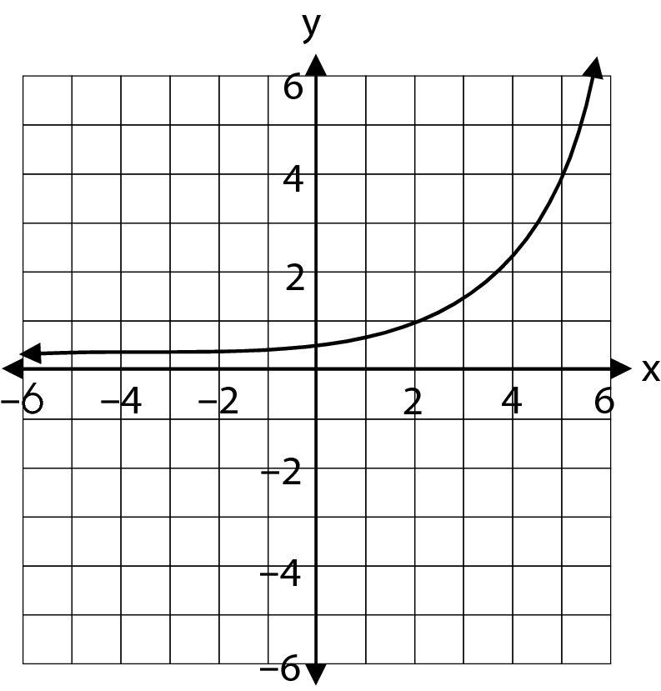
As the value of y decreases, what happens to the value of x?

  - The value of x decreases.
  - The value of x increases.
  - The value of x stays the same.
  - The value of x increases and decreases.
Commentary:
This multiple-choice question asks students to determine the effect of decreasing the value of y on the value of x in the relationship shown by the graph on a coordinate grid. One method students can use for determining the effect of decreasing the value of y on the value of x is to choose points on the graph and analyze how the change in one variable results in a change of the other variable. For example, some of the points from the graph appear to be (5, 4); (2, 1); (0, 0.5). As the y-coordinate decreases, the x coordinate also decreases, answer choice A.

If students choose answer choice B, they thought that the value of x increases because the graph goes up on the right. If students choose answer choice C, they confused the values of x with values of y which appear to be the same on the left side of the graph only. If students choose answer choice D, they thought that the value of x increases and decreases because x decreases to the left and increases to the right.

The complexity level of this question is High Complexity. This question requires students to compare statements.

Performance Data:
The percent of public school students selecting answer choice A for question 32 on the May 2008 Grade 7 Achievement Test was 32%.

Keywords: algebra, graph, increasing, decreasing

BACK TO INDEX

Benchmark: H | Solve linear equations and inequalities symbolically, graphically and numerically.
GLI: PFA 7.4 | Create visual representations of equation-solving processes that model the use of inverse operations.

Multiple Choice Question:

35. Ms. Larsen drew this model.
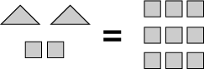
Which equation does this model represent?

  - x – 2 = 9
  - 2x – 2 = 9
  - 2x + 2 = 9
  - 4x = 9

Commentary:
This multiple-choice question asks students to select the equation representing a given model.
Students have to realize that if there are 9 squares on the right side of the equation, then each square equals one. The left side of the equation is represented by two triangles and the two squares. The triangle and the square do not have to represent the same values. If each of two triangles is represented by the value x and each square is represented by 1, then the left side of the equation is represented by the expression 2x + 2 and the right side is represented by the number 9. Therefore, the correct answer choice is C.

If students choose answer choice A, they ignored the presence of two triangles, and represented it as x, instead of 2x. If students choose answer choice B, they confused the addition with subtraction. If students choose answer choice C, they thought that the triangle and the square do not have to be different, counted the number of objects on the left side and expressed it as 4x.

The complexity level of this question is Moderate Complexity. This question requires students to use different representations for the given situation.

Performance Data:
The percent of public school students selecting answer choice C for question 35 on the May 2008 Grade 7 Achievement Test was 48%.

Keywords: equation, variable, model

BACK TO INDEX

Benchmark: B | Represent, analyze and generalize a variety of patterns and functions with tables, graphs, words and symbolic rules.
GLI: PFA 7.1 | Represent and analyze patterns, rules and functions with words, tables, graphs and simple variable expressions.

Multiple Choice Question:

39. A plumber's total charge (t) for working a given number of hours (h) is displayed in the table shown.
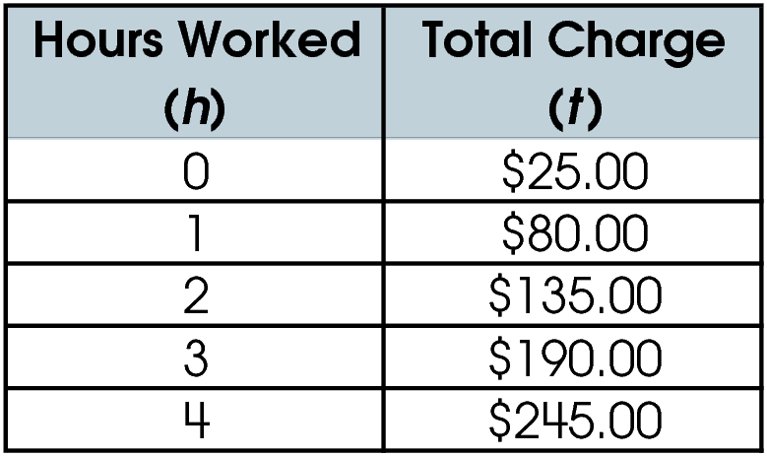
Which equation represents the relationship between the hours worked and the plumber's total charge?

  - t = h + 25
  - t = h + 55
  - t = 25h + 55
  - t = 55h + 25

Commentary:
This multiple-choice question asks students to select the equation that represents the relationship given in a table. To solve this problem students need to study the given relationship. The first row in the table shows that plumber’s charge at 0 hours is $25. Then, by subtracting any two consecutive total charges the student can determine that the charge increases by $55 every hour. So, the total charge is equal to the initial charge plus the charge for each additional hour, h, the plumber works which can be written as t = 55h + 25, answer choice D.

If a student chooses answer choice A, he or she used only the information for 0 hours (initial cost) but did not consider the charge per hour. If a student chooses answer choice B, he or she examined only the numbers in the Total Charge column, recognized that the charges increased by $55 each hour and added $55 to the number of hours, h. If a student chooses answer choice C, he or she confused the initial charge, $25, and the hourly rate, $55, and multiplied the initial cost by the number of hours, h.

The complexity level of this question is Moderate Complexity. This question requires students to interpret information in the table and select different representation of the same situation.

Performance Data:
The percent of public school students selecting answer choice D for question 39 on the May 2008 Grade 8 Achievement Test was 43%.

Keywords: algebra, equation, table

BACK TO INDEX

Benchmark: F | Use representations, such as tables, graphs and equations, to model situations and solve problems, especially those that involve linear relationships.
GLI: PFA 7.5 | Represent linear equations by plotting points in the coordinate plane.

Multiple Choice Question:

44. A line is shown on a coordinate plane.
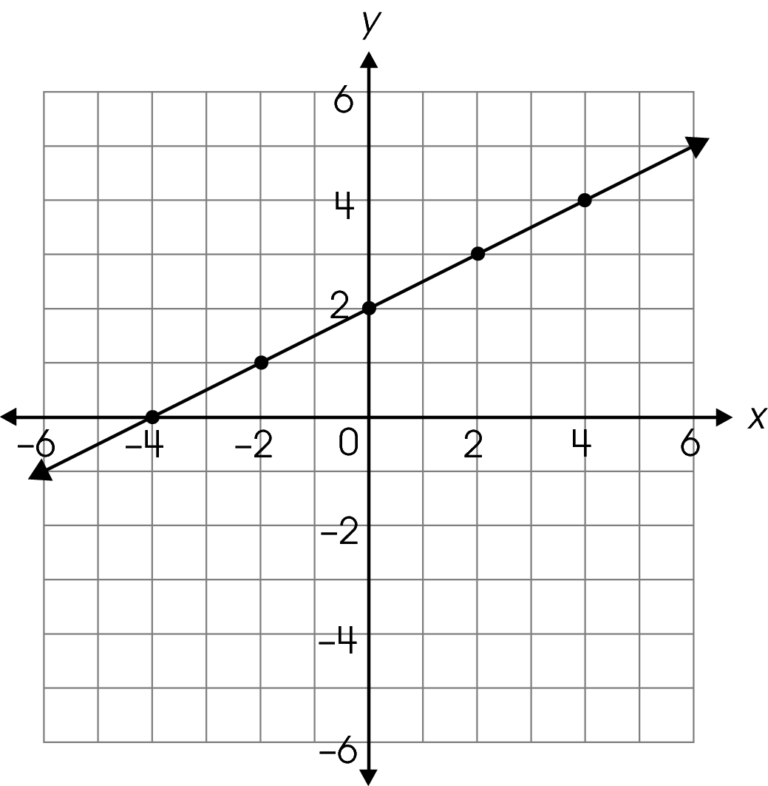
Which equation is represented by this line?

A. y = $\frac{1}{2}$x + 6
B. y = $\frac{1}{2}$x + 2
C. y = 2x + 2

D. y = 2x – 4
Commentary:
This multiple-choice question asks students to identify the equation of the line shown on a coordinate plane. One method students can use for selecting the equation is to determine the slope and the y-intercept of the line and then substitute this information into the slope-intercept form of the equation of the line y = mx + b, where m represents the slope and b is the
y-intercept. The slope of a line is measured by the ratio of vertical change to the corresponding horizontal change. For example, if a student selects a point (2, 3) and moves to the point (4, 4) the vertical change is the change in y-coordinates: 4 – 3 or 1 unit. The corresponding horizontal change is the change in x- coordinates: 4 – 2 or 2 units. The ratio of these changes or a slope of the line is $\frac{1}{2}$. The y-intercept, or the point where the line crosses the y axis, is (0, 2). When$\frac{1}{2}$is substituted for m and 2 is substituted for b in y = mx + b, the equation becomes y = $\frac{1}{2}$x + 2. Answer choice B is correct.
If a student chooses answer choice A, he or she found the correct slope of a line ($\frac{1}{2}$) but incorrectly selected the x-coordinate of the ordered pair (6, 5) instead of selecting a y-coordinate of the y-intercept (0, 2).
If a student chooses answer choice C, he or she correctly found the y-intercept of the line,
(0, 2) but incorrectly found the slope of the line by taking the ratio of horizontal change to the corresponding vertical change or $\frac{2}{1}$= 2.
If a student chooses answer choice D, he or she confused the x and the y – intercepts and miscalculated the slope.

The complexity level of this question is Low Complexity. This question requires students to retrieve information from the graph.

Performance Data:
The percent of public school students selecting answer choice B for question 44 on the May 2008 Grade 7 Achievement Test was 38%.

Keywords: algebra, graph, line, slope, y-intercept

BACK TO INDEX

