Index to Questions

Question Number | Source | BM | GLI | Description
6 | OAT Mar 06 | A | PFA 6.1, PFA 6.2 | This short-answer question asks students to write a rule for a pattern to find the number of dots for any figure in the pattern.
7 | OAT Mar 06 | D | PFA 6.3 | This multiple-choice question asks students to find an equivalent algebraic expression for the associative property for multiplication.
19 | OAT Mar 06 | G | PFA 6.6 | This multiple-choice question asks students to use the given algebraic expression to find the total cost of books and videos.
20 | OAT Mar 06 | L | PFA 6.7 | This multiple-choice question asks students to determine which input-output table shows a constant rate of decrease.
23 | OAT Mar 06 | H | PFA 6.4 | This multiple-choice question asks student to solve the given equation that represents a situation.
28 | OAT Mar 06 | L | PFA 6.7 | This multiple-choice question asks students to describe the rate of change from data given in a table.
41 | OAT Mar 06 | A | PFA 6.1, PFA 6.2 | This short-answer question asks students to indicate the number of blocks in the 10th layer of the staircase if the pattern continues.
43 | OAT Mar 06 | H | PFA 6.4 | This multiple-choice question asks students to solve the given equality. Students can use the two-step process to solve the inequality.
44 | OAT Mar 06 | D | PFA 6.3 | This multiple-choice question asks students to find an expression equivalent to the given expression.
3 | OAT May 07 | C | PFA 6.5 | This multiple-choice question asks students to use a graph of the relationship between the number of vans washed and the number of cars washed to earn exactly $360.
13 | OAT May 07 | E | PFA 6.2 | This multiple-choice question asks students to select the rule which describes the relationship between two variables in the input-output function.
31 | OAT May 07 | A & B | PFA 6.2, PFA 7.2 | This short-answer question asks students to describe the rule for the pattern and to find the next term in the pattern.
42 | OAT May 07 | L | PFA 6.7 | This multiple-choice question asks students to select the statement which describes the rate of change in the given situation.
Question Number | Source | BM | GLI | Description
3 | OAT May 08 | E | PFA 6.2 | This multiple-choice question asks students to select the rule that describes the given pattern.
31 | OAT May 08 | L | PFA 6.7 | This short-answer question asks students to explain who is hiking at a constant rate and who is hiking at a changing rate by using the information provided in the given table.

BACK TO INDEX

Benchmark: A | Describe, extend and determine the rule for patterns and relationships occurring in numeric patterns, computation, geometry, graphs and other applications.
GLI: PFA 6.1, PFA 6.2 | PFA 6.1: Represent and analyze patterns, rules and functions, using physical materials, tables and graphs.  PFA 6.2: Use words and symbols to describe numerical and geometric patterns, rules and functions.

Short Answer Question:

6. Jeff drew a pattern of dots and made the table shown to describe the pattern.

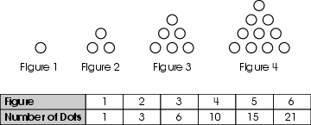
In your Answer Document, write a rule that Jeff can use to find the number of dots for any figure in this pattern. Show or explain your answer.

Commentary:
This short-answer question asks students to write a rule for a pattern to find the number of dots for any figure in the pattern. A pattern of dots and a table showing the number of dots in each figure is given. A response earning the maximum number of points (2 points) provides a written rule describing the pattern to find the number of dots for any figure with an adequate explanation or supporting work. An example of the rule to find the number of dots for any figure in the pattern is to add the current figure number and the number of dots in the last figure. The rule must describe the number of dots in any figure.

The complexity level of this question is High Complexity. This task requires students to generalize a pattern.

Performance Data:
The percent of public school students earning each score point for question 6 on the March 2006 Grade 6 Achievement Test:

Percent at Each Score Point
0 | 1 | 2
34% | 52% | 12%

Scoring Guidelines:
Sample Correct Response(s):
- Add the current figure number and the number of dots in the last figure.
Current figure number + Previous number of dots = Total number of dots for current figure
Points | Student Response
2 | The focus of this task is using words to describe the rule for this pattern. The response provides a description of the extended pattern.
1 | The response provides partial evidence of using words to describe the rule for this pattern; however, the solution may be incomplete or slightly flawed.  For example, the response may:  - State that the current figure’s number of dots is found by adding the previous figure number to the previous figure’s number of dots.  - Provide work that continues the pattern without an explanation.  - State that the number of dots in each figure increases by the number after it, such as the first figure has 1 dot, the 2nd figure has 2 more dots, and the 3rd figure has 3 more dots than the 2nd figure.
0 | The response provides inadequate evidence of using words to describe the rule for this pattern. The response provides major flaws in reasoning or irrelevant information.  For example, the response may:  - State that the number of dots increases.  - State that you need to add 16 to the figure number.  - Be blank or state unrelated statements.  - Recopy information from the stem.

do not copy or distribute ID: 3887; Version: 18

Keywords: pattern, rule

BACK TO INDEX

Benchmark: D | Use symbolic algebra to represent and explain mathematical relationships.
GLI: PFA 6.3 | Recognize and generate equivalent forms of algebraic expressions, and explain how the commutative, associative and distributive properties can be used to generate equivalent forms; e.g., perimeter as 2(1 + w) or 21 + 2w.

Multiple Choice Question:

7. Sarah used the associative property to find an expression equivalent to 5 x (a x 7).
Which expression did Sarah use?
A. (5 × a) + (5 × 7)
B. (5 + a) × (5 + 7)
C. (5 × a) × 7
D. 5 × (7 × a)

Commentary:
This multiple-choice question asks students to find an equivalent algebraic expression for the associative property for multiplication. Students are expected to recall that the associative property involves regrouping of the terms without changing the order and the result of the operation remains the same. Answer choice C shows the regrouping of the terms without changing the order and the result of the operation. Answer choices A, B and D are incorrect. Answer choices A and B involve addition and multiplication and would change the result of the operations. Answer choice D shows changing the order of two of the terms, which is the commutative property.

The complexity level of this question is Low Complexity. This question requires students to recognizing an example of a property.

Performance Data:
The percent of public school students selecting answer choice C for question 7 on the March 2006 Grade 6 Achievement Test was 44%.

Keywords: algebra, associative property for multiplication, algebraic expression

BACK TO INDEX

Benchmark: G | Write, simplify and evaluate algebraic expressions.
GLI: PFA 6.6 | Evaluate simple expressions by replacing variables with given values, and use formulas in problem-solving situations.

Multiple Choice Question:

19. Andrew buys books and videos in a store. He uses the expression 6 b + 12 v to find the cost of what he is buying, where b is the number of books and v is the number of videos he buys.
Use the expression to find the total cost of 4 books and 5 videos.
A. $27
B. $54
C. $78
D. $84

do not copy or distribute ID: 6656; Version: 3

Commentary:
This multiple-choice question asks students to use the given algebraic expression to find the total cost of books and videos. Students should evaluate the expression by substituting the number of books (4) and the number of videos (5) into the expression (6b + 12v), and then simplify the expression to find the total cost.

6b + 12v
6(4) + 12(5)
24 + 60
84

The total cost of 4 books and 5 videos is $84, answer choice D. In answer choices A, B and C, the total cost is the result of substitution errors or not evaluating the expression correctly resulted in errors in finding the total cost.

The complexity level of this question is Moderate Complexity. This question requires students to solve a word problem requiring multiple steps.

Performance Data:
The percent of public school students selecting answer choice D for question 19 on the March 2006 Grade 6 Achievement Test was 56%.

Keywords: algebra, algebraic expression, evaluate

BACK TO INDEX

Benchmark: L | Analyze functional relationships, and explain how a change in one quantity results in a change in the other.
GLI: PFA 6.7 | Identify and describe situations with constant or varying rates of change, and compare them.

Multiple Choice Question:

20. Which table shows a constant rate of decrease?
A. 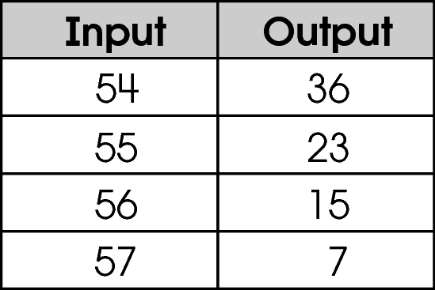
B. 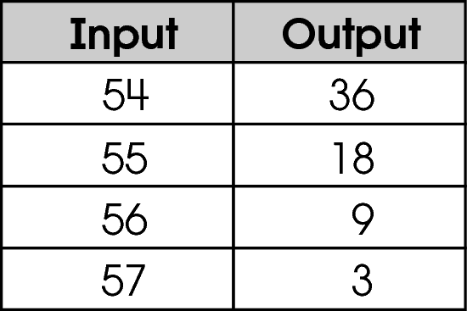
C. 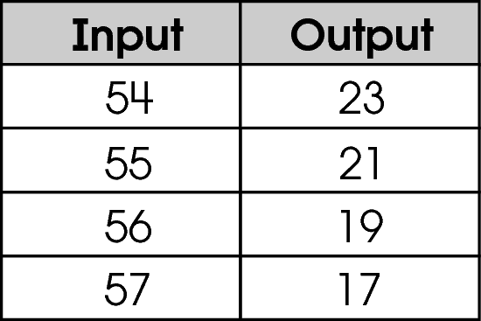
D. 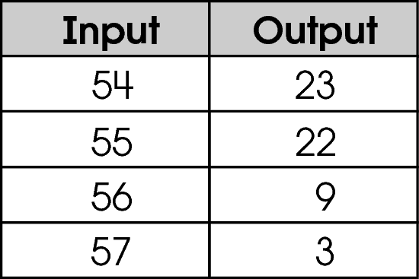

Commentary:
This multiple-choice question asks students to determine which input-output table shows a constant rate of decrease. Students should know that for a rate of decrease, the amount of decrease is the same each time. Although each table shows a decrease, answer choice C shows the same amount of decrease each time in the output (decreases by 2 each time).
The complexity level of this question is Moderate Complexity. This question requires students to interpret visual representations and compare with a table.

Performance Data:
The percent of public school students selecting answer choice C for question 20 on the March 2006 Grade 6 Achievement Test was 43%.

Keywords: data analysis, rate of change

BACK TO INDEX

Benchmark: H | Solve linear equations and inequalities symbolically, graphically and numerically.
GLI: PFA 6.4 | Solve simple linear equations and inequalities using physical models, paper and pencil, tables and graphs.

Multiple Choice Question:

23. Kristi is selling candy bars to raise money for her track team. Each of her neighbors bought 4 candy bars. She also sold 18 candy bars to her friends at school for a total of 38 candy bars. The equation 4x + 18 = 38 represents this situation where x is the number of neighbors.
How many neighbors bought candy bars from Kristi?
A. x = 5
B. x = 14
C. x = 16
D. x = 80

do not copy or distribute ID: 5958; Version: 4

Commentary:
This multiple-choice question asks students to solve the given equation that represents a situation. Students can use various methods to solve the equation, such as guess and check, creating a table or using a formal procedure. For example,

4x + 18 = 38
4x + 18 - 18 = 38 -18
4x = 20
$\frac{4x}{4}$ = $\frac{\text{20}}{4}$
x = 5

Answer choice A is the correct answer. The solutions in the answer choices B, C and D were chosen based on the use of incorrect procedures when solving the equation.

The complexity level of this question is Low Complexity. This question requires students to use a specified procedure.

Performance Data:
The percent of public school students selecting answer choice A for question 23 on the March 2006 Grade 6 Achievement Test was 63%.

Keywords: algebra, equation

BACK TO INDEX

Benchmark: L | Analyze functional relationships, and explain how a change in one quantity results in a change in the other.
GLI: PFA 6.7 | Identify and describe situations with constant or varying rates of change, and compare them.

Multiple Choice Question:

28. The table shows Jim’s savings over time.
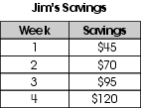
Which describes the rate of change of Jim’s savings over time?

A. constant rate of decrease
B. constant rate of increase
C. varying rate of decrease
D. varying rate of increase

Commentary:
This multiple-choice question asks students to describe the rate of change from data given in a table. Students should determine if the amount of savings is increasing or decreasing at a constant rate or varying rate by finding the difference between two consecutive weeks
($70 - $45 = $25). The amount of savings is increasing each week by $25. This shows a constant rate of increase, answer choice B. Answer choices A, C and D are not supported by the data in the table.

The complexity level of this question is Moderate Complexity. This question requires students to interpret data in a table.

Performance Data:
The percent of public school students selecting answer choice B for question 28 on the March 2006 Grade 6 Achievement Test was 69%.

Keywords: algebra, rate of change

BACK TO INDEX

Benchmark: A | Describe, extend and determine the rule for patterns and relationships occurring in numeric patterns, computation, geometry, graphs and other applications.
GLI: PFA 6.1, PFA 6.2 | PFA 6.1: Represent and analyze patterns, rules and functions, using physical materials, tables and graphs.  PFA 6.2: Use words and symbols to describe numerical and geometric patterns, rules and functions.

Short Answer Question:

41. The top 4 layers of a 10-layer staircase are shown.
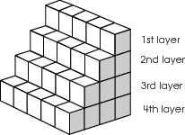
In your Answer Document, tell how many blocks are in the 10th layer of the staircase if the pattern continues. Show or explain how you found your answer.

Commentary:
This short-answer question asks students to indicate the number of blocks in the 10th layer of the staircase if the pattern continues. The task provides a staircase with the first four layers shown. A response earning the maximum number of points (2 points) indicates that the 10th layer of the staircase has 50 blocks with supporting work or an explanation. Students should determine that each new layer shown in the staircase has 5 more blocks than the previous layer. The number of blocks in the first four layers is a multiple of 5. If the pattern continues, the number of blocks in the next six layers would be 25, 30, 35, 40, 45 and 50.

The complexity level of this question is Moderate Complexity. This task requires students to retrieve information from a figure to extend a pattern.

Performance Data:
The percent of public school students earning each score point for question 41 on the March 2006 Grade 6 Achievement Test:

Percent at Each Score Point
0 | 1 | 2
34% | 34% | 30%

Scoring Guidelines:
Sample Correct Response(s):
- 50 blocks are in the 10th layer of the staircase.
I saw that each layer has 5 blocks times the layer number so the tenth layer has
5 × 10 = 50.
- I found that each layer has 5 more blocks than the previous layer so I made a table to show the pattern.
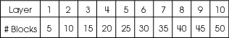

Points | Student Response
2 | The focus of this task is analyzing and extending a pattern. The response includes the correct number of cubes in the 10th layer AND shows supporting work OR gives an adequate explanation of the answer.
1 | The response provides partial evidence of analyzing and extending a pattern; however, the solution is incomplete or slightly flawed.  For example, the response may:  - Provide a correct description of the pattern but fail to identify the correct number of blocks.  - Provide the correct number of blocks but not show work or include an explanation.  - State that each layer has 5 more blocks than the last layer.  - State that if the pattern continues, the 10th layer will have 50 blocks.
0 | The response provides inadequate evidence of analyzing and extending the pattern. The response provides major flaws in reasoning or irrelevant information.  For example, the response may:  - State that the first layer has 5, then the 2nd layer has 6, then the 3 ^{rd} layer has 7. So I counted up and the 10th layer would have 14.  - Be blank or state unrelated statements.  - Recopy information from the stem.

Keywords: algebra, patterns

BACK TO INDEX
Benchmark: H | Solve linear equations and inequalities symbolically, graphically and numerically.
GLI: PFA 6.4 | Solve simple linear equations and inequalities using physical models, paper and pencil, tables and graphs.

Multiple Choice Question:

43. Solve for x: 2x + 5 < 17

A. x > 6
B. x < 6
C. x > 10
D. x < 10

do not copy or distribute ID: 6655; Version: 8

Commentary:
This multiple-choice question asks students to solve the given equality. Students can use the two-step process to solve the inequality. For example,

2x + 5 < 17
2x + 5 - 5 < 17 – 5
2x < 12
$\frac{2x}{2}$ < $\frac{\text{12}}{2}$
x < 6

The correct answer choice is B. Answer choice A is incorrect because the inequality symbol is reversed. Answer choice C is incorrect because 5 and 2 were subtracted from 17 and the inequality symbol was reversed. Answer choice D is incorrect since 5 and 2 were subtracted from 17.

The complexity level of this question is Low Complexity. This question requires students to perform a specified procedure.

Performance Data:
The percent of public school students selecting answer choice B for question 43 on the March 2006 Grade 6 Achievement Test was 44%.

Keywords: algebra, inequality

BACK TO INDEX

Benchmark: D | Use symbolic algebra to represent and explain mathematical relationships.
GLI: PFA 6.3 | Recognize and generate equivalent forms of algebraic expressions, and explain how the commutative, associative and distributive properties can be used to generate equivalent forms; e.g., perimeter as 2(1 + w) or 21 + 2w.

Multiple Choice Question:

44. Which expression is equivalent to (4 x 3) + (4 x 8)?

A. 16 x 8
B. 4 x (3 x 8)
C. 4 x (3 + 8)
D. 4 x 35

do not copy or distribute ID: 6040; Version: 7

G6 D. 4 x 35 D. 4 x 35
do not copy or distribute ID: 6655; Version: 8

Commentary:
This multiple-choice question asks students to find an expression equivalent to the given expression. Students need to find the expression that will result in the same value as the given expression. The expression in answer choice C, 4 × (3 + 8), has the same value as (4 × 3) + (4 × 8).

(4 × 3) + (4 × 8) and 4 × (3 + 8)
12 + 32 4 × 11
44 44

The expressions in answer choices A, B and D do not result in the same value as (4 × 3) + (4 × 8).

The complexity level of this question is Low Complexity. This question requires students to recognize an equivalent representation.

Performance Data:
The percent of public school students selecting answer choice C for question 44 on the March 2006 Grade 6 Achievement Test was 63%.

Keywords: algebra, expression, distributive property

BACK TO INDEX

Benchmark: C | Use variables to create and solve equations and inequalities representing problem situations.
GLI: PFA 6.5 | Produce and interpret graphs that represent the relationship between two variables.

Multiple Choice Question:

3. The student council is holding a car wash. Council members are charging $4 for cars and $6 for vans.
The graph shows some possible combinations of cars and vans they could wash to reach their goal of $360.
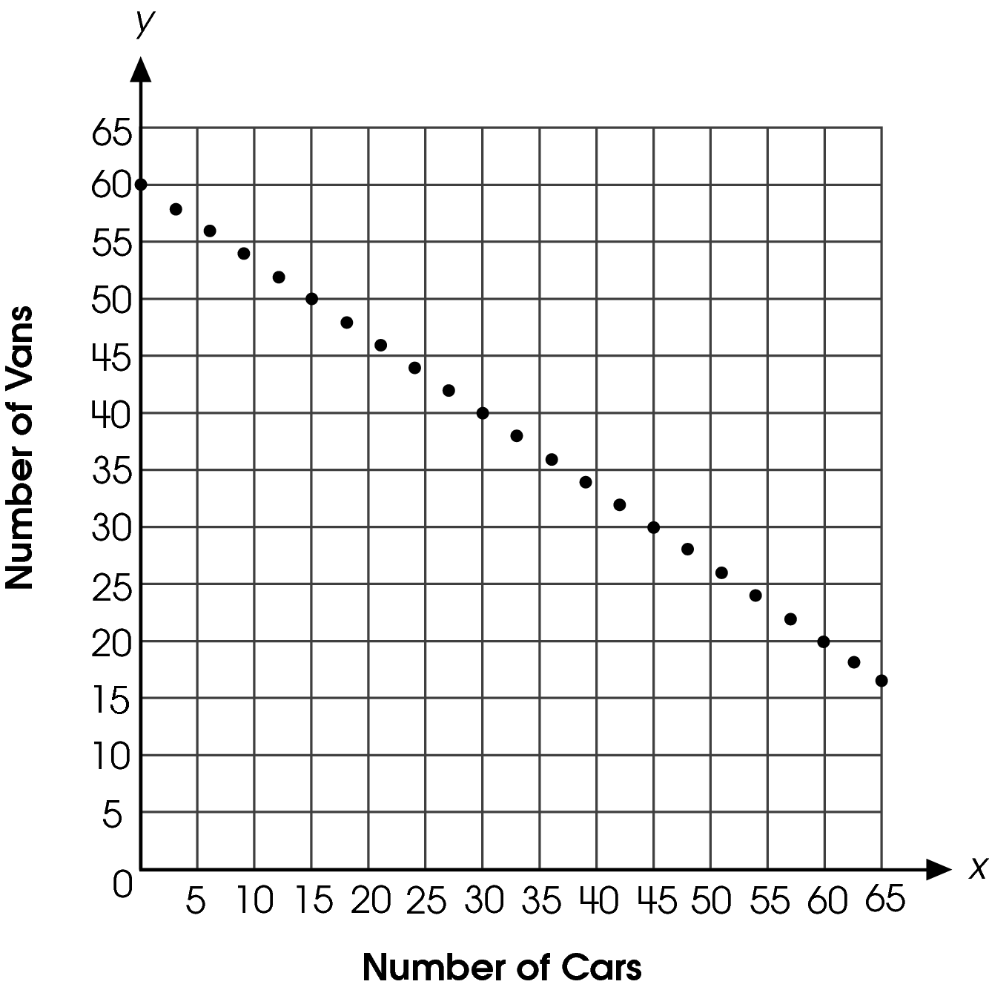
They washed 30 vans. How many cars did they need to wash to earn exactly $360?

A. 12
B. 40
C. 45
D. 60

Commentary:
This multiple-choice question asks students to use a graph of the relationship between the number of vans washed and the number of cars washed to earn exactly $360. Students need to find the number of cars to wash when 30 vans are washed. Students can locate a point on the graph that has a y-coordinate of 30 (number of vans washed) and find its x-coordinate. The x-coordinate is 45, which represents the number of cars washed, answer choice C.

The number of cars identified in answer choices A, B and D do not show the relationship between 30 vans washed and the number of cars needed to wash to earn exactly $360.

The complexity level of this question is Moderate Complexity. This question requires students to interpret a visual representation.

Performance Data:
The percent of public school students selecting answer choice C for question 3 on the May 2007 Grade 6 Achievement Test was 62%.

Keywords: algebra, graphs, relationships

BACK TO INDEX

Benchmark: E | Use rules and variables to describe patterns, functions and other relationships.
GLI: PFA 6.2 | Use words and symbols to describe numerical and geometric patterns, rules and functions.

Multiple Choice Question:

13. An input-output table is shown.
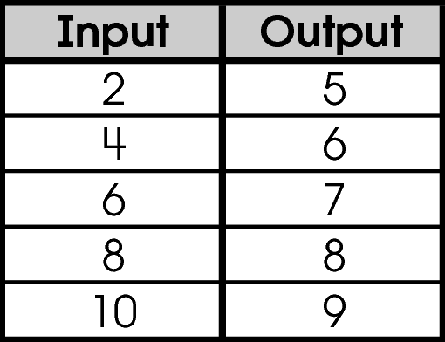
Which rule describes this input-output function?
A. double the input, and add 1
B. add 1 to each input number
C. add 2 to each input number
D. divide the input by 2, and add 4

Commentary:
This multiple-choice question asks students to select the rule which describes the relationship between two variables in the input-output function. Students should check to see that the rule is true for each input-output pair in the function. The rule in answer choice D is correct because it describes the relationship that would take each input value and produce the given output value.

The rule described in answer choices A, B and C is incorrect. The rule in answer choice A only works for the first pair in the function. The rule in answer choice B only describes how to find the next number in the output column from the previous number in the output column. The rule in answer choice C only describes how to find the next number in the input column from the previous number in the input column.

The complexity level of this question is Moderate Complexity. This question requires students to retrieve information from a table and use it to compare statements.

Performance Data:
The percent of public school students selecting answer choice D for question 13 on the May 2007 Grade 6 Achievement Test was 70%.
Keywords: algebra, function, rule

BACK TO INDEX

Benchmark: A  B | Describe, extend and determine the rule for patterns and relationships occurring in numeric patterns, computation, geometry, graphs and other applications.  Represent, analyze and generalize a variety of patterns and functions with tables, graphs, words and symbolic rules.
GLI: PFA 6.2, PFA 7.2 | PFA 6.2: Use words and symbols to describe numerical and geometric patterns, rules and functions.  PFA 7.2: Generalize patterns by describing in words how to find the next term.

Short Answer Question:

31. A pattern is shown.
1, 4, 13, 40, 121, . . .
In your Answer Document, describe the rule for the pattern and find the next term. Show how you found the next term in the pattern.

Commentary:
This short-answer question asks students to describe the rule for the pattern and to find the next term in the pattern. A response earning the maximum number of points (2 points) provides the rule to describe the pattern and the next term in the pattern with supporting work. Students need to recognize that the pattern begins with 1 and determine how to get from 1 to the next term 4. The rule needs to work for each following term. Adding 3 or multiplying by 3 does not work when going from 4 to 13. Students need to check to see if the rule works for each term in the pattern.

An example of the rule is 3 times the previous term plus 1. Using the rule, students can verify that it works for the terms shown in the pattern. For example,

3 × 1 + 1 = 4 and 3 × 4 + 1 = 13

To find the next term in the pattern, multiply the last number given (121) by 3 and add 1: (3 × 121 + 1 = 364).

The complexity level of this question is High Complexity. This question requires students to generalize a pattern.

Performance Data:
The percent of public school students earning each score point for question 31 on the May 2007 Grade 6 Achievement Test:

Percent at Each Score Point
0 | 1 | 2
61% | 34% | 6%

Scoring Guidelines:
Exemplar Response:

  - To find the next term, triple the previous number and add 1. The sixth term is 364 since 3 × 121 + 1 = 364.
- 3 times the previous number plus 13 × 121 + 1 = 364
- 3n+1, where n is the previous number. 3(121) + 1 = 364
Points | Student Response
2 point text | The focus of this task is using words or symbols to describe the rule for a pattern and finding the next term in the pattern. The response provides an adequate description of the rule for the pattern and correctly finds the next term with adequate supporting work.
1 point text | The response shows partial evidence of using words or symbols to describe the rule for a pattern and finding the next term in the pattern; however, the solution may be incomplete or slightly flawed.  For example, the response may:  - Provide an adequate description of the rule for the pattern but fail to find the next number.  - Provide the next number in the pattern with supporting work but fail to describe the rule for the pattern.  - Provide an adequate rule for the pattern and the correct next term but not show work.
0 point text | The response provides inadequate evidence of using words or symbols to describe the rule for a pattern and finding the next term in the pattern. The response provides an explanation with major flaws and errors of reasoning.  For example, the response may:  - Only state 364.  - Restate the information provided in the item.  - Be blank or give irrelevant information.

Keywords: algebra, pattern, rule

BACK TO INDEX

Benchmark: L | Analyze functional relationships, and explain how a change in one quantity results in a change in the other.
GLI: PFA 6.7 | Identify and describe situations with constant or varying rates of change, and compare them.

Multiple Choice Question:

42. Sal had a cactus that was 10 inches tall after 10 weeks. After 12 weeks, it was 14 inches tall, and after 13 weeks it was 15 inches tall.
Which statement describes the rate of change in the height of his cactus?

A. no rate of change
B. varying rate of change
C. constant rate of change
D. decreasing rate of change

Commentary:
This multiple-choice question asks students to select the statement which describes the rate of change in the given situation. Students need to determine how the height of a cactus plant changes over time. The cactus grew four inches in two weeks or about two inches in a week, but only one more inch a week later. Since the growth of the cactus is not the same from week to week, the rate that the cactus is growing is varying. Answer choice B, “varying rate of change,” is the correct answer.

The statements in answer choices A, C and D are incorrect since they do not describe the rate of change of the height of the cactus.

The complexity level of this question is Low Complexity. This question requires students to recognize an example of a concept.

Performance Data:
The percent of public school students selecting answer choice B for question 42 on the May 2007 Grade 6 Achievement Test was 52%.

Keywords: algebra, rate of change

BACK TO INDEX

Benchmark: E | Use rules and variables to describe patterns, functions and other relationships.
GLI: PFA 6.2 | Use words and symbols to describe numerical and geometric patterns, rules and functions.

Multiple Choice Question:

3. Monica created the number pattern shown.
2, 5, 11, 23, 47, . . .
Which rule describes Monica’s number pattern?
A. Add three to the previous number.
B. Double the previous number.
C. Double the previous number and add 1.
D. Triple the previous number and subtract 1.

Commentary:
This multiple-choice question asks students to select the rule that describes the given pattern. Students can test each of the given rules to determine if it works for the given pattern. For example, adding three to the previous number, answer choice A, only works for the first two numbers in the pattern. Using the rule in answer choice B of doubling the previous number does not work in this pattern because doubling 2 does not result in 5. Doubling the previous number and adding 1, answer choice C, works to create each number in the number pattern, making it the correct answer choice. The rule in answer choice D, triple the previous number and subtract 1, only works for the first number in the pattern.

The complexity level of this question is Moderate Complexity. This question requires students to compare statements.

Performance Data:
The percent of public school students selecting answer choice C for question 3 on the May 2008 Grade 6 Achievement Test was 81%.

Keywords: algebra, number pattern, rule

BACK TO INDEX

Benchmark: L | Analyze functional relationships, and explain how a change in one quantity results in a change in the other.
GLI: PFA 6.7 | Identify and describe situations with constant or varying rates of change, and compare them.

Short Answer Question:

31. Denise and Javier are hiking up the same trail. They measure how far they have hiked every 10 minutes. The table shows how far they have hiked.
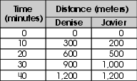
In your Answer Document, explain who is hiking at a constant rate and who is hiking at a changing rate. Use the data in the table to support your answer.

Commentary:
This short-answer question asks students to explain who is hiking at a constant rate and who is hiking at a changing rate by using the information provided in the given table. A response earning the maximum number of points (2 points) provides an explanation of who is hiking at a constant rate and who is hiking at a changing rate. Students should recall that a rate is constant when the quantity changes by the same amount during each equivalent time period. Students should be able to determine that Denise is hiking 300 meters every 10 minutes. This means that her rate is constant. Since the rate for Javier is not the same every 10 minutes (200 meters in 10 minutes, 300 meters in the next 10 minutes), his rate is changing.

The complexity level of this question is Moderate Complexity. This question requires students to retrieve information from a table and use it to solve a problem.

Performance Data:
The percent of public school students earning each score point for question 31 on the May 2008 Grade 6 Achievement Test:
Percent at Each Score Point
0 | 1 | 2
17% | 38% | 44%

Scoring Guidelines:
Sample Correct Response:
Denise is hiking at a constant rate because every 10 minutes she is hiking 300 meters. Javier is hiking at a changing rate because he travels 200 meters in the first 10 minutes, 300 meters in the second 10 minutes, 500 meters in the third 10 minutes and 200 meters in the last 10 minutes
Points | Student Response
2 | The focus of this task is determining constant or varying rates of change and comparing them. The response provides a complete and correct explanation of who is hiking at a constant rate and who is hiking at a changing rate by using the data in the table.
1 | The response provides partial evidence of determining constant or varying rates of change and comparing them. The response provides work with minor errors or flaws OR vague explanation.  For example, the response may:  - State that Denise is hiking at a constant rate and Javier is hiking at a changing rate without an explanation.  - State that Denise is hiking at a constant rate because each in 10-minute interval she goes the same distance. The response does not include Javier’s hiking.
0 | The response provides inadequate evidence of determining constant or varying rates of change and comparing them. The response provides major flaws in reasoning or irrelevant information.  For example, the response may:  - State that Denise and Javier are both walking at a constant rate because they started and stopped at the same time and distance.  - Be blank or state unrelated statements.  - Recopy information from the stem.

Keywords: algebra, constant rate of change, varying rate of change

BACK TO INDEX

