Index to Questions

Question Number | Source | BM | GLI | Description
2 | OAT Mar 06 | B & C | PFA 5.3, PFA 5.4 | This multiple-choice question asks students to select the inequality that represents the given situation.
6 | OAT Mar 06 | B & C | PFA 5.3, PFA 5.4 | This multiple-choice question asks students to select the equation that represents the given situation.
24 | OAT Mar 06 | A | PFA 5.1 | This multiple-choice question asks students to select the rule which explains how to get the output number from the input number in the given table.
33 | OAT Mar 06 | A | PFA 5.1 | This extended-response question asks students to use the data in the table to write a rule that relates the amount of time it takes to rake a lawn to the number of square feet in the lawn and then use the rule or the table to determine the length of time it would take to rake a 150-square-foot lawn.
41 | OAT Mar 06 | B & C | PFA 5.3, PFA 5.4 | This multiple-choice question asks students to select the equation which represents the given situation.
45 | OAT Mar 06 | F | PFA 5.5 | This multiple-choice question asks students to select the graph that represents the given situation.
16 | OAT May 07 | F | PFA 5.5 | This multiple-choice question asks students to select the graph that represents the given problem situation.
27 | OAT May 07 | F | PFA 5.5 | This multiple-choice question asks students to predict the number of CDs that be purchased for a given amount using data presented in a graph.
3 | OAT May 08 | A (3-4), F | PFA 4.2, PFA 5.5 | This multiple-choice question asks students to select the table that represents the given situation.
8 | OAT May 08 | B | PFA 5.3 | This multiple-choice question asks students to determine the rule used to create the input-output table shown.
28 | OAT May 08 | L | PFA 5.6 | This multiple-choice question asks students to describe the change in temperature during the period of time shown on the graph.
33 | OAT May 08 | C | PFA 5.4 | This short-answer question asks students to write an equation to describe a problem situation, and then use that equation to find the number of cards in a specified time period (6 weeks).

BACK TO INDEX

Benchmark: B  C | Represent, analyze and generalize a variety of patterns and functions with tables, graphs, words and symbolic rules.  Use variables to create and solve equations and inequalities representing problem situations.
GLI: PFA 5.3, PFA 5.4 | PFA 5.3: Use variables as unknown quantities in general rules when describing patterns and other relationships.  PFA 5.4: Create and interpret the meaning of equations and inequalities representing problem situations.

Multiple Choice Question:

2. Roberto had $20. He bought a soccer ball that cost m dollars. He now has less than $5 left.
Which inequality represents this situation?
A. 20 – m < 5
B. 20 – m > 5
C. m – 20 < 5
D. m – 20 > 5

do not copy or distribute ID: 8624; Version: 13

Commentary:
This multiple-choice question asks students to select the inequality that represents the given situation. Students need to select the inequality that shows subtracting the cost of the soccer ball, m, from the original amount, $20, resulting in an amount that is less than $5. Answer choice A is the inequality that represents the situation. Answer choice B shows the amount left being greater than $5. In answer choices C and D, the original amount ($20) is subtracted from the cost of the soccer ball.

The complexity level of this question is Low Complexity. This question requires students to recognize an equivalent representation.

Performance Data:
The percent of public school students selecting answer choice A for question 2 on the March 2006 Grade 5 Achievement Test was 32%.

Keywords: algebra, inequality

BACK TO INDEX

Benchmark: B  C | Represent, analyze and generalize a variety of patterns and functions with tables, graphs, words and symbolic rules.  Use variables to create and solve equations and inequalities representing problem situations.
GLI: PFA 5.3, PFA 5.4 | PFA 5.3: Use variables as unknown quantities in general rules when describing patterns and other relationships.  PFA 5.4: Create and interpret the meaning of equations and inequalities representing problem situations.

Mathematical Processes
Benchmark: K | Recognize and use mathematical language and symbols when reading, writing and conversing with others.

Multiple Choice Question:

6. Grant does 20 sit-ups each day.
Which expression represents the total number of sit-ups that Grant will do in n days?
A. n + 20
B. n – 20
C. n × 20
D. n ÷ 20

do not copy or distribute ID: 8625; Version: 9

Commentary:
This multiple-choice question asks students to select the expression that represents the given situation. Students need to select the expression which will represent the total number of sit-ups for any number of days when 20 sit-ups are done each day. For example,

If Grant does 20 sit-ups on the first day, another 20 on the second day and repeats the same number of sit-ups for the rest of n days, then the number of sit-ups that Grant does equals 20 + 20 + 20 + … + 20. This means that 20 is being repeated n times. Another way to show this repeated addition is 20n or n × 20.

Answer choice C represents the number of sit-ups for n days. Answer choices A, B and D do not represent the total number of sit-ups for n days.

The complexity level of this question is Moderate Complexity. This question requires students to represent a situation mathematically.

Performance Data:
The percent of public school students selecting answer choice C for question 6 on the March 2006 Grade 5 Achievement Test was 73%.

Keywords: algebra, algebraic expression

BACK TO INDEX

Benchmark: A | Describe, extend and determine the rule for patterns and relationships occurring in numeric patterns, computation, geometry, graphs and othe applications.
GLI: PFA 5.1 | Justify a general rule for a pattern or a function by using physical materials, visual representations, words, tables or graphs.

Multiple Choice Question:

24. Amber made the input-output table shown.
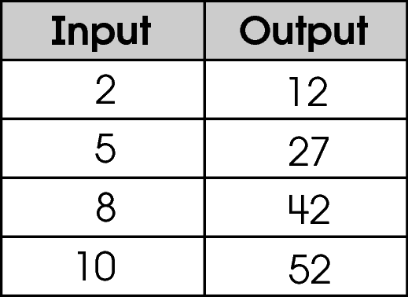
Which rule explains how to get the output number from the input number?
A. add 5, multiply by 2
B. add 10
C. multiply by 5, add 2
D. multiply by 6

do not copy or distribute ID: 9517; Version: 22

Commentary:
This multiple-choice question asks students to select the rule which explains how to get the output number from the input number in the given table. Students need to find the rule that works for each entry in the input-output table. The rule in answer choice C, multiply by 5 and add 2, works for getting the output number for each of the input numbers.
5 × 2 + 2 = 12
5 × 5 + 2 = 27
5 × 8 + 2 = 42
5 × 10 + 2 = 52

The rules in answer choices A, B and D do not work for all of the entries in the input-output table.

The complexity level of this question is Moderate Complexity. This question requires students to retrieve information from a table and provide justification for steps in a solution process.

Performance Data:
The percent of public school students selecting answer choice C for question 24 on the March 2006 Grade 5 Achievement Test was 74%.

Keywords: algebra, rule, input-output table

BACK TO INDEX

Benchmark: A | Describe, extend and determine the rule for patterns and relationships occurring in numeric patterns, computation, geometry, graphs and other applications.
GLI: PFA 5.1 | Justify a general rule for a pattern or a function by using physical materials, visual representations, words, tables or graphs.

Extended Response Question:

- Ethan rakes leaves to earn money. He uses the information in the table shown to find how long he takes to rake lawns of different sizes.
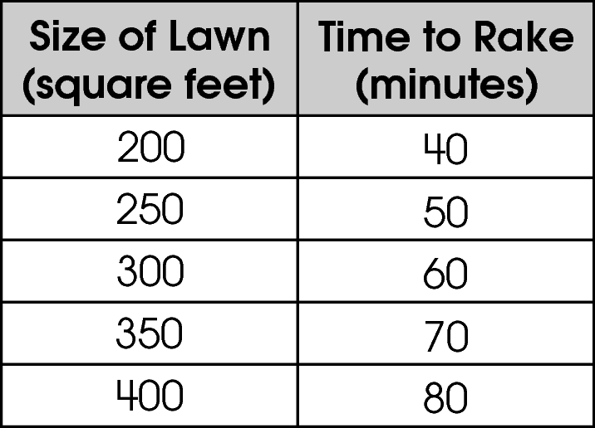
In your Answer Document, write a rule that tells how the amount of time Ethan needs to rake a lawn is related to the number of square feet in the lawn.
One of Ethan’s neighbors has a 150-square-foot lawn. Use the table or your rule to state how long it will take Ethan to rake this lawn. Show or explain your work.
Use the table or your rule to state what size lawn Ethan can rake in 65 minutes. Show or explain your work. (4 points)

Commentary:
This extended-response question asks students to use the data in the table to write a rule that relates the amount of time it takes to rake a lawn to the number of square feet in the lawn and then use the rule or the table to determine the length of time it would take to rake a 150-square-foot lawn. The question also asks students to determine the size of lawn that can be raked in 65 minutes. The response earning the maximum number of points (4 points) provides an adequate rule, the number of minutes to rake a 150-square-foot lawn and the size of the lawn that can be raked in 65 minutes, with supporting work or an adequate explanation.

An example of the rule relating the amount of time to rake a lawn to the number of square feet of lawn is that for every 50 square feet of lawn, it takes 10 more minutes to rake. Using this rule, it would take 30 minutes to rake a 150-square-foot lawn
(150 square feet ÷ 50 square feet = 3; 10 minutes × 3 = 30 minutes). Half way between 60 minutes and 70 minutes is 65 minutes, and half way between 300 square feet and 350 square feet is 325 square feet. Therefore, a 325-square-foot lawn can be raked in 65 minutes.

The complexity level of this question is High Complexity. This task requires students to perform a procedure having multiple steps and multiple decision points.

Performance Data:
The percent of public school students earning each score point for question 33 on the March 2006 Grade 5 Achievement Test:

Percent at Each Score Point
0 | 1 | 2 | 3 | 4
29% | 23% | 18% | 16% | 12%

Scoring Guidelines:
Sample Correct Response(s):
- The size of a lawn is 5 times the number of minutes it takes to rake it.
OR
The time it takes to rake a lawn is $\frac{1}{5}$ the number of square feet in the lawn.
AND
150 ÷ 5 = 30. I predict it will take Ethan 30 minutes to rake a 150-square-foot lawn.
AND
65 x 5 = 325. Ethan can rake a 325-square-foot lawn in 65 minutes.
- The time increases by 10 minutes for each additional 50 square feet
AND
150 square feet will take 30 minutes (40 – 10 = 30)
AND
Ethan can rake 325 square feet of lawn in 65 minutes (300 + 25, since it’s halfway).
Points | Student Response
4 | The focus of this task is using data in a table to draw conclusions and make predictions. The response includes a rule that accurately relates the size of the lawn and the time needed and uses the rule to explain how long it will take Ethan to rake a 150-square-foot lawn and the size of the lawn Ethan can rake in 65 minutes.

3 | The response provides adequate evidence of using data in a table to draw conclusions and make predictions. However, the solution may contain a slight error, a flaw or a vague explanation.  For example, the response may:  - Provide the correct rule relating the size of the lawn to the amount of time it takes to rake, AND the correct amount of time it will take Ethan to rake 150 square feet, AND the correct size of a lawn Ethan can rake in 65 minutes with little or no work shown.  - Provide a correct prediction for the amount of time it will take Ethan to rake 150 square feet AND the correct size of a lawn Ethan can rake in 65 minutes with an adequate explanation, but not provide a rule.
2 | The response provides partial evidence of using data in a table to draw conclusions or make predictions. However, the solution is incomplete and/or contains minor flaws.  For example, the response may:  - Provide an adequate rule and one of the predictions.  - Provide correct predictions with inadequate or no support AND the rule is flawed or missing.
1 | The response provides minimal evidence of using data in a table to draw conclusions and make predictions. The response contains major flaws and the explanation is incomplete or missing.  For example, the response may:  - Provide one correct prediction.  - Provide an appropriate rule.
0 | The response provides inadequate evidence of using data in a table to draw conclusions and make predictions. The response provides major flaws in reasoning or gives irrelevant information.  For example, the response may:  - State 200 – 40 = 160.  - Be blank or make unrelated statements.  - Recopy information from the stem.

Keywords: algebra, pattern, rule

BACK TO INDEX

Benchmark: B  C | Represent, analyze and generalize a variety of patterns and functions with tables, graphs, words and symbolic rules.  Use variables to create and solve equations and inequalities representing problem situations.
GLI: PFA 5.3, PFA 5.4 | PFA 5.3: Use variables as unknown quantities in general rules when describing patterns and other relationships.  PFA 5.4: Create and interpret the meaning of equations and inequalities representing problem situations.

Multiple Choice Question:

41. Ryan is painting faces at the fair. It takes him 10 minutes to set up his materials. Each face takes 6 minutes to paint. Ryan wants to know how many faces (f) he can paint in 60 minutes.
Which equation represents this situation?
A. 6f + 10 = 60
B. 10f + 6 = 60
C. 6f – 10 = 60
D. 10f – 6 = 60

do not copy or distribute ID: 11312; Version: 6

Commentary:
This multiple-choice question asks students to select the equation which represents the given situation. Students need to select the equation that can be used to find the number of faces (f) that can be painted in 60 minutes if it takes 6 minutes to paint each face, and takes into account the 10 minutes needed to set up the materials. The equation in answer choice A represents this situation. Answer choice C is incorrect because the time needed to set up the materials is subtracted from the time needed to paint the faces. Answer choices B and D are incorrect because the 10 minutes to set up the materials is not the number of minutes needed to paint each face.

The complexity level of this question is Moderate Complexity. This question requires students to represent a situation mathematically.

Performance Data:
The percent of public school students selecting answer choice A for question 41 on the March 2006 Grade 5 Achievement Test was 50%.

Keywords: algebra, equation

BACK TO INDEX

Benchmark: F | Use representations, such as tables, graphs and equations, to model situations and to solve problems, especially those that involve linear relationships.
GLI: PFA 5.5 | Model problems with physical materials and visual representations, and use models, graphs and tables to draw conclusions and make predictions.

Multiple Choice Question:

45. Kip earns $5 an hour baby-sitting.
Which graph represents the amount of money he earns over time?
A. 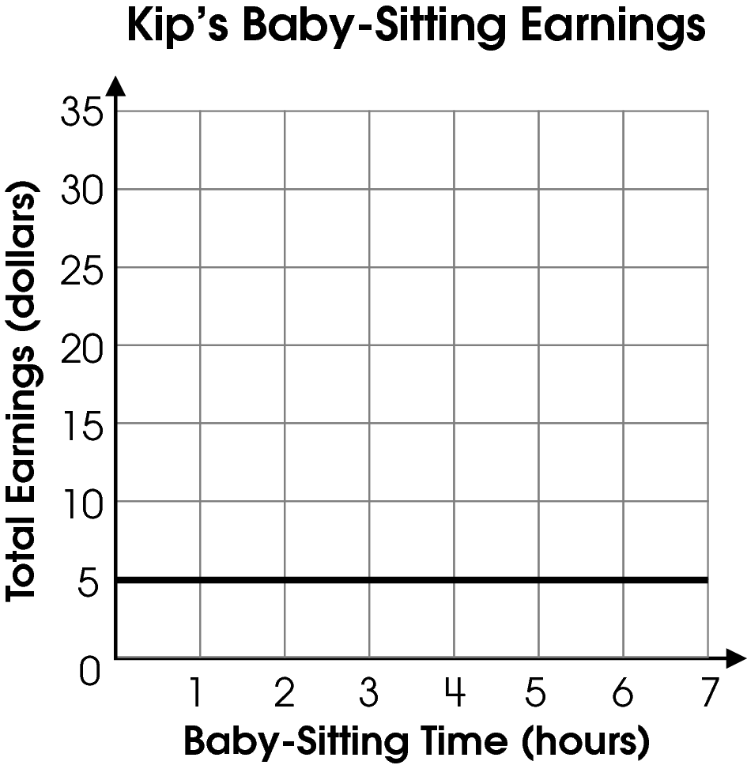
B. 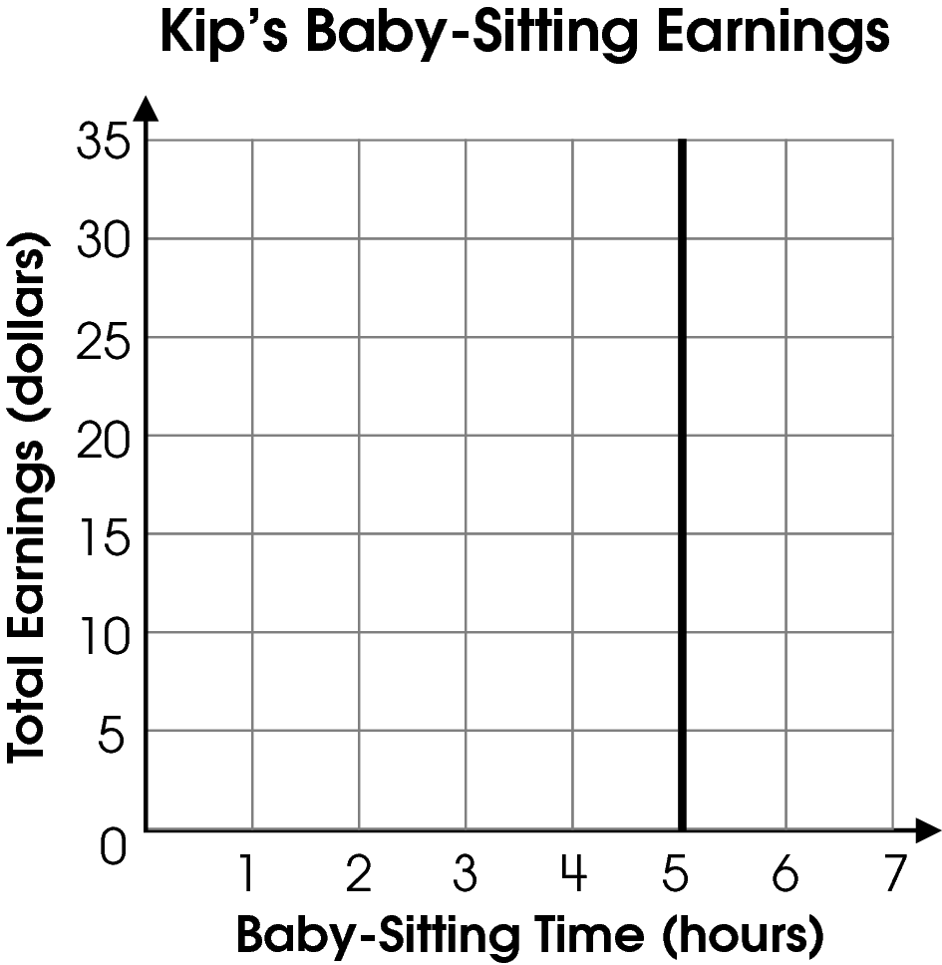
C. 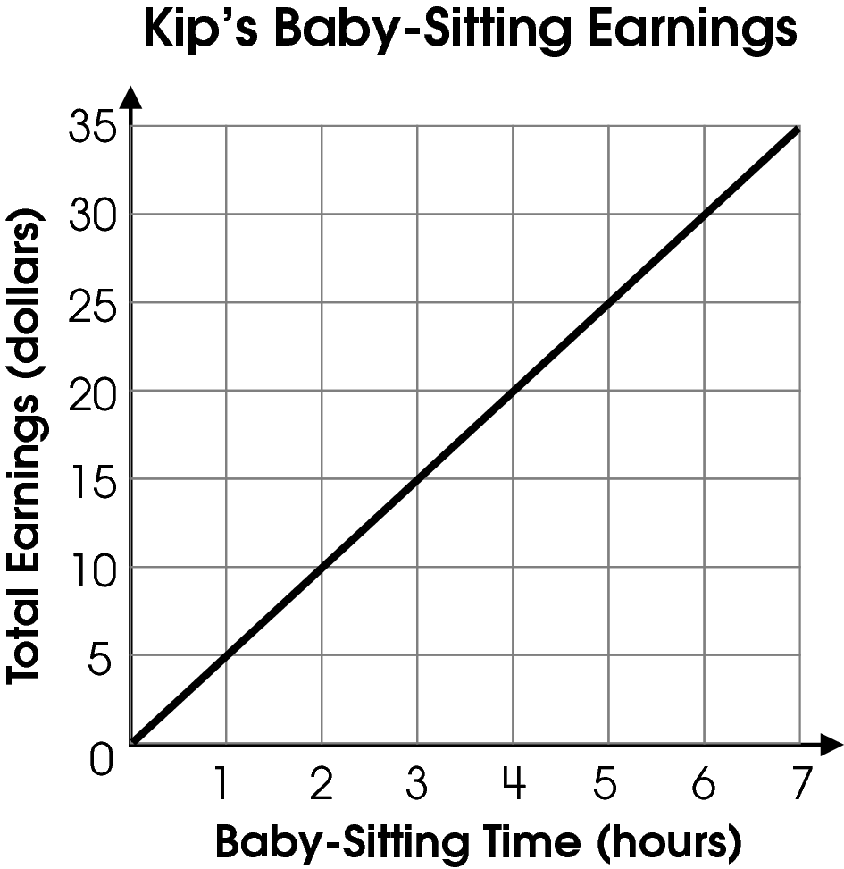
D. 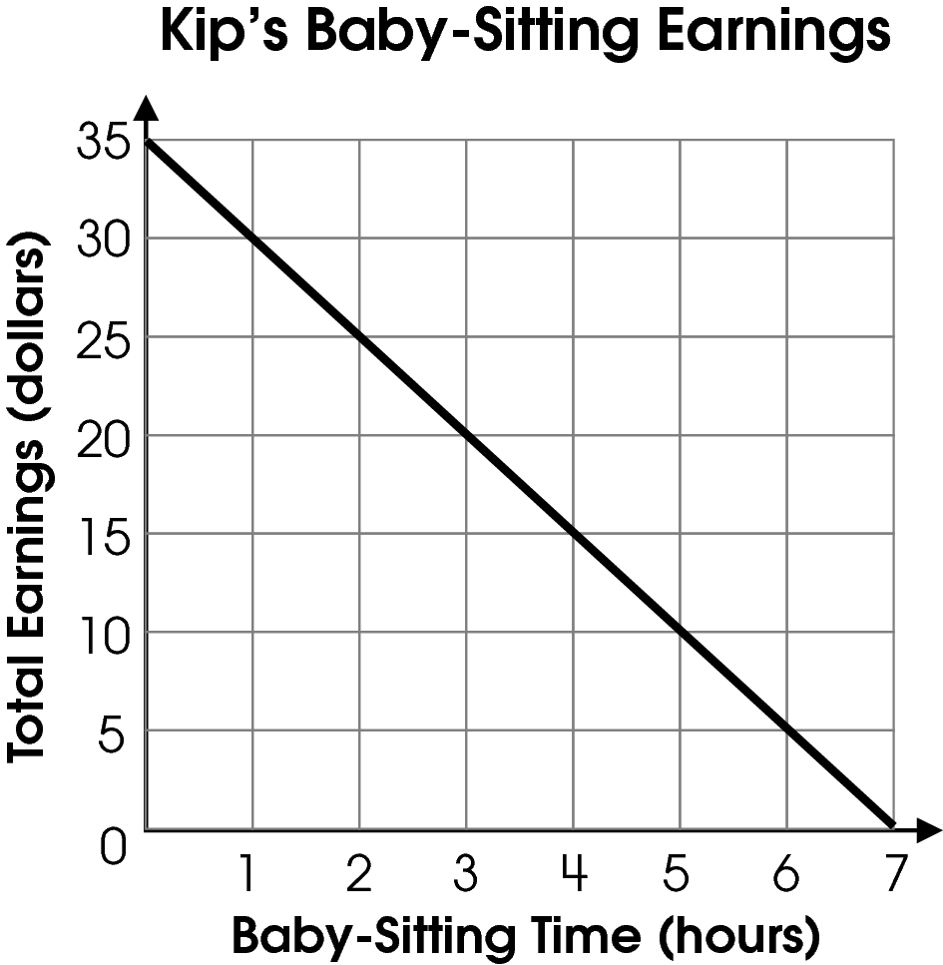

Commentary:
This multiple-choice question asks students to select the graph that represents the given situation. Students need to select the graph that shows that as the number of hours of baby-sitting increases, the amount of money earned also increases. The graph in answer C shows this relationship. The graphs in answer choices A, B and D do not show the amount of money earned increasing $5 each hour as the number of hours of baby-sitting increase. In answer choice A, the graph shows no change in the amount earned as the number of hours baby-sitting increases. The graph in answer choice B shows no change in the number of hours of baby-sitting but shows a change in the amount of earnings. The graph in answer choice D shows that as the number of hours of baby-sitting increases, the amount of money earned decreases.

The complexity level of this question is Moderate Complexity. This question requires students to interpret visual representations.

Performance Data:
The percent of public school students selecting answer choice C for question 45 on the March 2006 Grade 5 Achievement Test was 54%.

Keywords: algebra, function, graphs

BACK TO INDEX

Benchmark: F | Use representations, such as tables, graphs and equations, to model situations and to solve problems, especially those that involve linear relationships.
GLI: PFA 5.5 | Model problems with physical materials and visual representations, and use models, graphs and tables to draw conclusions and make predictions.

Multiple Choice Question:

16. Chelsea made bracelets and sold them at craft fairs. She found that most people would pay up to $3.00 for a bracelet. When the price went above $3.00, her sales dropped.
Which graph might show Chelsea’s sales as her prices went up?

A.
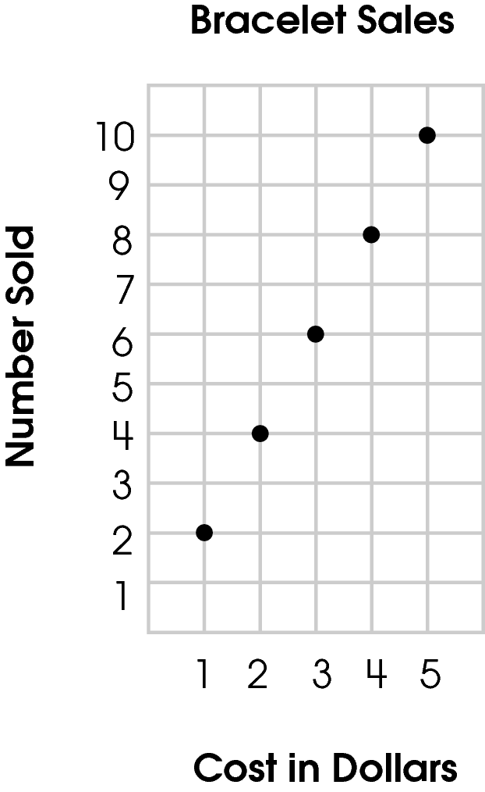

B.
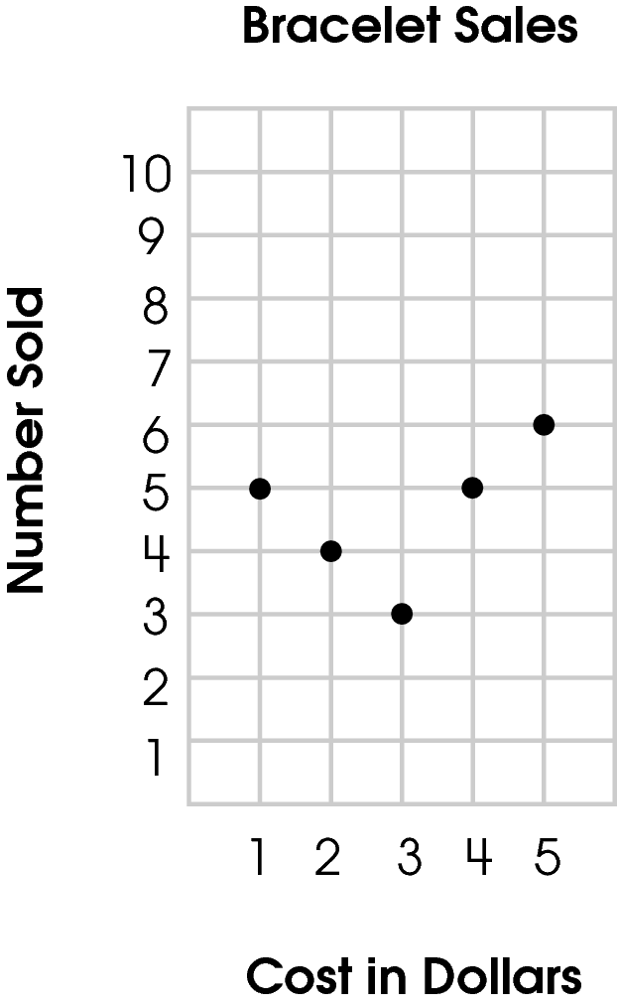

C.
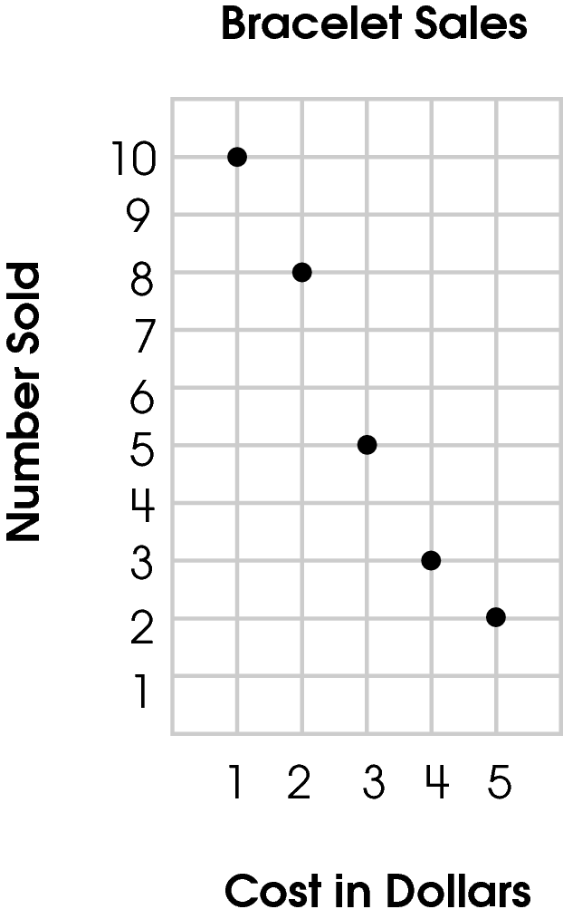

D.
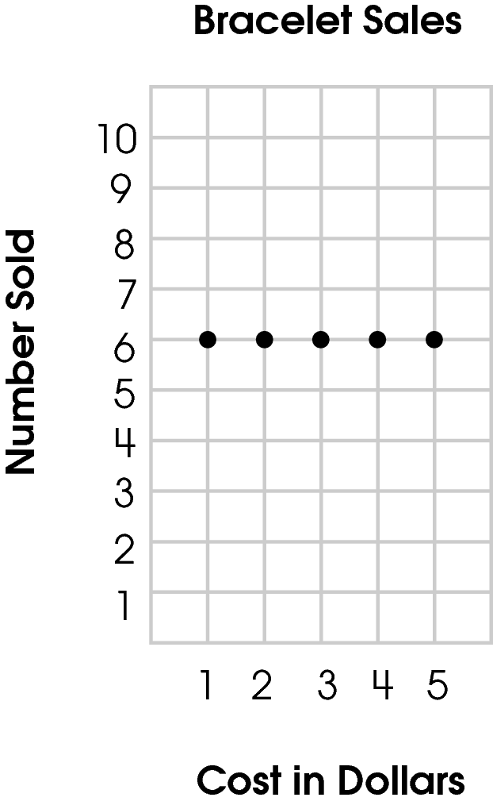

Commentary:
This multiple-choice question asks students to select the graph that represents the given problem situation. Students need to select the graph that shows a decrease in sales as the price for a bracelet went up. The graph in answer choice C is correct because it shows this relationship.

The graphs in answer choices A, B and D are incorrect since they do not show the sales decreasing as the cost of the bracelet went up. The graph in answer choice A shows that as the cost increased, the sales increased. The graph in answer choice B shows the sales decreased when the cost of the bracelet went below $3.00, but increasing when the cost of the bracelet increased. The graph in answer choice D shows no change in sales as the cost of the bracelet went up.

The complexity level of this question is Moderate Complexity. This question requires students to represent a situation mathematically in more than one way.

Performance Data:
The percent of public school students selecting answer choice C for question 16 on the May 2007 Grade 5 Achievement Test was 56%.

Keywords: algebra, linear equation

BACK TO INDEX

Benchmark: F | Use representations such as tables, graphs, and equations, to model situations and to solve problems, especially those that involve linear relationships.
GLI: PFA 5.5 | Model problems with physical materials and visual representations, and use models, graphs and tables to draw conclusions and make predictions.

Multiple Choice Question:

- The graph shows the cost of different numbers of CDs.
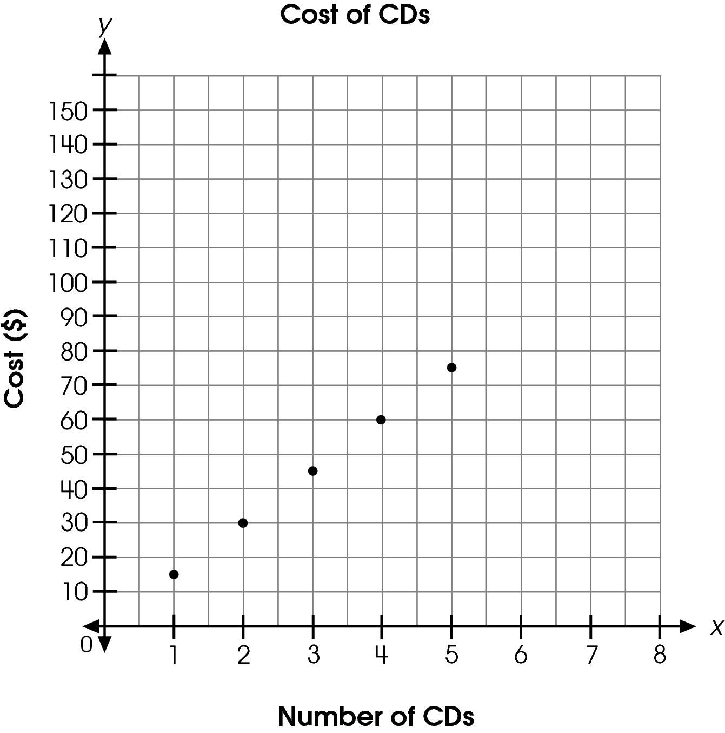

What is a reasonable prediction for the number of CDs that can be purchased for $105?
A. 5
B. 6
C. 7
D. 8

Commentary:
This multiple-choice question asks students to predict the number of CDs that be purchased for a given amount using data presented in a graph. Students could determine from the graph that each CD costs about $15. Using the cost of one CD, the number of CDs that can be purchased for $105 is 7 ($105 ÷ $15 per CD = 7 CDs), answer choice C. Students could also use the graph and extend it to find the cost for 6 CDs ($90) and for the cost of 7 CDs ($105).

The number of CDs in answer choices A, B and D are incorrect since they are not a reasonable prediction of the number of CDs that can be purchased for $105.

The complexity level of this question is Moderate Complexity. This question requires students to retrieve information from a graph and use it to solve a problem.

Performance Data:
The percent of public school students selecting answer choice C for question 27 on the May 2007 Grade 5 Achievement Test was 47%.

Keywords: algebra, linear relationships

BACK TO INDEX

Benchmark: A (3-4)  F | Analyze and extend patterns, and describe the rule in words.  Use representations, such as tables, graphs and equations, to model situations and to solve problems, especially those that involve linear relationships.
GLI: PFA 4.2, PFA 5.5 | PFA 4.2: Represent and analyze patterns and functions using words, tables and graphs.  PFA 5.5: Model problems with physical materials and visual representations, and use models, graphs and tables to draw conclusions and make predictions.

Multiple Choice Question:

3. Paul walked 3 miles per hour while on a 4-hour hike.
Which table shows the total number of miles that Paul has walked at the end of each hour?

A.
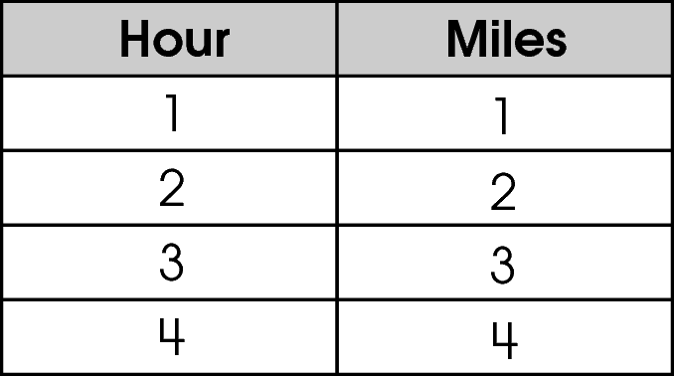

B.
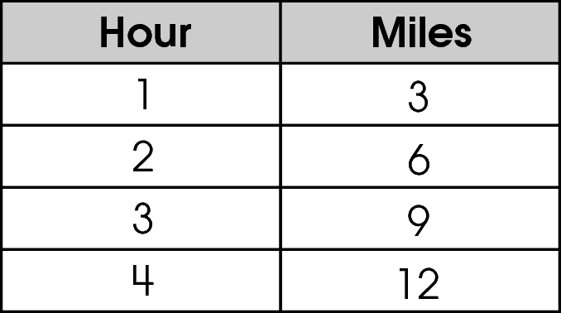

C.
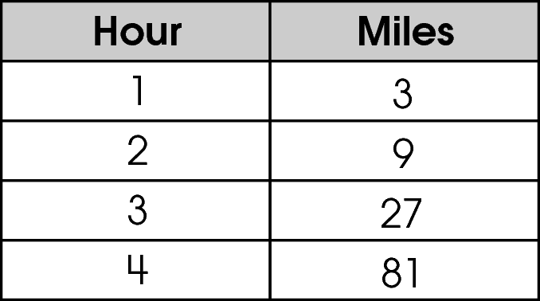

D.
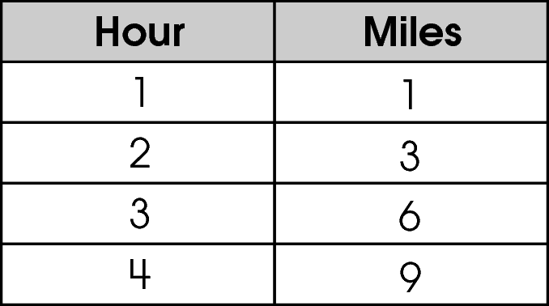

Commentary:
This multiple-choice question asks students to select the table that represents the given situation. Students are looking for the table that shows an increase of 3 miles each hour. The table in answer choice B is correct because it shows this relationship.

The tables in answer choices A, C and D do not show an increase of 3 miles each hour. The table in answer choice A shows an increase of 1 mile every hour. The table in answer choice C shows the number of miles tripling every hour. Although the table in answer choice D shows an increase of 3 miles every hour after the first hour, it should have shown 3 miles for the first hour.

The complexity level of this question is Moderate Complexity. The question requires students to represent a situation mathematically.

Performance Data:
The percent of public school students selecting answer choice B for question 3 on the May 2008 Grade 5 Achievement Test was 86%.

Keywords: algebra, function, table, linear relationship

BACK TO INDEX

Benchmark: B | Represent, analyze and generalize a variety of patterns and functions with tables, graphs, words and symbolic rules.
GLI: PFA 5.3 | Use variables as unknown quantities in general rules when describing patterns and other relationships.

Multiple Choice Question:

8. Simon used a rule to create the input-output table shown.
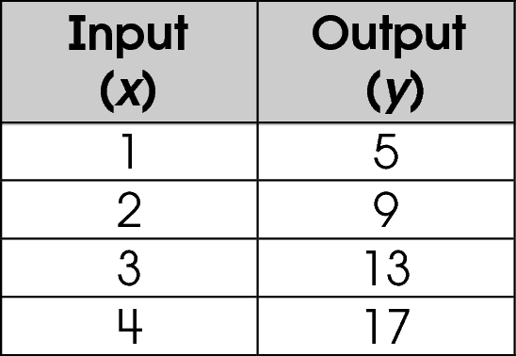
Which rule did Simon use to make the table?

A. y = x + 4
B. y = x + 10
C. y = 3x + 5
D. y = 4x + 1

Commentary:
This multiple-choice question asks students to determine the rule used to create the input-output table shown. Students need to find the rule which works for each entry in the input-output table. Students can substitute each input value for (x) and its corresponding output value (y) in each equation to verify the rule for all entries. The rule in answer choice D works for all of the entries in the input-output table.

y = 4x + 1
5 = 4 × 1 + 1
9 = 4 × 2 + 1
13 = 4 × 3 + 1
17 = 4 × 4 + 1

The rule in answer choices A, B and C do not work for all of the entries in the input-output table.

The complexity level of this question is Moderate Complexity. The question requires students to retrieve information from a table and use it to solve a problem.

Performance Data:

The percent of public school students selecting answer choice D for question 8 on the May 2008 Grade 5 Achievement Test was 52 %.

Keywords: algebra, rule, input-output table

BACK TO INDEX

Benchmark: L | Analyze functional relationships, and explain how a change in one quantity results in a change in the other.
GLI: PFA 5.6 | Describe how the quantitative change in a variable affects the value of a related variable; e.g., describe how the rate of growth varies over time, based upon data in a table or graph.

Multiple Choice Question:

28. The graph shows the change in temperature over a period of time.
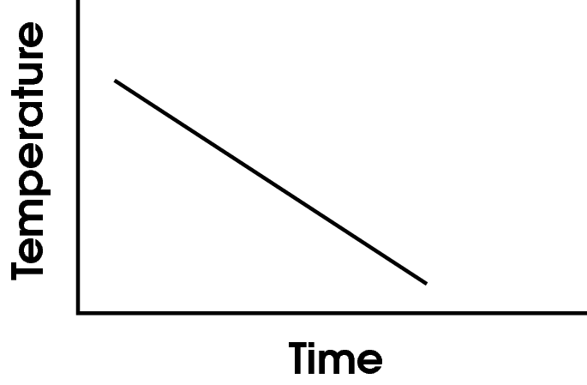
Which describes the change in temperature during this period of time?
A. The temperature gets hot, then cold, then hot again.
B. The temperature gets colder during this period of time.
C. The temperature gets warmer during this period of time.
D. The temperature stays the same during this period of time.

Commentary:
This multiple-choice question asks students to describe the change in temperature during the period of time shown on the graph. The graph shows that as time increases, the temperature decreases, which means that the temperature is getting colder. Therefore, answer choice B is correct.

The descriptions in answer choices A, C and D do not reflect the temperature getting consistently colder during this time period.

The complexity level of this question is Moderate Complexity. The question requires students to interpret a visual representation.

Performance Data:
The percent of public school students selecting answer choice B for question 28 on the May 2008 Grade 5 Achievement Test was 62%.

Keywords: algebra, function, rate of change

BACK TO INDEX

Benchmark: C | Use variables to create and solve equations and inequalities representing problem situations.
GLI: PFA 5.4 | Create and interpret the meaning of equations and inequalities representing problem situations.

Mathematical Processes
Benchmark: I | Select, apply, and translate among mathematical representations to solve problems; e.g., representing a number as a fraction, decimal or percent as appropriate for a problem.

Short Answer Question:

- Pam has 70 baseball cards. She decides that she will buy 10 more baseball cards each week.
In your Answer Document , write an equation that describes the number of cards, c , she will have in w weeks.
Then, use your equation to find the number of baseball cards Pam will have in 6 weeks. (2 points)

Commentary:
This short-answer question asks students to write an equation to describe a problem situation, and then use that equation to find the number of cards in a specified time period (6 weeks). The response earning the maximum number of points (2 points) provides the equation describing the situation and the number of cards in 6 weeks.

Students are given the fact that Pam starts with 70 cards. Each week, w, Pam adds 10 more cards. The number of cards Pam started with (70) and the cards to be added each week (10w) will result in the number of cards (c) Pam will have in w weeks, or 70 + 10w = c.

To use the equation to find the number of cards in 6 weeks, students can substitute 6 for w in the equation. For example,

70 + 10w = c
70 + 10 × 6 = c
70 + 60 = c
130 = c
Pam will have 130 baseball cards in 6 weeks.

The complexity level of this question is High Complexity. The question requires students to represent a situation mathematically.

Performance Data:
The percent of public school students earning each score point for question 33 on the May 2008 Grade 5 Achievement Test:

Percent at Each Score Point
0 | 1 | 2
42% | 50% | 7%

Scoring Guidelines:
Exemplar Response:
- 70 + 10w = c. Pam will have 70 + 10(6) = 130 baseball cards in 6 weeks.
- 70 + 10w = c. 130 cards in 6 weeks.
Points | Student Response
2 | The focus of this task is using variables as unknown quantities in equations when describing patterns and other relationships. The response provides the correct equation using the variables and the correct number of cards in 6 weeks.
1 | The response shows partial evidence of using variables as unknown quantities in equations when describing patterns and other relationships; however, the solution may be incomplete or slightly flawed.  For example, the response may:  - Only provide the correct number of cards she will have in 6 weeks.  - Only provide the correct equation.
0 | The response provides inadequate evidence of using variables as unknown quantities in equations when describing patterns and other relationships. The response provides major flaws in explanations or irrelevant information.  For example, the response may:  - State that she gets 10 cards each week.  - Provide the equation 10w = c.  - Restate the information provided in the item.  - Be blank or give irrelevant information.

Keywords: algebra, equation, variable

BACK TO INDEX

