Index to Questions

Question Number | Source | BM | GLI | Description
3 | OAT Mar 06 | A & B | PFA 4.1, PFA 4.2 | This multiple-choice question asks students to identify an answer that displays the pattern showing the number of birdhouses being made at the end of each week.
7 | OAT Mar 06 | A & B | PFA 4.1, PFA 4.2 | This multiple-choice question asks students to select the statement that represents the data displayed in the chart.
19 | OAT Mar 06 | A & B | PFA 4.1, PFA 4.2 | This multiple-choice question asks students to identify a table that displays the situation described in the problem.
24 | OAT Mar 06 | C & E | PFA 4.4, PFA 4.5 | This multiple-choice question asks students to select the equation that represents the given situation.
29 | OAT Mar 06 | A & B | PFA 4.1, PFA 4.2 | This short-answer question asks students to extend the given pattern and to describe the pattern.
34 | OAT Mar 06 | C & E | PFA 4.4, PFA 4.5 | This multiple-choice question asks students to select the equation that represents the given situation.
40 | OAT Mar 06 | C & E | PFA 4.4, PFA 4.5 | This multiple-choice question asks students to recognize the expression representing a given situation.
44 | OAT Mar 06 | G | PFA 4.6 | This multiple-choice question asks students to select the statement that correctly describes how the total earnings change as the number of baby-sitting hours increases.
20 | OAT May 07 | A, B & E | PFA 4.1, PFA 4.2, PFA 4.4 | This extended-response question asks students to analyze a situation and represent the pattern using tables, words, and expressions.
37 | OAT May 07 | E | PFA 4.4 | This multiple-choice question asks students to select the inequality that represents the given situation.
45 | OAT May 07 | A & F | PFA 4.3 | This multiple-choice question asks students to choose the completed table that correctly represents the given relationship.
5 | OAT May 08 | B | PFA 4.1 | This short-answer question asks students to analyze the patterns in the table to predict the number of benches that can be painted with 8 cans of paint and explain their work.
19 | OAT May 08 | A | PFA 4.2 | This multiple-choice question asks students to select the number pattern described by the rule: start with 2 and multiply each number by 3 to get the next number.
Question Number | Source | BM | GLI | Description
42 | OAT May 08 | A | PFA 4.2 | This multiple-choice question asks students to select the rule for the given number pattern.
45 | OAT May 08 | B | PFA 3.1, PFA 4.2 | This multiple-choice question asks students to identify a statement that compares the amounts of money saved after four weeks using two different savings plans.

BACK TO INDEX

Benchmark: A & B | Analyze and extend patterns, and describe the rule in words.  Use patterns to make predictions, identify relationships, and solve problems.
GLI: PFA 4.1, PFA 4.2 | PFA 4.1: Use models and words to describe, extend and make generalizations of patterns and relationships occurring in computation, numerical patterns, geometry, graphs and other applications.  PFA 4.2: Represent and analyze patterns and functions using words, tables and graphs.

Multiple Choice Question:

3. Courtney starts with 12 birdhouses. She makes three new birdhouses each week.
Which pattern shows the number of birdhouses Courtney has at the end of the each week?
- 3, 6, 9, 12
- 3, 15, 27, 39
- 12, 15, 18, 21
- 12, 24, 36, 48

do not copy or distribute ID: 9470; Version: 9

Commentary:
This multiple-choice question asks students to identify an answer that displays the pattern showing the number of birdhouses being made at the end of each week. Answer choice C is the correct answer because the pattern starts at 12 and each following number is the sum of 3 and the previous number, such as 12 + 3 = 15, 15 + 3 = 18, 18 + 3 = 21. Answer choice A is incorrect because it starts with 3 instead of 12 and adds 3 each time. Answer choice B is also incorrect because it starts with 3 instead of 12 and adds 12 instead of 3 each time. Answer choice D is incorrect because it starts with 12 and adds 12 instead of 3 each time.

The complexity level of this question is Moderate Complexity. Students are asked to create and extend a pattern.

Performance Data:
The percent of public school students selecting answer choice C for question 3 on the March 2006 Grade 4 Achievement Test was 69%.

Keywords: algebra, pattern

BACK TO INDEX

Benchmark: A & B | Analyze and extend patterns, and describe the rule in words.  Use patterns to make predictions, identify relationships, and solve problems.
GLI: PFA 4.1, PFA 4.2 | PFA 4.1: Use models and words to describe, extend and make generalizations of patterns and relationships occurring in computation, numerical patterns, geometry, graphs and other applications.  PFA 4.2: Represent and analyze patterns and functions using words, tables and graphs.

Multiple Choice Question:

7. Lyn and Kris were picking up pine cones. Every 15 minutes they counted to check the total number of pine cones they had picked up. The chart shows their results.
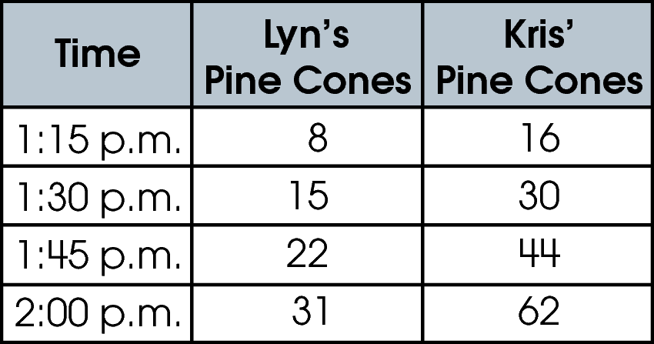
Which statement is true according to the data in the chart?
A. Kris always picked up 8 more pine cones than Lyn.
B. Kris and Lyn picked up the same number of pine cones every 15 minutes.
C. Kris picked up fewer pine cones than Lyn.
D. Kris picked up twice as many pine cones as Lyn.

do not copy or distribute ID: 9884; Version: 6

Commentary:
This multiple-choice question asks students to select the statement that represents the data displayed in the chart. Answer choice D is the correct answer because the number of pine cones Kris picked at the end of each 15 minute period is two times the number of pine cones Lyn picked at the end of each 15 minute period. Answer choice A is incorrect because the statement is true only for the first line of the chart. Answer choices B and C are incorrect because the data in the problem is misinterpreted.

The complexity level of this question is Moderate Complexity. The question requires students to retrieve information from a chart and use it to solve a problem.

Performance Data:
The percent of public school students selecting answer choice D for question 7 on the March 2006 Grade 4 Achievement Test was 81%.

Keywords: algebra, pattern, relationship

BACK TO INDEX

Benchmark: A & B | Analyze and extend patterns, and describe the rule in words.  Use patterns to make predictions, identify relationships, and solve problems.
GLI: PFA 4.1, PFA 4.2 | PFA 4.1: Use models and words to describe, extend and make generalizations of patterns and relationships occurring in computation, numerical patterns, geometry, graphs and other applications.  PFA 4.2: Represent and analyze patterns and functions using words, tables and graphs.

Multiple Choice Question:

19. Mai Lee is buying notebooks. The first notebook costs $0.78 and each additional notebook costs $0.22.
Which table shows the cost of the notebooks?
A. 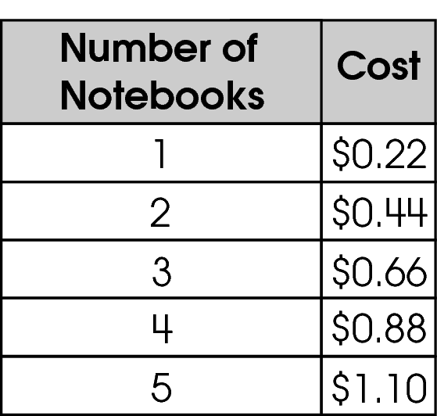
B. 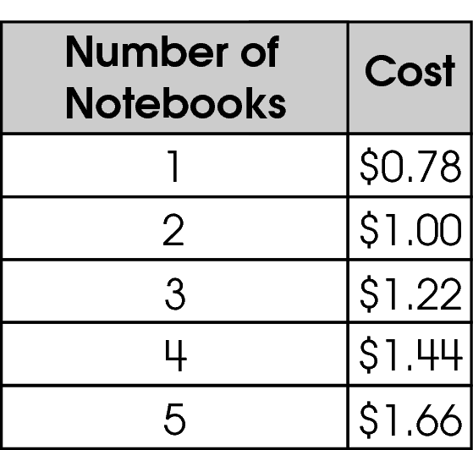
C. 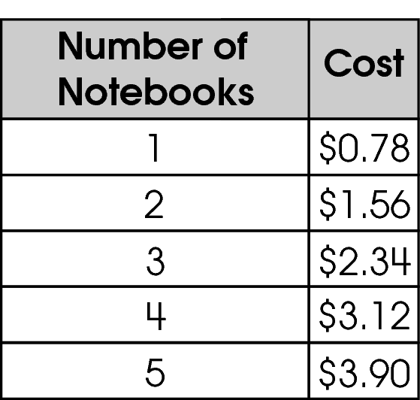
D. 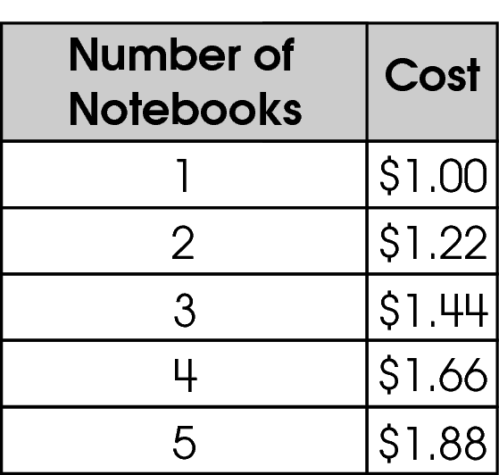

Commentary:
This multiple-choice question asks students to identify a table that displays the situation described in the problem. Answer choice B is the correct answer because the cost of the first notebook is $0.78 and the cost of each additional notebook, $0.22, is added to the cost of the previous notebook. Answer choices A and D are incorrect because the price of the first notebook is not $0.78. Answer choice C is incorrect because it demonstrates a pattern that starts at $0.78 but the cost of each additional notebook is $0.78, not $0.22.

The complexity level of this question is Moderate Complexity. The question requires students to compare a statement with a table.

Performance Data:
The percent of public school students selecting answer choice B for question 19 on the March 2006 Grade 4 Achievement Test was 66%.

Keywords: algebra, pattern

BACK TO INDEX

Benchmark: C & E | Write and solve open sentences and explain strategies.  Use variables to create and solve equations representing problem situations.
GLI: PFA 4.4, PFA 4.5 | PFA 4.4: Use rules and variables to describe patterns and other relationships.  PFA 4.5: Represent mathematical relationships with equations or inequalities.

Multiple Choice Question:

24. A theater has 14 rows of seats. Each row has the same number of seats. The theater has a total of 168 seats.
Which equation can be used to find the number of seats, s, in each row?
A. 168 × 14 = s
B. 14 × s = 168
C. 168 – s = 14
D. 14 + s = 168

do not copy or distribute ID: 9682; Version: 11

Commentary:
This multiple-choice question asks students to select the equation that represents the given situation. The situation is described in words and students are asked to select an equivalent representation using numbers and a variable. Answer choice B is the correct answer because it shows 168 as the total of 14 rows with s seats in each row. Answer choices A and C are incorrect because they do not show the total number of seats in 14 rows. Answer choice D is also incorrect because the sum of the number of rows and the number of seats does not equal to168 seats.

The complexity level of this question is Moderate Complexity. The question requires students to select an equation that represents a given situation.

Performance Data:
The percent of public school students selecting answer choice B for question 24 on the March 2006 Grade 4 Achievement Test was 62%.

Keywords: algebra, equation, variable

BACK TO INDEX

Benchmark: A & B | Analyze and extend patterns, and describe the rule in words.  Use patterns to make predictions, identify relationships, and solve problems.
GLI: PFA 4.1, PFA 4.2 | PFA 4.1: Use models and words to describe, extend and make generalizations of patterns and relationships occurring in computation, numerical patterns, geometry, graphs and other applications.  PFA 4.2: Represent and analyze patterns and functions using words, tables and graphs.

Mathematical Processes
Benchmark: K | Use mathematical language to explain and justify mathematical ideas, strategies and solutions.

Short Answer Question:

29. Casey made the pattern shown.
8, 19, 30, 41, ____, ____, ____
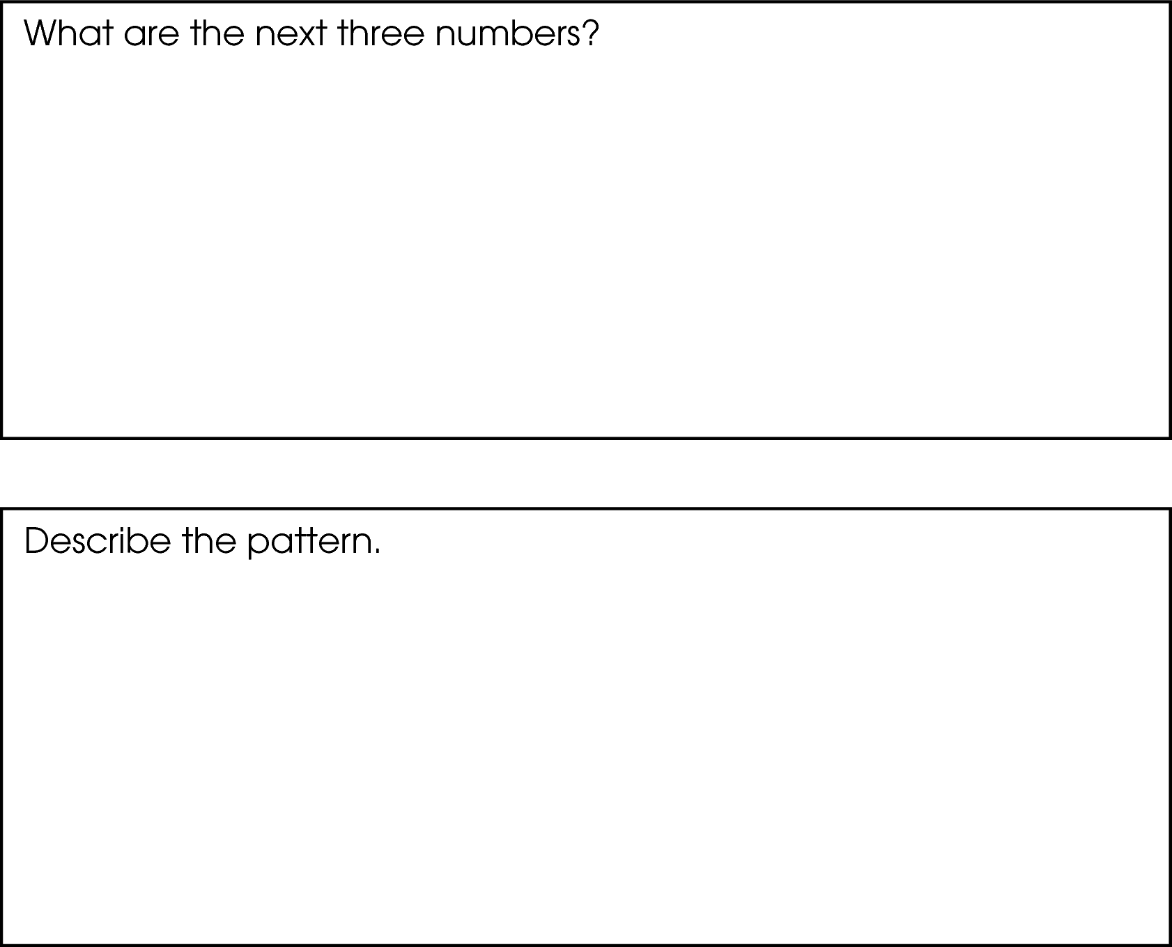

Commentary:
This short-answer question asks students to extend the given pattern and to describe the pattern. A response earning the maximum number of points (2 points) shows 52, 63 and 74 as the next three numbers in the pattern and provides an adequate description of the pattern. For example, the pattern starts with 8, and adds 11 to the previous number.

The complexity level of this question is Moderate Complexity. The task requires student to extend a pattern and provide a description of the pattern.

Performance Data:
The percent of public school students earning each score point for question 29 on the March 2006 Grade 4 Achievement Test:

Percent at Each Score Point
0 | 1 | 2
15% | 12% | 73%

Scoring Guidelines:
Sample Correct Response(s):
- 52, 63, 74. The pattern is to add 11 to the previous number.
- 52, 63, 74. Plus 11 each time.

Points | Student Response
2 | The focus of this task is analyzing, extending and describing numerical patterns. The response provides the next three numbers in the pattern and describes the pattern.
1 | The response shows partial evidence of analyzing, extending and describing numerical patterns; however, the solution may be incomplete or slightly flawed.  For example, the response may:  - State that the next numbers in the pattern are 52, 63, and 74, but not correctly describe the rule.  - Identify an accurate rule, but not correctly find all three of the numbers in the pattern. E.g., 53, 64, 75. The pattern is to add 11 each time.
0 | The response provides inadequate evidence of analyzing, extending and describing numerical patterns. The response provides an explanation with major flaws and errors of reasoning.  For example, the response may:  - State that the next three numbers in the pattern are 42, 43, 44 and that the numbers get bigger each time.  - Be blank or state unrelated statements.  - Recopy information from the stem.

do not copy or distribute ID: 10829; Version: 1

Keywords: algebra, pattern

BACK TO INDEX

Benchmark: C & E | Write and solve open sentences and explain strategies.  Use variables to create and solve equations representing problem situations.
GLI: PFA 4.4, PFA 4.5 | PFA 4.4: Use rules and variables to describe patterns and other relationships.  PFA 4.5: Represent mathematical relationships with equations or inequalities.

Multiple Choice Question:

34. Alice has 12 markers. Ben has half as many markers as Alice. M is the number of markers that Ben has.
Which equation can Ben use to find the number of markers that he has?
A. 12 ÷ 2 = M
B. 12 + 2 = M
C. 12 × 2 = M
D. 12 – 2 = M

do not copy or distribute ID: 9679; Version: 10

Commentary:
This multiple-choice question asks students to select the equation that represents the given situation. The situation is described in words and students are asked to select an equivalent representation using numbers and variables. Answer choice A is the correct because when dividing by 2 or multiplying by $\frac{1}{2}$, the result will be half of the original amount (122 = 6).
Answer choices B, C and D are incorrect because they simplify to a number other than 6.

The complexity level of this question is Moderate Complexity. The question requires students to select a representation for a given situation.

Performance Data:
The percent of public school students selecting answer choice A for question 34 on the March 2006 Grade 4 Achievement Test was 69%.

Keywords: algebra, equation

BACK TO INDEX

Benchmark: C & E | Write and solve open sentences and explain strategies.  Use variables to create and solve equations representing problem situations.
GLI: PFA 4.4, PFA 4.5 | PFA 4.4: Use rules and variables to describe patterns and other relationships.  PFA 4.5: Represent mathematical relationships with equations or inequalities.

Multiple Choice Question:

40. Susan saved 50 bottle caps for her school. She plans to save 2 more bottle caps each week.
Which expression tells the total number of bottle caps Susan saves after w weeks?
A. 50 + 2w
B. 50 + 2 + w
C. 50w + 2
D. 50w + 2w

do not copy or distribute ID: 9677; Version: 8

Commentary:
This multiple-choice question asks students to recognize the expression representing a given situation. The initial saving of bottle caps is given in the problem along with the number of bottle caps that is planned to be saved each week after w weeks. Answer choice A (50 + 2w) is the correct answer because it reflects the initial saving of 50 bottle caps and a weekly saving of two caps during w weeks. Answer choice B is incorrect because instead of the initial saving of 50 bottle caps, it reflects the initial saving of 52 (52 = 50 + 2) bottle caps. Answer choice C is also incorrect because it reflects the initial saving of 2 bottle caps. Answer choice D is incorrect because it does not reflect the initial saving of bottle caps.

The level of complexity of this question is Moderate Complexity. The question requires students to represent a situation mathematically.

Performance Data:
The percent of public school students selecting answer choice A for question 40 on the March 2006 Grade 4 Achievement Test was 47%.

Keywords: algebra, algebraic expression

BACK TO INDEX
Benchmark: G | Describe how a change in one variable affects the value of a related variable.
GLI: PFA 4.6 | Describe how a change in one variable affects the value of a related variable; e.g., as one increases the other increases or as one increases the other decreases.

Multiple Choice Question:

44. The graph shows Beth’s earnings while baby-sitting.
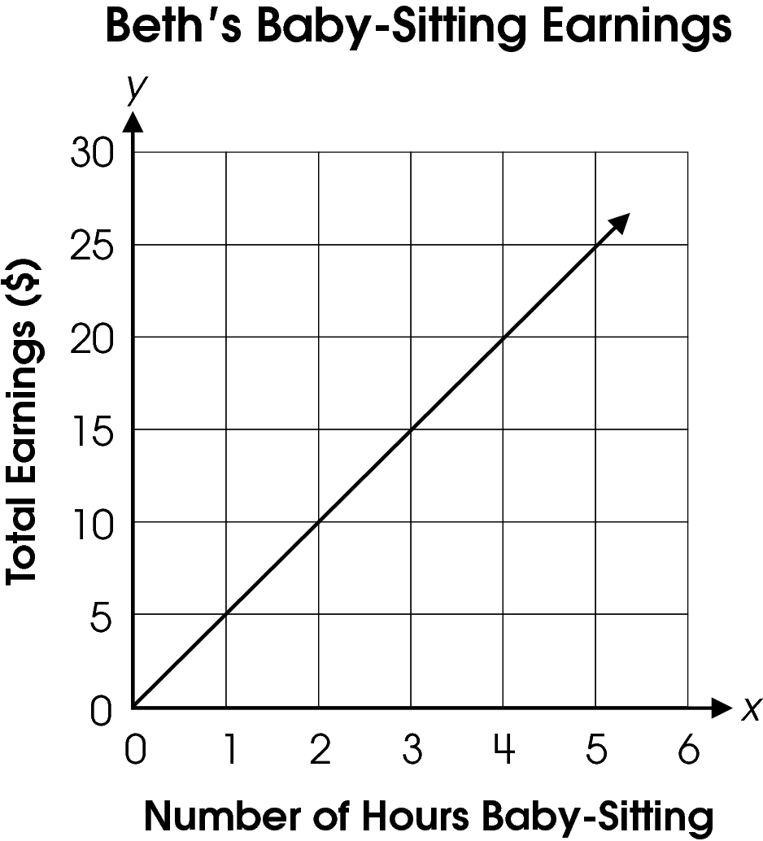
Which statement describes how Beth’s total earnings change as the number of hours of baby-sitting increases?
A. For every hour, the amount she earns doubles.
B. For every five hours, the amount she earns increases by $1.
C. For every five hours, the amount she earns increases by $10.
D. For every hour, the amount she earns increases by $5.

Commentary:
This multiple-choice question asks students to select the statement that correctly describes how the total earnings change as the number of baby-sitting hours increases. Answer choice D is correct because it describes how Beth’s earnings increase by $5 every hour. Answer choice A is incorrect because it is true only for the first two hours, then the pattern changes. Answer choice B is incorrect because the x- and y-axis of the graph have been switched. Answer choice C is incorrect because it reflects misreading of the number of hours of baby-sitting on the x-axis.

The complexity level of this question is Moderate Complexity. The task requires students to interpret information in a graph and use it to solve a problem.

Performance Data:
The percent of public school students selecting answer choice D for question 44 on the March 2006 Grade 4 Achievement Test was 65%.

Keywords: algebra, rate of change

BACK TO INDEX

Benchmark: A, B & E | Analyze and extend patterns, and describe the rule in words.  Use patterns to make predictions, identify relationships, and solve problems.  Use variables to create and solve equations representing problem situations.
GLI: PFA 4.1, PFA 4.2, PFA 4.4 | PFA 4.1: Use models and words to describe, extend and make generalizations of patterns and relationships occurring in computation, numerical patterns, geometry, graphs and other applications.  PFA 4.2: Represent and analyze patterns and functions using words, tables and graphs.  PFA 4.4: Use rules and variables to describe patterns and other relationships.

Extended Response Question:

20. Anthony’s family plants 15 trees each weekend.
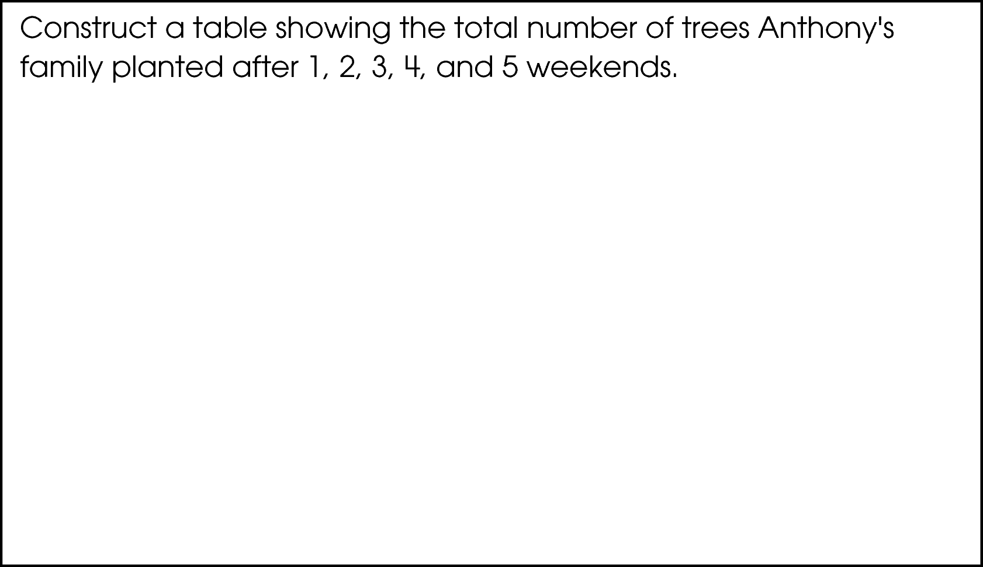
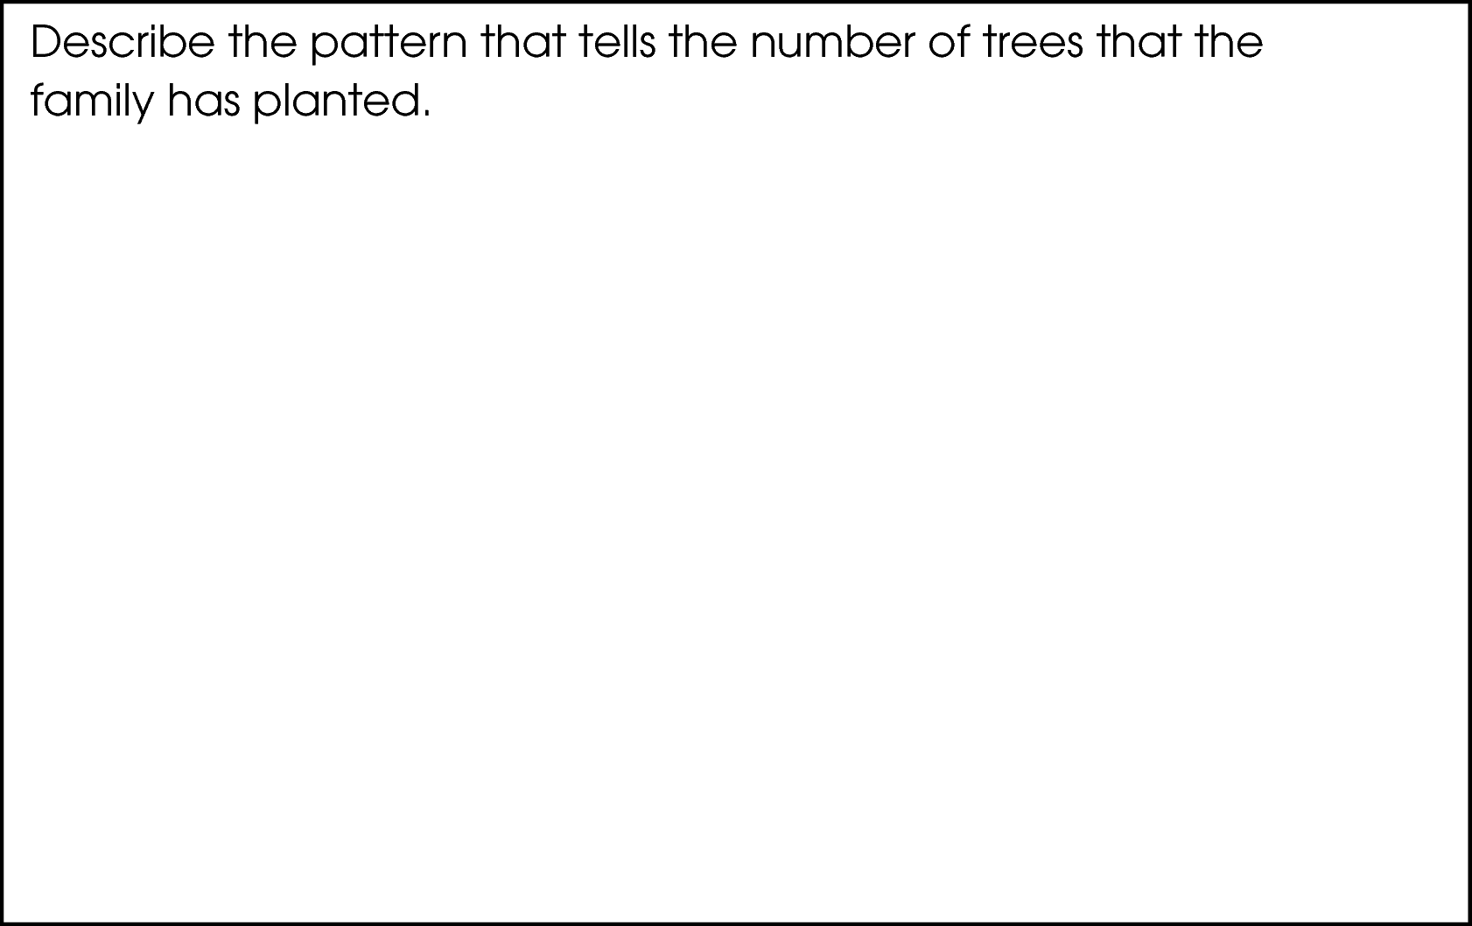
If t is the total number of trees planted and w is the number of weeks, write an expression for the total number of trees, t, that are planted after w weeks.
_________________________________________________
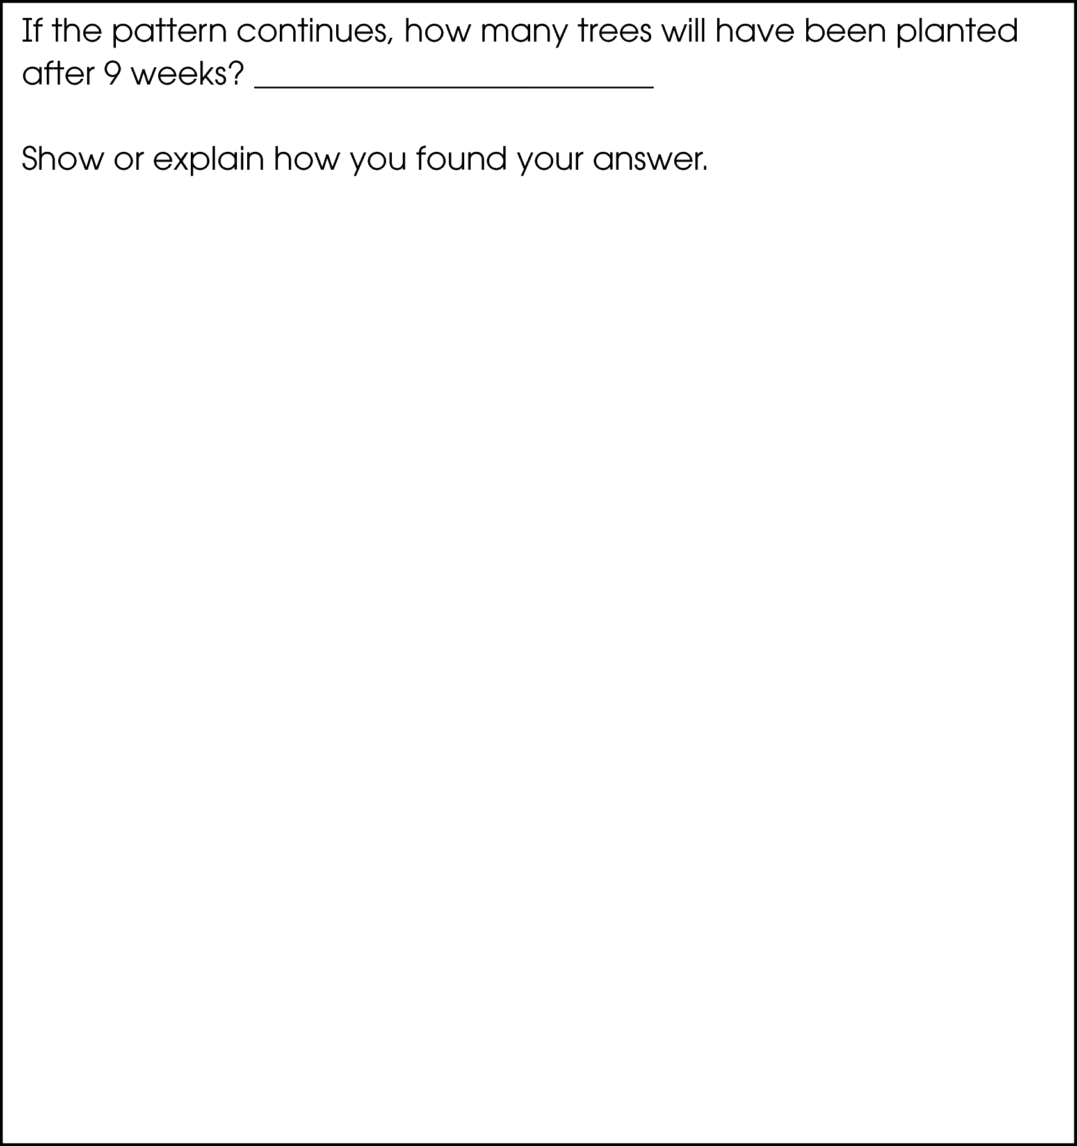
Commentary:
This extended-response question asks students to analyze a situation and represent the pattern using tables, words, and expressions. The response earning the maximum number of points (4 points) includes a correct table for the first five weeks, a correct description of the pattern, a correct equation for t in terms of w, and identifies the number of trees planted after 9 weeks.
To construct a table that shows weeks in one column and the total number of trees in the other column, students can either multiply the week number by the number of trees planted each week, 15, or add 15 to the number of trees planted in the previous week. For example, for week 1, the number of trees planted is 1x15 = 15; for week 2, the number of trees planted is 2 x 15 = 30, and so on. To write the rule as a number sentence, students need to substitute w for “week” and t for “total number of trees”. The rule can be written as t = w x 15.
To find the total number of trees, t, after 9 weeks, students can either substitute 9 for w in the equation, 9 x 15 = 135, or continue the pattern in their table by adding 15 each week until they get to 9 weeks.

The complexity level of this question is Moderate Complexity. This task asks students to represent a situation mathematically in more than one way.

Performance Data:
The percent of public school students earning each score point for question 20 on the May 2007 Grade 4 Achievement Test:

Percent at Each Score Point
0 | 1 | 2 | 3 | 4
25% | 26% | 27% | 20% | 3%

Scoring Guidelines:
Exemplar Response:

Other Correct Response(s):

Points | Student Response
4 point text | Example Correct Response:  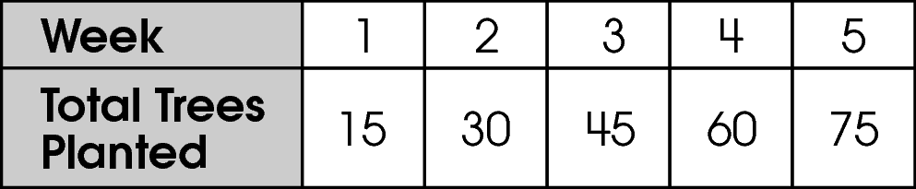  OR  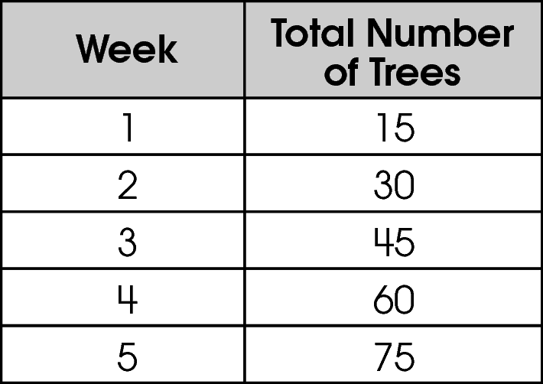  AND  Each week, there are 15 more trees planted, so multiply the week number by 15 to get the total number of trees planted.  AND  t = 15 w or t = 15 × w or t = w × 15  AND  If the pattern continues, there will be 135 trees planted after 9 weeks. Because each week, 15 more trees are planted, I just multiplied 9 weeks by 15 trees per week. That gave me 135.  The focus of this task is completing a pattern, creating a table and an expression to represent the pattern and then using the pattern to predict.  The response includes a correct table for the first five weeks and a correct description of the patterns and a correct expression for t in terms of w , and a correct prediction.
3 point text | The response clearly addresses extending and analyzing a pattern. However, the response may include minor errors in calculation or minimal flaws in reasoning. The response may not address all aspects of the questions.  For example, the response may:  - Correctly construct the table, explain the pattern, and write an expression.  - Give all of the correct answers with no explanations.  - Include the table, explain the pattern and determine how many after 9 weeks but not state the expression or state an incorrect expression.
3 point text | 3 point sample answer:
2 point text | The response provides evidence of a partial interpretation and solution of extending and describing a pattern. The response may address parts but not the entire problem appropriately.  For example, the response may:  - State the pattern and construct the table correctly, but fail to give an accurate expression and description after 9 weeks.  - State the pattern and what happens after 9 weeks correctly.  - Show the table and the expression.
2 point text | 2 point sample answer:
1 point text | The response provides minimal evidence of understanding patterns. The response omits significant aspects of extending and analyzing patterns. However, there is slight evidence of the process needed to yield the correct answer. The response may only address one aspect of the problem correctly.  For example, the response may:  - Draw a complete and correct table.  - State the expression.  - Explain the pattern.  - State the amount of trees after 9 weeks.
1 point text | 1 point sample answer:
0 point text | The response indicates inadequate evidence of understanding, analyzing and extending patterns. The response may be highly flawed or completely incorrect.  For example, the response may:  - State that after the first week there are 15 trees and 30 after the second week.  - Recopy information given in the stem.  - Be blank or make unrelated statements.
0 point text | 0 point sample answer:

Keywords: algebra, table, pattern, equation, expression

BACK TO INDEX

Benchmark: E | Use variables to create and solve equations representing problem situations.
GLI: PFA 4.4 | Use rules and variables to describe patterns and other relationships.

Multiple Choice Question:

37. Scott added seven to a number, and the answer was less than 12.
Which inequality represents this situation?

A. 
B. 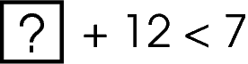
C. 
D. 

Commentary:
This multiple-choice question asks students to select the inequality that represents the given situation. The situation is described in words and students are asked to select an equivalent representation using numbers and a symbol. Answer choice D is correct answer because it represents the sum of 7 and an unknown number (shown as a box) that is less than 12.

Answer choices A and B are incorrect because they do not show the total being less than 12. Answer choice C is also incorrect because it shows the difference of unknown number and 7 that is smaller than 12.

The complexity level of this question is Moderate Complexity. This question requires students to select an inequality that represents a given situation.

Performance Data:
The percent of public school students selecting answer choice D for question 37 on the May 2007 Grade 4 Achievement Test was 53%.

Keywords: algebra, inequality, variable

BACK TO INDEX

Benchmark: A & F | Analyze and extend patterns, and describe the rule in words.  Construct and use a table of values to solve problems associated with mathematical relationships.
GLI: PFA 4.3 | Construct a table of values to solve problems associated with a mathematical relationship.

Multiple Choice Question:

45. Matt recorded the total number of pennies he has saved at the end of each week in the table shown.
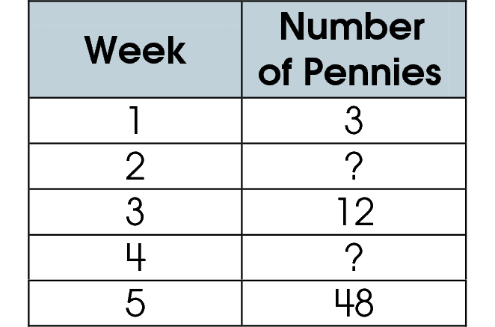
Each week, Matt doubles the number of pennies he has saved. He forgot to record the total number of pennies in week 2 and week 4.
Which completed table shows the correct number of pennies for weeks 2 and 4?

A. 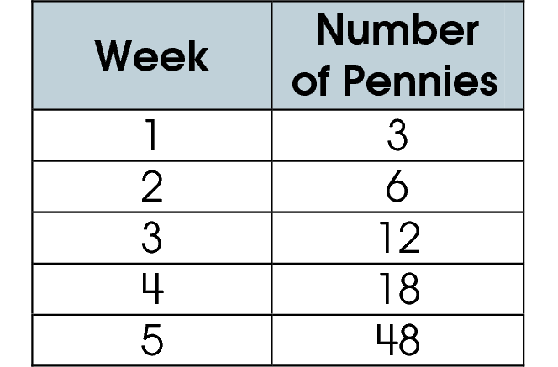
B. 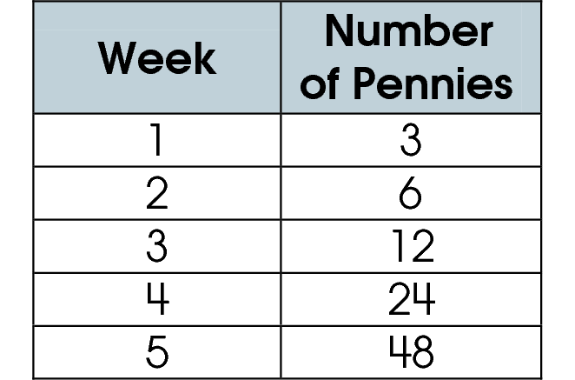
C. 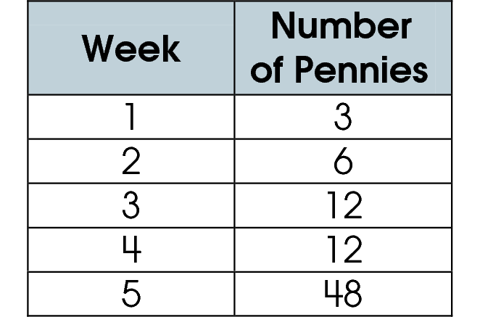
D. 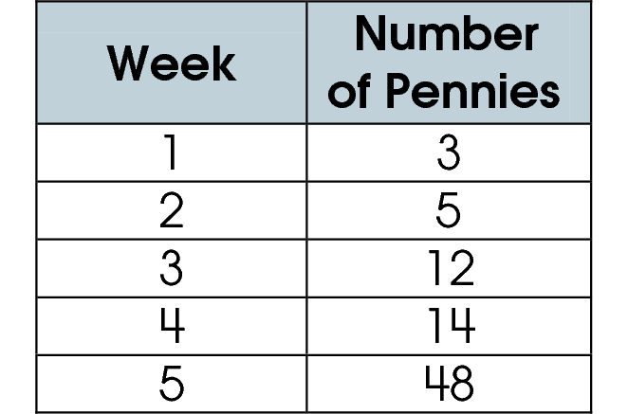

Commentary:
This multiple-choice question asks students to choose the completed table that correctly represents the given relationship. Students need to recognize that the number of pennies saved doubles each week. To find the number of pennies in week 2, students need to double the number of pennies in week 1 (3 x 2 = 6). To find the number of pennies in week 4, students need to double the number of pennies in week 3 (12 x 2 = 24 or 12 + 12 = 24). So, answer choice B is correct.

Answer choice A is incorrect because students may have added 6 to the number of pennies in week 4 instead of doubling the number of pennies in week 3. Answer choice C is incorrect because students may have doubled the number of pennies in week 2 to get the number of pennies in week 4 instead of doubling the number of pennies in week 3. Answer choice D is incorrect as well because students may have added 2 to the number of pennies in the previous week instead of multiplying the number of pennies by 2.

The complexity level of this question is Low Complexity. The question requires students to perform a specified procedure by completing a table.

Performance Data:
The percent of public school students selecting answer choice B for question 45 on the May 2007 Grade 4 Achievement Test was 77%.

Keywords: algebra, table, rule

BACK TO INDEX

Benchmark: B | Use patterns to make predictions, identify relationships, and solve problems.
GLI: PFA 4.1 | Use models and words to describe, extend and make generalizations of patterns and relationships occurring in computation, numerical patterns, geometry, graphs and other applications.

Short Answer Question:

5. The table shows the number of cans of paint Joe used to paint benches.
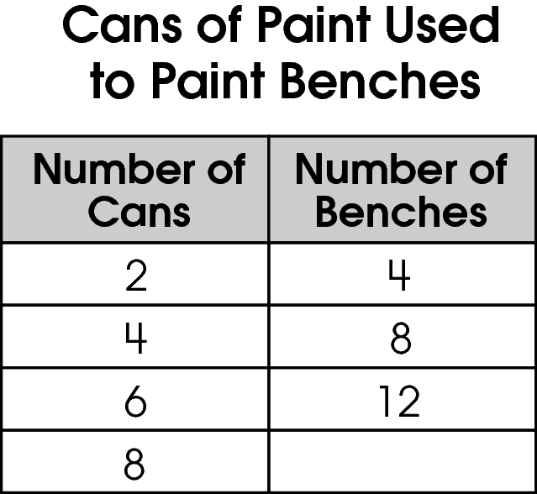
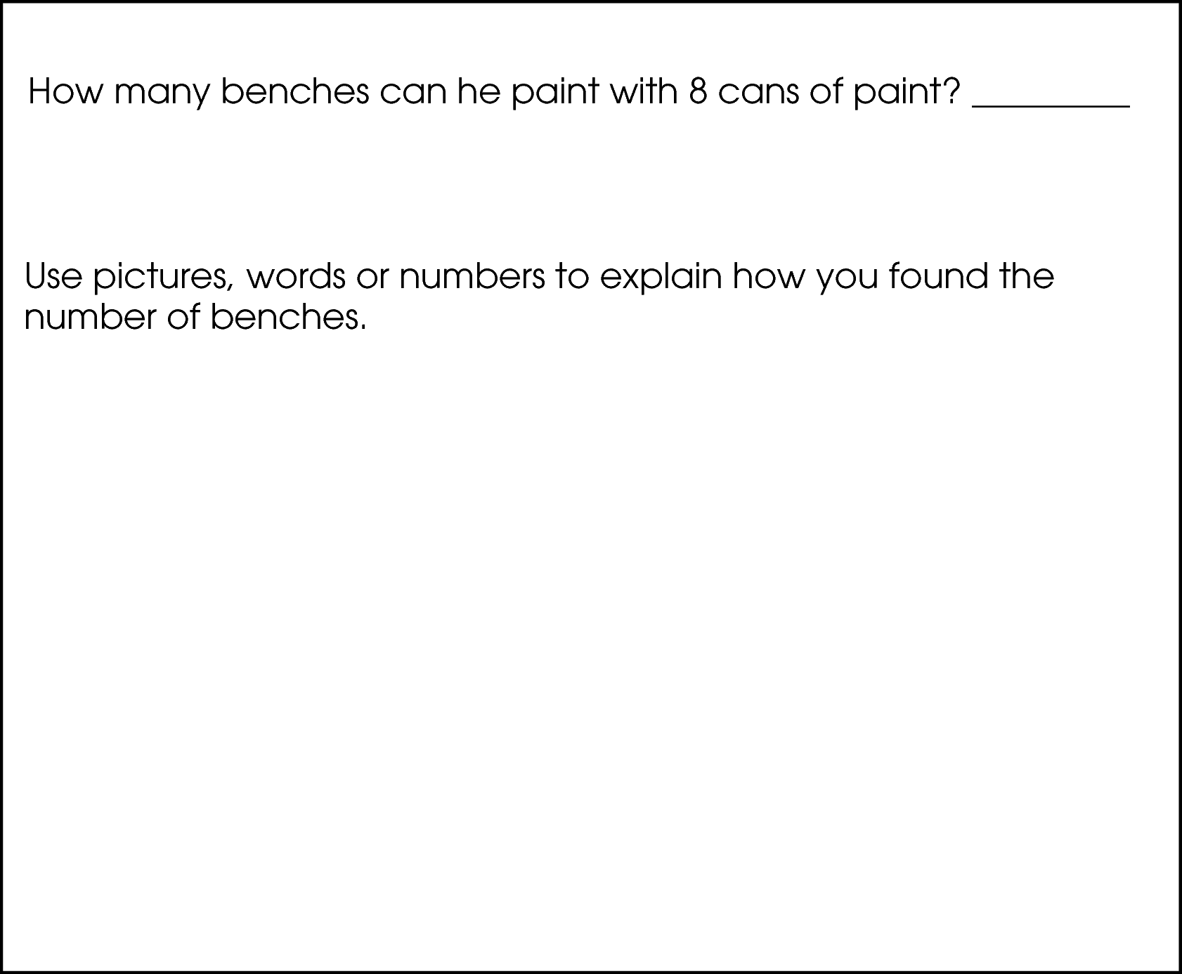

Commentary:
This short-answer question asks students to analyze the patterns in the table to predict the number of benches that can be painted with 8 cans of paint and explain their work. A response earning the maximum number of points (2 points) gives the correct number of benches that can be painted with 8 cans of paint (16) and adequately explains the procedure for finding 16 as the answer. Students would need to understand the relationship between the number of cans of paint and the number of benches. They could examine the values across the rows to find that the number of benches that can be painted is two times the number of cans of paints used. So, 8 cans of paint would cover 16 benches (8 cans x 2).

Number of Cans | Number of Benches
2 | 4
4 | 8
6 | 12
8 | 16
x 2
x 2
x 2
x 2

The complexity level of this question is Moderate Complexity. Students are asked to extend a pattern.

Performance Data:
The percent of public school students earning each score point for question 5 on the May 2008 Grade 4 Achievement Test:

Percent at Each Score Point
0 | 1 | 2
9% | 12% | 79%

Scoring Guidelines:
Sample Correct Responses:
- 16 benches. The pattern is that you multiply the number of cans by 2 to get the number of benches you can paint. 8 × 2 = 16
- 16 benches. The table shows that the number of benches goes up by 4 so I added 12 + 4 = 16.
- 16 benches. The number of cans is doubled to get the number of benches. 8 + 8 = 16.

Points | Student Response
2 | The focus of this task is to provide evidence of analyzing, extending and describing patterns. The response correctly identifies the number of benches and provides adequate support to explain how to find the answer.
1 | The response provides partial evidence of analyzing, extending and describing patterns; however, the solution may be incomplete or slightly flawed.  For example, the response may:  - State that 16 benches can be painted but not explain how the answer was found or there is a flaw in the explanation.  - Indicate an accurate rule for finding the number of benches that can be painted but does not correctly find the number of benches that can be painted. E.g., 14 benches. You keep adding 4 to the number of benches.
0 | The response provides inadequate evidence of analyzing, extending and describing patterns. The response will provide major flaws or irrelevant information.  For example, the response may:  - Show some work but use a highly flawed strategy. E.g., 20 benches. Add 4 + 8 = 12, 8 + 12 = 20.  - Be blank or state unrelated statements.  - Recopy information from the stem.

Keywords: algebra, pattern, table, relationship

BACK TO INDEX

Benchmark: A | Analyze and extend patterns, and describe the rule in words.
GLI: PFA 4.2 | Represent and analyze patterns and functions using words, tables and graphs.

Multiple Choice Question:

19. Mr. James described a number pattern as “start with 2 and multiply each number by 3 to get the next number.”
Which number pattern is Mr. James describing?

A. 2, 5, 8, 11
B. 2, 5, 15, 45
C. 2, 6, 12, 24
D. 2, 6, 18, 54

Commentary:
This multiple-choice question asks students to select the number pattern described by the rule: start with 2 and multiply each number by 3 to get the next number. Students need to be able to analyze number sequences and identify the rule used to generate the sequences. The correct answer is choice D. These numbers, starting with 2, are generated by multiplying each number by 3 to get the next number: 2; 2 x 3 = 6; 6 x 3 = 18; 18 x 3 = 54.

Answer choice A is incorrect since the numbers were generated by the rule “start with 2 and add 3 to each number to get the next number”. Answer choice B is incorrect because 3 was added to 2 to get 5, then 5 and 15 were multiplied by 3. Answer choice C is incorrect since 2 was multiplied by 3 to get 6, but 6, 12 and 24 were multiplied by 2.

The complexity level of this question is Low Complexity. Students are asked to recognize an equivalent representation for a rule.

Performance Data:
The percent of public school students selecting answer choice D for question 19 on the May 2008 Grade 4 Achievement Test was 60%.

Keywords: algebra, pattern, rule

BACK TO INDEX

Benchmark: A | Analyze and extend patterns, and describe the rule in words.
GLI: PFA 4.2 | Represent and analyze patterns and functions using words, tables and graphs.

Multiple Choice Question:

42. Rocco made this pattern.
53, 48, 43, 38
Which describes the rule for Rocco’s pattern?

A. subtract 15
B. subtract 10
C. subtract 5
D. subtract 3

Commentary:
This multiple-choice question asks students to select the rule for the given number pattern. Students need to know how to analyze a number pattern to determine the rule then use this rule to get from the first number to the second number, from the second number to the third number and so on. They also need to know that a rule typically involves at least one of the four operations: addition, subtraction, multiplication and division. For example, starting with 1, the rule “add 4” will generate these numbers: 1, 5, 9, 13 (1; 1 + 4 = 5; 5 + 4 = 9; 9 + 4 = 13).

To analyze the given pattern and find the rule, students should compare the consecutive pairs of numbers: 53 and 48, 48 and 43, 43 and 38. They also need to identify an operation(s) that relates the two numbers in all pairs. For this given pattern and the answer choices provided, students should compare the number pairs using subtraction: 53 – 48 = 5, 48 – 43 = 5 and
43 – 38 = 5. Since the numbers in each pair all differ by 5, “subtract 5”, answer choice C, is the correct rule.

Answer choices A, B, and D are incorrect because the difference between the numbers in all pairs is 5, not 15, 10, or 3.

The complexity level of this question is Moderate Complexity. Students are asked to analyze and extend a pattern.

Performance Data:
The percent of public school students selecting answer choice C for question 42 on the May 2008 Grade 4 Achievement Test was 87%.

Keywords: algebra, pattern

BACK TO INDEX

Benchmark: B | Use patterns to make predictions, identify relationships, and solve problems.
GLI: PFA 3.1, PFA 4.2 | PFA 3.1: Extend multiplicative and growing patterns, and describe the pattern or rule in words.  PFA 4.2: Represent and analyze patterns and functions using words, tables and graphs.

Multiple Choice Question:

45. Jim’s and Sarah’s total savings at the end of each week are shown in the table.
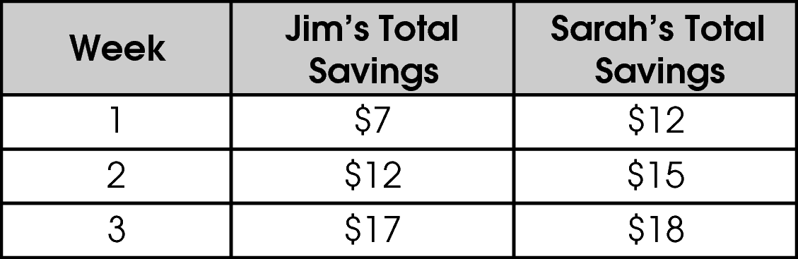
The pattern of savings continues.
Which statement about their savings is true?

- Jim will have $1 less than Sarah at the end of week 4.
- Sarah will have saved more money than Jim at the end of week 4.
- Jim will have saved more money than Sarah at the end of week 4.
- Sarah and Jim will have saved the same amount at the end of week 4.

Commentary:
This multiple-choice question asks students to identify a statement that compares the amounts of money saved after four weeks using two different savings plans. Students need to be able to identify the rule for a number pattern. They also need to be able to use the rule to extend the number pattern to make predictions.

First students need to identify the number patterns for the weekly savings patterns used by Jim and Sarah. They should compare the values for each savings plan given in the table for each week. Jim’s Total Savings grew from $7 to $12 to $17. Students should compare these number pairs: 7 and 12 and 12 and 17. They should see that the two numbers in each pair differ by 5 (7 + 5 = 12; 12 + 5 = 17). So “add 5” is a rule for the pattern used for Jim’s savings plan. Next students will need to use this rule to extend the pattern to Week 4. They should find that after Week 4, Jim will have saved $22 ($17 + $5 = $22). In the same manner, students should compare pairs of values in Sarah’s Total Savings: $12 and $15 and $15 and $18. The numbers in each pair differ by 3 (12 + 3 = 15; 15 + 3 = 18), so students would arrive at “add 3” for the rule. Students would then extend this pattern to find that after week 4, Sarah will have saved $21 ($18 + $3 = $21). So answer choice C is correct. After Week 4, Jim saved $22, which is more than Sarah who saved $21.

Answer choice A is incorrect because Jim saved $1 more than Sarah after Week 4
($22 - $21 = $1). Answer choice B is incorrect because Sarah saved $1 less than Jim after Week 4. Jim and Sarah saved different amounts of money because Jim saved $1 more than Sarah after Week 4. So, answer choice D is incorrect.

The complexity level of this question is Moderate Complexity. Students are asked to extend a pattern.

Performance Data:
The percent of public school students selecting answer choice C for question 45 on the May 2008 Grade 4 Achievement Test was 34%.

Keywords: algebra, pattern

BACK TO INDEX

