Index to Questions

Question Number | Source | BM | GLI | Description
4 | OAT March 05 | C & E | PFA 3.4, PFA 3.6 | This multiple-choice question asks students to select a number sentence that represents a given situation.
8 | OAT March 05 | A | PFA 3.2 | This multiple-choice question asks students to find the missing number in a sequence.
10 | OAT March 05 | A | PFA 3.1 | This short-answer question asks students to extend a pattern and write a rule to describe the pattern.
14 | OAT March 05 | F | PFA 3.7 | This multiple-choice question asks students to identify a table that displays the pattern of each bag containing 2 red marbles.
18 | OAT March 05 | A | PFA 3.1 | This multiple-choice question asks students to describe a pattern.
23 | OAT March 05 | A | PFA 3.1 | This multiple-choice question asks students to identify part of a rule for the pattern.
38 | OAT March 05 | C | PFA 3.5 | This multiple-choice question asks students to choose an answer to make a number sentence true.
42 | OAT March 05 | G | PFA 3.8 | This short-answer question asks students to continue a pattern of spending to find the amount of money remaining after five weeks.
10 | OAT March 06 | A & F | PFA 3.1 | This short-answer question asks students to complete the table by continuing the pattern and to describe the rule for the pattern.
18 | OAT March 06 | G | PFA 3.8 | This multiple-choice question asks students to find how tall a tomato plant will be at the end of 3 weeks.
31 | OAT March 06 | B | PFA 3.3 | This multiple-choice question asks students to extend a pattern to find the number of tiles in the next figure.
40 | OAT March 06 | C | PFA 3.5 | This multiple-choice question asks students to select a number that make an open statement true.
46 | OAT March 06 | C | PFA 3.6 | This multiple-choice question asks students to select a number sentence that represents a given situation.
3 | OAT May 07 | C | PFA 3.5 | This multiple-choice question asks students to select a number that makes the number sentence true.
Question Number | Source | BM | GLI | Description
12 | OAT May 07 | E | PFA 3.4 | This multiple-choice question asks students to select an expression that represents a given situation.
15 | OAT May 07 | A | PFA 3.1 | This short-answer question asks students to extend, and describe the rule for the pattern.
28 | OAT May 07 | A | PFA 3.1 | This multiple-choice question asks students to extend a pattern to find the number of stars in the next figure.
34 | OAT May 07 | F | PFA 3.7 | This multiple-choice question asks students to recognize the rule that describes the relationship between the input values and the output values shown in the table.
8 | OAT May 08 | C | PFA 3.5 | This multiple-choice question asks students to solve a simple mathematical statement.
10 | OAT May 08 | A | PFA 3.1 | This extended-response question asks students to extend a pattern and provide explanations for their work.
31 | OAT May 08 | B | PFA 4.1 | This multiple-choice question asks students to predict the height of a candle at a future time by identifying the pattern in a table.
41 | OAT May 08 | F | PFA 3.7 | This multiple-choice question asks students to identify the table that shows the correct relationship between the nights that Marsha reads 5 pages and the total number of pages read in the book at the end of each night.

BACK TO INDEX

Benchmark: C & E | Write and solve open sentences and explain strategies.  Use variables to create and solve equations representing problem situations.
GLI: PFA 3.4, PFA 3.6 | PFA 3.4: Model problem situations using objects, pictures, tables, numbers, letters and other symbols.  PFA 3.6: Express mathematical relationships as equations and inequalities.

Multiple Choice Question:
4. | It takes 38 stickers to fill a page. Charlene has 14 stickers. Which number sentence shows how many more stickers she needs to fill the page?
 | A. | 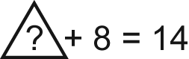
 | B. | 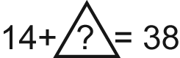
 | C. | 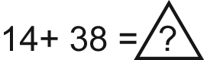

Commentary:
This multiple-choice question asks students to select a number sentence that represents a given situation. The situation is described in words and students are asked to select an equivalent representation using numbers and symbols. Answer choice B is the correct answer because it shows 38 as the total of 14 and a missing number. Answer choices A and C are incorrect because they show something other than 38 as the total.

The complexity level of this question is Moderate Complexity. Students are asked to select a different representation for a given situation.

Performance Data:
The percent of public school students selecting answer choice B for question 4 on the March 2005 Grade 3 Achievement Test was 79%.

Keywords: algebra, equations

BACK TO INDEX

Benchmark: A | Analyze and extend patterns, and describe the rule in words.
GLI: PFA 3.2 | Analyze and replicate arithmetic sequences with and without a calculator.

Multiple Choice Question:

- Find the missing number in the pattern.

750, 775, 800, ? , 850, 875

A. 725
B. 825
C. 900

Commentary:
This multiple-choice question asks students to find the missing number in a sequence. Several solution methods are possible, One common method is to recognize that the sequence starts at 750 and adds 25 to each term. Thus, the term following 800 is 800 + 25 = 825. Another solution method identifies that the numbers in the pattern continue to increase and that the missing number is between 800 and 850. Answer choice B is the only choice between 800 and 850.

The level of complexity of this question is Moderate Complexity. Students are asked to extend a pattern.

Performance Data:
The percent of public school students selecting answer choice B for question 8 on the March 2005 Grade 3 Achievement Test was 96%.

Keywords: patterns, analyze

BACK TO INDEX

Benchmark: A | Analyze and extend patterns, and describe the rule in words.
GLI: PFA 3.1 | Extend multiplicative and growing patterns, and describe the pattern or rule in words.

Short Answer Question:
10. | Write the missing numbers to continue this pattern.  8, 10, 14, 20, _____ , _____  Describe the rule for this pattern.

Commentary:
This short-answer question asks students to extend a pattern and write a rule to describe the pattern. Adequate responses first recognize that the pattern is a growing pattern, adding two more than were previously added. For example, 10 is 8 + 2, 14 is 10 + 4, 20 is 14 + 6. The next term is found by adding 8 to 20, 20 + 8 = 28. The sixth term is found by adding 10, 28 + 10 = 38. To describe the rule, students may describe where the pattern starts and then explain how to find the next term. For example, students might describe the rule by stating that the pattern starts at 8 and adds two more each time, + 2, + 4, + 6, an so on.

The level of complexity for this question is High Complexity. The task asks students to generalize a pattern by writing the rule for the pattern.

Performance Data:
The percent of public school students earning each score point for question 10 on the March 2005 Grade 3 Achievement Test:

Percent at Each Score Point
0 | 1 | 2
64% | 18% | 17%

Scoring Guidelines:
Points | Student Response
2 | The response correctly completes the pattern and explains the rule correctly.  Examples of correct rules:  - Growing pattern  - growing pattern by two more each time  - add 2, then 4, then 6, then 8, then 10  - goes up by consecutive even numbers  - goes up by 2, 4, 6, 8, 10  - increase the number that goes up 2 more each time  - going 2 more each time
1 | The response completes the pattern but does not explain rule OR correctly explains the rule but does not write the numbers correctly.  For example: 28, 38 the rule is add 2
0 | The response indicates no understanding of the concept or task.

Keywords: patterns, rule

BACK TO INDEX

Benchmark: F | Construct and use a table of values to solve problems associated with mathematical relationships.
GLI: PFA 3.7 | Create tables to record, organize and analyze data to discover patterns and rules.

Multiple Choice Question:
14. | Marco buys packages of marbles. Each package has 2 red marbles. Which table shows the total number of red marbles Marco will get in one to four packages?
  A. | 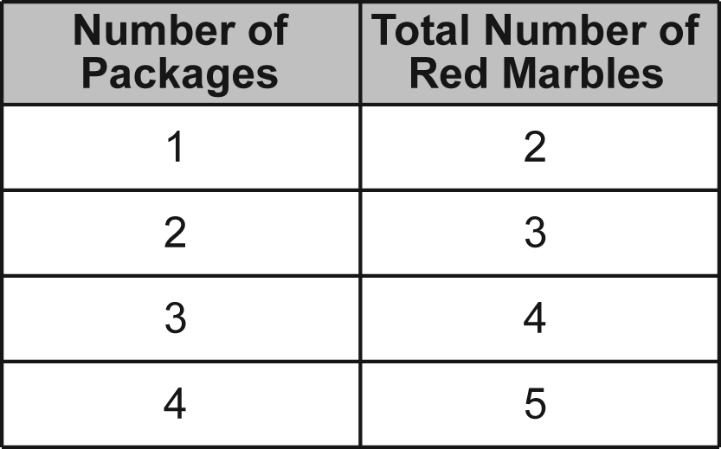
  B. | 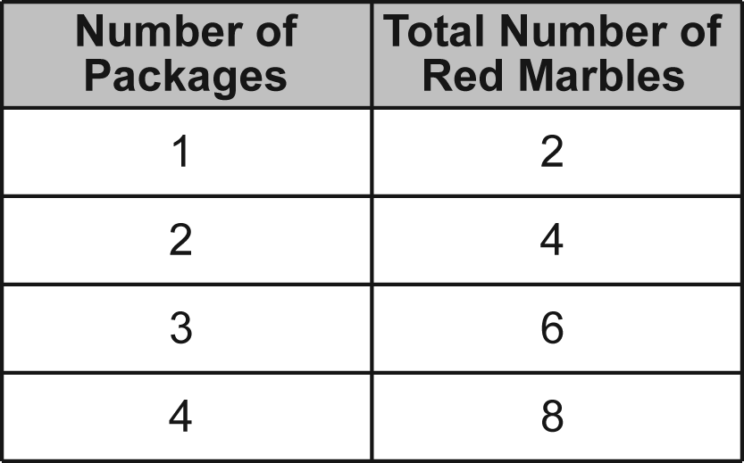
  C. | 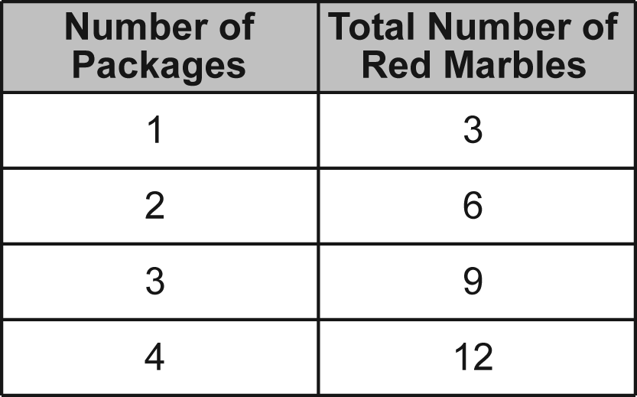

Commentary:
This multiple-choice question asks students to identify a table that displays the pattern of each bag containing 2 red marbles. Answer choice B is the correct answer because the total number of red marbles will be two times the number of bags. Answer choice A has the correct number of red marbles for one bag, but not for the other bags. Answer choice C demonstrates a pattern of 3 red marbles in each bag.

The complexity level of this question is Moderate Complexity. Students are asked to compare a statement to information in a figure.

Performance Data:
The percent of public school students selecting answer choice B for question 14 on the March 2005 Grade 3 Achievement Test was 77%.

Keywords: patterns, tables

BACK TO INDEX

Benchmark: A | Analyze and extend patterns, and describe the rule in words.
GLI: PFA 3.1 | Extend multiplicative and growing patterns, and describe the pattern or rule in words.

Multiple Choice Question:
18. | Which describes the rule for this pattern?  2, 6, 18, 54

A. | multiply by 3
B. | multiply by 4
C. | multiply by 6

Commentary:
This multiple-choice question asks students to describe a pattern. The pattern starts at 2 and each term is multiplied by 3 to find the next term. Answer choice A describes the operation applied to each term to find the next term.

The level of complexity for this question is Moderate Complexity. Students extend a pattern to find the rule.
Performance Data:
The percent of public school students selecting answer choice A for question 18 on the March 2005 Grade 3 Achievement Test was 47%.

Keywords: patterns, rule

BACK TO INDEX

Benchmark: A | Analyze and extend patterns, and describe the rule in words.
GLI: PFA 3.1 | Extend multiplicative and growing patterns, and describe the pattern or rule in words.

Multiple Choice Question:
23. | Which is a rule for the pattern below?

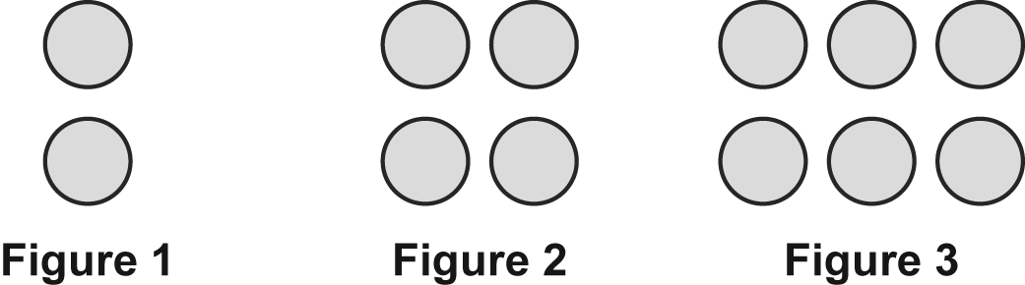

A. | Take away two circles.
B. | Add two circles.
C. | Add four circles.

Commentary:
This multiple-choice question asks students to identify part of a rule for the pattern. Answer choice B is the correct answer. Students should first recognize that the pattern begins with 2 dots in Figure 1 and then consider how to make Figure 2. In this case, two circles are added to make the Figure 2. Students then check to make sure adding two circles to Figure 2 generates Figure 3, which it does. So the rule is to start with two circles and add two circles to make the next figure. Students who select answer choice C may be counting the total number of circles in one figure and not considering how to move from one figure to the next.

The level of complexity for this question is Moderate Complexity. This question requires students to consider how a pattern was extended.

Performance Data:
The percent of public school students selecting answer choice B for question 23 on the March 2005 Grade 3 Achievement Test was 82%.

Keywords: patterns, rule

BACK TO INDEX

Benchmark: C | Write and solve open sentences and explain strategies.
GLI: PFA 3.5 | Write, solve and explain simple mathematical statements, such as: 7 + □ > 8 or ∆ + 8 = 10.

Multiple Choice Question:
38. | Which number makes this number sentence true?    A. 5  B. 12  C. 18

Commentary:
This multiple-choice question asks students to choose an answer to make a number sentence true. Students may use several methods to solve this problem. One method is to try each answer choice in the number sentence. For example, replace the “?” with 5, answer choice A. Since 5 + 3 is 8, and 8 is less than 15, answer choice A is correct. Confusing the less than symbol (<) for the equal sign (=) or the greater than symbol (>) may result in selecting answer choices B or C.

The level of complexity for this question is Moderate Complexity. The task requires students to use informal methods of reasoning.

Performance Data:
The percent of public school students selecting answer choice A for question 38 on the March 2005 Grade 3 Achievement Test was 46%.

Keywords: algebra, inequalities

BACK TO INDEX

Benchmark: G | Describe how a change in one variable affects the value of a related variable.
GLI: PFA 3.8 | Identify and describe quantitative changes, especially those involving addition and subtraction; e.g., the height of water in a glass becoming 1 centimeter lower each week due to evaporation.

Short Answer Question:

42. Ricky earned $50 helping his neighbors. He spent $4 each week for snacks from the money he earned.

How much money did Ricky have left after five weeks?

Use pictures, words or number to show how you found the amount of money Ricky had left after five weeks.

Commentary:
This short-answer question asks students to continue a pattern of spending to find the amount of money remaining after five weeks. Students may solve the problem in several ways. One way is to begin with $50 and subtract $4 for each of the five weeks:
$50 – $4 = $46, $46 – 4 = $42, $42 - $4 = $38, $38 - $4 = $34, $34 - $4 = $30.
Therefore, the correct answer is $30. Another method is to recognize that spending $4 for each of 5 weeks results in spending $20 (4 x 5 = 20). Subtracting the money spent from the starting amount ($50 - $20) leaves $30.

The level of complexity for this question is Moderate Complexity. This task requires students to extend a pattern.

Performance Data:
The percent of public school students earning each score point for question 42 on the March 2005 Grade 3 Achievement Test:

Percent at Each Score Point
0 | 1 | 2
45% | 20% | 33%

Scoring Guidelines:
Points | Student Response
2 | The response correctly answers $30 or 30 AND provides correct work or strategy to support their answer.  Examples of correct responses:  - 50 – 4 – 4 – 4 – 4 – 4 = 30 or $30  - 4 × 5 = 20; 50 – 20 = 30 or $30  - 50 – (4 × 5) = 30 or $30
1 | The response correctly answers $30 or 30 OR provides correct work or strategy with a computational or counting error.  OR  The response shows an incomplete strategy that could lead to a correct solution.  For example: 4 × 5 = 20 OR 50 – 4 – 4 – 4 – 4 = 34 (incomplete strategy must be shown)
0 | The response indicates no understanding of the concept or task.

Keywords: patterns, predictions

BACK TO INDEX

Benchmark: A | Analyze and extend patterns, and describe the rule in words.
Benchmark: F | Construct and use a table of values to solve problems associated with mathematical relationships.
GLI: PFA 3.1 | Extend multiplicative and growing patterns, and describe the pattern or rule in words.

Short Answer Question:

10. Sam and his mom put pennies into his bank and wrote the amount in this table.

Complete the table by continuing the pattern.
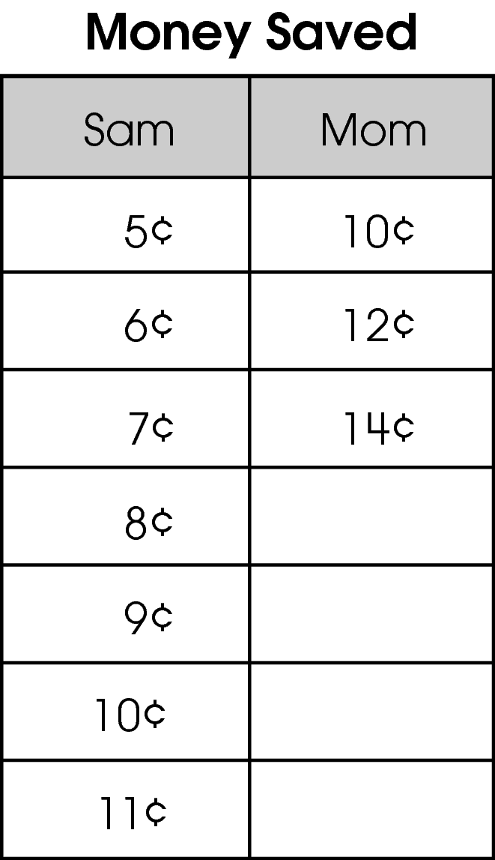
Describe the rule for this pattern.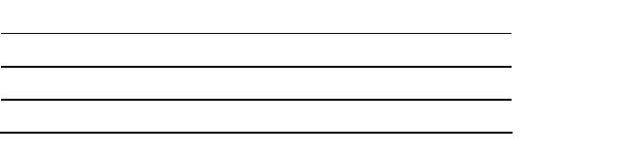

Points Student Response
Do not copy or distribute ID: 3114; Version: 12

Commentary:
This short-answer question asks students to complete the table by continuing the pattern and to describe the rule for the pattern. A response earning the maximum number of points (2 points) shows the correct pattern and provides an adequate rule for this pattern. For example Sam’s mom saves twice the amount that Sam saves and 5 x 2 = 10; 6 x 2 = 12; 7 x 2 = 14; 8 x 2 = 16, 9 x 2 = 18; 10 x 2 = 20; 11 x 2 = 22.
The complexity level of this question is High Complexity. The task asks students to extend a pattern and write a rule for the pattern.

Performance Data:
The percent of public school students earning each score point for question 10 on the March 2006 Grade 3 Achievement Test:

Percent at Each Score Point
0 | 1 | 2
8% | 20% | 72%

Scoring Guidelines:
Sample Correct Response(s):

- 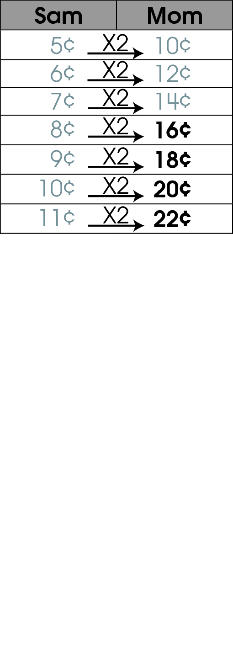
- Count by twos (2s)
- Add twos (2s)
- +2
- Going by twos (2s)
- Sam by one, mom by two
- Sam’s mom saves twice the amount that Sam saves
- Sam’s mom saves 2¢ more each day and/or Sam saves 1¢ more each day.
- Double the number

NOTE: No penalty for omitting the ¢ sign.
Points | Student Response
2 | The response completes the table with 16¢, 18¢, 20¢ and 22¢ and states a correct pattern for the table.
1 | The response has the table completed correctly, but rule is not stated or incorrect  OR  Response gives a correct rule, but the table is not completed correctly.
0 | The response indicates no understanding of the concept or task.

Keywords: pattern, rule

BACK TO INDEX

Benchmark: G | Describe how a change in one variable affects the value of a related variable.
GLI: PFA 3.8 | Identify and describe quantitative changes, especially those involving addition and subtraction; e.g., the height of water in a glass becoming 1 centimeter lower each week due to evaporation.

Multiple Choice Question:

18. A tomato plant is 7 inches tall. It grows 2 inches each week. How tall will the tomato plant be at the end of 3 weeks?
A. 9 inches
B. 10 inches
C. 13 inches

Commentary:
This multiple-choice question asks students to find how tall a tomato plant will be at the end of 3 weeks. One common method is to recognize that the sequence starts at 7 and then adds 2 to each following sum three times in a row: 7 + 2 = 9; 9 + 2 = 11; 11 + 2 = 13. Another solution method would be to identify how much taller the plant is going to be after 3 weeks by multiplying the number of inches a tomato plant grows each week by the number of weeks (2 x 3 = 6), and then adding this number to the initial height of a plant (7 + 6 = 13). The correct answer is choice C. Answer choices A and B are incorrect. Answer choice A, represents the height of the plant after 1 week. In answer choice B, students may have added the initial height of the plant and the number of weeks (7 + 3 = 10).

The complexity level of this question is Moderate Complexity. The question requires students to extend a pattern.

Performance Data:
The percent of public school students selecting answer choice C for question 18 on the March 2006 Grade 3 Achievement Test was 73%.

Keywords: pattern, growth change

BACK TO INDEX

Benchmark: B | Use patterns to make predictions, identify relationships, and solve problems.
GLI: PFA 3.3 | Use patterns to make predictions, identify relationships, and solve problems.

Multiple Choice Question:

31. André made this pattern of figures with tiles.
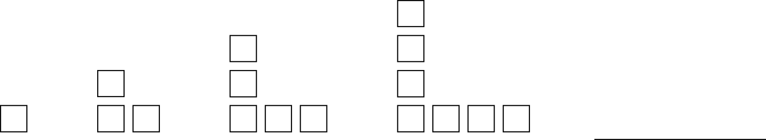
How many tiles would be in the next figure?
A. 8
B. 9
C. 10

Commentary:
This multiple-choice question asks students to extend a pattern to find the number of tiles in the next figure. An adequate response recognizes that the pattern is adding a total of 2 tiles to the previous figure (1 tile to the right end and 1 tile to the upper end). For example, the second figure is built by adding 2 more tiles to the first tile, one to the right end and one to the upper end, (1 + 2 = 3 tiles). The third figure is built by adding 2 more tiles to the second figure, one to the right end and one to the upper end, (3 +2 = 5 tiles). The fourth figure is built by adding 2 more tiles to the third figure, one to the right end and one to the upper end, (5 + 2 =7 tiles).
The fifth figure is built by adding another 2 tiles) to the fourth figure, one to the right end and one to the upper end, (7 + 2 = 9). Answer choice B is the correct answer.

The complexity level of this question is Moderate Complexity. The question requires students to extend a pattern.

Performance Data:
The percent of public school students selecting answer choice B for question 31 on the March 2006 Grade 3 Achievement Test was 69 %.

Keywords: pattern, rule

BACK TO INDEX

Benchmark: C | Write and solve open sentences and explain strategies.
GLI: PFA 3.5 | Write, solve and explain simple mathematical statements, such as: 7 + □ > 8 or ∆ + 8 = 10.

Multiple Choice Question:

40. Which number makes this statement true?
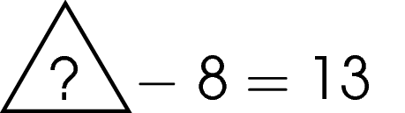
A. 5
B. 21
C. 84

Commentary:
This multiple-choice question asks students to select a number that makes an open statement true. Answer choice B is the correct answer because it shows that 21- 8 = 13. Answer choice A is incorrect because students may have subtracted 13 and 8 (13 – 8 = 5), but 5 minus 8 does not equal 13. Answer choice C is also incorrect because 84 minus 8 does not equal 13 either.

The complexity level of this question is Low Complexity. The question requires students to solve an open sentence.

Performance Data:
The percent of public school students selecting answer choice B for question 40 on the March 2006 Grade 3 Achievement Test was 83%.

Keywords: patterns, open sentence

BACK TO INDEX

Benchmark: C | Write and solve open sentences and explain strategies.
GLI: PFA 3.6 | Express mathematical relationships as equations and inequalities.

Mathematical Processes
Benchmark: I | Represent problem situation in a variety of forms (physical model, diagrams, in words or symbols), and recognize when some ways of representing a problem may be more helpful than others.

Multiple Choice Question:

46. Monica had 18 books. She shared some books with a friend and had 12 books left.
Which number sentence could be used to find the number of books Monica shared?
A. 18 – n = 12
B. 12 – 18 = n
C. 18 + 12 = n

Do not copy or distribute ID: 10208; Version: 4

Commentary:
This multiple-choice question asks students to select a number sentence that represents a given situation. The situation is described in words and students have to select an equivalent representation using numbers and symbols. Answer choice A is the correct answer because it shows that after some of the 18 books are shared there are 12 books left. Answer choice B and C are incorrect answer choices because they illustrate an incorrect representation how to find the missing part.

The complexity level of this question is Moderate Complexity. Students are asked to select a representation for a given situation.

Performance Data:
The percent of public school students selecting answer choice A for question 46 on the March 2006 Grade 3 Achievement Test was 65%.

Keywords: algebra, number sentence, variable

BACK TO INDEX

Benchmark: C | Write and solve open sentences and explain strategies.
GLI: PFA 3.5 | Write, solve and explain simple mathematical statements, such as: 7 + □ > 8 or ∆ + 8 = 10.

Multiple Choice Question:

3. Which number makes this number sentence true?
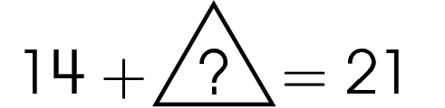

A. 7
B. 14
C. 35

Commentary:
This multiple-choice question asks students to select a number that makes the number sentence true. Answer choice A is correct because 7 will produce a true sentence when it is substituted in the given equation (14 + 7 = 21).

Answer choice B is incorrect because 14 + 14 = 28 and does not equal 21. Answer choice C is also incorrect because 14 + 35 = 49 and it does not equal 21.

The complexity level of this question is Moderate Complexity. This question requires students to use problem-solving strategies.

Performance Data:
The percent of public school students selecting answer choice A for question 3 on the May 2007 Grade 3 Achievement Test was 97%.

Keywords: algebra, number sentence

BACK TO INDEX

Benchmark: E | Use variables to create and solve equations representing problem situations.
GLI: PFA 3.4 | Model problem situations using objects, pictures, tables, numbers, letters and other symbols.

Multiple Choice Question:

12. Laura baked 36 cookies. Her brother Sam ate n cookies.
Which expression represents the number of cookies Laura has left?

- n – 36
- 36 – n
- 36 ÷ n

Commentary:
This multiple-choice question asks students to select an expression that represents a given situation. The situation is described in words and students have to select its equivalent representation using numbers and symbols. Answer choice B, 36 – n, is the correct answer because it shows the number of cookies that Sam ate is being subtracted from 36 cookies that Laura baked.

Answer choices A and C are incorrect because they illustrate an incorrect representation for finding the number of cookies left. Answer choice A, n – 36, shows the number of cookies baked is being subtracted from the number of cookies eaten. Answer choice C, 36 n, shows that 36 cookies were equally shared between n people.

The complexity level of this question is Moderate Complexity. This question requires students to select a different representation depending on the situation.

Performance Data:
The percent of public school students selecting answer choice B for question 12 on the May 2007 Grade 3 Achievement Test was 72%.

Keywords: algebra, expression, variable.

BACK TO INDEX

Benchmark: A | Analyze and extend patterns, and describe the rule in words.
GLI: PFA 3.1 | Extend multiplicative and growing patterns, and describe the pattern or rule in words.

Short Answer Question:

15. What number comes next in this pattern?
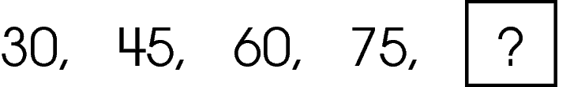
Describe the rule.
________________________________________________
________________________________________________

Commentary:
This short-answer question asks students to extend, and describe the rule for the pattern. A response earning the maximum number of points (2points) shows an understanding of analyzing and extending the pattern and describing the rule for the pattern. The response provides the next number, the pattern, and states the correct rule. To solve this problem students have to decide whether the pattern is increasing or decreasing. Since it is increasing, students need to determine the amount of increase from term to term and operation being used in the pattern. Students will check if this rule works for all given terms in a pattern. After that students need to use their rule for finding the next term in the pattern.

The complexity level of this question is High Complexity. This task requires students to extend a pattern and generate a rule for it.

Performance Data:
The percent of public school students earning each score point for question 15 on the May 2007 Grade 3 Achievement Test:

Percent at Each Score Point
0 | 1 | 2
21% | 36% | 43%

Scoring Guidelines:
Exemplar Response:

- 90. Add 15.
Other Correct Response(s):

Points | Student Response
2 point text | The response shows an understanding of analyzing and extending patterns and describing the rule in words. The response provides the next number, 90, and states a correct rule.
1 point text | The response shows a partial understanding of analyzing and extending patterns and describing the rule in words; however, the solution is incomplete or slightly flawed.
1 point text | 1 point sample answer:  For example, the response may:  - Provide the next number and an incorrect rule or no rule.  - State the correct rule but not find the correct next number.
0 point text | The response shows minimal or no understanding of analyzing and extending patterns and describing a rule in words.
0 point text | 0 point sample answer:  For example, the response may:  - Provide an incorrect missing number AND an incorrect rule.  - Describe the pattern as a repeating pattern (e.g., 30, 45, 60, 75, 30, because it starts over).

Keywords: algebra, rule, pattern

BACK TO INDEX

Benchmark: A | Analyze and extend patterns, and describe the rule in words.
GLI: PFA 3.1 | Extend multiplicative and growing patterns, and describe the pattern or rule in words.

Multiple Choice Question:

- A pattern is shown.
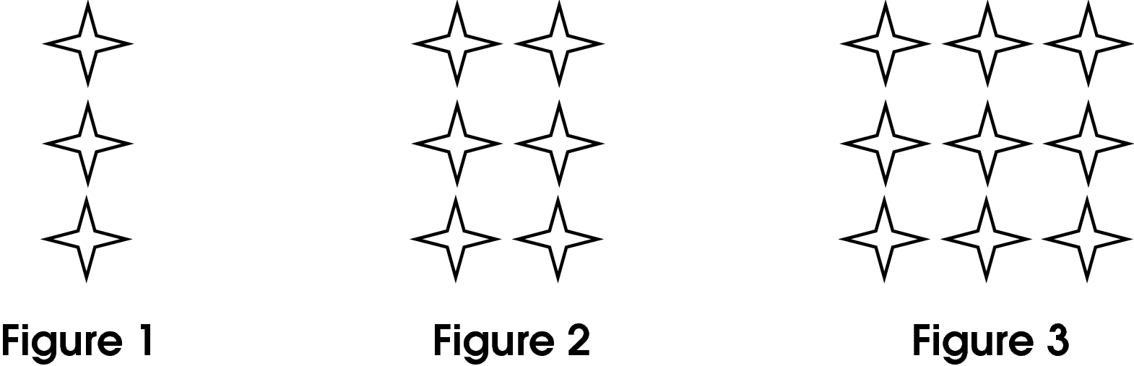
How many stars will Figure 4 have?

- 4
- 9
- 12

Commentary:
This multiple-choice question asks students to extend a pattern to find the number of stars in the next figure. Students need to recognize that the pattern is adding a column of 3 stars to the previous figure. Figure 2 is built by adding a column of three stars to Figure 1 (3 + 3 = 6 stars). Figure 3 is built by adding another column of three stars to Figure 2 (6 + 3 = 9 stars). So, Figure 4 will be built by adding one more column of three stars (9 + 3 = 12 stars) to Figure 3. Answer choice C is correct.

Students who selected answer choice A may have selected the number of columns of stars in Figure 4 instead of the total number of stars. Students who selected answer choice B may have found the number of stars in Figure 3.

The complexity level of this question is Moderate Complexity. This question requires students to extend a pattern.

Performance Data:
The percent of public school students selecting answer choice C for question 28 on the May 2007 Grade 3 Achievement Test was 88%.

Keywords: algebra, pattern, rule

BACK TO INDEX

Benchmark: F | Construct and use a table of values to solve problems associated with mathematical relationships.
GLI: PFA 3.7 | Create tables to record, organize and analyze data to discover patterns and rules.

Multiple Choice Question:

34. A table is shown.
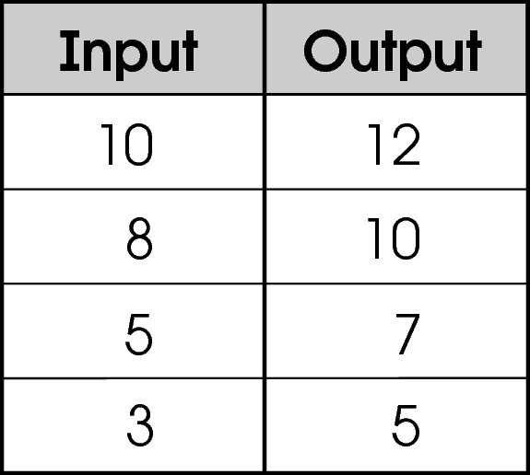
Which rule was used to find the output for each input?

- add 2 to input
- multiply input by 2
- subtract 2 from input

Commentary:
This multiple-choice question asks students to recognize the rule that describes the relationship between the input values and the output values shown in the table. The rule for the table can be found by looking at pairs of numbers such as 10 and 12 in the first row, 8 and 10 in the second row and 5 and 7 in the third row. Students may notice that each output value is 2 more than corresponding input value. Therefore, the correct rule is to “add 2 to input”. The correct answer choice is A.
The rule for answer choice B will multiply the input values by two making each output value twice the input value which makes answer choice B incorrect.
Students choosing answer choice C have found the rule for going from the output to the input instead of input to output making answer choice C incorrect.

The complexity level of this question is Low Complexity. This question asks students to retrieve information from the table.

Performance Data:
The percent of public school students selecting answer choice A for question 34 on the May 2007 Grade 3 Achievement Test was 72%.

Keywords: algebra, input, output, table, rule

BACK TO INDEX

Benchmark: C | Write and solve open sentences and explain strategies.
GLI: PFA 3.5 | Write, solve and explain simple mathematical statements, such as: 7 + □ > 8 or ∆ + 8 = 10.

Multiple Choice Question:

8. Which number makes this statement true?
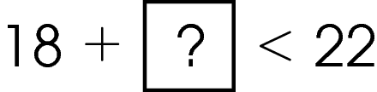

  - 3
  - 8
  - 14

Commentary:
This multiple-choice question asks students to solve a simple mathematical statement. This open sentence reads that 18 plus some number is “less than” (< ) 22. Students need to know how to find the missing number using various strategies. One strategy is counting on by ones from 18 to 21 (19, 20, and 21). Since three ones were added to 18, 3 would be the value that would make this inequality true, so answer choice A is correct.

Answer choice B is incorrect because 18 + 8 = 26 and 26 is greater than 22. Answer choice C is incorrect since 18 + 14 = 32 and 32 is greater than 22.

The complexity level of this question is Moderate Complexity. This question requires students to choose a strategy to solve an open sentence.

Performance Data:
The percent of public school students selecting answer choice A for question 8 on the May 2008 Grade 3 Achievement Test was 81%.

Keywords: algebra, open sentence, inequality

BACK TO INDEX

Benchmark: A | Analyze and extend patterns, and describe the rule in words.
GLI: PFA 3.1 | Extend multiplicative and growing patterns, and describe the pattern or rule in words.

Mathematical Processes
Benchmark: A | Use mathematical language to explain and justify mathematical ideas, strategies and solutions.

Extended Response Question:

10. A plant is 12 inches tall today. The plant grows three inches more each week.

Complete the table below showing the plant’s height over the next three weeks.
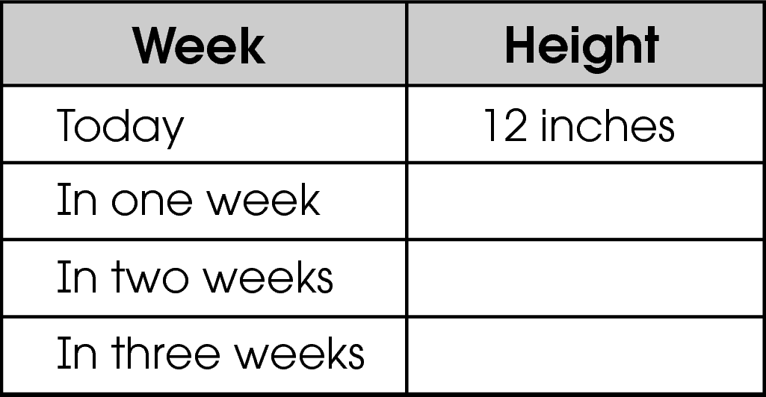I

If this growth pattern continues, how many inches tall will the plant be in five weeks?

________________________
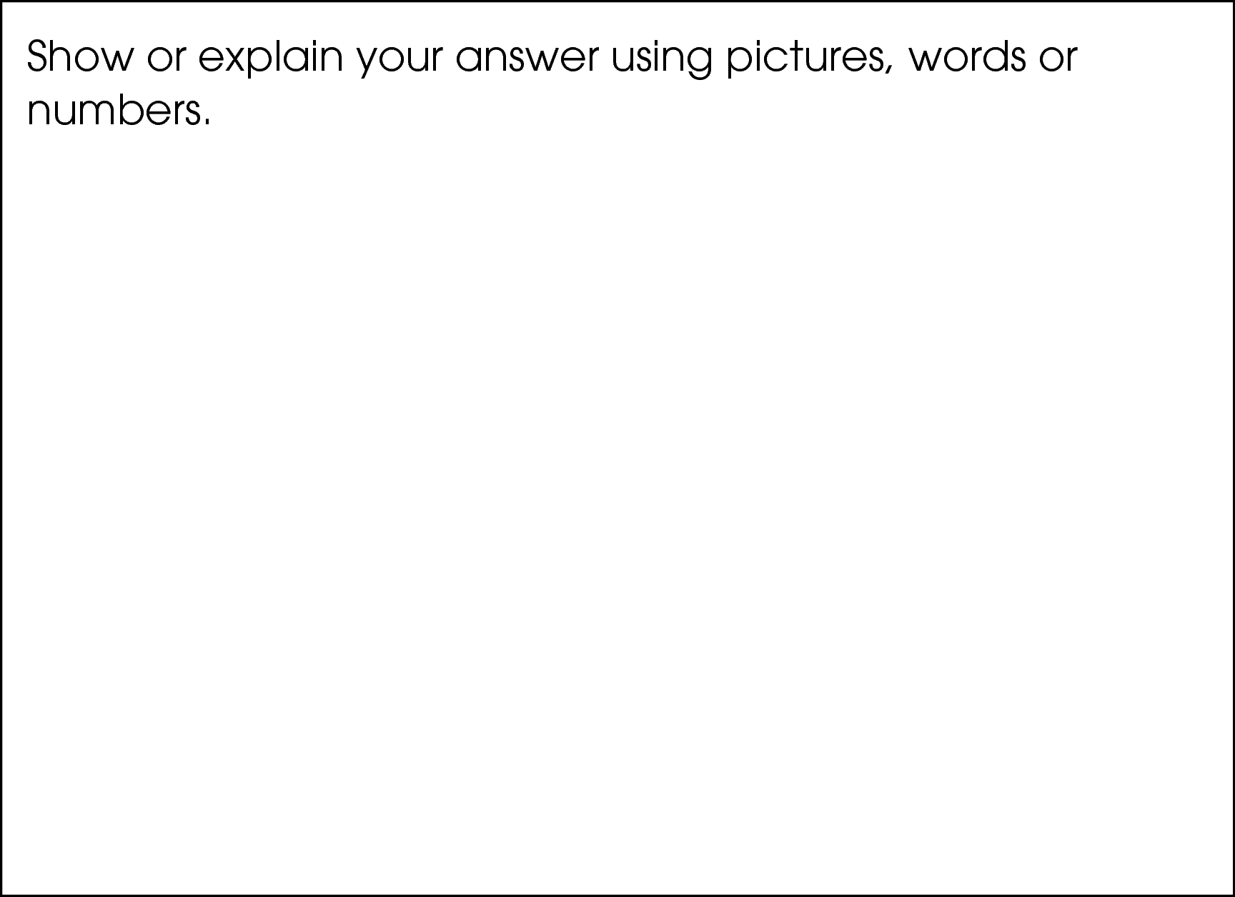
If this growth pattern continues, in how many weeks will the plant be 36 inches tall?

Commentary:
This extended-response question asks students to extend a pattern and provide explanations for their work. A response earning the maximum number of points (4 points) includes the correct height for the plant after Weeks 1, 2, 3 and 5 with adequate supporting work and the correct number of weeks when the plant will be 36 inches tall with adequate supporting work. The correct heights that complete the table are: 12 + 3 = 15 inches (In one week),
15 + 3 = 18 inches (In two weeks), and 18 + 3 = 21 inches (In three weeks). Students should use 24, the height of the plant in four weeks (21 + 3 = 24 inches), to calculate the height in five weeks (24 + 3 = 27 inches). Students can continue to extend this growth pattern to find the number of weeks when the plant will be 36 inches tall: 27 + 3 = 30 inches (In six weeks),
30 + 3 = 33 inches (In seven weeks) and 33 + 3 = 36 inches (In eight weeks).

The complexity level of this question is High Complexity. This task requires students to extend a pattern and justify a solution to a problem.

Performance Data:
The percent of public school students earning each score point for question 10 on the May 2008 Grade 3 Achievement Test:

Percent at Each Score Point
0 | 1 | 2 | 3 | 4
25% | 9% | 13% | 16% | 36%

Scoring Guidelines:
Points | Student Response
4 | The response shows:  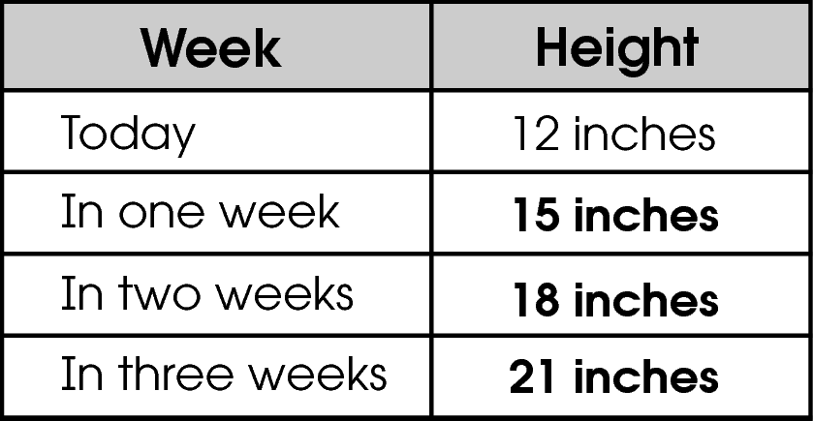  - 27 inches or 27  - a strategy that would lead to the correct response of 27  - 8 weeks or 8 (or 3 weeks with work showing calculation from the fifth week) based on previous work  - a strategy that would lead to the correct response of 8 weeks (3 weeks) based on previous work.
3 | The response correctly completes the table and all bullets.
2 | The response correctly completes the table and 3 bullets.  OR  The response correctly completes 0-2 table entries and all 4 bullets.
1 | The response correctly completes the table and 1 or 2 bullets.  OR  The response correctly completes 0-2 table entries and 2 or 3 bullets.
0 | The response correctly completes 1 bullet.  OR  The response correctly completes 2 table entries.

Keywords: pattern, rule, table

BACK TO INDEX

Benchmark: B | Use patterns to make predictions, identify relationships, and solve problems.
GLI: PFA 4.1 | Use models and words to describe, extend and make generalizations of patterns and relationships occurring in computation, numerical patterns, geometry, graphs and other applications.

Multiple Choice Question:

31. The table shows the height of a candle that is burning.
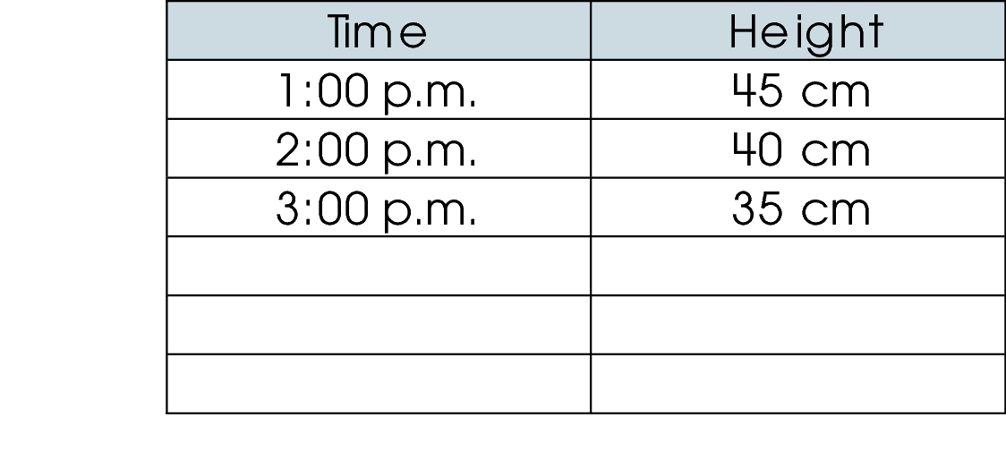
If the pattern continues, what will the height of the candle be at 5:00 p.m.?
  - 30 cm
  - 25 cm
  - 20 cm

Commentary:
This multiple-choice question asks students to predict the height of a candle at a future time by identifying the pattern in a table. Students need to identify the increasing pattern in the Time column and the decreasing pattern in the Height column. They should also determine the relationship between Time and Height: For every hour that the candle burns the height of the candle decreases by 5 cm. Answer choice B is correct since the height of the candle at
4:00 p.m. will be 30 cm (35 cm – 5 cm = 30 cm) and the height of the candle at 5:00 p.m. will be 25 cm (30 cm – 5 cm = 25 cm). A time of 5:00 p.m. and a height of 25 cm would correctly complete the fifth row of the table.

Answer choice A is incorrect because it shows the candle’s height of 30 cm (35 cm – 5 cm) at 4:00 p.m. and not at 5:00 p.m. Answer choice C is incorrect because a time of 6:00 p.m. and a height of 20 cm (25 cm – 5 cm) would complete the sixth row of the table.

The complexity level of this question is Moderate Complexity. Students are asked to identify and extend patterns.

Performance Data:
The percent of public school students selecting answer choice B for question 31 on the May 2008 Grade 3 Achievement Test was 74%.

Keywords: pattern, prediction

BACK TO INDEX

Benchmark: F | Construct and use a table of values to solve problems associated with mathematical relationships.
GLI: PFA 3.7 | Create tables to record, organize and analyze data to discover patterns and rules.

Multiple Choice Question:

41. Marsha reads 5 pages from her book every night.
Which table shows the total number of pages Marsha has read in her book at the end of each night?

A.
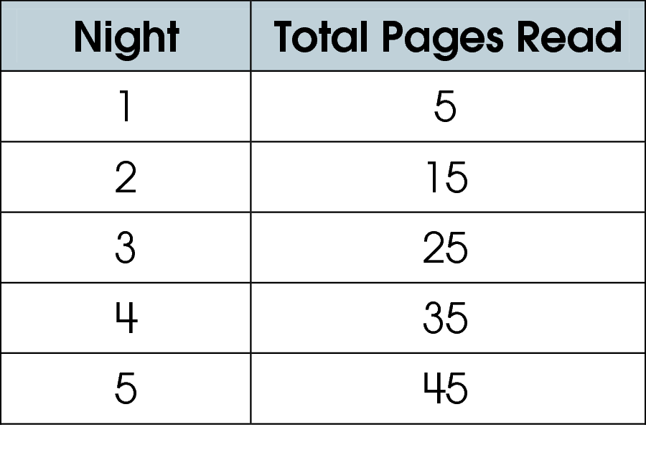

B.
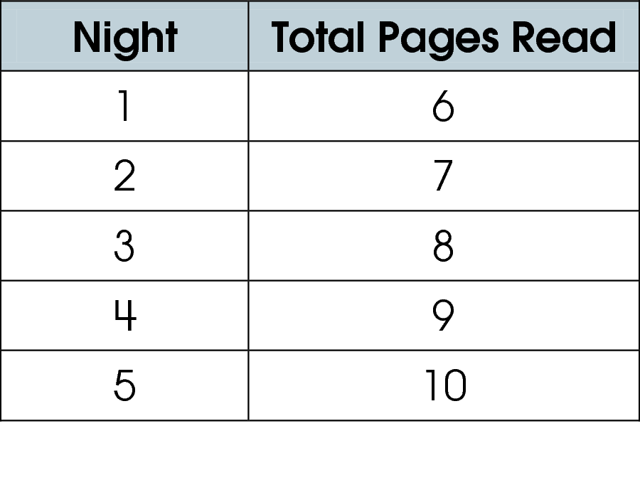

C.
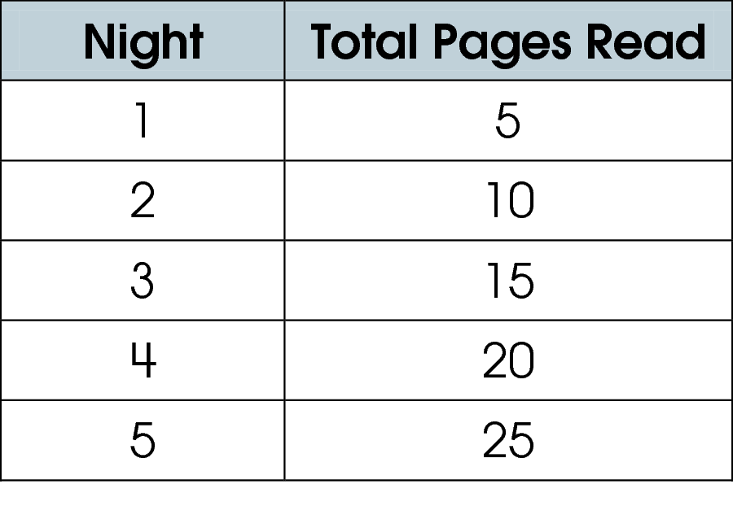

Commentary:
This multiple-choice question asks students to identify the table that shows the correct relationship between the nights that Marsha reads 5 pages and the total number of pages read in the book at the end of each night. Students need to understand that the table should display growing or increasing patterns in each column. Marsha reads every night so the number of nights would increase. Since she reads 5 pages every night, the number of pages read would increase by 5 every night. So, answer choice C is the correct answer as the nights increase by 1 the total pages read increase by 5.

Answer choice A is incorrect because the values in the Total Pages Read column start at 5 and increase by 10, showing that 10 pages were read every night starting at night 2. Answer choice B is incorrect because the total pages read increased by 1 page each night instead of 5 pages each night.

The complexity level of this question is Moderate Complexity. Students are asked to extend a pattern.

Performance Data:
The percent of public school students selecting answer choice C for question 41 on the May 2008 Grade 3 Achievement Test was 86%.

Keywords: pattern, rule, table

BACK TO INDEX

