Index to Questions

Question Number | Source | BM | GLI | Description
7 | OAT Mar 06 | I | NNS 5.13 | This multiple-choice question asks students to find a reasonable estimate of a given amount.
10 | OAT Mar 06 | B | NNS 5.3 | This short-answer question asks students to determine the store with the best sale.
20 | OAT Mar 06 | I | NNS 5.13 | This extended-response question asks students to determine the reasonableness of an estimate.
23 | OAT Mar 06 | E | NNS 5.9 | This multiple-choice question asks students to simplify a numeric expression.
26 | OAT Mar 06 | I | NNS 5.13 | This multiple-choice question asks students to find a reasonable estimate for the number of paintings in each room of a museum.
28 | OAT Mar 06 | A | NNS 5.6 | This multiple-choice question asks students to select the temperature that is shown on the given thermometer.
35 | OAT Mar 06 | D | NNS 5.1 | This multiple-choice question asks students to find the ratio of cats to dogs from the picture of 6 cats and 9 dogs.
37 | OAT Mar 06 | I | NNS 5.13 | This multiple-choice question asks students to determine a reasonable estimate for the total amount of pounds of two meats.
40 | OAT Mar 06 | B | NNS 5.2 | This multiple-choice question asks students to determine the fraction that can be used to simplify the given fraction.
46 | OAT Mar 06 | I | NNS 5.7 | This multiple-choice question asks students to select a numerical expression that is equivalent to the given expression.
2 | OAT May 07 | I | NNS 5.4 | This multiple-choice question asks students to round a decimal to the nearest tenth.
14 | OAT May 07 | A | NNS 5.6 | This multiple-choice question asks students to identify the number with the least value that is marked on a number line consisting of positive and negative numbers.
28 | OAT May 07 | D | NNS 5.1 | This multiple-choice question asks students to choose the number that represents the shaded part of the rectangle shown.
32 | OAT May 07 | B | NNS 5.3 | This multiple-choice question asks students to find the fraction that is equivalent to the given percent.
Question Number | Source | BM | GLI | Description
42 | OAT May 07 | H (3-4) | NNS 3.10a | This short-answer question asks students to write two number sentences using different operations for a problem situation.
46 | OAT May 07 | I | NNS 5.7 | This multiple-choice question asks students to select a numerical expression to represent the given problem situation.
1 | OAT May 08 | D | NNS 5.1 | This multiple-choice question asks students to find the ratio of black marbles to the total number of marbles using the picture of 3 black marbles and 5 white marbles.
10 | OAT May 08 | B | NNS 5.3 | This extended-response question asks students to first write a fraction and a percent that represents the number of desks in Row 1 as shown in the picture.
27 | OAT May 08 | A | NNS 5.6 | This multiple-choice question asks students to identify the number represented on a number line by the designated point G.
39 | OAT May 08 | I | NNS 5.4 | This multiple-choice question asks students to determine the length which could have been rounded to a specified length.

BACK TO INDEX

Benchmark: I | Use a variety of strategies, including proportional reasoning, to estimate, compute, solve and explain solutions to problems involving integers, fractions, decimals and percents.
GLI: NNS 5.13 | Estimate the results of computations involving whole numbers, fractions and decimals, using a variety of strategies.

Multiple Choice Question:

7. Peggy sold a total of 6,198 vanilla and chocolate ice cream cones during the carnival. About half the cones she sold were vanilla.
Which estimate is reasonable for the number of chocolate ice cream cones sold?
A. 2,500
B. 3,000
C. 3,500
D. 6,000

Commentary:
This multiple-choice question asks students to find a reasonable estimate of a given amount. Students are finding an estimate for half of 6,198.

6,198 is close to 6,000.
Half of 6,000 is 3,000.

Answer choice B, 3,000, is a reasonable estimate. Answer choice A is incorrect because the estimate is too low and the estimates in answer choices C and D are too high.

The complexity level of this question is Low Complexity. This question requires students to perform a specified procedure.

Performance Data:
The percent of public school students selecting answer choice B for question 7 on the March 2006 Grade 5 Achievement Test was 67%.

Keywords: number, number sense, estimation

BACK TO INDEX

Benchmark: B | Compare, order and convert among fractions, decimals and percents.
GLI: NNS 5.3 | Identify and generate equivalent forms of fractions, decimals and percents.

Mathematical Processes
Benchmark: I | Select, apply, and translate among mathematical representations to solve problems; e.g., representing a number as a fraction, decimal or percent as appropriate for a problem.

Short Answer Question:

- Maria found the same pair of shoes on sale at three different stores. All the stores have the same original price. The first store has the shoes on sale for $\frac{1}{3}$ off. The second store has them on sale for 20% off. The third store has them on sale for one-fourth off.
In your Answer Document, determine which store has the best sale for the shoes. Explain your answer, using pictures, numbers or words. (2 points)

Commentary:
This short-answer question asks students to determine the store with the best sale. The amount off for the sale is given in fraction or percent form. A response earning the maximum number of points (2 points) provides the correct store with the best sale based on the greatest discount and provides supporting work or an adequate explanation. Students need to convert each representation to the same form (all fractions or all decimals or all percents) and make a comparison to determine the store with the best sale. For example, converting the fractions to percents,

$\frac{1}{3}$ is 33$\frac{1}{3}$% and $\frac{1}{4}$is 25%. After putting the percents in order from greatest to least (33$\frac{1}{3}$%, 25%, 20%), students can determine the store with the greatest discount. The store with the best sale based on the greatest discount is the first store with $\frac{1}{3}$ off or 33$\frac{1}{3}$% off.

The complexity level of this question is Moderate Complexity. This task requires students to select and use different representations of numbers to solve a problem.

Performance Data:
The percent of public school students earning each score point for question 10 on the March 2006 Grade 5 Achievement Test:

Percent at Each Score Point
0 | 1 | 2
44% | 29% | 26%

Scoring Guidelines:
Sample Correct Response(s):
- Store 1 = 33 $\frac{1}{3}$ % or 33% off, Store 2 = 20% off, Store 3 = 25% off. Store 1 gives the most off, because it has the largest percent off.
- Store 1 = $\frac{1}{3}$ off, Store 2 = $\frac{1}{5}$ off and Store 3 = $\frac{1}{4}$ off. Store 1 gives the most off because it has the largest fraction.
- Store 1 = .3$\overline{3}$ or 0.33 off, Store 2 = .20 off, Store 3 = .25 off. Store 1 gives the most off, because it has the largest decimal.
Points | Student Response
2 | The focus of this task is identifying and generating equivalent forms of fractions, decimals or percents. The response correctly converts the numbers to the same form (all fractions or all decimals or all percents), OR correctly compares the amounts off with adequate evidence AND chooses the first store as having the best sale.
1 | The response provides partial evidence of identifying and generating equivalent forms of fractions, decimals or percents; however, the solution may be incomplete or slightly flawed.  For example, the response may:  - Provide correct conversions of the numbers to the same form without an explanation.  - Provide correct store with no supporting work.  - Provide incorrect conversions of one of the numbers, but find the best sale based on the incorrect calculation.
0 | The response provides inadequate evidence of identifying and generating equivalent forms of fractions, decimals or percents. The response provides major flaws in reasoning or irrelevant information.  For example, the response may:  - Compare two stores, without identifying correct store.  - Be blank or state unrelated statements.  - Recopy information from the stem.

Keywords: numbers, percents, fractions, equivalent representations

BACK TO INDEX

Benchmark: I | Use a variety of strategies, including proportional reasoning, to estimate, compute, solve and explain solutions to problems involving integers, fractions, decimals and percents.
GLI: NNS 5.13 | Estimate the results of computations involving whole numbers, fractions and decimals, using a variety of strategies.

Extended Response Question:

- The diagram shows how far it is from Anna’s home to her school, from her school to the library, and from the library to her home.
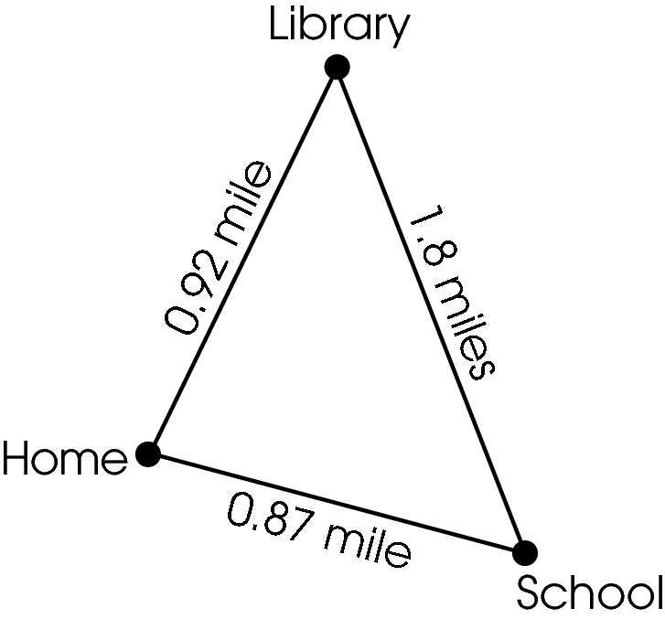
Each school day, Anna rides her bike from her home to her school. After school, she rides to the library and then home. On Saturday, Anna rides her bike from home to the library and back home. She does not ride her bike on Sunday. Anna’s mother says that her daughter rides about 30 miles every week between her home, the school and the library.
In your Answer Document, use estimation to determine whether Anna’s mother has made a reasonable estimate. Show or explain your work. (4 points)

Commentary:
This extended-response question asks students to determine the reasonableness of an estimate. The response earning the maximum number of points (4 points) provides an estimation strategy that determines the reasonableness of a given estimate with supporting work or an adequate explanation. Students need to first determine an estimate of the distance from home to school, from school to the library, and then from the library to home for 5 days and an estimate of the distance from home to the library and then home for 1 day. Then, students need to determine if the estimate made by the mother is reasonable. For example, each distance can be rounded to the nearest whole mile.

From home to school is 0.87 which is about 1 mile.
From school to the library is 1.8 which is about 2 miles.
From the library to home is 0.92 which is about 1 mile.

The distance from home to school, from school to the library, and then from the library to home is about 4 miles (1 + 1 + 2 = 4 miles) for 1 day. The total distance for the school week is about 20 miles (4 miles per day × 5 days = 20 miles). On Saturday, the distance from home to the library and then from the library to home is about 2 miles (1 + 1 = 2 miles). The total distance for Anna riding her bike every week is about 22 miles (20 + 2 = 22 miles). The mother’s estimate of 30 miles is not a reasonable estimate because 22 miles is closer to 20 miles than 30 miles.

The complexity level of this question is Moderate Complexity. This task requires students to retrieve information from a chart and use it to solve a problem.

Performance Data:
The percent of public school students earning each score point for question 20 on the March 2006 Grade 5 Achievement Test:

Percent at Each Score Point
0 | 1 | 2 | 3 | 4
58% | 20% | 10% | 6% | 5%

Scoring Guidelines:
Sample Correct Response(s):
- 0.87 is almost 1 mile
1.8 is almost 2 miles
0.92 is almost 1 mile
1 + 2 + 1 = 4; 4 x 5 = 20 miles
0.92 is almost 1 mile
1 x 2 = 2; 20 + 2 = 22 miles
Total for the week is 22 miles.
Her mother’s estimate is not reasonable because 22 is less than 30.

Points | Student Response
4 | The focus of this task is using an estimation strategy to solve a problem and determine the reasonableness of the result. The response provides a reasonable estimate for the number of miles biked from Monday through Saturday with an adequate explanation or supporting work. The response also gives an adequate explanation of the reasonableness of the mother’s estimate.  NOTE: Rounding distances to nearest tenth is an acceptable estimation strategy.
3 | The response provides adequate evidence of using an estimation strategy to solve a problem and determine the reasonableness of the result; however, the solution may be incomplete or slightly flawed.  For example, the response may:  - Provide an accurate estimate for the total miles biked in 6 days without support, AND the explanation of the reasonableness of the mother’s estimate is correct.  - Provide work with an error in the estimation strategy AND provide an explanation of the reasonableness of the mother’s estimate that is based on that error.
2 | The response provides partial evidence of using an estimation strategy to solve a problem and determine the reasonableness of the result; however, the solution may be incomplete or slightly flawed.  For example, the response may:  - Provide an accurate estimate with supporting work, but the explanation of the reasonableness of the mother’s estimate is missing or incorrect.  - Provide a correct estimate for an incorrect number of days and an explanation of the reasonableness of the mother’s estimate that is based on that error.
1 | The response provides minimal evidence of using an estimation strategy to solve a problem and determine the reasonableness of the result; however, the solution may be incomplete or slightly flawed.  For example, the response may:  - Provide exact, correct computation rather than an estimate, AND provide a correct explanation of the reasonableness of the mother’s estimate.  - Provide a correct estimate for one day with or without an explanation of the reasonableness for the mother’s estimate.
0 | The response provides inadequate evidence of using an estimation strategy to solve a problem and determine the reasonableness of the result. The response provides major flaws in reasoning or gives irrelevant information.  For example, the response may:  - Provide an exact calculation and rounds the result of that calculation without an explanation of the reasonableness of the mother’s estimation.  - Provide an exact calculation with no evidence of estimation.  - Show a total of 30 miles biked.  - Be blank or give unrelated statements.  - Recopy information from the stem.

Keywords: number, number sense, estimation, decimals

BACK TO INDEX

Benchmark: E | Use order of operations, including use of parentheses and exponents to solve multi-step problems, and verify and interpret the results.
GLI: NNS 5.9 | Use order of operations, including use of parentheses, to simplify numerical expressions.

Multiple Choice Question:

23. Simplify: 9 ÷ 3 + 6 × 5

- 5
- 6
- 33
- 45

do not copy or distribute ID: 8741; Version: 28

Commentary:
This multiple-choice question asks students to simplify a numeric expression. Students need to use order of operations since three different operations appear in the problem. Students should perform the division and multiplication in order from left to right and perform the addition last.

9 ÷ 3 + 6 × 5 = 3 + 6 × 5
= 3 + 30
= 33

Answer choice C is the correct answer. Order of operations was not used in answer choices A, B and D.

The complexity level of this question is Low Complexity. This question requires students to perform a specified procedure.

Performance Data:
The percent of public school students selecting answer choice C for question 23 on the March 2006 Grade 5 Achievement Test was 55%.

Keywords: number, order of operations

BACK TO INDEX

Benchmark: I | Use a variety of strategies, including proportional reasoning, to estimate, compute, solve and explain solutions to problems involving integers, fractions decimals and percents.
GLI: NNS 5.13 | Estimate the results of computations involving whole numbers, fractions and decimals, using a variety of strategies.

Multiple Choice Question:

26. There are 2,382 paintings in an art museum. The museum has 124 rooms.
Which is a reasonable estimate for the number of paintings in each room?
- 10
- 20
- 30
- 200

do not copy or distribute ID: 11310; Version: 7

Commentary:
This multiple-choice question asks students to find a reasonable estimate for the number of paintings in each room of a museum. Students need to use an estimation strategy and decide how to solve the problem. For example,
2,382 can be rounded to 2,400 and 124 can be rounded to 120. Then, students can divide 2,400 by 120 to find the number of paintings in the museum (2,400 ÷ 120 = 20 paintings).

Another estimation strategy is to use front-end estimation. For example,
2,000 can be used for 2,382 and 100 can be used for 124. To find the number of paintings in the museum, students can divide 2,000 by 100 (2,000 ÷ 100 = 20 paintings).

The number of paintings in answer choice B is a reasonable estimate.

The complexity level of this question is Moderate Complexity. This question requires students to use informal methods of reasoning and problem-solving.

Performance Data:
The percent of public school students selecting answer choice B for question 26 on the March 2006 Grade 5 Achievement Test was 39%.

Keywords: number, estimation

BACK TO INDEX
Benchmark: A | Represent and compare numbers less than 0 through familiar applications and extending the number line.
GLI: NNS 5.6 | Represent and compare numbers less than 0 by extending the number line and using familiar applications; e.g., temperature, owing money.

Multiple Choice Question:

28. Mary checked the outside temperature.
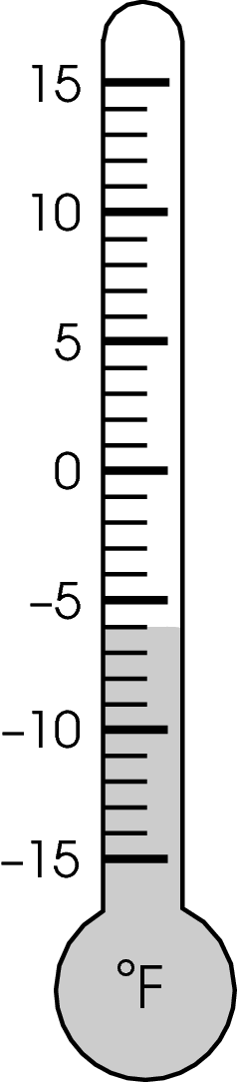
What temperature is shown on the thermometer?
A. –6°F
B. –4°F
C. 4°F
D. 6°F

Commentary:
This multiple-choice question asks students to select the temperature that is shown on the given thermometer. Students should recognize that the temperature is below 0°F, which means that the temperature is negative. This eliminates answer choices C and D which are positive temperatures or above 0°F. Answer choice A, -6°F, is the correct temperature because the shading goes with the line below -5°F. Answer choice B, -4°F, is incorrect since this temperature is above -5°F.

The complexity level of this question is Low Complexity. This question requires students to retrieve information from a thermometer.

Performance Data:
The percent of public school students selecting answer choice A for question 28 on the March 2006 Grade 5 Achievement Test was 57%.

Keywords: number, integers

BACK TO INDEX

Benchmark: D | Use models and pictures to relate concepts of ratio, proportion and percent.
GLI: NNS 5.1 | Use models and visual representation to develop the concept of ratio as part-to-part and part-to-whole, and the concept of percent as part-to-whole.

Multiple Choice Question:

35. John saw 6 cats and 9 dogs in the veterinarian’s waiting room.
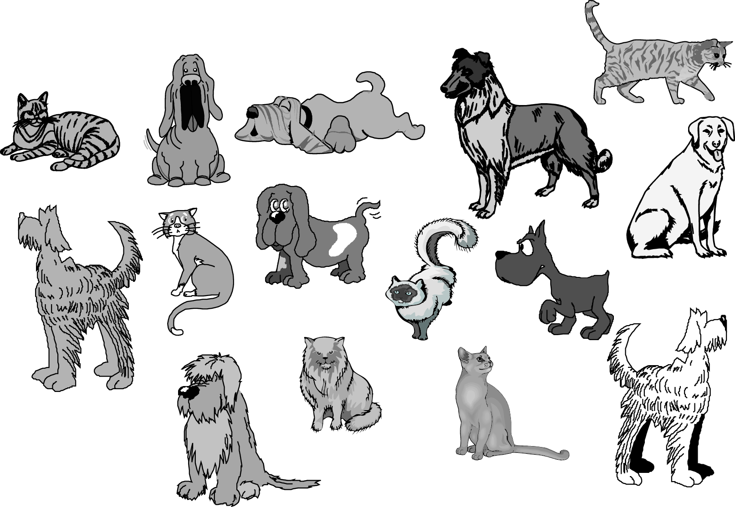
What is the ratio of cats to dogs?

A. 6:9
B. 6:15
C. 9:6
D. 9:15

Commentary:
This multiple-choice question asks students to find the ratio of cats to dogs from the picture of 6 cats and 9 dogs. Students are to compare the number of cats to the number of dogs. Answer choice A has the correct ratio of cats to dogs, 6:9. Answer choice C is incorrect because it has the ratio of dogs to cats. Answer choices B and D are incorrect because they have the ratios for the number of cats or dogs to total number of animals (15).
The complexity level of this question is Low Complexity. This question requires students to recognize an example of a concept.

Performance Data:
The percent of public school students selecting answer choice A for question 35 on the March 2006 Grade 5 Achievement Test was 71%.

Keywords: number, ratio

BACK TO INDEX

Benchmark: I | Use a variety of strategies, including proportional reasoning, to estimate, compute, solve and explain solutions to problems involving integers, fractions, decimals and percents.
GLI: NNS 5.13 | Estimate the results of computations involving whole numbers, fractions and decimals, using a variety of strategies.

Multiple Choice Question:

37. Russell bought 2 $\frac{1}{8}$ pounds of turkey and 3 $\frac{3}{4}$ pounds of roast beef to make sandwiches.
Which estimate is reasonable for the amount of meat he bought?

A. 4 pounds
B. 5 pounds
C. 6 pounds
D. 7 pounds

Commentary:
This multiple-choice question asks students to determine a reasonable estimate for the total amount of pounds of two meats. Students need to use an estimation strategy to determine the total amount in whole pounds. For example, 2$\frac{1}{8}$ pounds is close to 2 pounds and 3$\frac{3}{4}$ pounds is close to 4 pounds. The total amount of meat is 6 pounds. Answer choice C, 6 pounds, is a reasonable estimate. Answer choice A is incorrect because the estimate does not consider the number of pounds of turkey. Answer choices B is incorrect because the estimate does not consider the fractional pounds. Answer choice D is incorrect because the number of pounds was rounded to the next whole number without regard to how close the fractions were to the closest whole number.

The complexity level of this question is Low Complexity. This question requires students to perform a specified procedure.

Performance Data:
The percent of public school students selecting answer choice C for question 37 on the March 2006 Grade 5 Achievement Test was 57%.

Keywords: number, number sense, estimation

BACK TO INDEX

Benchmark: B | Compare, order and convert among fractions, decimals and percents.
GLI: NNS 5.2 | Use various forms of “one” to demonstrate the equivalence of fractions; e.g., $\frac{\text{18}}{\text{24}}=\frac{9}{\text{12}}$ x $\frac{2}{2}=\frac{3}{4}$x $\frac{6}{6}$.

Multiple Choice Question:
40. Which fraction should he use to simplify $\frac{9}{\text{12}}$ to lowest terms?
A. $\frac{2}{2}$
B. $\frac{3}{3}$
C. $\frac{9}{9}$
D. $\frac{\text{12}}{\text{12}}$

Commentary:
This multiple-choice question asks students to determine the fraction that can be used to simplify the given fraction. The fractions to choose from are equivalent forms of 1. Students can use several methods to find the fraction. Students can decompose the numbers in the numerator and denominator so that they have the greatest common factor (GCF). For example,

$\frac{9}{\text{12}}$ = $\frac{3×3}{3×4}$. The greatest common factor in the numerator and the denominator is 3. The fraction that can be used to simplify $\frac{9}{\text{12}}$ is$\frac{3}{3}$. Another method that can be used to find the fraction is to simplify $\frac{9}{\text{12}}$ by finding the greatest common factor (GCF) of the numerator and the denominator.

Factors of 9: 1, 3, 9
Factors of 12: 1, 2, 3, 4, 6, 12
Common factors of 9 and 12: 1, 3
Greatest common factor of 9 and 12: 3
Using the greatest common factor, the fraction used to simplify $\frac{9}{\text{12}}$ is$\frac{3}{3}$, answer choice B.
The fractions in answer choices A, C and D are incorrect because the numbers in the numerators and denominators are not common factors of both 9 and 12.

The complexity level of this question is Low Complexity. This question requires students to perform a specified procedure.

Performance Data:
The percent of public school students selecting answer choice B for question 40 on the March 2006 Grade 5 Achievement Test was 66%.

Keywords: number, fraction, lowest term, greatest common factor (GCF)

BACK TO INDEX

Benchmark: I | Use a variety of strategies, including proportional reasoning, to estimate, compute, solve and explain solutions to problems involving integers, fractions, decimals and percents.
GLI: NNS 5.7 | Use commutative, associative, distributive, identity and inverse properties to simplify and perform computations.

Multiple Choice Question:

46. Shelly’s photo album has 6 sections. Each section has 16 pages. Each page has 5 pictures. To find the total number of pictures in the album, Shelly needs to multiply
6 × 16 × 5.
Which other expression represents the total number of pictures in the album?
A. (6 × 16) + (6 × 5)
B. (6 + 16) + 5
C. (6 + 5) + (16 + 5)
D. 6 × 5 × 16

do not copy or distribute ID: 11292; Version: 7

Commentary:
This multiple-choice question asks students to select a numerical expression that is equivalent to the given expression. Students need the expression that has the same value
(6 x 16 x 5 = 480) as the given expression. The expression in answer choice D, 6 × 5 × 16, has the same value of 480. The order of the factors was changed, which is an application of the commutative property of multiplication. The expressions in answer choices A, B and C do not have the same value as 6 × 16 × 5.

The complexity level of this question is Moderate Complexity. This question requires students to represent a situation mathematically in another way.

Performance Data:
The percent of public school students selecting answer choice D for question 46 on the March 2006 Grade 5 Achievement Test was 54%.

Keywords: number, number system properties

BACK TO INDEX

Benchmark: I | Use a variety of strategies, including proportional reasoning, to estimate, compute, solve and explain solutions to problems involving integers, fractions, decimals and percents.
GLI: NNS 5.4 | Round decimals to a given place value and round fractions (including mixed numbers) to the nearest half.

Multiple Choice Question:

- Colleen ran a race in 27.28 seconds.

What is her time rounded to the nearest tenth of a second?

A. 27.0 seconds
B. 27.2 seconds
C. 27.3 seconds
D. 28.0 seconds

Commentary:
This multiple-choice question asks students to round a decimal to the nearest tenth. Students need to know that 27.28 is between 27.2 and 27.3 and determine if it is closer to 27.2 or 27.3.

Using a number line such as the one shown,
27.0
27.1
27.2
27.3
27.28

Students should see that 27.28 is closer to 27.3, answer choice C.

The estimate in answer choice B is incorrect because 27.2 is farther from 27.28 than 27.3. The estimates in answer choices A and D are incorrect because 27.0 and 28.0 are more than a tenth away from 27.28.

The complexity level of this question is Low Complexity. This question requires students to perform a specified procedure.

Performance Data:
The percent of public school students selecting answer choice C for question 2 on the May 2007 Grade 5 Achievement Test was 61%.

Keywords: number, decimals, estimation, rounding

BACK TO INDEX

Benchmark: A | Represent and compare numbers less than 0 through familiar applications and extending the number line.
GLI: NNS 5.6 | Represent and compare numbers less than 0 by extending the number line and using familiar applications; e.g., temperature, owing money.

Multiple Choice Question:

- Four numbers are marked with an X on this number line.
Which marked number is the least?

A. 20
B. -10
C. 5
D. 15

Commentary:
This multiple-choice question asks students to identify the number with the least value that is marked on a number line consisting of positive and negative numbers. Students should recall that negative numbers are less than 0 and positive numbers are greater than 0. They should also know that the number with the least value is the number farthest to the left on the number line. The least number marked on this number line is -20, answer choice A.

Although -10, answer choice B, is to the left of 0, it is not the farthest from 0; therefore, it is incorrect. Answer choices C and D are incorrect because they are positive numbers which are to the right of 0, and therefore, they are greater than -10 and -20.

The complexity level of this question is Moderate Complexity. This question requires students to interpret a visual representation.

Performance Data:
The percent of public school students selecting answer choice A for question 14 on the May 2007 Grade 5 Achievement Test was 81%.

Keywords: number, integers, number line

BACK TO INDEX

Benchmark: D | Use models and pictures to relate concepts of ratio, proportion and percent.
GLI: NNS 5.1 | Use models and visual representation to develop the concept of ratio as part-to-part and part-to-whole, and the concept of percent as part-to-whole.

Multiple Choice Question:

- Part of this rectangle is shaded.

Which number represents the shaded part of the rectangle?

A. 25%
B. 0.3
C. $\frac{1}{3}$
D. 75%

Commentary:
This multiple-choice question asks students to choose the number that represents the shaded part of the rectangle shown. Students should notice that the rectangle is divided into four equal parts with one part shaded. This means that $\frac{1}{4}$ of the rectangle is shaded. Answer choice A is correct since $\frac{1}{4}$ is equivalent to 0.25 and 25%.

Answer choice D is incorrect since it represents the unshaded parts of the rectangle. Students may have chosen answer choice C based on the three unshaded parts and the one shaded part of the rectangle. Answer choice B may have been chosen based on rounding the conversion of $\frac{1}{3}$ to a decimal.
The complexity level of this question is Moderate Complexity. This question requires students to interpret a visual representation.

Performance Data:
The percent of public school students selecting answer choice A for question 28 on the May 2007 Grade 5 Achievement Test was 80%.

Keywords: number, percent, part-to-whole

BACK TO INDEX

Benchmark: B | Compare, order and convert among fractions, decimals and percents.
GLI: NNS 5.3 | Identify and generate equivalent forms of fractions, decimals and percents.

Multiple Choice Question:

- Which fraction is equivalent to 40%?

A. 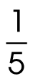

B. 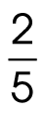
C. 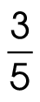
D. 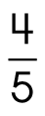
Commentary:
This multiple-choice question asks students to find the fraction that is equivalent to the given percent. Students need to know that the word percent means “out of 100.” Therefore, 40% is$\frac{\text{40}}{\text{100}}$. In simplest form, $\frac{\text{40}}{\text{100}}$ is $\frac{2}{5}$, answer choice B.

Answer choices A, C and D are incorrect since these fractions are equivalent to 20%, 60% and 80%, respectively.
The complexity level of this question is Low Complexity. This question requires students to recognize an equivalent representation.

Performance Data:
The percent of public school students selecting answer choice B for question 32 on the May 2007 Grade 5 Achievement Test was 59%.

Keywords: number, percents, fractions

BACK TO INDEX

Benchmark: H (3-4) | Use relationships between operations, such as subtraction as the inverse of addition and division as the inverse of multiplication.
GLI: NNS 3.10a | Explain and use relationships between operations, such as:  - relate addition and subtraction as inverse operations

Short Answer Question:

42. A class needs 64 brownies for a bake sale. Mike brings 28 brownies.
In your Answer Document, write two number sentences using different operations to find the number of brownies the class still needs for the bake sale. (2 points)

Commentary:
This short-answer question asks students to write two number sentences using different operations for a problem situation. The response earning the maximum number of points (2 points) provides two correct number sentences that use different operations. Addition and subtraction can be used to write the number sentences. For example, an addition number sentence for this situation is 36 + 28 = 64 and a subtraction number sentence is 64 – 28 = 36.

The complexity level of this question is Moderate Complexity. This question requires students to represent a situation mathematically in more than one way.

Performance Data:
The percent of public school students earning each score point for question 42 on the May 2007 Grade 5 Achievement Test:

Percent at Each Score Point
0 | 1 | 2
30% | 35% | 35%

Scoring Guidelines:
Exemplar Response:

- 28 + n = 64 and 64 – 28 = n, where n is the number of brownies still needed for the bake sale.
- 28 +  = 64 and 64 –  = 28.
- 64 – 28 = 36 and 28 + 36 = 64.

Points | Student Response
2 point text | The focus of this task is identifying and using relationships between operations to solve problems. The response provides two correct number sentences using different operations.
1 point text | The response provides partial evidence of identifying and using relationships between operations to solve problems; however, the solution may be incomplete or slightly flawed.
1 point text | 1 point sample answer:  For example, the response may:  - Provide one correct number sentence, but the other may be missing or have flaws.  - Provide two correctly related number sentences but have computational errors.
0 point text | The response provides inadequate evidence of identifying and using relationships between operations to solve problems. The response provides major flaws in reasoning or irrelevant information.
0 point text | 0 point sample answer:  For example, the response may:  - Provide number sentences that are incorrect, such as 64 × 28 and 28 × 64.  - Be blank or provide unrelated statements.  - Copy information from the stem.

Keywords: number, number sentence

BACK TO INDEX

Benchmark: I | Use a variety of strategies, including proportional reasoning, to estimate, compute, solve and explain solutions to problems involving integers, fractions, decimals and percents.
GLI: NNS 5.7 | Use commutative, associative, distributive, identity and inverse properties to simplify and perform computations.

Multiple Choice Question:

- A florist sells roses in bunches of 12. He sold four bunches and has 36 roses left at the end of the day.
Which expression represents the number of roses he had at the beginning of the day?

A. 4 + 12 + 36
B. 4 × 12 + 36
C. 4 + 12 – 36
D. 4 × 12 – 36

Commentary:
This multiple-choice question asks students to select a numerical expression to represent the given problem situation. Students need to understand the relationships between the problem situation and the operations needed to solve the problem. In this problem, each bunch of roses sold contains 12 roses. There would be 4 times 12 roses in four bunches. To find the number of roses at the beginning of the day, students need to add the number of roses left (36) to the number of roses sold (4 × 12). Therefore, 4 × 12 + 36, answer choice B, is the expression that represents this situation.

The expressions in answer choices A, C and D are incorrect because they do not represent this situation.

The complexity level of this question is Moderate Complexity. This question requires students to represent a situation mathematically.

Performance Data:
The percent of public school students selecting answer choice B for question 46 on the May 2007 Grade 5 Achievement Test was 49%.

Keywords: number, operations, numerical expression

BACK TO INDEX

Benchmark: D | Use models and pictures to relate concepts of ratio, proportion and percent.
GLI: NNS 5.1 | Use models and visual representation to develop the concept of ratio as part-to-part and part-to-whole, and the concept of percent as part-to-whole.

Multiple Choice Question:

1. This diagram represents Melvin’s marble collection.

What is the ratio of black marbles to total marbles?

A. 3:5
B. 3:8
C. 5:3
D. 8:3

Commentary:
This multiple-choice question asks students to find the ratio of black marbles to the total number of marbles using the picture of 3 black marbles and 5 white marbles. Students can use part-to-whole comparisons to identify that there is a ratio of 3 black marbles (part) to 8 marbles (whole). Answer choice B has the correct ratio of black marbles to total marbles, 3:8.

Answer choice A is incorrect because it is the ratio of black marbles to white marbles. Answer choice C is incorrect because it is the ratio of white marbles to black marbles. Answer choice D is incorrect because it is the ratio of total marbles to black marbles.

The complexity level of this question is Low Complexity. This question requires students to recognize an example of a concept.

Performance Data:
The percent of public school students selecting answer choice A for question 1 on the May 2008 Grade 5 Achievement Test was 76%.

Keywords: number, ratio

BACK TO INDEX
Benchmark: B | Compare, order and convert among fractions, decimals and percents.
GLI: NNS 5.3 | Identify and generate equivalent forms of fractions, decimals and percents.

Extended Response Question:

- Mrs. Garner’s classroom had 25 desks. They were arranged in 5 rows that each contained 5 desks.
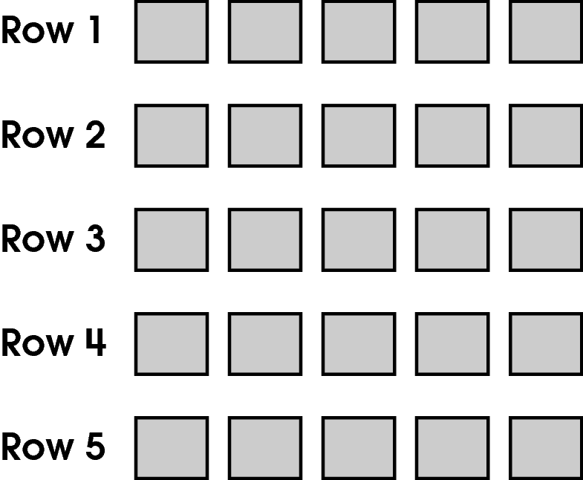
In your Answer Document, write the fraction of the desks that are in Row 1. Write this fraction as a percent. Show or explain your work.
Another classroom has between 15 and 22 desks with the same number of desks in each row. Row 1 has 25% of the desks in this classroom. Draw an arrangement of the desks in this classroom. How many desks are in Row 1? (4 points)

Commentary:
This extended-response question asks students to first write a fraction and a percent that represents the number of desks in Row 1 as shown in the picture. Then, students are asked to draw an arrangement of desks between 15 and 25 so that Row 1 now has 25% of the desks with the same number of desks in each row. A response earning the maximum number of points (4 points) provides the fraction and percent of desks in Row 1 out of the 25 desks. The response also provides a drawing representing an arrangement of desks between 15 and 22 with the same number of desks in each row where Row 1 has 25% of the desk and provides the number of desks in Row 1. Students need to know that the word percent means “out of 100.” 5 Row 1 has 5 desks out of a total of 25 desks. The fraction would be$\frac{5}{\text{25}}$. To change this fraction to a percent, students can multiply the numerator and denominator by 4 ($\frac{5}{\text{25}}$×$\frac{4}{4}$=$\frac{\text{20}}{\text{100}}$). The percent for $\frac{\text{20}}{\text{100}}$ is 20%.

To draw the arrangement of desks, students need to know the total number of desks in the classroom so that Row 1 has 25% or one-fourth of the number of desks. Since the total number of desks is between 15 and 22, the total number of desks must be divisible by 4 without a remainder. Row 1 could have 4 desks in each row for a total of 16 desks or 5 desks in each row for a total of 20 desks.

The complexity level of this question is High Complexity. The problem requires students to perform a procedure having multiple steps and multiple decision points.

Performance Data:
The percent of public school students earning each score point for question 10 on the May 2008 Grade 5 Achievement Test:

Percent at Each Score Point
0 | 1 | 2 | 3 | 4
20% | 30% | 19% | 10% | 19%

Scoring Guidelines:
Exemplar Response:

- 5 out of 25 = $\frac{5}{\text{25}}$ = $\frac{1}{5}$
1 ÷ 5 = 0.20
0.20 × 100% = 20%
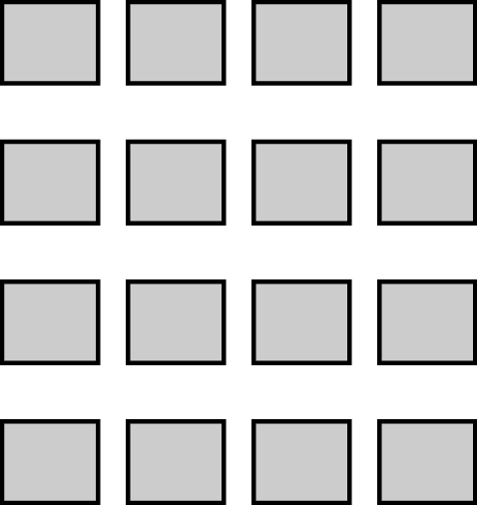
I have 4 desks in each row for a total of 16.
OR
$\frac{1}{4}$ of 20 = 5. I have 5 desks in each row for a total of 20 desks.
Points | Student Response
4 | The focus of this task is generating equivalent forms of fractions and percents. The response includes the correct fraction and percent for the number of desks that are in Row 1 out of 25 total desks. The response also provides a drawing representing an arrangement of desks for 25% of the desks between 15 and 22 and identifies the number of desks in row one.
3 | The response provides adequate evidence of generating equivalent forms of fractions and percents; however, the solution may be incomplete or slightly flawed.  For example, the response may:  - Provide a calculation error in one of the equivalent forms, but provide a correct drawing with a complete and correct explanation.  - Provide the correct equivalent forms and a complete drawing with a slight flaw.
2 | The response provides partial evidence of generating equivalent forms of fractions and percents; however, the solution may be incomplete or slightly flawed.  For example, the response may:  - Provide all the equivalent forms correctly, but does not provide an adequate drawing of the second classroom.  - Provide one form of 5 out of 25 and a correct drawing with an explanation.
1 | The response provides minimal evidence of generating equivalent forms of fractions and percents; however, the solution may be incomplete or slightly flawed.  For example, the response may:  - Provide only one equivalent form of 5 out of 25.  - Provide only a drawing showing 25% of the desks in Row 1.
0 | The response provides inadequate evidence of generating equivalent forms of fractions and percents. The response provides major flaws in reasoning or irrelevant information.  For example, the response may:  - State that 5% is an equivalent form.  - Be blank or state unrelated statements.  - Recopy information from the stem.
Keywords: number, fraction, percent

BACK TO INDEX

Benchmark: A | Represent and compare numbers less than 0 through familiar applications and extending the number line.
GLI: NNS 5.6 | Represent and compare numbers less than 0 by extending the number line and using familiar applications; e.g., temperature, owing money.

Multiple Choice Question:

27. Point G is shown on this number line.
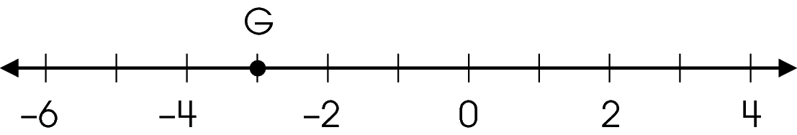
Which number does point G represent?

A. –5
B. –4$\frac{1}{2}$
C. –3
D. –2$\frac{1}{2}$

Commentary:
This multiple-choice question asks students to identify the number represented on a number line by the designated point G. Filling in the missing numbers on the number line can help students see that point G represents -3, answer choice C.

Answers choices A, B and D are incorrect. Students may have chosen answer choice A incorrectly thinking that -5 is to the right of -4 instead of the left of -4. Students may have chosen answer choices B and D incorrectly thinking that point G is half way between two numbers.

The complexity level of this question is Low Complexity. This question requires students to recognize an equivalent representation.

Performance Data:
The percent of public school students selecting answer choice C for question 27 on the May 2008 Grade 5 Achievement Test was 87%.

Keywords: number, number line, integer

BACK TO INDEX

Benchmark: I | Use a variety of strategies, including proportional reasoning, to estimate, compute, solve and explain solutions to problems involving integers, fractions, decimals and percents.
GLI: NNS 5.4 | Round decimals to a given place value and round fractions (including mixed numbers) to the nearest half.

Multiple Choice Question:

39. Cammie rounded a length to 3.37 meters.
Which length could be the actual length she measured?

A. 3.372 meters
B. 3.376 meters
C. 3.382 meters
D. 3.471 meters

Commentary:
This multiple-choice question asks students to determine the length which could have been rounded to a specified length. Students need to know place value for decimals. Students can eliminate the decimal in answer choice C (3.382) because the 8 in the hundredths is larger than the 7 in 3.37. The decimal in answer choice D (3.471) can also be eliminated because the 4 in the tenths place is larger that the 3 in the tenths place in 3.37. Students can then determine if 3.372 or 3.376 is closer to 3.37. Answer choice A is correct since 3.372 is closer to 3.37 than 3.376. 3.372 rounded to the nearest hundredth is 3.37.

The complexity level of this question is Low Complexity. The question requires students to recognize an example of a concept.

Performance Data:
The percent of public school students selecting answer choice A for question 39 on the May 2008 Grade 5 Achievement Test was 67 %.

Keywords: number, decimal, estimation, rounding

BACK TO INDEX

