Tree-Ring Dating
Age-Dating Trees By Counting Annual Rings
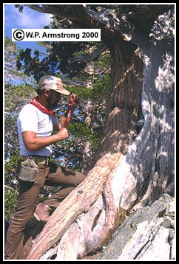

This remarkable tree was approximately 1400 years old, and grew on this rugged mountain ridge during the time of Mohammed, founder of the Moslem religion.
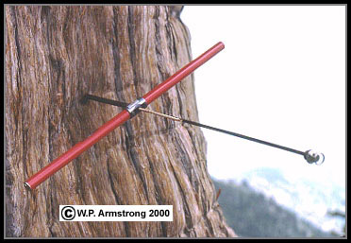
The increment borer removes a small cylinder or core of wood from the tree trunk. By counting the thin bands (annual rings) on the wood cylinder, the approximate age of the tree can be determined. Often the borer does not reach the center of the trunk, so the total number of years must be extrapolated from the radius of the trunk. The radius (r) can be determined from the circumference of the trunk (C=2πr), or from special tape measures that give the diameter directly.

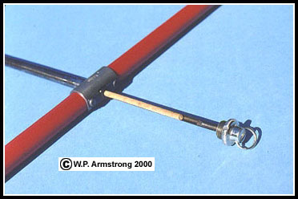
Close-up view of the increment borer, showing the slender wood core that is extracted from the trunk. The core is sanded and treated with a wood oil to make the rings more distinct. Since the rings are so close together, they must be counted under a dissecting microscope.

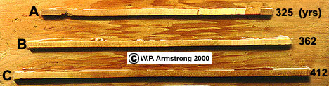
Three wood cylinders (cores) extracted from the trunk of an old Sierra juniper (Juniperus occidentalis var. australis). Core A has 325 rings, B has 362 rings and C has 412 rings. The rings are very close together and require magnification in order to count them. Due to the enormous size of the trunk, it was necessary to extrapolate the age based on the radius of the trunk. This ancient juniper was approximately 1400 years old, and grew on this mountain ridge during the time of Mohammed.
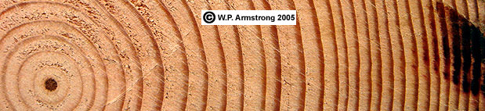
How many years of growth are represented in this block of Douglas fir wood (Pseudotsuga menziesii)? Count the dark center as one year.

Cross-Dating By Comparing Tree Ring Patterns
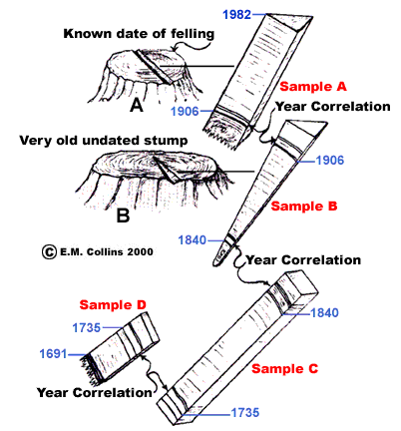
A tree was felled in 1982 giving rise to Stump A which dates back to 1906. The 1906 ring pattern in wood Sample A (which was cut from Stump A) correlates with a 1906 ring pattern in Sample B which was cut from an older, undated Stump B. Wood Sample B dates back to the year 1840. By matching up similar spaced rings in Samples B, C and D, the ages of ancient timbers can be determined. As long as the wood samples being compared have some ring patterns that coincide, time may be extended back through an unbroken succession of growth rings. In this example, wood Sample D dates back to the year 1691. This represents an unbroken succession of 291 annual rings, almost three centuries of time recorded in four small pieces of wood. Today, scientists have painstakingly established an unbroken succession of rings extending back in time over 80 centuries (8,000 years). Cross-dating is a valuable tool in dendrochronology and archaeology.

Lack Of Visible Annual Rings In Tropical Trees?
In the tropical rain forest, relatively few species of trees, such as teak, have visible annual rings. The difference between wet and dry seasons for most trees is too subtle to make noticeable differences in the cell size and density between wet and dry seasonal growth. According to Pascale Poussart, geochemist at Princeton University, tropical hardwoods have "invisible rings." She and her colleagues studied the apparently ringless tree (Miliusa velutina) of Thailand. Their team used X-ray beams at the Brookhaven National Synchrotron Light Source to look at calcium taken up by cells during the growing season. There is clearly a difference between the calcium content of wood during the wet and dry seasons that compares favorably with carbon isotope measurements. The calcium record can be determined in one afternoon at the synchrotron lab compared with four months in an isotope lab.

Name:_________________ Class Period:______ Date:__________

- How does an increment borer work?

- How many years of growth are represented in the block of Douglas fir wood on this page?

- Why do most tropical tree lack visible annual rings?

