Number, Number Sense, and Operations

Code | Grade Level Indicator | Ques #  w/  Answer | Question | State  %  Correct | District  %  Correct | Building  %  Correct
NNS 5.5 | Recognize and identify perfect squares and their roots. | 33  B | 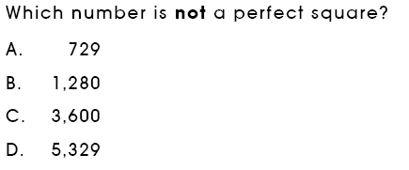 | 61%  A=19%  C=4%  D=16%
NNS 8.1 | Use scientific notation to express large numbers and small numbers between 0 and 1. | 26  D | 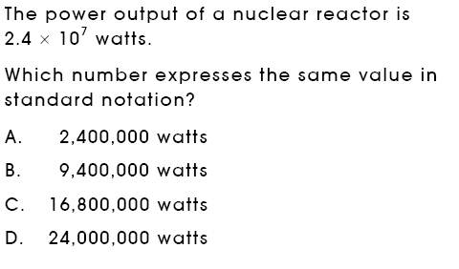 | 80%
NNS 8.1  NNS 8.8 | Use scientific notation to express large numbers and small numbers between 0 and 1.  Add, subtract, multiply, divide and compare numbers written in scientific notation. | 43  C | 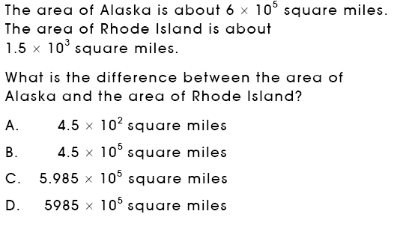 | 51%  A=31%  B=11%  D=7%
Number, Number Sense, and Operations

Code | Grade Level Indicator | Ques #  w/  Answer | Question | State  %  Correct | District  %  Correct | Building  %  Correct
NNS 8.2  NNS 7.3 | Recognize that natural numbers, whole numbers, integers, rational numbers and irrational numbers are subsets of the real number system.  Describe differences between rational and irrational numbers; e.g., use technology to show that some numbers (rational) can be expressed as terminating or repeating decimals and others (irrational) as non-terminating and non-repeating decimals. | 38  D | 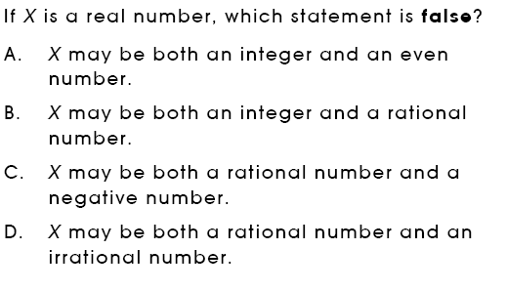 | 56%  A=12%  B=12%  C=20%
Number, Number Sense, and Operations

Code | Grade Level Indicator | Ques #  w/  Answer | Question | State  %  Correct | District  %  Correct | Building  %  Correct
NNS 8.6  NNS 9.4 | Estimate, compute and solve problems involving rational numbers, including ratio, proportion and percent, and judge the reasonableness of solutions.  Demonstrate fluency in computations using real numbers. | 4  SA | 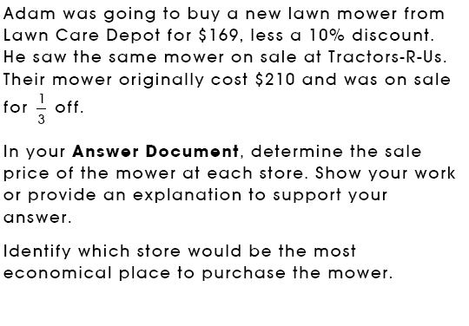 | 2pt=39%  1.5pt=6%  1pt=14%  .5pt=4%  0pt=33%  NR=4%
NNS 8.6  NNS 9.4 |  | 8  B | 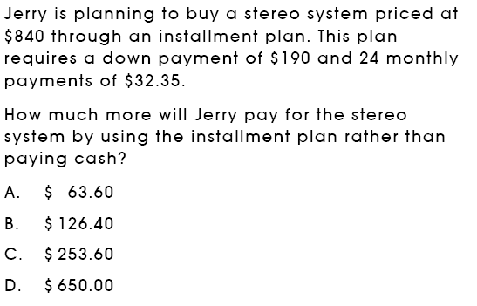 | 82%
NNS 8.6  NNS 9.4 |  | 36  B | 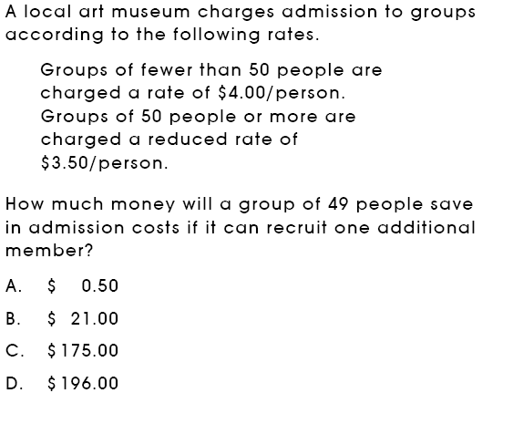 | 73%
Number, Number Sense, and Operations

Code | Grade Level Indicator | Ques #  w/  Answer | Question | State  %  Correct | District  %  Correct | Building  %  Correct
NNS 10.1 | Connect physical, verbal and symbolic representations of irrational numbers; e.g., construct √ 2 as a hypotenuse or on a number line. | 23  B | 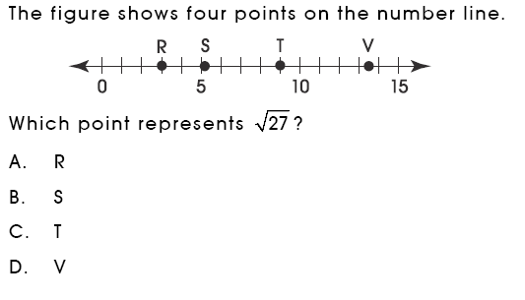 | 78%
Measurement

Code | Grade Level Indicator | Ques #  w/  Answer | Question | State  %  Correct | District  %  Correct | Building  %  Correct
MEA 6.3b  MEA 7.5 | Estimate perimeter or circumference and area for circles, triangles and quadrilaterals, and surface area and volume for prisms and cylinders by:  b. measuring attributes (diameter, side lengths, or heights) and using established formulas for circles, triangles, rectangles, parallelograms and rectangular prisms.  Analyze problem situations involving measurement concepts, select appropriate strategies, and use an organized approach to solve narrative and increasingly complex problems. | 3  A | 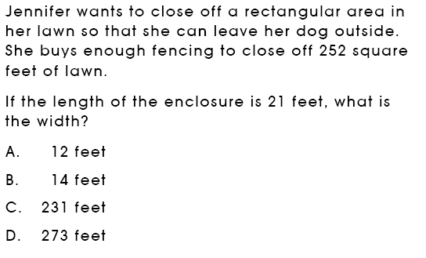 | 87%
MEA 6.3b  MEA 7.5 |  | 30  D | 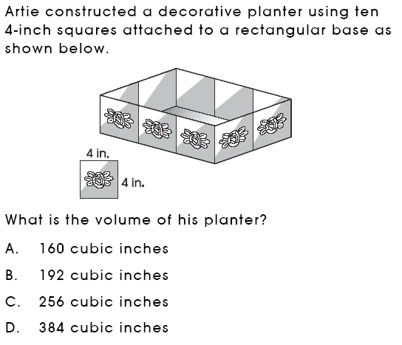 | 50%  A=33%  B=7%  C=10%
Measurement

Code | Grade Level Indicator | Ques #  w/  Answer | Question | State  %  Correct | District  %  Correct | Building  %  Correct
MEA 7.4 | Solve problems involving proportional relationships and scale factors; e.g., scale models that require unit conversions within the same measurement system. | 7  A | 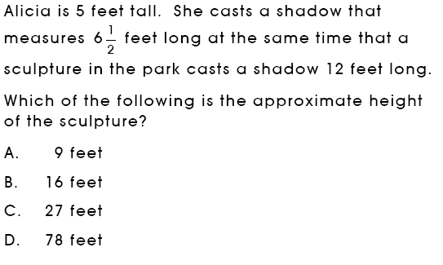 | 78%
Measurement

Code | Grade Level Indicator | Ques #  w/  Answer | Question | State  %  Correct | District  %  Correct | Building  %  Correct
MEA 7.6  MEA 7.5 | Use strategies to develop formulas for finding area of trapezoids and volume of cylinders and prisms.  Analyze problem situations involving measurement concepts, select appropriate strategies, and use an organized approach to solve narrative and increasingly complex problems. | 34  SA | 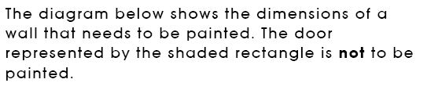  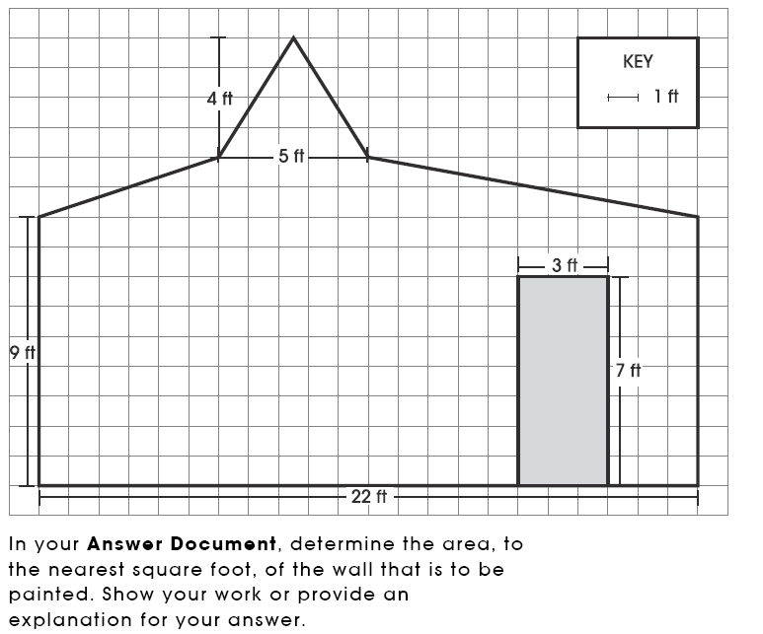  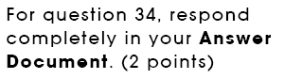 | 2pt=20%  1.5pt=3%  1pt=7%  .5pt=6%  0pt=58%  NR=7%
Measurement

Code | Grade Level Indicator | Ques #  w/  Answer | Question | State  %  Correct | District  %  Correct | Building  %  Correct
MEA 8.10 | Use conventional formulas to find the surface area and volume of prisms, pyramids and cylinders and the volume of spheres and cones to a specified level of precision. | 13  C | 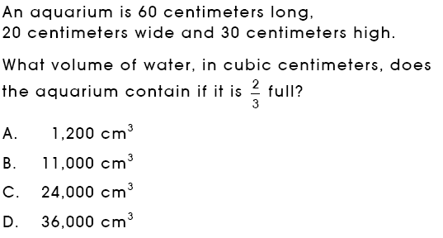 | 65%  A=7%  B=8%  D=19%
Geometry and Spatial Sense

Code | Grade Level Indicator | Ques #  w/  Answer | Question | State  %  Correct | District  %  Correct | Building  %  Correct
GSS 5.8 | Predict what three-dimensional object will result from folding a two-dimensional net, then confirm the prediction by folding the net. | 11  D | 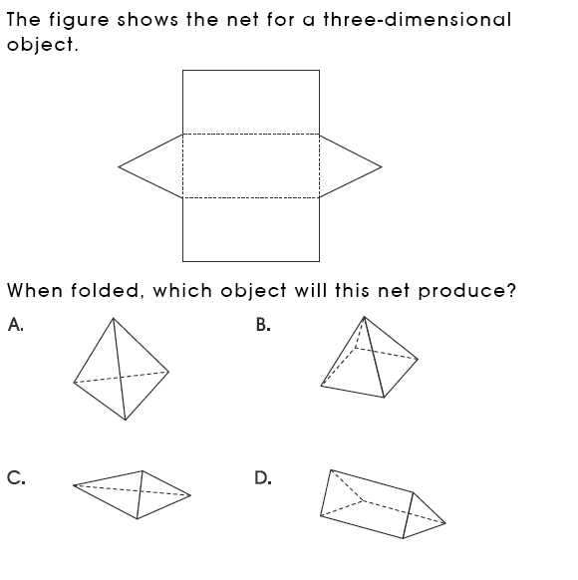 | 97%
GSS 7.3a | Use and demonstrate understanding of the properties of triangles. For example:  - Use Pythagorean Theorem to solve problems involving right triangles. | 42  D | 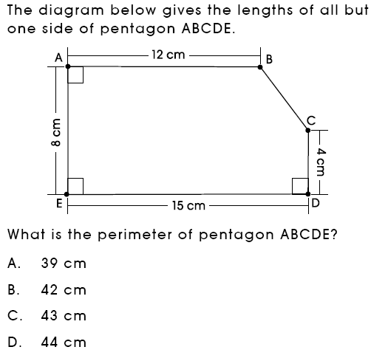 | 46%  A=18%  B=7%  C=29%
Geometry and Spatial Sense

Code | Grade Level Indicator | Ques #  w/  Answer | Question | State  %  Correct | District  %  Correct | Building  %  Correct
GSS 7.5 | Apply properties of congruent or similar triangles to solve problems involving missing lengths and angle measures. | 12  A | 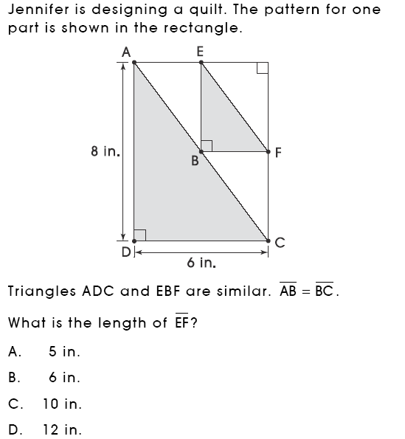 | 64%  B=21%  C=8%  D=7%
GSS 7.5 |  | 37  A | 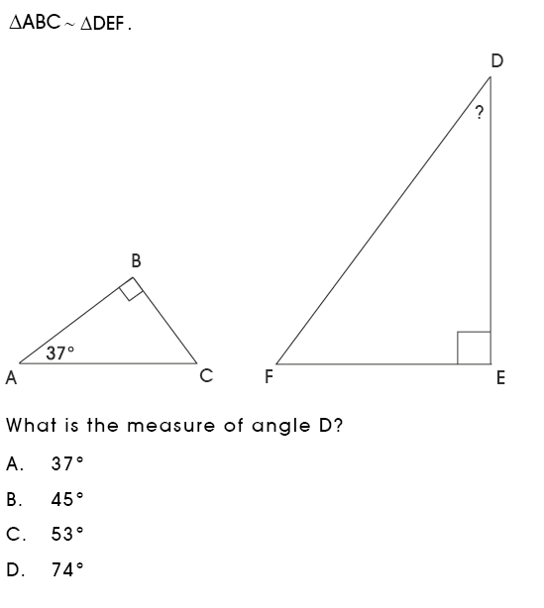 | 68%  B=10%  C=13%  D=8%
Geometry and Spatial Sense

Code | Grade Level Indicator | Ques #  w/  Answer | Question | State  %  Correct | District  %  Correct | Building  %  Correct
GSS 8.2 | Recognize the angles formed and the relationship between the angles when two lines intersect and when parallel lines are cut by a transversal. | 25  C | 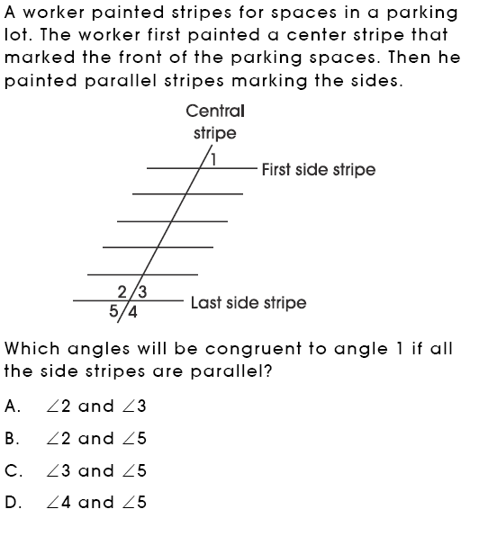 | 68%  A=11%  B=12%  D=9%
Geometry and Spatial Sense

Code | Grade Level Indicator | Ques #  w/  Answer | Question | State  %  Correct | District  %  Correct | Building  %  Correct
GSS 8.4 | Represent and analyze shapes using coordinate geometry; e.g., given three vertices and the type of quadrilateral, find the coordinates of the fourth vertex. | 29  D | 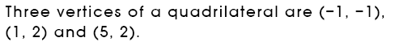  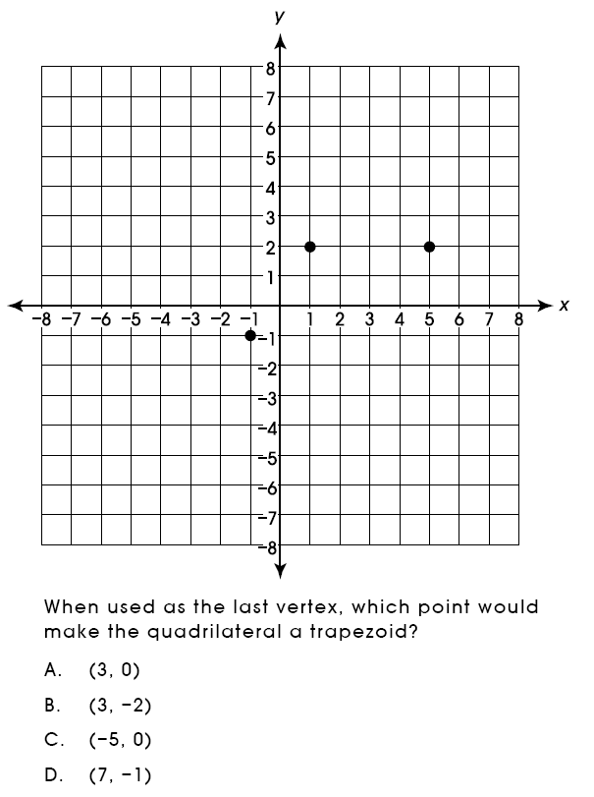 | 71%
Geometry and Spatial Sense

Code | Grade Level Indicator | Ques #  w/  Answer | Question | State  %  Correct | District  %  Correct | Building  %  Correct
GSS 9.3 | Analyze two-dimensional figures in a coordinate plane; e.g., use slope and distance formulas to show that a quadrilateral is a parallelogram. | 40  ER | 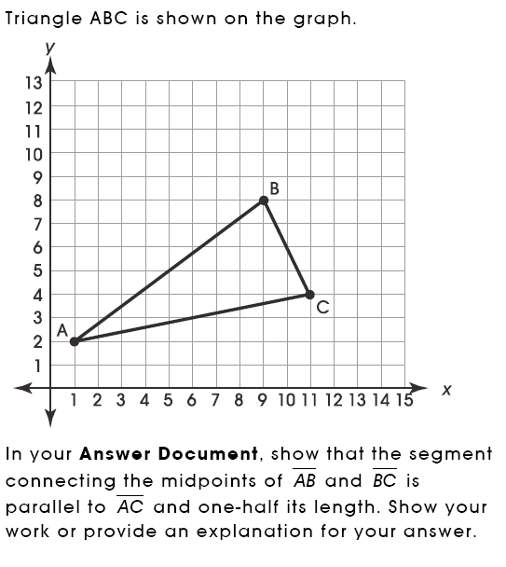 | 4pt=3%  3.5pt-1%  3pt=1%  2.5pt=1%  2pt=5%  1.5pt=2%  1pt=10%  .5pt=5%  0pt=60%  NR=13%
Patterns, Functions, and Algebra

Code | Grade Level Indicator | Ques #  w/  Answer | Question | State  %  Correct | District  %  Correct | Building  %  Correct
PFA 8.2  PFA 9.2 | Generalize patterns and sequences by describing how to find the nth term.  Generalize patterns using functions or relationships (linear, quadratic and exponential), and freely translate among tabular, graphical and symbolic representations. | 15  D | 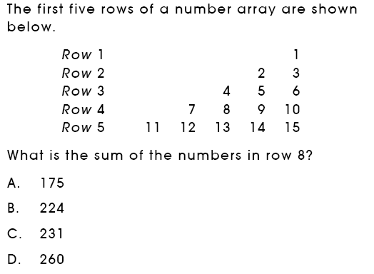 | 75%
PFA 8.6 | Describe the relationship between the graph of a line and its equation, including being able to explain the meaning of slope as a constant rate of change and y-intercept in real-world problems. | 24  B | 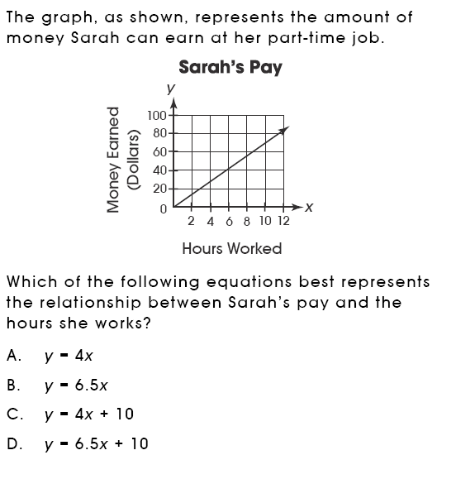 | 49%  A=12%  C=26%  D=12%
Patterns, Functions, and Algebra

Code | Grade Level Indicator | Ques #  w/  Answer | Question | State  %  Correct | District  %  Correct | Building  %  Correct
PFA 8.6 | Describe the relationship between the graph of a line and its equation, including being able to explain the meaning of slope as a constant rate of change and y-intercept in real-world problems. | 41  B | 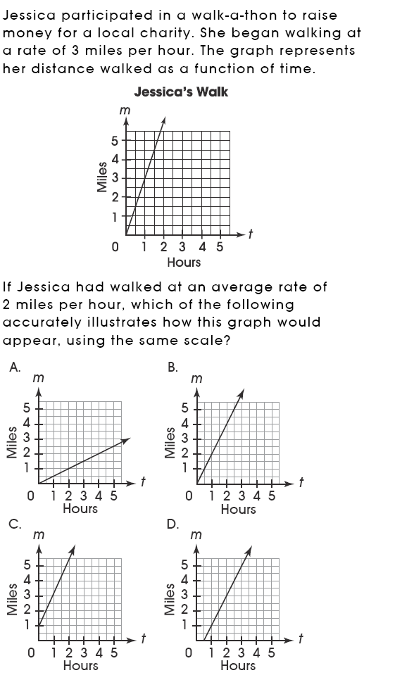 | 73%
Patterns, Functions, and Algebra

Code | Grade Level Indicator | Ques #  w/  Answer | Question | State  %  Correct | District  %  Correct | Building  %  Correct
PFA 8.8 | Write, simplify and evaluate algebraic expressions (including formulas) to generalize situations and solve problems. | 1  B |  | 75%
PFA 9.2 | Generalize patterns using functions or relationships (linear, quadratic and exponenetial), and freely translate among tabular, graphical and symbolic. | 6  C |  | 69%  A=5%  B=17%  D=8%
Patterns, Functions, and Algebra

Code | Grade Level Indicator | Ques #  w/  Answer | Question | State  %  Correct | District  %  Correct | Building  %  Correct
PFA 9.3 | Describe problem situations (linear, quadratic and exponential) by using tabular, graphic and symbolic representations | 28  SA |  | 2pt=14%  1.5 pt=3%  1pt=63%  .5pt=2%  0pt=14%  NR=4%
PFA 9.9 | Solve and interpret the meaning of 2 by 2 systems of linear equations graphically, by substitution and by elimination, with and without technology. | 10  SA | 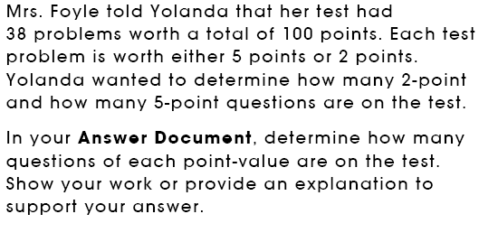 | 2pt=46%  1.5pt=5%  1pt=3%  .5pt=1%  0pt=40%  NR=5%
Patterns, Functions, and Algebra

Code | Grade Level Indicator | Ques #  w/  Answer | Question | State  %  Correct | District  %  Correct | Building  %  Correct
PFA 9.10 | Solve quadratic equations with real roots by factoring, graphing, using the quadratic formula and with technology. | 32  A | 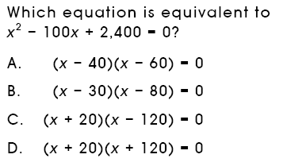 | 43%  B=14%  C=29%  D=14%
Data Analysis and Probability

Code | Grade Level Indicator | Ques #  w/  Answer | Question | State  %  Correct | District  %  Correct | Building  %  Correct
DAP 7.3 | Analyze a set of data by using and comparing combinations of measures of center (mean, mode, median) and measures of spread (range, quartile, interquartile range), and describe how the inclusion or exclusion of outliers affects those measures. | 35  D | 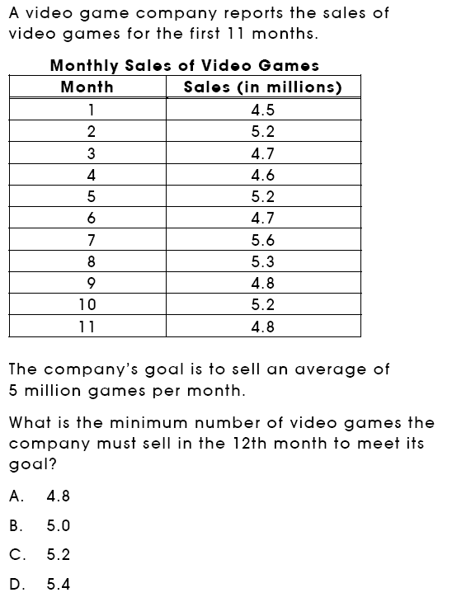 | 50%  A=14%  B=22%  C=13%
DAP 7.3 |  | 44  C | 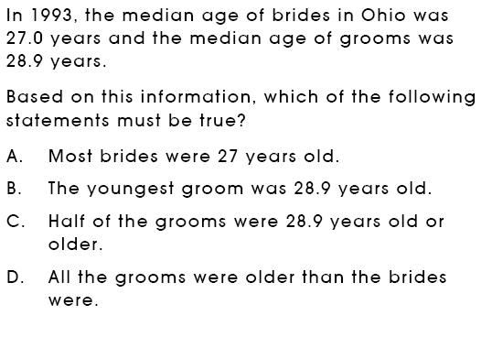 | 44%  A=32%  B=3%  D=21%
Data Analysis and Probability

Code | Grade Level Indicator | Ques #  w/  Answer | Question | State  %  Correct | District  %  Correct | Building  %  Correct
DAP 8.1 | Use, create and interpret scatterplots and other types of graphs as appropriate. | 2  D | 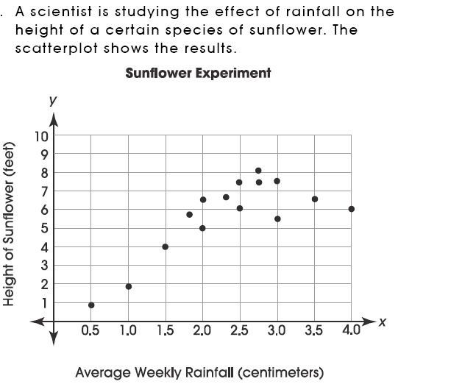  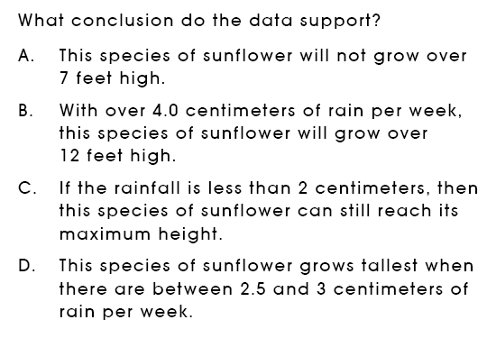 | 93%
Data Analysis and Probability

Code | Grade Level Indicator | Ques #  w/  Answer | Question | State  %  Correct | District  %  Correct | Building  %  Correct
DAP 8.1 | Use, create and interpret scatterplots and other types of graphs as appropriate. | 27  C | 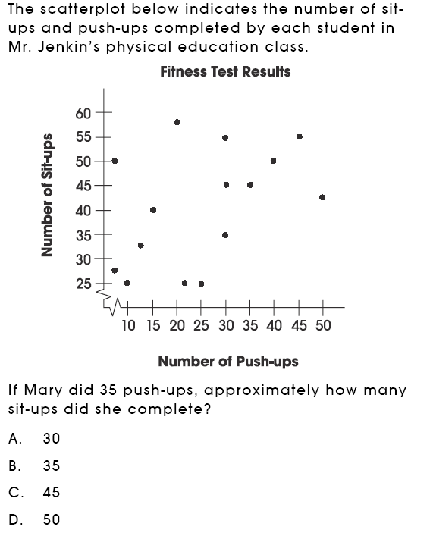 | 82%
Data Analysis and Probability

Code | Grade Level Indicator | Ques #  w/  Answer | Question | State  %  Correct | District  %  Correct | Building  %  Correct
DAP 8.2 | Evaluate different graphical representations of the same data to determine which is the most appropriate representation for an identified purpose; e.g., line graph for change over time, circle graph for part-to-whole comparison, scatterplot for relationship between two variants. | 9  B | 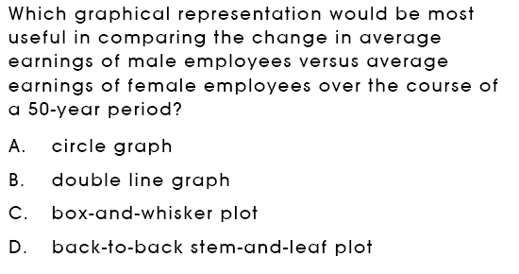 | 85%
DAP 8.4 | Compare two sets of data using measures of center (mean, mode, median) and measures of spread (range, quartiles, interquartile range, percentiles). | 22  SA | 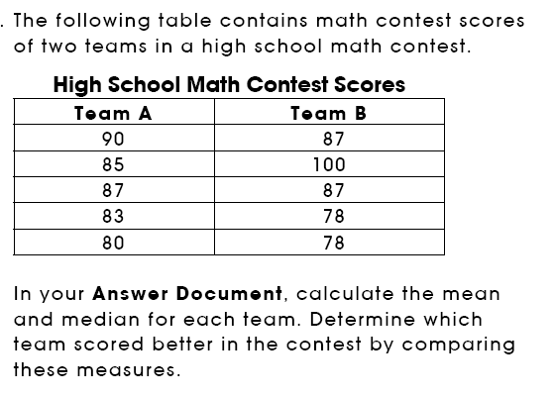  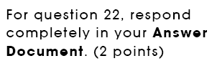 | 2pt=48%  1.5pt=4%  1pt=23%  .5pt=4%  0pt=18%  NR=3%
Data Analysis and Probability

Code | Grade Level Indicator | Ques #  w/  Answer | Question | State  %  Correct | District  %  Correct | Building  %  Correct
DAP 9.7 | Use counting techniques and the Fundamental Counting principle to determine the total number of possible outcomes for mathematical situations. | 31  C | 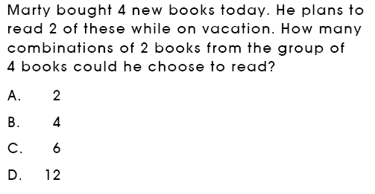 | 58%  A=10%  B=11%  D=22%
DAP 9.7 |  | 39  C | 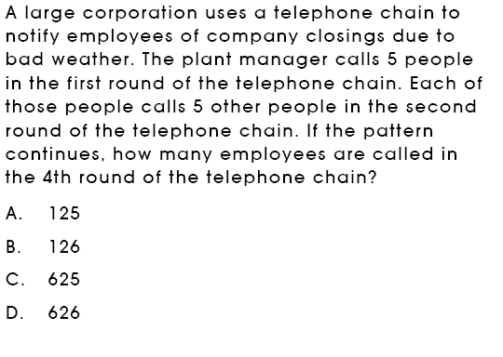 | 68%  A=21%  B=5%  D=6%
Data Analysis and Probability

Code | Grade Level Indicator | Ques #  w/  Answer | Question | State  %  Correct | District  %  Correct | Building  %  Correct
DAP 9.10 | Use theoretical and experimental probability, including simulations or random numbers, to estimate probabilities and to solve problems dealing with uncertainty; e.g., compound events, independent events, simple dependent events. | 5  B | 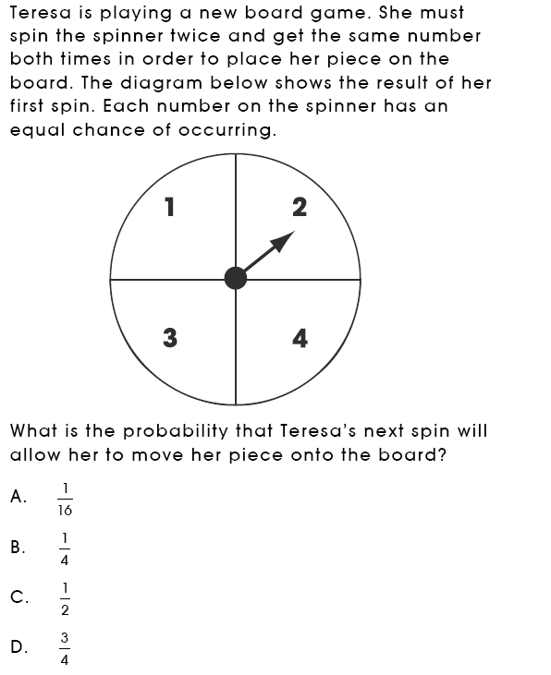 | 86%
Data Analysis and Probability

Code | Grade Level Indicator | Ques #  w/  Answer | Question | State  %  Correct | District  %  Correct | Building  %  Correct
DAP 9.10 | Use theoretical and experimental probability, including simulations or random numbers, to estimate probabilities and to solve problems dealing with uncertainty; e.g., compound events, independent events, simple dependent events. | 14  C | 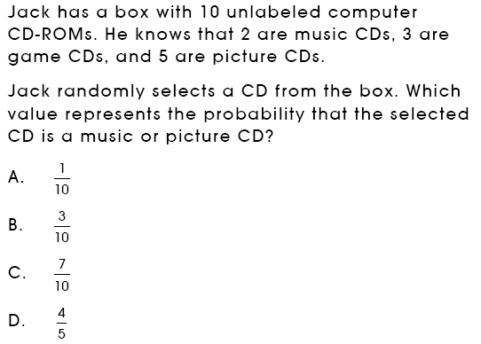 | 85%

