Index to Questions

Question Number | Source | BM | GLI | Description
2 | OAT March 05 | B | MEA 8.4a | This multiple-choice question asks students to determine the volume of a cylinder given the height and the diameter.
5 | OAT March 05 | D | MEA 8.2 | This multiple-choice question asks students to convert  from degrees Fahrenheit to degrees Celsius.
8 | OAT March 05 | C | MEA 8.5 | This multiple-choice question asks students to find the  amount paper needed to cover a square pyramid.
16 | OAT March 05 | C, E | MEA 7.5, MEA 8.3, MEA 8.9 | This short-answer question asks students to determine the number of gallons needed to paint a fence.
29 | OAT March 05 | D | MEA 8.2 | This multiple-choice question asks students to use a scale to estimate the distance between cities.
38 | OAT March 05 | E | MEA 8.8 | This multiple-choice question asks students to determine the sum of the exterior angles of a triangle.
44 | OAT March 05 | D | MEA 8.7 | This multiple-choice question asks students to find the number of minutes it will take the temperature of the stove to increase from 22°C to 100°C.
18 | OAT March 06 | D | MEA 8.1 | This multiple-choice question asks students to determine the number of miles Eric is from Paris.
34 | OAT March 06 | E | MEA 8.8 | This multiple-choice question asks students to determine the measure of each interior angle of a regular hexagon.
37 | OAT March 06 | C | MEA 8.9 | This multiple-choice question asks students to determine the height the water will reach in the second tank if the water from the first tank is poured into it.
43 | OAT March 06 | C | MEA 8.9 | This multiple-choice question asks students to find  the total surface area of a pyramid.
Question Number | Source | BM | GLI | Description
17 | OAT May 07 | C | MEA 8.9 | This multiple-choice question asks students to determine the approximate volume of a cone given its height (4 inches) and circumference of its base (12π inches).
37 | OAT May 07 | A | MEA 8.6 | This multiple-choice question asks students to determine the average speed in miles per hour that Sabrina travels when going to school.
42 | OAT May 07 | E | MEA 8.8 | This multiple-choice question asks students to determine the measure of an interior angle of a regular pentagon.
2 | OAT May 08 | B | MEA 8.4b | This multiple-choice question asks students to approximate the volume of a cone.
9 | OAT May 08 | A | MEA 7.5 | This multiple-choice question asks students to select a possible distance between the local park and Andy’s school.
11 | OAT May 08 | C | MEA 8.9 | This short-answer question asks students to determine the dimensions (length and width) of the rectangular box that contains the same amount of cereal as the cylindrical box when both boxes have equal heights.
19 | OAT May 08 | B | MEA 5.6 | Listed on IMS site as GSS  This multiple-choice question asks students to use proportional reasoning to solve a problem involving a scale drawing.
24 | OAT May 08 | D | MEA 8.7 | This multiple-choice question asks students to apply an indirect measurement technique to solve a problem involving rates.

BACK TO INDEX

Benchmark: B | Use formulas to find surface area and volume for specified three-dimensional objects accurate to a specified level of precision.
GLI: MEA 8.4a | Derive formulas for surface area and volume and justify them using geometric models and common materials. For example, find:  a. the surface area of a cylinder as a function of its height and radius;

Multiple Choice Question:
2. Aqua Water Company purchased a new water tank. The tank is a cylinder with a diameter of 14 feet and a height of 24 feet.
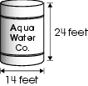
What is the volume of the tank in cubic feet?
- 168 $π$cubic feet
- 336 $π$cubic feet
- 1,176 $π$cubic feet
- 4,704 $π$cubic feet

Commentary:
This multiple-choice question asks students to determine the volume of a cylinder given the height and the diameter. The correct answer, choice C, is obtained by using the formula for volume of a cylinder with a radius of 7 feet and a height of 24 feet. Answer choices A is the result of multiplying the radius by the height. Answer choice B is the result of multiplying the diameter by the height. Answer choice D is the result of using the diameter to find the volume instead of using the radius.

The level of complexity for this question is Low Complexity. The task requires students to perform a specified procedure (find the volume). The volume formula for a cylinder is provided on the Ohio Grade 8 Mathematics Achievement Test Reference Sheet.

Performance Data:
The percent of public school students selecting answer choice C for question 2 on the March 2005 Grade 8 Achievement Test was 39%.

Keywords: measurement, volume, cylinder

BACK TO INDEX

Benchmark: D | Use proportional reasoning and apply indirect measurement techniques, including right triangle trigonometry and properties of similar triangles, to solve problems involving measurements and rates.
GLI: MEA 8.2 | Use proportional relationships and formulas to convert units from one measurement system to another; e.g., degrees Fahrenheit to degrees Celsius.

Multiple Choice Question:

5. The formula used for converting the temperature from Fahrenheit ( F ) to Celsius ( C ) is $°C = \frac{5}{9} \left(°F − \text{32}\right)$.
The outside temperature is 80ºF.
About what is this temperature in degrees Celsius?
A. 27ºC
B. 45ºC
C. 80ºC
D. 140ºC

Commentary:
This multiple-choice question asks students to convert from degrees Fahrenheit to degrees Celsius. Students need to substitute 80°F into the provided formula to convert 80°F to 27°C (answer choice A). Answer choices B, C and D are the result of incorrectly using the formula.

The complexity of this question is Low Complexity. The task requires students to perform a specified procedure.
Performance Data:
The percent of public school students selecting answer choice A for question 5 on the March 2005 Grade 8 Achievement Test was 60%.

Keywords: measurement, conversion, degrees, temperatures

BACK TO INDEX

Benchmark: C | Apply indirect measurement techniques, tools and formulas, as appropriate, to find perimeter, circumference and area of circles, triangles, quadrilaterals and composite shapes, and to find volume of prisms, cylinders, and pyramids.
GLI: MEA 8.5 | Determine surface area for pyramids by analyzing their parts.

Multiple Choice Question:

8. Marco is building a model of a square pyramid.
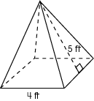
He wants to cover the entire model, including the base, with gray paper.
How many square feet of paper will he need to cover the model?
- 40 square feet
- 46 square feet
- 56 square feet
- 96 square feet

Commentary:
This multiple-choice question asks students to find the amount paper needed to cover a square pyramid. The task requires student to realize that covering an object refers to finding the surface area. Student may use the formulas provided on the Reference Sheet to find the area of the square base and the areas of the triangular faces.

Area of square base: 4 x 4 = 16 square feet
Area of the four triangular faces: $\frac{1}{2} (4 x 5) x 4 = \text{40} \text{square} \text{feet}$
The total surface area is 16 + 40 = 56 square feet.
The correct answer is choice C. Finding the area of only the four triangular faces will result in answer choice A. Finding the area of the base and three triangular faces will result in answer choice B. Forgetting to divide the area of the triangular face by $\frac{1}{2}$ will result in answer choice D.

The level of complexity for this question is Moderate Complexity. The task requires retrieving information from a figure to solve a problem requiring multiple steps.

Performance Data:
The percent of public school students selecting answer choice D for question 8 on the March 2005 Grade 8 Achievement Test was 37%.

Keywords: measurement, surface area, pyramid

BACK TO INDEX

Benchmark: B | Describe and apply the properties of similar and congruent figures; and justify conjectures involving similarity and congruence.
GLI: GSS 8.3 | Differentiate between discrete and continuous data and appropriate ways to represent each.

Multiple Choice Question:

15. Δ PQR is similar to Δ XYZ.
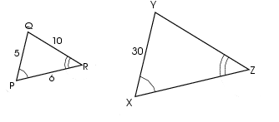
What is the perimeter of Δ XYZ?
A. 21 cm
B. 63 cm
C. 105 cm
D. 126 cm

Commentary:
This multiple-choice question asks students to use similarity of triangles to find the perimeter of a triangle. Students need to use properties of similar triangles to find that the ratio of ΔPQR to ΔXYZ is 1:6. Students use this ratio to determine that the length of $\overline{\text{YZ}}$ is 60 and that the length of $\overline{\text{ZX}}$ is 36. The perimeter of ΔXYZ is 30 + 60 + 36 or 126 cm (answer choice D). Answer choice A is obtained by finding the perimeter of ΔPQR. Answer choices B and C are the result of incorrectly determining the ratio between the two triangles.

The level of complexity for this question is Moderate Complexity. The task requires students to solve a problem requiring multiple steps.

Performance Data:
The percent of public school students selecting answer choice D for question 15 on the March 2005 Grade 8 Achievement Test was 62%.

Keywords: geometry, similarity, perimeter

BACK TO INDEX

Benchmark: C | Apply indirect measurement techniques, tools and formulas, as appropriate, to find perimeter, circumference and area of circles, triangles, quadrilaterals and composite shapes and to find volume of prisms, cylinders, and pyramids.
Benchmark: E | Estimate and compute various attributes, including length, angle measure, area, surface area and volume, to a specified level of precision.
GLI: MEA 7.5, MEA 8.3, MEA 8.9 | MEA 7.5: Analyze problem situations involving measurement concepts, select appropriate strategies, and use an organized approach to solve narrative and increasingly complex problems.  MEA 8.3: Use appropriate levels of precision when calculating with measurements.  MEA 8.9: Demonstrate understanding of the concepts of perimeter, circumference and area by using established formulas for triangles, quadrilaterals, and circles to determine the surface area and volume of prisms, pyramids, cylinders, spheres and cones. (Note: Only volume should be calculated for spheres and cones.)

Short Answer Question:

16. A wooden fence was built around a construction site. The wall is 600 feet long and 8 feet high. Each 12-foot length of the fence has a 2-foot by 2-foot window cut into the wall so people can watch the construction.

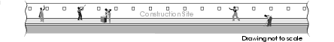

The city council asked the construction company to paint the side of the fence facing the street. A gallon of paint will cover approximately 250 square feet.

In your Answer Document, determine how many gallons of paint are needed to paint one side of the fence. Show your work to support your answer.

Commentary:
This short-answer question asks students to determine the number of gallons needed to paint a fence. To earn the maximum number of points (2 points), provide an appropriate strategy to determine how many gallons of paint are needed (18.4 or about 19 gallons) to cover the fence. One strategy is to find the area of the entire fence, subtract the area of each window, and then divide by the area covered by a gallon of paint.

The complexity of the question is Moderate Complexity. This task requires students to solve a multi-step word problem.

Performance Data:
The percent of public school students earning each score point for question 16 on the March 2005 Grade 8 Achievement Test:

Percent at Each Score Point
0 | 1 | 2
60% | 22% | 12%

Scoring Guidelines:
Points | Student Response
2 | Sample Correct Responses:  - A(wall) = 600 x 8 = 4,800 sq ft  Number of windows = 600 / 12 = 50  A(windows) = 50 x (2x2) = 200 sq ft  A(wall-windows) = 4,800 – 200 = 4,600 sq ft  Paint needed: 4,600 / 250 = 18.4 gallons OR 19 gallons  - Area of wall before windows cut out 4,800 / 250 = 19.2 gallons to paint full wall. Area of windows 50(4) = 200 so this means almost a gallon is not needed. So between 18 and 19 gallons are needed.  The focus of this task is to use conventional formulas to find area. A correct response will determine the amount of paint required to cover a wall that has a given number of openings. The response shows all work and gives the correct number of gallons.  Note: Students may deal with the partial gallon differently as long as process and computation are accurate. For example, if sample corrected response is rounded to 18 with all work shown.
1 | The response provides partial evidence of using conventional formulas to find area; however, the solution may be incomplete or slightly flawed.  For example, the response may:  - Show the correct formulas, but an error in calculation results in an incorrect response.  - Provide a miscalculation of the number of windows but calculates the rest of the problem correctly.  - Use the drawing exactly as shown.  - Not consider the windows in the calculation of the area but works the answer down to 4,800/250 = 19.2 gallons.  - State the correct surface area of the wall but forgets to determine how many gallons are needed.
0 | The response provides inadequate evidence of using conventional formulas to find area. The response provides an explanation with major flaws and errors of reasoning.  For example, the response may:  - State 600/250 = 2.4 gallons are needed.  - State any number of gallons with no supporting work.  - Restate the information provided in the item.

Keywords: measurement, area

BACK TO INDEX

Benchmark: D | Use proportional reasoning and apply indirect measurement techniques, including right triangle trigonometry and properties of similar triangles, to solve problems involving measurements and rates.
GLI: MEA 8.2 | Use proportional relationships and formulas to convert units from one measurement system to another; e.g., degrees Fahrenheit to degrees Celsius.

Multiple Choice Question:

29. Dave wants to estimate the distance from Harrisburg to Jonestown. The distance on the map is about 13 inches. The scale on the map indicates that 2.5 inches = 6 miles.

About how many miles is it from Harrisburg to Jonestown?

- 5 miles
- 15 miles
- 31 miles
- 39 miles

Commentary:
This multiple-choice question asks students to use a scale to estimate the distance between cities. Students can use the proportion$\frac{2\text{.}5}{6} = \frac{\text{13}}{x}$ to determine that x = 31.2. So Harrisburg and Jonestown are about 31 miles apart, answer choice C. Answer choices A and D are the results of setting up the proportion incorrectly and answer choice B is the result of multiplying 2.5 and 6.

The level of complexity for this question is Moderate Complexity. The task asks students to solve a word problem requiring multiple steps.

Performance Data:
The percent of public school students selecting answer choice C for question 29 on the March 2005 Grade 8 Achievement Test was 66%.

Keywords: measurement, proportion

BACK TO INDEX

Benchmark: H | Establish the validity of conjectures about geometric objects, their properties and relationships by counter-example, inductive and deductive reasoning, and critiquing arguments made by others.
GLI: GSS 8.1 | Use, create and interpret scatterplots and other types of graphs as appropriate.

Mathematical Processes
Benchmark: D | Apply reasoning processes and skills to construct logical verifications or counter-examples to test conjectures and to justify and defend algorithms and solutions.

Multiple Choice Question:

30. Circle A has a radius that is twice the length of the radius of Circle B.

Which is an accurate statement about the relationship of the areas of Circles A and B?

- The area of Circle A is four times the area of Circle B.
- The area of Circle A is twice the area of Circle B.
- The area of Circle A is one-half the area of Circle B.
- The area of Circle A is one-fourth the area of Circle B.
Commentary:
This multiple-choice question asks students to compare the relative areas of two circles. Students may approach this question in several ways. One method is to examine the effect of doubling a number and then squaring the result. Students may use examples for each circle and compare their areas. Students should conclude that the area of circle A is four times the area of circle B (answer choice A). Answer choices B, C and D are the results of misconceptions about area and/or a misunderstanding of which circle is larger.

The level of complexity for this question is Moderate Complexity. The task requires students to use informal methods of reasoning and problem solving strategies.

Performance Data:
The percent of public school students selecting answer choice A for question 30 on the March 2005 Grade 8 Achievement Test was 33%.

Keywords: geometry, area, circle

BACK TO INDEX

Benchmark: E | Estimate and compute various attributes, including length, angle measure, area, surface area and volume, to a specified level of precision.
GLI: MEA 8.8 | Find the sum of the interior and exterior angles of regular convex polygons with and without measuring the angles with a protractor.

Multiple Choice Question:
38. Three lines intersect as shown.

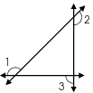

What is the sum of the measures of angles 1, 2 and 3 in this figure?

A. 450º
B. 360º
C. 270º
D. 180º
Commentary:
This multiple-choice question asks students to determine the sum of the exterior angles of a triangle. One way is to recall that the sum of the exterior angles of a triangle is 360°. Another approach is to use information about interior and exterior angles of a triangle. Recalling that two angles that create a line are supplementary and their sum is 180°, angles 1, 2 and 3 and their supplements (the interior angles of the triangle) will have a total of 540° (3 × 180° = 540°). Because the sum of the interior angles of a triangle equal 180°, this sum can be subtracted from the 540° which leaves the sum of the exterior angles, 540° – 180° = 360° (answer choice B). Answer choices A, C and D are the results of incorrect calculations or misunderstanding of how to determine the measure of each angle.

The level of complexity for this question is Moderate Complexity. The task asks students to retrieve information from a figure and use it to solve a problem requiring multiple steps.

Performance Data:
The percent of public school students selecting answer choice B for question 38 on the March 2005 Grade 8 Achievement Test was 38%.

Keywords: measurement, exterior angles, interior angles

BACK TO INDEX

Benchmark: D | Use proportional reasoning and apply indirect measurement techniques, including right triangle trigonometry and properties of similar triangles, to solve problems involving measurements and rates.
GLI: MEA 8.7 | Apply proportional reasoning to solve problems involving indirect measurements or rates.

Mathematical Processes
Benchmark: B | Apply mathematical knowledge and skills routinely in other content areas and practical situations.

Multiple Choice Question:

44. A cup of water is heated in a pan on the stove. The temperature of the water increased from 22ºC to 35ºC in 20 seconds.

At this rate how long would it take the water temperature to increase from 22ºC to 100ºC?
- 2 minutes
- 3 minutes
- 5 minutes
- 6 minutes

Commentary:
This multiple-choice question asks students to find the number of minutes it will take the temperature of the stove to increase from 22°C to 100°C. To solve this question, students can use proportional reasoning to determine the solution. Since the temperature rises 13° in 20 second (35° - 22° = 13°), this change represents the rate of increase. To determine the time it will take to rise 78° (100° - 22° = 78°), students could set up a table, such as:

Time (seconds) | Temperature (degrees)
0 | 22
20 | 35
40 | 48
60 | 61
80 | 74
100 | 87
120 | 100

The temperature will reach 100°C in 120 seconds or 2 minutes, answer choice A. Students may also use other strategies to answer the question. Answer choices B, C and D are the result of calculation errors or not completing the task.

The level of complexity for this question is Moderate Complexity. The task requires students to solve a problem requiring multiple steps.

Performance Data:
The percent of public school students selecting answer choice A for question 44 on the March 2005 Grade 8 Achievement Test was 48%.

Keywords: measurement, temperature, proportional reasoning

BACK TO INDEX

Benchmark: D | Use proportional reasoning and apply indirect measurement techniques, including right triangle trigonometry and properties of similar triangles, to solve problems involving measurements and rates.
GLI: MEA 8.1 | Compare and order the relative size of common U.S. customary units and metric units; e.g., mile and kilometer, gallon and liter, pound and kilogram.

Multiple Choice Question:

18. While driving in France, Eric sees a sign that says “Paris 61 Kilometers.”
About how many miles is Eric from Paris?
A. 35 miles
B. 65 miles
C. 100 miles
D. 125 miles

Commentary:
This multiple-choice question asks students to determine the number of miles Eric is from Paris. The student may approach this using one of several different methods. One method is to know that there are about 2 Kilometers in every mile. So, if you divide the number of Kilometers by 2, (61 ÷ 2 ≈ 30), then a good estimation of the 61 Kilometers is 35 miles, answer choice A. Answer choices B, C and D represent a misunderstanding of the relation between miles and Kilometer.

The complexity level of this question is Moderate Complexity. The question requires student to use informal methods of reasoning to solve a problem.

Performance Data:
The percent of public school students selecting answer choice A for question 18 on the March 2006 Grade 8 Achievement Test was 41%.

Keywords: measurement, miles, kilometer, estimation

BACK TO INDEX

Benchmark: E | Estimate and compute various attributes, including length, angle measure, area, surface area and volume, to a specified level of precision.
GLI: MEA 8.8 | Find the sum of the interior and exterior angles of regular convex polygons with and without measuring the angles with a protractor.

Multiple Choice Question:

34. The figure shown is a regular hexagon.
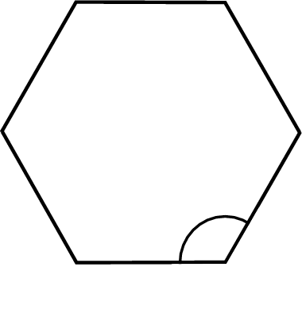
What is the measure of each interior angle?
A. 60˚
B. 100˚
C. 120˚
D. 150˚

Commentary:
This multiple-choice question asks students to determine the measure of each interior angle of a regular hexagon. Students may solve this using one of several methods. One method is to divide the regular hexagon ( a six sided polygon with six congruent interior angles) into triangles as shown in the diagram.

Each triangle has an angle sum of 180°. There are 4 triangles that were created in the regular hexagon. To find the measure of each angle of the regular hexagon, students should multiply 180° by the number of triangles (4) and then divide this product by the number of interior angles, $\left(\frac{\text{180}° × 4}{6}\right) = \frac{\text{720}°}{6} = \text{120}°$. Answer choice C is correct. Answer choices A, B and D are not the measures of an interior angle of a regular hexagon.

The complexity level of this question is Moderate Complexity. This question asks students to solve a problem requiring multiple steps.

Performance Data:
The percent of public school students selecting answer choice C for question 34 on the March 2006 Grade 8 Achievement Test was 44%.

Keywords: measurement, interior angle, regular hexagon

BACK TO INDEX

Benchmark: B | Use formulas to find surface area and volume for specified three-dimensional objects accurate to a specified level of precision.
GLI: MEA 8.9 | Demonstrate understanding of the concepts of perimeter, circumference and area by using established formulas for triangles, quadrilaterals, and circles to determine the surface area and volume of prisms, pyramids, cylinders, spheres and cones. (Note: Only volume should be calculated for spheres and cones.)

Multiple Choice Question:

37. The first tank shown is half filled with water. The water from this tank is poured into the second tank, which is empty.
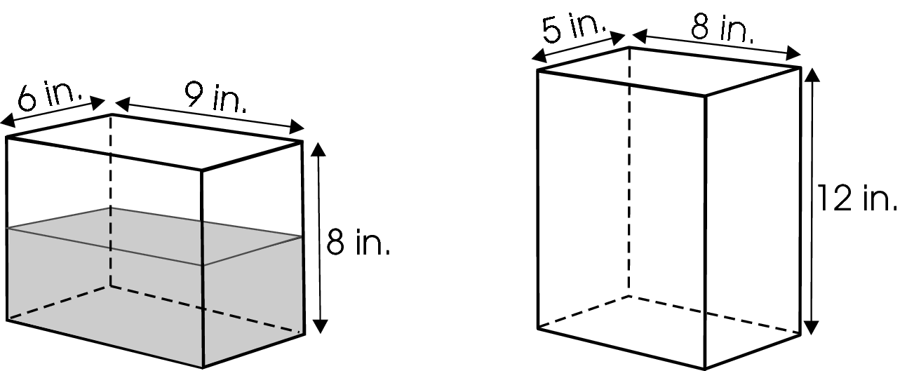
What height will the water reach in the second tank?
- 4 inches
- 5.4 inches
- 6 inches
- 10.8 inches

Commentary:
This multiple-choice question asks students to determine the height the water will reach in the second tank if the water from the first tank is poured into it. Students must realize that the concept of volume is being used and that the height of water in the first tank is only 4 inches. Student can then find the volume of water in the first tank, (6 in x 9 in x 4 in = 216 in³⁾. To find the height of the water in the second tank the student can take the volume of the first tank and divide it by the length and width of the second tank ($\frac{\text{216} {\text{in}}^{3}}{5 \text{in} × 8 \text{in}} = 5\text{.}4 \text{in}$ ), answer choice B. answer choice A, C and D are incorrect. The student may have identified the height of water in the first tank for answer choice A. The student may have assumed that the water would fill the second tank half way as well or 6 inches, Answer choice C. In answer choice D the student may have used the total volume of the first tank when finding the height the volume would reach in the second tank.
The complexity level of this question is High Complexity. This question requires student to use multiple discussion point to solve a multiple step problem.

Performance Data:
The percent of public school students selecting answer choice B for question 37 on the March 2006 Grade 8 Achievement Test was 26%.

Keywords: measurement, volume, rectangular prism

BACK TO INDEX

Benchmark: C | Apply indirect measurement techniques, tools and formulas, as appropriate, to find perimeter, circumference and area of circles, triangles, quadrilaterals and composite shapes, and to find volume of prisms, cylinders, and pyramids.
GLI: MEA 8.9 | Demonstrate understanding of the concepts of perimeter, circumference and area by using established formulas for triangles, quadrilaterals, and circles to determine the surface area and volume of prisms, pyramids, cylinders, spheres and cones. (Note: Only volume should be calculated for spheres and cones.)

Multiple Choice Question:

43. A square pyramid has the dimensions shown.
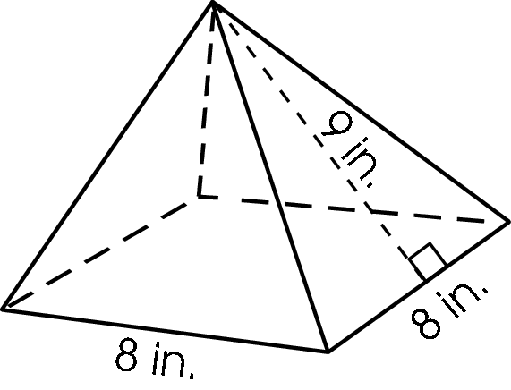
What is the total surface area of the pyramid?
A. 192 square inches
B. 208 square inches
C. 352 square inches
D. 576 square inches

Commentary:
This multiple-choice question asks students to find the total surface area of a pyramid. One method for finding the surface area of a pyramid is to find the area of each triangular face and the area of the square base and add them together. Area of the square base:
8 in. × 8 in. = 64 in².

The area of one of the four congruent triangular faces:
$\frac{1}{2} × 8 × 9 = \text{36} {\text{in}}^{2}$.

Then multiply it by four to find the area of all the triangular faces:
36in² x 4 = 144 in².

Finally add the area of the four triangular faces with the area of the base:
144 in² + 64 in² = 208in², answer choice B.

Answer Choice A, is incorrect because the student may have incorrectly found the volume, using the slant height in its place of the altitude, instead of the surface area. Answer choice C is incorrect, because the student may not have multiplied by $\frac{1}{2}$when finding the area of the triangles, and answer choice D is incorrect because the student may have multiplied the three measurements provided in the question.

The complexity level of this question is Moderate Complexity. This question asks students to retrieve information from a figure and use it to solve problem requiring multiple steps.

Performance Data:
The percent of public school students selecting answer choice B for question 43 on the March 2006 Grade 8 Achievement Test was 37%.

Keywords: measurement, surface area, pyramid

BACK TO INDEX

Benchmark: C | Apply indirect measurement techniques, tools and formulas, as appropriate, to find perimeter, circumference and area of circles, triangles, quadrilaterals and composite shapes, and to find volume of prisms, cylinders, and pyramids.
GLI: MEA 8.9 | Demonstrate understanding of the concepts of perimeter, circumference and area by using established formulas for triangles, quadrilaterals, and circles to determine the surface area and volume of prisms, pyramids, cylinders, spheres and cones. (Note: Only volume should be calculated for spheres and cones.)

Multiple Choice Question:

17. A cone has a height of 4 inches and a circumference at the base of 12π inches.
What is the approximate volume of the cone?

A. 150 inches³
B. 200 inches³
C. 450 inches³
D. 600 inches³

Commentary:
This multiple-choice question asks students to determine the approximate volume of a cone given its height (4 inches) and circumference of its base (12π inches). To find the volume of the cone students must first find the radius of the base of the cone. The circumference of the circle that makes up the base of cone is equal to the twice the radius times π (pi), (C=2πr). The radius for the base of the cone is 6 inches.
The volume of a cone can be found using the formula V =$\frac{1}{3} hπ r^{2}$,
$\begin{aligned}\frac{1}{3} 4 π 6^{2} = \frac{1}{3} 4 π \text{36} \\ = \text{48}π \\ ≈ \text{150} {\text{inches}}^{3}\end{aligned}$
Answer choice A is correct.
A student who selected answer choice B may have used the diameter instead of the radius to find the volume. Answer choice C is the result of not multiplying by $\frac{1}{3}$when simplifying the expression. Answer choice D is the result of using the diameter instead of the radius and not multiplying by $\frac{1}{3}$ when simplifying.

The complexity level of this question is Moderate Complexity. This question requires students to solve a problem requiring multiple steps.

Performance Data:
The percent of public school students selecting answer choice A for question 17 on the May 2007 Grade 8 Achievement Test was 64%.

Keywords: measurement, cone, volume

BACK TO INDEX

Benchmark: A | Solve increasingly complex non-routine measurement problems and check for reasonableness of results.
GLI: MEA 8.6 | Solve and determine the reasonableness of the results for problems involving rates and derived measurements, such as velocity and density, using formulas, models and graphs.

Multiple Choice Question:

37. Sabrina rides her bike 2 miles to school each day. She leaves her house at 7:30 and arrives at 7:50.
What is Sabrina's average speed in miles per hour?

  - 1 mile per hour
  - 6 miles per hour
  - 10 miles per hour
  - 40 miles per hour

Commentary:
This multiple-choice question asks students to determine the average speed in miles per hour that Sabrina travels when going to school. Students are given the distance, the start time and end times for her travel to school. Students must first determine the number of hours it takes Sabrina to go to school. The difference between 7:50 and 7:30 is 20 minutes or $\frac{1}{3}$ of an hour, ($\frac{\text{20}}{\text{60}} = \frac{1}{3}$). The rate of travel can be found by taking the distance and dividing it by the time it takes to travel that distance, $\left(\frac{2\text{miles}}{\frac{1}{3} \text{hour}}\right) = \frac{\frac{3}{1} ⋅ 2 \text{miles}}{\frac{3}{1} ⋅ \frac{1}{3} \text{hour}} = \frac{6 \text{miles}}{1\text{hour} } \text{or} 6 \text{miles} \text{per} \text{hour}$. Answer choice B is correct.
Answer choices A, C and D are the result of calculation errors or not converting the 20 minutes to hours.

The complexity level of this question is Moderate Complexity. This question requires students to solve a multi-step word problem.

Performance Data:
The percent of public school students selecting answer choice B for question 37 on the May 2007 Grade 8 Achievement Test was 44%.

Keywords: measurement, rate, speed

BACK TO INDEX

Benchmark: E | Estimate and compute various attributes, including length, angle measure, area, surface area and volume, to a specified level of precision.
GLI: MEA 8.8 | Find the sum of the interior and exterior angles of regular convex polygons with and without measuring the angles with a protractor.

Multiple Choice Question:

42. What is the measure of one interior angle of a regular pentagon?

A. 108°
B. 72°
C. 54°
D. 36°

Commentary:
This multiple-choice question asks students to determine the measure of an interior angle of a regular pentagon. Students must first recall that a regular pentagon has five congruent sides and five congruent angles. One method to determine the measure of one angle of a regular polygon is to divide the pentagon into 3 triangles by drawing diagonals from a common vertex.

The sum of the angles in any triangle is 180°. Therefore, since there are three triangles in a pentagon the sum of all the angles will be 540° (180° • 3 = 180°). To find the number of degrees for one angle divide the sum by 5, (540° ÷ 5 = 108°). Answer choice A is correct.
Students who selected answer choice B may have thought all polygons have a total interior angle measure of 360° and divided it by 5, (360° ÷ 5 = 72°). Students who selected answer choice C, may have thought that 108° was too large and divided 108° by 2 to get 54°. Students selecting answer choice D may have thought that all polygons have a total interior angle measure of 180° and divided 180° by 5.

The complexity level of this question is Moderate Complexity. This question requires students to solve a word problem that requires multiple steps.

Performance Data:
The percent of public school students selecting answer choice A for question 42 on the May 2007 Grade 8 Achievement Test was 37%.

Keywords: measurement, pentagon, angle measure, degree, interior angle

BACK TO INDEX

Benchmark: B | Use formulas to find surface ara and volume for specified three-dimensional objects accurate to a specified level of precision.
GLI: MEA 8.4b | Derive formulas for surface area and volume and justify them using geometric models and common materials. For example, find:  - that the volume of a pyramid (or cone) is one-third of the volume of a prism or cylinder) with the same base area and height.

Multiple Choice Question:

2. The cone shown has a height of 5 inches and a radius of 1.5 inches.
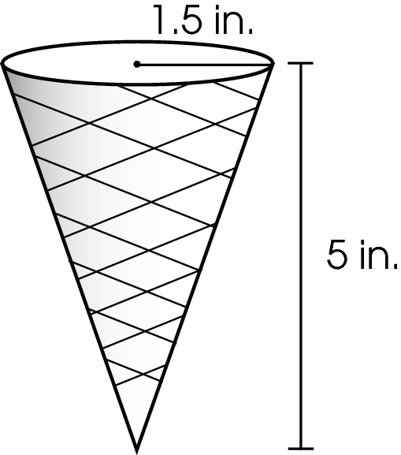
What is the approximate volume of the cone?

- between 11 and 12 cubic inches
- between 15 and 16 cubic inches
- between 35 and 36 cubic inches
- between 39 and 40 cubic inches

Commentary:
This multiple-choice question asks students to approximate the volume of a cone. Students may use the formula for the volume of a cone V = $\frac{1}{3}$$π$r²h, where V stands for volume, $π$ is approximately 3.14, r stands for radius of the circular base, and h stands for height of the cone. By substituting a cone’s dimensions in the formula, the volume is approximately 11.77 cubic inches, which is between 11 and 12 cubic inches, answer choice A.

V = $\frac{1}{3}$$π$1.5²(5)
V = $\frac{1}{3}$$π$(2.25)(5)
V 11.77 cubic inches.

If a student chooses answer choice B, he or she used the diameter of the circle instead of the radius when finding the volume of the cone (V = $\frac{1}{3}$$π$3²(5)). If a student chooses answer choice C, he or she found the volume of the cylinder (V = $π$r²h = $π$3²(5)) instead of the volume of the cone (V = $\frac{1}{3}$$π$r²h =$\frac{1}{3}$$π$3²(5)). If a student chooses answer choice D, he or she switched the values for the height and the radius when substituting them into the formula for the volume of the cone.

The complexity level of this question is Low Complexity. This question requires students to evaluate a formula for the given values of variables.

Performance Data:
The percent of public school students selecting answer choice A for question 2 on the May 2008 Grade 8 Achievement Test was 74%.

Keywords: measurement, cone, volume, radius, height

BACK TO INDEX

Benchmark: A | Formally define geometric figures.
GLI: MEA 7.5 | Analyze problem situations involving measurement concepts, select appropriate strategies, and use an organized approach to solve narrative and increasingly complex problems.

Multiple Choice Question:

9. The locations of Andy’s house, school and local park form a triangle, as shown.
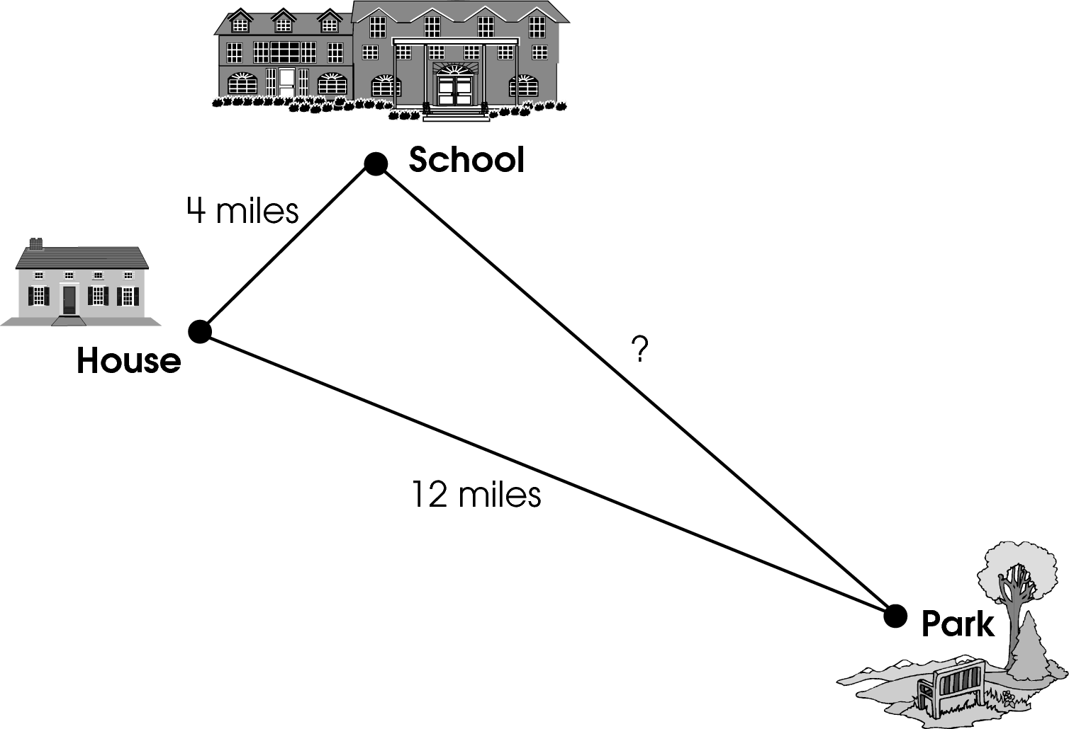
Which is a possible distance from the local park to Andy’s school?

- 4 miles
- 8 miles
- 10 miles
- 16 miles

Commentary:
This multiple-choice question asks students to select a possible distance between the local park and Andy’s school. The diagram shows a triangle formed using the three locations (house, school and local park) as the vertices. The distances between the locations represent the lengths of the sides of the triangle.

Students should know the relationship between the lengths of the sides in a triangle. The relationship states that the sum of lengths of any two sides of triangle must be greater than the length of the remaining side.

If the missing side is 10 miles, answer choice C, a relationship would work:
4 + 10 is greater than 12 miles
4 + 12 is greater than 10 miles
10 +12 is greater than 4 miles
Choice C is correct.

Answer choice A is incorrect because the sum of the lengths of the sides of the triangle is less than the remaining side, 4 + 4 < 12. Answer choice B is incorrect because the sum of the lengths of the sides of the triangle is equal to the remaining side, 4 + 8 = 12. Answer choice D is incorrect because the sum of the lengths of the sides of the triangle is equal to the remaining side, 12 + 4 = 16.

The complexity level of this question is Moderate Complexity. This question requires students to bring together skills and knowledge from different domains.

Performance Data:
The percent of public school students selecting answer choice C for question 9 on the May 2008 Grade 8 Achievement Test was 65%.

Keywords: triangle, distance, side length, triangle inequality

BACK TO INDEX

Benchmark: C | Apply indirect measurement techniques, tools and formulas, as appropriate, to find perimeter, circumference and area of circles, triangles, quadrilaterals and composite shapes, and to find volume of prisms, cylinders, and pyramids.
GLI: MEA 8.9 | Demonstrate understanding of the concepts of perimeter, circumference and area by using established formulas for triangles, quadrilaterals, and circles to determine the surface area and volume of prisms, pyramids, cylinders, spheres and cones. (Note: Only volume should be calculated for spheres and cones.)

Short Answer Question:

11. A cereal maker is currently packaging cereal in cylindrical boxes with a 6” diameter and height of 10”. The cereal maker is considering changing to rectangular boxes.
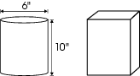
The two boxes need to have the same height to fit on the grocery store shelf and they need to have the same volume.
In your Answer Document, determine the dimensions of the rectangular box that meets these conditions. Show your work.
Commentary:
This short-answer question asks students to determine the dimensions (length and width) of the rectangular box that contains the same amount of cereal as the cylindrical box when both boxes have equal heights. Students should be able to use the formulas for the volume of the cylinder
V = $π$x r² x h and for the volume of a rectangular prism (box) V = l x w x h that can be found on the reference sheet. A response earning the maximum number of points (2 pts) provides the dimensions of the rectangular box and demonstrates the steps needed to determine the dimensions of the box using the dimensions of the cylinder.

Students can first find a volume of the cylinder V = 3.14 x 3² x 10 = 282.6 cubic inches. Next they have to find a product of the dimensions of the box (l x w) by substituting 282.6 for the volume and 10 for the height in the formula for the volume of a prism:
V = l x w x h
282.6 = l x w x 10
28.26 = l x w

Students can also set the formula for a volume of a prism and the formula for a volume of a cylinder equal to each other, substitute all given values into the equation and find a product of the dimensions of the box (l x w)
$π$x r² x h = l x w x h
3.14 x 3² x 10 = l x w x 10
3.14 x 3² = l x w
28.26 = l x w

Finally, students will state two numbers representing the reasonable length and the width of the box. The dimensions (length and width) will vary based on the dimension selected first.
For example, if the length is 3 inches, then the width is about 9.4 inches and the height is 10 inches. If the length is 4 inches, then the width is about 7 inches and the height is 10 inches.

The complexity level of this question is Moderate Complexity. This question asks students to solve a word problem requiring multiple steps.

Performance Data:
The percent of public school students earning each score point for question 11 on the May 2008 Grade 8 Achievement Test:

Percent at Each Score Point
0 | 1 | 2
62% | 13% | 21%

Scoring Guidelines:
Exemplar Response:
- V(cylinder) = π• r ² • h
V(cylinder) = 3.14 x 9 x 10 = 282.6 in³
V(box) = l x w x h
282.6 in³= l x w x10 in.
28.26 in²= l x w
Any length and width whose product is approximately 28.26 is acceptable.
- V =π• r ² • h
V = π • 9.10
V = 282.7433
282.7 = l x w x 10
28.3 = l x w
28 = l x w
7 x 4 x 10 could be the dimensions of the box.

Points | Student Response
2 point text | The focus of this task is to use formulas to find the volume of cylinders and find the dimensions of a rectangular prism. A correct response will find the volume of a cylinder and determine the dimensions of a rectangular prism with a given volume and height. The response gives the approximate correct volume of the cylinder and shows the steps needed to determine an appropriate length and width for the 10-inch-tall box.  NOTE: Leaving answers in terms of π is acceptable.
1 point text | The response provides partial evidence of how to find the volume of a cylinder and to determine the length and width of a rectangular prism with a given volume and height; however, the solution may be incomplete or slightly flawed.  For example, the response may:  - Use the correct formulas but make a calculation error that leads to an incorrect answer.  - Use the correct formulas and calculations, but fail to provide a final answer; e.g., correctly finds the volume of the cylinder and attempts to find the length and width.
0 point text | The response provides inadequate evidence of how to find the volume for a cylinder and a prism, or there is no response.  For example the response may:  - State erroneous formulas and arrive at an incorrect solution.  - Simply state dimensions of a box.  - State only the volume of the cylinder.  - Be blank or give irrelevant information.

Keywords: cylinder, rectangular prism, volume, height, dimensions

BACK TO INDEX

Benchmark: B | Describe and apply the properties of similar and congruent figures; and justify conjectures involving similarity and congruence.
GLI: MEA 5.6 | Use strategies to develop formulas for determining perimeter and area of triangles, rectangles and parallelograms, and volume of rectangular prisms.

Multiple Choice Question:

19. On a scale drawing of a house, a rectangular bedroom has a length of 8 inches and a perimeter of 30 inches. The scale is 0.5 inch = 1 foot.
What is the actual width in feet of the bedroom?

- 7 feet
- 14 feet
- 15 feet
- 22 feet

Commentary:
This multiple-choice question asks students to use proportional reasoning to solve a problem involving a scale drawing. The formula for the perimeter of a rectangle states that the perimeter is equal to the sum of the lengths of its four sides (P = l + l + w + w). Students have to substitute 8 for l (length) and 30 for P (perimeter) and then solve the formula for the variable w

30 = 8 + 8 + w + w.
30 = 16 + 2w
14 = 2w
7 = w

Since the scale is 0.5 inch = 1 foot and the width of the rectangle on the scale drawing is
7 inches, a proportion can be set up to find the missing length

$\frac{0\text{.}5 \text{inches}}{1 \text{foot}}$= $\frac{7 \text{inches}}{w \text{feet}}$
w = $\frac{1⋅7}{0\text{.}5}$
w = 14 feet

So, the actual width of the bedroom is 14 feet, answer choice B.

If a student chooses answer choice A, he or she correctly found the width of the rectangle on the scale drawing but did not use the scale to find the actual width for the bedroom in feet. If a student chooses answer choice C, he or she multiplied 30 inches (the perimeter) by the scale of 0.5 inches to calculate the number of feet. If a student chooses answer choice D, he or she subtracted the length on the scale drawing from the perimeter on the scale drawing
(30 – 8 = 22 feet).

The complexity level of this question is Moderate Complexity. This question asks students to use informal methods of reasoning and solve a word problem requiring multiple steps.

Performance Data:
The percent of public school students selecting answer choice B for question 19 on the May 2008 Grade 8 Achievement Test was 36%.

Keywords: proportional reasoning, proportion, scale, perimeter

BACK TO INDEX

Benchmark: D | Use proportional reasoning and apply indirect measurement techniques, including right triangle trigonometry and properties of similar triangles, to solve problems involving measurements and rates
GLI: MEA 8.7 | Apply proportional reasoning to solve problems involving indirect measurements or rates.

Multiple Choice Question:

24. A family drove 164 miles to an amusement park. It took them 2$\frac{3}{4}$hours. The average rate for the drive home was 10 miles per hour less than the average rate for the drive to the park.
Approximately how long did it take the family to get home?

- 2 hours 20 minutes
- 2 hours 40 minutes
- 3 hours 20 minutes
- 3 hours 40 minutes

Commentary:
This multiple-choice question asks students to apply an indirect measurement technique to solve a problem involving rates. The appropriate formula to solve this problem is the distance formula, d = r • t, distance = rate • time. The time of the trip, t, can be determined by solving this formula for t in terms of d and r, t =$\frac{d}{r}$. Since a family drove the distance of 164 mi in 2$\frac{3}{4}$hours, the original average rate of the family was 59.6 miles per hour (1642$\frac{3}{4}$= 59.6). On the way home the average family rate was 10 miles per hour less or 49.6 miles per hour
(59.6 – 10 = 49.6). Using the same formula t = $\frac{d}{r}$, the time, it took a family to get home, approximates as 3.3 hours (t =$\frac{\text{164}}{\text{49}\text{.}6}$ 3.3), or 3 hours 18 minutes
(60 minutes x 0.3 = 18 minutes), or approximately 3 hours 20 minutes, answer choice C.

If students choose answer choice A, they thought that on the way home the family averaged
10 miles per hour faster, or 69.9 miles per hour (59.6 + 10 = 69.9) and it took them 2 hours and 20 minutes to get home ( 16469.6 2.36).
If students choose answer choice B, they subtracted 10 miles from 164 miles and then determined the time it took a family to drive home at 59 miles per hour
(164 – 10 = 154; 153 59 2.6). It is approximately 2 hours and 40 minutes.
If students choose answer choice D, they had a correct solution strategy but misinterpreted the correct answer of 3.3 hours as 3 hours and 30 minutes and approximated it as 3 hours and
40 minutes.

The complexity level of this question is Moderate Complexity. This question asks students to solve a word problem requiring multiple steps.

Performance Data:
The percent of public school students selecting answer choice C for question 24 on the May 2008 Grade 8 Achievement Test was 42%.

Keywords: rate, time, distance

BACK TO INDEX

