Index to Questions

Question Number | Source | BM | GLI | Description
6 | OAT March 05 | E | MEA 7.4 | This short-answer question asks students to determine the actual dimensions of a drawing from a scale model.
13 | OAT March 05 | A | MEA 7.1 | This multiple-choice question asks students to select  the unit that describes the rate of change.
17 | OAT March 05 | B | MEA 7.2 | This multiple-choice question asks students to find the  number of tiles needed to cover a floor.
26 | OAT March 05 | G | MEA 7.8 | This short-answer question asks students to sketch or describe a box with the same volume as the given box, but with a smaller surface area than the given box.
32 | OAT March 05 | C | MEA 7.7 | This multiple-choice question asks students to find the area of a composite figure.
38 | OAT March 05 | D | MEA 7.3 | This multiple-choice question asks students to determine which measurement is closest to the exact measurement of an object.
44 | OAT March 05 | F | MEA 7.9 | This multiple-choice question asks students to determine how the volume of a shape changes when the dimensions are changed.
22 | OAT March 06 | F | MEA 7.9 | This multiple-choice question asks students to determine the affects on the volume of a cylindrical barrel when reducing the height of a barrel.
30 | OAT March 06 | D | MEA 7.3 | This multiple-choice question asks students to estimate the measure of an angle to a degree greater that the tool provides.
36 | OAT March 06 | B | MEA 7.2 | This short-answer question asks students to determine the number of 8-ounce serving that can be obtained from 1 gallon of ginger ale and 1 quart of punch.
44 | OAT March 06 | C | MEA 7.7 | This multiple-choice question asks students to find the area of the shaded portion of a given figure.
20 | OAT May 07 |  | MEA 6.5 | QUESTION ON THE NNS LIST
28 | OAT May 07 | G | MEA 7.8 | This multiple-choice question asks students to compare the volumes and surface areas of two rectangular prisms.
Question Number | Source | BM | GLI | Description
30 | OAT May 07 | A | MEA 7.1 | This multiple-choice question asks students to identify the derived unit of measure that would be appropriate to measure reading speed in a given situation.
31 | OAT May 07 | E | MEA 7.4 | This short-answer question asks students to determine the scale factor that was used to build a smaller pool and then to use the scale factor to find the length of the smaller pool.
43 | OAT May 07 | C | MEA 7.7 | This multiple-choice question asks students to find the area of a window that is a composite of two shapes.
26 | OAT May 08 | C & F | MEA 7.6, MEA 7.9 | This extended-response question asks students to find the volume of a three-dimensional cylindrical object and describe changes in the volume of this object if the measurements of the object have been changed.
29 | OAT May 08 | C | MEA 7.7 | This multiple-choice question asks students to find the area of a tabletop that is in the shape of a trapezoid.
38 | OAT May 08 | A | MEA 7.1 | This multiple-choice question asks students to identify the derived unit of measure that would be appropriate for measuring the average rate of saving.
43 | OAT May 08 | E | MEA 7.4 | This multiple-choice question asks students to solve a problem using the scale factor.

BACK TO INDEX

Benchmark: E | Use problem solving techniques and technology as needed to solve problems involving length, weight, perimeter, area, volume, time and temperature.
GLI: MEA 7.4 | Solve problems involving proportional relationships and scale factors; e.g., scale models that require unit conversions within the same measurement system.

Short Answer Question:
6. A drawing for a house uses the scale of $\frac{1}{4}$inch = 1 foot.
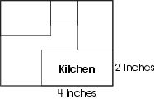
The dimensions of a kitchen on the drawing are 2 inches by 4 inches.
In your Answer Document, determine the actual dimensions of the kitchen. Show or describe how you found the length and width. Label your answer with appropriate units.

Commentary:
This short-answer question asks students to determine the actual dimensions of a drawing from a scale model. A drawing providing the dimensions of a kitchen in a scale model (4 inches by
2 inches) and a scale of $\frac{1}{4}$inch = 1 foot are given. A response earning the maximum number of points (2 points) indicates the dimensions of the kitchen labeled as 16 feet by 8 feet with supporting work or an explanation appropriate for this situation. A variety of methods may be used to find the actual dimensions, including formal and informal proportional reasoning strategies. An example of an informal strategy is determining that for every inch in the scale model of the kitchen, there are 4 feet in the actual dimensions of the kitchen; 4 inches in the scale model is 16 feet (4  4) and 2 inches in the scale model is 8 feet (4 2) in the actual kitchen.

The level of complexity for this question is Moderate Complexity. The task requires interpreting the representation and information provided and making a decision about how to find the dimensions of the kitchen.

Performance Data:
The percent of public school students earning each score point for question 6 on the March 2005 Grade 7 Achievement Test:

Percent at Each Score Point
0 | 1 | 2
51% | 12% | 32%

Scoring Guidelines:
Points | Student Response
2 | Sample Correct Responses:  - $\frac{1}{4}$inch = 1 foot, therefore 1 inch = 4 feet, so 4 × 2 = 8, and 4  4 = 16 . Dimension of kitchen is 8 feet by 16 feet.  - $\frac{1}{4}$inch = 1 foot; $\frac{1}{2}$inch = 2 feet, $\frac{3}{4}$inch = 3 feet, 1 inch = 4 feet. So length = 4 × 4 = 16 feet and width = 2 × 4 = 8 feet  - $\frac{1}{4}$inch = 1 foot; $\frac{1}{4}$inch = 12 inches; 1 inch = 48 inches; length = 48  4 = 192 inches; width = 48  2 = 96 inches.  - $\frac{\frac{1}{4}}{1}$= $\frac{2}{x}$ so x = 8 feet = width AND $\frac{\frac{1}{4}}{1}$ = $\frac{4}{y}$ so y = 16 feet = length  The focus of the task is solving problems involving scale factors. The response includes the correct dimensions of the kitchen AND includes work or an explanation that shows how to find the length and width. Answers are labeled with the appropriate units.
1 | The response provides partial evidence of solving problems involving scale factors; however, the solution is incomplete or slightly flawed.  For example, the response may:  - Provide a calculation error with correct set up: 4 ÷ $\frac{1}{4}$ = 1.  - Provide an incorrect set up, but correct follow through: $\frac{1}{4}$÷ 4 = 16.  - Provide the correct answer with insufficient or no supporting work or explanation.
0 | The response provides inadequate evidence of solving problems involving scale factors. The response will provide major flaws in reasoning or irrelevant information.  For example, the response may:  - Set up the problem incorrectly (e.g., 2($\frac{1}{4}$) = $\frac{1}{2}$ foot and 4($\frac{1}{4}$) = 1 foot.  - Not provide any correct dimensions.  - Provide a highly flawed description.  - Convert 2 inches by 4 inches into 2 feet by 4 feet.  - Be blank or make unrelated statements.

Keywords: measurement, scale factor

BACK TO INDEX

Benchmark: A | Select appropriate units to measure angles, circumference, surface area, mass, volume, using U.S. customary units; e.g., degrees, square feet, pounds, and other units as appropriate; metric units: e.g., square meters, kilograms and other units as appropriate.
GLI: MEA 7.1 | Select appropriate units for measuring derived measurements; e.g., miles per hour, revolutions per minute.

Multiple Choice Question:

13. At 7:00 a.m., the temperature was 55ºF. The temperature was 72ºF at 3:00 p.m.
Which is the most appropriate way to describe the average rate of change in temperature?
    - degrees per hour
    - degrees per minute
    - hours per degree
    - minutes per degree

Commentary:
This multiple-choice question asks students to select the unit that describes the rate of change. The response in answer choice A (degrees per hour) is the most appropriate way to describe the average rate of change in the temperature as the change. The temperature is given by the hour.

The level of complexity for this question is Low Complexity. This task requires students to recognize an example of a concept.

Performance Data:
The percent of public school students selecting answer choice A for question 13 on the March 2005 Grade 7 Achievement Test was 74%.

Keywords: measurement, derived measurement

BACK TO INDEX

Benchmark: B | Convert units of length, area, volume, mass and time within the same measurement system.
GLI: MEA 7.2 | Convert units of area and volume within the same measurement system using proportional reasoning and a reference table when appropriate; e.g., square feet to square yards, cubic meters to cubic centimeters.

Multiple Choice Question:

17. Aaron is tiling a floor. The floor measures 6 feet by 5 feet. Aaron is using square tiles with sides that measure 3 inches.
How many tiles will it take to cover the entire floor?
A. 30 tiles
B. 90 tiles
C. 270 tiles
D. 480 tiles

ID: 508; Version: 13

Commentary:
This multiple-choice question asks students to find the number of tiles needed to cover a floor. Students should determine which measure (area) relates to the context in the situation (covering). The dimensions of the floor need to be converted from feet into inches so the dimensions of the floor and the tile use the same unit. Students find the area of the floor and the square tile using an established formula or an appropriate strategy.

Area of floor: 72 inches  60 inches = 4320 square inches
Area of tile: 3 inches  3 inches = 9 square inches
Number of tiles: 4320 ÷ 9 = 480

The correct answer is answer choice D. Answer choices A, B and C are the result of errors, which may include forgetting to convert the dimensions of the floor before attempting to find the number of tiles.

The level of complexity for this question is High Complexity. This task requires performing a procedure having multiple steps and multiple decision points. Specified procedures are not provided; therefore students must reason and plan what to do to find the number of tiles to cover the floor.

Performance Data:
The percent of public school students selecting answer choice D for question 17 on the March 2005 Grade 7 Achievement Test was 16%.

Keywords: measurement, area

BACK TO INDEX

Benchmark: G | Understand and demonstrate the independence of perimeter and area for two-dimensional shapes and of surface area and volume for three-dimensional shapes.
GLI: MEA 7.8 | Understand the difference between surface area and volume and demonstrate that two objects may have the same surface area, but different volumes or may have the same volume, but different surface areas.

Short Answer Question:

26. A company needs to create a box shaped like a rectangular prism. The volume must be 216 cubic inches, but the surface area needs to be as small as possible. One possible box is shown.
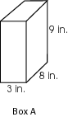
In your Answer Document, sketch or describe a different box that has the same volume as Box A, and a surface area less than that of Box A. Show work or provide an explanation to verify that the new box meets the criteria.

Commentary:
This short-answer question asks students to sketch or describe a box with the same volume as the given box, but with a smaller surface area than the given box. One approach is to rearrange the given dimensions using factors, e.g., 3 × 8 × 9 = 6 × 4 × 9. The new dimensions are then used to compare surface areas. A response earning the maximum number of points (2 points) provides the dimensions of another box with the volume of 216 cubic inches, but with a surface area smaller than the surface area of the given box (246 square inches).

Performance Data:
The percent of public school students earning each score point for question 26 on the March 2005 Grade 7 Achievement Test:

Percent at Each Score Point
0 | 1 | 2
67% | 21% | 05%

Scoring Guidelines:
Points | Student Response
2 | Sample Correct Responses:  - The box is a rectangular prism with length 4, width 6 and height 9. Volume 4×6×9=216 cubic in. Surface area: 2(4)(9) + 2(4)(6) + 2(9)(6)=228 sq in. This is less than the surface area of Box A, which is: 2(3)(9) + 2(3)(8) + 2(9)(8) =  246 sq in.  - The box is a cube with height, length and width all equal to 6 inches. The volume of this cube will be 216 cubic inches (6  6  6) and the surface area is  2 (6  6) + 2 (6  6) + 2 (6  6) square inches. This is less than the surface area of Box A, which is: 2(3)(9) + 2(3)(8) + 2(9)(8) = 246 sq in.  The focus of the task is to understand the difference between surface area and volume and that objects may have the same volume but different surface areas. The response includes an appropriate sketch or description of a different box that has the same volume, 216 cubic inches, but a smaller surface area than Box A. The response shows work or provides an adequate explanation to verify that the box has the same volume but a smaller surface area. A sketch and dimensions may or may not be provided.
1 | The response provides partial evidence of understanding the difference between surface area and volume and that objects may have the same volume but different surface areas; however, the solution may be incomplete or slightly flawed.  For example, the response may:  - Include an appropriate drawing or description of a different box with dimensions that result in the same volume with greater surface area or without stating surface area.  - Provide an adequate explanation but minor calculation errors contribute to a volume that is not equal to 216 or a surface area that is not less than 246.
0 | The response provides inadequate evidence of understanding the difference between surface area and volume and that objects may have the same volume but different surface areas. The response provides major flaws in reasoning or irrelevant information.  For example, the response may:  - Draw a box with length 200, height 8 and width 8. 200 + 8 + 8 = 216.  - Draw the box from the problem.  - Draw a figure that is not three-dimensional.  - Be blank or make unrelated statements.  - Recopy information from the stem.

Keywords: measurement, surface area, volume

BACK TO INDEX

Benchmark: C | Identify appropriate tools and apply appropriate techniques for measuring angles, perimeter or circumference and area of triangles, quadrilaterals, circles and composite shapes, and surface area and volume of prisms and cylinders.
GLI: MEA 7.7 | Develop strategies to find the area of composite shapes using the areas of triangles, parallelograms, circles and sectors.

Multiple Choice Question:

32. Tina created a display as shown below.
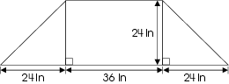
What is the total area of her display?
- 1,152 square inches
- 1,440 square inches
- 2,016 square inches
- 2,880 square inches

Commentary:
This multiple-choice question asks students to find the area of a composite figure. Students can create a new figure by moving the triangle from the left side, connecting it to the vertices of the triangle on the right side. This forms two rectangles. Students can add the areas of the rectangles to find the total area.

Area of original rectangle: 36 in.  24 in. = 864 square inches
Area of new rectangle: 24 in.  24 in. = 576 square inches
Total area of figure: 864 square inches + 576 square inches = 1440 square inches (answer choice B)

Answer choices A, C and D include errors in finding the area(s) of part(s) of the figure.

The level of complexity for this question is Moderate Complexity. This task requires students to retrieve information from a figure and use it to solve a problem requiring multiple steps.

Performance Data:
The percent of public school students selecting answer choice B for question 32 on the March 2005 Grade 7 Achievement Test was 39%.

Keywords: measurement, area

BACK TO INDEX

Benchmark: D | Select a tool and measure accurately to a specified level of precision.
GLI: MEA 7.3 | Estimate a measurement to a greater degree of precision than the tool provides.

Multiple Choice Question:

38. Dagny measured a paper clip as shown.
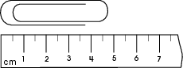
Which measurement is closest to the exact length of the paper clip?
- 4.25 cm
- 4.5 cm
- 4.75 cm
- 4.95 cm

ID: 682; Version: 11

Commentary:
This multiple-choice question asks students to determine which measurement is closest to the exact measurement of an object. The correct answer is 4.75 cm, answer choice C. Students are expected to read the ruler and conclude that the length of the paper clip is more than 4.5 cm, but less than 5 cm. Both 4.75 cm (answer choice C) and 4.95 cm (answer choice D) fit the criteria for the length of the paper clip. However, the end of the paper clip appears to be half way between 4.5cm and 5cm, making 4.75cm a better estimate. The measurements in answer choices A and B are less than 4.5 cm.

The level of complexity for this question is Low Complexity. The task requires students to retrieve information from a figure.

Performance Data:
The percent of public school students selecting answer choice C for question 38 on the March 2005 Grade 7 Achievement Test was 59%.

Keywords: measurement, centimeters

BACK TO INDEX

Benchmark: F | Analyze and explain what happens to area and perimeter or surface area and volume when the dimensions of an object are changed.
GLI: MEA 7.9 | Describe what happens to the surface area and volume of a three-dimensional object when the measurements of the object are changed; e.g., length of sides are doubled.

Multiple Choice Question:

44. A packing company is changing the size of a shipping carton.

The carton is in the shape of a rectangular prism. The height of the carton will be doubled and the width will be tripled.
By what scale factor will the volume of the original carton increase?
- 5
- 6
- 9
- 36

Commentary:
This multiple-choice question asks students to determine how the volume of a shape changes when the dimensions are changed. A carton in the shape of a rectangular prism is provided without dimensions. The task requires finding the scale factor for the change in the volume. One strategy is to assign values to the dimensions of the carton, change the dimensions of the carton to the criteria given (double the height and triple the width) and compare the new volume to the original volume. For example,

The carton is 2 feet long by 3 feet wide and 5 feet high.
Volume = 2 feet  3 feet  5 feet
Volume = 30 cubic feet

Changing the dimensions, the new carton is 2 feet long by 9 feet wide by 10 feet high.
Volume = 2 feet  9 feet  10 feet
Volume = 180 cubic feet

The volume of the new carton is 6 times the volume of the original carton (answer choice B).

The level of complexity for this question is Moderate Complexity. The task requires students to solve a word problem requiring multiple steps.

Performance Data:
The percent of public school students selecting answer choice B for question 44 on the March 2005 Grade 7 Achievement Test was 40%.

Keywords: measurement, scale factor

BACK TO INDEX

Benchmark: F | Analyze and explain what happens to area and perimeter or surface area and volume when the dimensions of an object are changed.
GLI: MEA 7.9 | Describe what happens to the surface area and volume of a three-dimensional object when the measurements of the object are changed; e.g., length of sides are doubled.

Multiple Choice Question:

22. The Burton Company produces cylindrical barrels.
If the height of a cylindrical barrel is reduced from 12 feet to 4 feet, what will happen to the volume of the barrel?
- The volume triples.
- The volume doubles.
- The volume is reduced to one half of the original.
- The volume is reduced to one third of the original.

Commentary:
This multiple-choice question asks students to determine the affects on the volume of a cylindrical barrel when reducing the height of a barrel. Students must understand that changing the height will affect the volume proportionally. The ratio of the heights between the new barrel and the old barrel is$\frac{4}{\text{12}} \text{or} \frac{1}{3}$. So the volume of the barrel is being reduced to $\frac{1}{3}$ of the original volume, answer choice D. Answer choices A and B are incorrect because they reference the volume increasing when the height is decreasing. Answer choice C is incorrect because it states that it is only reducing the volume to $\frac{1}{2}$ instead of$\frac{1}{3}$.

The complexity level of this question is Moderate Complexity. This question requires the student to compare statements for a given situation.

Performance Data:
The percent of public school students selecting answer choice D for question 22 on the March 2006 Grade 7 Achievement Test was 67%.

Keywords: measurement, volume, cylinder

BACK TO INDEX

Benchmark: D | Select a tool and measure accurately to a specified level of precision.
GLI: MEA 7.3 | Estimate a measurement to a greater degree of precision than the tool provides.

Multiple Choice Question:

30. An angle is shown on this protractor.
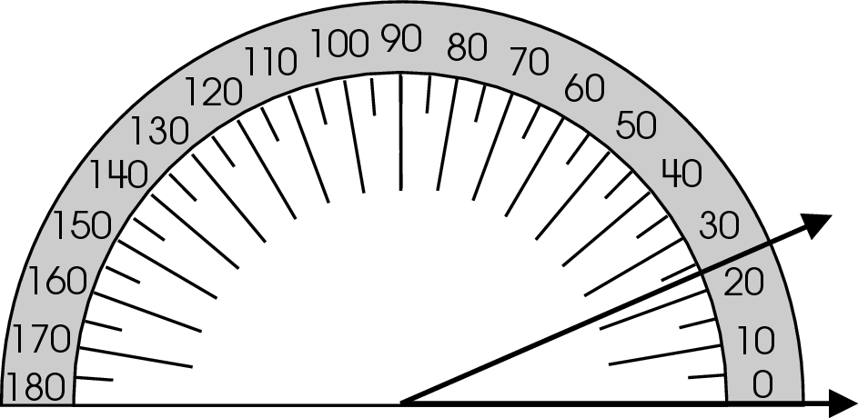
Estimate the measure of the angle to the nearest degree.
A. 23°
B. 26°
C. 27°
D. 37°

Commentary:
This multiple-choice question asks students to estimate the measure of an angle to a degree greater that the tool provides. In this problem the student must be able to read a protractor and realize that the upper ray of the angle is between the 20° and the mark that is between 20° and 30° or 25°. The ray is just a little below the 25° mark so a student may estimate that it is about 23° or 24°, answer choice A. Answer choices B, C and D are incorrect. Students selecting one of these answer choices may not fully understand how to read a protractor.

The complexity level of this question is Moderate Complexity. This question requires students to interpret a visual representation.

Performance Data:
The percent of public school students selecting answer choice A for question 30 on the March 2006 Grade 7 Achievement Test was 81%.

Keywords: measurement, protractor, estimation

BACK TO INDEX

Benchmark: B | Convert units of length, area, volume, mass and time within the same measurement system.
GLI: MEA 7.2 | Convert units of area and volume within the same measurement system using proportional reasoning and a reference table when appropriate; e.g., square feet to square yards, cubic meters to cubic centimeters.

Short Answer Question:

36. After a game, Coach Larson wants to serve punch to the players on her soccer team. She will mix 1 quart of ginger ale and 1 gallon of fruit punch together.
In your Answer Document, find the number of 8-ounce servings she can make. Show how you found the answer.

Commentary:
This short-answer question asks students to determine the number of 8-ounce serving that can be obtained from 1 gallon of ginger ale and 1 quart of punch. Students need to have an understanding of how to convert liquid units to the ounces contained in the total amount of punch. A response earning the maximum number of points (2 points) identifies that 20 8-ounce servings can be obtained from 1 gallon of ginger ale and 1 quart of punch. Supporting work or explanation must be provided. For example:
1 quart = 32 ounces = 4 cups.
1 gallon = 4 quarts. 4 x 4 = 16. 16 + 4 = 20.
She can make 20 cups (servings).

The complexity level of this question is Moderate Complexity. This task requires students to provide a justification for steps in a solution process.

Performance Data:
The percent of public school students earning each score point for question 36 on the March 2006 Grade 7 Achievement Test:

Percent at Each Score Point
0 | 1 | 2
67% | 16% | 7%

Scoring Guidelines:
Sample Correct Response(s):
- 1 quart = 32 ounces and 1 gallon = 128 ounces, so Coach Larson has a total of 160 ounces of punch. At 8 ounces per serving/cup (160 oz ÷ 8 oz = 20), she can make 20 servings/cups.
- 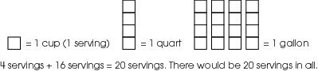

- 1 quart = 32 ounces = 4 cups. 1 gallon = 4 quarts. 4 x 4 = 16. 16 + 4 = 20. She can make 20 cups (servings).

Points | Student Response
2 | The focus of the task is to provide evidence of converting units within the same measurement system to figure out the number of 8-ounce servings. The response indicates the correct number of servings/cups AND provides work showing the correct conversion of units.  NOTE: Other conversion methods are acceptable (e.g., gallons to cups, quarts to cups).
1 | The response indicates partial evidence of how to convert units of measure; however, the solution is incomplete or slightly flawed.  For example, the response may:  - Make one correct conversion and one incorrect conversion.  - Indicate that one quart is 32 ounces and one gallon is the same as 128 ounces, and state that Coach Larson has 160 ounces of punch.  - State the correct answer without providing work (e.g., 20 cups can be made with this recipe).  - Use an inaccurate conversion but show an appropriate process.
0 | The response indicates inadequate evidence of how to convert units of measure. The response may have major flaws or be completely incorrect.  For example, the response may:  - State that a gallon is larger than a quart.  - Copy information that is stated in the stem

Keywords: measurement, liquid units, gallon, quart, ounces

BACK TO INDEX

Benchmark: C | Identify appropriate tools and apply appropriate techniques for measuring angles, perimeter or circumference and area of triangles, quadrilaterals, circles and composite shapes, and surface area and volume of prisms and cylinders.
GLI: MEA 7.7 | Develop strategies to find the area of composite shapes using the areas of triangles, parallelograms, circles and sectors.

Multiple Choice Question:
44. A circle is cut out of a square as shown.
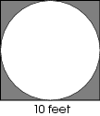
What is the approximate area of the shaded portion of the figure?
A. 22 square feet
B. 37 square feet
C. 69 square feet
D. 85 square feet

Commentary:
This multiple-choice question asks students to find the area of the shaded portion of a given figure. To solve this question, students must find the remaining area of the square after the area of the circle has been removed. They must also realize that the diameter of the circle is equal to the length of the side of the square. The area of the square can be determined by squaring the side length (10² = 100 square feet). The area of the circle can be found by using the formula
A = r² where r is the radius or half of the diameter or 5 ft. (A = 5² = 25 ≈ 78.5 square feet)
Finally the students need to find the difference between the area of the square and the area of the circle (100 - 78.5 ≈ 22 square feet), answer choice A. The student may have made a calculation error resulting in selecting answer choices B, C or D.

The complexity level of this question is Moderate Complexity. The question requires the student to retrieve information from a figure and use it to solve a problem requiring multiple steps.

Performance Data:
The percent of public school students selecting answer choice A for question 44 on the March 2006 Grade 7 Achievement Test was 50%.

Keywords: measurement, area, square, circle

BACK TO INDEX
Benchmark: G | Use and analyze the steps in standard and non-standard algorithms for computing with fractions, decimals and integers.
GLI:

Multiple Choice Question:

20. A realtor advertises the office space in a building as 3,600 square feet. The office space is square shaped.
What is the length of each side of the office space?

A. 25 feet
B. 60 feet
C. 300 feet
D. 900 feet

Commentary:
This multiple-choice question asks students to find the length of a side of a square. Since the area of a square is equal to the square of its sides, students can apply the concept of perfect squares to determine what number squared would result in 3600, (60 x 60 = 3600). Answer choice B is correct.
Answer choice A is obtained by dividing 3600 square feet by 144 (the number of square inches in one square foot). Answer choice C is the result of dividing 3600 square feet by 12 (the number of inches in one foot). Answer choice D is the result of finding the length of one side when the perimeter of a square area is 3600 feet.

The complexity level of this question is Moderate Complexity. The question requires students to bring together skills and knowledge from various domains and then perform a specific procedure.

Performance Data:
The percent of public school students selecting answer choice B for question 20 on the May 2007 Grade 7 Achievement Test was 29%.

Keywords: number, perfect square, square root

BACK TO INDEX

Benchmark: G | Understand and demonstrate the independence of perimeter and area for two-dimensional shapes and of surface area and volume for three-dimensional shapes.
GLI: MEA 7.8 | Understand the difference between surface area and volume and demonstrate that two objects may have the same surface area, but different volumes or may have the same volume, but different surface areas.

Multiple Choice Question:

28. How do the volumes and surface areas of these rectangular prisms compare?
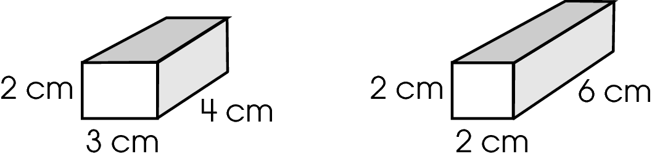

A. The volumes are the same, but the surface areas are different.
B. The volumes and surface areas are the same.
C. The volumes are different, but the surface areas are the same.
D. The volumes and surface areas are both different.

Commentary:
This multiple-choice question asks students to compare the volumes and surface areas of two rectangular prisms. Students can use one of several strategies to determine the volume of each prism. One strategy is to divide the prism into centimeter cubes.
Volume = 24 cm³ Volume = 24 cm³

The surface area can be found by finding the area of each side and adding them together.

Front and Back; 6 cm² + 6 cm² Front and Back; 4 cm² + 4 cm²
Top and bottom; 12 cm² + 12 cm² Top and bottom; 12 cm² + 12 cm²
Left and right sides; 8 cm² + 8 cm² Left and right sides; 12 cm² + 12 cm²
Total surface area 52 cm² Total surface area 56 cm²

Answer choice A is correct, “The volumes are the same, but the surface areas are different.”

Answer choice B may be the result of assuming that if the volumes are the same then the surface areas must also be the same. Students may have confused volume and surface area if they selected answer choice C. Students may have made a computational error in determining the volume if they selected answer choice D.

The complexity level of this question is Moderate Complexity. The question requires students to retrieve information from a figure and use it to solve a problem requiring multiple steps.

Performance Data:
The percent of public school students selecting answer choice A for question 28 on the May 2007 Grade 7 Achievement Test was 48%.

Keywords: measurement, volume, surface area, rectangular prism

BACK TO INDEX

Benchmark: A | Select appropriate units to measure angles, circumference, surface area, mass, volume, using U.S. customary units; e.g., degrees, square feet, pounds, and other units as appropriate; metric units: e.g., square meters, kilograms and other units as appropriate.
GLI: MEA 7.1 | Select appropriate units for measuring derived measurements; e.g., miles per hour, revolutions per minute.

Multiple Choice Question:

30. May Li read the first 30 pages of a novel in half an hour. The entire novel is 250 pages long. She wants to estimate how long it will take her to finish the book.
Which rate would be an appropriate measure of her reading speed?

A. hours per page
B. minutes per book
C. pages per minute
D. seconds per page

Commentary:
This multiple-choice question asks students to identify the derived unit of measure that would be appropriate to measure reading speed in a given situation. Students need to understand that speed is a unit of measure per time. In this problem, May Li reads 30 pages in half an hour or 30 minutes. A measure of speed could be pages per minute. Answer choice C is the correct derived unit of measure.
Answer choices A, B and D are incorrect because they are all units of time per unit of measure.

The complexity level of this question is Low Complexity. This question requires students to recognize an example of a concept.

Performance Data:
The percent of public school students selecting answer choice C for question 30 on the May 2007 Grade 7 Achievement Test was 78%.

Keywords: measurement, rate, speed

BACK TO INDEX

Benchmark: E | Use problem solving techniques and technology as needed to solve problems involving length, weight, perimeter, area, volume, time and temperature.
GLI: MEA 7.4 | Solve problems involving proportional relationships and scale factors; e.g., scale models that require unit conversions within the same measurement system.

Short Answer Question:

31. An Olympic-size pool is shown.
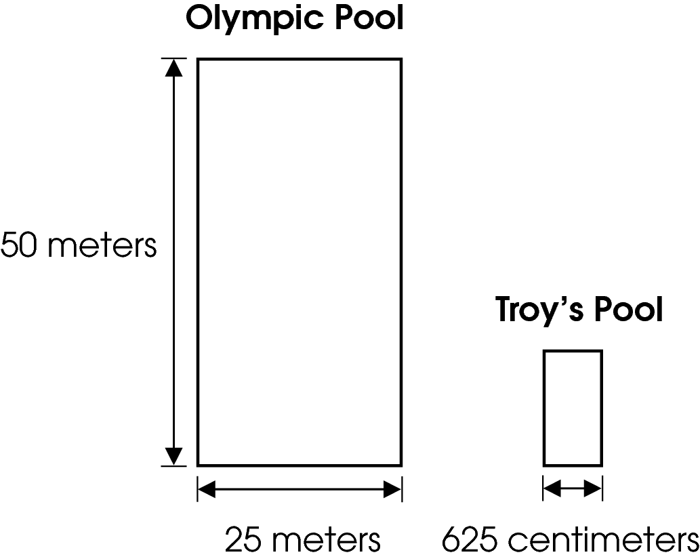
Troy is building a pool that is proportional to the Olympic-size pool. The width of his pool will be 625 centimeters.
In your Answer Document, find the scale factor Troy will use to build his pool.
Then show or explain how you found the scale factor. Use the scale factor to find the length of Troy's pool. Show or explain how you found the length.

Commentary:
This short-answer question asks students to determine the scale factor that was used to build a smaller pool and then to use the scale factor to find the length of the smaller pool. A response earning the maximum number of point (2 points) provides the scale factor and the length of Troy’s pool with supporting work for each. Students need to use properties of similar figures to determine the scale factor. First, students can convert the 625 centimeters to 6.25 meters or 25 meters to 2500 centimeters. Then they can set up the ratio between corresponding parts of the two pools $\left(\frac{\text{Troy}'s \text{Pool}}{\text{Olympic} \text{Pool}}\right) = \left(\frac{6\text{.}\text{25}}{\text{25}}\right) = \left(\frac{1}{4}\right)$. To find the length of Troy’s Pool, students can set up the proportion,
$$\begin{aligned}\left(\frac{1}{4} = \frac{\text{Troy}'s \text{pool} \text{length}\left(x\right)}{\text{50} \text{meters}}\right) \\ \text{50} = 4x \\ \text{12}\text{.}5 \text{meters} = x\end{aligned}$$

The length of Troy’s Pool will be 12.5 meters or 1250 centimeters.

The complexity level of this question is Moderate Complexity. This task requires students to retrieve information from a diagram and use it to solve a problem requiring multiple steps.

Performance Data:
The percent of public school students earning each score point for question 31 on the May 2007 Grade 7 Achievement Test:

Percent at Each Score Point
0 | 1 | 2
67% | 28% | 5%

Scoring Guidelines:
Student Response:

- The scale factor used to build Troy's pool is$\frac{1}{4}$. I found it by comparing the width of Troy's pool (625 cm = 6.25 m) to the width of the Olympic-size pool: $\frac{6\text{.}\text{25}}{\text{25}} = \frac{1}{4}$. To find the length of Troy's pool, I divided the length of the Olympic-size pool by 4: 50 ÷ 4 = 12.5. Troy's pool is 12.5 meters long.
- The width of Troy's pool compared to the width of the larger pool is 625:2500 or 1:4. To find the length of Troy's pool:$\frac{\text{625}}{\text{2500}} = \frac{x}{\text{5000}}$, x = 1250 cm. The length of Troy's pool is 1250 centimeters.
- 625 cm = 6.25 m. The scale factor of Troy's pool to the Olympic-size pool is$\frac{6\text{.}\text{25}}{\text{25}}$or$\frac{1}{4}$. The length and width of Troy's pool are$\frac{1}{4}$ the length and width of the larger pool. $\frac{1}{4}$ of 50 is 12.5, so the length of Troy's pool is 12.5 meters.
NOTE: A scale factor of 4:1 or 4 is acceptable, provided the response shows or states the relationship correctly.
Points | Student Response
2 point text | The focus of this task is solving problems involving proportional relationships and scale factors. The response provides the scale factor for the two pools and work showing how it was found. It gives the length of Troy's pool, with supporting work.
1 point text | The response shows partial evidence of solving problems involving proportional relationships and scale factors; however, the solution may be incomplete or slightly flawed.
1 point text | For example, the response may:  - Provide only the length of Troy's pool, with supporting work but no scale factor.  - Provide only the scale factor, with supporting work.  - Provide the scale factor and length but show no work.  - Find an incorrect scale factor but use it correctly to arrive at a length for Troy's pool.
0 point text | The response provides inadequate evidence of solving problems involving proportional relationships and scale factors. The response provides major flaws in explanations, or irrelevant information.
0 point text | For example, the response may:  - State an incorrect length.  - Restate the information provided in the item.  - Be blank or give irrelevant information.

Keywords: measurement, similar figures, scale factor, proportion

BACK TO INDEX

Benchmark: C | Identify appropriate tools and apply appropriate techniques for measuring angles, perimeter or circumference and area of triangles, quadrilaterals, circles and composite shapes, and surface area and volume of prisms and cylinders.
GLI: MEA 7.7 | Develop strategies to find the area of composite shapes using the areas of triangles, parallelograms, circles and sectors.

Multiple Choice Question:

43. A window consists of a semicircle and a rectangle, as shown.
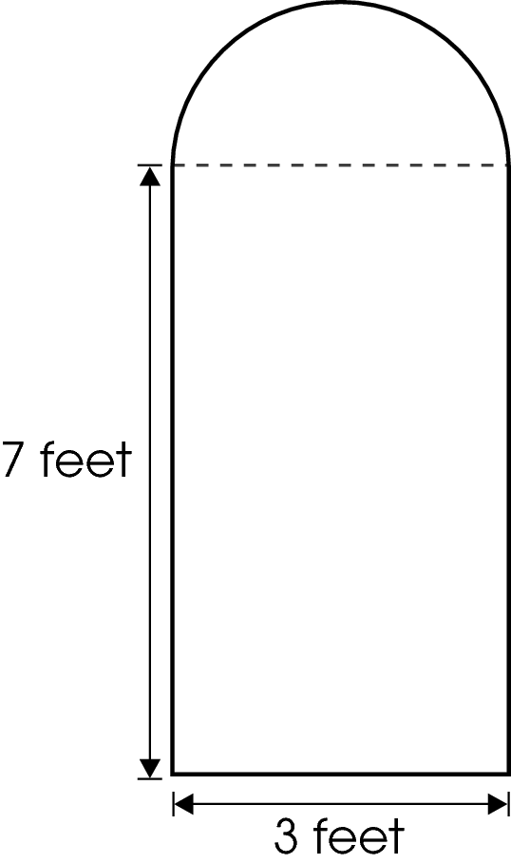
What is the approximate area of the window?

A. 21 square feet
B. 24$\frac{1}{2}$square feet
C. 28 square feet
D. 35$\frac{1}{2}$square feet

Commentary:
This multiple-choice question asks students to find the area of a window that is a composite of two shapes. Students must first identify the two shapes used to create the window shown. This window is made up of a rectangle and a semi-circle. The area of the rectangular section of the window can be found by multiplying the length and the width, 3 feet • 7 feet = 21 square feet. To find the area of the semi-circle students can find the area of the circle and divide it by 2. The diameter of the circle is equal to the width of the rectangle, 3 feet, therefore the radius of the circle is equal to half of its diameter, 1.5 feet. The area of the whole circle (A = r²) with a radius of 1.5 feet is about 7 square feet. The area of the semi-circle would be 3.5 square feet. The total area of the window would be 21 + 3.5 = 24.5 square feet, answer choice B.
Students who only found the area of the rectangular section of the window would have selected answer choice A. Students who selected answer choice C found the sum of the area of the rectangle and the area of the whole circle instead of the area of the semi-circle. Students selecting answer choice D may have used the diameter of 3 feet as the radius when finding the area of the semi-circle.

The complexity level of this question is Moderate Complexity. The question requires students to retrieve information from a figure and use it to solve a problem requiring multiple steps.

Performance Data:
The percent of public school students selecting answer choice B for question 43 on the May 2007 Grade 7 Achievement Test was 32%.

Keywords: measurement, area, composite shape, rectangle, semi-circle

BACK TO INDEX

Benchmark:  C  F | Identify appropriate tools and apply appropriate techniques for measuring angles, perimeter or circumference and area of triangles, quadrilaterals, circles, and composite shapes, and surface area and volume of prisms and cylinders.  Analyze and explain what happens to area and perimeter or surface area and volume when the dimensions of an object are changed.
GLI: MEA 7.6, MEA 7.9 | MEA 7.6: Use strategies to develop formulas for finding area of trapezoids and volume of cylinders and prisms.  MEA 7.9: Describe what happens to the surface area and volume of a three-dimensional object when the measurements of the object are changed; e.g., length of sides are doubled.

Extended Response Question:

26. Carson wanted to make a cylindrical pillow for his mother’s birthday. The pillow was to be 15 inches long, with a diameter of 6 inches and would be filled with stuffing.

In your Answer Document, determine how many cubic inches of stuffing Carson will need to make the pillow. Show your work.
Before he started making the pillow, Carson decided he wanted to make it bigger.
Compare the amount of stuffing needed when he doubles the length to the amount of stuffing needed when he doubles the diameter. Show work or provide an explanation to support your comparison.

Commentary:
This extended-response question asks students to find the volume of a three-dimensional cylindrical object and describe changes in the volume of this object if the measurements of the object have been changed. A response earning the maximum number of points (4 points) provides a correct strategy to find the number of cubic inches of stuffing needed for making the pillow and a comparison of the amount of stuffing needed for making a pillow when the length is doubled to the amount of stuffing needed when the diameter is doubled.

The amount of stuffing can be calculated using the formula for the volume of a cylinder
V = r²h.In this formula, r represents the radius (1/2 of diameter) of the circular base and h is the height of the cylinder (length of the pillow).
For making a pillow with a length of 15-inches and a diameter of 6-inches the amount of stuffing is calculated as shown.
V = r²h
V =   • 3² • 15
V = 424.12 in³
The amount of stuffing needed for the 6-inch diameter and
15-inch long pillow is 424.12 in³
For 12-inch diameter pillow (doubles diameter), the amount of stuffing can be calculated using the same formula for the volume of a cylinder

V = r²h
V =   • 6² • 15
V = 1696.46 in³
The amount of stuffing needed for the 12-inch diameter and
15–inch long pillow is 1696.46 in³
For 30-inch long pillow (doubles the length), the amount of stuffing can be calculated using the formula for the volume of a cylinder:

V = r²h
V =   • 3² • 30
V = 848.23 in³
The amount of stuffing needed for the 6–inch diameter and 30-inch long pillow is 848.23 in³
A comparison of the volume of the pillow with a 30–inch length to the volume of the pillow with the 12–inch diameter is shown below:

$\frac{\text{848}\text{.}\text{23}}{\text{1696}\text{.}\text{46}}$ = $\frac{1}{2}$

Carson would only need $\frac{1}{2}$the amount of stuffing if he doubles the length of the pillow compared to the amount of stuffing if he doubles the diameter of the pillow.

The complexity level of this question is High Complexity. This question asks students to solve a word – problem requiring multiple steps and provide mathematical justification for a solution process.

Performance Data:
The percent of public school students earning each score point for question 26 on the May 2008 Grade 7 Achievement Test:

Percent at Each Score Point
0 | 1 | 2 | 3 | 4
39% | 32% | 16% | 5% | 4%

Scoring Guidelines:
Exemplar Response:
Work for 6-inch diameter pillow:
V = r²h
V =  • 3² • 15
V = 424.12 in³
Carson needs 424.12 in³ of stuffing for the 6-inch diameter pillow
Work for 12-inch diameter pillow (doubles diameter):
V = r²h
V =  • 6² • 15
V = 1696.46 in³
Carson needs 1696.46 in³ of stuffing for the 12-inch diameter pillow
Work for the 30-inch long pillow (doubles the length):
V = r²h
V =  • 3² • 30
V = 848.23 in³
1696.46 / 848.23 = 2
Carson would only need $\frac{1}{2}$ the amount of stuffing if he doubles the length compared to if he doubles the diameter OR The amount of stuffing needed for the larger pillow is more than the amount needed for the smaller pillow.
Points | Student Response
4 | The focus of the task is finding the volume of a three-dimensional cylindrical object and describing changes in the volume of a three-dimensional object when the measurements of the object are changed. The response provides a correct strategy to find the number of cubic inches of stuffing Carson will need to make the pillow AND a comparison of the amount of stuffing needed when Carson doubles the length to the amount of stuffing needed when he doubles the diameter. The response also shows or explains all calculations.
3 | The response provides clear evidence of finding the volume of a three dimensional cylindrical object and describing changes in the volume of a three-dimensional object when the measurements of the object are changed; however, the solution is incomplete, slightly flawed with a minor calculation error.  For example, the response may:  - Finds all three volumes correctly but makes no comparisons.  - Makes a calculation error when finding volume (the same error may be carried out through all three volume calculations), and makes an accurate comparison based on those errors.  Calculation errors include:  - Not properly squaring the radius  - Using the diameter instead of the radius but squares correctly.  - Using  h or 2rh to find volume.  Doubling the diameter.
2 | The response provides partial evidence of finding the volume of a three-dimensional cylindrical object and describing changes in the volume of a three-dimensional object when the measurements of the object are changed; however, the solution is incomplete or slightly flawed.  For example, the response may:  - Provides a correct strategy to find the number of cubic inches of stuffing Carson will need to make the original pillow, showing or explaining most calculations.  - Provide a correct comparison of the amount of stuffing needed when Carson doubles the length to the amount of stuffing needed when he doubles the diameter, based on flawed calculations.  - Provide a strategy to find the number of cubic inches of stuffing Carson will need to make the pillow AND a comparison of the amount of stuffing needed when Carson doubles the length to the amount of stuffing needed when he doubles the diameter; but, contains multiple calculation errors.  - State for 12-inch-diameter pillow (doubled the diameter)  V = dh  V =  • 12 • 15  V = 565.49 in³  For 30-inch-long pillow (doubles the length):  V = dh  V =  • 6 • 30  V = 565.49 in³  565.49/ 565.49 = 1  Carson would need the same amount of stuffing if he doubles the length instead of doubling the diameter.
1 | The response provides minimal evidence of finding the volume of a three-dimensional cylindrical object and describing changes in the volume of a three-dimensional object when the measurements of the object are changed; however, the solution is incomplete or flawed.  For example, the response may:  - Provide a partially correct strategy to find the number of cubic inches of stuffing Carson will need to make the pillow with multiple calculation errors and no comparison.  - Provide an inadequate comparison of the amount of stuffing needed when Carson doubles the length to the amount of stuffing needed when he doubles the diameter with multiple calculation errors.
0 | The response provides inadequate evidence of finding the volume of a three-dimensional cylindrical object and describing changes in the volume of a three-dimensional object when the measurements of the object are changed. The response provides irrelevant information or major flaws in reasoning.  For example, the response may:  - State that doubling the length is definitely going to be much larger than doubling the diameter because the length is a bigger number to begin with.  - Be blank or make unrelated statements.  - Copy information from the stem.

Keywords: volume, length, diameter

BACK TO INDEX

Benchmark: C | Identify appropriate tools and apply appropriate techniques for measuring angles, perimeter or circumference and area of triangles, quadrilaterals, circles and composite shapes, and surface area and volume of prisms and cylinders.
GLI: MEA 7.7 | Develop strategies to find the area of composite shapes using the areas of triangles, parallelograms, circles and sectors.

Multiple Choice Question:

29. A tabletop in the shape of a trapezoid is made up of a rectangle and two congruent right triangles.
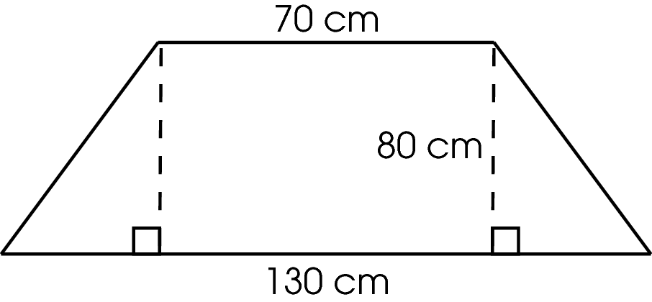
The bases of the trapezoid are 70 cm and 130 cm, and the height is 80 cm.
What is the area of the tabletop?

  - 240 sq cm
  - 5,600 sq cm
  - 8,000 sq cm
  - 10,400 sq cm

Commentary:
This multiple-choice question asks students to find the area of a tabletop that is in the shape of a trapezoid. The trapezoid is made up of two congruent right triangles and a rectangle. Each triangle has a height of 80 cm and a base of 30 cm ((130 – 70) 2 = 60 2 = 30). Therefore, the area of each right triangle is
A = $\frac{1}{2}$x Base x Height
A = $\frac{1}{2}$x (30) x (80)
A = 1,200 sq cm.

The rectangle has a height of 80 cm and a width of 70 cm. Therefore, its area is

A = Base x Width
A = 80 x 70
A = 5,600 sq cm.

The area of the trapezoid is the sum of the areas of all shapes used to create the trapezoid:
1,200 + 1,200 + 5,600 = 8,000 sq cm. So, answer choice C is correct.

If a student chooses answer choice A, he or she found only the sum of the areas of the two right triangles, 2,400 sq cm (1,200 + 1,200 = 2,400). If a student chooses answer choice B, he or she found only the area of the rectangle 5,600 sq cm (70 x 80 = 5,600). If a student chooses answer choice D, he or she multiplied the longer base of the trapezoid by the height of the trapezoid, 10,400 sq cm (130 x 70 = 10,400).

The complexity level of this question is Moderate Complexity. This question asks students to retrieve information from a figure and use it to solve a problem requiring multiple steps.

Performance Data:
The percent of public school students selecting answer choice C for question 29 on the May 2008 Grade 7 Achievement Test was 40%.

Keywords: measurement, area, trapezoid, composite shape, rectangle, triangle

BACK TO INDEX

Benchmark: A | Select appropriate units to measure angles, circumference, surface area, mass and volume, using: U.S. customary units; e.g., degrees, square feet, pounds, and other units as appropriate; metric units; e.g., square meters, kilograms and other units as appropriate.
GLI: MEA 7.1 | Select appropriate units for measuring derived measurements; e.g., miles per hour, revolutions per minute.

Multiple Choice Question:

38. A woman saves a part of each paycheck and hasn’t spent any of her savings. She has saved a total of $6,500 in the last 5 years.
Which unit could be used to measure her average rate of savings?

  - years/dollar
  - dollars/year
  - months/dollar
  - cents/dollar

Commentary:
This multiple-choice question asks students to identify the derived unit of measure that would be appropriate for measuring the average rate of saving.
The average rate of saving money is the amount of money (dollars) saved over a period of time (year). In this problem the average rate of savings is expressed as dollars/year;
answer choice B.

Answer choices A, C and D are incorrect because they are all units of time per unit of money saved.

The complexity level of this question is Moderate Complexity. This question requires students to compare statements.

Performance Data:
The percent of public school students selecting answer choice B for question 38 on the May 2008 Grade 7 Achievement Test was 60%.

Keywords: measurement, unit rate

BACK TO INDEX

Benchmark: E | Use problems solving techniques and technology as needed to solve problem involving length, weight, perimeter, area, volume, time and temperature.
GLI: MEA 7.4 | Solve problems involving proportional relationships and scale factors; e.g., scale models that require unit conversions within the same measurement system.

Multiple Choice Question:

43. Lisa’s father is an architect. He builds a cardboard model of each building he designs. The scale of his model to the actual building is 1 inch = 8 feet.
How tall will the actual building be when the model is 3 feet tall?

- 24 feet
- 96 feet
- 192 feet
- 288 feet

Commentary:
This multiple-choice question asks students to solve a problem using the scale factor. To determine the actual height of the building students first have to change the height of the model from feet to inches. Since 1 foot is 12 inches, 3 feet is 36 inches. The scale factor states that every 1 inch of the model equals 8 feet of actual building. Therefore, the 36 inches of the model equal 288 feet (36 inches x 8 feet per unit = 228 inches), answer choice D.

If a student chooses answer choice A, he or she ignored the scale factor and multiplied 8 feet by 3 feet (8 x 3 = 24). If a student chooses answer choice B, he or she made an attempt to use the scale factor by using the fact that there are 12 inches in a foot but only multiplied 8 feet by 12 feet (8 x 12 = 96). If a student chooses answer choice C, he or she multiplied 8 feet by 24 feet (8 x 24 = 192).

The complexity level of this question is High Complexity. This question requires students to perform a procedure having multiple steps.

Performance Data:
The percent of public school students selecting answer choice D for question 43 on the May 2008 Grade 7 Achievement Test was 42%.

Keywords: measurement, scale factor, proportion, length, height

BACK TO INDEX

