Index to Questions

Question Number | Source | BM | GLI | Description
2 | OAT Mar 06 | E | MEA 6.4 | This multiple-choice question asks students to choose the measure used to determine the amount of paint to buy.
5 | OAT Mar 06 | C | MEA 6.3a | This multiple-choice question asks students to estimate the number of 1-foot by 1-foot square tiles needed to cover a floor that is 85 feet long and 8 feet wide.
31 | OAT Mar 06 | F | MEA 6.6 | This extended-response task asks students to compare the perimeters and the areas of a rectangular playground that is 15 feet wide and 25 feet long with a new rectangular playground that has doubled the length and doubled the width.
40 | OAT Mar 06 | C | MA 6.3b | This multiple-choice question asks students to estimate the area of a triangular street sign with a height of 26 inches and a base of 30 inches.
42 | OAT Mar 06 | G | MEA 6.5 | This multiple-choice question asks students to select the description that is true for the given square and rectangle.
5 | OAT May 07 | C | MEA 6.3b | This multiple-choice question asks students to estimate the circumference of a circle given the radius.
34 | OAT May 07 | G | MEA 6.1 | This multiple-choice question asks students to select the statement that is true about the measurement and the label on a can.
43 | OAT May 07 | F | MEA 6.6 | This multiple-choice question asks students to determine which statement is true about the area and perimeter of the given square and rectangle.
9 | OAT May 08 | E | MEA 6.4 | This multiple-choice question asks students to determine the information Jeb needs to cover the floor with square tiles.
20 | OAT May 08 | G | MEA 6.1 | This multiple-choice question asks students to choose the measurement that represents the amount a container would hold.
32 | OAT May 08 | C | MEA 6.3b | This multiple-choice question asks students to determine the number of bricks needed to build a wall.
39 | OAT May 08 | C | MEA 6.3b | This multiple-choice question asks students to determine the estimated area of the circular section of a lawn that is watered by a sprinkler.

BACK TO INDEX

Benchmark: E | Use problem solving techniques and technology as needed to solve problems involving length, weight, perimeter, area, volume, time and temperature.
GLI: MEA 6.4 | Determine which measure (perimeter, area, surface area, volume) matches the context for a problem situation; e.g., perimeter is the context for fencing a garden, surface area is the context for painting a room.

Mathematical Processes
Benchmark: B | Apply and adapt problem-solving strategies to solve a variety of problems, including unfamiliar and non-routine problem situations.

Multiple Choice Question:

2. Joe wants to paint the outside of the toy chest shown.
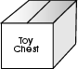
Which measure of the toy chest should he use to determine how much paint to buy?
A. height
B. perimeter
C. surface area
D. volume

Commentary:
This multiple-choice question asks students to choose the measure used to determine the amount of paint to buy. Students should recall the measure which describes painting or covering a surface. Answer choice C (surface area) is the measure to use to determine the amount of paint to buy.

The complexity level of this question is Low Complexity. This question requires students to recognize an example of a concept.

Performance Data:
The percent of public school students selecting answer choice C for question 2 on the March 2006 Grade 6 Achievement Test was 65%.

Keywords: measurement, surface area

BACK TO INDEX

Benchmark: C | Identify appropriate tools and apply appropriate techniques for measuring angles, perimeter or circumference and area of triangles, quadrilaterals, circles and composite shapes, and surface area and volume of prisms and cylinders.
GLI: MEA 6.3a | Estimate perimeter or circumference and area for circles, triangles and quadrilaterals, and surface area and volume for prisms and cylinders by:  - estimating lengths using string or links, areas using tiles or grid, and volumes using cubes;

Multiple Choice Question:

5. Square floor tiles will be put on the floor of a school hallway. Each tile is 1 foot by 1 foot. The hallway is 85 feet long and 8 feet wide.
About how many tiles will be needed to cover the floor of the hallway?
A. 95 tiles
B. 100 tiles
C. 200 tiles
D. 700 tiles

do not copy or distribute ID: 899; Version: 15

Commentary:
This multiple choice question asks students to estimate the number of 1-foot by 1-foot square tiles needed to cover a floor that is 85 feet long and 8 feet wide. Students may approach finding the number of tiles using different methods. For example,

Area of the floor is 680 square feet (85 × 8)
Area of the tile is 1 square foot (1 × 1)
680 square feet ÷ 1 square foot = 680 tiles

The number of tiles in answer choice D, 700 tiles, is a reasonable estimate for 680 tiles.

In answer choice A, all of the dimensions were added (1 + 1 + 85 + 8 = 95 tiles). In answer choice B the measurements were estimated appropriately, then added, while in answer choice C, the measurements of the tile were added, then multiplied by 100 to find the number of tiles.

The complexity level of this question is Moderate Complexity. This question requires students to solve a word problem requiring multiple steps.

Performance Data:
The percent of public school students selecting answer choice C for question 5 on the March 2006 Grade 6 Achievement Test was 62%.

Keywords: measurement, area, estimation

BACK TO INDEX

Benchmark: F | Analyze and explain what happens to area and perimeter or surface area and volume when the dimensions of an object are changed.
GLI: MEA 6.6 | Describe what happens to the perimeter and area of a two-dimensional shape when the measurements of the shape are changed; e.g. length of sides are doubled.

Mathematical Processes
Benchmark: E | Use deductive thinking to construct informal arguments to support reasoning and to justify solutions to problems,

Extended Response Question:

31. Marla and her cousins invented a game. Marla used chalk to draw a rectangle that was 15 feet wide and 25 feet long for a space to play her game.
Several other children joined in, and Marla realized that the rectangle was now too small. She doubled the length and doubled the width to create a new play area.
In your Answer Document, compare the perimeters of the original play space and the new play space. Determine how much greater the new perimeter is than the original perimeter. Show or explain your work.
Then, compare the areas of the original and the new play spaces. Determine how much greater the new area is than the original area. Show or explain your work.

Commentary:
This extended-response task asks students to compare the perimeters and the areas of a rectangular playground that is 15 feet wide and 25 feet long with a new rectangular playground that has doubled the length and doubled the width. A response earning the maximum number of points (4 points) indicates that the perimeter of the new rectangular playground is 80 feet longer than the perimeter of the original rectangular playground, and that the area of the new rectangular playground is 1125 square feet larger than the area of the original rectangular playground. Supporting work or an explanation is provided for each part of the task.

The complexity level of this task is Moderate Complexity. This task requires students to solve a word problem using multiple steps and make comparisons.

Performance Data:
The percent of public school students earning each score point for question 31 on the March 2006 Grade 6 Achievement Test:

Percent at Each Score Point
0 | 1 | 2 | 3 | 4
47% | 13% | 15% | 5% | 17%

Scoring Guidelines:
Sample Correct Response(s):
- New Length – 2 × 25 = 50 feet
New Width – 2 × 15 = 30 feet
Original chalk line: 25 + 25 + 15 + 15 = 80 feet
New Chalk line: 50 + 50 + 30 + 30 = 160 feet
160 – 80 = 80. The new chalk line is 80 feet longer or double than the original line.
Original Area: 25 × 15 = 375 square feet
New Area: 50 × 30 = 1500 square feet
1500 – 375 = 1125. The new area is 1125 square feet or 4 times larger than the original area.
Points | Student Response
4 | The focus of this task is finding the perimeter and area of a rectangular shape and describing what happens to the perimeter and area when the measurements of a shape are changed. The response provides a correct calculation of how much longer the new perimeter is, showing or explaining work, AND a correct calculation of how much larger the new area is, showing or explaining work.
3 | The response provides adequate evidence of finding the perimeter and area and describing what happens to the perimeter and area when the measurements of a shape are changed. The response provides work with a minor error or flaw in a calculation or explanation.  For example, the response may:  - Provide work with a calculation error in the area or perimeter, but base the comparison on that error.  - Provide correct work for the areas and perimeters, but state a comparison for the area or perimeter.
2 | The response provides partial evidence of finding the perimeter and area of a rectangular shape and describing what happens to the perimeter and area when the measurements of a shape are changed. The response provides work with minor errors or flaws OR vague explanation.  For example, the response may:  - Show work with calculation errors in the area and perimeter, and fail to state a conclusion.  - Provide the correct answers to how much larger the new perimeter is and how much larger the new area is; but, lacks an explanation or work.  - Provide correct work for the perimeters or the areas and comparison for the perimeter or the area.  - State, the new perimeter is 80 feet longer than the original one and the new area is 1,125 square feet larger than the original area.
1 | The response provides minimal evidence of finding the perimeter and area of a rectangular shape and describing what happens to the perimeter and area when the measurements of a shape are changed. The response provides work with multiple errors or flaws and a vague explanation.  For example, the response may:  - Provide the perimeter of the original or the new play space.  - Provide the area of the original or the new play space.  - Provide a partially accurate comparison of perimeter and area as it relates to the original and new play areas.  - State only the area and perimeter of the original play space.
0 | The response provides inadequate evidence of finding the perimeter and area of a rectangular shape and describing what happens to the perimeter and area when the measurements of a shape are changed. The response provides major flaws in explanation or irrelevant information.  For example, the response may:  - State the area and perimeter is doubled.  - Be blank or state unrelated statements.  - Recopy information from the stem.

Keywords: measurement, perimeter, area

BACK TO INDEX

Benchmark: C | Identify appropriate tools and apply appropriate techniques for measuring angles, perimeter or circumference and area of triangles, quadrilaterals, circles and composite shapes, and surface area and volume of prisms and cylinders.
GLI: MEA 6.3b | Estimate perimeter or circumference and area for circles, triangles and quadrilaterals, and surface area and volume for prisms and cylinders by:  - measuring attributes (diameter, side lengths, or heights) and using established formulas for circles, triangles, rectangles, parallelograms and rectangular prisms.

Multiple Choice Question:

40. The triangular street sign shown has a base 30 inches long and a height of 26 inches.
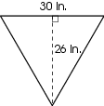
Which estimate of the area of the street sign is reasonable?
A. about 60 square inches
B. about 250 square inches
C. about 400 square inches
D. about 750 square inches

Commentary:
This multiple-choice question asks students to estimate the area of a triangular street sign with a height of 26 inches and a base of 30 inches. Students can use the established formula to find the area of the triangle, A = $\frac{1}{2}$bh, where A represents the area, b represents the base of the triangle and h represents the height of the triangle. Students should round 26 inches to
30 inches, since they are estimating the area of the triangle.

A = $\frac{1}{2}$bh
A = $\frac{1}{2}$ × 30 inches × 30 inches
A = 450 square inches

Students can also move half of the triangle to the other side of the original triangle to create a rectangle and find the area of the rectangle. For example,

Using 15 inches as the base and 30 inches as the height of the rectangle, the area would be about 450 square inches (15 inches × 30 inches).

The measurement in answer choice C, 400 square inches, is a reasonable estimate since one of the measurements was rounded up.

The complexity level of this question is Moderate Complexity. This question requires students to retrieve information form a figure and use it to solve a problem.

Performance Data:
The percent of public school students selecting answer choice C for question 40 on the March 2006 Grade 6 Achievement Test was 30%.

Keywords: measurement, area, triangle, estimation

BACK TO INDEX

Benchmark: G | Understand and demonstrate the independence of perimeter and area for two-dimensional shapes and of surface area and volume for three-dimensional shapes.
GLI: MEA 6.5 | Understand the difference between perimeter and area, and demonstrate that two shapes may have the same perimeter, but different areas or may have the same area, but different perimeters.

Multiple Choice Question:

42. The square and the rectangle have the dimensions shown.
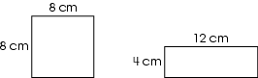
What description is true about the figures?
A. same area, same perimeter
B. same area, different perimeter
C. different area, same perimeter
D. different area, different perimeter

do not copy or distribute ID: 5876; Version: 8

Commentary:
This multiple-choice question asks students to select the description that is true for the given square and rectangle. In order to determine which of the descriptions is true, students need to find the perimeter and area of the square and rectangle. The perimeter of the square is 32 cm (8 × 4 = 32) and its area is 64 cm² (8 × 8 = 64). The perimeter of the rectangle is 32 cm (12 × 2 + 4 × 2 = 32) and its area is 48 cm² (12 × 4 = 48). The square and the rectangle have the same perimeters (32 cm), but different areas (64 cm² for the square and 48 cm² for the rectangle). Answer choice C is the correct answer.

The complexity level of this question is Moderate Complexity. This question requires students to retrieve information from a figure and use it to solve a problem.

Performance Data:
The percent of public school students selecting answer choice C for question 42 on the March 2006 Grade 6 Achievement Test was 54%.

Keywords: measurement, perimeter, area

BACK TO INDEX

Benchmark: C | Identify appropriate tools and apply appropriate techniques for measuring angles, perimeter or circumference and area of triangles, quadrilaterals, circles and composite shapes, and surface area and volume of prisms and cylinders.
GLI: MEA 6.3b | Estimate perimeter or circumference and area for circles, triangles and quadrilaterals, and surface area and volume for prisms and cylinders by:  b. measuring attributes (diameter, side lengths, or heights) and using established formulas for circles, triangles, rectangles, parallelograms and rectangular prisms.

Multiple Choice Question:

5. A circle with a radius of 8 inches is shown.
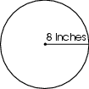
Which estimate of the circumference of this circle is reasonable?
A. about 5 inches
B. about 16 inches
C. about 24 inches
D. about 48 inches

Commentary:
This multiple-choice question asks students to estimate the circumference of a circle given the radius. Students should know the relationships among the radius, diameter and circumference of a circle. The circumference of a circle is about three times the diameter of the circle and the radius is half of the diameter. The radius of the circle is given as 8 inches. This means that the diameter is 16 inches, since 8 is half of 16. The circumference of the circle would be about 48 inches or three times the diameter (3 × 16). The correct answer choice is D.

Answer choices A, B and C are incorrect. Answer choice A is the result of dividing the diameter by 3. Answer choice B represents the length of the diameter. Answer choice C is the result of multiplying the radius by 3.

The complexity level of this question is Moderate Complexity. This question requires students to retrieve information from a figure and use it to solve a problem.

Performance Data:
The percent of public school students selecting answer choice D for question 5 on the May 2007 Grade 6 Achievement Test was 38%.

Keywords: measurement, circle, circumference, diameter, radius

BACK TO INDEX

Benchmark: G | Understand and demonstrate the independence of perimeter and area for two-dimensional shapes and of surface area and volume for three-dimensional shapes.
GLI: MEA 6.1 | Understand and describe the difference between surface area and volume.

Multiple Choice Question:

34. A can of tomato soup and its label are shown.
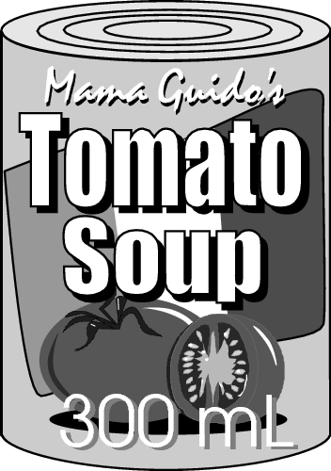
Which statement is true?

A. The label represents surface area and the perimeter is 300 mL.
B. The label represents surface area and the volume is 300 mL.
C. The label represents volume and the surface area is 300 mL.
D. The label represents volume and the perimeter is 300 mL.

Commentary:
This multiple-choice question asks students to select the statement that is true about the measurement and the label on a can. Students need to know that the 300 mL on the label represent the volume since it tells the amount of soup the can holds. The label represents surface area since it is the amount of material needed to cover the lateral surface of the can. The statement in answer choice B is correct.

The statement in answer choice A is incorrect since only part of the statement is true about the 300 mL and the label. The statements in answer choices C and D are incorrect since neither of the statements about the 300 mL and the label are true.

The complexity level of this question is Moderate Complexity. This question requires students to interpret a visual representation and compare statements.

Performance Data:
The percent of public school students selecting answer choice B for question 34 on the May 2007 Grade 6 Achievement Test was 61%.

Keywords: measurement, surface area, volume

BACK TO INDEX

Benchmark: F | Analyze and explain what happens to area and perimeter or surface area and volume when the dimensions of an object are changed.
GLI: MEA 6.6 | Describe what happens to the perimeter and area of a two-dimensional shape when the measurements of the shape are changed; e.g. length of sides are doubled.

Multiple Choice Question:

43. A square and a rectangle are shown.
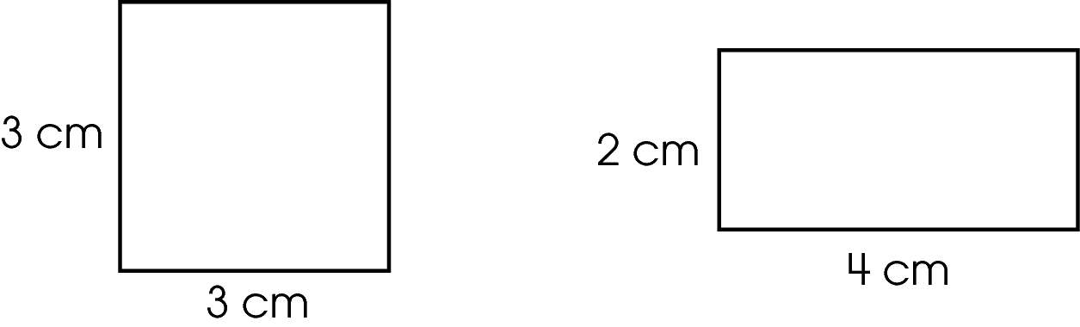
Which statement is true about these two figures?

A. They have the same area and the same perimeter.
B. They have different areas and the same perimeter.
C. They have the same area and different perimeters.
D. They have different areas and different perimeters.

Commentary:
This multiple-choice question asks students to determine which statement is true about the area and perimeter of the given square and rectangle. Students need to find the area and perimeter of the square and the rectangle to select the true statement. The area of the square is 9 square cm (3 cm × 3 cm) and the perimeter is 12 cm (3 cm + 3 cm + 3 cm + 3 cm). The area of the rectangle is 8 square cm (2 cm × 4 cm) and the perimeter is 12 cm (2 cm + 4 cm + 2 cm + 4 cm). This shows that the areas are different, but the perimeters are the same. Answer choice B is correct.

The statements in answer choices A, C and D are not true statements about the square and the rectangle.

The complexity level of this question is Moderate Complexity. This question requires students to compare statements.

Performance Data:
The percent of public school students selecting answer choice B for question 43 on the May 2007 Grade 6 Achievement Test was 58%.

Keywords: measurement, perimeter, area, square, rectangle

BACK TO INDEX

Benchmark: E | Use problem solving techniques and technology as needed to solve problems involving length, weight, perimeter, area, volume, time and temperature.
GLI: MEA 6.4 | Determine which measure (perimeter, area, surface area, volume) matches the context for a problem situation; e.g., perimeter is the context for fencing a garden, surface area is the context for painting a room.

Multiple Choice Question:

9. Jeb wants to cover the floor of a sixth-grade classroom with square tiles.
What information does Jeb need?

A. the area of the floor and the area covered by each tile
B. the volume of the classroom and the volume of each tile
C. the perimeter of the classroom and the perimeter of each tile
D. the height of the classroom and the height of each tile

Commentary:
This multiple-choice question asks students to determine the information Jeb needs to cover the floor with square tiles. Students should recall that covering a floor with tiles is an example of finding the area of the floor. Therefore, answer choice A is correct.

Answer choices B, C and D are incorrect. Volume is the amount of space inside the classroom and perimeter is the distance around the classroom. The height of the classroom is not needed to cover the floor.

The complexity level of this question is Low Complexity. This question requires students to recognize an example of a concept.

Performance Data:
The percent of public school students selecting answer choice A for question 9 on the May 2008 Grade 6 Achievement Test was 74%.

Keywords: measurement, area

BACK TO INDEX

Benchmark: G | Understand and demonstrate the independence of perimeter and area for two-dimensional shapes and of surface area and volume for three-dimensional shapes.
GLI: MEA 6.1 | Understand and describe the difference between surface area and volume.

Multiple Choice Question:

20. A carryout restaurant is choosing between two different soup containers. The manager wants to choose the container that holds the most soup.
What measurement should the manager use to decide?

A. circumference
B. surface area
C. perimeter
D. volume

Commentary:
This multiple-choice question asks students to choose the measurement that represents the amount a container would hold. Students should recall that volume is the amount of space occupied by a solid. The measurement that describes the amount of soup that a container holds is volume, answer choice D.

The measurement in answer choices A and C represent the distance around the outside of the base of the container. The measurement in answer choice B represents the area of the surfaces of the container.

The complexity level of this question is Low Complexity. This question requires students to recognize an example of a concept.

Performance Data:
The percent of public school students selecting answer choice D for question 20 on the May 2008 Grade 6 Achievement Test was 79%.

Keywords: measurement, volume

BACK TO INDEX

Benchmark: C | Identify appropriate tools and apply appropriate techniques for measuring angles, perimeter or circumference and area of triangles, quadrilaterals, circles and composite shapes, and surface area and volume of prisms and cylinders.
GLI: MEA 6.3b | Estimate perimeter or circumference and area for circles, triangles and quadrilaterals, and surface area and volume for prisms and cylinders by:  - measuring attributes (diameter, side lengths, or heights) and using established formulas for circles, triangles, rectangles, parallelograms and rectangular prisms.

Multiple Choice Question:

32. Pam is building a brick wall between her flower garden and her patio.
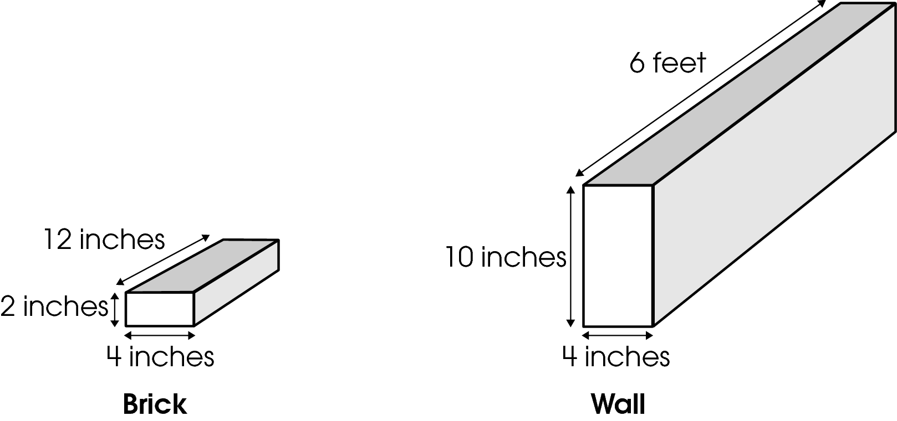
Each brick is 12 inches long, 4 inches wide and 2 inches tall. The wall will be 6 feet long, 4 inches wide and 10 inches tall.
How many bricks will Pam need to build the wall?

A. 5 bricks
B. 6 bricks
C. 30 bricks
D. 240 bricks

Commentary:
This multiple-choice question asks students to determine the number of bricks needed to build a wall. Students are provided the dimensions of a brick (12 inches by 2 inches by 4 inches) and the dimensions of the wall (6 feet by 10 inches by 4 inches). First, students need to change 6 feet to inches. Since there are 12 inches in 1 foot, there are 72 inches in 6 feet (12 inches per foot × 6 feet = 72 inches). Then, students can determine the number of bricks needed to build the wall. For example, the length of the wall would be 6 bricks long (72 inches ÷ 12 inches). The height of the wall would be 5 bricks tall (10 inches ÷ 2 inches). The width of the wall would be 1 brick wide (4 inches ÷ 4 inches). The complete wall would need 30 bricks (6 × 5 × 1). Answer choice C is correct.

Answer choice A, B and D are incorrect. Answer choice A is the number of bricks for the height of the wall, whereas answer choice B is the number of bricks for the length of the wall. Answer choice D is the result of multiplying the dimensions in the wall without regard to the units of measure (6 feet ×10 inches × 4 inches).

The complexity level of this question is High Complexity. This question requires students to perform a procedure having multiple steps and multiple decision points.

Performance Data:
The percent of public school students selecting answer choice C for question 32 on the May 2008 Grade 6 Achievement Test was 61%.

Keywords: measurement, conversion

BACK TO INDEX

Benchmark: C | Identify appropriate tools and apply appropriate techniques for measuring angles, perimeter or circumference and area of triangles, quadrilaterals, circles and composite shapes, and surface area and volume of prisms and cylinders.
GLI: MEA 6.3b | Estimate perimeter or circumference and area for circles, triangles and quadrilaterals, and surface area and volume for prisms and cylinders by:  b. measuring attributes (diameter, side lengths, or heights) and using established formulas for circles, triangles, rectangles, parallelograms and rectangular prisms.

Multiple Choice Question:

39. A sprinkler waters a circular section of a square lawn as shown.
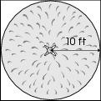
The radius of the section watered by the sprinkler is 10 feet.
What is the estimated area of the circular section that the sprinkler waters?

A. about 100 square feet
B. about 200 square feet
C. about 300 square feet
D. about 400 square feet

Commentary:
This multiple-choice question asks students to determine the estimated area of the circular section of a lawn that is watered by a sprinkler. The radius of the circular section that is watered is given as 10 ft.

Students should recall that the area of a circle is about three times the radius squared. Therefore, an estimate of the area of the circular section of the lawn watered by the sprinkler is about 300 square feet (3 × 10 feet × 10 feet = 300 square feet).

Answer choices A, B and D are incorrect. Answer choice A is the result of squaring the radius (10 ft × 10 ft = 100 square feet). Answer choice B is the result of squaring the radius then multiplying by 2 (10 ft × 10 ft × 2 = 200 square feet). Answer choice D is the result of finding the area of the entire lawn (20 ft × 20 ft = 400 square feet).

The complexity level of this question is Moderate Complexity. This question requires students to retrieve information from a figure and use it to solve a problem.

Performance Data:
The percent of public school students selecting answer choice C for question 39 on the May 2008 Grade 6 Achievement Test was 39%.

Keywords: measurement, area, circle, radius

BACK TO INDEX

