Index to Questions

Question Number | Source | BM | GLI | Description
4 | OAT Mar 06 | C | MEA 5.6 | This multiple-choice question asks students to determine the number of 2-foot sections of fencing needed to go around a rectangular flower bed that is 4 feet wide and 6 feet long.
9 | OAT Mar 06 | C | MEA 5.7 | This multiple-choice question asks students to use a protractor to measure the given angle.
19 | OAT Mar 06 | F | MEA 5.4 | This multiple-choice question asks students to select the unit of measure which describes the amount of carpet used to cover a floor.
25 | OAT Mar 06 | G | MEA 5.3 | This short-answer question asks students to explain the difference between the volume of a box and the surface area of a box.
31 | OAT Mar 06 | B | MEA 5.5 | This multiple-choice question asks students to find the weight, in pounds, of a 3 ton truck.
34 | OAT Mar 06 | E | MEA 5.2 | This multiple-choice question asks students to determine the direction from one point on a coordinate grid to another point.
38 | OAT Mar 06 | B | MEA 5.5 | This short-answer question asks students to determine the amount of time needed to meet a specific goal.
8 | OAT May 07 | C | MEA 5.6 | This multiple-choice question asks students to select the numerical expression that represents the area of the parallelogram shown.
13 | OAT May 07 | C | MEA 5.7 | This multiple-choice question asks students to recognize an angle in a diagram that appears to be greater than 90°.
30 | OAT May 07 | B | MEA 5.5 | This multiple-choice question asks students to determine the number of laps around a 400-meter oval track during a 6-kilometer race.
2 | OAT May 08 | C (3-4)  G | MEA 4.2, MEA 5.3 | This multiple-choice question asks students to determine the measure that represents the amount of paper needed to wrap a box.
5 | OAT May 08 | C | MEA 5.4, MEA 5.6 | This short-answer question asks students to find the area and perimeter of the given rectangle using the appropriate units.
12 | OAT May 08 | A  B (K-2) | MEA 2.1a | This multiple-choice question asks students to determine the unit which is appropriate for describing the height of a flag after it is raised.
Question Number | Source | BM | GLI | Description
24 | OAT May 08 | C | MEA 5.7 | This multiple-choice question asks students to estimate the measure of angle P shown in the bird house.
43 | OAT May 08 | B & C | MEA 4.5, MEA 5.5 | This multiple-choice question asks students to determine the number of quarts left over from 6 gallons of milk after they drank 10 quarts.

BACK TO INDEX

Benchmark: C | Identify appropriate tools and apply appropriate techniques for measuring angles, perimeter or circumference and area of triangles, quadrilaterals, circles, and composite shapes, and surface area and volume of prisms and cylinders.
GLI: MEA 5.6 | Use strategies to develop formulas for determining perimeter and area of triangles, rectangles and parallelograms, and volume of rectangular prisms.

Multiple Choice Question:

4. Joe is putting a low fence around all four sides of a rectangular flower bed. The flower bed is 4 feet wide and 6 feet long.

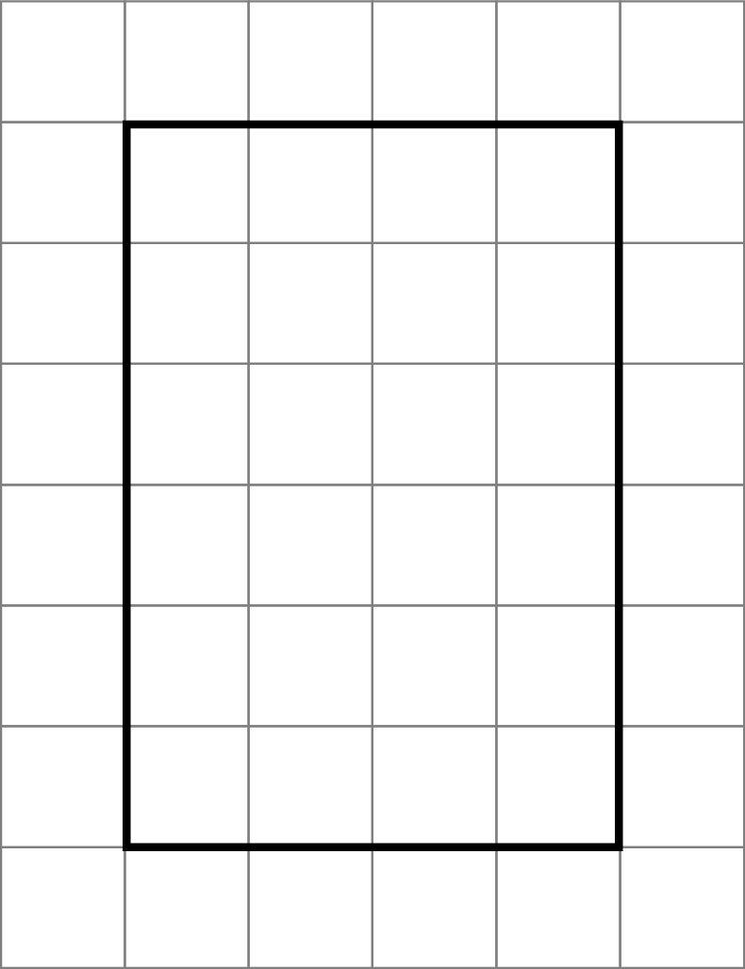

Each section of fencing is 2 feet long. How many sections of fencing will Joe need?

A. 10 sections
B. 20 sections
C. 24 sections
D. 40 sections

Commentary:
This multiple-choice question asks students to determine the number of 2-foot sections of fencing needed to go around a rectangular flower bed that is 4 feet wide and 6 feet long. Students should recall that the perimeter is the measure to be used when finding the distance around a figure. Students can use various strategies to solve this problem, such as using a counting technique or a strategy to develop the formula for finding the perimeter. Students should recall that pairs of opposite sides of a rectangle have the same length; therefore, adding the measurements (4 + 6 + 4 + 6 = 20 feet) is the same as finding the perimeter. Since each section of fencing is 2 feet long, then 20 feet should be divided by 2, resulting in 10 sections of fencing being needed to go around the rectangular flower bed.

Students can also count the number of 2-feet sections around the flower bed shown in the drawing to determine the number of sections needed.

The complexity level of this question is Moderate Complexity. This question requires students to retrieve information from a figure and use it to solve a problem.

Performance Data:
The percent of public school students selecting answer choice A for question 4 on the March 2006 Grade 5 Achievement Test was 26%.

Keywords: measurement, perimeter

BACK TO INDEX

Benchmark: C | Identify appropriate tools and apply appropriate techniques for measuring angles, perimeter or circumference and area of triangles, quadrilaterals, circles and composite shapes, and volume of prisms and cylinders.
GLI: MEA 5.7 | Use benchmark angles (e.g.; 45º, 90º, 120º) to estimate the measure  of angles, and use a tool to measure and draw angles.

Multiple Choice Question:

9. Angle KJL is shown.
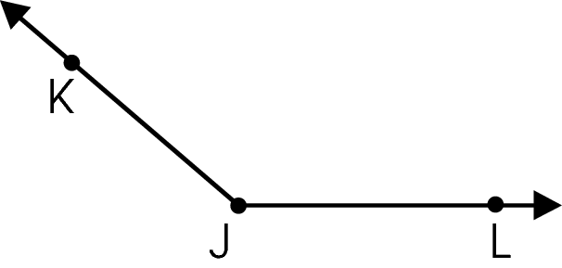
Use your protractor to find the measure of angle KJL.
- 60 °
- 80 °
- 140 °
- 160 °

do not copy or distribute ID: 10545; Version: 7

Commentary:
This multiple-choice question asks students to use a protractor to measure the given angle. Students need to recognize that the angle is an obtuse angle since it appears to be greater than 90°. When reading the measure of the angle on the protractor, students should read the measure that is greater than 90°. Answer Choice C is the correct angle measure. Answer choices A and B should be eliminated since the measures of the angles are less than 90°. Answer choice D may be a result of the incorrect placement of the protractor when measuring the angle.

The complexity level of this question is Low Complexity. This question requires students to measure an angle.

Performance Data:
The percent of public school students selecting answer choice C for question 9 on the March 2006 Grade 5 Achievement Test was 87%.

Keywords: measurement, angle measure, protractor

BACK TO INDEX

Benchmark: F | Analyze and explain what happens to area and perimeter or surface area and volume when the dimensions of an object are changed.
GLI: MEA 5.4 | Demonstrate understanding of the differences among linear units, square units and cubic units.

Multiple Choice Question:

19. Bob covered a floor with carpet.
Which unit of measure describes how much carpet he used?
A. inches
B. feet
C. square feet
D. cubic inches

Commentary:
This multiple-choice question asks students to select the unit of measure which describes the amount of carpet used to cover a floor. Students should recall that covering a floor with carpet is an example of finding the area of the floor and that area is measured in square units. The measure in answer choice C, square feet, is an appropriate measure for the amount of carpet used to cover a floor. The measure in answer choices A and B are linear units that are used for measuring perimeter or circumference, while the measure in answer choice D, cubic inches, is used for measuring volume.

The complexity level of this question is Low Complexity as it requires students to recognize an example of a concept.

Performance Data:
The percent of public school students selecting answer choice C for question 19 on the March 2006 Grade 5 Achievement Test was 71%.

Keywords: measurement, unit

BACK TO INDEX

Benchmark: G | Understand and demonstrate the independence of perimeter and area for two-dimensional shapes and of surface area and volume for three-dimensional shapes.
GLI: MEA 5.3 | Demonstrate and describe the differences between covering the faces (surface area) and filling the interior (volume) of three-dimensional objects.

Mathematical Processes
Benchmark: J | Communicate mathematical thinking to others and analyze the mathematical thinking and strategies of others.

Short Answer Question:

- Justin keeps his toys in a box like the one shown.
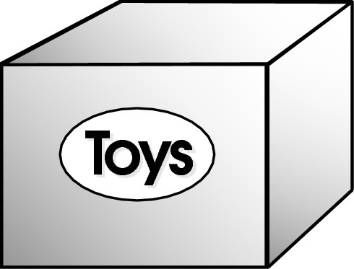
In your Answer Document, explain the difference between the volume and the surface area of the box.

Commentary:
This short-answer question asks students to explain the difference between the volume of a box and the surface area of a box. The response earning the maximum number of points (2 points) provides an adequate explanation of the difference between the volume of the box and the surface area of the box. For example, the volume of the box may be explained as the space inside the box and the surface area may be explained as the sum of the area of all the faces of the box.

The complexity level of this question is High Complexity. This task requires students to analyze differences between concepts.

Performance Data:
The percent of public school students earning each score point for question 25 on the March 2006 Grade 5 Achievement Test:

Percent at Each Score Point
0 | 1 | 2
41% | 35% | 21%

Scoring Guidelines:
Sample Correct Response(s):
- The surface area is the area of the faces (top, bottom and sides) of the toy box and the volume is the amount of space inside the toy box.
- The surface area is measured with square units but the volume is measured in cubic units.
- The surface area is how much material is used to cover the toy box and the volume is how many toys Justin can fit into the box.
Points | Student Response
2 | The focus of this task is describing the difference between surface area and volume for a three-dimensional object. The response provides an adequate explanation of the difference between surface area and volume, using appropriate examples.
1 | The response provides partial evidence of describing the difference between surface area and volume for a figure; however, the solution may be incomplete or slightly flawed.  For example, the response may:  - Provide an adequate explanation of surface area as it pertains to the toy box, but the explanation of volume is incorrect or missing.  - Provide an adequate explanation of volume as it pertains to the toy box, but the explanation of surface area is incorrect or missing.  - State that the surface area is outside of the box and/or the volume is inside of the box.
0 | The response provides inadequate evidence of describing the difference between surface area and volume for a figure. The response provides major flaws in reasoning or irrelevant information.  For example, the response may:  - State that volume and surface area are the same.  - Be blank or provide unrelated statements.  - Recopy information from the stem.

Keywords: measurement, volume, surface area

BACK TO INDEX

Benchmark: B | Convert units of length, area, volume, mass and time within the same measurement system.
GLI: MEA 5.5 | Make conversions within the same measurement system while performing computations.

Multiple Choice Question:

31. A pickup truck weighs 3 tons.
How many pounds does the truck weigh?
A. 600 pounds
B. 2,000 pounds
C. 3,000 pounds
D. 6,000 pounds

do not copy or distribute ID: 10705; Version: 10

Commentary:
This multiple-choice question asks students to find the weight, in pounds, of a 3 ton truck. Students need to know that there are 2,000 pounds in 1 ton. Therefore, there would be 6,000 pounds in 3 tons (2,000 pounds per ton × 3 tons = 6,000 pounds). Answer choice D is the correct answer. Answer choice A is incorrect because only 200 pounds was used for each ton. Answer choice B is incorrect because it identifies the number of pounds for 1 ton instead of 3 tons. Answer choice C is incorrect because only 1,000 pounds was used for each ton.

The complexity level of this question is Low Complexity. This question requires students to recall a fact.

Performance Data:
The percent of public school students selecting answer choice D for question 31 on the March 2006 Grade 5 Achievement Test was 47%.

Keywords: measurement, conversion, ton, pounds

BACK TO INDEX

Benchmark: E | Use problem solving techniques and technology as needed to solve problems involving length, weight, perimeter, area, volume, time and temperature.
GLI: MEA 5.2 | Identify paths between points on a grid or coordinate plane and compare the lengths of the paths; e.g., shortest path, paths of equal length.

Multiple Choice Question:

34. Point J and point K are shown on the grid.
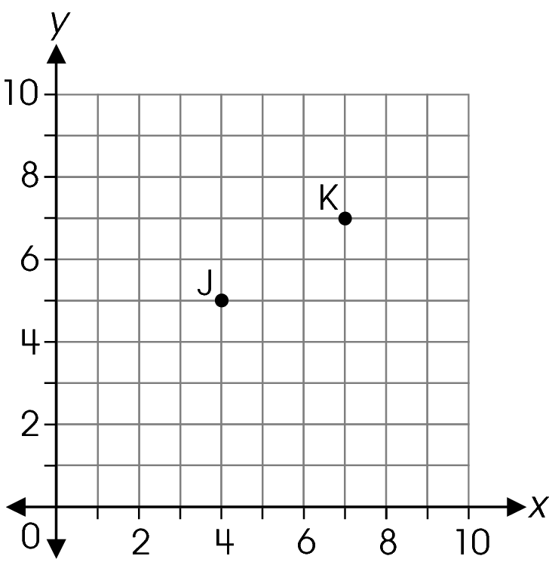
What is the direction from point J to point K along the grid lines?

A. 3 units right and 2 units up
B. 3 units right and 3 units up
C. 4 units right and 3 units up
D. 4 units right and 2 units up

Commentary:
This multiple-choice question asks students to determine the direction from one point on a coordinate grid to another point. Students need to locate point J and follow the path along the grid lines to point K. One way to get to point K from point J, is to move 3 units to the right, then up 2 units to point K, answer choice A. Answer choices B, C and D are incorrect because the move from point J will not end at point K.

The complexity level of this question is Low Complexity. This question requires students to perform a specified procedure.

Performance Data:
The percent of public school students selecting answer choice A for question 34 on the March 2006 Grade 5 Achievement Test was 67%.

Keywords: geometry, coordinate grid, path

BACK TO INDEX

Benchmark: B | Convert units of length, area, volume, mass and time within the same measurement system.
Benchmark: B | Convert units of length, area, volume, mass and time within the same measurement system.
GLI: MEA 5.5 | Make conversions within the same measurement system while performing computations.

Short Answer Question:

38. Peter’s goal is to read 5 hours every school week. He reads every evening during the school week and records his time in the chart shown.
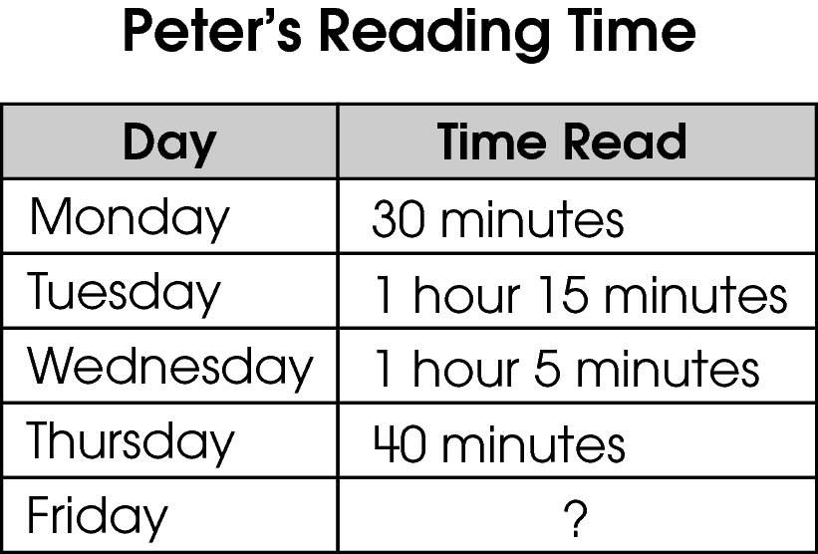
In your Answer Document, determine how much time Peter should read on Friday to meet his goal. Show or explain how you found your answer. (2 points)

Commentary:
This short-answer question asks students to determine the amount of time needed to meet a specific goal. The response earning the maximum number of points (2 points) provides the amount of time needed to meet the specified goal with supporting work or an adequate explanation. Students need to first determine the total amount of time read for the four days using the information given in the chart. If students add the times given for the four days, they will get 2 hours 90 minutes. This time needs to be converted to 3 hours 30 minutes because there is one hour in the 90 minutes, with 30 minutes left over. Students need to use this time to determine the amount of time needed to read on Friday to meet the goal. Students can count up to 5 hours to determine this time needed to meet the goal or subtract the hours already read from 5 hours. For example,

30 minutes + 1 hour 15 minutes + 1 hour 5 minutes + 40 minutes = 2 hours 90 minutes
2 hours 90 minutes = 3 hours 30 minutes because there is 1 more hour in 90 minutes and 30 minutes left over. Peter has already read 3 hours 30 minutes for the four days. Adding 30 minutes to this time is 4 hours plus one more hour is 5 hours. Peter needs to read 1 hour and 30 minutes more to meet his goal of reading 5 hours every school week.

The complexity level of this question is Moderate Complexity. This task requires students to retrieve information from a chart and use it to solve a problem.

Performance Data:
The percent of public school students earning each score point for question 38 on the March 2006 Grade 5 Achievement Test:

Percent at Each Score Point
0 | 1 | 2
50% | 21% | 27%

Scoring Guidelines:
Correct Sample Response(s):
- 30 minutes + 1 hour 15 minutes + 1 hour 5 minutes + 40 minutes = 2 hours 90 minutes; 60 minutes = 1 hour so 2 hours 90 minutes = 3 hours 30 minutes. 5 hours – 3 hours 30 minutes = 1 hour 30 minutes.
- 60 minutes = 1 hour, so 30 minutes + 75 minutes + 65 minutes + 40 minutes = 210 minutes. 5 hours = 300 minutes, so 300 minutes – 210 minutes = 90 minutes. Peter must read for 90 minutes.
- 3 hours 30 minutes = 3.5 hours so 5 hours – 3.5 hours = 1.5 hours.
Points | Student Response
2 | The focus of this task is converting units of time within the same measurement system. The response correctly determines the time Peter should read on Friday with supporting work or an adequate explanation.
1 | The response provides partial evidence of converting units of time within the same measurement system; however, the solution may be incomplete or slightly flawed.  For example, the response may:  - Show a minor computational error when converting, adding or subtracting.  - Find only the total time Peter has already read.  - Provide the correct answer without an explanation or work.
0 | The response provides inadequate evidence of converting units of time within the same measurement system. The response provides major flaws in conversion or irrelevant information.  For example, the response may:  - State 100 minutes.  - Be blank or provide unrelated statements.  - Recopy information from the stem.
Keywords: measurement, time, conversions

BACK TO INDEX

Benchmark: C | Identify appropriate tools and apply appropriate techniques for measuring angles, perimeter or circumference and area of triangles, quadrilaterals, circles and composite shapes, and volume of prisms and cylinders.
GLI: MEA 5.6 | Use strategies to develop formulas for determining perimeter and area of triangles, rectangles and parallelograms, and volume of rectangular prisms.

Multiple Choice Question:

- A parallelogram is shown on the grid.
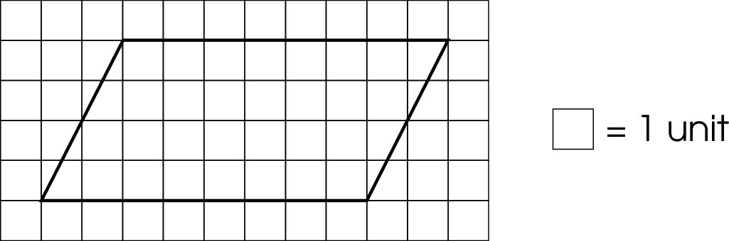
Which expression represents the area of this parallelogram?

A. 6 + 6 + 4 + 4
B. 8 + 8 + 4 + 4
C. 6 × 4
D. 8 × 4

Commentary:
This multiple-choice question asks students to select the numerical expression that represents the area of the parallelogram shown. Students can use various strategies to find the area of the parallelogram. For example, students can count the squares inside the parallelogram. The parallelogram can be divided into a rectangle and two triangles. There are 24 squares inside the rectangular part of the parallelogram. Moving the two triangular parts together will create another rectangle that is 2 units in length and 4 units in height. Therefore, there are 8 squares inside the triangular parts of the parallelogram. This means the area of the parallelogram is 32 square units, the total number of squares inside the rectangular part of the parallelogram and the inside the triangular parts of the parallelogram. Answer choice D, 8 × 4, can be used to find the area of the parallelogram.
Answer choices A, B and C are incorrect. Answer choice A can be used to find the perimeter of the rectangular part of the parallelogram. Answer choice C can be used to find the area of the rectangular part of the parallelogram. Students may think that the expression in answer choice B can be used to find the perimeter of the rectangle, but the slanted sides do not have a length of 4 units.

The complexity level of this question is Moderate Complexity. This question requires students to retrieve information from a figure.

Performance Data:
The percent of public school students selecting answer choice D for question 8 on the May 2007 Grade 5 Achievement Test was 65%.

Keywords: measurement, parallelogram, area

BACK TO INDEX

Benchmark: C | Identify appropriate tools and apply appropriate techniques for measuring angles, perimeter or circumference and area of triangles, quadrilaterals, circles, and composite shapes, and surface area and volume of prisms and cylinders.
GLI: MEA 5.7 | Use benchmark angles (e.g.; 45º, 90º, 120º) to estimate the measure  of angles, and use a tool to measure and draw angles.

Multiple Choice Question:

13. Han compared the angles on this diagram.
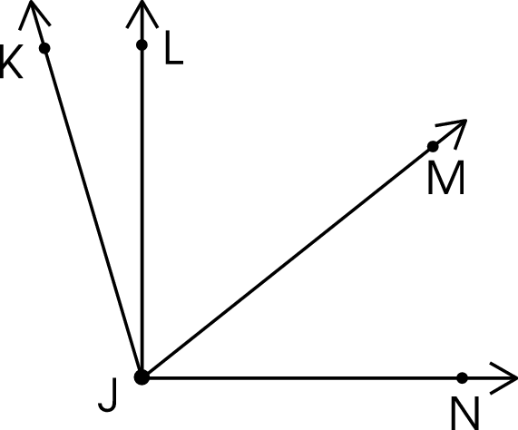

Which angle appears to be greater than 90° ?

A. $∠$ LJN
B. $∠$MJN
C. $∠$ KJM
D. $∠$ KJN

Commentary:
This multiple-choice question asks students to recognize an angle in a diagram that appears to be greater than 90°. First, students need to recognize that angle LJN appears to be 90°, which is answer choice A. Therefore, answer choice A is incorrect. Angle KJN, answer choice D, is correct because the angle appears to be greater than 90° since ray JK is rotated farther to the left of ray JL from ray JN. The angles in answer choices B and C are incorrect since they appear to be less than 90°.

The complexity level of this question is Low Complexity. This question requires students to recognize an example of a concept.

Performance Data:
The percent of public school students selecting answer choice D for question 13 on the May 2007 Grade 5 Achievement Test was 80%.

Keywords: measurement, angles, right angle

BACK TO INDEX

Benchmark: B | Convert units of length, area, volume, mass and time within the same measurement system.
GLI: MEA 5.5 | Make conversions within the same measurement system while performing computations.

Multiple Choice Question:

- Julia ran a 6-kilometer race on a 400-meter oval track.
How many laps around the track did Julia run?

A. 0.15 lap
B. 1.5 laps
C. 15 laps
D. 150 laps

Commentary:
This multiple-choice question asks students to determine the number of laps around a 400-meter oval track during a 6-kilometer race. Students need to recall that there are 1000 meters in a kilometer and convert 6 kilometers to meters. There are 6000 meters in 6 kilometers (6 kilometers × 1000 meters per kilometer = 6000 meters). To find the number of laps around the track, students need to divide 6000 meters by 400 meters (6000 meters ÷ 400 meters per lap = 15 laps). There are 15 laps around the track in this race. Answer choice C is correct.

Answer choices A, B and D are incorrect because they could be the results of incorrectly converting kilometers to meters.

The complexity level of this question is Moderate Complexity. This question requires students to solve a word problem involving multiple steps.

Performance Data:
The percent of public school students selecting answer choice C for question 30 on the May 2007 Grade 5 Achievement Test was 56%.

Keywords: measurement, metric units, conversions

BACK TO INDEX

Benchmark: C (3-4)  G | Develop common referents for units of measure for length, weight, volume (capacity) and time to make comparisons and estimates.  Understand and demonstrate the independence of perimeter and area for two-dimensional shapes and of surface area and volume for three-dimensional shapes.
GLI: MEA 4.2, MEA 5.3 | MEA 4.2: Demonstrate and describe perimeter as surrounding and area as covering a two-dimensional shape, and volume as filling a three-dimensional object.  MEA 5.3: Demonstrate and describe the differences between covering the faces (surface area) and filling the interior (volume) of three-dimensional objects.

Multiple Choice Question:

- Dan wraps a box with paper.

What should Dan measure to determine the amount of paper he needs to wrap the box?

A. circumference
B. perimeter
C. surface area
D. volume

Commentary:
This multiple-choice question asks students to determine the measure that represents the amount of paper needed to wrap a box. Students should realize that they are covering the area of each face of the box with the wrapping paper. Wrapping the entire box means that the area of all the surfaces of the box has to be covered. Therefore, the measure that should be used in determining the amount of paper needed to wrap the box is surface area, answer choice C.

Answer choices A, B and D are incorrect. Answer choices A and B are measures to find the distance around each of the sides of the box. Answer choice D is the measure to determine the amount of space inside the box.

The complexity level of this question is Low Complexity. The question requires students to recognize an example of a concept.

Performance Data:
The percent of public school students selecting answer choice C for question 2 on the May 2008 Grade 5 Achievement Test was 56%.

Keywords: measurement, surface area

BACK TO INDEX
Benchmark: C | Identify appropriate tools and apply appropriate techniques for measuring angles, perimeter or circumference and area of triangles, quadrilaterals, circles and composite shapes, and volume of prisms and cylinders.
GLI: MEA 5.4, MEA 5.6 | MEA 5.4: Demonstrate understanding of the differences among linear units, square units and cubic units.  MEA 5.6: Use strategies to develop formulas for determining perimeter and area of triangles, rectangles and parallelograms, and volume of rectangular prisms.

Mathematical Processes
Benchmark: K | Recognize and use mathematical language and symbols when reading, writing and conversing with others.

Short Answer Question:

5. A rectangle is shown.
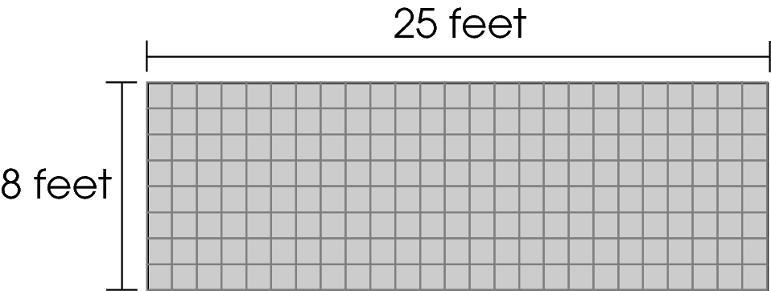
In your Answer Document , find the area and the perimeter of the rectangle. Show your work. Label the area and the perimeter with the appropriate units. (2 points)

Commentary:
This short-answer question asks students to find the area and perimeter of the given rectangle using the appropriate units. The response earning the maximum number of points (2 points) provides the area and perimeter of the rectangle labeled with appropriate units. Students can use various strategies to find the area and perimeter of the rectangle. For example, students can count the squares inside the rectangle to find the area (200 square feet) or find the area by multiplying the length times the width (25 feet × 8 feet = 200 square feet).

One way to find the perimeter is to count the number of 1-foot units around the edge of the rectangle. There are 66 feet around the rectangle. Or, students can add the length of each side of the rectangle (25 feet + 8 feet + 25 feet + 8 feet = 66 feet).

The complexity level of this question is Moderate Complexity. The question requires students to retrieve information from a figure and use it to solve a problem requiring multiple steps.

Performance Data:
The percent of public school students earning each score point for question 5 on the May 2008 Grade 5 Achievement Test:

Percent at Each Score Point
0 | 1 | 2
30% | 47% | 22%

Scoring Guidelines:
Exemplar Response:
- There are 200 squares inside the rectangle. The area is 200 square feet. I counted the lines on the outside of the rectangle. Perimeter = 66 feet.
- Area: 8 × 25 = 200 square feet; Perimeter: 25 + 8 + 25 + 8 = 66 feet.
- Area = lw = 200 square feet; Perimeter = 2(l + w) = 66 feet.
Points | Student Response
2 | The focus of this task is finding the area and perimeter of a rectangle. The response correctly finds the area and the perimeter of the rectangle with appropriate units.
1 | The response provides partial evidence of finding the area and perimeter of a rectangle; however, the solution may be incomplete or slightly flawed.  For example, the response may:  - State the area and perimeter correctly but show no work.  - State at least one measurement correctly with work.  - State both measurements correctly with supporting work but incorrect or no units.  - Provide the correct strategy to find area and perimeter but show area and perimeter incorrectly.
0 | The response provides inadequate evidence of finding the area and perimeter of a rectangle. The response provides major flaws in reasoning or irrelevant information.  For example, the response may:  - Show that area and perimeter are the same.  - State the perimeter is 33 feet.  - Be blank or state unrelated statements.  - Recopy information from the stem.

Keywords: measurement, rectangle, perimeter, area

BACK TO INDEX
Benchmark: A  B (K-2) | Select appropriate units to measure angles, circumference, surface area, mass and volume, using:  - U.S. customary units; e.g., degrees, square feet, pounds, and other units as appropriate;  - metric units; e.g., square meters, kilograms and other units as appropriate.  Select appropriate units for length, weight, volume (capacity) and time, using:  - objects; i.e., non-standard units;  - U.S. customary units: inch, foot, yard, ounce, pound, cup, quart, gallon, minute, hour, day, week and year;  metric units: centimeter, meter, gram and liter.
GLI: MEA 2.1a | Identify and select appropriate units of measure for:  - length – centimeters, meters, inches, feet, or yards;

Multiple Choice Question:

12. Tina helps raise the flag outside her school every morning.
Which unit is appropriate for describing the height of the flag after Tina raises it?

A. meters
B. cubic feet
C. square feet
D. square meters

Commentary:
This multiple-choice question asks students to determine the unit which is appropriate for describing the height of a flag after it is raised. Students should recall that the height of an object is a measure of length, which is measured in linear units. Therefore, answer choice A, meters, is correct.

Answer choices B, C and D can be eliminated since they are not linear units. The unit in answer choice B is a measure of volume, while the units in answer choices C and D are measures of area.

The complexity level of this question is Low Complexity. The question requires students to recognize an example of a concept.

Performance Data:
The percent of public school students selecting answer choice A for question 12 on the May 2008 Grade 5 Achievement Test was 67%.

Keywords: measurement, unit of measure

BACK TO INDEX

Benchmark: C | Identify appropriate tools and apply appropriate techniques for measuring angles, perimeter or circumference and area of triangles, quadrilaterals, circles and composite shapes, and volume of prisms and cylinders.
GLI: MEA 5.7 | Use benchmark angles (e.g.; 45º, 90º, 120º) to estimate the measure  of angles, and use a tool to measure and draw angles.

Multiple Choice Question:

24. Maria drew this design for a bird house.
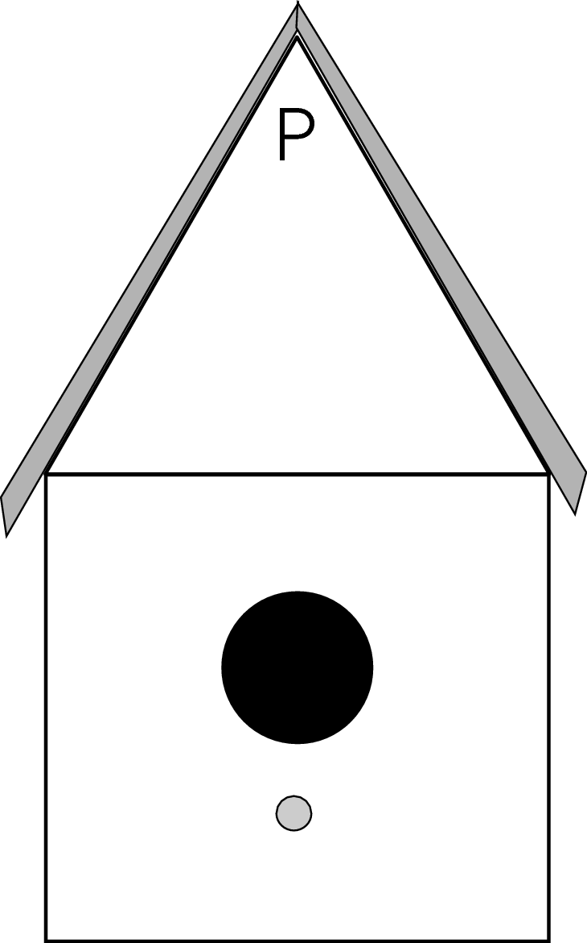
About how many degrees does angle P appear to be?

A. 30 º
B. 60 º
C. 90 º
D. 120º

Commentary:
This multiple-choice question asks students to estimate the measure of angle P shown in the bird house. Students can use benchmark angles such as 45°, 90° or 120° to estimate the number of degrees in angle P. Angle P is between 45° and 90°. Using these benchmark angles, students should see that angle P appears to be about 60°. Answer choice B is correct.

90°
45°

Answer choices A, C and D are incorrect. The estimate of the measure of the angle in answer choice A is too low because angle P appears to be larger than half of 90°. The estimate of the measure in answer choice C is incorrect because angle P is not a right angle. Answer choice D is incorrect because the measure of angle P is not greater than a right angle.

The complexity level of this question is Low Complexity. The question requires students to retrieve information from a figure.

Performance Data:
The percent of public school students selecting answer choice B for question 24 on the May 2008 Grade 5 Achievement Test was 67 %.

Keywords: measurement, angle

BACK TO INDEX
Benchmark: B  C | Convert units of length, area, volume, mass and time within the same measurement system.  Develop common referents for units of measure for length, weight, volume (capacity) and time to make comparisons and estimates.
GLI: MEA 5.4, MEA 5.5 | MEA 5.4: Demonstrate understanding of the differences among linear units, square units and cubic units.  MEA 5.5: Make conversions within the same measurement system while performing computations.

Multiple Choice Question:

43. Louis bought 6 gallons of milk for the soccer team. They drank 10 quarts of the milk.
How many quarts of milk were left over?

A. 2 quarts
B. 4 quarts
C. 14 quarts
D. 24 quarts

Commentary:
This multiple-choice question asks students to determine the number of quarts left over from 6 gallons of milk after they drank 10 quarts. First, students need to convert 6 gallons to quarts. Since there are 4 quarts in one gallon, there are 24 quarts in 6 gallons (4 quarts per gallon × 6 gallons = 24 quarts). Then, students can subtract to find the number of quarts left over (24 quarts – 10 quarts = 14 quarts). There were 14 quarts of milk left over; answer choice C.

Answer choices A, B and D are incorrect. Answer choice A is the result of using 2 quarts for each gallon (6 × 2 quarts per gallon – 10 quarts = 2 quarts). Answer choice B is the result of subtracting the numbers in the problem without converting gallons to quarts (10 – 6 = 4). Answer choice D is the result of converting 6 gallons to quarts without subtracting the amount of milk drank (6 × 4 quarts per gallon = 24 quarts).

The complexity level of this question is Moderate Complexity. The question requires students to solve a word problem requiring multiple steps.

Performance Data:
The percent of public school students selecting answer choice C for question 43 on the May 2008 Grade 5 Achievement Test was 56%.

Keywords: measurement, conversions, gallons, quarts

BACK TO INDEX

