Index to Questions

Question Number | Source | BM | GLI | Description
4 | OAT Mar 06 | B | MEA 4.1 | This multiple-choice question asks students to select the appropriate container that can be used for filling a fish tank with water and making the fewest number of trips to the faucet.
9 | OAT Mar 06 | D | MEA 4.4 | This multiple-choice question asks students to find the area of an irregular figure.
22 | OAT Mar 06 | C | MEA 4.2 | This short-answer question asks students to select the measurement that represents counting the number of units around the outside of the shape.
25 | OAT Mar 06 | D | MEA 4.4 | This short-answer question asks students to find the perimeter of the given shape.
32 | OAT Mar 06 | D | MEA 4.4 | This multiple-choice question asks students to find the number of cubes in a tower.
35 | OAT Mar 06 | A | MEA 4.3b | This multiple-choice question asks students to select the object that can be measured in square inches.
41 | OAT Mar 06 | A | MEA 4.3c | This multiple-choice question asks students to select the appropriate unit that can be used for measuring the volume of a hamster cage.
4 | OAT May 07 | A | MEA 4.3a | This multiple-choice question asks students to select the appropriate unit of measurement that can be used for finding the length of a border around a bulletin board.
18 | OAT May 07 | A | MEA 4.3b | This multiple-choice question asks students to select the appropriate unit for measuring the area of the bottom of a pan.
30 | OAT May 07 | B | MEA 4.1 | This multiple-choice question asks students to determine the effect of changing the unit used to measure the same object.
3 | OAT May 08 | D | MEA 4.4 | This multiple-choice question asks students to identify a common multiple for two different numbers.
8 | OAT May 08 | C | MEA 4.2 | This multiple-choice question asks students to identify an example of perimeter. Students need to know that the perimeter of a two-dimensional figure is the total distance around the figure.

BACK TO INDEX

Benchmark: B | Know that the number of units is inversely related to the size of the unit for any item being measured.
GLI: MEA 4.1 | Relate the number of units to the size of the units used to measure an object; e.g., compare the number of cups to fill a pitcher to the number of quarts to fill the same pitcher.

Multiple Choice Question:

4. Paco is filling his fish tank with water.
Which container should Paco use to make the fewest trips to the faucet?
A. one-cup container
B. one-gallon container
C. one-pint container
D. one-quart container

Commentary:
This multiple-choice question asks students to select the appropriate container that can be used for filling a fish tank with water and making the fewest number of trips to the faucet. Students may approach this problem by thinking about familiar containers such as a cup, a gallon, a pint and a quart. Answer choice B is the correct answer. Paco should use a one-gallon container because it is larger than a cup, a pint or a quart. Therefore, he will make the fewest trips to the faucet while filling his fish tank.

The complexity level of this question is Moderate Complexity. The task requires students to select an answer from the different representations.

Performance Data:
The percent of public school students selecting answer choice B for question 4 on the March 2006 Grade 4 Achievement Test was 80%.

Keywords: measurement, capacity (volume)

BACK TO INDEX

Benchmark: D | Identify appropriate tools and apply counting techniques for measuring side lengths, perimeter and area of squares, rectangles, and simple irregular two-dimensional shapes, volume of rectangular prisms and time, and temperature.
GLI: MEA 4.4 | Develop and use strategies to find perimeter using string or links, area using tiles or a grid, and volume using cubes; e.g., count squares to find area of regular or irregular shapes on a grid, layer cubes in a box to find its volume.

Multiple Choice Question:

9. A figure is shown on the grid.
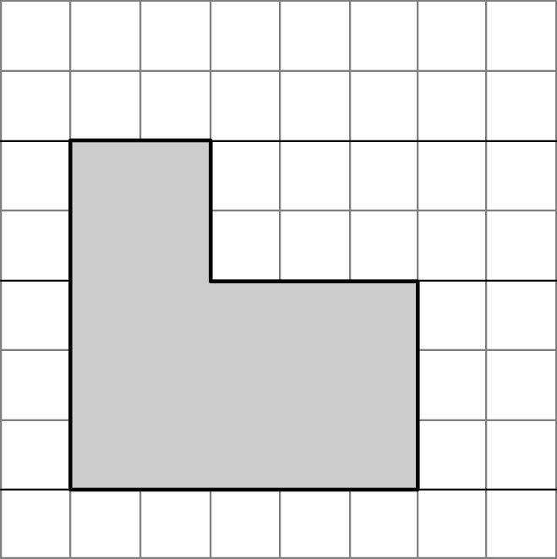
What is the area of the figure?
A. 16 square units
B. 19 square units
C. 20 square units
D. 25 square units

Commentary:
This multiple-choice question asks students to find the area of an irregular figure. To find the area, students may either count the square of the irregular figure or divide the irregular figure into two regular rectangles, such as a 5-units by 3-units rectangle and a 2-units by 2-units rectangle. Then, students can count the squares of each individual rectangle or apply multiplication properties and add the two products together. For example, the 5-units by 3-units rectangle has an area of 15 square units (5 x 3 = 15) and the 2-units x 2-units rectangle has an area of 4 square units (2 x 2 = 4). The sum of the areas of the two regular rectangles is 19 square units (15 + 4 = 19), answer choice B. Answer choices A, C and D are incorrect.

The level of complexity for this question is Moderate Complexity. The question requires students to solve a problem requiring multiple steps.

Performance Data:
The percent of public school students selecting answer choice B for question 9 on the March 2006 Grade 4 Achievement Test was 67%.

Keywords: measurement, area

BACK TO INDEX

Benchmark: C | Develop common referents for units of measure for length, weight, volume (capacity) and time to make comparisons and estimates.
GLI: MEA 4.2 | Demonstrate and describe perimeter as surrounding and area as covering a two-dimensional shape, and volume as filling a three-dimensional object.

Multiple Choice Question:

22. Abdul counted the number of units around the outside of the shape shown.
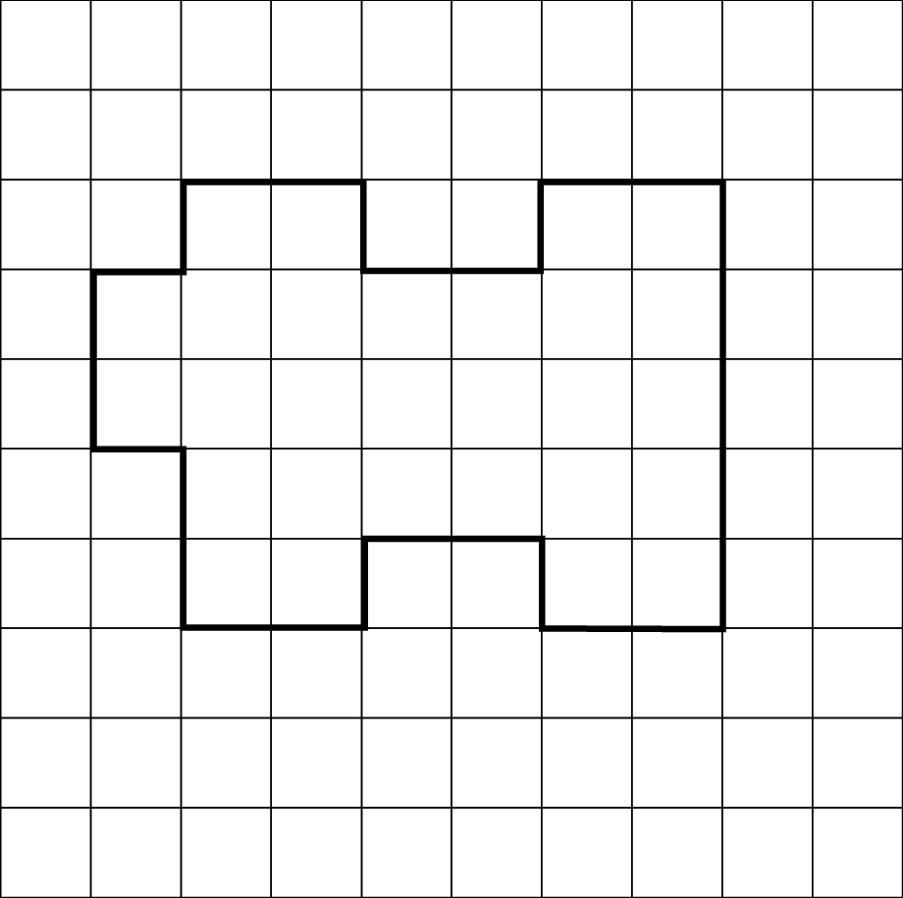
Which measurement did Abdul find?
A. area
B. height
C. perimeter
D. volume

Commentary:
This short-answer question asks students to select the measurement that represents counting the number of units around the outside of the shape. Finding the perimeter of the shape is the same as counting the units around the outside of the shape. Answer choice C is the correct answer. Answer choices A, B and D are incorrect because they cannot be determined by counting around outside of the shape.

The level of complexity for this question is Low Complexity. This task requires students to recognize an example of a concept.

Performance Data:
The percent of public school students selecting answer choice C for question 22 on the March 2006 Grade 4 Achievement Test was 69%.

Keywords: measurement, perimeter

BACK TO INDEX

Benchmark: D | Identify appropriate tools and apply counting techniques for measuring side lengths, perimeter and area of squares, rectangles, and simple irregular two-dimensional shapes, volume of rectangular prisms and time, and temperature.
GLI: MEA 4.4 | Make simple unit conversions within a measurement system; e.g., inches to feet, kilograms to grams, quarts to gallons.

Short Answer Question:

25. Randy made this shape with toothpicks.
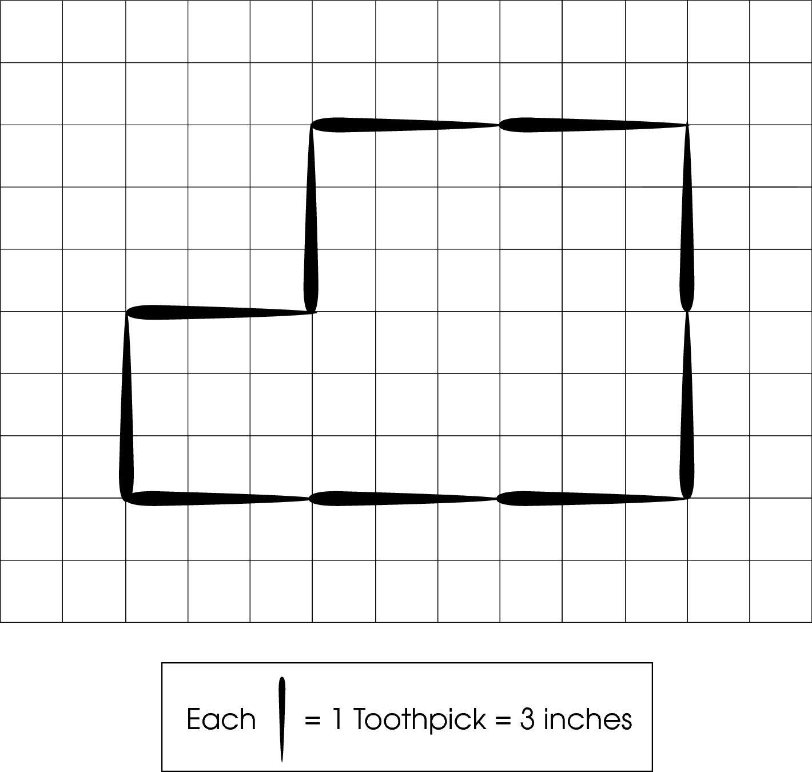
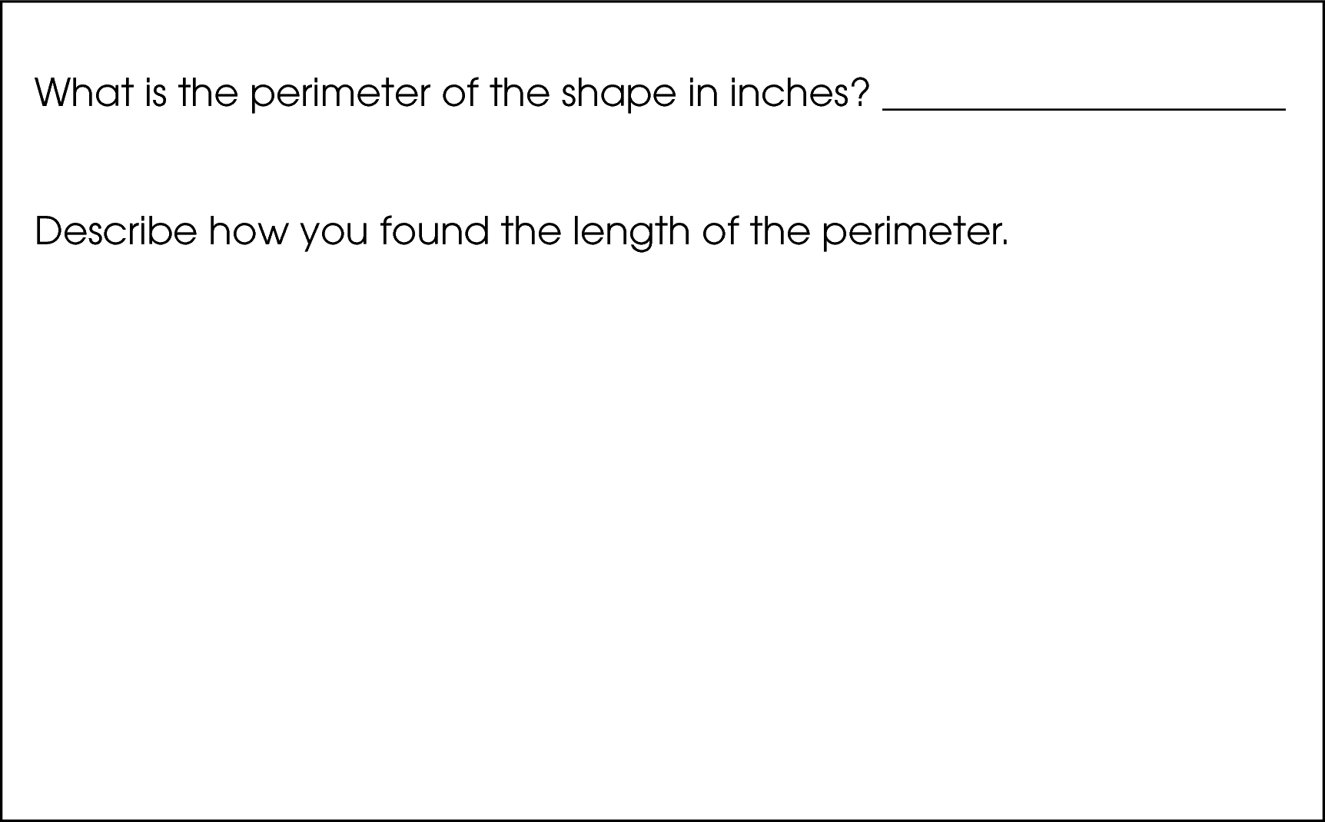

Commentary:
This short-answer question asks students to find the perimeter of the given shape. A response earning the maximum number of points (2 points) provides the correct answer for the perimeter (30 inches) with supporting work or an explanation. For example, students may state that they counted all the units around the shape (3 + 3 + 3 + 3 + 3 + 3 + 3 + 3 + 3 = 30 inches), or they counted 10 toothpicks in the shape and multiplied it by the length of one tooth pick
(10 x 3 = 30 inches).

The complexity level of this question is Moderate Complexity. The task requires students to retrieve information from a figure and provide a justification for steps in a solution process.
Performance Data:
The percent of public school students earning each score point for question 25 on the March 2006 Grade 4 Achievement Test:

Percent at Each Score Point
0 | 1 | 2
12% | 23% | 64%

Scoring Guidelines:
Sample Correct Response(s):
- There are 10 toothpicks in the shape and 10 × 3 = 30. The perimeter is 30 inches.
- 30 inches. I added all the toothpicks. 3 + 3 + 3 + 3 + 3 + 3 + 3 + 3 + 3 + 3 = 30
- Perimeter = 30. I counted all the lines around the shape and got 30.

Points | Student Response
2 | The focus of this task is developing and using strategies to find the perimeter of an irregular shape. The response provides the correct perimeter and demonstrates a strategy that can be used to find the perimeter.  NOTE: The correct answer without correct units is acceptable.
1 | The response shows partial evidence of developing and using strategies to find the perimeter of an irregular shape; however, the solution may be incomplete or slightly flawed.  For example, the response may:  - State that there are 10 toothpicks around the shape, so the perimeter is 10 inches.  - Include a correct perimeter with no explanation or an incomplete explanation of how perimeter was found.  - Provide an incorrect perimeter based upon a calculation (or counting) error, but a reasonable process or description of how to find perimeter.
0 | The response provides inadequate evidence of developing and using strategies to find the perimeter of an irregular shape. The response provides an explanation with major flaws and errors of reasoning.  For example, the response may:  - State 10 only without referring to the toothpicks.  - Give an answer of 45, which refers to the area.  - Be blank or state unrelated statements.  - Recopy information from the stem.

Keywords: measurement, perimeter

BACK TO INDEX

Benchmark: D | Identify appropriate tools and apply counting techniques for measuring side lengths, perimeter and area of squares, rectangles, and simple irregular two-dimensional shapes, volume of rectangular prisms, and time and temperature.
GLI: MEA 4.4 | Make simple unit conversions within a measurement system; e.g., inches to feet, kilograms to grams, quarts to gallons.

Multiple Choice Question:

32. Torrance made a tower that is three cubes long, five cubes high and two cubes wide.
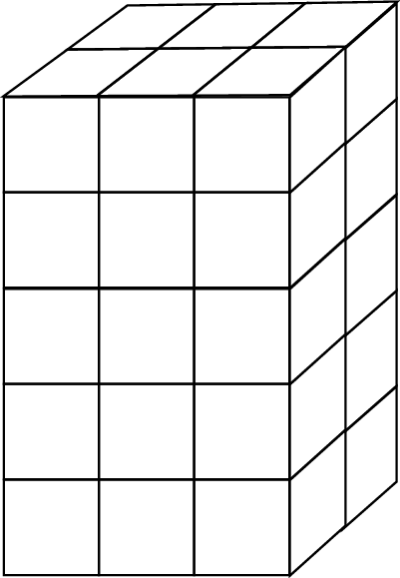
How many cubes in all did he use to make the tower?
A. 10
B. 22
C. 30
D. 31

Commentary:
This multiple-choice question asks students to find the number of cubes in a tower. Using knowledge of volume, the question may be answered by counting the number of cubes in each layer of the rectangular prism (a tower) or applying multiplication. For example, the first layer of the prism has 6 cubes because it has 3 cubes along the length and 2 cubes along the width (3 x 2 = 6). The prism has 5 layers of cubes. Therefore, 6 x 5 = 30 cubes. The correct answer choice is C. Answer choice A is incorrect because students may have added the number of cubes along the length, the width and the height of the rectangular prism. Answer choice B is incorrect because students may have only counted the visible cubes. Answer choice D is also incorrect because students may have counted the number of cube faces shown.

The level of complexity for this question is Moderate Complexity. The question requires students to retrieve information from a figure and use it to solve a problem.

Performance Data:
The percent of public school students selecting answer choice C for question 32 on the March 2006 Grade 4 Achievement Test was 53%.

Keywords: measurement, volume

BACK TO INDEX

Benchmark: A | Select appropriate units for perimeter, area, weight, volume (capacity), time and temperature.
GLI:MEA 4.3b | Identify and select appropriate units to measure:  b. area – tiles (square inches or square centimeters).

Multiple Choice Question:

35. Which would be measured in square inches?

A. the amount of juice in a can
B. the height of a flag pole
C. the area of a CD case
D. the length of a pencil

do not copy or distribute ID: 10371; Version: 3

Commentary:
This multiple-choice question asks students to select the object that can be measured in square inches. Area is the measure that is measured in square units. Therefore, answer C is the correct answer choice. Answer choices B and D are incorrect answers because the height of a flag and the length of a pencil are measured in linear units (inches). Answer choice A is also incorrect because the amount of juice in a can can be measured in cubic inches, the unit of capacity.

The complexity level of this question is Low Complexity because it requires students to recognize an example of a concept.

Performance Data:
The percent of public school students selecting answer choice C for question 35 on the March 2006 Grade 4 Achievement Test was 65%.

Keywords: measurement, unit

BACK TO INDEX

Benchmark: A | Select appropriate units for perimeter, area, weight, volume (capacity), time and temperature.
GLI: MEA 4.3c | Identify and select appropriate units to measure:  c. volume – cubes (cubic inches or cubic centimeters).

Multiple Choice Question:

41. Sheila bought a new hamster cage.
Which unit of measure would be used to describe the volume of the hamster cage?
A. cubic inches
B. yards
C. square inches
D. square feet

do not copy or distribute ID: 10114; Version: 6

Commentary:
This multiple-choice question asks students to select the appropriate unit that can be used for measuring the volume of a hamster cage. Answer choice A is correct because volume is the only measurement that is measured in cubic units. Answer choices C and D are incorrect because both square inches and square feet are used for measuring area. Answer choice B (yards) is also incorrect. Yards are used for measuring the length of an object.

The complexity level of this question is Low Complexity because it requires students to recognize an example of a concept.

Performance Data:
The percent of public school students selecting answer choice A for question 41 on the March 2006 Grade 4 Achievement Test was 50%.

Keywords: measurement, units

BACK TO INDEX

Benchmark: A | Select appropriate units for perimeter, area, weight, volume (capacity), time and temperature.
GLI:  MEA 4.3a | Identify and select appropriate units to measure:  a. perimeter – string or links (inches or centimeters)

Multiple Choice Question:

4. What unit of measurement is likely to be used to find the length of a border around a bulletin board?

A. inches
B. square feet
C. cubic yards
D. miles

Commentary:
This multiple-choice question asks students to select the appropriate unit of measurement that can be used for finding the length of a border around a bulletin board. The length of an object is measured in linear units such as inches or miles. Since miles are used to measure distance between cities and places and are too large for measuring the distance around a bulletin board, answer choice D would be incorrect and answer choice A correct. Answer choices B and C are also incorrect because square units are used for measuring area and cubic units are used for measuring volume, respectively.

The complexity level of this question is Low Complexity. This question requires students to recognize an example of a concept.

Performance Data:
The percent of public school students selecting answer choice A for question 4 on the May 2007 Grade 4 Achievement Test was 47 %.

Keywords: measurement, unit, perimeter

BACK TO INDEX

Benchmark: A | Select appropriate units for perimeter, area, weight, volume (capacity), time and temperature.
GLI: MEA 43.b | Identify and select appropriate units to measure:  b. area – tiles (square inches or square centimeters).

Multiple Choice Question:

18. Which unit is appropriate for measuring the area of the bottom of a pan?

A. inch
B. foot
C. square inch
D. cubic foot

Commentary:
This multiple-choice question asks students to select the appropriate unit for measuring the area of the bottom of a pan. Students may approach this problem by thinking of area as the amount of space that is covered by a shape. Area is always measured in square units which make answer choice C the correct answer.

Answer choices A, B and D are incorrect. Answer choices A and B are the results of confusing measurement units used for perimeter with those used for area. Answer choice D is the result of confusing measurement units used for volume with those used for area.

The complexity level of this question is Low Complexity. The question requires students to recognize an example of a concept.

Performance Data:
The percent of public school students selecting answer choice C for question 18 on the May 2007 Grade 4 Achievement Test was 45%.

Keywords: measure, units, area

BACK TO INDEX

Benchmark: B | Know that the number of units is inversely related to the size of the unit for any item being measured.
GLI: MEA 4.1 | Relate the number of units to the size of the units used to measure an object; e.g., compare the number of cups to fill a pitcher to the number of quarts to fill the same pitcher.

Multiple Choice Question:

30. Robin measured the length of a piece of rope and found it to be 12 feet long.
What would happen to the number of units if Robin measured the length of the rope in yards instead of feet?

A. There would be no units.
B. There would be more units.
C. There would be fewer units.
D. There would be the same number of units.

Commentary:
This multiple-choice question asks students to determine the effect of changing the unit used to measure the same object. Students need to know what happens to the number of units when feet are changed to yards.
The given rope is 12 feet long. If measured in yards it is going to be 4 yards long, because there are 3 feet in one yard (12 3 = 4) and 4 is less than 12. Because yards are larger units than feet, there will be fewer yards than feet to measure the rope. Answer choice C is correct.

The use of smaller units will yield a greater number of units, and the use of larger units will yield a smaller number of units when used to measure the same object when used to measure the same object. It makes answer choices A, B or D incorrect.

The complexity level of this question is Moderate Complexity. This problem requires students to compare statements.

Performance Data:
The percent of public school students selecting answer choice C for question 30 on the May 2007 Grade 4 Achievement Test was 51%.

Keywords: measurement, unit, feet, yards

BACK TO INDEX

Benchmark: D | Identify appropriate tools and apply counting techniques for measuring side lengths, perimeter, and area of squares, rectangles, and simple irregular two-dimensional shapes, volume of rectangular prisms, and time and temperature.
GLI: MEA 4.4 | Develop and use strategies to find perimeter using string or links, area using tiles or a grid, and volume using cubes; e.g., count squares to find area of regular or irregular shapes on a grid, layer cubes in a box to find its volume.

Multiple Choice Question:

3. A place mat is 10 inches wide and 20 inches long.
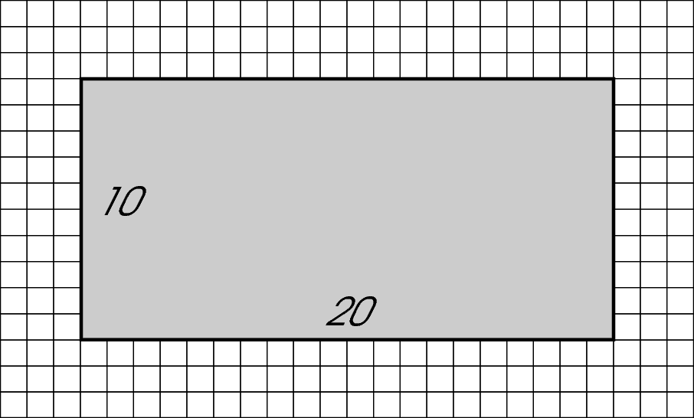
What is the perimeter of the mat?

A. 30 inches
B. 60 inches
C. 100 inches
D. 200 inches

Commentary:
This multiple-choice question asks students to identify a common multiple for two different numbers. Students need to know various strategies for finding perimeter and know that the perimeter is the distance around a figure. One strategy would be to count the number of units around the rectangle using the one-inch grid: 10 inches + 20 inches + 10 inches + 20 inches = 60 inches. Another strategy for finding a perimeter is to find the sum of all side lengths of the rectangle (10 inches + 10 inches + 20 inches + 20 inches = 60 inches). So 60 inches, answer choice B, is correct.

A perimeter of 30 inches, answer choice A, is incorrect since adding one width to one length (10 inches + 20 inches = 30 inches) is only half of 60 inches, the correct perimeter. Multiplying the two widths (10 inches x 10 inches = 100 inches), as in answer choice C, is incorrect. A student choosing answer D may have incorrectly thought that multiplying the length by the width (20 inches x 10 inches = 200 inches) is a proper strategy for finding the perimeter. This strategy, however, could lead to finding the area of the rectangle in square inches.

The complexity level of this question is Moderate Complexity. Students are asked to compare figures or statements.

Performance Data:
The percent of public school students selecting answer choice B for question 3 on the May 2007 Grade 4 Achievement Test was 79%.

Keywords: measurement, perimeter

BACK TO INDEX

Benchmark: C | Develop common referents for units of measure for length, weight, volume (capacity) and time to make comparisons and estimates.
GLI: MEA 4.2 | Demonstrate and describe perimeter as surrounding and area as covering a two-dimensional shape, and volume as filling a three-dimensional object.

Multiple Choice Question:

8. Which is an example of perimeter?

A. the amount of sand in a sandbox
B. the distance around a window
C. the number of tiles that cover a floor
D. the length of a bus

Commentary:
This multiple-choice question asks students to identify an example of perimeter. Students need to know that the perimeter of a two-dimensional figure is the total distance around the figure. The distance around a window is the perimeter of the window, so answer choice B is correct.

Answer choice A is incorrect because it is an example of the volume of sand, or the amount of the sand in a sandbox. The number of tiles that cover a floor is incorrect because it is an example of the floor’s area, so answer choice C is incorrect. Answer choice D is incorrect since it is an example of measuring only the length of the three-dimensional bus, not a distance around a two-dimensional figure.

The complexity level of this question is Low Complexity. Students are asked to recognize an example of a concept.

Performance Data:
The percent of public school students selecting answer choice B for question 8 on the May 2007 Grade 4 Achievement Test was 81%.

Keywords: measurement, perimeter

BACK TO INDEX

