Index to Questions

Question Number | Source | BM | GLI | Description
2 | OAT March 05 | D | MEA 3.7 | This multiple-choice question asks students to find the area of a figure.
6 | OAT March 05 | E | MEA 3.3 | This multiple-choice question asks students to use a calendar to find the ending date for a two week trip.
16 | OAT March 05 | D | MEA 3.4 | This multiple-choice question asks students to identify the temperature shown on a thermometer.
22 | OAT March 05 | A | MEA 3.1c | This multiple-choice question asks students to make an estimate for the weight of a card.
27 | OAT March 05 | C | MEA 3.5 | This multiple-choice question asks students to approximate the height of an object.
31 | OAT March 05 | E | MEA 3.3 | This multiple-choice question asks students to find elapsed time.
44 | OAT March 05 | A | MEA 3.1b | This multiple-choice question asks students to recognize an appropriate situation for using liters.
46 | OAT March 05 | C & D | MEA 3.5, NEA 3.6 | This short-answer question asks students to measure the sides of a rectangle.
1 | OAT March 06 | A | MEA 3.1b | This multiple-choice question asks students to identify the appropriate unit for capacity of a swimming pool.
3 | OAT March 06 | C | MEA 3.2, MEA 3.5 | This multiple-choice question asks students to estimate the length of a pencil.
8 | OAT March 06 | D | MEA 3.7 | This multiple-choice question asks students to find the number of beans needed to go all the way around a rectangle.
25 | OAT March 06 | E | MEA 3.3 | This short-answer question asks students to use a clock to write the elapsed time and then to show that time on a clock.
11 | OAT May 07 | E | MEA 3.3 | This multiple-choice question asks students to find the time an event ends using elapsed time.
27 | OAT May 07 | D | MEA 3.7 | This multiple-choice question asks students to measure a line by using a nonstandard unit.
Question Number | Source | BM | GLI | Description
30 | OAT May 07 | C | MEA 3.2 | This multiple-choice question asks students to select the appropriate estimate of the weight of a spoon.
38 | OAT May 07 | A | MEA 3.4 | This short-answer question asks students to read a thermometer and use common referents for determining whether the thermometer is broken.
44 | OAT May 07 | C | MEA 3.2 | This multiple-choice question asks students to select an object that holds about 1 gallon of water.
6 | OAT May 08 | D | MEA 3.6 | This multiple-choice question asks students to estimate the volume (capacity) of the liquid in a pitcher.
19 | OAT May 08 | A | MEA 3.1a | This multiple-choice question asks students to choose an appropriate unit for measuring the length of their classroom.
33 | OAT May 08 | D | MEA 3.6 | This short-answer question asks students to use a ruler to measure one side length of a given square in centimeters and to construct a new square with side lengths equal to 3 inches.
39 | OAT May 08 | E | MEA 3.3 | This multiple-choice question asks students to tell the starting time for a music program that begins “fifteen minutes before seven.”

BACK TO INDEX

Benchmark: D | Identify appropriate tools and apply counting techniques for measuring side lengths, perimeter and area of squares, rectangles, and simple irregular two-dimensional shapes, volume of rectangular prisms, and time and temperature.
GLI: MEA 3.7 | Make estimates for perimeter, area and volume using links, tiles, cubes and other models.

Multiple Choice Question:
2. | What is the area of this square?

A. | 12 square units
B. | 16 square units
C. | 22 square units
Commentary:
This multiple-choice question asks students to find the area of a figure. Using knowledge of area, the question may be answered by counting the squares or applying multiplication properties. For example, the grid is 4 squares across and 4 squares down, so 4 x 4 = 16 square units (answer choice B). Answer choices A and C are incorrect.

The level of complexity for this question is Low Complexity. The question requires students to perform a specified procedure, find the area.

Performance Data:
The percent of public school students selecting answer choice B for question 2 on the March 2005 Grade 3 Achievement Test was 94%.

Keywords: measurement, area

BACK TO INDEX

Benchmark: E | Tell time to the nearest minute.
GLI: MEA 3.3 | Tell time to the nearest minute and find elapsed time using a calendar or a clock.

Multiple Choice Question:
6. | Ling leaves for a trip on July 12th.

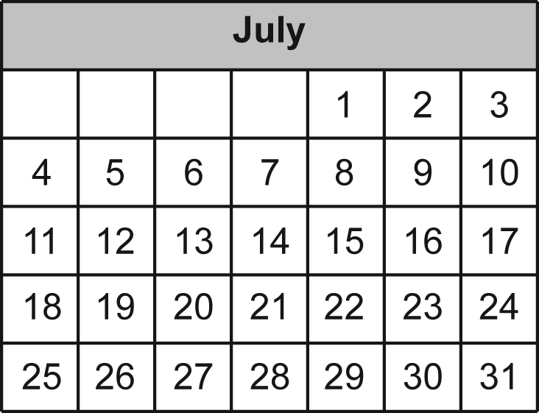

He will return two weeks later. What date will he return?
- July 14
- July 19
- July 26

Commentary:
This multiple-choice question asks students to use a calendar to find the ending date for a two-week trip. There are several methods for finding the ending data. One example is to find the starting date, July 12th, on the calendar, and trace along the calendar for 2 weeks, moving from July 12th to July 19th, and then to July 26th. Answer choice A confuses 2 days with 2 weeks, and answer choice B uses only one week.

The complexity level for this question is Low Complexity. Students retrieve information from a table (the calendar).

Performance Data:
The percent of public school students selecting answer choice C for question 6 on the March 2005 Grade 3 Achievement Test was 87%.

Keywords: measurement, time, weeks

BACK TO INDEX

Benchmark: D | Identify appropriate tools and apply counting techniques for measuring side lengths, perimeter and area of squares, rectangles, and simple irregular two-dimensional shapes, volume of rectangular prisms, and time and temperature.
GLI: MEA 3.4 | Read thermometers in both Fahrenheit and Celsius scales.

Multiple Choice Question:
16. | What temperature does this thermometer show?  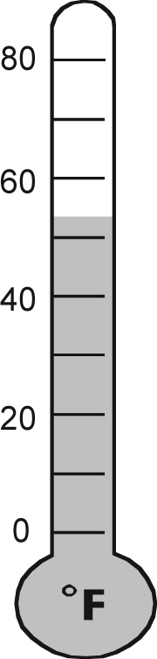

A. | 50ºF
B. | 53ºF
C. | 59ºF

Commentary:
This multiple-choice question asks students to identify the temperature shown on a thermometer. The scale on the thermometer is in intervals of 10ºF. Students should recognize that the shading on the thermometer is above 50ºF, eliminating answer choice A, but is closer to 50ºF than to 60ºF. Thus, answer choice B is the correct answer, because answer choice C is too close to 60ºF.

The complexity level of the question is Low Complexity. Students are asked to retrieve information from a figure (the thermometer).

Performance Data:
The percent of public school students selecting answer choice B for question 16 on the March 2005 Grade 3 Achievement Test was 76%.

Keywords: measurement, temperature

BACK TO INDEX

Benchmark: A | - Select appropriate units for perimeter, area, weight, volume (capacity), time and temperature, using:  - objects of uniform size;  - U.S. customary units; e.g., mile, square inch, cubic inch, second, degree Fahrenheit, and other units as appropriate;  - metric units; e.g., millimeter, kilometer, square centimeter, kilogram, cubic centimeter, degree Celsius, and other units as appropriate.
GLI: MEA 3.1c | Identify and select appropriate units for measuring:  c. weight – ounces, pounds, grams, or kilograms

Multiple Choice Question:
22. | About how much does a card weigh?

A. | 2 ounces
B. | 2 pounds
C. | 2 inches

Commentary:
This multiple-choice question asks students to make an estimate for the weight of a card. Answer choice A is the correct answer. Answer choices A and B both use units that measure weight. One pound is equal to16 ounces, so ounces are more appropriate for measuring the weight of a card. Answer choice C can be eliminated because inches is used to measure length.

The level of complexity for this question is Moderate Complexity. This question requires students to interpret a visual representation and then recall information.

Performance Data:
The percent of public school students selecting answer choice A for question 22 on the March 2005 Grade 3 Achievement Test was 78 %.

Keywords: measurement, weight, estimate

BACK TO INDEX

Benchmark: C | Develop common referents for units of measure for length, weight, volume (capacity) and time to make comparisons and estimates.
GLI: MEA 3.5 | Estimate and measure length, weight and volume (capacity), using metric and U.S. customary units, accurate to the nearest $\frac{1}{2}$or $\frac{1}{4}$unit as appropriate.

Multiple Choice Question:
27. | Which object is about 10 feet high?

A. | a desk
B. | a classroom wall
C. | a mountain

Commentary:
This multiple-choice question asks students to approximate the height of an object. Students may approach this problem by thinking about a familiar object that is one foot long and then imagining 10 of those objects together. The correct answer is choice B. Answer choices A and C are either shorter than or much taller than 10 feet.

The level of complexity for this question is Low Complexity. This question requires students to recall a fact (the approximate length of a foot) and then recognize an example of a concept (understanding which object could be 10 feet long).
Performance Data:
The percent of public school students selecting answer choice B for question 27 on the March 2005 Grade 3 Achievement Test was 74%.

Keywords: measurement, length

BACK TO INDEX

Benchmark: E | Tell time to the nearest minute.
GLI: MEA 3.3 | Tell time to the nearest minute and find elapsed time using a calendar or a clock.

Multiple Choice Question:
31. | The two clocks show when soccer practice starts and when it ends.  How long was practice?

A. | 1 hour 5 minutes
B. | 1 hour 15 minutes
C. | 1 hour 20 minutes

Commentary:
This multiple-choice question asks students to find elapsed time. The correct answer is answer choice A. Students may begin with the practice start time, 6:15 and count forward one hour to 7:15. From 7:15, practice continues for 5 more minutes, ending at 7:20. Therefore, the practice was 1 hour and 5 minutes long. Selecting answer choices B or C may reflect incorrect use of the number of minutes after the hour to decide the length of practice (6:15 is 15 minutes after the hour, and 7:20 is 20 minutes after the hour).

The level of complexity for this question is Moderate Complexity. This question requires students to interpret a visual representation and then use the information to answer a question.

Performance Data:
The percent of public school students selecting answer choice A for question 31 on the March 2005 Grade 3 Achievement Test was 53%.

Keywords: measurement, elapsed time

BACK TO INDEX

Benchmark: A | Select appropriate units for perimeter, area, weight, volume (capacity), time and temperature.
GLI:  MEA 3.1b | Identify and select appropriate units for measuring:  b. volume (capacity) – gallons

Multiple Choice Question:
44. | When would you use liters?

A. | to find the weight of a book
B. | to find the length of a pencil
C. | to find the volume of a bottle

Commentary:
This multiple-choice question asks students to recognize an appropriate situation for using liters. The correct answer is choice C. Liter is a metric unit for measuring volume or the capacity of an object. Liters are not used to measure weight or length. Examples of metric units that measure weight are grams and milligrams. Examples of metric units that measure length are meters and centimeters.

The level of complexity for this question is Moderate Complexity. This question requires students to compare the statements to select a representation of a liter.

Performance Data:
The percent of public school students selecting answer choice C for question 44 on the March 2005 Grade 3 Achievement Test was 65%.

Keywords: measurement, metric, liters

BACK TO INDEX

Benchmark: C & D | Develop common referents for units of measure for length, weight, volume (capacity) and time to make comparisons and estimates.  Identify appropriate tools and apply counting techniques for measuring side lengths, perimeter and area of squares, rectangles, and simple irregular two-dimensional shapes, volume of rectangular prisms, and time and temperature.
GLI: MEA 3.5,  MEA 3.6 | MEA 3.5: Estimate and measure length, weight and volume (capacity), using metric and U.S. customary units, accurate to the nearest $\frac{1}{2}$or $\frac{1}{4}$unit as appropriate.  MEA 3.6: Use appropriate measurement tools and techniques to construct a figure or approximate an amount of specified length, weight or volume (capacity); e.g., construct a rectangle with length 2$\frac{1}{2}$ inches and width 3 inches, fill a measuring cup to the $\frac{3}{4}$cup mark.

Short Answer Question:

46. | Use your inch ruler to measure each side of this rectangle. Write the length of each side of the rectangle on the blank lines.  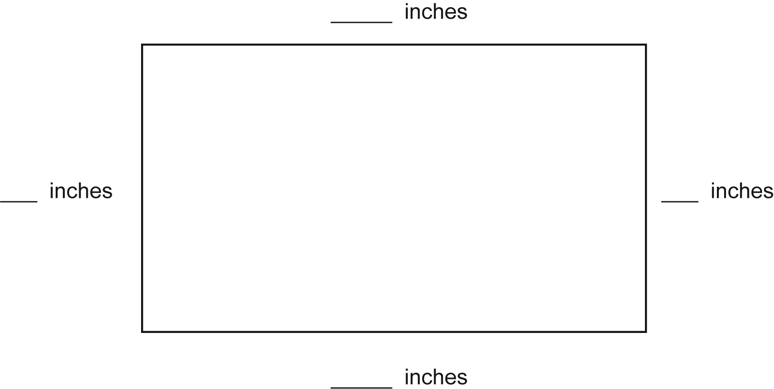

Commentary:
This short-answer question asks students to measure the sides of a rectangle. The top side of the rectangle is $3\frac{1}{2}$ inches long and the right side is 2 inches long. Students may decide to measure the other two sides, or they may recognize that the bottom side has the same measure as the top and that the left side has the same measure as the right side. Students who found different measures may have misaligned their rulers or measured in centimeters instead of in inches.

The level of complexity for this question is Low Complexity. This task requires students to measure a rectangle.

Performance Data:
The percent of public school students earning each score point for question 46 on the March 2005 Grade 3 Achievement Test:

Percent at Each Score Point
0 | 1 | 2
9% | 35% | 55%

Scoring Guidelines:
Points | Student Response
2 | The response shows a correct measure of 3 and 2 for each pair of opposite sides with no incorrect measures  3.5 inches  3.5 inches  2 inches  2 inches
1 | The response shows at least one side correctly labeled, or each pair of opposite sides correctly measured in centimeters instead of inches (9 cm and 5 cm).
0 | The response indicates no understanding of the task or the underlying skills, concepts, tasks, or processes.

Keywords: measurement, length

BACK TO INDEX

Benchmark: A | Select appropriate units for perimeter, area, weight, volume (capacity), time and temperature.
GLI: MEA 3.1b | Identify and select appropriate units for measuring:  b. volume (capacity) – gallons

Multiple Choice Question:

1. Which unit is best used for measuring the amount of water in a swimming pool?

- ounce
- foot
- gallon

Commentary:
This multiple-choice question asks students to identify the appropriate unit for capacity of swimming pool. The correct answer choice is C. Answer choice B can be eliminated because a foot is an inappropriate unit for measuring the capacity of the pool. Feet are used to measure the length of objects. Answer choice A can be also eliminated because ounces are too small for measuring the capacity of a swimming pool.

The complexity level of this question is Low Complexity. The question requires students to recognize a term.

Performance Data:
The percent of public school students selecting answer choice C for question 1 on the March 2006 Grade 3 Achievement Test was 79%.

Keywords: measurement, unit

BACK TO INDEX

Benchmark: C | Develop common referents for units of measure for length, weight, volume (capacity) and time to make comparisons and estimates.
GLI:  MEA 3.2,  MEA 3.5 | MEA 3.2: Establish personal or common referents to include additional units; e.g., a gallon container of milk; a postage stamp is about a square inch.  MEA 3.5: Estimate and measure length, weight and volume (capacity), using metric and U.S. customary units, accurate to the nearest $\frac{1}{2}$or $\frac{1}{4}$unit as appropriate.

Multiple Choice Question:

3. About how long is a pencil?

- 6 inches
- 6 feet
- 6 yards

Commentary:
This multiple-choice question asks students to estimate the length of a pencil. The correct answer is answer choice A. All of the answer choices use units that measure length; however, inches are more appropriate for measuring the length of a pencil. All of the other answers can be eliminated because they represent measurements that are too long for a pencil.

The complexity level of this question is Moderate Complexity. This question requires students to use informal methods of reasoning.

Performance Data:
The percent of public school students selecting answer choice A for question 3 on the March 2006 Grade 3 Achievement Test was 96%.

Keywords: measurement, units

BACK TO INDEX

Benchmark: D | Identify appropriate tools and apply counting techniques for measuring side lengths, perimeter and area of squares, rectangles, and simple irregular two-dimensional shapes, volume of rectangular prisms, and time and temperature.
GLI: MEA 3.7 | Make estimates for perimeter, area and volume using links, tiles, cubes and other models.

Multiple Choice Question:

8. Rachel lines up beans on two sides of a rectangle.
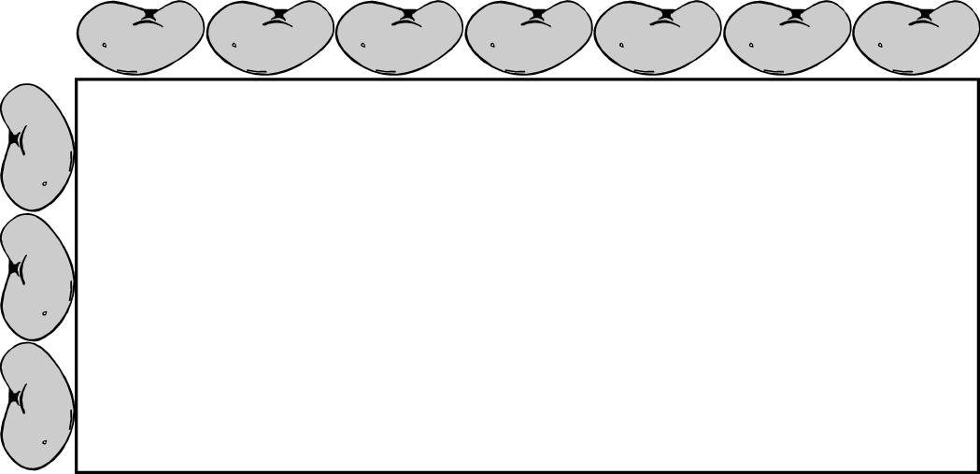
How many beans will Rachel need to go all the way around the rectangle?
- 7
- 13
- 20

Commentary:
This multiple-choice question asks students to find the number of beans needed to go all the way around a rectangle. Using the notion of perimeter, the question may be answered by counting the beans around four sides of the rectangle or by applying the multiplication and then addition. For example, the rectangle is 7 beans across and 3 beans down, as well as 7 beans across and 3 beans down on the opposite sides. Therefore 3 + 3 +7 +7 = 20 beans, (answer choice C). Answer choice A is incorrect because only two sides of the rectangle were included in the calculations. Answer B is also incorrect because only three sides of the rectangle instead of four sides were included in the calculations.

The complexity level of this question is Low Complexity. The question requires students to perform a specified procedure.

Performance Data:
The percent of public school students selecting answer choice C for question 8 on the March 2006 Grade 3 Achievement Test was 80%.

Keywords: measurement, perimeter
BACK TO INDEX

Benchmark: E | Tell time to the nearest minute.
GLI: MEA 3.3 | Tell time to the nearest minute and find elapsed time using a calendar or a clock.

Short Answer Question:

25. Melissa left for soccer practice at 3:30 p.m. She returned home two hours later. Write the time she returned home.
Show the return time on the clock.
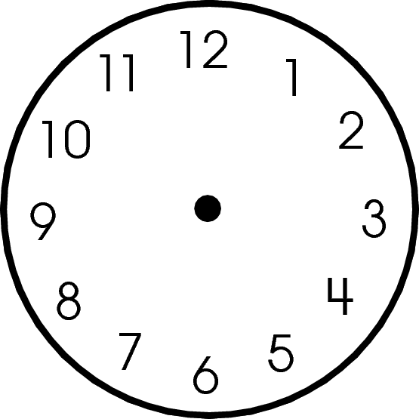

Points Student Response
Do not copy or distribute ID: 9179; Version: 7

Commentary:
This short-answer question asks students to use a clock to write the elapsed time and then to show that time on a clock. A response earning the maximum number of points (2 points) shows both the correct elapsed time (5:30 pm) and the correct position of the hour and minute hands on the clock.

The complexity level of this question is Moderate Complexity. The task requires student to represent a situation in more then one way.

Performance Data:
The percent of public school students earning each score point for question 25 on the March 2006 Grade 3 Achievement Test:

Percent at Each Score Point
0 | 1 | 2
7% | 22% | 71%

Scoring Guidelines:
Sample Correct Response(s):
- Writes 5:30, correctly draws short hand to the 5 or halfway between the 5 and 6, AND draws long hand to 6.

Points | Student Response
2 | The response states the correct time of 5:30 and draws the hours and minutes hands accurately on the clock.
1 | The response states the correct time OR shows the correct elapsed time (5:30) on the clock.  OR  The response draws the hours and minutes hands correctly for the time given.  Example: 1:30, hands drawn to accurately reflect 1:30
0 | The response indicates no understanding of the concept or task.

Keywords: measurement, elapsed time

BACK TO INDEX

Benchmark: E | Tell time to the nearest minute.
GLI: MEA 3.3 | Tell time to the nearest minute and find elapsed time using a calendar or a clock.

Multiple Choice Question:

11. A movie began at 3:15 p.m.
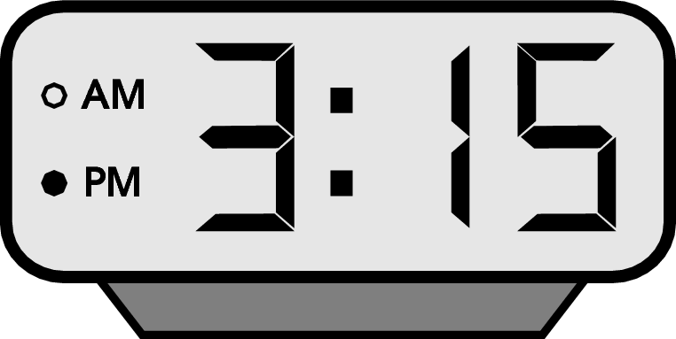
The movie lasted 1 hour and 35 minutes. What time did the movie end?

A. 1:35 p.m.
B. 4:50 p.m.
C. 5:50 p.m.

Commentary:
This multiple-choice question asks students to find the time an event ends using elapsed time.
Students can solve this problem by adding the times or creating a clock and using it to calculate the time the event ends. Students can first add 15 minutes + 35 minutes = 50 minutes and then 3 hours + 1 hour = 4 hours. The end time is 4:50 pm. Students creating a clock can first add one hour to 3:15 by rotating the short hand of the clock past the 4. Next, students can add 35 minutes by rotating the long hand past the 7 numbers to the “10”. The end time of the movie is 4:50 pm. The correct answer choice is B.
Answer choices A and C are incorrect answers. Students, who choose answer choice A, may have thought that the movie began at noon, lasted 1 hour and 35 minutes and ended at 1:35 p.m. Students, who choose answer choice C, may have added 2 hours and 35 minutes to the start time instead of 1 hour and 35 minutes.

The complexity level of this question is Moderate Complexity. This question requires students to use informal methods of reasoning.

Performance Data:
The percent of public school students selecting answer choice B for question 11 on the May 2007 Grade 3 Achievement Test was 91%.

Keywords: measurement, time, elapsed time
BACK TO INDEX

Benchmark: D | Identify appropriate tools and apply counting techniques for measuring side lengths, perimeter and area of squares, rectangles, and simple irregular two-dimensional shapes, volume of rectangular prisms, and time and temperature.
GLI: MEA 3.7 | Make estimates for perimeter, area and volume using links, tiles, cubes and other models.

Multiple Choice Question:

27. About how many paper clips long is this line?
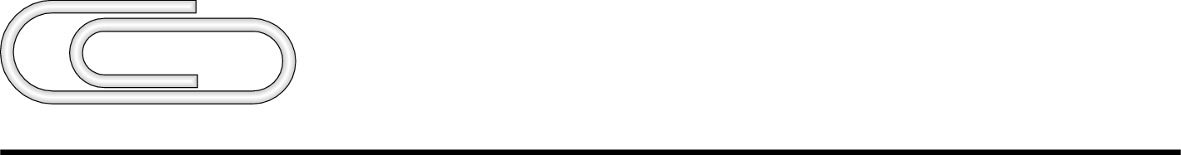

A. 2
B. 4
C. 6

Commentary:
This multiple-choice question asks students to measure a line by using a nonstandard unit. Students can estimate the length of the line by seeing that one more paper clip will cover half of the line and therefore, another 2 paper clips will cover the rest of the line. The total number of clips will be 4. Answer choice B is the correct answer. Students can also measure the length of one paper clip (about 1.25 inches) and then mark off 3 more 1.25 inch sections for a total of 4 paper clips to measure the approximate length of the line. Therefore, about 4 paper clips will cover the line. Students, who chose answer choice A or answer choice C, may have either underestimated or overestimated the length of the line.

The complexity level of this question is Low Complexity. This question requires students to measure a simple geometric figure.

Performance Data:
The percent of public school students selecting answer choice B for question 27 on the May 2007 Grade 3 Achievement Test was 83%.

Keywords: measurement, unit, length

BACK TO INDEX

Benchmark: C | Develop common referents for units of measure for length, weight, volume (capacity) and time to make comparisons and estimates.
GLI: MEA 3.2 | Establish personal or common referents to include additional units; e.g., a gallon container of milk; a postage stamp is about a square inch.

Multiple Choice Question:

30. About how much does a spoon weigh?
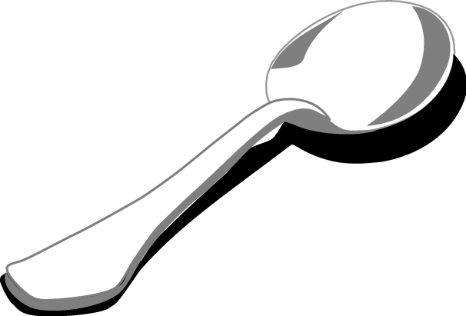

A. 50 meters
B. 50 grams
C. 50 kilograms

Commentary:
This multiple-choice question asks students to select the appropriate estimate of the weight of a spoon. One method students can use for solving this problem is to eliminate incorrect units of measurement. Students should think of a spoon being light in weight. The 50 kilograms in answer choice C is a measurement of weight but it is too heavy for the spoon and can be eliminated. Meters in answer choice A is a measurement of length and also can be eliminated. Therefore, answer choice B is the correct weight for a spoon.

The complexity level of this question is Moderate Complexity. This question requires students to use informal methods of reasoning.

Performance Data:
The percent of public school students selecting answer choice B for question 30 on the May 2007 Grade 3 Achievement Test was 69%.

Keywords: measurement, weight, gram, kilogram

BACK TO INDEX

Benchmark: A | Select appropriate units for perimeter, area, weight, volume (capacity), time and temperature.
GLI: MEA 3.4 | Read thermometers in both Fahrenheit and Celsius scales.

Short Answer Question:

38. Kelly thinks her outdoor thermometer is broken.
The outdoor thermometer is shown.
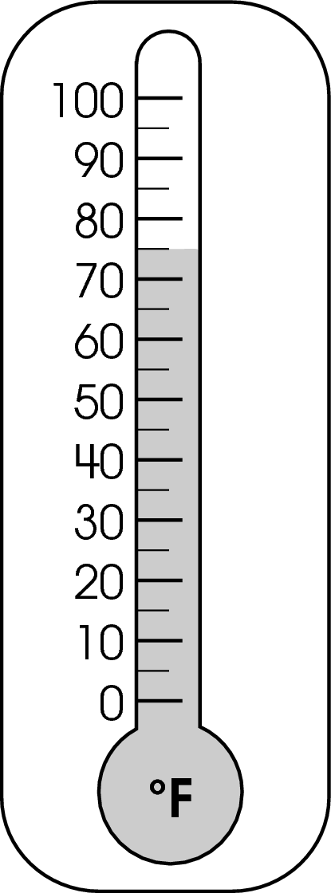
It was a cold, snowy day.
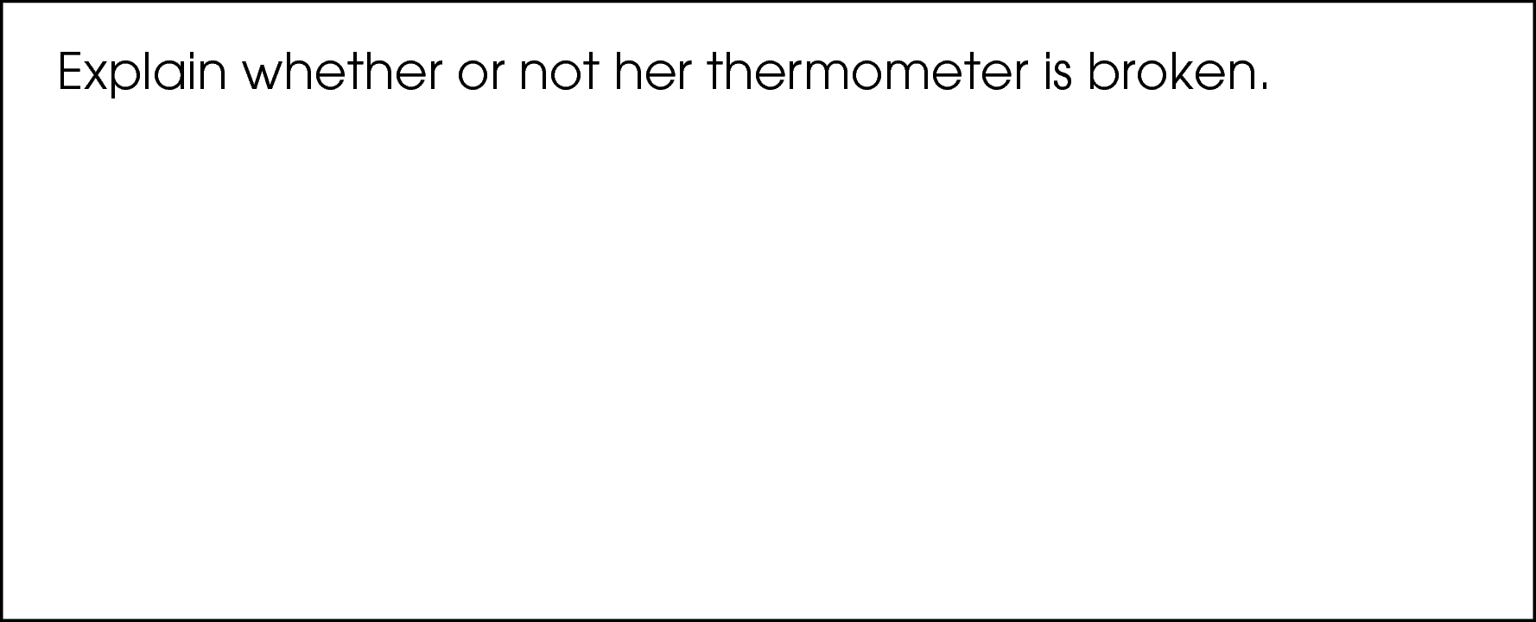

Commentary:
This short-answer question asks students to read a thermometer and use common referents for determining whether the thermometer is broken. A response earning the maximum number of points (2 points) states that the thermometer is broken and provides an adequate explanation that the temperature on the thermometer is too high. Students should recognize that on an average snowy day the temperature will stay in thirty’s or below. The thermometer must be broken if it shows 75*F when it is snowy.

The complexity level of this question is Moderate Complexity. This task requires students to interpret a visual representation and provide a justification.

Performance Data:
The percent of public school students earning each score point for question 38 on the May 2007 Grade 3 Achievement Test:

Percent at Each Score Point
0 | 1 | 2
31% | 43% | 26%

Scoring Guidelines:
Scoring Guideline Exemplar Response:

- The thermometer is broken because the temperature is too high for a snowy day.
- The thermometer is broken because the temperature is 75 degrees. That’s too hot!

Other Correct Response(s):

Points | Student Response
2 point text | The focus of this task is identifying appropriate units for measuring temperature. The response states that the thermometer is broken and provides an adequate explanation that the temperature is too high.
1 point text | The response provides partial evidence of identifying appropriate units for measuring temperature ; however, the solution may be incomplete or slightly flawed.
1 point text | 1 point sample answer:  For example, the response may:  - State that the thermometer is broken, and give an inadequate explanation.  - State that the thermometer says it is too hot to snow.  - State that it is too cold to be 75 degrees.
0 point text | The response provides inadequate evidence of identifying appropriate units for measuring temperature. The response provides an explanation with major flaws and errors of reasoning.
0 point text | 0 point sample answer:  For example, the response may:  - Only state that the thermometer is broken.  - restate the information provided in the item.  - be blank or give irrelevant information.

Keywords: measurement, temperature

BACK TO INDEX

Benchmark: C | Develop common referents for units of measure for length, weight, volume (capacity) and time to make comparisons and estimates.
GLI: MEA 3.2 | Establish personal or common referents to include additional units; e.g., a gallon container of milk; a postage stamp is about a square inch.

Multiple Choice Question:

44. Which object would hold about one gallon of water?

A. 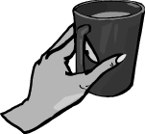
B. 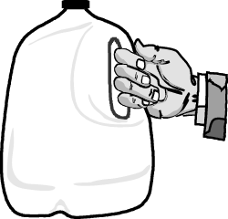
C. 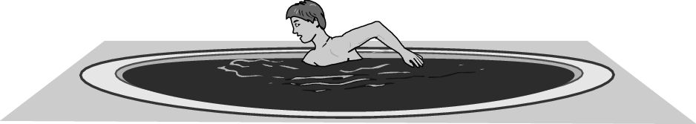

Commentary:
This multiple-choice question asks students to select an object that holds about 1 gallon of water. Students should be able to estimate measures of objects using common referents. Students can use a container of a gallon of milk as a referent for a gallon.
A gallon is larger than a cup but smaller than a swimming pool. Answer choice B is the correct answer.

Answer choices A and C are incorrect. Students, who select one of these choices, have either underestimated or overestimated the size of a gallon.

The complexity level of this question is Low Complexity. This question asks students to recognize an example of a concept.

Performance Data:
The percent of public school students selecting answer choice B for question 44 on the May 2007 Grade 3 Achievement Test was 92%.

Keywords: measure, gallon, capacity

BACK TO INDEX

Benchmark: D | Identify appropriate tools and apply counting techniques for measuring side lengths, perimeter, and area of squares, rectangles, and simple irregular two-temperature.
GLI: MEA 3.6 | Use appropriate measurement tools and techniques to construct a figure or approximate an amount of specified length, weight or volume (capacity); e.g., construct a rectangle with length 2$\frac{1}{2}$ inches and width 3 inches, fill a measuring cup to the $\frac{3}{4}$cup mark.

Multiple Choice Question:

6. About how many quarts of liquid are in this pitcher?
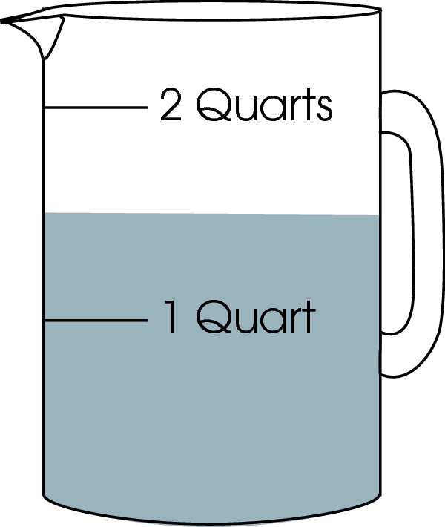

A. 1$\frac{1}{2}$quarts

B. 2 quarts

C. 2$\frac{1}{2}$ quarts

Commentary:
This multiple-choice question asks students to estimate the volume (capacity) of the liquid in a pitcher. They need to realize that the liquid partially fills the pitcher to 1 quart and above to about half-way between the marks for 1 quart and 2 quarts. The correct estimate for the volume of liquid would then be 1 quart + $\frac{1}{2}$ quart = 1 $\frac{1}{2}$ quarts, or answer choice A.

Answer choice B is incorrect because it does not include the $\frac{1}{2}$ quart as needed but is rounded up to the nearest whole quart. Answer choice C is also incorrect because $\frac{1}{2}$ quart is added to the 2 quarts instead of the 1 quart.

The complexity level of this question is Low Complexity. This question requires students to perform a measurement procedure.

Performance Data:
The percent of public school students selecting answer choice A for question 6 on the May 2008 Grade 3 Achievement Test was 91%.

Keywords: measurement, volume, quart

BACK TO INDEX

Benchmark: A | Select appropriate units for perimeter, area, weight, volume (capacity), time and temperature.
GLI: MEA 3.1a | Identify and select appropriate units for measuring:  - length – miles, kilometers and other units of measure as appropriate;

Multiple Choice Question:

19. Which unit is best for measuring the length of your classroom?

- inches
- feet
- miles

Commentary:
This multiple-choice question asks students to choose an appropriate unit for measuring the length of their classroom. Students need to know the appropriate units for measuring lengths of various objects and distances. For example, inches are small units and are used to measure the length of small objects, such as the length of a pen. Miles are large units and would be used to measure lengths such as the distance between cities. So, answer choices A and C would be inappropriate units to use for measuring the length of a typical classroom.

Answer choice B is correct. Feet would be the appropriate unit for measuring the length of a classroom since it is not too small or too large.

The complexity level of this question is Low Complexity. This question requires students to recognize linear measurement terms.

Performance Data:
The percent of public school students selecting answer choice B for question 19 on the May 2008 Grade 3 Achievement Test was 87%.

Keywords: measurement, length, unit

BACK TO INDEX

Benchmark: D | Identify appropriate tools and apply counting techniques for measuring side lengths, perimeter, and area of squares, rectangles, and simple irregular two-temperature.
GLI: MEA 3.6 | Use appropriate measurement tools and techniques to construct a figure or approximate an amount of specified length, weight or volume (capacity); e.g., construct a rectangle with length 2$\frac{1}{2}$ inches and width 3 inches, fill a measuring cup to the $\frac{3}{4}$cup mark.

Short Answer Question:

33. Pam is cutting squares of colored paper to glue together. She wants the squares to be the same size. She made a mistake and cut the square shown.

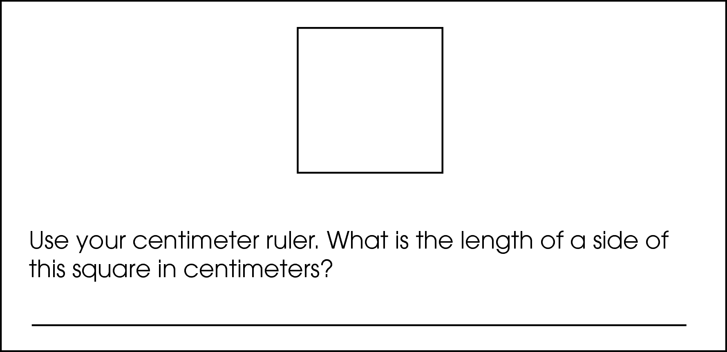
She wanted each side to be 3 inches long.

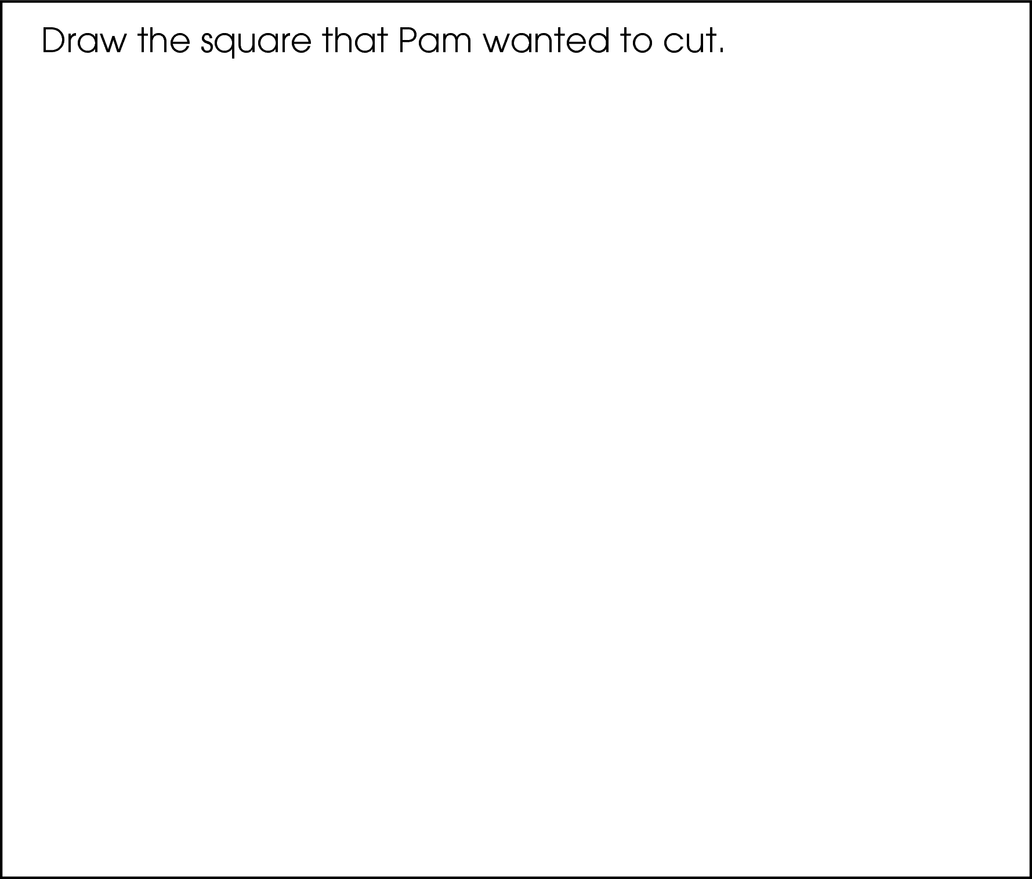

Commentary:
This short-answer question asks students to use a ruler to measure one side length of a given square in centimeters and to construct a new square with side lengths equal to 3 inches. Students need to recognize and properly use the correct scale on their rulers to measure the given square (side lengths of 3 centimeters) and construct a new square with side lengths equal to 3 inches. A response earning the maximum number of points (2 points) should include the correct measurement for the side of the given square (3 cm) and an accurate drawing of a square with side lengths equal to 3 inches.

The complexity level of this question is Moderate Complexity. Students are asked to compare the measurements of two squares that have side lengths equal to 3 units using both metric and U.S. customary units.

Performance Data:
The percent of public school students earning each score point for question 33 on the May 2008 Grade 3 Achievement Test:

Percent at Each Score Point
0 | 1 | 2
21% | 34% | 45%

Scoring Guidelines:
Exemplar Response:

- 3 cm

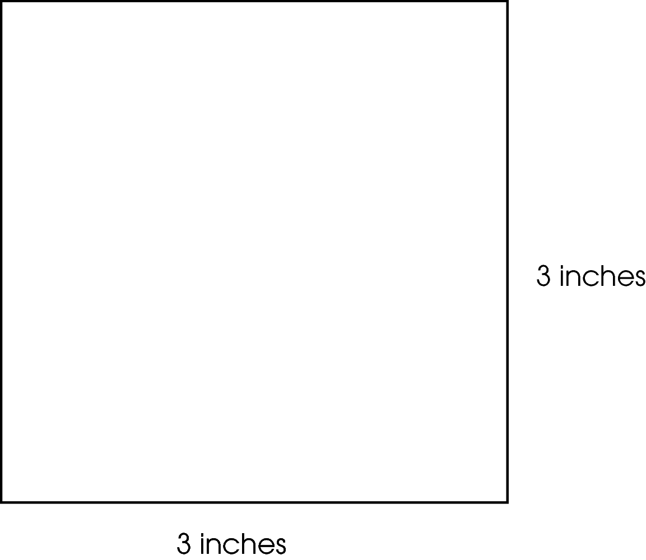

Points | Student Response
2 | The focus of this task is using appropriate measurement tools and techniques to measure the length of a given figure and to construct a figure of specified length. The response provides the correct length of the side in centimeters of the original square and an accurate drawing of a square with 3 inch long sides.  NOTE: Side lengths should be within one-quarter of an inch.
1 | The response provides partial evidence of using appropriate measurement tools and techniques to measure the length of a given figure and to construct a figure of specified length; however, the solution may be incomplete or slightly flawed.  For example, the response may:  - State an incorrect measurement or incorrect units for the side of the original three-centimeter square but drew the square correctly in inches.  - Show a drawing of a square with incorrect measurements; but, states the original squares’ measurements correctly.
0 | The response provides inadequate evidence of using appropriate measurement tools and techniques to measure the length of a given figure and to construct a figure of specified length.  For example, the response may:  - State an incorrect measurement of the square and provide a drawing of a shape that is not a square.  - Restate the information provided in the item.  - Be blank or give irrelevant information.

Keywords: measurement, square, centimeters, inches

BACK TO INDEX

Benchmark: E | Tell time to the nearest minute.
GLI: MEA 3.3 | Tell time to the nearest minute and find elapsed time using a calendar or a clock.

Multiple Choice Question:

- A music program starts “fifteen minutes before seven.” What time does the music program start?

A. 6:15 p.m.
B. 6:45 p.m.
C. 7:15 p.m.

Commentary:
This multiple-choice question asks students to tell the starting time for a music program that begins “fifteen minutes before seven.” Students need to know how to read a clock and represent a written phrase for a given time using the standard notation for time. Students should know that fifteen minutes before seven means that the hour hand has passed the 6:00 time and is almost to the 7:00 location since the starting time is “before seven.” They also need to know that “fifteen minutes before seven” means that the minutes are before the 7:00 location and should be located at 7:00 minus 15 minutes. Students can calculate this time by subtracting 15 minutes from 60 minutes (60 minutes = 1 hour) to get 45 minutes. So answer choice B is correct since 6:45 p.m. is before 7:00 p.m. and 45 minutes after 6:00 p.m.

Answer choice A is incorrect because student may have interpreted “before seven” as 6:00 and “fifteen minutes” as 15 minutes more to 6:00. Answer choice C is incorrect because students may have combined the numbers “fifteen” and “seven” in the phrase “fifteen minutes before seven”.

The complexity level of this question is Low Complexity. Students are asked to recognize equivalent representation for a time.

Performance Data:
The percent of public school students selecting answer choice B for question 39 on the May 2008 Grade 3 Achievement Test was 77%.

Keywords: measurement, time

BACK TO INDEX

