Index to Questions

Question Number | Source | BM | GLI | Description
4 | OAT March 05 | D | GSS 8.4 | This multiple-choice question asks students to identify  the fourth vertex of a trapezoid.
6 | OAT March 05 | C, E | GSS 8.2, GSS 8.6 | This short-answer question asks students to identify two  properties that verify that is congruent to$∠ \text{EFG}$.
15 | OAT March 05 | B, C (5-7) | GSS 8.3, MEA 4.2 | Is this also MEA?  This multiple-choice question asks students to use similarity of triangles to find the perimeter of a triangle.
17 | OAT March 05 | E | GSS 8.6 | This multiple-choice question asks students to identify  the shape when the net (cut-out) is folded.
30 | OAT March 05 | C (5-7), H | GSS 8.1, MEA 6.2 | Is this also MEA?  This multiple-choice question asks students to compare  the relative areas of two circles.
35 | OAT March 05 | C | GSS 8.2 | This multiple-choice question asks students to use the properties of parallel lines intersected by a transversal to identify congruent angles.
39 | OAT March 05 | F | GSS 8.5 | This multiple-choice question asks students to analyze a figure after a translation and determine the effects of the transformation.
31 | OAT March 06 | B | GSS 8.3 | This short-answer question asks students to identify the required conditions in order for PQR and EFD to be similar triangles.
39 | OAT March 06 | C | GSS 8.2 | This multiple-choice question asks students to find the measure of an angle.
40 | OAT March 06 | D | GSS 8.4 | This multiple-choice question asks students to identify the ordered pair that would create a triangle similar to a given triangle.
8 | OAT May 07 | D (5-7) | GSS 6.1 | This multiple-choice question asks students to identify the statement that is always true for the given triangle and whose angles X and Z are congruent.
11 | OAT May 07 | F | GSS 8.5 | This short-answer question asks students to perform a transformation on a given object and identify a characteristic of the object that does not change after the transformation.
Question Number | Source | BM | GLI | Description
32 | OAT May 07 | C | GSS 8.2 | This multiple-choice question asks students to use angle and line relationships to determine the measure of angle X.
5 | OAT May 08 | C | GSS 8.2 | This multiple-choice question asks students to find the measure of an angle in a parallelogram.
19 | OAT May 08 | B | GSS 8.3 | This multiple-choice question asks students to use proportional reasoning to solve a problem involving a scale drawing.

BACK TO INDEX

Benchmark: D | Use coordinate geometry to represent and examine the properties of geometric figures.
GLI: GSS 8.4 | Compare two sets of data using measures of center (mean, mode, median) and measures of spread (range, quartiles, interquartile range, percentiles).

Multiple Choice Question:

4. Three vertices of a trapezoid are located at points (2, 3), (–2, – 2) and (5, –2).
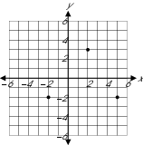
Which point could represent the fourth vertex of the figure?
A. (5, 0)
B. (5, 4)
C. (–1, 3)
D. (–1, 5)

Commentary:
This multiple-choice question asks students to identify the fourth vertex of a trapezoid. Given three vertices, students identify answer choice C, (-1, 3), as the fourth vertex of a quadrilateral that has one pair of parallel sides, (trapezoid). Answer choices A, B, and D would create quadrilaterals that have no parallel sides, therefore not trapezoids.

The complexity of this question is Low Complexity. The task requires recalling the properties of a trapezoid.

Performance Data:
The percent of public school students selecting answer choice C for question 4 on the March 2005 Grade 8 Achievement Test was 58%.

Keywords: geometry, trapezoid, coordinate geometry

BACK TO INDEX

Benchmark: C | Recognize and apply angle relationships in situations involving intersecting lines, perpendicular lines, and parallel lines.
Benchmark: E | Draw and construct representations of two- and three-dimensional geometric objects using a variety of tools such as straightedge, compass and technology.
GLI: GSS 8.2, GSS 8.6 | GSS 8.2: Evaluate different graphical representations of the same data to determine which is the most appropriate representation for an identified purpose; e.g., line graph for change over time, circle graph for part-to-whole comparison, scatterplot for relationship between two variants.  GSS 8.6: Make conjectures about possible relationship in a scatterplot and approximate line of best fit.

Mathematical Processes
Benchmark: F | Use precise mathematical language and notations to represent problem situations and mathematical ideas.

Short Answer Question:

6. Jason constructed the figure shown.

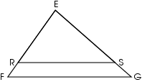

He knows $Δ$ERS is similar to $Δ$EFG and that$\overline{\text{RS}} ‖\overline{ \text{FG}}$.
Jason claims ERS EFG .

In your Answer Document , identify two geometric properties that can be used to justify Jason’s claim.

Commentary:
This short-answer question asks students to identify two properties that verify that $∠ \text{ERS}$ is congruent to $∠ \text{EFG}$. To receive the maximum number of points, students can use properties of similar triangles and properties of parallel lines cut by a transversal. Because corresponding angles of similar triangles are congruent, $∠ \text{ERS}$ and $∠ \text{EFG}$ are congruent. Additionally when two parallel lines are cut by a transversal, corresponding angles are congruent. Since $\overline{\text{RS}}$is parallel to $\overline{\text{FG}}$ and $∠ \text{ERS}$ and $∠ \text{EFG}$ are corresponding angles, then $∠ \text{ERS}$ and $∠ \text{EFG}$ are congruent.

The complexity of this question is Moderate Complexity. The question requires students to interpret a visual representation.

Performance Data:
The percent of public school students earning each score point for question 6 on the March 2005 Grade 3 Achievement Test:

Percent at Each Score Point
0 | 1 | 2
79% | 8% | 1%

Scoring Guidelines:
Points | Student Response
2 | Sample Correct Response:  - Since the triangles are similar, corresponding angles ERS and EFG are congruent. In addition, angle ERS is congruent to angle EFG, because EF intersects parallel lines (RS and FG) and creates congruent corresponding angles.  The focus of this task is to describe and apply the properties of similar triangles and parallel lines. The response explains that because the two triangles are similar, the corresponding angles of similar triangles are congruent. The response also explains that because the lines are parallel corresponding angles are congruent.  Note: Response does not need to use formal geometric notation.
1 | The response shows partial evidence of describing and applying the properties of similar triangles or parallel lines; however, the solution may be incomplete or slightly flawed.  For example, the response may:  - Suggest that angles ERS and EFG are congruent by similar triangles but fails to mention parallel lines.  - Explain that parallel lines create congruent corresponding angles but fails to use properties of similar triangles.
0 | The response shows inadequate evidence of describing and applying the properties of similar triangles and parallel lines. The response provides an explanation with major flaws and errors of reasoning.  For example, the response may:  - Restate the information provided in the item.  - Provide irrelevant information.  - Be blank.

Keywords: geometry, properties, similar triangles, parallel lines

BACK TO INDEX

Benchmark: B | Describe and apply the properties of similar and congruent figures; and justify conjectures involving similarity and congruence.
Benchmark: C (5-7) | Specify locations and plot ordered pairs on a coordinate plane.
GLI: GSS 8.3 | Differentiate between discrete and continuous data and appropriate ways to represent each.
GLI: MEA 4.2 | Demonstrate and describe perimeter as surrounding and area as covering a two-dimensional shape, and volume as filling a three-dimensional object.

Multiple Choice Question:

15. Δ PQR is similar to Δ XYZ.
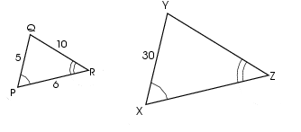
What is the perimeter of Δ XYZ?
A. 21 cm
B. 63 cm
C. 105 cm
D. 126 cm

Commentary:
This multiple-choice question asks students to use similarity of triangles to find the perimeter of a triangle. Students need to use properties of similar triangles to find that the ratio of ΔPQR to ΔXYZ is 1:6. Students use this ratio to determine that the length of $\overline{\text{YZ}}$ is 60 and that the length of $\overline{\text{ZX}}$ is 36. The perimeter of ΔXYZ is 30 + 60 + 36 or 126 cm (answer choice D). Answer choice A is obtained by finding the perimeter of ΔPQR. Answer choices B and C are the result of incorrectly determining the ratio between the two triangles.

The level of complexity for this question is Moderate Complexity. The task requires students to solve a problem requiring multiple steps.

Performance Data:
The percent of public school students selecting answer choice D for question 15 on the March 2005 Grade 8 Achievement Test was 62%.

Keywords: geometry, similarity, perimeter

BACK TO INDEX

Benchmark: E | Draw and construct representations of two- and three-dimensional geometric objects using a variety of tools, such as straightedge, compass and technology.
GLI: GSS 8.6 | Make conjectures about possible relationship in a scatterplot and approximate line of best fit.

Multiple Choice Question:

17. Ray found the paper cut-out shown.
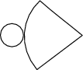

Which 3-dimensional object is formed when the cut-out is assembled?
A. cone
B. cylinder
C. prism
D. sphere

Commentary:
This multiple-choice question asks students to identify the shape when the net (cut-out) is folded. The students need to use spatial visualization to realize that when the net is folded, the resulting shape will be a cone (answer choice A). Answer choices B, C and D are represented by different nets.

The level of complexity for this question is Low Complexity. The task requires students to recognize a representation of a cone.

Performance Data:
The percent of public school students selecting answer choice A for question 17 on the March 2005 Grade 8 Achievement Test was 86%.

Keywords: geometry, spatial sense, net, cone

BACK TO INDEX

Benchmark: C | Specify locations and plot ordered pairs on a coordinate plane.
Benchmark: H | Establish the validity of conjectures about geometric objects, their properties and relationships by counter-example, inductive and deductive reasoning, and critiquing arguments made by others.
GLI: GSS 8.1 | Use, create and interpret scatterplots and other types of graphs as appropriate.
GLI: MEA 6.2 | Use strategies to develop formulas for finding circumference and area of circles, and to determine the area of sectors; e.g., $\frac{1}{2}$circle, $\frac{2}{3}$circle, $\frac{1}{3}$circle, $\frac{1}{4}$circle.

Multiple Choice Question:

30. Circle A has a radius that is twice the length of the radius of Circle B.

Which is an accurate statement about the relationship of the areas of Circles A and B?

- The area of Circle A is four times the area of Circle B.
- The area of Circle A is twice the area of Circle B.
- The area of Circle A is one-half the area of Circle B.
- The area of Circle A is one-fourth the area of Circle B.

Commentary:
This multiple-choice question asks students to compare the relative areas of two circles. Students may approach this question in several ways. One method is to examine the effect of doubling a number and then squaring the result. Students may use examples for each circle and compare their areas. Students should conclude that the area of circle A is four times the area of circle B (answer choice A). Answer choices B, C and D are the results of misconceptions about area and/or a misunderstanding of which circle is larger.

The level of complexity for this question is Moderate Complexity. The task requires students to use informal methods of reasoning and problem solving strategies.

Performance Data:
The percent of public school students selecting answer choice A for question 30 on the March 2005 Grade 8 Achievement Test was 33%.

Keywords: geometry, area, circle

BACK TO INDEX

Benchmark: C | Recognize and apply angle relationships in situations involving intersecting lines, perpendicular lines and parallel lines.
GLI: GSS 8.2 | Evaluate different graphical representations of the same data to determine which is the most appropriate representation for an identified purpose; e.g., line graph for change over time, circle graph for part-to-whole comparison, scatterplot for relationship between two variants.

Multiple Choice Question:

35. In the figure, lines j and k are parallel.
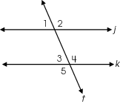
Which angle is congruent to ∠1?

- ∠2
- ∠3
- ∠4
- ∠5

Commentary:
This multiple-choice question asks students to use the properties of parallel lines intersected by a transversal to identify congruent angles. Students may use one or a combination of properties to identify congruent angles. One way is to recall that when parallel lines are cut by a transversal, corresponding angles are congruent. Because angles 1 and 3 are corresponding, they are congruent (answer choice B). Angles 2, 4 and 5 (answer choices A, C and D) are congruent to each other but not congruent to angle 1.

The level of complexity for this question is Low Complexity. The task requires students to recall properties of parallel lines intersected by a transversal.

Performance Data:
The percent of public school students selecting answer choice B for question 35 on the March 2005 Grade 8 Achievement Test was 67%.
Keywords: geometry, parallel lines, congruent angles

BACK TO INDEX

Benchmark: F | Represent and model transformations in a coordinate plane and describe the results.
GLI: GSS 8.5 | Explain the mean's sensitivity to extremes and its use in comparison with the median and mode.

Multiple Choice Question:

39. The parallelogram shown is translated 4 units to the left and 2 units down.

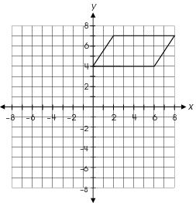

Which property will remain the same?

A. length of the sides
B. coordinates of the vertices
C. coordinates of the y-intercept
D. distance from the vertices to the origin

Commentary:
This multiple-choice question asks students to analyze a figure after a translation and determine the effects of the transformation. Students can answer this question by performing the translation and comparing the two figures. When a translation is preformed, the two figures are congruent and maintain the same orientation, however the position on the grid (coordinates and relative position to the origin), is subject to change. In this translation, the length of the sides will remain the same (answer choice A). The properties in answer choices B, C and D are affected by the translation.

The level of complexity for this question is Moderate Complexity. The task requires performing a procedure and comparison of figures to answer the question.

Performance Data:
The percent of public school students selecting answer choice A for question 39 on the March 2005 Grade 8 Achievement Test was 71%.

Keywords: geometry, translation

BACK TO INDEX

Benchmark: B | Describe and apply the properties of similar and congruent figures; and justify conjectures involving similarity and congruence.
GLI: GSS 8.3 | Differentiate between discrete and continuous data and appropriate ways to represent each.

Mathematical Processes
Benchmark: D | Apply reasoning processes and skills to construct logical verifications or counter-examples to test conjectures and to justify and defend algorithms and solutions.

Short Answer Question:

31. In the figures, m∠PQR = m∠EFD.
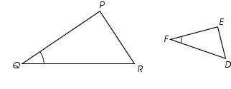
In your Answer Document, identify what else must be true about the sides or the angles of the triangle in order for ΔPQR and ΔEFD to be similar triangles. Provide specific examples for these two triangles.

Commentary:
This short-answer question asks students to identify the required conditions in order for ΔPQR and ΔEFD to be similar triangles. To answer this question students need to understand and know what makes two triangles similar. A response earning the maximum number of points
(2 points) provides one of the possible conditions required that must be true for the triangles to be similar, $\frac{\text{PQ}}{\text{EF}} = \frac{\text{QR}}{\text{FD}}$. Triangles can be considered similar if two sides of one triangle are proportional to the corresponding sides of the second triangle and the angles located between the two sides are congruent. The conditions must be specific for these triangles to earn the maximum number of points

The complexity level of this question is Moderate Complexity. This task asks student to retrieve information from a figure and use it to provide justification for a problem situation.

Performance Data:
The percent of public school students earning each score point for question 31 on the March 2006 Grade 8 Achievement Test:

Percent at Each Score Point
0 | 1 | 2
72% | 7% | 16%

Scoring Guidelines:
Sample Correct Response(s):
- $\frac{\text{PQ}}{\text{EF}} = \frac{\text{QR}}{\text{FD}}$must be true
- $\frac{\text{PQ}}{\text{QR}} = \frac{\text{EF}}{\text{FD}}$must be true
- $\frac{\text{PQ}}{\text{EF}} = \frac{\text{QR}}{\text{FD}} = \frac{\text{PR}}{\text{ED}}$must be true
- m∠ P = m∠E or m∠QPR= m∠ FED
- m∠ R = m∠D or m∠QRP= m∠EDF
Points | Student Response
2 | The focus of this task is to make and test conjectures about characteristics and properties of two-dimensional figures. The response correctly identifies what else must be true about the sides or the angles of the triangles in order for PQR and EFD to be similar triangles. The response also provides specific examples for these two triangles.  Note: ∠ P = ∠E is acceptable or P = E is acceptable.
1 | The response provides partial evidence of making and testing conjectures about characteristics and properties of two-dimensional figures; however, the solution is incomplete or slightly flawed.  For example, the response may:  - Provide a proportional statement but reverses the ratios; e.g., $\frac{\text{PQ}}{\text{EF}} = \frac{\text{DF}}{\text{QR}}$ .  - Provide the definition of similar triangles; e.g., states that sides are proportional and angles are equal.
0 | The response provides inadequate evidence of making and testing conjectures about characteristics and properties of two-dimensional figures. The response has major flaws in reasoning or irrelevant information.  For example, the response may:  - State that if one pair of angles is congruent then all the angles are congruent. So, the triangles are similar.  - Be blank or state unrelated statements.  - Recopy information from the item.

Keywords: geometry, similar triangles

BACK TO INDEX

Benchmark: C | Recognize and apply angle relationships in situations involving intersecting lines, perpendicular lines and parallel lines.
GLI: GSS 8.2 | Evaluate different graphical representations of the same data to determine which is the most appropriate representation for an identified purpose; e.g., line graph for change over time, circle graph for part-to-whole comparison, scatterplot for relationship between two variants.

Multiple Choice Question:

39. In the diagram below, line m is parallel to line n.
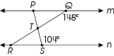

What is the measure of ∠ PTR?
A. 72 °
B. 76 °
C. 108 °
D. 118 °

Commentary:
This multiple-choice question asks students to find the measure of an angle. Student may use geometric concepts related to parallel lines cut by a transversal, Triangle Sums Theorem and the measure of two supplementary angles. The measure of angle PTR is 108, answer choice C. One method for finding the measure of angle PTR is, to first find angle TSR using the definition of supplementary angles (180° - 104° = 76°). Secondly find angle PQR using the definition of supplementary angles (180° - 148° = 32°).Thirdly use the theorem of alternate interior angles to determine that angle QRS is congruent to angle PQR. Therefore, angle QRS is 32°. Then use the Triangle Sums Theorem to determine that the measure of angle RTS is 72°
(180° - 32° - 76° = 72°). Finally to find the measure of angle PTR use the supplement of angle RTS (180° - 72° = 108°). Answer choice A and B are incorrect because they are the measures of angle STR and angle TSR respectfully, Answer choice D is incorrect because the student may have made a computational error.

The complexity level of this question is High Complexity. The task requires students to solve a problem requiring multiple discussion points.

Performance Data:
The percent of public school students selecting answer choice C for question 39 on the March 2006 Grade 8 Achievement Test was 56%.

Keywords: geometry, supplementary angles, alternate interior angles, triangle sum theorem

BACK TO INDEX

Benchmark: D | Use coordinate geometry to represent and examine the properties of geometric figures.
GLI: GSS 8.4 | Compare two sets of data using measures of center (mean, mode, median) and measures of spread (range, quartiles, interquartile range, percentiles).

Multiple Choice Question:

40. Right triangle XYZ and points J and K are shown below.
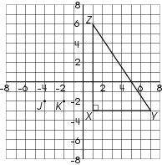
Triangle XYZ is similar to triangle JKL. What could be the location of point L so that triangle JKL is similar to triangle XYZ?
A. (-4, 4)
B. (-4, 1)
C. (-2, 2)
D. (-2, 0)

Commentary:
This multiple-choice question asks students to identify the ordered pair that would create a triangle similar to a given triangle. Students must first determine that the ratio between the original triangle and the similar triangle is 3:1. Using this ratio the length of side LJ would be 3 units. One of the points three units away from point J (-4, -2) would be (-4, 1), Answer choice B. Answer choices A, C and D would not create a triangle JKL that is similar to Triangle XYZ.

The complexity level of this question is Moderate Complexity. The question requires students to retrieve information from a figure to solve a problem requiring multiple steps.

Performance Data:
The percent of public school students selecting answer choice B for question 40 on the March 2006 Grade 8 Achievement Test was 47%.

Keywords: geometry, similarity, coordinate geometry, triangle

BACK TO INDEX

Benchmark: D (5-7) | Identify, describe and classify types of line pairs, angles, two-dimensional figures and three- dimensional objects using their properties.
GLI: GSS 6.1 | Classify and describe two-dimensional and three-dimensional geometric figures and objects by using their properties; e.g., interior angle measures, perpendicular/parallel sides, congruent angles/sides.

Multiple Choice Question:

8. Triangle XYZ is shown.
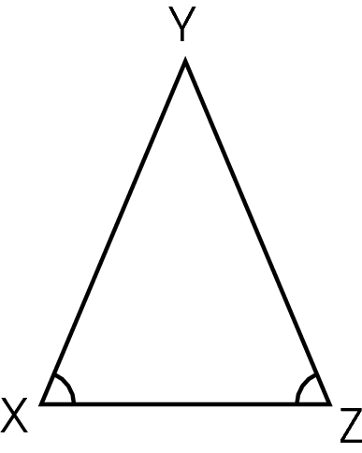
Angles X and Z are congruent.
Which statement is always true?

A. m∠Y = 90º
B. $\overline{\text{YZ}} ≃ \overline{\text{ZX}}$
C. $\text{ZX} > \text{XY}$
D. $\overline{\text{XY}} ≃ \overline{\text{YZ}}$

Commentary:
This multiple-choice question asks students to identify the statement that is always true for the given triangle and whose angles X and Z are congruent. Students need to know that if two angles of a triangle are congruent than the sides opposite of those angles are also congruent. Answer choice D, $\overline{\text{XY}} ≃ \overline{\text{YZ}}$, is correct.
Students who selected answer choices A, B or C may have identified a situation that is true some times, but not always true.

The complexity level of this question is Low Complexity. This question requires students to recall properties of triangles.

Performance Data:
The percent of public school students selecting answer choice D for question 8 on the May 2007 Grade 8 Achievement Test was 65%.

Keywords: geometry, triangle, congruent, angle, side

BACK TO INDEX

Benchmark: F | Represent and model transformations in a coordinate plane and describe the results.
GLI: GSS 8.5 | Explain the mean's sensitivity to extremes and its use in comparison with the median and mode.

Short Answer Question:

11. Rectangle PQRS is shown on the coordinate plane.
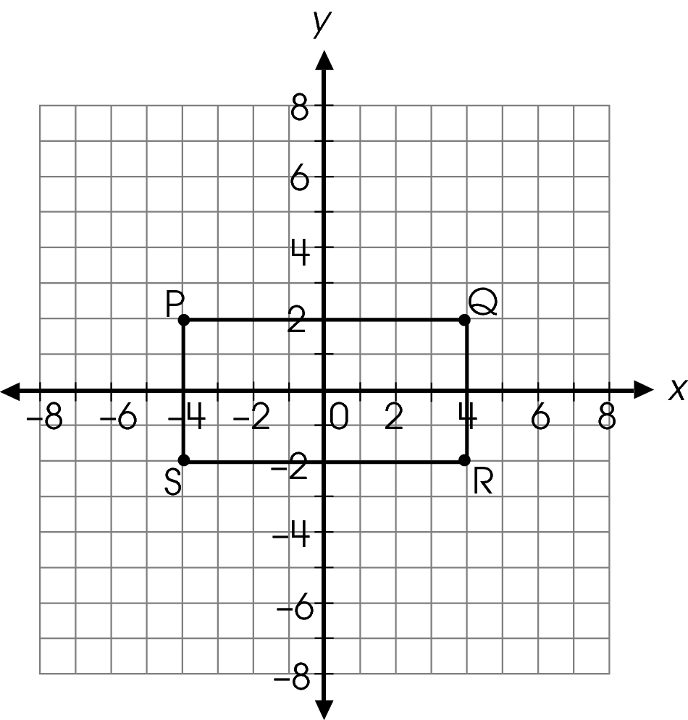
In your Answer Document, sketch rectangle ABCD centered at the origin to represent a dilation of rectangle PQRS by a scale factor of 1.5.
Then, state one characteristic of rectangle PQRS that does not change as a result of the dilation.

Commentary:
This short-answer question asks students to perform a transformation on a given object and identify a characteristic of the object that does not change after the transformation. A response earning the maximum number of points (2 points) provides the results from performing a dilation by a scale factor of 1.5 on the given rectangle, and then identifying a characteristic that has not changed as a result of the dilation. Students may approach the situation using one of several methods. One method is to multiply the x- and y- coordinates of the ordered pairs that represent the four vertices of the given rectangle by a factor of 1.5.

Original order pair | Function of dilating the coordinates | Dilated order pair
P(-4, 2) | -4 • 1.5 , 2 • 1.5 | A(-6, 3)
Q(4, 2) | 4 • 1.5 , 2 • 1.5 | B(6, 3)
R( 4, -2) | 4 • 1.5 , 2 • 1.5 | C(6, -3)
S(-4, -2) | -4 • 1.5 , -2 • 1.5 | D(-6, -3)

Students can then plot the new vertices, connect and label them. A second method is for students to look at the two horizontal sides. Since they are 2 units away from the origin and x-axis, they will be 1.5 times that distance or 3 units when dilated. Additionally, the two vertical sides are four units away from the origin and y-axis. So when they are dilated they will be 6 units from the origin which is 1.5 times the original distance.
Students need to analyze the two figures to determine a characteristic that has not been affected by the transformation. There are several characteristics that students may identify such as, the new rectangle still has four right angles or the ratio between the length and width of the two rectangles are the same.

The complexity level of this question is Moderate Complexity. This task requires students to transfer a specified procedure and use informal methods reasoning to compare figures.

Performance Data:
The percent of public school students earning each score point for question 11 on the May 2007 Grade 8 Achievement Test:

Percent at Each Score Point
0 | 1 | 2
71% | 22% | 7%

Scoring Guidelines:
Exemplar Response:
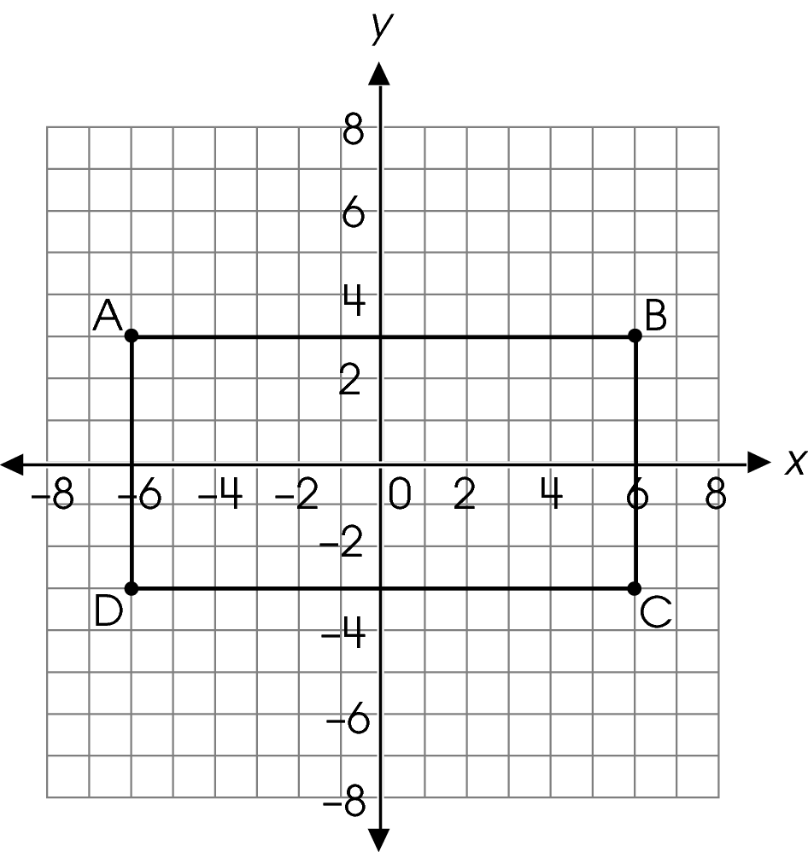
All four angles still measure 90°.
OR
One characteristic that does not change is the ratio of length to width which is 2 in both rectangles.
Points | Student Response
2 point text | The focus of this task is to draw the results of a dilation about a fixed point and to state a characteristic of the object that remains fixed following the dilation. The response provides a grid with the dilated rectangle and states a characteristic that does not change as a result of the dilation.  Note:  - Vertex labels are not considered in scoring.  - Characteristics may include but are not limited to: angles are 90 degrees, ratio of sides stays the same, opposite sides are parallel, adjacent sides are perpendicular. Unacceptable responses: it is still a rectangle, the perimeter or the area stay the same.
1 point text | The response shows partial evidence of drawing the results of a dilation about a fixed point and stating a characteristic of the object that remains fixed following the dilation; however, the solution may be incomplete or slightly flawed.  For example, the response may:  - Provide a correct sketch of the dilated rectangle without a description of a characteristic that does not change.  - Provide a correct statement about a characteristic of a dilation that does not change; however, the response does not provide a correctly drawn dilation of the rectangle or provides no dilation at all.
0 point text | The response provides inadequate evidence of drawing the results of a dilation about a fixed point and stating a characteristic of the object that remains fixed following the dilation. The response contains major flaws and errors in reasoning.  For example, the response may:  - Extend the rectangle 1.5 units in every direction.  - Dilate the rectangle but move the center off the origin.  - Incorrectly draw rectangle PQRS.  - Restate the information provided in the item.  - Be blank or give irrelevant information.

Keywords: geometry, transformation, dilation, rectangle

BACK TO INDEX

Benchmark: C | Recognize and apply angle relationships in situations involving intersecting lines, perpendicular lines and parallel lines.
GLI: GSS 8.2 | Evaluate different graphical representations of the same data to determine which is the most appropriate representation for an identified purpose; e.g., line graph for change over time, circle graph for part-to-whole comparison, scatterplot for relationship between two variants.

Multiple Choice Question:

32. A map of downtown Centerville shows North Street parallel to Canal Street.
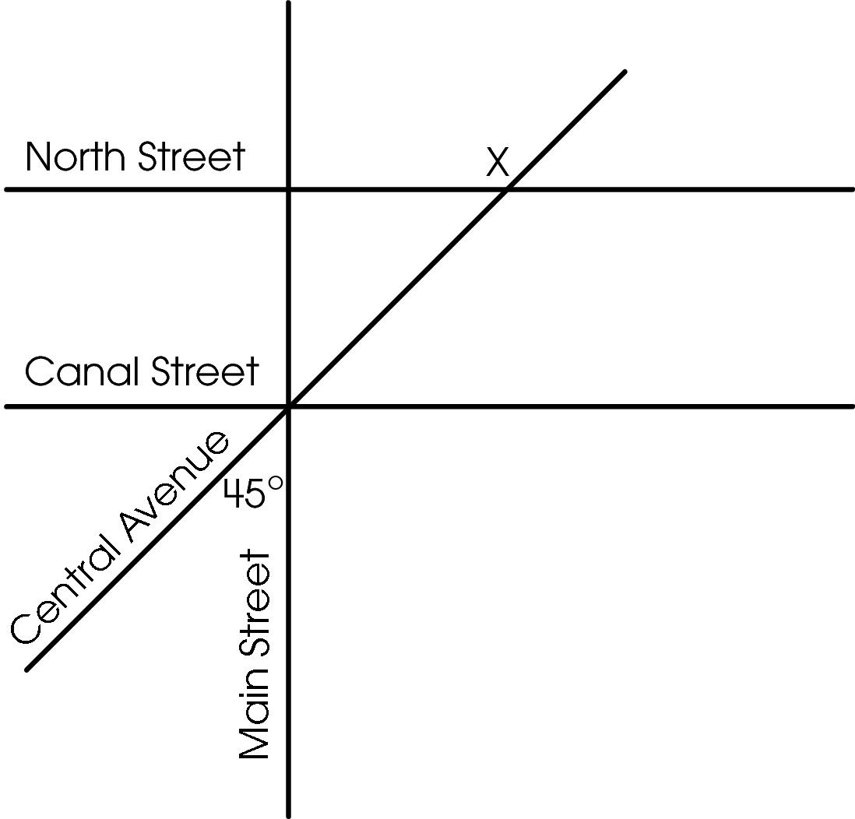
Main Street is perpendicular to both North and Canal streets. The angle between Central Avenue and Main Street is 45º.
What is the measure of angle X?

- 45º
- 120º
- 135º
- 150º

Commentary:
This multiple-choice question asks students to use angle and line relationships to determine the measure of angle X. Students may use several combinations of angle relationships to determine the measure of the identified angle. One strategy is to follow this process:
The given angle and angle 1 are vertical angles; therefore, the measure of angle 1 is 45°. Angle 2 is the complement to the angle formed by Central Avenue and Canal Street; therefore Angle 3 is the corresponding angle to the angle formed by Central Avenue and North Street; therefore, this angle is also 45°. Finally, angle X and angle 3 are supplements and must equal 180°. Therefore, angle X equals 180° – 45° = 135°, answer choice C. Answer choices A, B and D are the results of not understanding angle and line relationships or an error in determining one or more of the intermediate angle measures.

1
2
3

The complexity level of this question is Moderate Complexity. This question requires students to retrieve information from a graph and to use it to solve a problem that requires multiple steps.

Performance Data:
The percent of public school students selecting answer choice C for question 32 on the May 2007 Grade 8 Achievement Test was 61%.

Keywords: geometry, angle, parallel, perpendicular, vertical angles, corresponding, supplementary

BACK TO INDEX

Benchmark: C | Recognize and apply angle relationship in situations involving intersecting lines, perpendicular lines and parallel lines.
GLI: GSS 8.2 | Evaluate different graphical representations of the same data to determine which is the most appropriate representation for an identified purpose; e.g., line graph for change over time, circle graph for part-to-whole comparison, scatterplot for relationship between two variants.

Multiple Choice Question:

5. A parallelogram is shown.
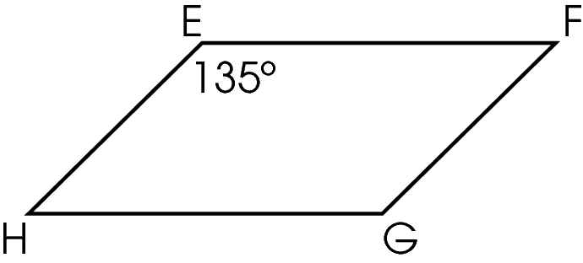
What is the measure of angle F?
  - 45 degrees
  - 65 degrees
  - 90 degrees
  - 135 degrees

Commentary:
This multiple-choice question asks students to find the measure of an angle in a parallelogram. To solve the problem students may use geometric concepts related to parallel lines cut by a transversal or the properties of parallelograms. One method for finding the measure of angle F is to use geometric concepts related to parallel lines cut by a transversal.
↔ ↔
Angles E and F are located between two parallel lines (EH and FG) and on the same side of
↔
transversal (EF), and the sum of their measures is 180 degrees:

m$∠$E + m$∠$F = 180°
135 + m$∠$F = 180°
m$∠$F = 45°

Another method for finding the measure of angle F is to use properties of parallelograms. In parallelograms, the opposite angles are congruent (measures of angles E and G are equal, as well as measures of angles F and H) and the sum of all angle measures in a parallelogram is 360°. If the measure of angle F is x and the measure of angle H is also x, then the following equation can be solved to find the missing measure of angle F:

135 + 135 + x + x = 360
270 + 2x = 360
2x = 90
x = 45
m$∠$F = 45°

The measure of angle F is 45 degrees, answer choice A.

Answer choices B and C are incorrect because the student made a computational error. Answer choice D is incorrect because students thought that all angles of a parallelogram must be equal and the measure of angle F is also 135 degrees.

The complexity level of this question is Moderate Complexity. This question requires students to retrieve information from a figure and represent a situation mathematically.

Performance Data:
The percent of public school students selecting answer choice A for question 5 on the May 2008 Grade 8 Achievement Test was 74%.

Keywords: geometry, angle, measure of an angle, parallelogram, parallel lines

BACK TO INDEX

Benchmark: B | Describe and apply the properties of similar and congruent figures; and justify conjectures involving similarity and congruence.
GLI: GSS 8.3 | Differentiate between discrete and continuous data and appropriate ways to represent each.

Multiple Choice Question:

19. On a scale drawing of a house, a rectangular bedroom has a length of 8 inches and a perimeter of 30 inches. The scale is 0.5 inch = 1 foot.
What is the actual width in feet of the bedroom?

- 7 feet
- 14 feet
- 15 feet
- 22 feet

Commentary:
This multiple-choice question asks students to use proportional reasoning to solve a problem involving a scale drawing. The formula for the perimeter of a rectangle states that the perimeter is equal to the sum of the lengths of its four sides (P = l + l + w + w). Students have to substitute 8 for l (length) and 30 for P (perimeter) and then solve the formula for the variable w

30 = 8 + 8 + w + w.
30 = 16 + 2w
14 = 2w
7 = w

Since the scale is 0.5 inch = 1 foot and the width of the rectangle on the scale drawing is
7 inches, a proportion can be set up to find the missing length

$\frac{0\text{.}5 \text{inches}}{1 \text{foot}}$= $\frac{7 \text{inches}}{w \text{feet}}$
w = $\frac{1⋅7}{0\text{.}5}$
w = 14 feet

So, the actual width of the bedroom is 14 feet, answer choice B.

If a student chooses answer choice A, he or she correctly found the width of the rectangle on the scale drawing but did not use the scale to find the actual width for the bedroom in feet. If a student chooses answer choice C, he or she multiplied 30 inches (the perimeter) by the scale of 0.5 inches to calculate the number of feet. If a student chooses answer choice D, he or she subtracted the length on the scale drawing from the perimeter on the scale drawing
(30 – 8 = 22 feet).

The complexity level of this question is Moderate Complexity. This question asks students to use informal methods of reasoning and solve a word problem requiring multiple steps.

Performance Data:
The percent of public school students selecting answer choice B for question 19 on the May 2008 Grade 8 Achievement Test was 36%.

Keywords: proportional reasoning, proportion, scale, perimeter

BACK TO INDEX

