Index to Questions

Question Number | Source | BM | GLI | Description
2 | OAT March 05 | G | GSS 7.3a | This multiple-choice question asks students to find the length of the diagonal pathway of a rectangular garden.
8 | OAT March 05 | E | GSS 7.1 | This multiple-choice question asks students to determine the scale of a model sign to the actual sign.
10 | OAT March 05 | E | GSS 7.6 | This multiple-choice question asks students to find  the length of a side in a parallelogram.
18 | OAT March 05 | G | GSS 7.3b | This multiple-choice question asks students to find the measure of an angle in a triangle given the measures of two angles.
31 | OAT March 05 | I | GSS 7.9 | This extended-response question asks students to draw sketches and different perspectives of a cone and a cylinder with the dimensions with descriptions of the perspectives (top- and front- views).
42 | OAT March 05 | D | GSS 7.2b | This multiple-choice question asks students to select the statement that describes a characteristic of all parallelograms.
43 | OAT March 05 | E & G | GSS 7.1, GSS 7.5 | This multiple-choice question asks students to find the side length in a right triangle.
2 | OAT March 06 | D | GSS 7.2a,b | This multiple-choice question asks students to identify the statement that provides reasoning for a square to be considered a rhombus.
20 | OAT March 06 | F | GSS 7.7 | This multiple-choice question asks students to determine the degree of rotational symmetry in a given figure.
26 | OAT March 06 | E | GSS 7.1 | This short-answer question asks students to find the ratio between the circumferences of two circles.
33 | OAT March 06 | H | GSS 7.8 | This multiple-choice question asks students to identify the coordinates of a triangle after is has been translated.
2 | OAT May 07 | F | GSS 7.4 | This multiple-choice question asks students to determine which type of quadrilateral will always have two congruent triangles when divided by a diagonal.
6 | OAT May 07 | H | GSS 7.8 | This short-answer question asks students to describe two different transformations that will create trapezoid B when starting from trapezoid A.
Question Number | Source | BM | GLI | Description
9 | OAT May 07 | E | GSS 7.6 | This multiple-choice question asks students to find the length of Oscar’s father’s shadow.
12 | OAT May 07 | J | GSS 7.6 | This multiple-choice question asks students to determine the scale factor that was used in creating the diagram of the soccer field.
23 | OAT May 08 | G | GSS 7.3a | This multiple-choice question asks students to find the distance between two out of three students sitting in the classroom.
28 | OAT May 08 | E | GSS 7.6 | This multiple-choice question asks students to determine the distance between two cities on a map using the given scale factor.
33 | OAT May 08 | F | GSS 7.7 | This multiple-choice question asks students to identify a two dimensional figure that has only 180° or 360° rotational symmetry.
42 | OAT May 08 | E | GSS 7.1 | This multiple-choice question asks students to find the length of the side in one of two similar triangles.

BACK TO INDEX

Benchmark: G | Describe and use properties of triangles to solve problems involving angle measures and side lengths of right triangles.
GLI: GSS 7.3a | Use and demonstrate understanding of the properties of triangles. For example:  - Use Pythagorean Theorem to solve problems involving right triangles.

Mathematical Processes
Benchmark: B | Apply and adapt problem-solving strategies to solve a variety of problems, including unfamiliar and non-routine problem situations.

Multiple Choice Question:

2. A rectangular garden has the dimensions shown.
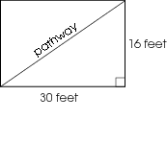
A pathway cuts diagonally through the garden.

What is the length of the pathway?

  - 25 feet
  - 34 feet
  - 46 feet
  - 92 feet

Commentary:
This multiple-choice question asks students to find the length of the diagonal pathway of a rectangular garden. The Pythagorean Theorem or a reason about the relationship among the sides of a right triangle can be used to find the length of the diagonal pathway. For example, the diagonal which is the hypotenuse in the right triangle has to be longer than 30 feet, but less than the sum of the other two sides of the triangle. Answer choice B is the correct response. Answer choice A is less than the sum of the other two sides in the right triangle. The lengths in answer choices C and D are equal to or longer than the sum of the other two sides of the right triangle.
The level of complexity for this question is Moderate Complexity. The task requires students to retrieve information from a figure and use it to solve a problem and make a decision on how to solve the problem.

Performance Data:
The percent of public school students selecting answer choice B. for question 2 on the March 2005 Grade 7 Achievement Test was 39%.

Keywords: geometry, Pythagorean Theorem, right triangle, triangle properties

BACK TO INDEX

Benchmark: E | Use proportions to express relationships among corresponding parts of similar figures.
GLI: GSS 7.1 | Use proportional reasoning to describe and express relationships between parts and attributes of similar and congruent figures.

Multiple Choice Question:

8. Jason made a model stop sign for his model train set. An actual stop sign measures 12 inches on each side. Jason’s model stop sign measures $\frac{1}{2}$inch on each side.
What is the scale of the model sign to the actual sign?
  - 1 : 2
  - 1 : 6
  - 1 : 12
  - 1 : 24

ID: 656; Version: 15

Commentary:
This multiple-choice question asks students to determine the scale of a model sign to the actual sign. To find the scale using the information in the problem, students can use proportional reasoning. There are 12 inches in the actual sign to $\frac{1}{2}$inch on the model sign. Therefore, there are 24 inches in the actual sign for every 1 inch in the model sign. The scale would be 1 inch in the model sign for every 24 inches in the actual sign. Answer choice D is the correct response. Answer choices A, B and C do not correctly use proportional reasoning.

The level of complexity for this question is Moderate Complexity. The task requires students to represent a situation mathematically.

Performance Data:
The percent of public school students selecting answer choice D for question 8 on the March 2005 Grade 7 Achievement Test was 44%.

Keywords: geometry, proportional reasoning

BACK TO INDEX

Benchmark: E | Use proportions to express relationships among corresponding parts of similar figures.
GLI: GSS 7.6 | Determine and use scale factors for similar figures to solve problems using proportional reasoning.

Multiple Choice Question:

10. Parallelogram EFGH is similar to parallelogram WXYZ.
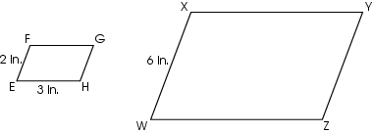
What is the length of$\overline{\text{WZ}}$?
  - 3 in.
  - 6 in.
  - 7 in.
  - 9 in.

ID: 84; Version: 30

Commentary:
This multiple-choice question asks students to find the length of a side in a parallelogram. Students may use the fact that the lengths of corresponding sides in similar figures have the same ratios. For example, the ratio of side WX to side EF is 6 to 2 or 3 to 1, so the ratio of side WZ to side EH must also be 3 to 1. Since the length of side EH is 3 inches, the length of side WZ must be 9 inches. Therefore, the correct answer is answer choice D. Answer choices A, B and C do not maintain the ratio of 3 to 1.
The level of complexity for this question is Low Complexity. This task requires students to recall the properties of similar figures.

Performance Data:
The percent of public school students selecting answer choice D for question 10 on the March 2005 Grade 7 Achievement Test was 71%.

Keywords: geometry, similar figures

BACK TO INDEX

Benchmark: G | Describe and use properties of triangles to solve problems involving angle measures and side lengths of right triangles.
GLI: GSS 7.3b | Use and demonstrate understanding of the properties of triangles. For example:  - use triangle angle sum relationships to solve problems.

Multiple Choice Question:

18. Two interior angles of triangle FGH measure 25 º and 50 º.
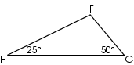
What is the measure of HFG?
  - 15 º
  - 25 º
  - 90 º
  - 105 º

ID: 2796; Version: 4

Commentary:
This multiple-choice question asks students to find the measure of an angle in a triangle given the measures of two angles. Students should recall that the sum of the measures of the interior angles of a triangle is 180 degrees. Subtracting the sum of the given angles (25+ 50 =75) from 180 results in the measure of HFG (105), which is answer choice D.

The level of complexity of this question is Low Complexity. The task requires students to recall a property.

Performance Data:
The percent of public school students selecting answer choice D for question 18 on the March 2005 Grade 7 Achievement Test was 55%.

Keywords: measurement, interior angles, triangle

BACK TO INDEX

Benchmark: I | Identify and draw three-dimensional objects from different views (top, side, front and perspective).
GLI: GSS 7.9 | Draw representations of three-dimensional geometric objects from different views.

Extended Response Question:

31. A cone with a height of 7 inches and a base with a diameter of 3 inches is standing on its base. A cylinder with a height of 7 inches and a base with a diameter of 3 inches is also standing on its base next to the cone.
In your Answer Document, draw a sketch of the cone and the cylinder. Label the dimensions.
Describe how the cone and the cylinder will look when each object is viewed from the top. Draw and label sketches of this top-view perspective.
Now describe how the cone and the cylinder will look when each object is viewed from the front. Draw and label sketches of this front-view perspective.

Commentary:
This extended-response question asks students to draw sketches and different perspectives of a cone and a cylinder with the dimensions with descriptions of the perspectives (top- and front- views). The maximum points (4 points) are awarded for drawings of the cone and cylinder with the height and diameter labeled, and drawings of the top- and front- views of the cone and cylinder. The response also includes a description of the top-and front-views of the cone and the cylinder.

The level of complexity for this question is High Complexity. This task requires students to perform a procedure having multiple steps and multiple decision points and to analyze similarities and differences in the representations.

Performance Data:
The percent of public school students earning each score point for question 31 on the March 2005 Grade 7 Achievement Test:

Percent at Each Score Point
0 | 1 | 2 | 3 | 4
12% | 48% | 24% | 8% | 4%

Scoring Guidelines:
Points | Student Response
4 | Sample Correct Responses:  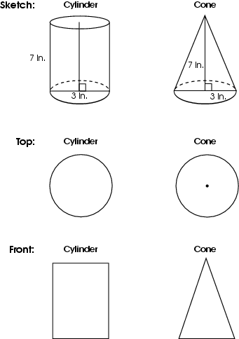  They will both look like circles from the top. The cylinder will look like a rectangle from the front and the cone will look like a triangle from the front.  NOTE: Top of cone drawing may or may not include vertex.
Points |  | Student Response
4 |  |  | The focus of this task is drawing three-dimensional geometric objects from different views. The response provides an accurate three-dimensional sketch of the cone and cylinder, with heights and diameters clearly labeled; drawings of the cone and cylinder from the top; and drawings of the cone and cylinder from the front. The front- and top- perspective drawings do not need dimensions. The response also includes a description of how the cone and cylinder look when viewed from the top and from the front.
3 |  |  | The response provides clear evidence of drawing three-dimensional geometric objects from different views. However, the response might be slightly flawed.  For example, the response may:  - Include three-dimensional sketches of a cone and cylinder with correctly labeled dimensions. Both drawings of cylinder (side and top) are correct. One of two drawings of cone (side OR top) are incorrect. It also provides two accurate descriptions.  - Include three-dimensional sketches of a cone and cylinder with correctly labeled dimensions. Both drawings of cone (side and top) are correct. One of two drawings of cylinder (side OR top) are incorrect. It also provides two accurate descriptions.  - Include three-dimensional sketches of a cone and cylinder that are correct but without labeled dimensions. Both drawings of cone and cylinder (sides and tops) are correct. It also provides two accurate descriptions.  - Include three-dimensional sketches of a cone and cylinder that are not three-dimensional, but are labeled with dimensions. Both drawings of cone and cylinder (sides and tops) are correct. It also provide two accurate descriptions.  - Include all correct drawings with labels but the descriptions are omitted or flawed.  - Include correct and complete descriptions but one set of views is incorrectly drawn.
2 |  |  | The response provides partial evidence of drawing three-dimensional geometric objects from different views. However, the response might be incomplete or slightly flawed.  For example, the response may:  - Include all accurate drawings without labels or descriptions.  - Include three-dimensional drawings that are incorrect and do not have dimensions, but the two-dimensional drawings for both shapes are correct.  - Include correct drawing for one shape (e.g. cylinder) but not the other (e.g. cone).  - Be incomplete with one perspective missing or incorrect, but includes description of a view or labeling of the 3-D perspective.  - Include correct and complete drawings for two views and correct and complete descriptions for two views.

Points | Student Response
1 |  | The response provides minimal evidence of drawing three-dimensional geometric objects from different views. However, the response might be incomplete or slightly flawed.  For example, the response may:  - Show the three-dimensional sketch drawn correctly with or without dimensions but no drawings from different perspectives for either shape.  - Show a drawing as complete and accurate for one shape or perspective but there is no three-dimensional sketch for either, and the other shape has no drawing perspective.
0 |  | The response provides inadequate evidence of drawing three-dimensional geometric objects from different views. The response provides major flaws in reasoning or irrelevant information.  For example, the response may:  - Indicate two shapes that are neither cone nor cylinder, such as a sphere and a rectangular prism.  - Be blank or make unrelated statements.  - Recopy information from the stem.

ID: 557; Version: 14

Keywords: geometry, three-dimensional objects, views, perspective

BACK TO INDEX

Benchmark: D | Identify, describe and classify types of line pairs, angles, two-dimensional figures and three-dimensional objects using their properties.
GLI: GSS 7.2b | Determine sufficient (not necessarily minimal) properties that define a specific two-dimensional figure or three-dimensional object. For example:  - Develop a set of properties that eliminates all but the desired figure; e.g., only squares are quadrilaterals with all sides congruent and all angles congruent.

Mathematical Processes
Benchmark: E | Use deductive thinking to construct informal arguments to support reasoning and to justify solutions to problems.

Multiple Choice Question:

42. Which statement is a characteristic of all parallelograms?

  - Adjacent sides are congruent.
  - Adjacent sides are perpendicular.
  - Opposite angles are congruent.
  - Opposite angles are supplementary.

Commentary:
This multiple-choice question asks students to select the statement that describes a characteristic of all parallelograms. Students should recall that opposite sides of a parallelogram and opposite angles of a parallelogram are congruent. The statement in answer choice C identifies one of the characteristics of parallelograms. The statements in answer choices A, B and D do not relate to all parallelograms.

The level of complexity for this question is Low Complexity. The task requires students to recall a property.

Performance Data:
The percent of public school students selecting answer choice C for question on the March 2005 Grade 7 Achievement Test was 36%.

Keywords: geometry, parallelograms

BACK TO INDEX
Benchmark: E | Use proportions to express relationships among corresponding parts of similar figures.
GLI: GSS 7.1 | Use proportional reasoning to describe and express relationships between parts and attributes of similar and congruent figures.
Benchmark: G | Describe and use properties of triangles to solve problems involving angle measures and side lengths of right triangles.
GLI: GS 7.5 | Apply properties of congruent or similar triangles to solve problems involving missing lengths and angle measures.

Multiple Choice Question:

43. Lance is 5 feet tall. His shadow is 8 feet long.
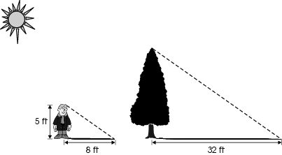
At the same time of day, a tree’s shadow is 32 feet long.
What is the height of the tree?

A. 20 feet
B. 24 feet
C. 29 feet
D. 51 feet

ID: 712; Version: 15

Commentary:
This multiple-choice question asks students to find the side length in a right triangle. Proportional reasoning can be used to find the height of a tree. One method is to compare Lance’s height to the tree’s height. The ratio of the length of Lance’s shadow (8 feet) to the length of the tree’s shadow (32 feet) is 1 to 4. Therefore, the ratio of Lance’s height to the tree’s height must also be 1 to 4. Since Lance’s height is 5 feet, the height of the tree is 20 feet (answer choice A), resulting in the ratio of Lance’s height to the tree’s height being 1 to 4. The heights given in answer choices B, C and D do not result in a ratio of 1 to 4.

The level of complexity for this question is Low Complexity. The task requires students to solve a one step word problem.

Performance Data:
The percent of public school students selecting answer choice A for question 43 on the March 2005 Grade 7 Achievement Test was 38%.

Keywords: geometry, proportional reasoning

BACK TO INDEX

Benchmark: D | Identify, describe and classify types of line pairs, angles, two-dimensional figures and three-dimensional objects using their properties.
GLI: GSS 7.2a,b | Determine sufficient (not necessarily minimal) properties that define a specific two-dimensional figure or three-dimensional object. For example:  - Determine when one set of figures is a subset of another; e.g., all squares are rectangles.  - Develop a set of properties that eliminates all but the desired figure; e.g., only squares are quadrilaterals with all sides congruent and all angles congruent.

Multiple Choice Question:

2. Coral was asked to draw a rhombus on the chalkboard.
Coral drew a square.
Ken told Coral that she didn’t draw a rhombus.
Coral responded, “A square is a rhombus.”

Which statement supports Coral’s reasoning that a square is a rhombus?
  - A rhombus must have at least four sides.
  - A rhombus must have one pair of parallel sides.
  - A rhombus must have right angles.
  - A rhombus must have four congruent sides.

ID: 202; Version: 10

Commentary:
This multiple-choice question asks students to identify the statement that provides reasoning for a square to be considered a rhombus. Students need to recall the definitions of both a square and a rhombus. A square is a parallelogram with 4 congruent sides with 4 right angles. A rhombus is a parallelogram with 4 congruent sides. A square meets these requirements therefore, a square is a special case of a rhombus. Answer choice D is correct. Answer choices A, B and C are incorrect. Answer choice A is incorrect because all quadrilaterals have 4 sides. Answer choice B is incorrect because a rhombus is a parallelogram and it has two pairs of parallel sides and answer choice C is incorrect because a rhombus is a parallelogram and it does not have to have right angles.
The complexity level of this question is Low Complexity. This question requires student to recall a fact about rhombuses.
Performance Data:
The percent of public school students selecting answer choice D for question 2 on the March 2006 Grade 7 Achievement Test was 40%.

Keywords: geometry, rhombus, square, parallelogram, properties

BACK TO INDEX

Benchmark: F | Describe and use the concepts of congruence, similarity and symmetry to solve problems.
GLI: GSS 7.7 | Identify the line and rotation symmetries of two-dimensional figures to solve problems.

Multiple Choice Question:

20. A figure is shown.
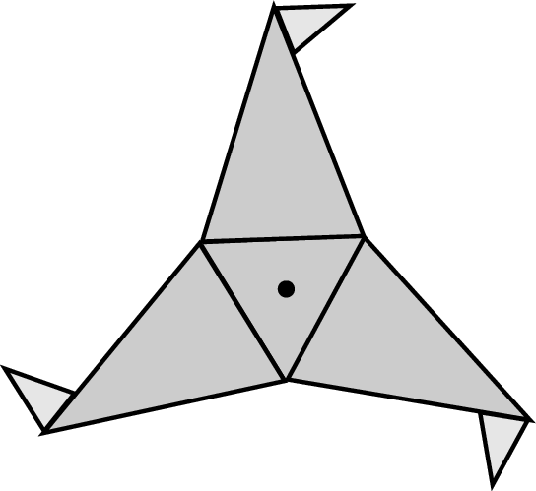
Which degree of rotational symmetry does this figure have?
  - 90
  - 120
  - 180
  - 270

Commentary:
This multiple-choice question asks students to determine the degree of rotational symmetry in a given figure. Students must understand that rotational symmetry is when the figure rotated it coincides with the original figure before rotating a full 360. The degree of rotation can be determined by dividing 360 by the number of times that the figure would coincide with itself as it is rotated. When this figure is rotated it has three instances where it coincides. Therefore,
360  3 = 120, answer choice B. Answer choice A is incorrect because it is the degree of rotation for an object that has four instances where it would be the same. Answer choice C is incorrect because it is the degree of rotation for an object that has two instances where it would be the same. The student may have found $\frac{3}{4}$ of 360 for answer choice D, which is incorrect.

The complexity level of this question is Moderate Complexity. This question asks students to interpret a visual representation to solve a problem.

Performance Data:
The percent of public school students selecting answer choice B for question 20 on the March 2006 Grade 7 Achievement Test was 37%.

Keywords: geometry, rotational symmetry, angle of rotation

BACK TO INDEX

Benchmark: E | Use proportions to express relationships among corresponding parts of similar figures.
GLI: GSS 7.1 | Use proportional reasoning to describe and express relationships between parts and attributes of similar and congruent figures.

Short Answer Question:

26. Two circles are shown.
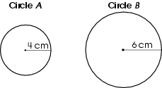
In your Answer Document, find the ratio of the circumference of Circle A to the circumference of Circle B. Show your work or provide an explanation to support your answer.

ID: 2608; Version: 12

Commentary:
This short-answer question asks students to find the ratio between the circumferences of two circles. A response earning the maximum number of points (2 points) provides the ratio of the circumferences as 2 to 3 or an equivalent ratio with supporting work. For example:
$$\frac{2 π r}{2 π r} = \frac{2 π 4}{2 π 6} = \frac{2}{3}$$

The complexity level of this question is Moderate Complexity. The task requires students to retrieve information form a figure and use it to solve a problem.

Performance Data:
The percent of public school students earning each score point for question 26 on the March 2006 Grade 7 Achievement Test:

Percent at Each Score Point
0 | 1 | 2
58% | 27% | 10%

Scoring Guidelines:
Sample Correct Response(s):
- The ratio is 2 to 3 since the ratio of the radius is also 2 to 3

- The ratio is 2 to 3.$\frac{2 π r}{2 π r} = \frac{2 π 4}{2 π 6} = \frac{2}{3}$

- The ratio is $\frac{2 π r}{2 π r} = \frac{2 π 4}{2 π 6} = \frac{\text{25}\text{.}\text{12}}{\text{37}\text{.}\text{68}}$

- The ratio is 4 to 6 or $\frac{4}{6}$because $2π÷ 2π = 1$, and 1 x $\frac{4}{6}$= $\frac{4}{6}$

- The ratio is $\frac{2 π r}{2 π r} = \frac{2 π 4}{2 π 6} = \frac{8}{\text{12}}$because $\frac{π}{π} = 1$

Points | Student Response
2 | The focus of the task is using proportional relationships to describe the relationship between the circumferences of similar circles. The response provides the correct ratio of one circle to the other circle with supporting work or an adequate explanation.
1 | The response provides partial evidence of using proportional relationships to describe the relationship between the circumferences of the two circles; however, the solution is incomplete or slightly flawed.  For example, the response may:  - Identify the ratio of 2 to 3 with no supporting work or explanation.  - Provide a correct ratio with computational errors during simplification. $\frac{2 π r}{2 π r} = \frac{2 π 4}{2 π 6} = \frac{6π}{\text{12}π} = \frac{1}{2}$  - Provide correct circumferences for both circles with or without work
0 | The response provides inadequate evidence of using proportional relationships to describe the relationship between the circumferences of the two circles. The response provides major flaws in reasoning or irrelevant information.  For example, the response may:  - State that $8 π × \text{12} π = \text{96}$  - Provide only the circumference of one circle.  - Show $8π$  - Be blank or state unrelated statements.  - Copy information from the stem.

Keywords: geometry, circle, circumference, ratio

BACK TO INDEX

Benchmark: H | Predict and describe results (size, position, orientation) of transformations of two-dimensional figures.
GLI: GSS 7.8 | Perform translations, reflections, rotations and dilations of two-dimensional figures using a variety of methods (paper folding, tracing, graph paper).

Multiple Choice Question:

33. Triangle LMN is shown on the graph.
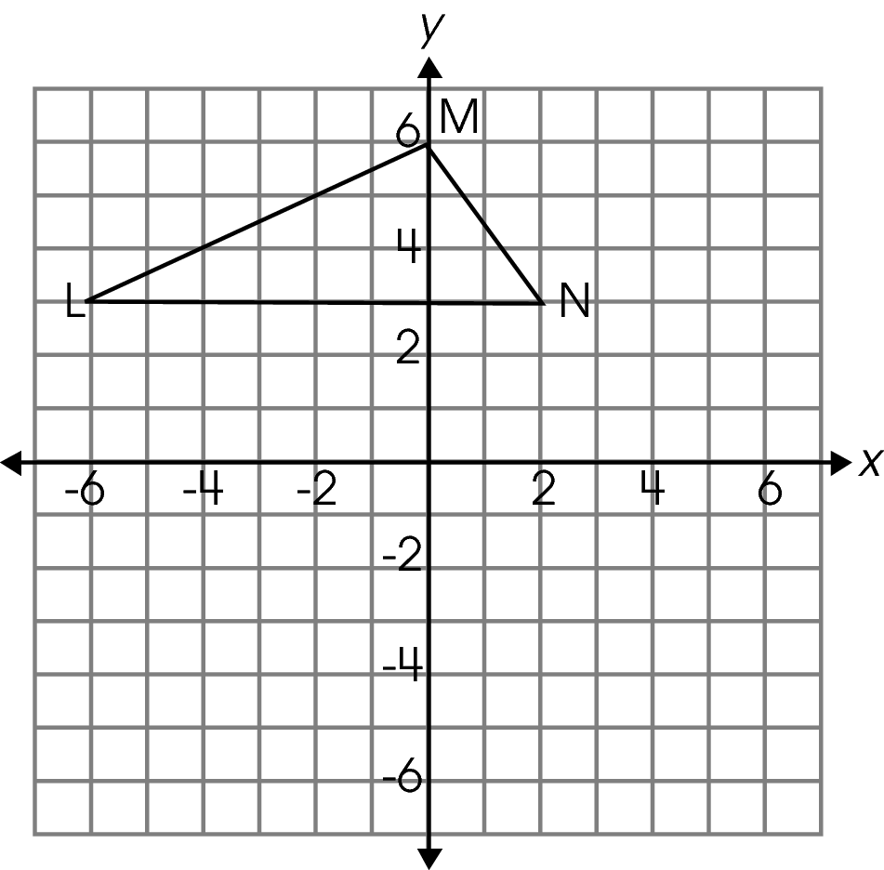
Triangle LMN is translated three units to the right and two units down. What are the coordinates of the vertices for triangle L′ M ′ N ′?
  - L ′ (–3, 1), M ′ (3, 4), N ′ (5, 1)
  - L ′ (–4, 1), M ′ (5, 1), N ′ (2, 4)
  - L ′ (5, 1), M ′ (3, 1), N ′ (2, 4)
  - L ′(4, 3), M ′(1, 5), N ′(1, –3)

Commentary:
This multiple-choice question asks students to identify the coordinates of a triangle after is has been translated. To answer this question, students need to translate a triangle three units to the right and two units down. A student may approach this problem in one of a couple ways. One method is to use the graph provided in the test booklet and move each vertex three units to the right and two units down. A second method is to identify the ordered pair for each vertex then to increase each x coordinate by 3 and decrease each y coordinate by 2. The correct answer choice is A. Answer choices B, C and D are incorrect and represent incorrect transformations.

The complexity level of this question is High Complexity. This question requires student to retrieve information from a graph and solve a problem requiring multiple steps and decision points.

Performance Data:
The percent of public school students selecting answer choice A for question 33 on the March 2006 Grade 7 Achievement Test was 53%.

Keywords: geometry, transformation, coordinate geometry, ordered pair

BACK TO INDEX

Benchmark: F | Describe and use the concepts of congruence, similarity and symmetry to solve problems.
GLI: GSS 7.4 | Determine necessary conditions for congruence of triangles.

Multiple Choice Question:

2. The diagonals divide each figure into two triangles.
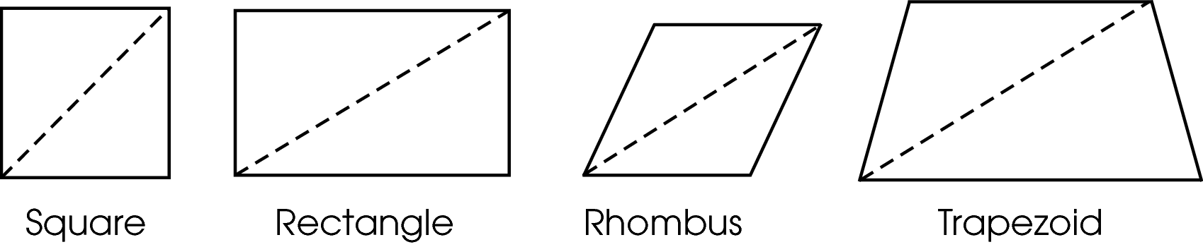
Which of the figures are always divided into congruent triangles by the diagonal?

  - only the square and rectangle
  - only the rhombus and trapezoid
  - only the square, rectangle and rhombus
  - only the rectangle, rhombus and trapezoid

Commentary:
This multiple-choice question asks students to determine which type of quadrilateral will always have two congruent triangles when divided by a diagonal. In understanding this problem, students must know that in squares, rectangles and rhombi opposite sides must be congruent. When the shape is cut by a diagonal it will create two triangles that have all corresponding sides being congruent. The trapezoid does not need to have two pairs of congruent opposite sides. Therefore, the two triangles created may not have corresponding sides that are congruent. The correct answer is C.
Answer choices A, B and D are incorrect. Students who selected A may not have realized that opposite sides of a rhombus are congruent. Students who may not have understood the importance of having opposite sides congruent would have included the trapezoid in their selection, therefore answers B and D could have been selected.

The complexity level of this question is Moderate Complexity. This question requires students to use and compare figures to solve a problem.

Performance Data:
The percent of public school students selecting answer choice C for question 2 on the May 2007 Grade 7 Achievement Test was 73 %.

Keywords: geometry, quadrilateral, square, rectangle, rhombus, trapezoid, diagonal, congruent

BACK TO INDEX

Benchmark: H | Predict and describe results (size, position, orientation) of transformations of two-dimensional figures.
GLI: GSS 7.8 | Perform translations, reflections, rotations and dilations of two-dimensional figures using a variety of methods (paper folding, tracing, graph paper).

Short Answer Question:

6. A trapezoid has been transformed on the coordinate plane as shown.
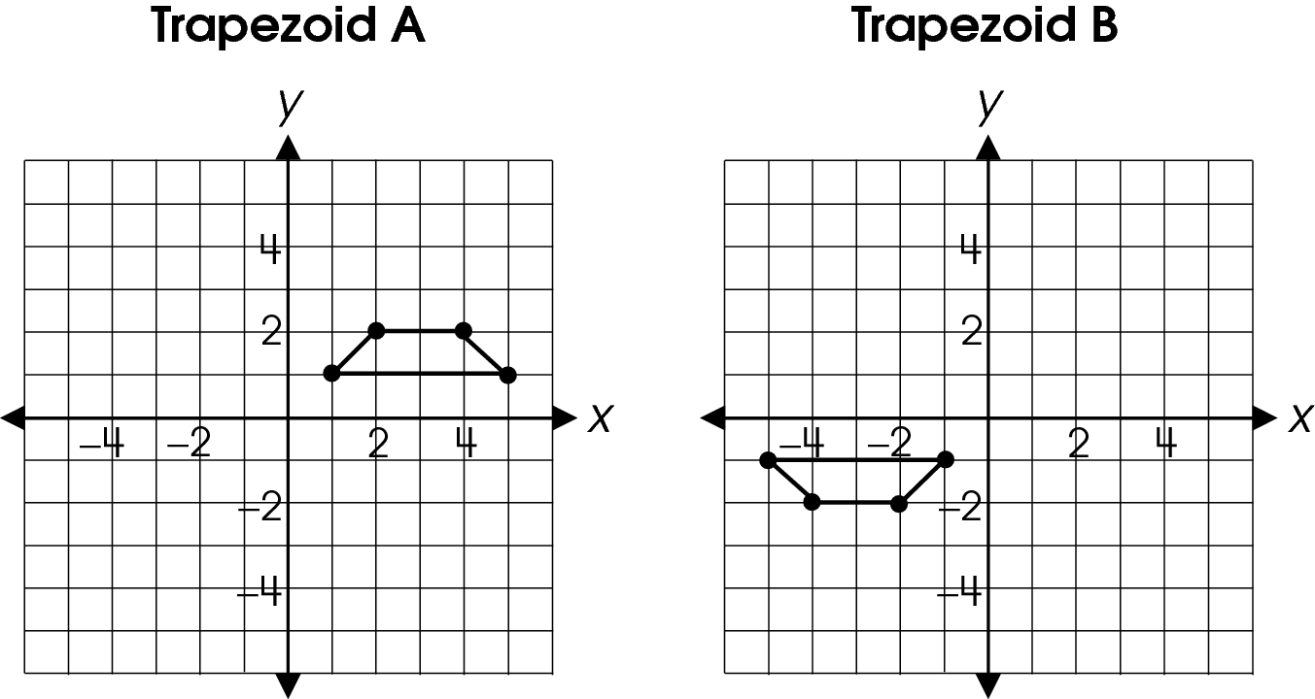
In your Answer Document, describe two different ways that trapezoid A can be transformed to create trapezoid B.

Commentary:
This short-answer question asks students to describe two different transformations that will create trapezoid B when starting from trapezoid A. A response earning the maximum number of point (2 points) adequately describe two different appropriate transformations. Students may use several different transformations, including: translation, rotation and reflection to move trapezoid A to the position of trapezoid B. One method is to use two reflections; the first reflection is over the x-axis, and the second reflection is over the y-axis.
A second method is to translate trapezoid A six units to the left and then reflect it over the x-axis. A third method is to rotate trapezoid A 180° about the origin.

The complexity level of this question is Moderate Complexity. The task requires students to represent a situation mathematically in more that one way.

Performance Data:
The percent of public school students earning each score point for question 6 on the May 2007 Grade 7 Achievement Test:

Percent at Each Score Point
0 | 1 | 2
72% | 19% | 9%

Scoring Guidelines:
Student Response:
- Trapezoid A can be reflected over the y-axis and then over the x-axis. It can also be reflected over the x-axis and then the y-axis.
- Trapezoid A can be transformed into Trapezoid B by being rotated 180 degrees around the origin (or: The coordinates of trapezoid A are changed to their opposites to make trapezoid B.) or by being reflected over the x-axis and then translated 6 units to the left.
- Trapezoid A can be reflected over the y = x line and then over the y = - x line. It can also be translated down 2 units, to the left 2 units, and then rotated 180 degrees around the point (-1,-1).

NOTE: Any combination of two appropriate transformations is acceptable.
Points | Student Response
2 point text | The focus of this task is to identify two different series of transformations (translations, reflections and rotations) of trapezoid A to produce trapezoid B in the coordinate grid. The response provides any two appropriate methods for transforming the trapezoid.  NOTE: The reverse order is accepted as a second method.
1 point text | The response provides partial evidence of identifying two different series of transformations (translations, reflections and rotations) of trapezoid A to produce trapezoid B in the coordinate grid; however, the solution may be incomplete or slightly flawed.
1 point text | For example, the response may:  - Provide only one appropriate method for transforming the trapezoid. The other transformation is incomplete, missing, or contains a flaw.
0 point text | The response provides inadequate evidence of identifying two different series of transformations (translations, reflections and rotations) of trapezoid A to produce trapezoid B in the coordinate grid. The response provides an explanation with major flaws and errors of reasoning.
0 point text | 0 point sample answer:  For example, the response may:  - Provide no correct method for the transformation.  - Restate the information provided in the item.
Keywords: geometry, transformation, coordinate geometry

BACK TO INDEX

Benchmark: E | Use proportions to express relationships among corresponding parts of similar figures.
GLI: GSS 7.6 | Determine and use scale factors for similar figures to solve problems using proportional reasoning.

Multiple Choice Question:

9. Oscar and his father are standing side by side with the sun behind them, as shown.
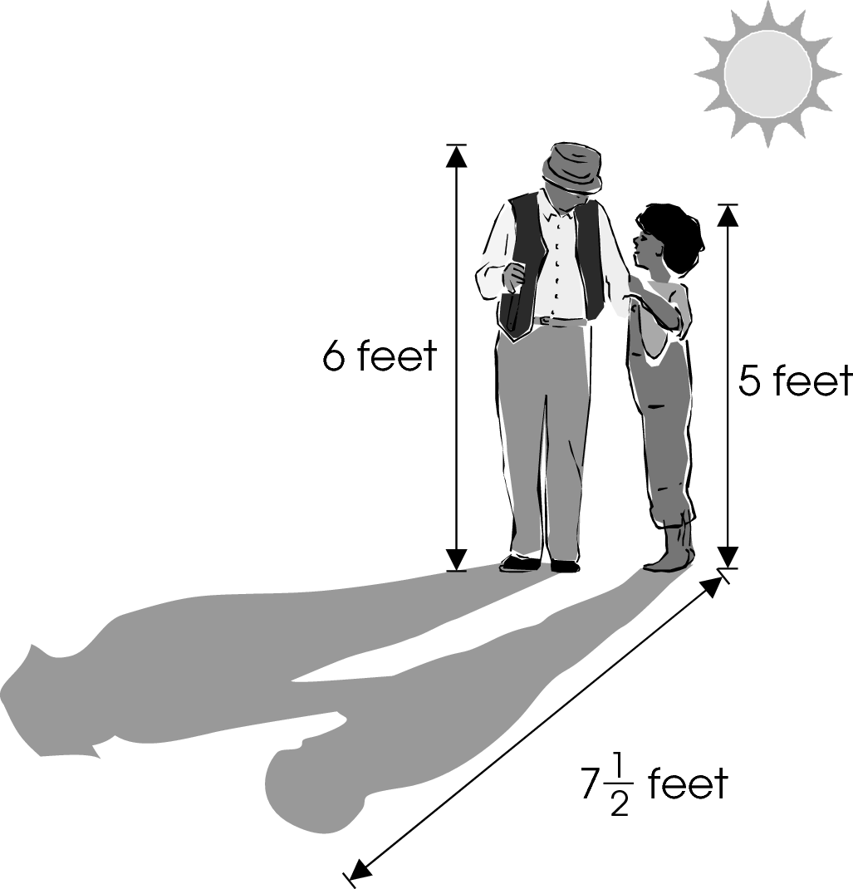
Oscar’s shadow is 7$\frac{1}{2}$feet long.

How long is his father’s shadow?

  - 4 feet
  - 6$\frac{1}{4}$feet
  - 8$\frac{1}{2}$feet
  - 9 feet

Commentary:
This multiple-choice question asks students to find the length of Oscar’s father’s shadow. One method students can use to find the length of the shadow is by setting up a proportion between corresponding parts, such as, heights of people and lengths of shadows. For example:

$\frac{\text{Oscar}'s \text{height}}{\text{Father}'s \text{height}} = \frac{\text{Oscar}'s \text{shadow}}{\text{Father}'s \text{shadow}}$;
$\frac{5 }{6 } = \frac{7\text{.}5}{x}$;
$5x = \text{45}$;
$x = 9$.

The length of his father’s shadow is 9 feet, answer choice D.
Answer choices A and B incorrect because they are the result of setting up an incorrect proportion, such as $\frac{6}{5} = \frac{7\text{.}5}{x}$. Answer choice C is incorrect because it is the result of finding the difference in the height of the two people and adding the same amount on the length of Oscar’s shadow.

The complexity level of this question is Moderate Complexity. The question requires students to retrieve information from a figure and use it to solve a problem requiring multiple steps.

Performance Data:
The percent of public school students selecting answer choice D for question 9 on the May 2007 Grade 7 Achievement Test was 32 %.

Keywords: geometry, proportional reasoning, proportion, corresponding parts, ratio

BACK TO INDEX

Benchmark: J | Apply properties of equality and proportionality to solve problems involving congruent or similar figures; e.g., create a scale drawing.
GLI: GSS 7.6 | Determine and use scale factors for similar figures to solve problems using proportional reasoning.

Multiple Choice Question:

12. At the start of each soccer season, Lucy uses the diagram shown to help her put lines on the soccer field.
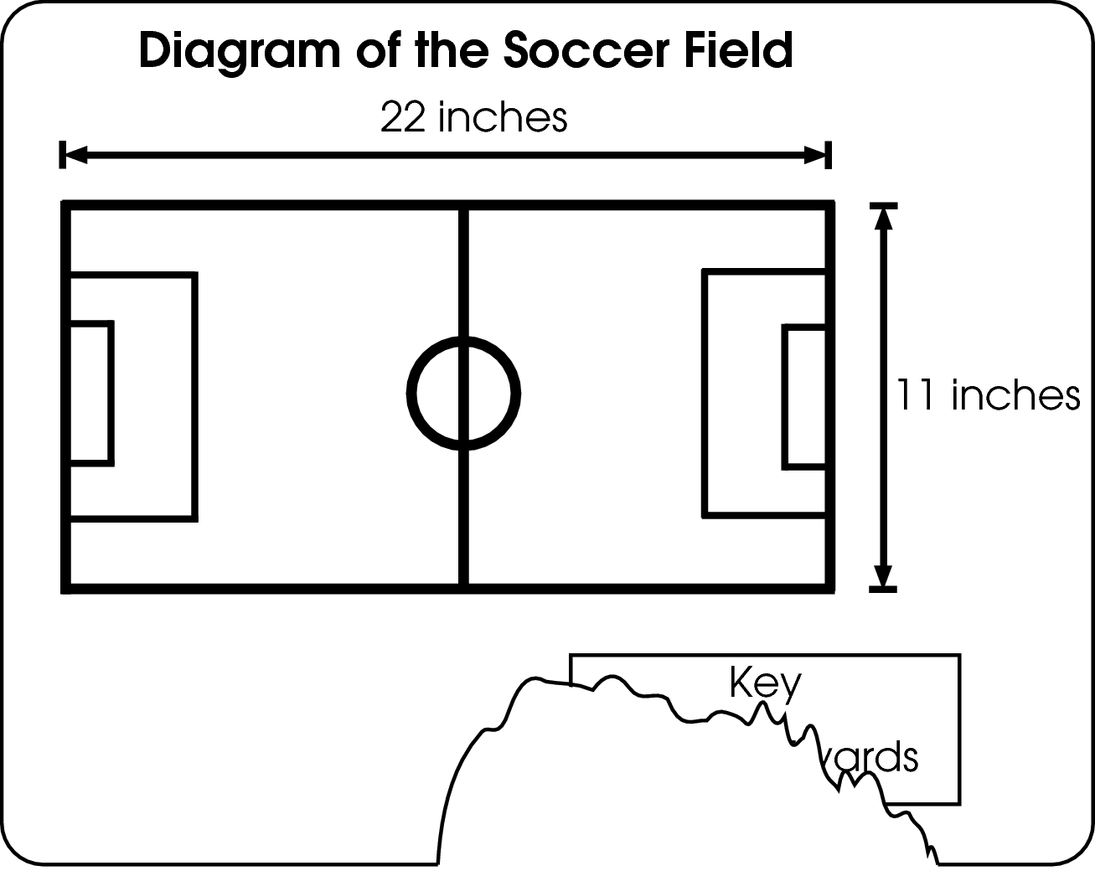
Her diagram is torn, and part of the key is missing. She knows that an actual soccer field is 110 yards long.
What should the key say?

  - 1 inch = 5 yards
  - 1 inch = 11 yards
  - 1 inch = 22 yards
  - 1 inch = 110 yards

Commentary:
This multiple-choice question asks students to determine the scale factor that was used in creating the diagram of the soccer field. To determine the scales used students must determine the corresponding sides of both objects for which the measurements are known. In this case, they know the length of the actual soccer field is 110 yards long and the length of the soccer field in the diagram is 22 inches long. The relationship of 22 inches to 110 yards can be determined. This can be simplified by dividing both values by 22. The scale used for this diagram is 1 inch = 5 yards, answer choice A.
Students selecting answer choices B, C or D may have used a scale of 1 inch to one of the values provided in the problem. Using the incorrect scale would not result in the field being 110 feet long. Therefore, answer choices B, C and D are incorrect.

The complexity level of this question is Low Complexity. The question requires students to perform a specific procedure.

Performance Data:
The percent of public school students selecting answer choice A for question 12 on the May 2007 Grade 7 Achievement Test was 72 %.

Keywords: geometry, scale factor, ratio, scaled drawing

BACK TO INDEX

Benchmark: G | Describe and use properties of triangles to solve problems involving angle measures and side lengths of right triangles.
GLI: GSS 7.3a | Use and demonstrate understanding of the properties of triangles. For example:  - Use Pythagorean Theorem to solve problems involving right triangles.

Multiple Choice Question:

23. In class, Darrell sits directly behind Terry, 6 feet away, and directly to the left of Marc, 4 feet away.
What is the approximate distance, in feet, between Terry and Marc?

A. 7
B. 10
C. 24
D. 52

Commentary:
This multiple-choice question asks students to find the distance between two out of three students sitting in the classroom. Students have to realize that in the given situation the seating arrangements of Darrell, Terry and Marc make a right triangle and that this problem can be solved by using the Pythagorean Theorem.

The Pythagorean Theorem states that in a right triangle, the square of the length of the hypotenuse (the side opposite the right angle) is equal to the sum of the squares of the lengths of two legs (the sides which form the right angle). The distance between Terry and Mark is represented by a hypotenuse of a right triangle. By applying Pythagorean Theorem, the square of the length of the hypotenuse, c, can be found by setting up an equation:

6² + 4² = c².
52 = c²
$\sqrt{\text{52}}$= c
7 c

Answer choice A is correct.

If students choose answer choice B, they added distances of 6 and 4 instead of adding 6² and 4². If students choose answer choice C, they multiplied the distances of 4 and 6 together. If students choose answer choice D, they used the Pythagorean Theorem to find the distance between Terry and Mark but forgot to take the square root of 52
(6² + 4² = 52).

The complexity level of this question is Moderate Complexity. This question asks students to bring together skills and knowledge from various domains and solve a word problem requiring multiple steps. .

Performance Data:
The percent of public school students selecting answer choice A for question 23 on the May 2008 Grade 7 Achievement Test was 24%.

Keywords: geometry, hypotenuse, distance, Pythagorean Theorem

BACK TO INDEX

Benchmark: E | Use proportions to express relationships among corresponding parts of similar figures.
GLI: GSS 7.6 | Determine and use scale factors for similar figures to solve problems using proportional reasoning.

Multiple Choice Question:

28. Dan created a map of the state of Ohio using a scale factor of 2 centimeters: 25 miles.
The actual distance from Cleveland to Columbus is 142 miles.
About how far apart are Cleveland and Columbus on Dan's map?

  - 5.70 cm
  - 11.40 cm
  - 71.00 cm
  - 1,775.00 cm

Commentary:
This multiple-choice question asks students to determine the distance between two cities on a map using the given scale factor. Students can create a proportion to find the distance from Cleveland to Columbus. Since 2 cm on the map represent 25 actual miles, then x cm would represent 142 miles between Cleveland and Columbus on the map.

$\frac{2}{\text{25}}$ = $\frac{x}{\text{142}}$
25 • x = 2 • 142
x = 11.4
Answer choice B is correct.

Students may also realize that if 142 miles is a little smaller than 150 miles (150 mi = 6 x 25), then the distance on the map should be represented by a number that is a little smaller than
12 cm (12 cm = 6 x 2) or 11.40 cm, answer choice B.

Students selecting answer choice A created and solved this incorrect proportion
$\frac{1}{\text{25}}$ = $\frac{x}{\text{142}}$.

Students selecting answer choice C created and solved this incorrect proportion
$\frac{1}{2}$ = $\frac{x}{\text{142}}$.

Students selecting answer choice D created and solved this incorrect proportion
$\frac{\text{25}}{2}$ = $\frac{x}{\text{142}}$.

The complexity level of this question is Moderate Complexity. This question asks students to use informal methods of reasoning for solving a word problem requiring multiple steps.

Performance Data:
The percent of public school students selecting answer choice B for question 28 on the May 2008 Grade 7 Achievement Test was 39%.

Keywords: geometry, proportion, ratio, scale factor

BACK TO INDEX

Benchmark: F | Describe and use the concepts of congruence, similarity and symmetry to solve problems.
GLI: GSS 7.7 | Identify the line and rotation symmetries of two-dimensional figures to solve problems.

Multiple Choice Question:

33. Becky designed a figure that has only 180º and 360º rotational symmetry.
Which figure did she design?

A.
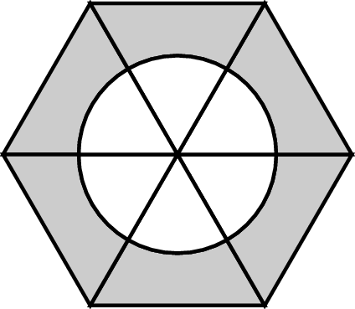

B.
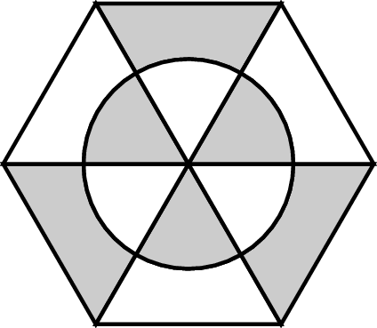

C.
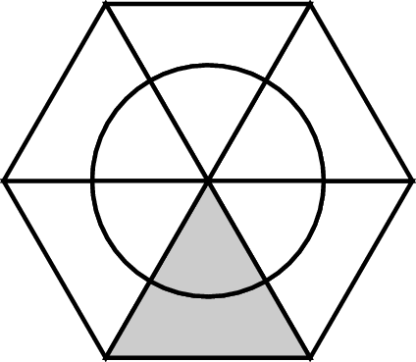

D.
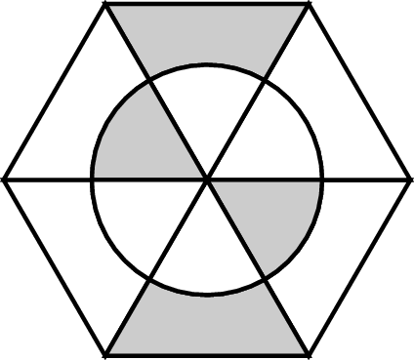

Commentary:
This multiple-choice question asks students to identify a two dimensional figure that has only 180° or 360° rotational symmetry. Students must understand that if a two dimensional figure has rotational symmetry then its image will coincide with the original figure after it has been rotated.
.
If a student chooses answer choice A, he or she did not realize that this figure has 60°, 120°, 240° and 360° rotational symmetry. If a student chooses answer choice B, he or she selected a figure that does not have 180° rotational symmetry but has 120°, 240° and 360° rotational symmetry. If a student chooses answer choice C, he or she selected a figure that has 360° rotational symmetry.

The figure in answer choice D is the only one that has both 180° and 360° rotational symmetry because it will coincide with the original one after it has been rotated 180° or 360°.

The complexity level of this question is Moderate Complexity. This question requires students to interpret a visual representation.

Performance Data:
The percent of public school students selecting answer choice D for question 33 on the May 2008 Grade 8 Achievement Test was 29%.

Keywords: geometry, rotational symmetry, angle of rotation

BACK TO INDEX

Benchmark: E | Use proportions to express relationships among corresponding parts of similar figures.
GLI: GSS 7.1 | Use proportional reasoning to describe and express relationships between parts and attributes of similar and congruent figures.

Multiple Choice Question:

42. Triangle PQR is similar to triangle XYZ.
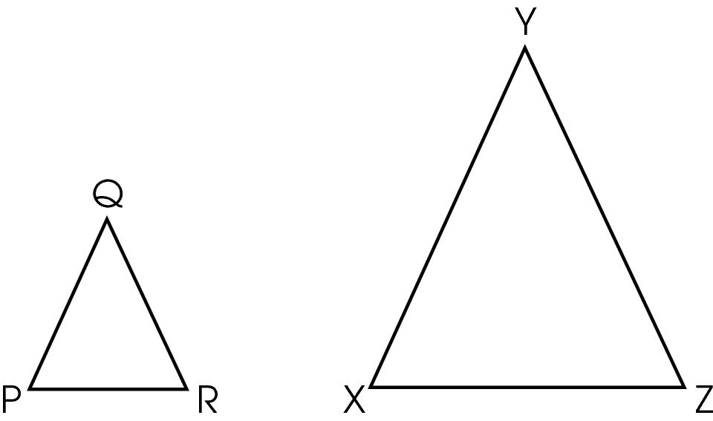
The length of $\overline{\text{PQ}}$ is one-half the length of$\overline{\text{XY}}$. The length of $\overline{\text{RP}}$is 2 cm.
Which proportion can be used to find the length of$\overline{\text{ZX}}$?

A. $\frac{1}{2} = \frac{\text{ZX}}{2}$

B. $\frac{1}{2} = \frac{1}{\text{ZX}}$

C. $\frac{1}{2} = \frac{2}{\text{ZX}}$

D. $\frac{1}{2} = \frac{\text{ZX}}{4}$

Commentary:
This multiple-choice question asks students to find the length of the side in one of two similar triangles. In similar triangles the ratio of the lengths of corresponding sides does not change. One method students can use to determine the length of the side ZX is by setting up a proportion between corresponding sides of the two triangles, such as $\frac{\text{PQ}}{\text{XY}}$=$\frac{\text{RP}}{\text{ZX}}$. Since the length of PQ is one - half of the length of XY, this proportion becomes $\frac{1}{2}$=$\frac{2}{\text{ZX}}$,
answer choice C.

Answer choices A, B and D are incorrect because they are the results of setting up incorrect proportions.

The complexity level of this question is Moderate Complexity. This question asks students to retrieve information from figures and use it to solve a problem requiring multiple steps.

Performance Data:
The percent of public school students selecting answer choice C for question 42 on the May 2008 Grade 7 Achievement Test was 42%.

Keywords: geometry, proportional reasoning, proportion, corresponding sides, ratio

BACK TO INDEX

