Index to Questions

Question Number | Source | BM | GLI | Description
3 | OAT Mar 06 | D | GSS 6.1, GSS 6.2 | This multiple-choice question asks students to name the type of triangle described with given attributes.
8 | OAT Mar 06 | I | GSS 6.7 | This multiple-choice question asks students to identify the front view of a set of blocks.
18 | OAT Mar 06 | D & G | GSS 6.1, GSS 6.2, GSS 6.3 | This multiple-choice question asks students to recognize the correct description of three triangles using their attributes.
21 | OAT Mar 06 | F | GSS 6.6 | This extended-response question asks students to create and draw a scale model of a playground, and label the dimensions based on the scale used.
27 | OAT Mar 06 | D | GSS 6.1, GSS 6.4 | This multiple-choice question asks students to select the figure that represents a perpendicular intersection of two planes.
30 | OAT Mar 06 | F | GSS 6.6 | This multiple-choice question asks students to find the graph that shows a triangle similar to the given triangle with a ratio of 1 to 3.
1 | OAT May 07 | A (3-4) D | GSS 4.4, GSS 6.1 | This multiple-choice question asks students to select the triangle that is an isosceles triangle based on side lengths of the triangle.
12 | OAT May 07 | D (3-4) G | GSS 3.2b | This multiple-choice question asks students to select the description of two identified angles represented by an opened book.
38 | OAT May 07 | D | GSS 6.1 | This multiple-choice question asks students to select the statement that describes how the four given objects are the same.
41 | OAT May 07 | H | GSS 6.5 | This short-answer question asks students to give the coordinates of the three vertices of the triangle and the coordinates of the endpoint of the new flag after it has been reflected over the x-axis.
45 | OAT May 07 | J | GSS 7.6 | This multiple-choice question asks students to find the ratio of the height of a small windowpane to the height of a window.
2 | OAT May 08 | J | GSS 7.1 | This multiple-choice question asks students to determine the length of one side of a triangle when given two similar triangles.
Question Number | Source | BM | GLI | Description
11 | OAT May 08 | I | GSS 6.7 | This extended-response question asks students to sketch two-dimensional views of the three-dimensional model shown and explain the relationship of opposite views.
27 | OAT May 08 | A | GSS 5.2 | This multiple-choice question asks students to describe the mathematical relationships between the covers and the spine of the textbook shown.
34 | OAT May 08 | G | GSS 6.3 | This multiple-choice question asks students to determine the type of triangles formed when a diagonal divides a square into two triangles.

BACK TO INDEX

Benchmark: D | Identify, describe and classify types of line pairs, angles, two-dimensional figures and three-dimensional objects using their properties.
GLI: GSS 6.1, GSS 6.2 | GSS 6.1: Classify and describe two-dimensional and three-dimensional geometric figures and objects by using their properties; e.g., interior angle measures, perpendicular/parallel sides, congruent angles/sides.  GSS 6.2: Use standard language to define geometric vocabulary: vertex, face, altitude, diagonal, isosceles, equilateral, acute, obtuse, etc.

Multiple Choice Question:

3. What is a triangle with exactly two congruent sides and exactly two congruent angles called?

A. equilateral
B. isosceles
C. right
D. scalene

Commentary:
This multiple-choice question asks students to name the type of triangle described with given attributes. Students should recall the name of the triangle with exactly two congruent sides and exactly two congruent angles. A triangle with these attributes is an isosceles triangle, answer choice B. An equilateral triangle (answer choice A) has exactly three congruent sides and exactly three congruent angles. A right triangle (answer choice C) does not always have exactly two congruent angles and exactly two congruent sides. A scalene triangle (answer choice D) does not have any congruent sides and does not have any congruent angles.

The complexity level of this question is Low Complexity. This question requires students to recall the properties of triangles.
Performance Data:
The percent of public school students selecting answer choice B for question 3 on the March 2006 Grade 6 Achievement Test was 54%.

Keywords: geometry, triangles, congruency

BACK TO INDEX

Benchmark: I | Identify and draw three-dimensional objects from different views (top, side, front and perspective).
GLI: GSS 6.7 | Build three-dimensional objects built with cubes and sketch the two-dimensional representations of each side; i.e., projection sets.

Multiple Choice Question:

- A playground has a set of big blocks for children to climb on as shown.
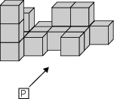
What does this set of blocks look like when viewed from point P, the front view?
A. 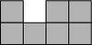
B. 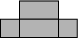
C. 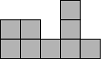
D. 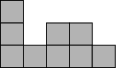

do not copy or distribute ID: 5878; Version: 7

Commentary:
This multiple-choice question asks students to identify the front view of a set of blocks. Students need to use spatial sense to determine the view from the front. The correct answer choice is D. From the front, starting from the left side to the right side, the blocks are stacked vertically in the following order: 3 blocks, 1 block, 2 blocks, 2 blocks and 1 block. The views in answer choices A, B and C are incomplete or in an incorrect order.

The complexity level of this question is Low Complexity as it requires students to recognize an equivalent representation of a model.

Performance Data:
The percent of public school students selecting answer choice D for question 8 on the March 2006 Grade 6 Achievement Test was 82%.

Keywords: geometry, three-dimensional, spatial sense

BACK TO INDEX

Benchmark: D  G | Identify, describe and classify types of line pairs, angles, two-dimensional figures and three-dimensional objects using their properties.  Describe and use properties of triangles to solve problems involving angle measures and side lengths of right triangles.
GLI: GSS 6.1, GSS 6.2, GSS 6.3 | GSS 6.1: Classify and describe two-dimensional and three-dimensional geometric figures and objects by using their properties; e.g., interior angle measures, perpendicular/parallel sides, congruent angles/sides.  GSS 6.2: Use standard language to define geometric vocabulary: vertex, face, altitude, diagonal, isosceles, equilateral, acute, obtuse, etc.  GSS 6.3: Use multiple classification criteria to classify triangles; e.g., right scalene triangle.

Multiple Choice Question:

18. Three triangles are shown.:
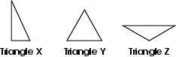
Which is the best description of triangles X, Y and Z?
A. Triangle X is right scalene, triangle Y is acute equilateral, and triangle Z is obtuse isosceles.
B. Triangle X is obtuse scalene, triangle Y is right equilateral, and triangle Z is acute isosceles.
C. Triangle X is right isosceles, triangle Y is acute scalene, and triangle Z is obtuse equilateral.
D. Triangle X is acute equilateral, triangle Y is obtuse isosceles, and triangle Z is right scalene.

Commentary:
This multiple-choice question asks students to recognize the correct description of three triangles using their attributes. Triangle X appears to be a right triangle, but also a scalene triangle since the side lengths appear to be different. Triangle Y is an acute triangle since all the angles are less than 90°, and also appears to be an equilateral triangle because the lengths of all the sides appear to be the same. Triangle Z appears to be an obtuse triangle because one angle appears to be greater than 90° and an isosceles triangle because the two sides adjacent to the obtuse angle appear to have the same length. Choice A is the correct answer. In answer choices B and C, only one of the descriptions is correct for each triangle. The descriptions in answer choice D do not apply to the designated triangle.

The complexity level of this question is Moderate Complexity. This question requires students to compare statements and interpret visual representations.
Performance Data:
The percent of public school students selecting answer choice A for question 18 on the March 2006 Grade 6 Achievement Test was 69%.

Keywords: geometry, triangles

BACK TO INDEX

Benchmark: F | Describe and use the concepts of congruence, similarity and symmetry to solve problems.
GLI: GSS 6.6 | Draw similar figures that model proportional relationships; e.g., model similar figures with a 1 to 2 relationship by sketching two of the same figure, one with corresponding sides twice the length of the other.

Mathematical Processes
Benchmark: H | Use representations to organize and communicate mathematical thinking and problem solutions.

Extended Response Question:

21. A rectangular playground is 80 meters long and 50 meters wide.
In your Answer Document, create and draw a scale model of the playground.
State the scale you used and label the dimensions of each side of your model. Show or explain how you determined the length of each side of your model.

Commentary:
This extended-response question asks students to create and draw a scale model of a playground, and label the dimensions based on the scale used. The dimensions of the rectangular playground are 80 meters long and 50 meters wide. A response earning the maximum number of points (4 points) includes a correct scaled drawing with the dimensions labeled as 8 units long and 5 units wide. The response also indicates the scale, such as 1 unit = 10 meters with work or an explanation that the length of each side of the original playground was divided by 10. Other appropriate scales are acceptable.

The complexity level of this question is High Complexity. This task requires students to perform a procedure having multiple steps and multiple decision points.

Performance Data:
The percent of public school students earning each score point for question 21 on the March 2006 Grade 6 Achievement Test:

Percent at Each Score Point
0 | 1 | 2 | 3 | 4
39% | 18% | 26% | 9% | 6%

Scoring Guidelines:
Sample Correct Response(s):
- 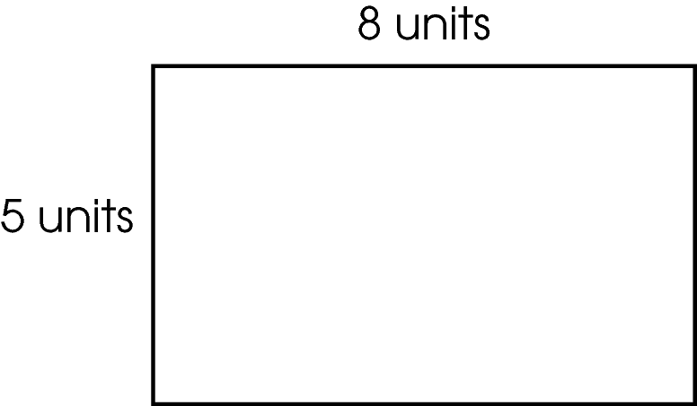
Scale: 1 unit = 10 meters
- I used the scale 1 unit: 10 meters. To determine the lengths of the sides, I divided each measurement of the playground by 10, which gave me 8 x 5, then drew a rectangle that was 8 units long by 5 units wide.

NOTE: Acceptable dimensions include 4 x 2.5, 16 x 10, etc.
Points | Student Response
4 | The focus of the task is using a description to draw a scale model. The response provides an accurate scale drawing of the rectangular playground with dimensions labeled AND shows work or gives an adequate explanation of the scale.
3 | The response provides evidence of using a description to draw a scale model. The response shows an accurate scale drawing of the rectangular playground with dimensions labeled and a scale provided AND shows work or gives an adequate explanation; however, the response may show minor errors or flaws.  For example, the response may:  - Show an accurate drawing that is correctly labeled, including an accurate explanation, but include no scale.  - Show an accurate drawing that is correctly labeled and with a correct scale, but lacks an explanation or work to justify the scale.  - Show a drawing with minor flaws and provide an accurate scale and an adequate explanation or work.
2 | The response provides partial evidence of using a description to draw a scale model. The response shows an accurate scale drawing of the rectangular playground; however, it includes multiple errors OR a vague explanation.  For example, the response may:  - Show a rectangle that is not drawn to scale, but provide a scale and a vague explanation.  - Show and label a rectangle that is drawn to scale and provide the scale, but fail to label the dimensions.
1 | The response provides minimal evidence of using a description to draw a scale model. The response contains major flaws and the explanation is incomplete or missing.  For example, the response may:  - Show a rectangle with correct dimensions but give no scale, work, or explanation.  - Provide a scale that does not match the rectangle.
0 | The response provides inadequate evidence of using a description to draw a scale model. The response provides major flaws in explanations or irrelevant information.  For example, the response may:  - Show an incomplete or inaccurate drawing.  - State that the playground is a rectangle measuring  50 meters by 80 meters.  - Show a rectangle that is not drawn to scale and labeled 50 meters x 80 meters with no scale.  - Give irrelevant information.

Keywords: geometry, scale model, scale

BACK TO INDEX

Benchmark: D | Identify, describe and classify types of line pairs, angles, two-dimensional figures and three-dimensional objects using their properties.
GLI: GSS 6.1, GSS 6.4 | GSS 6.1: Classify and describe two-dimensional and three-dimensional geometric figures and objects by using their properties; e.g., interior angle measures, perpendicular/parallel sides, congruent angles/sides.  GSS 6.4: Identify and define relationships between planes; i.e., parallel, perpendicular and intersecting.

Multiple Choice Question:

27. Which figure represents a perpendicular intersection of two planes?
A. 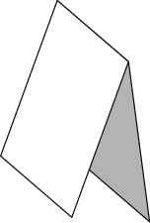
B. 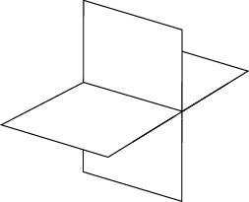
C. 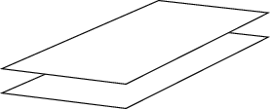
D. 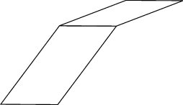

do not copy or distribute ID: 3753; Version: 9

Commentary:
This multiple-choice question asks students to select the figure that represents a perpendicular intersection of two planes. Students need to know that the perpendicular intersection of two planes form a right angle at the intersection. The figure in answer choice B represents a perpendicular intersection of the two planes. The figures in answer choices A and D do not form right angles at the intersection of the two planes. In answer choice C, the planes appear to represent parallel planes and they would not intersect.

The complexity level of this question is Low Complexity. This question requires students to recognize an example of a concept.

Performance Data:
The percent of public school students selecting answer choice B for question 27 on the March 2006 Grade 6 Achievement Test was 80%.

Keywords: geometry, perpendicular planes

BACK TO INDEX

Benchmark: F | Describe and use the concepts of congruence, similarity and symmetry to solve problems.
GLI: GSS 6.6 | Draw similar figures that model proportional relationships; e.g., model similar figures with a 1 to 2 relationship by sketching two of the same figure, one with corresponding sides twice the length of the other.

Multiple Choice Question:

30. Triangle PQR is shown.
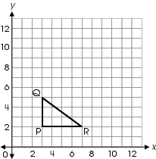
Which graph shows a figure similar to triangle PQR by a ratio of 1 to 3?
A. 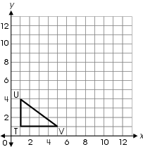
B. 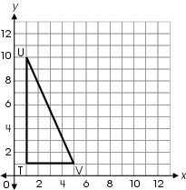
C. 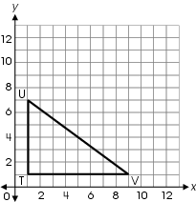
D. 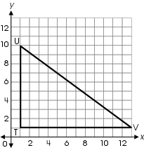

do not copy or distribute ID: 5881; Version: 10

Commentary:
This multiple-choice question asks students to find the graph that shows a triangle similar to the given triangle with a ratio of 1 to 3. Students need to know that a ratio of 1 to 3 means that each side length of the new triangle will be three times as large as the corresponding side lengths of the original triangle. Each of the side lengths of triangle TUV is to be three times as large as the corresponding side lengths of triangle PQR. Each side length in triangle TUV in answer choice D, the correct answer, is three times as large as the corresponding side lengths in triangle PQR. In answer choice A, triangle TUV is congruent to triangle PQR. Only the height is changed in answer choice B. The ratio is 1 to 2 instead of 1 to 3 in answer choice C.

The complexity level of this question is Moderate Complexity. This question requires students to compare geometric figures.

Performance Data:
The percent of public school students selecting answer choice D for question 30 on the March 2006 Grade 6 Achievement Test was 17%.

Keywords: geometry, similar figures, scale factor, ratio

BACK TO INDEX

Benchmark:  A (3-4)  D | Provide rationale for groupings and comparisons of two-dimensional figures and three-dimensional objects.  Identify, describe and classify types of line pairs, angles, two-dimensional figures and three-dimensional objects using their properties.
GLI: GSS 4.4, GSS 6.1 | GSS 4.4: Identify and define triangles based on angle measures (equiangular, right, acute and obtuse triangles) and side lengths (isosceles, equilateral and scalene triangles).  GSS 6.1: Classify and describe two-dimensional and three-dimensional geometric figures and objects by using their properties; e.g., interior angle measures, perpendicular/parallel sides, congruent angles/sides.

Multiple Choice Question:

1. Which triangle is isosceles?

A. 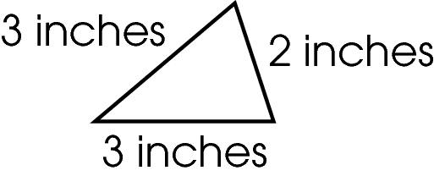
B. 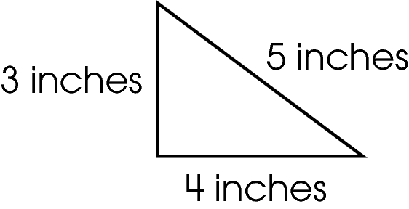
C. 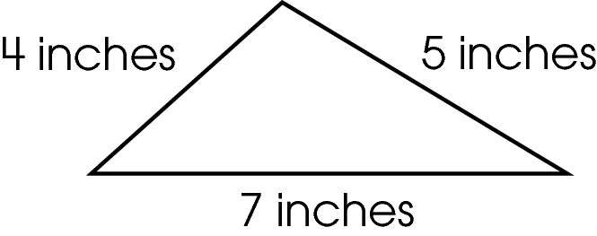
D. 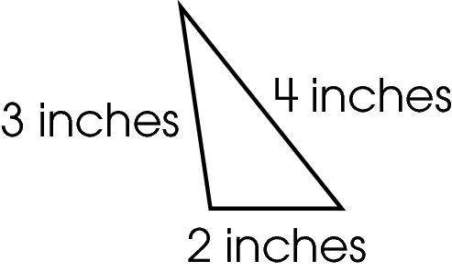

Commentary:
This multiple-choice question asks students to select the triangle that is an isosceles triangle based on side lengths of the triangle. Students need to know that an isosceles triangle is a triangle that has two sides of equal length. The triangle in answer choice A is an isosceles triangle because two of the sides of the triangle are 3 inches.

Answer choices B, C and D are incorrect because each triangle has sides of different lengths.

The complexity level of this question is Low Complexity. This question requires students to recognize an example of a concept.

Performance Data:
The percent of public school students selecting answer choice A for question 1 on the May 2007 Grade 6 Achievement Test was 65%.

Keywords: geometry, isosceles triangle

BACK TO INDEX

Benchmark:  D (3-4)  G | Identify and draw right, obtuse, acute and straight angles.  Describe and use properties of triangles to solve problems involving angle measures and side lengths of right triangles.
GLI: GSS 3.2b | Identify and describe the relative size of angles with respect to right angles as follows:  - b. Identify, classify and draw right, acute, obtuse and straight angles.

Multiple Choice Question:

12. A book is opened for reading. Two angles are shown.
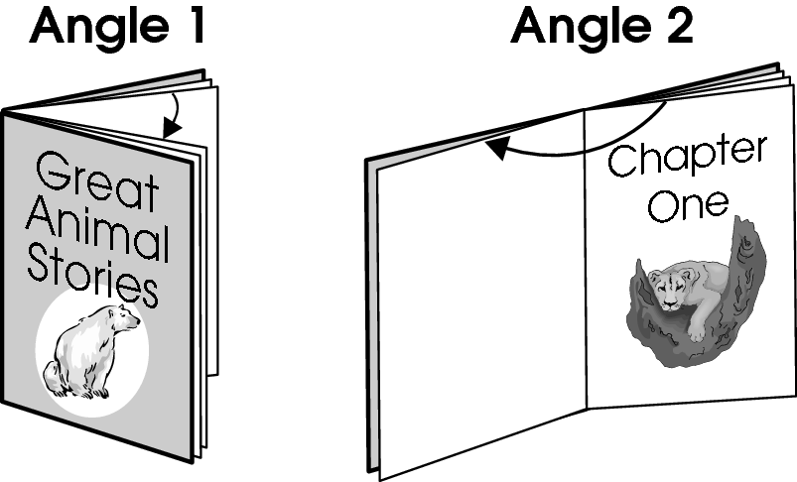
Which describes these two angles?

A. Angle 1 is an acute angle and angle 2 is a right angle.
B. Angle 1 is a right angle and angle 2 is an obtuse angle.
C. Angle 1 is an obtuse angle and angle 2 is an acute angle.
D. Angle 1 is an acute angle and angle 2 is an obtuse angle.
Commentary:
This multiple-choice question asks students to select the description of two identified angles represented by an opened book. Students can use a right angle as a benchmark angle to compare the angles. Angle 1 is an acute angle since it appears to be smaller than a right angle. Angle 2 is an obtuse angle since it appears to be larger than a right angle. Answer choice D has the correct description of the two angles. The descriptions in answer choices A, B and C are incorrect since they do not describe both angles correctly.

The complexity level of this question is Low Complexity. This question requires students to recognize an example of a concept.

Performance Data:
The percent of public school students selecting answer choice D for question 12 on the May 2007 Grade 6 Achievement Test was 85%.

Keywords: geometry, angles, acute angle, obtuse angle, right angle

BACK TO INDEX

Benchmark: D | Identify, describe and classify types of line pairs, angles, two-dimensional figures and three- dimensional objects using their properties.
GLI: GSS 6.1 | Classify and describe two-dimensional and three-dimensional geometric figures and objects by using their properties; e.g., interior angle measures, perpendicular/parallel sides, congruent angles/sides.

Multiple Choice Question:

38. Tony saw these four objects on his way to school.
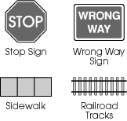
Which statement describes how all four of these objects are the same?
A. Opposite sides of each object are perpendicular.
B. All interior angles of each object are right angles.
C. Opposite sides of each object are parallel.
D. All sides of each object are congruent.

Commentary:
This multiple-choice question asks students to select the statement that describes how the four given objects are the same. Students need to classify the objects using the properties of two-dimensional figures. One property that is common to all four of the objects is that opposite sides of each object are parallel, answer choice C.

Answer choice A is incorrect because opposite sides in each of the given objects are not perpendicular. Answer choice B is incorrect because the angles in the Stop Sign appear to be greater than right angles. Answer choice D is incorrect because the sides of the Wrong Way Sign are not congruent (the same length).

The complexity level of this question is Moderate Complexity. This question requires students to compare figures.

Performance Data:
The percent of public school students selecting answer choice C for question 38 on the May 2007 Grade 6 Achievement Test was 68%.

Keywords: geometry, parallel lines, perpendicular lines, congruent

BACK TO INDEX

Benchmark: H | Predict and describe results (size, position, orientation) of transformations of two dimensional figures.
GLI: GSS 6.5 | Predict and describe sizes, positions and orientations of two-dimensional shapes after transformations such as reflections, rotations, translations and dilations.

Short Answer Question:

41. Kate drew a triangular flag in the coordinate plane as shown.
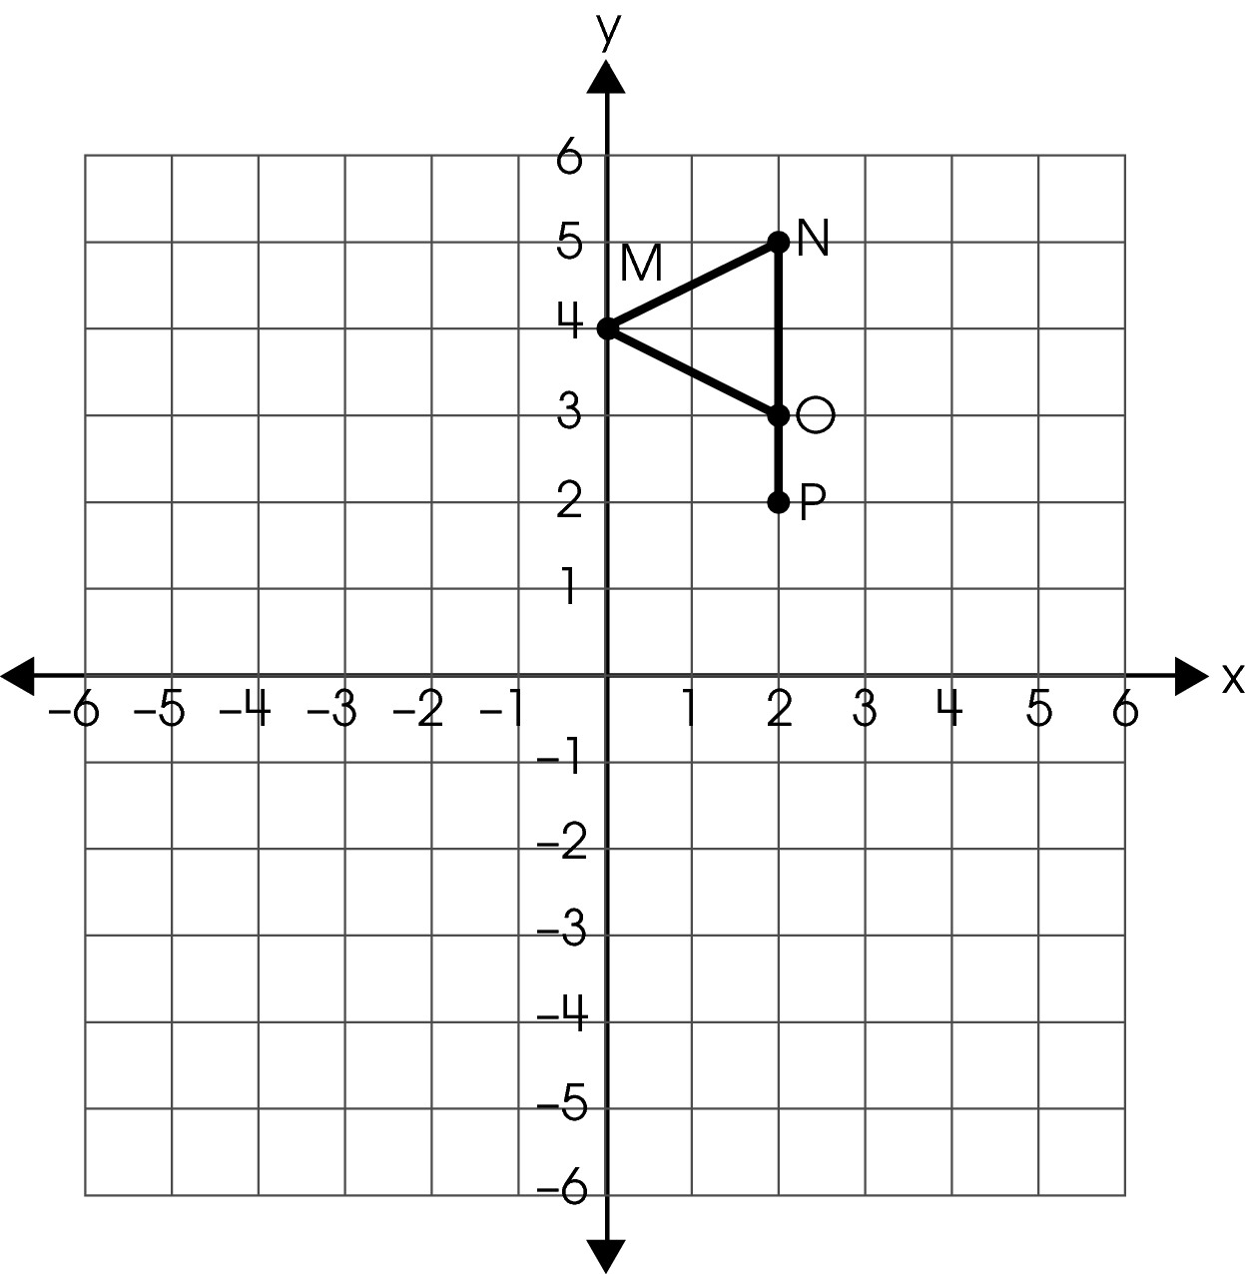
Kate then reflected the flag over the x-axis.
In your Answer Document, give the coordinates of the three vertices of the triangle and the coordinates of the endpoint of the new flag after it has been reflected over the x-axis.

Commentary:
This short-answer question asks students to give the coordinates of the three vertices of the triangle and the coordinates of the endpoint of the new flag after it has been reflected over the x-axis. A response earning the maximum number of points (2 points) provides the coordinates of the three vertices of the triangle and the endpoint of the reflected flag. Students need to know that a reflection is a transformation creating a mirror image of a figure on the opposite side of the reflection line (x-axis). Students also need to know how to reflect the given flag over the x-axis on a coordinate plane and name the coordinates by providing the ordered pairs of the three vertices of triangular part of the new flag and the endpoint of the new flag. The coordinates in the new flag are the same distance from the x-axis as the corresponding coordinates in the original figure.

M: (0, 4)
N: (2, 4)
O: (2, 3)
P: (2, 2)

M′: (0, -4)
N′: (2, -5)
O′: (2, -3)
P′: (2, -2)
P′

O′

M′

N′

The complexity level of this question is Moderate Complexity. This question requires students to retrieve information from a graph and use it to solve a problem requiring multiple steps.

Performance Data:
The percent of public school students earning each score point for question 41 on the May 2007 Grade 6 Achievement Test:

Percent at Each Score Point
0 | 1 | 2
72% | 13% | 15%

Scoring Guidelines:
Exemplar Response:

- M'(0, −4), N'(2, −5), O'(2, −3), P'(2, −2)
Points | Student Response
2 point text | The focus of this task is providing the coordinates of the vertices of a two-dimensional shape after a transformation. The response provides the accurate coordinates of the three vertices and the endpoint of the reflected flag.  Note: Coordinates may not have letter names.
1 point text | The response shows partial evidence of providing the coordinates of the vertices of a two-dimensional shape after a transformation; however, the solution may be incomplete or slightly flawed.  For example, the response may:  - Provide three out of four correct coordinates.  - Provide coordinates of the flag reflected across the y-axis: N'(−2,5), O'(−2, 3), M'(0, 4), P'(−2, 2).
0 point text | The response provides inadequate evidence of providing the coordinates of the vertices of a two-dimensional shape after a transformation. The response provides an explanation with major flaws and errors of reasoning.  For example, the response may:  - Provide two or more incorrect coordinates.  - Restate the information provided in the item.  - Be blank or give irrelevant information.

Keywords: geometry, transformations, reflection, coordinates

BACK TO INDEX

Benchmark: J | Apply properties of equality and proportionality to solve problems involving congruent or similar figures; e.g., create a scale drawing.
GLI: GSS 7.6 | Determine and use scale factors for similar figures to solve problems using proportional reasoning.

Multiple Choice Question:

45. The window shown is divided into 9 smaller windowpanes.
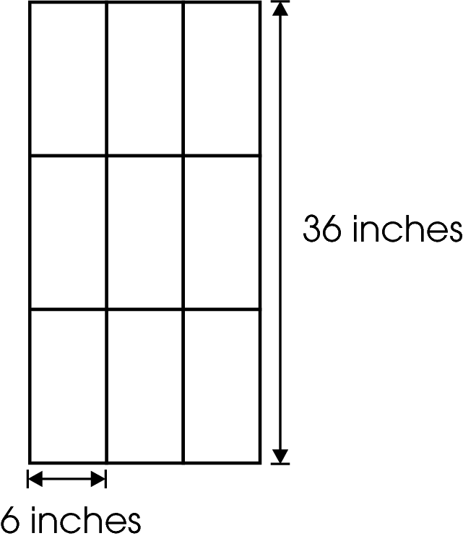
Each small windowpane is similar to the large window. The height of the large window is 36 inches. The width of the small windowpane is 6 inches.
What is the ratio of the height of a small windowpane to the height of the large window?
A. 1:1
B. 1:2
C. 1:3
D. 1:6

Commentary:
This multiple-choice question asks students to find the ratio of the height of a small windowpane to the height of a window. Since the small windowpane is similar to the large window, the corresponding heights are proportional. Students can use different approaches to find the ratio. The height of a small windowpane is 12 inches (36 ÷ 3 = 12). The ratio of the height of a small windowpane to the height of the large window is 12 inches to 36 inches or 12:36. In simplest form, the ratio is 1:3, answer choice C.

The height of three small windowpanes is equal to the height of the large windowpane. This ratio is also 1:3, answer choice C.
Answer choices A, B and D are incorrect since the ratios do not show that the height of the small windowpane is proportional to the height of the large window. Answer choice A shows that the height of the small window and the large window are the same; however, their sizes are different. Answer choice B shows that the height of the large window is twice the height of the small windowpane. Answer choice D shows that the height of the large window is six times the height of the small windowpane. However, the height of the large window is three times the height of a small windowpane.

The complexity level of this question is High Complexity. This question requires students to perform a procedure having multiple steps and multiple decision points.

Performance Data:
The percent of public school students selecting answer choice C for question 45 on the May 2007 Grade 6 Achievement Test was 33%.

Keywords: geometry, similar figures, ratio

BACK TO INDEX

Benchmark: J | Apply properties of equality and proportionality to solve problems involving congruent or similar figures; e.g., create a scale drawing.
GLI: GSS 7.1 | Use proportional reasoning to describe and express relationships between parts and attributes of similar and congruent figures.

Mathematical Processes
Benchmark: E | Use deductive thinking to construct informal arguments to support reasoning and to justify solutions to problems.

Multiple Choice Question:

2. Triangle LMN is similar to triangle RST as shown.
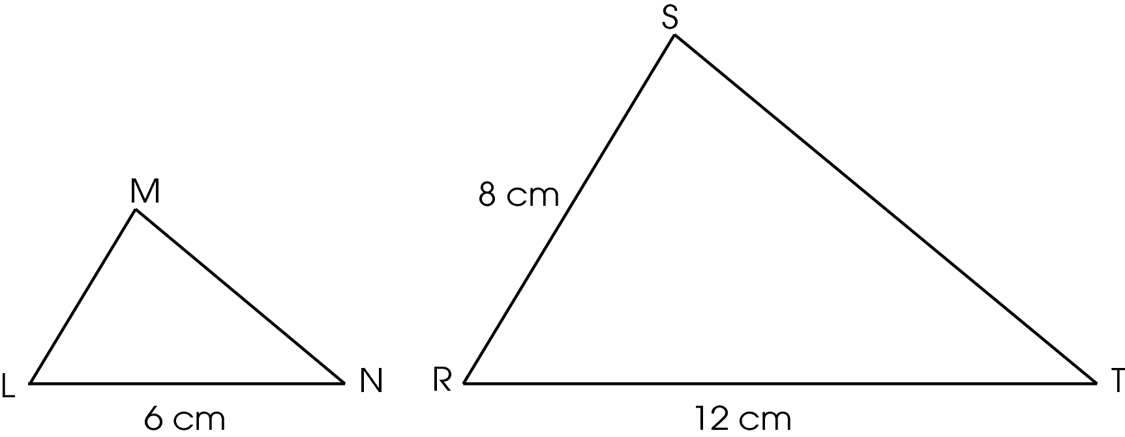
What is the length of$\overline{\text{LM}}$?

A. 2 cm
B. 4 cm
C. 8 cm
D. 16 cm

Commentary:
This multiple-choice question asks students to determine the length of one side of a triangle when given two similar triangles. Students are given that triangle LMN is similar to triangle RST. Students should use proportional reasoning and recall that the lengths of corresponding sides of similar figures are proportional. $\overline{\text{LN}}$ is the corresponding side to $\overline{\text{RT}}$. The ratio of these side lengths is 6 to 12 or 1 to 2. This means that the ratio of all corresponding sides is 1 to 2 and that the length of the sides is triangle LMN are half the length of the sides in triangle RST. $\overline{\text{LM}}$ is the corresponding side to $\overline{\text{RS}}$. Since $\overline{\text{RS}}$ is 8 cm, the length for $\overline{\text{LM}}$ is 4 cm, answer choice B.

Answer choices A, C and D are incorrect. These lengths for $\overline{\text{LM}}$are not in the correct proportion to the corresponding side$\overline{\text{RS}}$ because the ratio of the side length is not 1 to 2.

The complexity level of this question is Moderate complexity. This question requires students to retrieve information from a figure and use it to solve a problem.

Performance Data:
The percent of public school students selecting answer choice B for question 2 on the May 2008 Grade 6 Achievement Test was 85%.

Keywords: geometry, similar triangles, proportional reasoning

BACK TO INDEX

Benchmark: I | Identify and draw three-dimensional objects from different views (top, side, front and perspective).
GLI: GSS 6.7 | Build three-dimensional objects built with cubes and sketch the two-dimensional representations of each side; i.e., projection sets.

Mathematical Processes
Benchmark: H | Use representations to organize and communicate mathematical thinking and problem solutions.

Extended Response Question:

11. A scale model of a museum made of cubic blocks is shown.
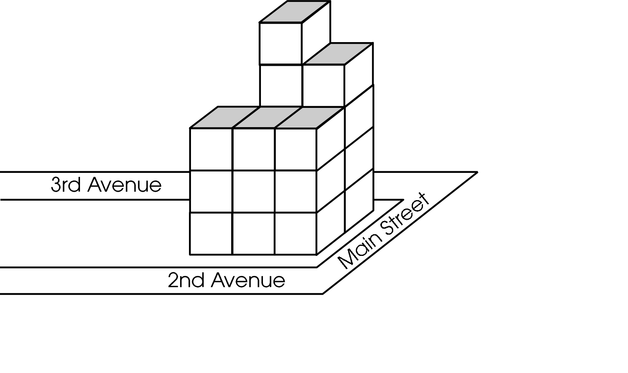
A view from the top would appear as shown.
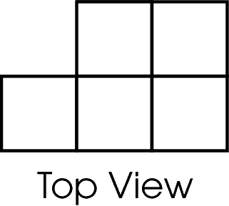
In your Answer Document, sketch the view as it would appear from 2nd Avenue.
Then, sketch the view as it would appear from Main Street.
Finally, explain how the view from 2nd Avenue is different from the view from 3rd Avenue.

Commentary:
This extended-response question asks students to sketch two-dimensional views of the three-dimensional model shown and explain the relationship of opposite views. The response earning the maximum number of points (4 points) provides the sketch as it would appear from 2nd Avenue and the sketch as it would appear from Main Street. The response also provides an explanation of how the view from 2nd Avenue is different from the view from 3rd Avenue.

Students should sketch the views as they appear from 2nd Avenue and Main Street as shown.

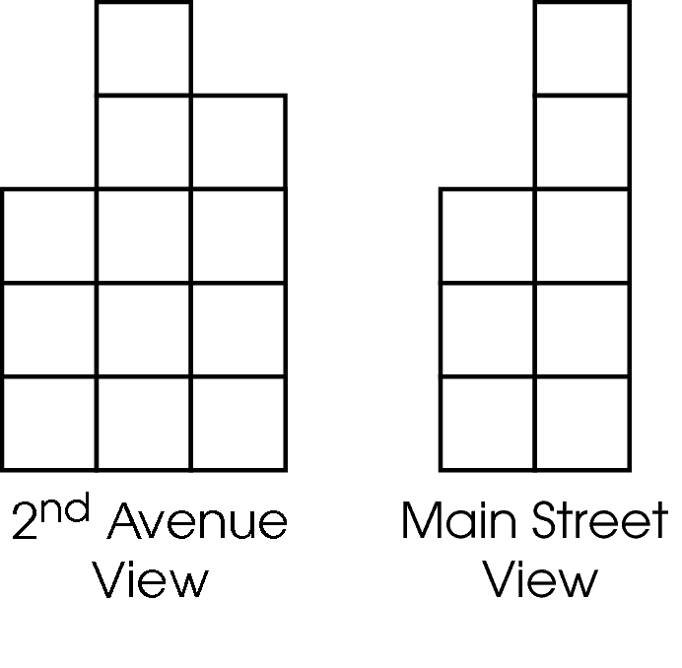

An example of an the explanation of how the view from 2nd Avenue is different from the view from 3rd Avenue is that the views are mirror images.

3rd Avenue View

The complexity level of this question is Moderate Complexity. This question requires students to interpret a visual representation.

Performance Data:
The percent of public school students earning each score point for question 11 on the May 2008 Grade 6 Achievement Test:

Percent at Each Score Point
0 | 1 | 2 | 3 | 4
32% | 14% | 35% | 4% | 15%

Scoring Guidelines:
Exemplar Response:

- The views from 2nd and 3rd avenues are mirror images.
Points | Student Response
4 | The focus of this task is sketching two-dimensional views of three-dimensional objects and explaining the relationship of opposite views. The response provides two sketches as seen from 2nd Avenue and Main Street and an explanation of the relationship between the views as seen from 2nd and 3rd Avenues.
3 | The response provides evidence of sketching two-dimensional views of three-dimensional objects and explaining the relationship of opposite views; however, the solution may contain a slight error, a flaw or a vague explanation.  For example, the response may:  - Provide the two sketches as seen from 2nd Avenue and Main Street with a slight error in sketching one of the views but be correct in the other view and provide an explanation that the opposite views would be mirror images or reflections.  - Provide correct sketches as seen from 2nd Avenue and Main Street with a vague explanation.
2 | The response provides partial evidence of sketching two-dimensional views of three-dimensional objects and explaining the relationship of opposite views; however, the solution is incomplete and/or contains minor flaws.  For example, the response may:  - Only provide two correct sketches as seen from 2nd Avenue and Main Street.  - Provide a correct description of the relationship between the views as seen from 2nd and 3rd Avenues.
1 | The response provides minimal evidence of sketching two-dimensional views of three-dimensional objects and explaining the relationship of opposite views. The response contains major flaws and the explanation is incomplete or missing.  For example, the response may:  - Provide only one correct sketch as seen from either 2nd Avenue or Main Street.  - Provide two partially correct sketches as seen from 2nd Avenue and Main Street.
0 | The response provides inadequate evidence of sketching two-dimensional views of three-dimensional objects and explaining the relationship of opposite views. The response provides major flaws in explanations or irrelevant information.  For example, the response may:  - Provide only one incorrect view.  - Restate the information provided in the item.  - Be blank or give irrelevant information.

Keywords: geometry, spatial sense, scale model

BACK TO INDEX

Benchmark: A | Identify and label angle parts and the regions defined within the plane where the angle resides.
GLI: GSS 5.2 | Use standard language to describe line, segment, ray, angle, skew, parallel and perpendicular.

Multiple Choice Question:

- A textbook is shown.
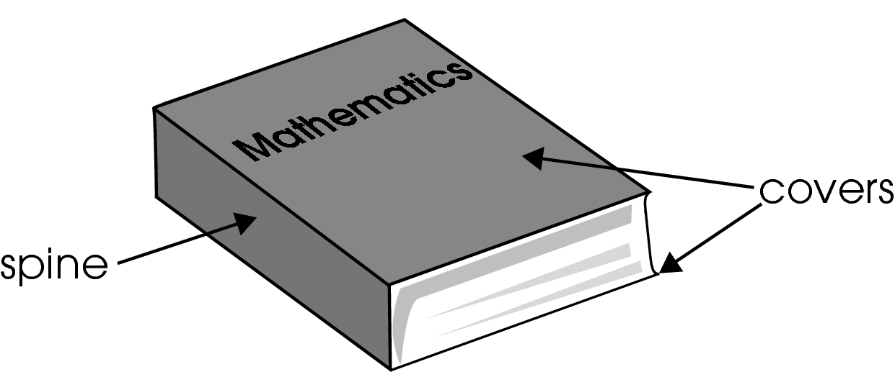
Which describes the relationships between the covers and the spine of the textbook?

A. The covers are parallel to each other. The spine is parallel to the covers.
B. The covers are perpendicular to each other. The spine is parallel to the covers.
C. The covers are parallel to each other. The spine is perpendicular to the covers.
D. The covers are perpendicular to each other. The spine is perpendicular to the covers.

Commentary:
This multiple-choice question asks students to describe the mathematical relationships between the covers and the spine of the textbook shown. Student should notice that the descriptions provided pertain to whether the relationships of the covers and spine of the textbook are parallel or perpendicular. Students should recall that parallel refers to lines and planes that do not intersect and that perpendicular refers to lines and planes that meet at right angles. The descriptions in answer choice C are correct. The covers are parallel to each other and the spine is perpendicular to the covers.

Answer choices A, B and D are incorrect. In answer choice A, only the statement that the covers are parallel to each other is true. In answer choices B and D, both statements are incorrect.

The complexity level of this question is Low Complexity. This question requires students to recognize an example of a concept.

Performance Data:
The percent of public school students selecting answer choice C for question 27 on the May 2008 Grade 6 Achievement Test was 73%.

Keywords: geometry, parallel planes, perpendicular planes

BACK TO INDEX

Benchmark: G | Describe and use properties of triangles to solve problems involving angle measures and side lengths of right triangles.
GLI: GSS 6.3 | Use multiple classification criteria to classify triangles; e.g., right scalene triangle.

Multiple Choice Question:

34. Diagonal $\overline{\text{GI}}$ divides square GHIJ into two triangles.
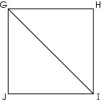
Which type of triangles are triangle GHI and triangle GJI?

A. right isosceles triangles
B. equilateral triangles
C. right scalene triangles
D. right acute triangles

Commentary:
This multiple-choice question asks students to determine the type of triangles formed when a diagonal divides a square into two triangles. Students should know that since squares have four right angles, each of the two triangles formed contains a right angle.

Answer choice B can be eliminated since equilateral triangles have all angles that are less than right angles. Answer choice D can also be eliminated since a triangle cannot be both right (having a right angle) and acute (all angles are less than 90°) at the same time. The triangles in answer choices A and C each have a right angle, but since a square has all equal sides, two sides of each of the formed triangles are equal, making answer choice A correct. Triangles GHI and GJI are right isosceles triangles. The triangles in answer choice C have no equal sides.

The complexity level of this question is Moderate Complexity. This question requires students to interpret a visual representation.

Performance Data:
The percent of public school students selecting answer choice A for question 34 on the May 2008 Grade 6 Achievement Test was 53%.

Keywords: geometry, right triangles

BACK TO INDEX

