Index to Questions

Question Number | Source | BM | GLI | Description
1 | OAT Mar 06 | D | GSS 5.2 | This multiple-choice question asks students to select the statement that appears to be true about two lines that intersect at a given point (G).
18 | OAT Mar 06 | I | GSS 5.8 | This multiple-choice question asks students to select the net for a rectangular prism.
21 | OAT Mar 06 | G | GSS 5.5 | This multiple-choice question asks students to determine the measure of an angle of an isosceles triangle.
27 | OAT Mar 06 | B | GSS 5.1 | This multiple-choice question asks students select the term that describes the length of a folded side of a circular tablecloth.
30 | OAT Mar 06 | G | GSS 5.5 | This multiple-choice question asks students to determine the measure of an angle of a right triangle.
36 | OAT Mar 06 | C | GSS 5.6 | This multiple-choice question asks students to identify the point located at point (0, -3) on a coordinate grid.
39 | OAT Mar 06 | I | GSS 5.8 | This multiple-choice question asks students to determine which three-dimensional object can be made from the given net.
42 | OAT Mar 06 | A | GSS 5.3 | This short-answer question asks students to draw an obtuse angle and give the measure of that angle.
44 | OAT Mar 06 | B | GSS 5.1 | This multiple-choice question asks students to determine the diameter of a circle when given the radius of the circle.
4 | OAT May 07 | A | GSS 5.3 | This multiple-choice question asks students to determine the point that lies in the interior of an angle.
19 | OAT May 07 | D | GSS 5.2 | This multiple-choice question asks students to identify the street that is parallel to a given street shown on a map.
31 | OAT May 07 | B | GSS 5.1 | This multiple-choice question asks students to select a statement that is true about the relationships among the parts of the given circle.
38 | OAT May 07 | J | GSS 5.4 | This short-answer question asks students to determine the length and width of two new congruent rectangular fields based on the dimensions of a given rectangular field.
4 | OAT May 08 | C | GSS 5.6 | This multiple-choice question asks students to identify the point located at (2, -2) on the coordinate grid.
Question Number | Source | BM | GLI | Description
19 | OAT May 08 | J | GSS 5.4 | This multiple-choice question asks students to select a sign that is congruent to a cardboard sign with side lengths of 12 inches.
22 | OAT May 08 | B | GSS 5.1 | This multiple-choice question asks students to select the statement which is true for the information provided in the circle.
35 | OAT May 08 | D | GSS 3.2b | This multiple-choice question asks students to determine the type of angle the third angle in a triangle must be when one angle is a right angle and another angle is an acute angle.

BACK TO INDEX

Benchmark: D | Identify, describe and classify types of line pairs, angles, two-dimensional figures and three-dimensional objects using their properties.
GLI: GSS 5.2 | Use standard language to describe line, segment, ray, angle, skew, parallel and perpendicular.

Multiple Choice Question:

1. Four lines are drawn as shown.
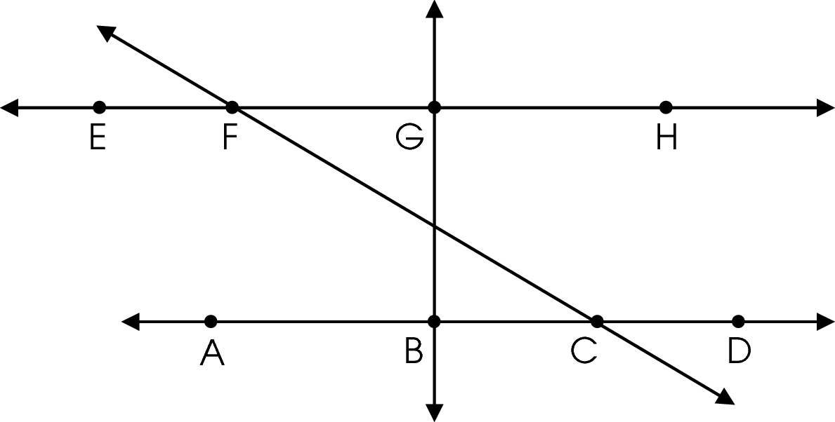
Which statement appears to be true of the two lines that intersect at point G?
A. They are rays.
B. They are skew.
C. They are parallel.
D. They are perpendicular.

do not copy or distribute ID: 10485; Version: 9

Commentary:
This multiple-choice question asks students to select the statement that appears to be true about two lines that intersect at a given point (G). Students need to locate point G and study the lines that intersect at point G. Line EH and line GB intersect at point G, forming right angles. Perpendicular lines are two lines that intersect and form right angles. Answer choice D is the correct answer. Answer choice A is incorrect because rays are not lines. Answer choice B is incorrect because lines that are skewed are not in the same plane. Parallel lines do not intersect; therefore, answer choice C is incorrect.

The complexity level of this question is Low Complexity. This question requires students to recognize an example of a concept.

Performance Data:
The percent of public school students selecting answer choice D for question 1 on the March 2006 Grade 5 Achievement Test was 59%.

Keywords: geometry, perpendicular lines, intersecting lines

BACK TO INDEX

Benchmark: I | Identify and draw where-dimensional objects from different views (top, side, front and perspective).
GLI: GSS 5.8 | Predict what three-dimensional object will result from folding a two-dimensional net, then confirm the prediction by folding the net.

Multiple Choice Question:

18. Which figure shows the net for a rectangular prism?

A. 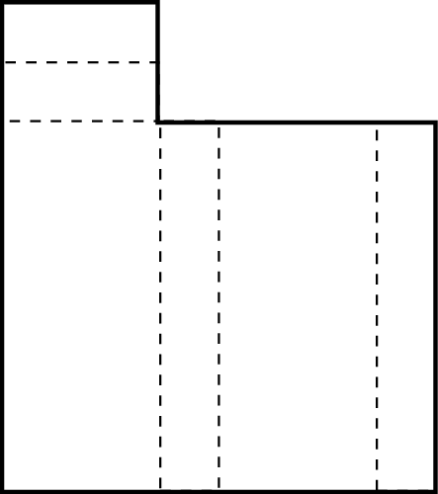

B. 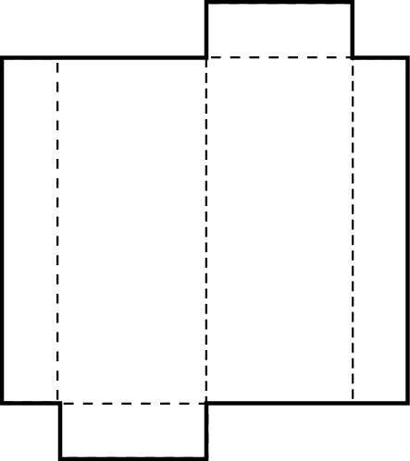

C. 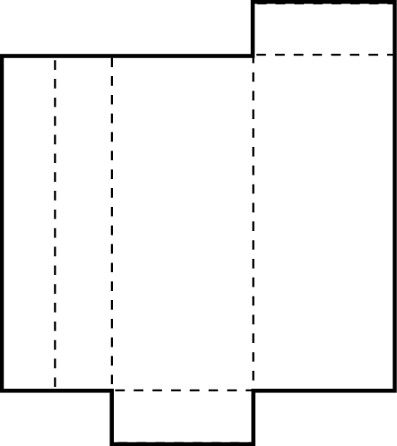

D. 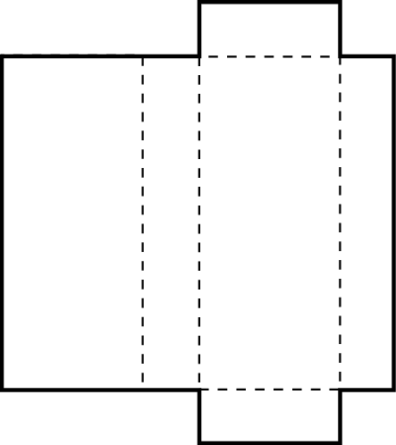

Commentary:
This multiple-choice question asks students to select the net for a rectangular prism. Students should recall that a rectangular prism is in the shape of a box with the congruent parallel faces being rectangles. Students should visualize folding the net in each answer choice to determine if it forms a rectangular prism. The net in answer choice D forms a rectangular prism when folded. The nets in answer choices A, B and C do not form a rectangular prism when they are folded.

The complexity level of this question is Moderate Complexity. This question requires students to interpret a visual representation.

Performance Data:
The percent of public school students selecting answer choice D for question 18 on the March 2006 Grade 5 Achievement Test was 56%.

Keywords: geometry, rectangular prism, spatial sense

BACK TO INDEX

Benchmark: G | Describe and use properties of triangles to solve problems involving angle measures and side lengths of right triangles.
GLI: GSS 5.5 | Use physical models to determine the sum of the interior angles of triangles and quadrilaterals.

Multiple Choice Question:

21. Triangle ABC is shown.
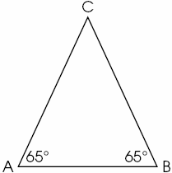
What is the measure of angle C?
A. 50º
B. 65º
C. 90º
D. 180º

NOTE: Commentary, Performance Data and Keywords not available at this time.

BACK TO INDEX

Benchmark: B | Draw circles, and identify and determine the relationships among the radius, diameter, center and circumference.
GLI: GSS 5.1 | Draw circles, and identify and determine relationships among the radius, diameter, center and circumference; e.g., radius is half the diameter, the ratio of the circumference of a circle to its diameter is an approximation of π.

Mathematical Processes
Benchmark: B | Apply and adapt problem-solving strategies to solve a variety of problems, including unfamiliar and non-routine problem situations.

Multiple Choice Question:

27. Malcolm needed to measure the distance across a circular tablecloth. He folded the tablecloth in half as shown.
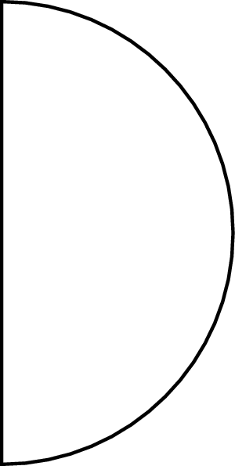
Malcolm measured the length of a folded side.
Which part of the circular tablecloth did Malcolm measure?
A. center
B. circumference
C. diameter
D. radius

do not copy or distribute ID: 10095; Version: 6

Commentary:
This multiple-choice question asks students to select the term that describes the length of a folded side of a circular tablecloth. Students need to study the picture and associate the length of the folded side with the diameter of a circle (a segment connecting two points on the circle and passing through the center). The correct answer is answer choice C. The terms in answer choices A, B and D do not represent the length of the folded side of a circular tablecloth.

The complexity level of this question is Low Complexity. This question requires students to recognize an example of a concept.

Performance Data:
The percent of public school students selecting answer choice C for question 27 on the March 2006 Grade 5 Achievement Test was 45%.

Keywords: measurement, circle, diameter

BACK TO INDEX

Benchmark: G | Describe and use properties of triangles to solve problems involving angle measures and side lengths of right triangles.
GLI: GSS 5.5 | Use physical models to determine the sum of the interior angles of triangles and quadrilaterals.

Multiple Choice Question:

30. Triangle PQR is a right triangle.
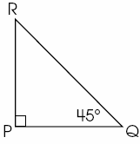
What is the measure of angle R?
A. 30º
B. 45º
C. 75º
D. 90º

NOTE: Commentary, Performance Data and Keywords not available at this time.

BACK TO INDEX

Benchmark: C | Specify locations and plot ordered pairs on a coordinate plane.
GLI: GSS 5.6 | Extend understanding of coordinate system to include points whose x or y values may be negative numbers.

Multiple Choice Question:

36. Four points are shown on the coordinate plane.
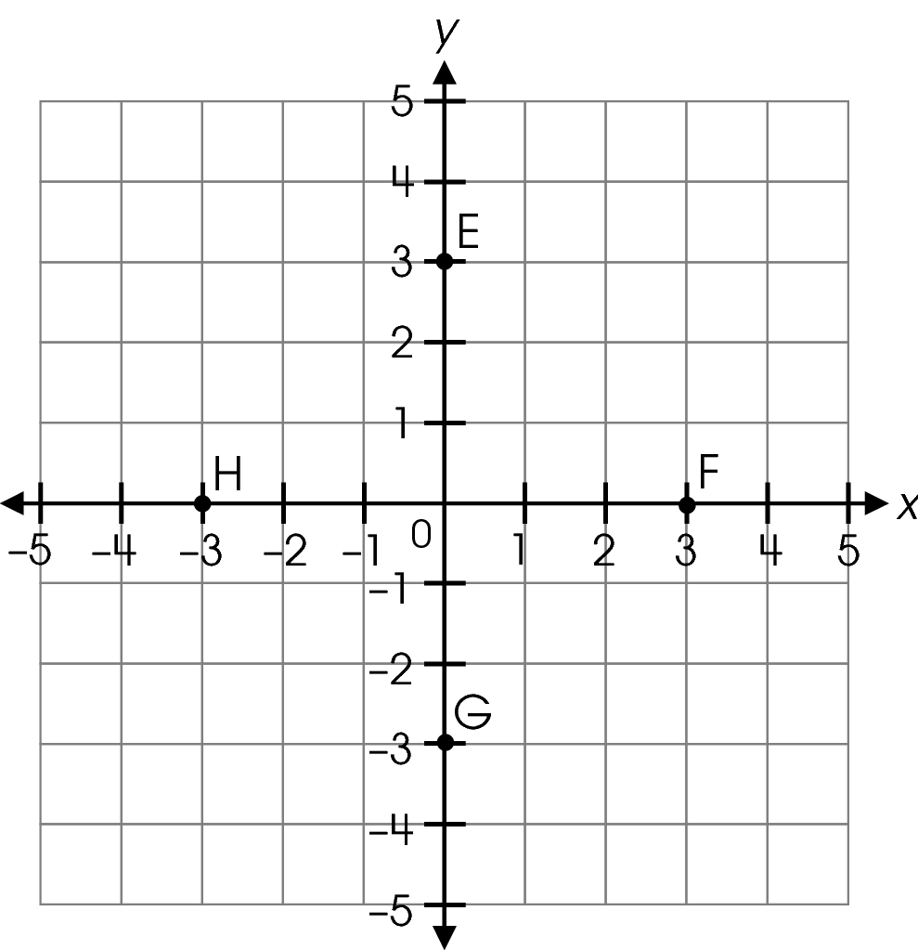
Which point is located at (0, –3)?

A. E
B. F
C. G
D. H

Commentary:
This multiple-choice question asks students to identify the point located at point (0, -3) on a coordinate grid. Students need to recall that the first number in an ordered pair, the
x-coordinate, moves horizontally to the left or right from the origin and the second number, the y-coordinate, moves vertically up or down from the first move. To identify the point located at (0, -3), students should begin at the origin (0, 0), but not move left or right since the x-coordinate is 0. Then, move 3 units down since the y-coordinate is negative. Point G is located at (0, -3). Answer choice C is the correct answer. Answer choices A, B and D are incorrect. Point E, answer choice A, is located at (0, 3); point F, answer choice B, is located at (3, 0); and point H is located at (-3, 0).

The complexity level of this question is Low Complexity. This question requires students to perform a specified procedure.

Performance Data:
The percent of public school students selecting answer choice C for question 36 on the March 2006 Grade 5 Achievement Test was 50%.

Keywords: geometry, ordered pair, coordinate grid

BACK TO INDEX

Benchmark: I | Identify and draw where-dimensional objects from different views (top, side, front and perspective).
GLI: GSS 5.8 | Predict what three-dimensional object will result from folding a two-dimensional net, then confirm the prediction by folding the net.

Multiple Choice Question:

39. A net of a three-dimensional shape is shown.
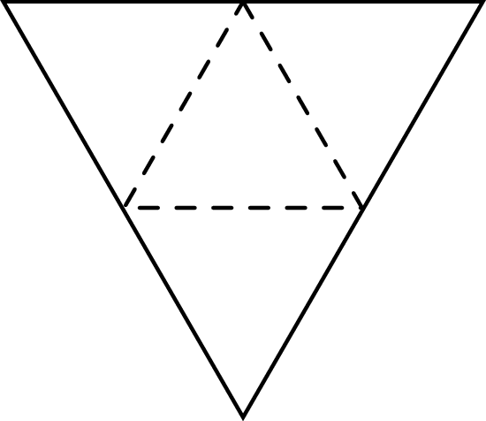
Which three-dimensional shape can be made from the net?
  - 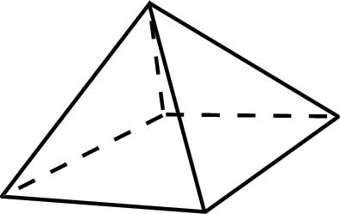
  - 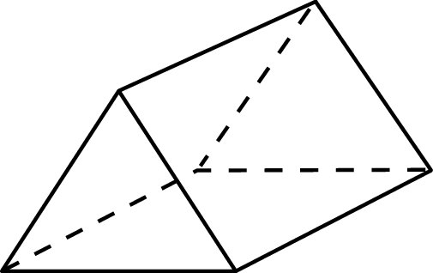
  - 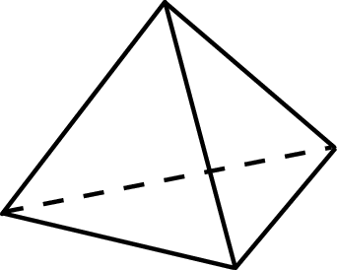
  - 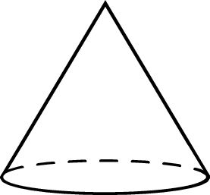

Commentary:
This multiple-choice question asks students to determine which three-dimensional object can be made from the given net. Students should notice that the net is made of four triangular pieces. This would eliminate answer choices A, B and D. Although answer choices A and B have triangles as either a face or the base, they also have other shapes for the face or base. The shape in answer choice D is a cone with a circular base and a curved shape. The shape in answer choice C can be made from the given net.

The complexity level of this question is Low Complexity. This question requires students to recognize an equivalent representation.

Performance Data:
The percent of public school students selecting answer choice C for question 39 on the March 2006 Grade 5 Achievement Test was 71%.
Keywords: geometry, net, spatial sense, three-dimensional shape

BACK TO INDEX

Benchmark: A | Identify and label parts and the regions defined within the plane where the angle resides.
GLI: GSS 5.3 | Label vertex, rays, interior and exterior for an angle.

Short Answer Question:

- In your Answer Document, draw an obtuse angle. Use your protractor to give the measure of the obtuse angle.

Commentary:
This short-answer question asks students to draw an obtuse angle and give the measure of that angle. The response earning the maximum number of points (2 points) provides the drawing of an obtuse angle and the measure of the angle drawn. Students need to draw an angle that is greater than 90°, but less than 180°.

The complexity level of this question is Low Complexity. This task requires students to draw and measure a simple geometric figure.

Performance Data:
The percent of public school students earning each score point for question 42 on the March 2006 Grade 5 Achievement Test:

Percent at Each Score Point
0 | 1 | 2
15% | 30% | 54%

Scoring Guidelines:
Correct Sample Response(s):

- 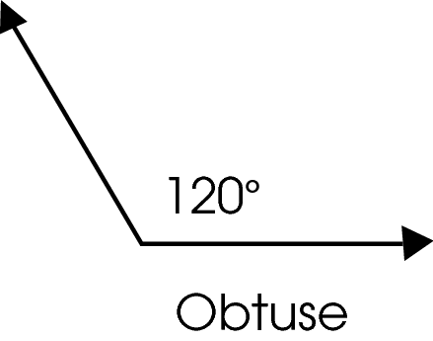
Points | Student Response
2 | The focus of this task is drawing an angle and using a tool to measure the angle. The response shows the drawing of an obtuse angle with the appropriate measure of the angle drawn.  NOTE: An appropriate angle measure must be within 5° of the actual angle measure and have a measurement from 91° to 179°.
1 | The response provides partial evidence of drawing an angle and using a tool to measure the angle; however, the solution may be incomplete or slightly flawed.  For example, the response may:  - Provide a drawing of an angle that is obtuse, but fail to measure it or states that it is greater than 90°.  - Provide a drawing of an acute angle, but accurately measures and labels the angle.  - Provide the drawing of an obtuse angle that is not accurately measured.
0 | The response provides inadequate evidence of drawing an angle and using a tool to measure the angle. The response provides major flaws in angle construction or irrelevant information.  For example, the response may:  - Provide a drawing of an angle that is not obtuse and not measure it.  - Provide a drawing of an angle that is not obtuse and give an angle measure that does not reflect the angle shown.  - Be blank or provide unrelated statements.  - Recopy information from the stem.

Keywords: geometry, obtuse angle

BACK TO INDEX
Benchmark: B | Draw circles, and identify and determine relationships among the radius, diameter, center and circumference.
GLI: GSS 5.1 | Draw circles, and identify and determine relationships among the radius, diameter, center and circumference; e.g., radius is half the diameter, the ratio of the circumference of a circle to its diameter is an approximation of π.

Multiple Choice Question:

44. Point F is the center of the circle shown.
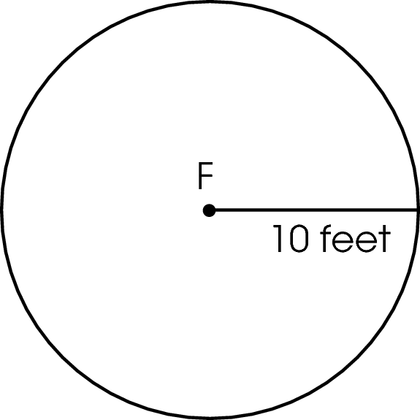
What is the diameter of this circle?

A. 10 feet
B. 20 feet
C. 30 feet
D. 100 feet

Commentary:
This multiple-choice question asks students to determine the diameter of a circle when given the radius of the circle. Students need to recall that the diameter of a circle is twice the radius of the circle. The given radius of the circle is 10 feet; therefore, the diameter of this circle is 20 feet
(10 feet × 2 = 20 feet), answer choice B. The measurement in answer choices A, C and D do not show the diameter as being twice the radius.

The complexity level of this question is Low Complexity. This question requires students to recognize an example of a concept.

Performance Data:
The percent of public school students selecting answer choice B for question 44 on the March 2006 Grade 5 Achievement Test was 72%.

Keywords: geometry, circle, radius, diameter

BACK TO INDEX

Benchmark: A | Identify and label parts and the regions defined within the plane where the angle resides.
GLI: GSS 5.3 | Label vertex, rays, interior and exterior for an angle.

Multiple Choice Question:

4. Angle XYZ is shown.
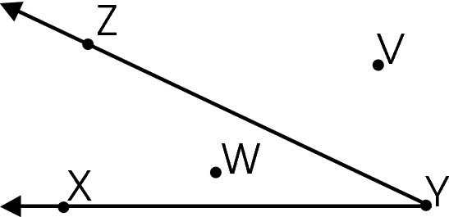
Which point lies in the interior of angle XYZ?

A. point V
B. point W
C. point X
D. point Y

Commentary:
This multiple-choice question asks students to determine the point that lies in the interior of an angle. Point W, answer choice B, lies in the interior of the angle XYZ because this point lies between rays YX and YZ. Therefore, answer choice B is correct.

The points in answer choices A, C and D do not lie in the interior of angle XYZ. Point V, answer choice A, is an exterior point outside of angle XYZ. Point X, answer choice C, lies on the ray XY. Point Y, answer choice D, is the vertex of angle XYZ.

The complexity level of this question is Low Complexity. This question requires students to recognize an example of a concept.

Performance Data:
The percent of public school students selecting answer choice B for question 4 on the May 2007 Grade 5 Achievement Test was 77%.

Keywords: geometry, interior of an angle, point

BACK TO INDEX

Benchmark: D | Identify, describe and classify types of line pairs, angles, two-dimensional figures and three-dimensional objects using their properties.
GLI: GSS 5.2 | Use standard language to describe line, segment, ray, angle, skew, parallel and perpendicular.

Multiple Choice Question:

- A street map is shown.
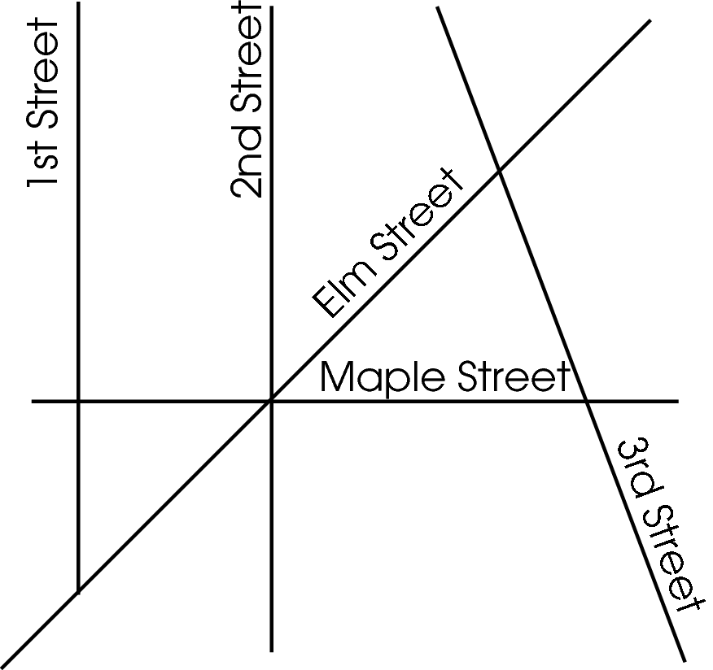
Susan lives on 1st Street. Her friend Allison lives on a street that is parallel to 1st Street.
On which street could Allison live?

A. 3rd Street
B. Elm Street
C. 2nd Street
D. Maple Street

Commentary:
This multiple-choice question asks students to identify the street that is parallel to a given street shown on a map. Students need to look for streets on the map that will not intersect with 1st Street if they continued. On this map, 2nd Street is parallel to 1st Street because they do not intersect when continued. Answer choice C, 2nd Street, is correct.

The streets in answer choices A, B and D are incorrect since these streets are not parallel to 1st Street.

The complexity level of this question is Low Complexity. This question requires students to recognize an example of a concept.

Performance Data:
The percent of public school students selecting answer choice C for question 19 on the May 2007 Grade 5 Achievement Test was 89%.

Keywords: geometry, parallel lines, intersecting lines

BACK TO INDEX

Benchmark: B | Draw circles, and identify and determine the relationships among the radius, diameter, center and circumference.
GLI: GSS 5.1 | Draw circles, and identify and determine relationships among the radius, diameter, center and circumference; e.g., radius is half the diameter, the ratio of the circumference of a circle to its diameter is an approximation of π.

Multiple Choice Question:

- A circle is shown.
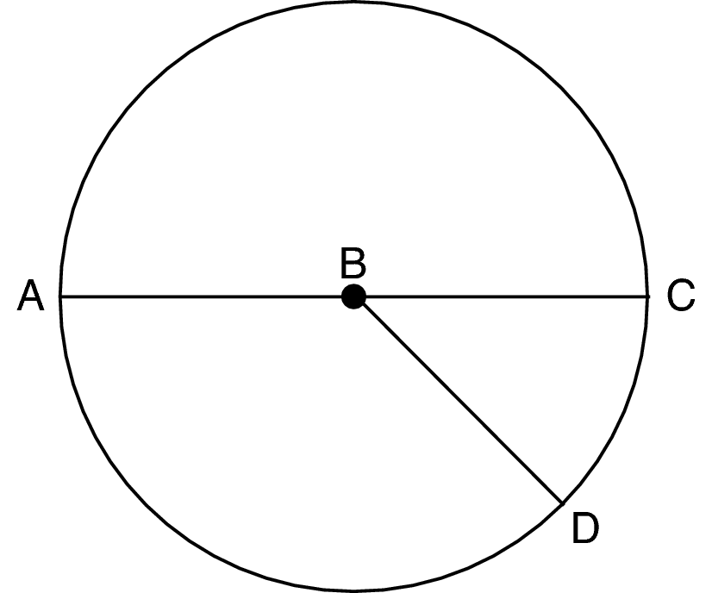
Which statement about the circle is true?
A. The diameter is  .
B. The diameter is 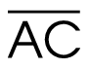 .
C. The only radius is 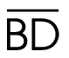 .
D. The radius is two times the length of  .

Commentary:
This multiple-choice question asks students to select a statement that is true about the relationships among the parts of the given circle. Students need to be able to identify and determine the relationships among the parts of a circle. The statement in answer choice B is a true statement. Line segment AC ($\overline{\text{AC}}$) is the diameter because it is a line segment that connects two points on the circle and passes through the center of the circle.

Answer choice A is incorrect since $\overline{\text{AB}}$ is a radius. Answer choice C is incorrect since $\overline{\text{BD}}$is one of the three radii ($\overline{\text{AB}}$,$\overline{\text{BC}}$ and$\overline{\text{BD}}$) shown in the circle. Answer choice D is incorrect since $\overline{\text{BC}}$ is a radius. A diameter is two times a radius.

The complexity level of this question is Moderate Complexity. This question requires students to interpret a visual representation.

Performance Data:
The percent of public school students selecting answer choice B for question 31 on the May 2007 Grade 5 Achievement Test was 64%.

Keywords: geometry, circle, diameter, radius

BACK TO INDEX

Benchmark: J | Apply properties of equality and proportionality to solve problems involving congruent or similar figures; e.g., create a scale drawing.
GLI: GSS 5.4 | Describe and use properties of congruent figures to solve problems.

Short Answer Question:

- Joel’s field is 20 yards wide and 50 yards long, as shown.
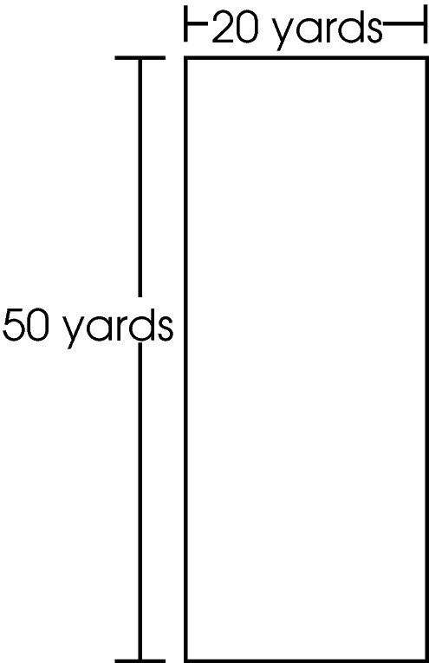
He wants to divide his field into two congruent rectangular fields, one for corn and the other for strawberries.
In your Answer Document, determine the length and the width of the two new fields.
Explain how you know that the two new fields are congruent. (2 points)

Commentary:
This short-answer question asks students to determine the length and width of two new congruent rectangular fields based on the dimensions of a given rectangular field. Students are also asked to explain how they know the two new fields are congruent. The response earning the maximum number of points (2 points) provides the length and width of two fields that are congruent with an adequate explanation. Students need to divide the field in half to make two new rectangular fields that have the same length and the same width. For example, dividing the length (50 yards) in half will result in two congruent rectangular fields with the new length of 25 yards and the width of 20 yards. Dividing the width (20 yards) in half will result in two congruent rectangular fields with the new width of 10 yards and the length of 50 yards. The new fields are congruent because they are the same shape and the same size.

The complexity level of this question is Moderate Complexity. This question requires students to retrieve information from a figure and use it to solve a problem.

Performance Data:
The percent of public school students earning each score point for question 38 on the May 2007 Grade 5 Achievement Test:

Percent at Each Score Point
0 | 1 | 2
38% | 44% | 18%

Scoring Guidelines:
Exemplar Response:

- The two new fields will be 20 yards wide and 25 yards long because half of 50 is 25. They are congruent because they are both rectangles with the same length and same width.
- The two new fields will be 10 yards wide and 50 yards long because I cut the width in half. They are congruent because they are exactly the same size and same shape.
Points | Student Response
2 point text | The focus of this task is using properties of congruent rectangles to solve a problem. The response provides a correct length and width for both of the congruent fields with an adequate explanation.
1 point text | The response shows partial evidence of using properties of congruent rectangles to solve a problem; however, the solution may be incomplete or slightly flawed.
1 point text | 1 point sample answer:  For example, the response may:  - State that he should divide the length in half and keep the width the same but not provide the new measurements or an explanation.  - Provide an accurate length and width for the two congruent fields without an explanation.  - Provide a length of 25 yards and a width of 10 yards.
0 point text | The response provides inadequate evidence of using properties of congruent rectangles to solve a problem. The response provides major flaws in explanations or irrelevant information.
0 point text | 0 point sample answer:  For example, the response may:  - State that the new field will be 20 yards wide and 50 yards long.  - Restate the information provided in the item.  - Be blank or give irrelevant information.

Keywords: geometry, congruent, rectangle

BACK TO INDEX

Benchmark: C | Specify locations and plot ordered pairs on a coordinate plane.
GLI: GSS 5.6 | Extend understanding of coordinate system to include points whose x or y values may be negative numbers.

Multiple Choice Question:

4. Points R, S, T, and U are plotted on the grid as shown.
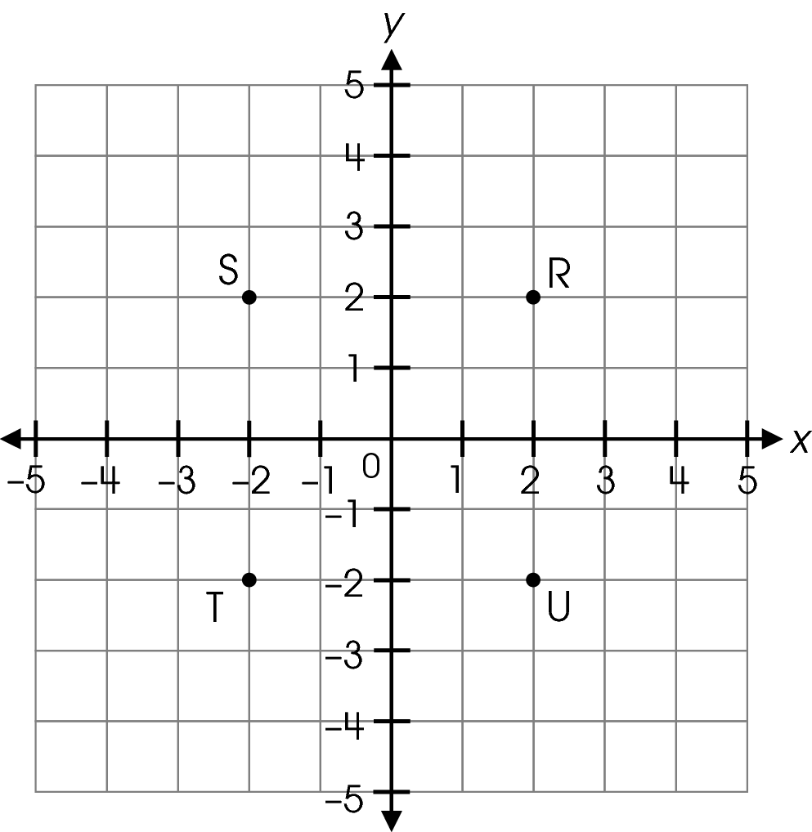
Which point is located at (2, –2)?
A. point R
B. point S
C. point T
D. point U

Commentary:
This multiple-choice question asks students to identify the point located at (2, -2) on the coordinate grid. Students need to recall that the first number in the ordered pair, the x- coordinate, indicates a horizontal move to the left or right from the origin and the second number, the y- coordinate, indicates a vertical move up or down from the first move. To identify the point at (2, -2), students should begin at the origin (0, 0) and move 2 units to the right since the x- coordinate is positive. From this position, move 2 units down since the y- coordinate is negative. Answer choice D, point U, is the point located at (2, -2).

Answer choices A, B and C are incorrect. Point R, answer choice A, is located at (2, 2); point S, answer choice B, is located at (-2, 2) and point T, answer choice C, is located at (-2, -2).

The complexity level of this question is Low Complexity. The question requires students to perform a specified procedure.

Performance Data:
The percent of public school students selecting answer choice D for question 4 on the May 2008 Grade 5 Achievement Test was 68%.

Keywords: geometry, coordinate plane, point, ordered pair

BACK TO INDEX

Benchmark: J | Apply properties of equality and proportionality to solve problems involving congruent or similar figures; e.g., create a scale drawing.
GLI: GSS 5.4 | Describe and use properties of congruent figures to solve problems.

Mathematical Processes
Benchmark: H | Use representations to organize and communicate mathematical thinking and problem solutions.

Multiple Choice Question:

19. Jay made a cardboard sign to announce an after-school picnic.
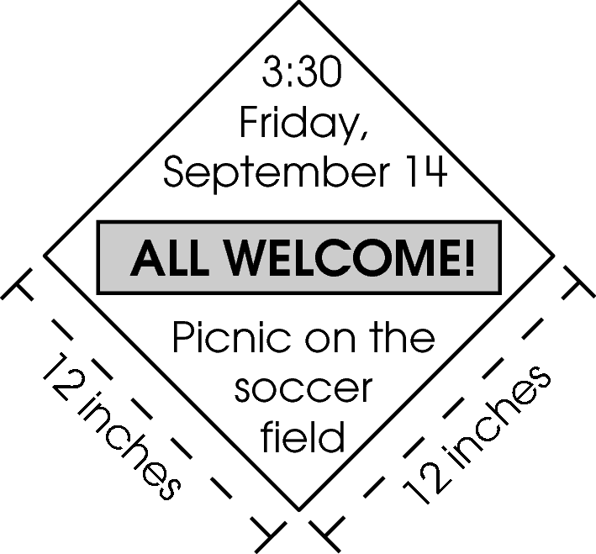
He is looking for a congruent piece of cardboard so that he can make a second sign.
Which piece of cardboard could Jay use?

A.
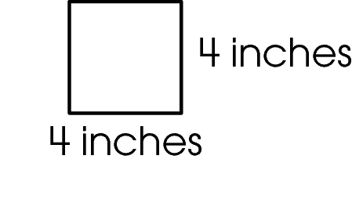
B.
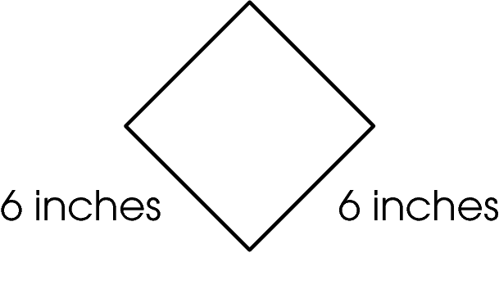

C.
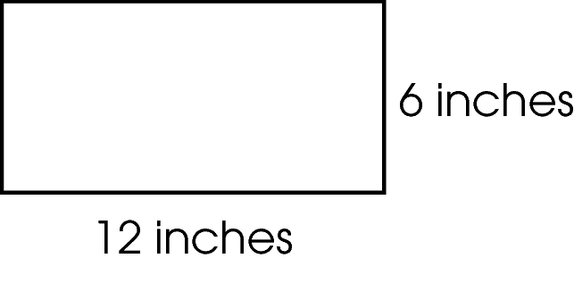

D.
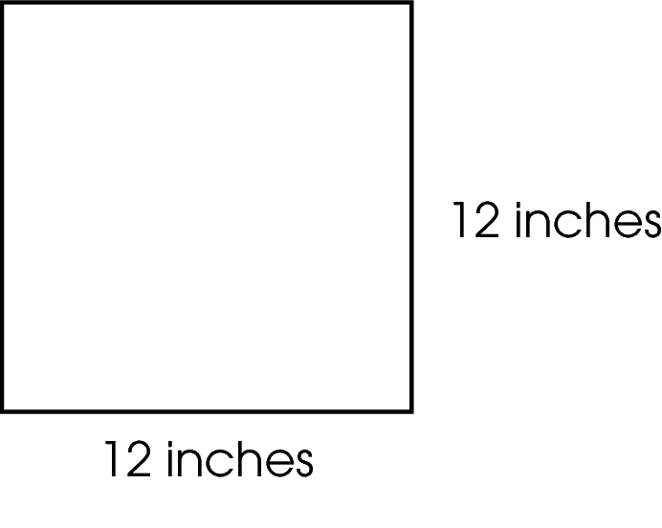

Commentary:
This multiple-choice question asks students to select a sign that is congruent to a cardboard sign with side lengths of 12 inches. Students should recall that a congruent shape will have the same shape and be the same size as the original shape. The sign in answer choice D is congruent to the original sign because it has the same shape and is the same size.

The signs in answer choices A, B and C are not congruent to the original cardboard sign. Although the sign in answer choices A and B are the same shape as the original sign, they are not the same size since their side lengths are not 12 inches. The sign in answer choice C is not the same shape or the same size as the original sign.

The complexity level of this question is Low Complexity. The question requires students to recognize an example of a concept.

Performance Data:
The percent of public school students selecting answer choice D for question 19 on the May 2008 Grade 5 Achievement Test was 80%.

Keywords: geometry, congruent

BACK TO INDEX

Benchmark: B | Draw circles, and identify and determine the relationships among the radius, diameter, center and circumference.
GLI: GSS 5.1 | Draw circles, and identify and determine relationships among the radius, diameter, center and circumference; e.g., radius is half the diameter, the ratio of the circumference of a circle to its diameter is an approximation of π.

Multiple Choice Question:

22. A circle is shown.
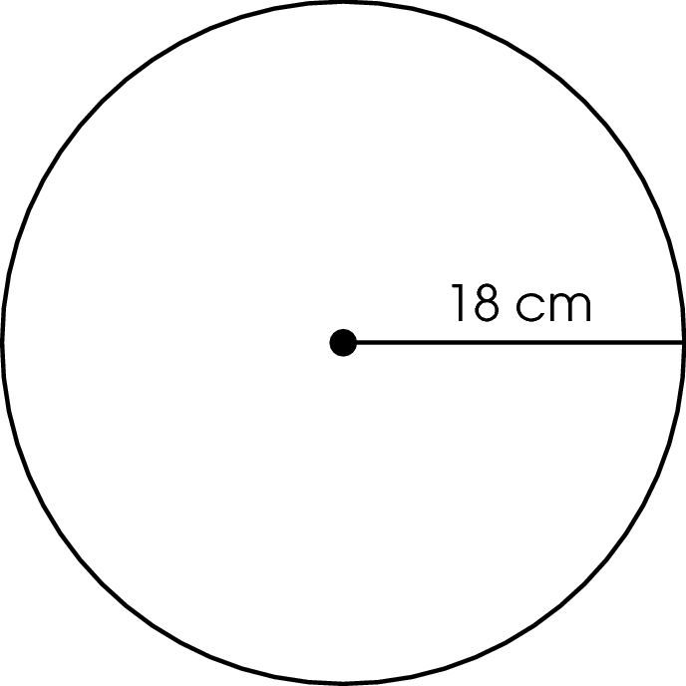
Which statement about the circle is true?

A. The diameter is 9 cm.
B. The diameter is 36 cm.
C. The radius is 9 cm.
D. The radius is 36 cm.

Commentary:
This multiple-choice question asks students to select the statement which is true for the information provided in the circle. A circle with a radius of 18 cm is shown. Students need to recall that the radius of a circle is half of the diameter of a circle or that the diameter of a circle is twice the radius of a circle. Since the given radius is 18 cm, this means that the diameter is 36 cm (18 cm × 2 = 36 cm), answer choice B.

Answer choices A, C and D are incorrect statements. The statements do not relate the relationship of the radius to the diameter correctly. In answer choice A, students may have thought the diameter was half of the radius. Answer choice C is the result of dividing the radius by 2. Answer choice D is the result of confusing radius and diameter.

The complexity level of this question is Low Complexity. The question requires students to recognize an example of a concept.

Performance Data:
The percent of public school students selecting answer choice B for question 22 on the May 2008 Grade 5 Achievement Test was 68%.

Keywords: geometry, circle, radius, diameter

BACK TO INDEX

Benchmark: D | Identify and draw right, obtuse, acute and straight angles.
GLI: GSS 3.2b | Identify and describe the relative size of angles with respect to right angles as follows:  - Identify, classify and draw right, acute, obtuse and straight angles.

Multiple Choice Question:

35. A triangle has one right angle and one acute angle.
What kind of angle must its third angle be?

A. acute
B. obtuse
C. right
D. straight

Commentary:
This multiple-choice question asks students to determine the type of angle the third angle in a triangle must be when one angle is a right angle and another angle is an acute angle. Students should recall that the sum of the measures of the angles in any triangle is 180°. The measure of a right angle is 90° which leaves 90° to be shared by the remaining two angles. Since one of the two remaining angles is an acute angle, the third angle must also be an acute angle, answer choice A.

Answer choices B, C and D are incorrect. The measure of the third angle being obtuse (greater than 90° but less than 180°), right (90°) or straight (180°) would result in the sum of the measures of the triangle being greater than 180°.

The complexity level of this question is Moderate Complexity. The question requires students to use informal methods of reasoning.

Performance Data:
The percent of public school students selecting answer choice A for question 35 on the May 2008 Grade 5 Achievement Test was 44%.

Keywords: geometry, triangles, angles

BACK TO INDEX

