Index to Questions

Question Number | Source | BM | GLI | Description
5 | OAT Mar 06 | E | GSS 4.2 | This short-answer question asks students to compare three-dimensional objects using their attributes and to provide one mathematically relevant characteristic of a similarity as well as one mathematically relevant characteristic of a difference between a cone and a cylinder.
18 | OAT Mar 06 | G | GSS 4.6 | This multiple-choice question asks students to identify a school by its ordered pair on a coordinate grid.
21 | OAT Mar 06 | B | GSS 4.5 | This multiple-choice question asks students to identify the description of an object in the environment.
26 | OAT Mar 06 | C | GSS 4.1 | This multiple-choice question asks students to identify the street that appears to be parallel to the railroad truck.
31 | OAT Mar 06 | I | GSS 4.7 | This multiple-choice question asks students to identify the transformation shown on a picture.
38 | OAT Mar 06 | F | GSS 4.4 | This short-answer question asks students to identify all of the triangles that appear to be scalene.
43 | OAT Mar 06 | E | GSS 4.2 | This multiple-choice question asks students to identify attributes that each of the shapes appear to have in common.
5 | OAT May 07 | I | GSS 4.7 | This short-answer question asks students to identify the transformation that helps to determine whether the two given triangles are congruent.
9 | OAT May 07 | A | GSS 4.4 | This multiple-choice question asks students to choose the type of triangle using the size of its angles and the length of its sides.
34 | OAT May 07 | F | GSS 4.3 | This multiple-choice question asks students to identify common attributes for a rhombus and a square.
1 | OAT May 08 | C | GSS 4.1 | This multiple-choice question asks students to describe line segments that mark parking spaces.
10 | OAT May 08 | E | GSS 4.2 | This extended-response question asks students to first draw four different types of quadrilaterals, e.g. square, trapezoid, rectangle, and parallelogram, each having at least one pair of parallel sides.
24 | OAT May 08 | I | GSS 4.7 | This multiple-choice question asks students to select a geometric transformation that could be used to determine if the two butterflies shown are congruent (same size and shape).
Question Number | Source | BM | GLI | Description
31 | OAT May 08 | I | GSS 4.7 | This multiple-choice question asks students to select the diagram that shows a translation (slide).

BACK TO INDEX

Benchmark: E | Use attributes to describe, classify and sketch plane figures and build solid objects.
GLI: GSS 4.2 | Describe, classify, compare and model two- and three-dimensional objects using their attributes.

Short Answer Question:

5. A cone and a cylinder are shown.
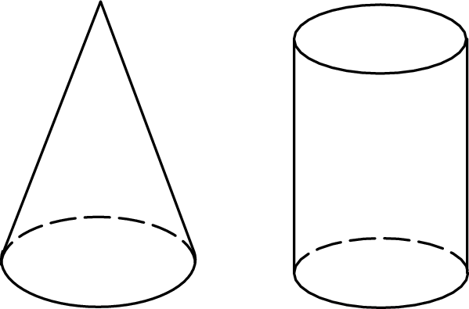
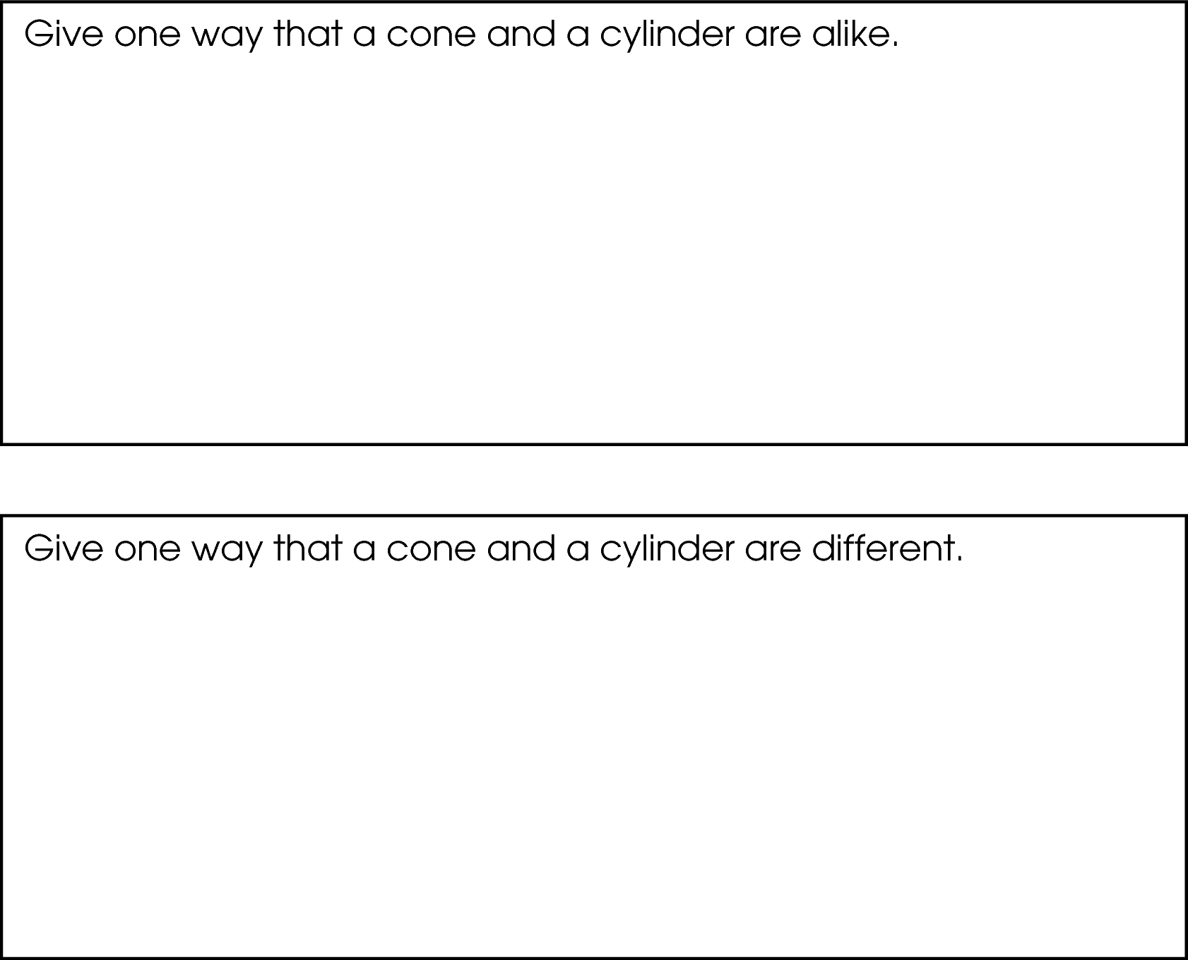

Commentary:
This short-answer question asks students to compare three-dimensional objects using their attributes and to provide one mathematically relevant characteristic of a similarity as well as one mathematically relevant characteristic of a difference between a cone and a cylinder.
A response earning the maximum number of points (2 points) provides one characteristic of similarity, such as both shapes are three-dimensional or both shapes have a circle for a base, and one characteristic of a difference, such as a cone has two faces and a cylinder has three faces. Students may identify other examples for similarity or difference between the two shapes. For example, a cylinder has circles for both bases and the cone narrowing to a point at one end (apex) and has one circular base on the other end.

The complexity level of this question is Moderate Complexity because the problem requires students to compare geometric shapes.

Performance Data:
The percent of public school students earning each score point for question 5 on the March 2006 Grade 4 Achievement Test:

Percent at Each Score Point
0 | 1 | 2
7% | 29% | 64%

Scoring Guidelines:
Sample Correct Response(s):
- A cone and a cylinder are alike because both are 3-dimensional. They are different because the cylinder has circles at both ends and the cone narrows to a point at one end.
- They both have a circle for a base. The cone has two faces but the cylinder has three faces.

Points | Student Response
2 | The focus of the task is describing and comparing three-dimensional objects using their attributes. The response provides at least one mathematically relevant similarity and one mathematically relevant difference between a cone and a cylinder.
1 | The response shows partial evidence of describing and comparing three-dimensional objects using their attributes; however, the solution may be incomplete or slightly flawed.  For example, the response may:  - State an accurate similarity but not adequately state a difference.  - State that the volume of the cone is less than the volume of the cylinder but not adequately state a similarity.  - State an adequate difference but state a similarity that is not true for all cones and cylinders. For example, state the figures are the same height. (this is a measurement difference not a geometrical difference)
0 | The response provides inadequate evidence of an understanding of describing and comparing three-dimensional objects using their attributes. The response provides an explanation with major flaws and errors of reasoning.  For example, the response may:  - State that the cone could be put on top of the cylinder.  - Be blank or state unrelated statements.  - Recopy information from the stem.

Keywords: geometry, shapes, cone, cylinder

BACK TO INDEX

Benchmark: G | Find and name locations in coordinate systems.
GLI: GSS 4.6 | Specify locations and plot ordered pairs on a coordinate plane, using first quadrant points.

Multiple Choice Question:

18. Mr. Yang is driving to the school located at (2, 0) on the coordinate grid.
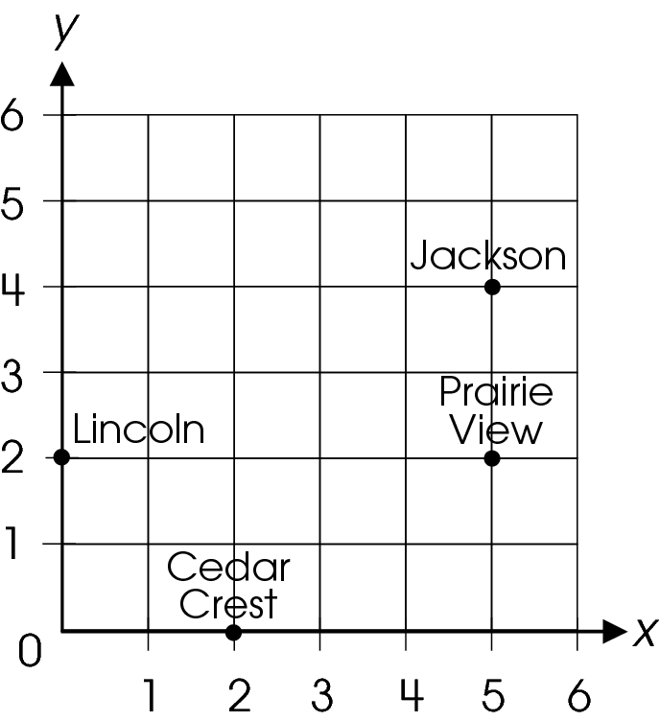
Which school is located at (2, 0)?
A. Cedar Crest
B. Jackson
C. Lincoln
D. Prairie View

Commentary:
This multiple-choice question asks students to identify a school by its ordered pair on a coordinate grid. Students need to know that the first number in an ordered pair indicates the number of units to move horizontally from the origin and the second number in an ordered pair indicates the number of units to move vertically. To find the name of the school with the ordered pair (2, 0), Mr. Yang moves 2 units vertically to the right from the origin and then remains at that point because the zero in the ordered pair tells Mr. Yang to stay at the same point and to move vertically. The correct answer is answer choice A. Answer choice C (0, 2) may be the result of forgetting that horizontal move from the origin (over) has to be done first, before the vertical move. Answer choices B (5, 4) and D (5, 2) are also incorrect because the ordered pairs of those schools are different then (2, 0).

The level of complexity for this question is Low Complexity. This question requires students to recall how points are associated with their coordinates.

Performance Data:
The percent of public school students selecting answer choice A for question 18 on the March 2006 Grade 4 Achievement Test was 79%.

Keywords: geometry, point, ordered pair, coordinate grid

BACK TO INDEX

Benchmark: B | Describe and identify points, lines and planes in the environment.
GLI: GSS 4.5 | Describe points, lines and planes, and identify models in the environment.

Multiple Choice Question:

21. A bug lands on a rope stretched between two trees on a lawn at a park.
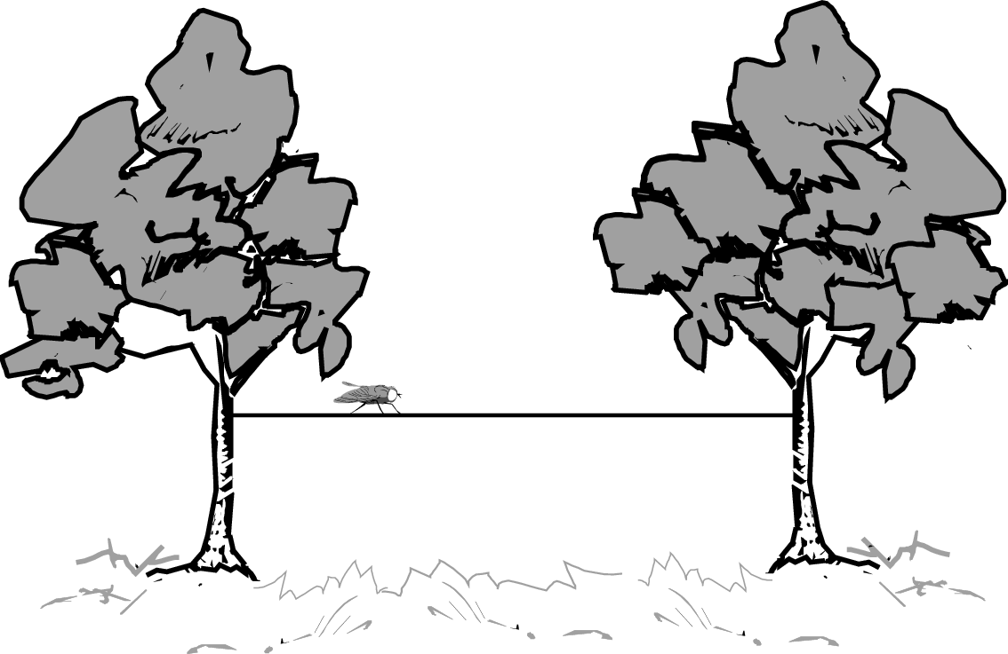
Which object (the bug, the rope, the lawn, the park) is best described as a point?
A. bug
B. rope
C. lawn
D. park

Commentary:
This multiple-choice question asks students to identify the description of an object in the environment. Students need to recognize an example of a geometric term within the environment. The bug sits on a rope (a point on a line); a rope connects two trees (a line segment); and the lawn is in the park (a plane in space). The correct answer choice is A.

The complexity level of this question is Low Complexity. The question requires students to recognize an example of a concept.

Performance Data:
The percent of public school students selecting answer choice A for question 21 on the March 2006 Grade 4 Achievement Test was 54%.

Keywords: geometry, point, line, plane

BACK TO INDEX

Benchmark: C | Describe and identify intersecting, parallel and perpendicular lines or segments in the environment.
GLI: GSS 4.1 | Identify, describe and model intersecting, parallel and perpendicular lines and line segments; e.g., use straws or other material to model lines.

Multiple Choice Question:

26. A map of Andrew’s neighborhood is shown. Andrew lives on the street that appears to be parallel to the railroad tracks.
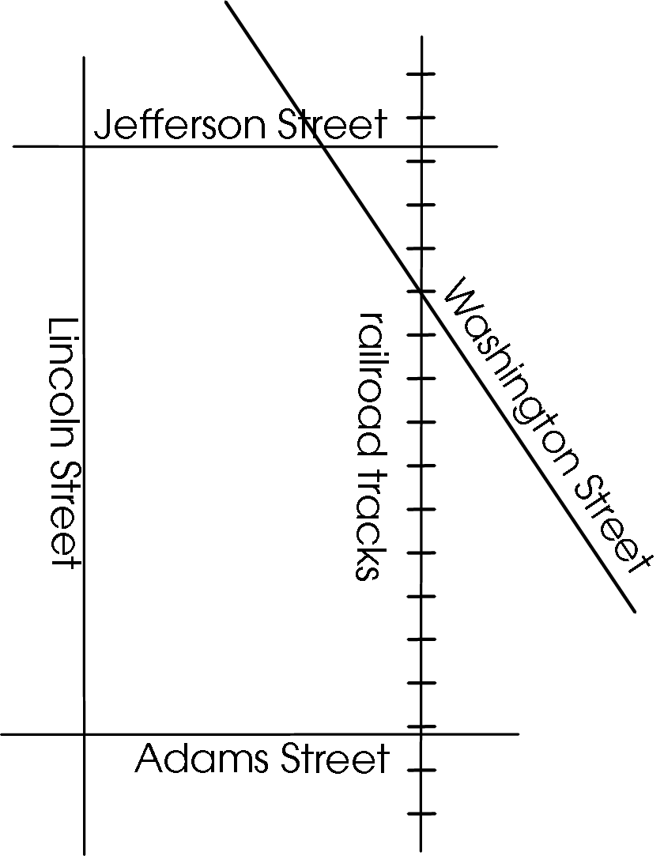
On which street does Andrew live?
A. Washington Street
B. Lincoln Street
C. Adams Street
D. Jefferson Street

Commentary:
This multiple-choice question asks students to identify the street that appears to be parallel to the railroad track. Lines are parallel if they are in the same plane and do not intersect. Only Lincoln Street appears to be parallel to the railroad tracks. Therefore, Andrew lives on Lincoln Street, answer choice B. The streets in answer choices A, C and D are incorrect because they intersect the railroad tracks.
The complexity level of this question is Low Complexity. The question requires students to recognize an example of a concept.

Performance Data:
The percent of public school students selecting answer choice B for question 26 on the March 2006 Grade 4 Achievement Test was 77%.

Keywords: geometry, parallel lines

BACK TO INDEX

Benchmark: I | Describe, identify and model reflections, rotations and translations, using physical materials.
GLI: GSS 4.7 | Identify, describe and use reflections (flips), rotations (turns), and translations (slides) in solving geometric problems; e.g., use transformations to determine if 2 shapes are congruent.

Multiple Choice Question:

31. The grid shows two shapes.
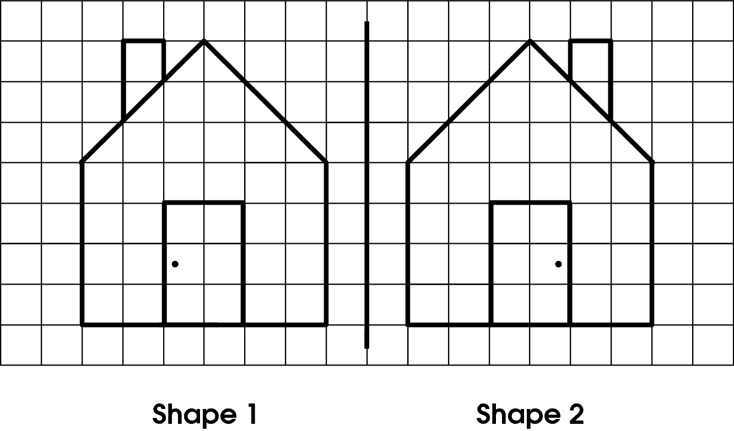
What transformation changed shape 1 to shape 2?

A. rotation (turn)
B. translation (slide)
C. reflection (flip)
D. no transformation

Commentary:
This multiple-choice question asks students to identify the transformation shown on a picture. Answer choice C is the correct answer because when shape 1 is flipped about the line of symmetry, shape 1 and shape 2 will coincide. Answer choice A is incorrect because if students rotate shape 1 on any angle, it will not coincide with shape 2. Answer choice B is also an incorrect because if students slide shape 1 onto shape 2, they will not coincide. Answer choice D is incorrect because a transformation is present in the problem.

The complexity level of this question is Low Complexity. The task requires students to recognize an example of a concept.

Performance Data:
The percent of public school students selecting answer choice C for question 31 on the March 2006 Grade 4 Achievement Test was 79%.

Keywords: geometry, transformations

BACK TO INDEX

Benchmark: F | Develop definitions of classes of shapes.
GLI: GSS 4.4 | Identify and define triangles based on angle measures (equiangular, right, acute and obtuse triangles) and side lengths (isosceles, equilateral and scalene triangles).

Mathematical Processes
Benchmark: H | Recognize basic valid and invalid arguments, and use examples and counter examples, models, number relationships and logic to support or refute.

Short Answer Question:

38. Six triangles are shown.
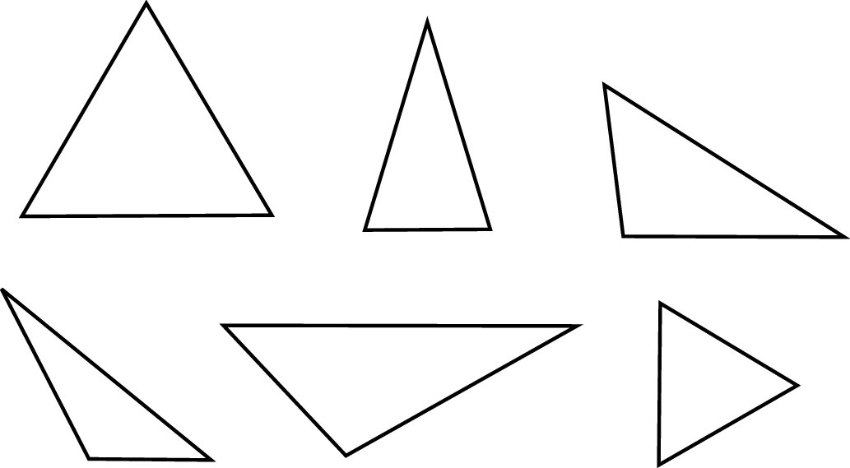
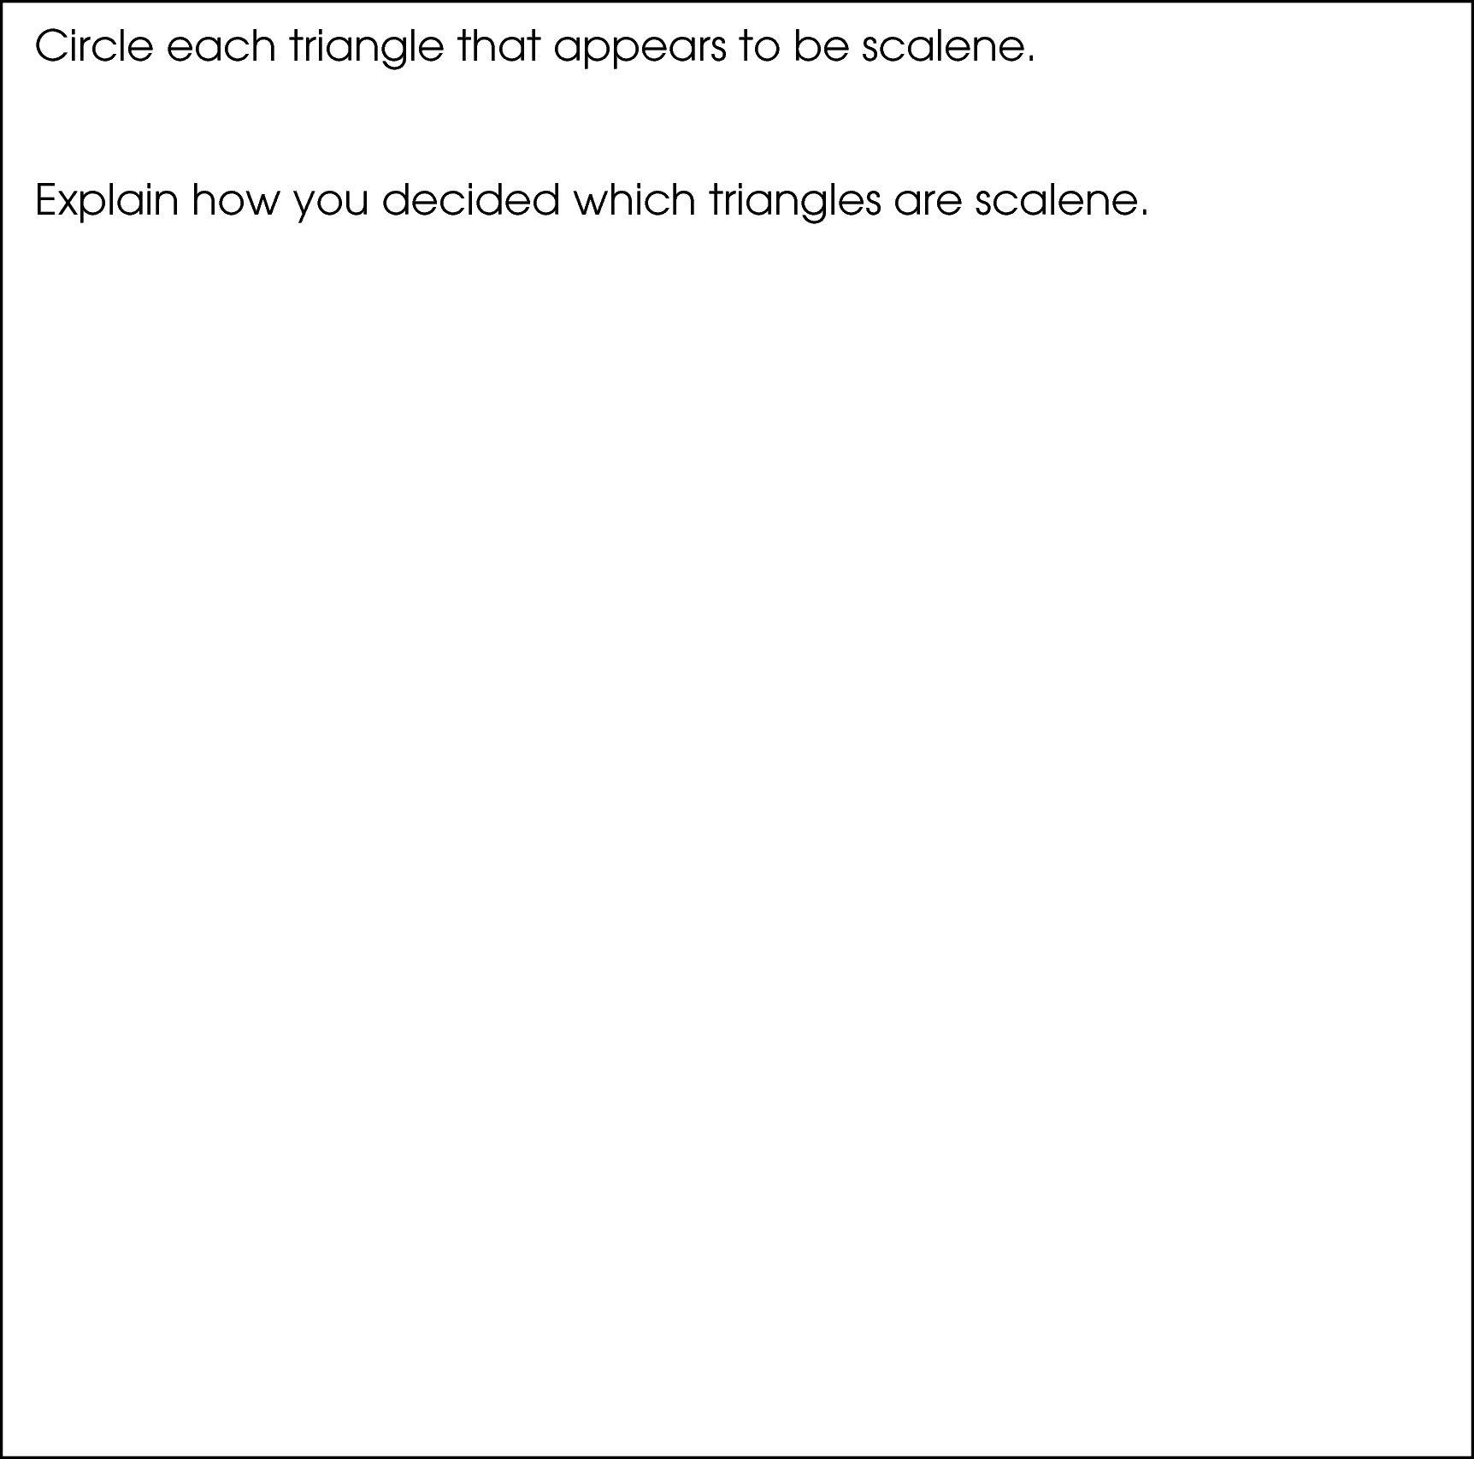

Commentary:
This short-answer question asks students to identify all of the triangles that appear to be scalene. A response earning the maximum number of points (2 points) provides a selection of three scalene triangles, such as the third triangle from the upper row and the first and the second triangles from the lower row, and provides an adequate explanation for the selection. For example, scalene triangles are the ones in which all of the sides have different lengths and all of the angles have different measures.

The complexity level of this question is Moderate Complexity. The task requires students to compare and select figures and then justify their selection.

Performance Data:
The percent of public school students earning each score point for question 38 on the March 2006 Grade 4 Achievement Test:

Percent at Each Score Point
0 | 1 | 2
39% | 27% | 32%

Scoring Guidelines:
Sample Correct Response(s):
- 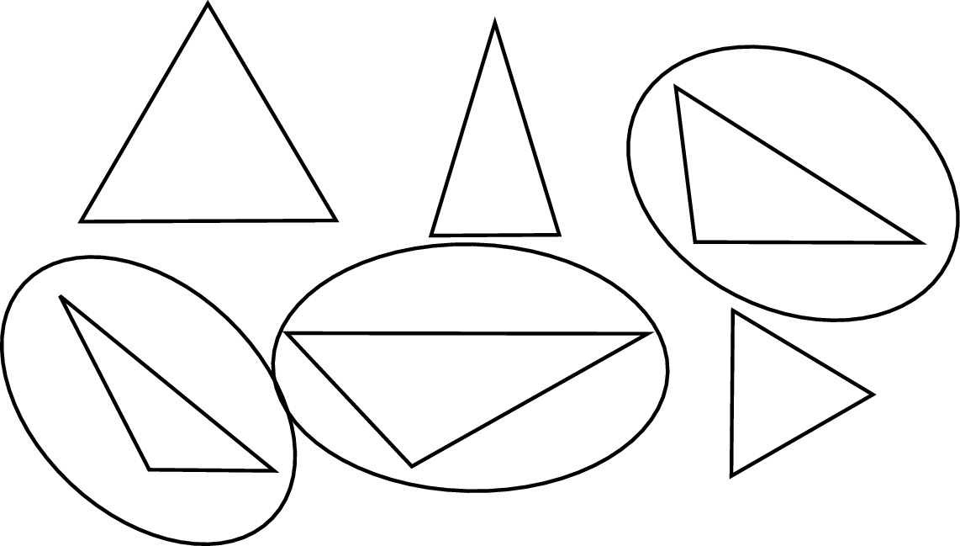
- Circles the three triangles that appear to be scalene. The scalene triangles are the ones that look like all of the sides are different lengths and all of the angles are different measures.
- Circles two of the triangles that appear to be scalene. I circled those triangles because it looked like none of the sides are the same length.

Points | Student Response
2 | The focus of the task is identifying and defining triangles based on angle measures and side measures. The response provides at least two of the triangles that appear to be scalene and provides an adequate explanation that demonstrates an understanding of the meaning of scalene.
1 | The response shows partial evidence of identifying and defining triangles based on angle measures and side measures; however, the solution is incomplete or slightly flawed.  For example, the response may:  - Circle two or three of the triangles that appear to be scalene, but the explanation is vague or omitted; e.g., those triangles look different than the other ones.  - Circle none or one of the scalene triangles, and/or circle a non-scalene triangle, but gives an appropriate explanation; e.g., the sides of scalene triangles aren’t the same length.
0 | The response provides inadequate evidence of identifying and defining triangles based on angle measures and side measures. The response provides an explanation with major flaws and errors of reasoning.  For example, the response may:  - Circle no scalene triangles or circle triangles that are not scalene and omit or provide support that is inaccurate; e.g., I circled the triangles that looked like they had equal sides.  - Be blank or state unrelated statements.  - Recopy information from the stem.

Keywords: geometry, triangles, scalene triangles

BACK TO INDEX

Benchmark: E | Use attributes to describe, classify and sketch plane figures and build solid objects.
GLI: GSS 4.2 | Describe, classify, compare and model two- and three-dimensional objects using their attributes.

Multiple Choice Question:

43. The shapes shown are part of a design.
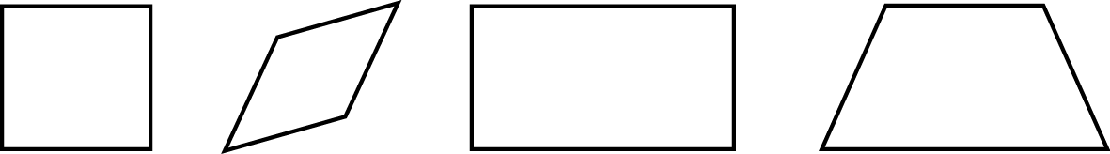
What do all these shapes appear to have in common?
- All have four right angles.
- All have at least one set of parallel sides.
- All have four equal angles.
- All have at least one set of perpendicular lines.

do not copy or distribute ID: 9494; Version: 9

Commentary:
This multiple-choice question asks students to identify attributes that each of the shapes appear to have in common. Students may compare the shapes and recognize that all of them have at least one pair of parallel sides, which makes answer choice B the correct answer. Answer choice A is incorrect because only the square and the rectangle have four right angles. Answer choice C is incorrect because only the square and the rectangle have four equal angles. Answer choice D is incorrect because in this problem only the square and the rectangle have at least one set of perpendicular lines.

The complexity level of this question is Moderate Complexity. The task requires students to compare geometric figures.

Performance Data:
The percent of public school students selecting answer choice B for question 43 on the March 2006 Grade 4 Achievement Test was 51%.

Keywords: geometry, quadrilaterals, rhombus, square, rectangle

BACK TO INDEX

Benchmark: I | Describe, identify and model reflections, rotations and translations, using physical materials.
GLI: GSS 4.7 | Identify, describe and use reflections (flips), rotations (turns), and translations (slides) in solving geometric problems; e.g., use transformations to determine if 2 shapes are congruent.

Short Answer Question:

5. Two triangles are drawn on the grid.
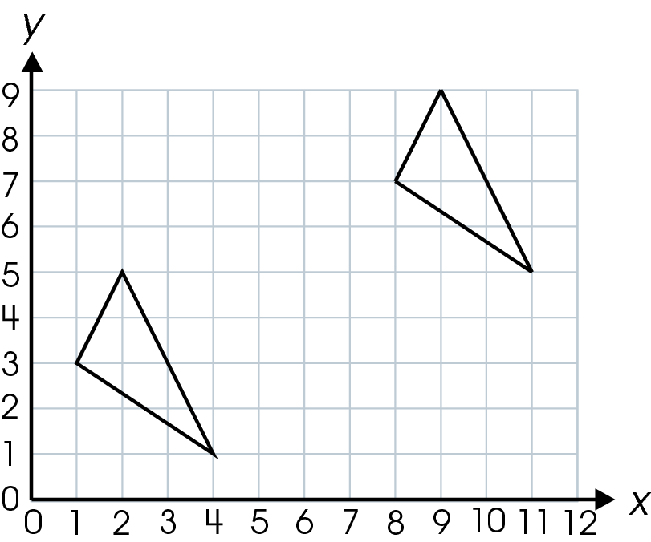
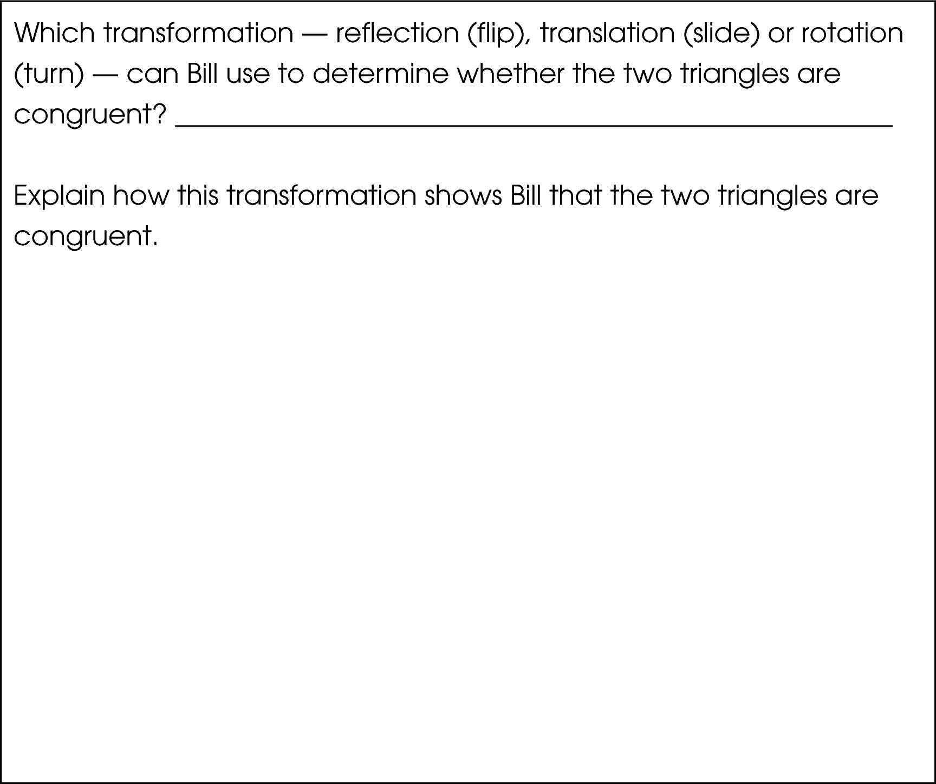

Commentary:
This short-answer question asks students to identify the transformation that helps to determine whether the two given triangles are congruent. A response earning the maximum number of points (2 points) provides the correct transformation, a translation (a slide), with an adequate explanation (for example, a translation of the top triangle 4 units down and 7 units left). To determine whether the shapes are congruent, one triangle can be translated to the other triangle until they coincide. If all sides of the triangles match up exactly, then the triangles must have the same size and shape. Therefore, they are congruent.

The complexity level of this question is Moderate Complexity. This task requires students to interpret a visual representation and then justify their solution.

Performance Data:
The percent of public school students earning each score point for question 5 on the May 2007 Grade 4 Achievement Test:

Percent at Each Score Point
0 | 1 | 2
35% | 58% | 7%

Scoring Guidelines:
Exemplar Response:

- A translation would show that these two triangles are congruent. The triangle was moved up and over and will fit perfectly on top of the second triangle.
Other Correct Response(s):

Points | Student Response
2 point text | The focus of this task is to determining whether two shapes are congruent using transformations. The response provides the correct transformation and an adequate explanation of why the transformation can show congruency.  NOTE: Acceptable responses may correctly state and explain how a combination of transformations can be used to show that the triangles are congruent.
1 point text | The response shows partial evidence of determining whether two shapes are congruent using transformations; however, the response may be incomplete or slightly flawed.
1 point text | 1 point sample answer:  For example, the response may:  - Provide the correct answer of translation without an adequate explanation of the transformation showing congruency.  - Provide an adequate explanation of the transformation showing congruency but not identify the correct transformation.
0 point text | The response provides inadequate evidence of determining whether two shapes are congruent using transformations. The response provides an explanation with major flaws and errors of reasoning.
0 point text | 0 point sample answer:  For example, the response may:  - State reflection.  - Restate the information provided in the item.  - Be blank or give irrelevant information.

Keywords: geometry, transformation, translation

BACK TO INDEX

Benchmark: A | Provide rationale for groupings and comparisons of two-dimensional figures and three-dimensional objects.
GLI: GSS 4.4 | Identify and define triangles based on angle measures (equiangular, right, acute and obtuse triangles) and side lengths (isosceles, equilateral and scalene triangles).

Multiple Choice Question:

9. Roy drew a triangle with exactly two congruent angles and two congruent sides.
What kind of triangle did Roy draw?

A. equiangular
B. equilateral
C. isosceles
D. scalene

Commentary:
This multiple-choice question asks students to choose the type of triangle using the size of its angles and the length of its sides. A triangle with at least two congruent sides and at least two congruent angles is an isosceles triangle. Roy’s triangle is an isosceles triangle because it has exactly two congruent sides and two congruent angles, answer choice C.

Answer choice A is incorrect because an equiangular triangle must have three congruent angles and Roy’s triangle has exactly two congruent angles and two congruent sides. Answer choice B is incorrect because an equilateral triangle must have three congruent sides and Roy’s triangle has exactly two congruent sides and two congruent angles. Answer choice D is also incorrect because a scalene triangle has no congruent sides and no congruent angles and Roy’s triangle has two congruent sides and two congruent angles.

The complexity level of this question is Moderate Complexity. This question requires students to compare geometric figures.

Performance Data:
The percent of public school students selecting answer choice C for question 9 on the May 2007 Grade 4 Achievement Test was 43%.

Keywords: geometry, triangle, equiangular, equilateral, isosceles, scalene

BACK TO INDEX

Benchmark: F | Develop definitions of classes of shapes.
GLI: GSS 4.3 | Identify similarities and differences of quadrilaterals; e.g., squares, rectangles, parallelograms and trapezoids.

Multiple Choice Question:

34. How are a rhombus and a square alike?

- They both have four equal sides.
- They both have four right angles.
- They both have four equal angles.
- They both have only one pair of parallel sides.

Commentary:
This multiple-choice question asks students to identify common attributes for a rhombus and a square. A rhombus has four equal sides and its opposite sides are parallel. A square, in addition to having four equal sides and two pairs of parallel sides, has four right angles. Since four equal sides is a common attribute for both a rhombus and a square, answer choice A is correct.

Answer choice B is incorrect because it states that a rhombus and a square both have all right angles. However, only a square must have right angles. Answer choice C is also incorrect because it states that a rhombus and a square must have four equal angles. However, only a square must have four equal angles. Answer choice D is incorrect as well because it states that a rhombus and a square have only one pair of parallel sides. However, both a rhombus and a square have two pairs of parallel sides.

The complexity level of this question is Moderate Complexity. This question requires students to compare statements.

Performance Data:
The percent of public school students selecting answer choice A for question 34 on the May 2007 Grade 4 Achievement Test was 55%.

Keywords: geometry, rhombus, square, right angle, parallel sides

BACK TO INDEX

Benchmark: C | Describe and identify intersecting, parallel and perpendicular lines or segments in the environment.
GLI: GSS 4.1 | Identify, describe and model intersecting, parallel and perpendicular lines and line segments; e.g., use straws or other material to model lines.

Multiple Choice Question:

1. The spaces in a parking lot are marked by line segments, as shown.
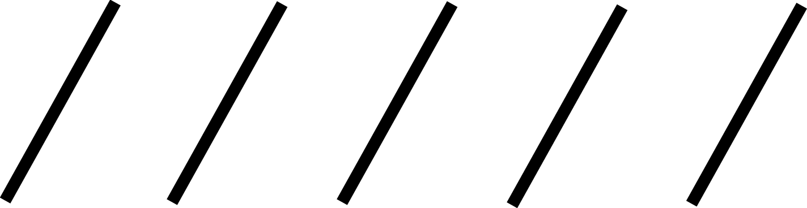
Which describes the line segments that are marked in the parking lot?

- curved
- intersecting
- parallel
- perpendicular

Commentary:
This multiple-choice question asks students to describe line segments that mark parking spaces. Students need to recognize that these line segments are separated at equal distances and if the segments were extended, they will never intersect. Parallel lines or line segments, when extended infinitely, do not intersect, so answer choice C is correct.

Answer choice A is incorrect since curved line segments do not describe these slanted, parallel line segments. Since these line segments do not intersect, choice B is incorrect. Perpendicular, answer choice D is incorrect since the given line segments do not intersect to form right angles (90°).

The complexity level of this question is Low Complexity. Students are asked to recognize terms and an example of a concept.

Performance Data:
The percent of public school students selecting answer choice C for question 1 on the May 2007 Grade 4 Achievement Test was 85%.

Keywords: geometry, line segment, parallel

BACK TO INDEX

Benchmark: E | Use attributes to describe, classify and sketch plane figures and build solid objects.
GLI: GSS 4.2 | Describe, classify, compare and model two- and three-dimensional objects using their attributes.

Mathematical Processes
Benchmark: J | Read, interpret, discuss and write about mathematical ideas and concepts using both everyday and mathematical language.

Extended Response Question:

- Joe and Janice are playing a guessing game. Joe tells Janice that he is thinking of a quadrilateral with at least one pair of parallel sides.
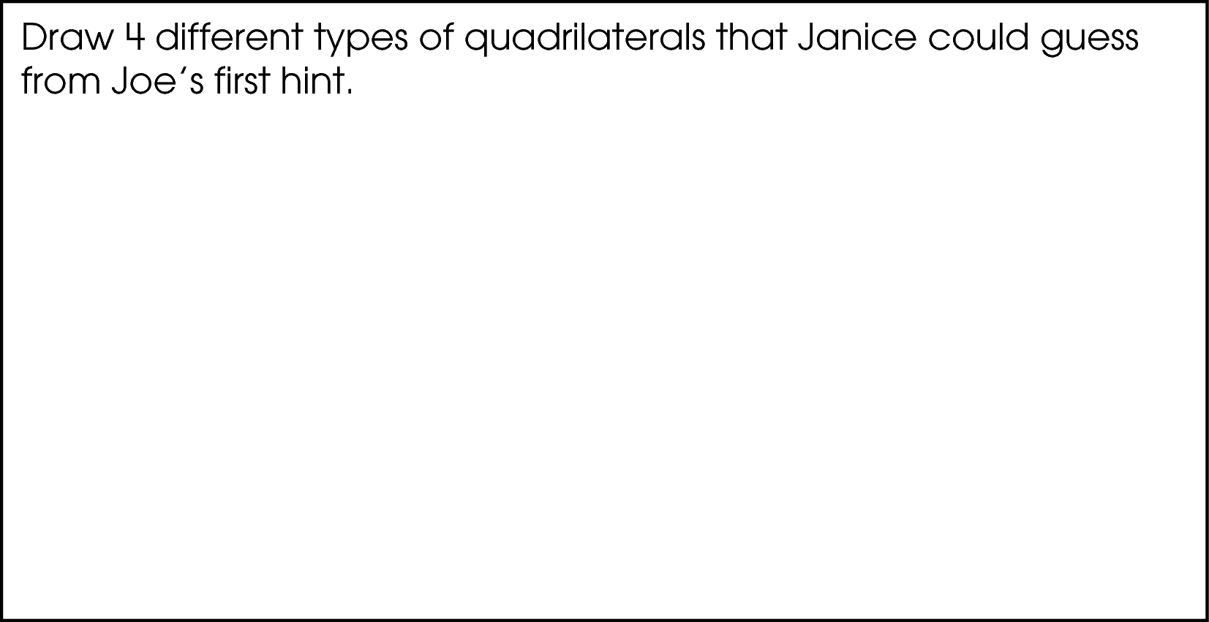
Then, Joe tells Janice that the figure has 4 right angles.
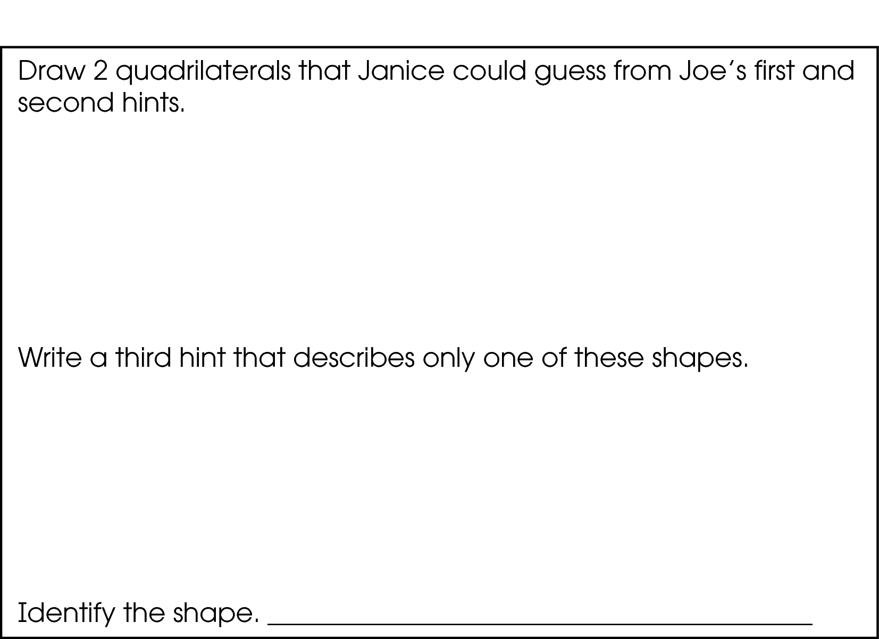

Commentary:
This extended-response question asks students to first draw four different types of quadrilaterals, e.g. square, trapezoid, rectangle, and parallelogram, each having at least one pair of parallel sides. Next students are asked to draw two different quadrilaterals with at least one pair of parallel sides and four right angles, which should be a square and a rectangle. Finally students are asked to write a property that will apply to either the square or the rectangle and then name the shape to which the property applies.
A response earning the maximum number of points (4 points) provides drawings of four quadrilaterals with at least one pair of parallel sides, and two quadrilaterals that have four right angles (a square and a rectangle). The response also provides a description and the name of either a square or a rectangle.

Students need to understand the attributes for all types of quadrilaterals, which are four-sided, two-dimensional figures. For example, some quadrilaterals have parallel sides, or four right angles, or equal sides. Students must be able to select and then draw four of the five quadrilaterals that have at least one pair of parallel sides: 1) trapezoid,
2) parallelogram, 3) rhombus, 4) rectangle and 5) square. They must also know the types of interior angles formed by the types of quadrilaterals so they can choose the square and rectangle as quadrilaterals with 4 right angles. Finally, students must know the attributes that are unique to squares or to rectangles so they can use them to distinguish a square from a rectangle and vice versa.

The complexity level of this question is High Complexity. Students are asked to analyze the similarities and differences between types of quadrilaterals.

Performance Data:
The percent of public school students earning each score point for question 10 on the May 2008 Grade 4 Achievement Test:

Percent at Each Score Point
0 | 1 | 2 | 3 | 4
18% | 26% | 18% | 18% | 20%

Scoring Guidelines:
Exemplar Response:

- 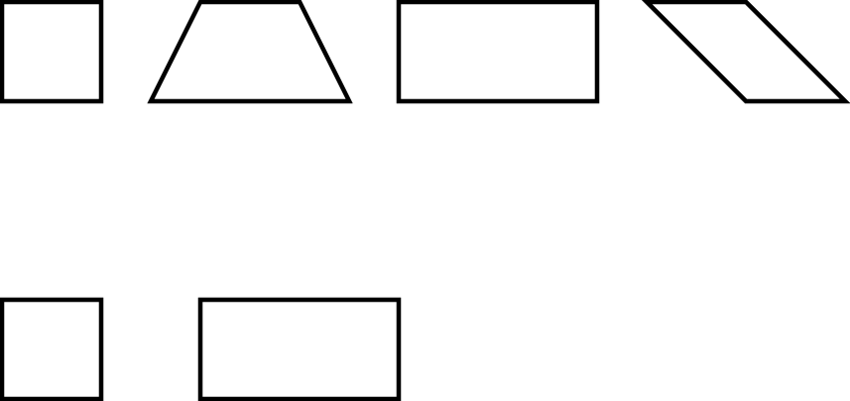
Hint: The figure has 4 equal sides; the figure is a square.
Points | Student Response
4 | The focus of this task is drawing two-dimensional figures using their attributes. The response provides four correct figures with at least one pair of parallel sides AND two correct figures that also have four right angles. The response also provides a description of one of the two shapes with the correct name.
3 | The response provides evidence of drawing two-dimensional figures using their attributes; however, the solution may contain a slight error, a flaw or a vague explanation.  For example, the response may:  - Correctly name all of the figures instead of sketching them and provide a correct third hint that describes only one of the two remaining shapes with the correct name of the shape.  - Correctly sketch all of the figures and provide a correct third hint that describes only one of the two remaining shapes; but sketches the final shape instead of naming it.  - Provide three correct sketches of quadrilaterals, two figures that match both rules, and an appropriate third hint along with the correct name of the shape.
2 | The response provides partial evidence of drawing two-dimensional figures using their attributes; however, the solution is incomplete and/or contains minor flaws.  For example, the response may:  - Provide four sketches of figures but one of them is incorrect; also provide two sketches based on the second hint, but one may be incorrect; the final hint is based on the correctly drawn figure and includes the correct name of the shape.  - Only provide two correct sketches based on the second hint, and an appropriate third hint along with the correct name of the shape.
1 | The response provides minimal evidence of drawing two-dimensional figures using their attributes. The response contains major flaws and errors in reasoning.  For example, the response may:  - Only provide sketches of the first four figures.  - Only provide sketches of the two figures based on the second hint.  - Provide the third hint and sketch the shape.
0 | The response provides inadequate evidence of drawing two-dimensional figures using their attributes. The response provides major flaws in explanations or irrelevant information.  For example, the response may:  - Sketch the incorrect shapes.  - Restate the information provided in the item.  - Be blank or state irrelevant information.

Keywords: geometry, quadrilateral, trapezoid, parallelogram, rhombus, rectangle, square,
attributes

BACK TO INDEX

Benchmark: I | Describe, identify and model reflections, rotations and translations, using physical materials.
GLI: GSS 4.7 | Identify, describe and use reflections (flips), rotations (turns), and translations (slides) in solving geometric problems; e.g., use transformations to determine if 2 shapes are congruent.

Multiple Choice Question:

24. Kevin has the two butterfly stickers shown.
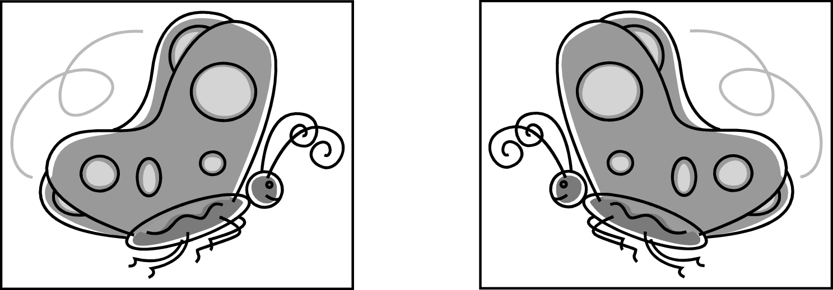
Which transformation could he use to see whether the butterflies are congruent?

- translation (slide)
- rotation (turn) and translation (slide)
- reflection (flip)
- rotation (turn)

Commentary:
This multiple-choice question asks students to select a geometric transformation that could be used to determine if the two butterflies shown are congruent (same size and shape). Students should understand translations (slides), rotations (turns) and reflections (flips) and their uses for determining whether figures are congruent or not. Answer choice C is correct. Since the two butterflies are facing each other, similar to a reflection in a mirror, the transformation that should be used is a reflection. To verify this, students should imagine flipping the left picture on top of the right picture, or vice versa, so that the two butterflies coincide. If the pictures of the butterflies exactly match, then the two figures are congruent.

Answer choice A is incorrect because a translation would slide the left picture on top of the right picture and the butterflies would face different ways and will not match. Answer choice B is incorrect because after rotating (turning) the left picture then translating (sliding) it on top of the right picture, the butterflies would face different ways and will not match. Answer choice D is incorrect because rotating (turning) the left picture to be on top of the right picture would not make the pictures match.

The complexity level of this question is Low Complexity. Students are asked to recognize an example of a concept and perform a specified procedure.

Performance Data:
The percent of public school students selecting answer choice C for question 24 on the May 2008 Grade 4 Achievement Test was 78%.

Keywords: geometry, transformation, reflection

BACK TO INDEX

Benchmark: I | Describe, identify and model reflections, rotations and translations, using physical materials.
GLI: GSS 4.7 | Identify, describe and use reflections (flips), rotations (turns), and translations (slides) in solving geometric problems; e.g., use transformations to determine if 2 shapes are congruent.

Multiple Choice Question:

31. Which pair of figures shows only a translation (slide)?

A.


B.


C.


D.


Commentary:
This multiple-choice question asks students to select the diagram that shows a translation (slide). Students need to understand the differences among these transformations: translations (slides), rotations (turns) and reflections (flips) and identify the type of transformation that has been performed on an object.

Answer choice B is correct. The figure F maintains its vertical position but moved to the right.

Answer choices A and C are incorrect since the figure F turned (rotated) to obtain the final figure.

Choice A is an example of a clockwise rotation:

Choice C is an example of a counterclockwise rotation:

Answer choice D is incorrect since the figure F was flipped (reflected) to obtain the final figure.

The complexity level of this question is Low Complexity. Students are asked to recognize an example of a concept.

Performance Data:
The percent of public school students selecting answer choice B for question 31 on the May 2008 Grade 4 Achievement Test was 85%.

Keywords: geometry, transformation, reflection, rotation, translation

BACK TO INDEX

