Index to Questions

Question Number | Source | BM | GLI | Description
5 | OAT March 05 | H | GSS 3.4 | This short-answer question asks students to draw lines of symmetry for regular polygons.
9 | OAT March 05 | C  K-2 | GSS 1.1a, GSS 1.1b | This multiple-choice question asks students to select a shape with the same characteristics as other shapes.
13 | OAT March 05 | D | GSS 3.2b | This multiple-choice question asks students to identify a right angle.
19 | OAT March 05 | E | GSS 3.1 | This multiple-choice question asks students to identify attributes of a cylinder.
24 | OAT March 05 | E | GSS 3.1 | This multiple-choice question asks students to compare characteristics of a group of triangles.
28 | OAT March 05 | E | GSS 3.1 | This multiple-choice question asks students to recognize a representation of a three-dimensional shape.
40 | OAT March 05 | G | GSS 3.3 | This multiple-choice question asks students to identify the coordinates of an object.
43 | OAT March 05 | E | GSS 3.1 | This multiple-choice question asks students to count the number of faces on a square pyramid.
43 | OAT March 06 | A | GSS 3.1 | This multiple-choice question asks students to identify attributes of two shapes that are alike.
6 | OAT May 07 | D | GSS 3.2b | This multiple-choice question asks students to find the number of right angles in the given shape.
9 | OAT May 07 | A | GSS 3.1 | This multiple-choice question asks students to choose an object based on the given description having only 1 vertex and I flat face.
14 | OAT May 07 | D | GSS 3.2a | This multiple-choice question asks students to identify the angle with the largest measure from the given angles.
45 | OAT May 07 | E | GSS 3.1 | This multiple-choice question asks students to recognize the shape of the given group of objects.
2 | OAT May 08 | H | GSS 3.4 | This multiple-choice question asks students to choose the figure that has more than one line of symmetry.
Question Number | Source | BM | GLI | Description
24 | OAT May 08 | A | GSS 3.1 | This multiple-choice question asks students to compare a square with a triangle to identify lines of symmetry.
27 | OAT May 08 | E | GSS 3.1, GSS 3.5 | This multiple-choice question asks students to identify the three-dimensional object that can be formed by six two-dimensional, congruent squares.
37 | OAT May 08 | A | GSS 3.1 | This multiple-choice question asks students to select the sentence that describes the pyramid.

Benchmark: H | Identify and describe line and rotational symmetry in two-dimensional shapes and designs.
GLI: GSS 3.4 | Draw lines of symmetry to verify symmetrical two-dimensional shapes.

Short Answer Question:
5. | Draw two lines of symmetry for each shape. You may use your ruler.

Commentary:
This short-answer question asks students to draw lines of symmetry for regular polygons. A response earning the maximum number of points (2 points) shows at least two of the four possible lines of symmetry for the square and at least two of the five possible lines of symmetry for the regular pentagon. Including additional lines that are not lines of symmetry reduces the number of points earned.
The level of complexity for this question is Low Complexity. The task requires student to recall a fact (definition of line of symmetry) and then draw a simple geometric figure (the line of symmetry).

Performance Data:
The percent of public school students earning each score point for question 5 on the March 2005 Grade 3 Achievement Test:

Percent at Each Score Point
0 | 1 | 2
8% | 69% | 21%

Scoring Guidelines:
Points | Student Response
2 | The response shows two correct lines of symmetry for each shape with no incorrect lines.  NOTE: The square may have a combination of vertical/horizontal and diagonal lines.  The pentagon should only have lines from a vertex to the midpoint of the opposite side.
1 | The response shows at least one correct shape with or without incorrect line(s).  OR  The response shows two correct lines of symmetry for one figure.
0 | The response indicates no understanding of the concept or task.

Keywords: spatial sense, symmetry

BACK TO INDEX

Benchmark: C | Sort and compare two-dimensional figures and three-dimensional objects according to their characteristics and properties.
GLI:  GSS 1.1a, b | Identify, compare and sort two-dimensional shapes; i.e., square, circle, ellipse, triangle, rectangle, rhombus, trapezoid, parallelogram, pentagon and hexagon. For example:  - Recognize and identify triangles and rhombuses independent of position, shape or size;  - Describe two-dimensional shapes using attributes such as number of sides and number of vertices (corners or angles).

Multiple Choice Question:
9. | Two groups of shapes are shown below.

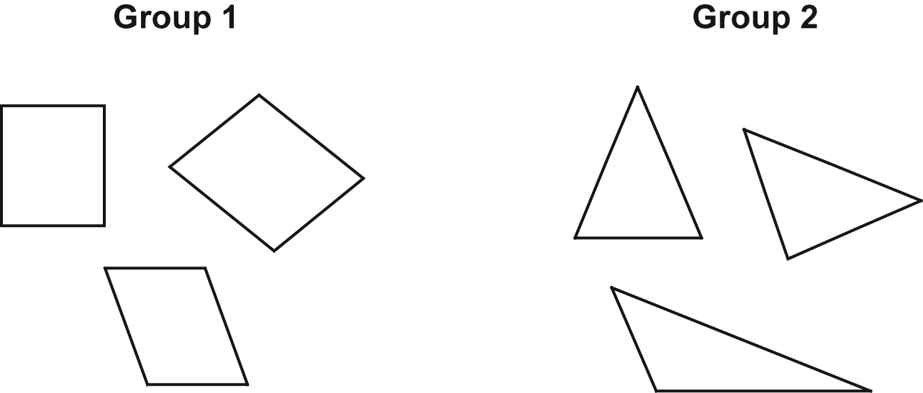
Which shape belongs in Group 2?

A.
B.
C.

Commentary:
This multiple-choice question asks students to select a shape with the same characteristics as other shapes. Students are shown two groups of shapes and asked to select a shape that fits into one of the groups. The correct choice, answer choice A, fits into Group 2 because all the shapes in Group 2 are triangles. Answer choices B and C are incorrect because they have too many sides.

The level of complexity for this question is Moderate Complexity. Students are asked to compare figures.

Performance Data:
The percent of public school students selecting answer choice A for question 9 on the March 2005 Grade 3 Achievement Test was 91%.

Keywords: geometry, comparisons

BACK TO INDEX

Benchmark: D | Identify and draw right, obtuse, acute and straight angles.
GLI: GSS 3.2b | Identify and describe the relative size of angles with respect to right angles as follows:  - Identify, classify and draw right, acute, obtuse and straight angles.

Multiple Choice Question:
13. | Which picture shows a right angle?

A.
B.
C.

Commentary:
This multiple-choice question asks students to identify a right angle. Students are likely to refer to a common referent for a right angle. They may compare the pictures to a corner of a book or a piece of paper, or the corner of a room. Answer choice C appears to be a right angle. Answer choice A appears to be an obtuse angle, and answer choice B is an acute angle.

The level of complexity for this question is Low Complexity. Students recognize and example of a concept (a right angle).

Performance Data:
The percent of public school students selecting answer choice C for question 13 on the March 2005 Grade 3 Achievement Test was 69%.

Keywords: geometry, right angle

BACK TO INDEX

Benchmark: E | Use attributes to describe, classify and sketch plane figures and build solid objects.
GLI: GSS 3.1 | Analyze and describe properties of two-dimensional shapes and three-dimensional objects using terms such as vertex, edge, angle, side and face.

Multiple Choice Question:
19. | John placed this can on a piece of paper. He traced around the bottom of the can.  What shape did he draw?

A. | triangle
B. | rectangle
C. | circle

Commentary:
This multiple-choice question asks students to identify attributes of a cylinder. Students are asked to recognize that the base of a can is a circle. Answer choice C is the correct answer.

The level of complexity of this question is Moderate Complexity. Students are asked to interpret the visual representation of the can.

Performance Data:
The percent of public school students selecting answer choice C for question 19 on the March 2005 Grade 3 Achievement Test was 95%.

Keywords: geometry, attributes

BACK TO INDEX

Benchmark: E | Use attributes to describe, classify and sketch plane figures and build solid objects.
GLI: GSS 3.1 | Analyze and describe properties of two-dimensional shapes and three-dimensional objects using terms such as vertex, edge, angle, side and face.

Multiple Choice Question:
24. | A group of triangles is shown below.  Which is true about all triangles?

A. | All have three angles.
B. | All have four sides.
C. | All are three-dimensional shapes.

Commentary:
This multiple-choice question asks students to compare characteristics of a group of triangles. The correct answer is choice A. All triangles have 3 sides, 3 angles and are two-dimensional shapes.

The level of complexity for this question is Moderate Complexity. This question requires students to compare figures.

Performance Data:
The percent of public school students selecting answer choice A for question 24 on the March 2005 Grade 3 Achievement Test was 85%.

Keywords: geometry, attributes, triangles

BACK TO INDEX

Benchmark: E | Use attributes to describe, classify and sketch plane figures and build solid objects.
GLI: GSS 3.1 | Analyze and describe properties of two-dimensional shapes and three-dimensional objects using terms such as vertex, edge, angle, side and face.

Multiple Choice Question:
28. | Which shape is three-dimensional?

A.
B.
C.

Commentary:
This multiple-choice question asks students to recognize a representation of a three-dimensional shape. Three-dimensional shapes have length, width and depth, so answer choice C is the correct answer. Answer choices A and B have only length and width.

The level of complexity for this question is Low Complexity. This question requires students to recognize an example of a three-dimensional shape.

Performance Data:
The percent of public school students selecting answer choice C for question 28 on the March 2005 Grade 3 Achievement Test was 66%.

Keywords: geometry, three-dimensional

BACK TO INDEX

Benchmark:  G | Find and name locations in coordinate systems.
GLI: GSS 3.3 | Find and name locations on a labeled grid or coordinate system; e.g., a map or graph.

Multiple Choice Question:
40. | What is the location of the star on the grid?
- (3, 1)
- (3, 5)
- (5, 3)

Commentary:
This multiple-choice question asks students to identify the coordinates of an object. To find the coordinates of the star, students should notice that it is lined up with 3 on the horizontal axis (over 3) and 5 on the vertical axis (up 5). So, the correct answer is answer choice B, (3, 5). Answer choices A and C may be the result of forgetting that the horizontal coordinate (over) should always be placed in the first position and the vertical coordinate in the second position.

The level of complexity for this question is Low Complexity. This question requires students to recall how points are plotted.

Performance Data:
The percent of public school students selecting answer choice B for question 40 on the March 2005 Grade 3 Achievement Test was 72%.

Keywords: geometry, coordinates

BACK TO INDEX

Benchmark: E | Use attributes to describe, classify and sketch plane figures and build solid objects.
GLI: GSS 3.1 | Analyze and describe properties of two-dimensional shapes and three-dimensional objects using terms such as vertex, edge, angle, side and face.

Multiple Choice Question:
43. | How many faces does this solid have?  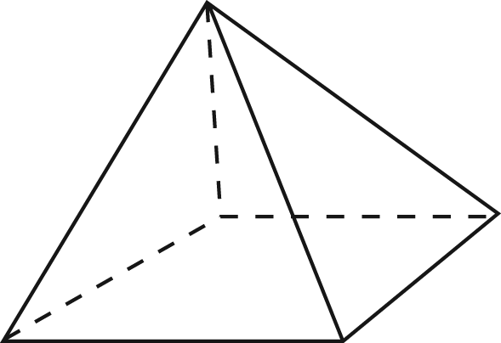

A. | 4
B. | 5
C. | 6

Commentary:
This multiple-choice question asks students to count the number of faces on a square pyramid. The correct answer is choice B. The pyramid has 4 lateral faces (one on the right side, one on the left side, one on the front, and one on the back) and one face that is the base (bottom) of the pyramid. Answer choice A is the result of not counting the base as one of the faces. Answer choice C is the number of faces on other familiar solids, e.g., cubes and rectangular prisms.

The level of complexity for this question is Low Complexity. This question requires students to recall the meaning of a term (face).

Performance Data:
The percent of public school students selecting answer choice B for question 43 on the March 2005 Grade 3 Achievement Test was 64%.

Keywords: geometry, face, spatial sense

BACK TO INDEX

Benchmark: A | Provide rationale for groupings and comparisons of two-dimensional figures and three-dimensional objects.
GLI: GSS 3.1 | Analyze and describe properties of two-dimensional shapes and three-dimensional objects using terms such as vertex, edge, angle, side and face.

Multiple Choice Question:

43. In which way are these two shapes alike?
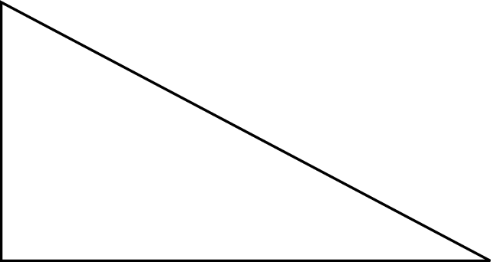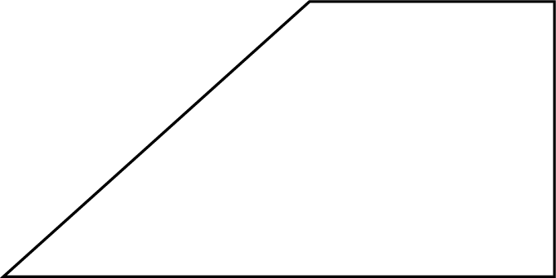

A. Both seem to have at least one right angle.
B. Both have all sides of equal length.
C. Both have four vertices.

Commentary:
This multiple-choice question asks students to identify attributes of two shapes that are alike. The correct answer choice is A. Students should recognize that both shapes appear to have at least one right angle as a common attribute. Answer choice B can be eliminated because neither of the shapes appears to have all equal sides. Answer choice C can be eliminated because only one of the two shapes has four vertices.

The complexity level of this question is Moderate Complexity. The question requires students to interpret visual representations and compare statements.

Performance Data:
The percent of public school students selecting answer choice A for question 43 on the March 2006 Grade 3 Achievement Test was 81%.

Keywords: geometry, attribute

BACK TO INDEX

Benchmark: D | Identify and draw right, obtuse, acute and straight angles.
GLI: GSS 3.2b | Identify and describe the relative size of angles with respect to right angles as follows:  - Identify, classify and draw right, acute, obtuse and straight angles.

Multiple Choice Question:

6. How many right angles are in this shape?
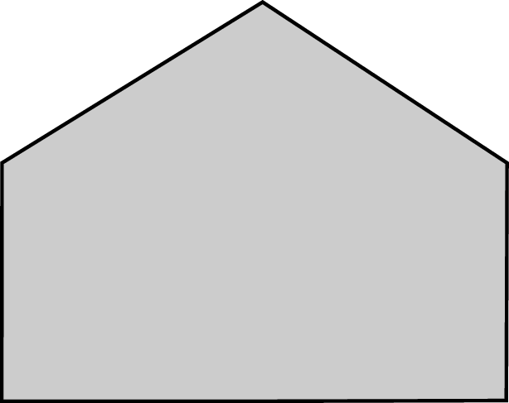
- 1
- 2
- 3

Commentary:
This multiple-choice question asks students to find the number of right angles in the given shape. The correct answer choice is B. Students should recognize that two bottom angles in the shape are similar to those found in a square or in a rectangle, which are shapes that have all right angles.

Students picking answer choices A and C may have miscalculated the number of right angles or may have misinterpreted angles as being right angles.

The complexity level of this question is Low Complexity. This question requires students to recognize an example of a concept.

Performance Data:
The percent of public school students selecting answer choice B for question 6 on the May 2007 Grade 3 Achievement Test was 78%.

Keywords: geometry, angles, right angles

BACK TO INDEX

Benchmark: A | Provide rationale for groupings and comparisons of two-dimensional figures and three-dimensional objects.
GLI: GSS 3.1 | Analyze and describe properties of two-dimensional shapes and three-dimensional objects using terms such as vertex, edge, angle, side and face.

Multiple Choice Question:

9. Parker has the 3 objects shown.
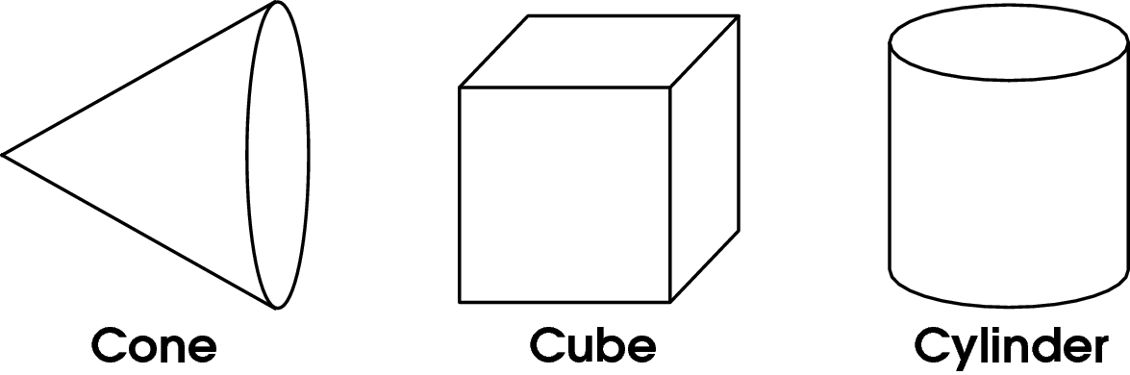
He chooses one object and describes it as having only 1 vertex and only 1 flat face.
Which object did Parker choose?

- cone
- cube
- cylinder

Commentary:
This multiple-choice question asks students to choose an object based on the given description having only 1 vertex and I flat face. The cone, the cube and the cylinder are three dimensional objects. Students should recognize their faces and the vertices.
The vertex of a cone is a pointy part of a cone. The vertex of the cube is a place where three edges meet. The face of the cone, the cylinder or the cube is their flat surface.
The cone has only 1 vertex and only 1 flat face. The cube has 6 flat faces and 8 vertices. The cylinder has 2 flat faces and no vertices. So, the correct answer choice is A.

The complexity level of this question is Low Complexity. This question requires students to recognize an example of a concept.

Performance Data:
The percent of public school students selecting answer choice A for question 9 on the May 2007 Grade 3 Achievement Test was 89%.

Keywords: geometry, cube, cone, cylinder, vertex, face

BACK TO INDEX

Benchmark: D | Identify and draw right, obtuse, acute and straight angles.
GLI: GSS 3.2a | Identify and describe the relative size of angles with respect to right angles as follows:  - Use physical models, like straws, to make different sized angles by opening and closing the sides, not by changing the side lengths.

Multiple Choice Question:

14. Amy, Mia and Sam made angles with two pencils.
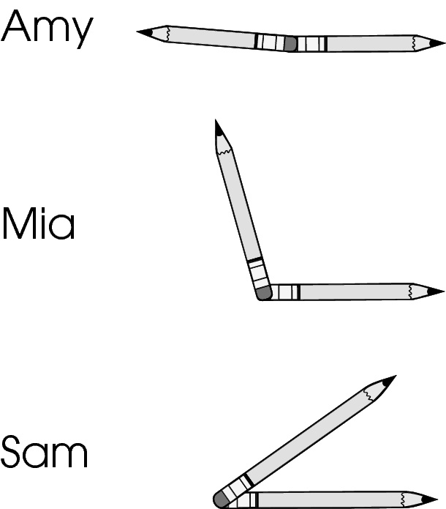
Who made the angle with the largest measure?

- Amy
- Mia
- Sam

Commentary:
This multiple-choice question asks students to identify the angle with the largest measure from the given angles. The measure of an angle depends on the amount of opening from one side to the other side. The angle with the largest measure is the angle with the largest amount of rotation from one side to the other side. Students may use a right angle as a referent to compare the sizes of the angles. Answer choice A is the correct because it is significantly larger than a right angle.

Answer choice B is incorrect because it is slightly larger than a right angle. Answer choice C is also incorrect because it is smaller than a right angle.

The complexity level of this question is Low Complexity. This question requires students to recognize an example of a concept.

Performance Data:
The percent of public school students selecting answer choice A for question 14 on the May 2007 Grade 3 Achievement Test was 69%.

Keywords: geometry, right angle, measure

BACK TO INDEX

Benchmark: E | Use attributes to describe, classify and sketch plane figures and build solid objects.
GLI: GSS 3.1 | Analyze and describe properties of two-dimensional shapes and three-dimensional objects using terms such as vertex, edge, angle, side and face.

Multiple Choice Question:

45. What is the shape of these objects?
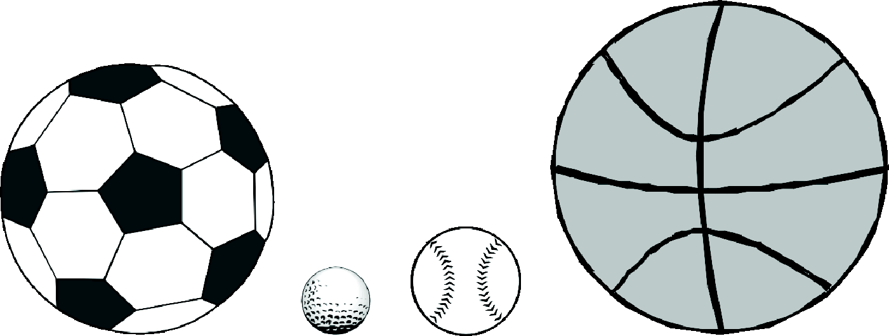

- cone
- cylinder
- sphere

Commentary:
This multiple-choice question asks students to recognize the shape of the given group of objects. Answer choice C is the correct answer. Spheres are three-dimensional objects, commonly described as balls, where each point of their surface is equidistant from their center.

Students choosing answer choice A may have confused a cone with a sphere, but cones have one flat face and one vertex (a pointy part). Spheres do not have any flat faces or vertices. Students, choosing answer choice B, may have confused a cylinder with a sphere, but cylinders have two flat faces and spheres do not have any flat faces.

The complexity level of this question is Low Complexity. This question requires students to recognize an example of a concept.

Performance Data:
The percent of public school students selecting answer choice C for question 45 on the May 2007 Grade 3 Achievement Test was 88%.

Keywords: geometry, sphere, cylinder, cone

BACK TO INDEX

Benchmark: H | Identify and describe line and rotational symmetry in two-dimensional shapes and designs.
GLI: GSS 3.4 | Draw lines of symmetry to verify symmetrical two-dimensional shapes.

Multiple Choice Question:

2. Which figure below has more than one line of symmetry?

A.
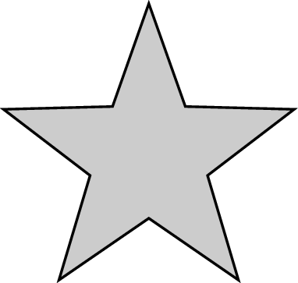

B.
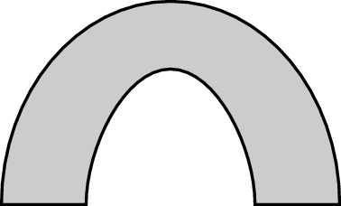

C.
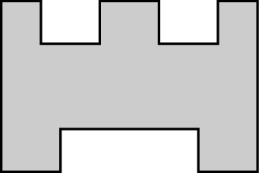

Commentary:
This multiple-choice question asks students to choose the figure that has more than one line of symmetry. Students should know that a line of symmetry divides two-dimensional shapes into two congruent halves that have the same size and shape when the shape is folded along this line. The correct answer is choice A since the star can be divided into congruent halves by five different lines of symmetry.

Choices B and C are incorrect because they have only one line of symmetry.

The complexity level of this question is Moderate Complexity. This question asks students to compare figures.

Performance Data:
The percent of public school students selecting answer choice A for question 2 on the May 2008 Grade 3 Achievement Test was 63%.

Keywords: geometry, line of symmetry, congruent

BACK TO INDEX

Benchmark: A | Provide rationale for groupings and comparisons of two-dimensional figures and three-dimensional objects.
GLI: GSS 3.1 | Analyze and describe properties of two-dimensional shapes and three-dimensional objects using terms such as vertex, edge, angle, side and face.

Multiple Choice Question:

24. Two shapes are shown.
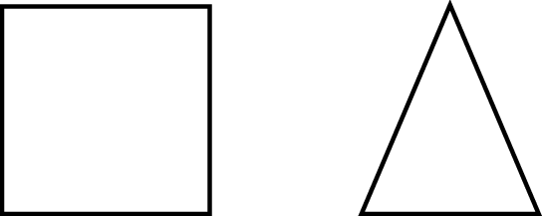
What is the same about both of these shapes?

- Both shapes have exactly two lines of symmetry.
- Both shapes have at least one line of symmetry.
- Neither shape has any lines of symmetry.

Commentary:
This multiple-choice question asks students to compare a square with a triangle to identify lines of symmetry. Students must know that a line of symmetry divides a shape into two congruent halves that have the same size and shape. They also need to relate symmetry to folding models of these shapes into two congruent halves. Students should know that a fold line represents a line of symmetry. The dashed lines below show the lines of symmetry for the square and triangle.

Answer choice B is correct since both the square and triangle have at least one line of symmetry.

Answer choice A is incorrect since the square has four lines of symmetry and the triangle only has one. Answer choice C is incorrect because both figures have at least one line of symmetry.

The complexity level of this question is Moderate Complexity. Students are required to compare a square with a triangle to identify lines of symmetry.

Performance Data:
The percent of public school students selecting answer choice B for question 24 on the May 2008 Grade 3 Achievement Test was 81%.

Keywords: geometry, square, triangle, line of symmetry

BACK TO INDEX

Benchmark: E | Use attributes to describe, classify and sketch plane figures and build solid objects.
GLI: GSS 3.1 | Analyze and describe properties of two-dimensional shapes and three-dimensional objects using terms such as vertex, edge, angle, side and face.
GLI: GSS 3.5 | Build a three-dimensional model of an object composed of cubes; e.g., construct a model based on an illustration or actual object.

Multiple Choice Question:

27. The six faces of a three-dimensional figure are shown.
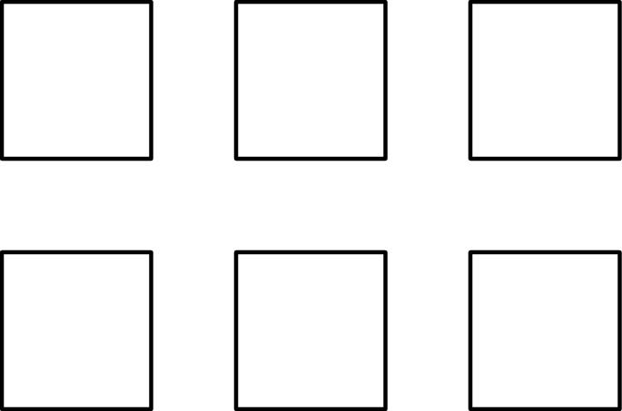
Which figure could these faces form?

A.
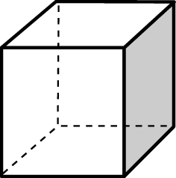

B.
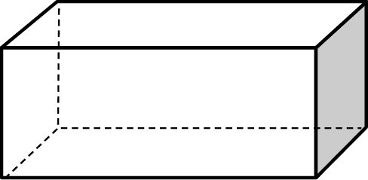

C.
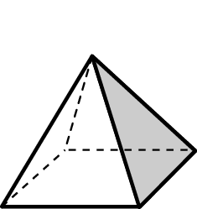

Commentary:
This multiple-choice question asks students to identify the three-dimensional object that can be formed by six two-dimensional, congruent squares. Students need to remember the properties of a cube, rectangular prism and rectangular pyramid. Answer choice A is correct since it shows a cube with six congruent square faces.

Answer choice B is incorrect since only two faces of this rectangular prism are congruent squares and the other four faces are rectangles that connect to them. Answer choice C is also incorrect because only the base of this pyramid is a square and four triangular faces connect to it.

The complexity level of this question is Moderate Complexity. Students are required to compare two-dimensional figures with three-dimensional objects.

Performance Data:
The percent of public school students selecting answer choice A for question 27 on the May 2008 Grade 3 Achievement Test was 86%.

Keywords: geometry, square, cube

BACK TO INDEX

Benchmark: A | Provide rationale for groupings and comparisons of two-dimensional figures and three-dimensional objects.
GLI: GSS 3.1 | Analyze and describe properties of two-dimensional shapes and three-dimensional objects using terms such as vertex, edge, angle, side and face.

Multiple Choice Question:

37. A pyramid is shown.
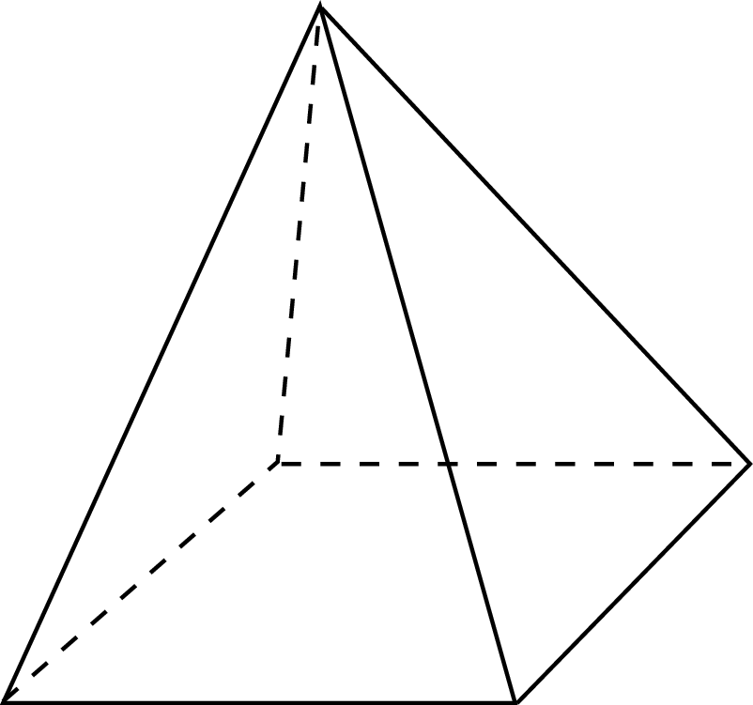
Which sentence describes this pyramid?

- The pyramid has 4 faces and 4 edges.
- The pyramid has 4 faces and 8 edges.
- The pyramid has 5 faces and 8 edges.

Commentary:
This multiple-choice question asks students to select the sentence that describes the pyramid. Students need to recall the attributes of a pyramid. Students also need to know that a face is a flat surface on a three-dimensional object and that edges are line segments where two faces meet. This pyramid has 4 triangular faces connected to 1 square face for a total of 5 faces. It also has 4 edges joining all triangular faces and 4 edges joining the triangular faces to the square face, which makes a total of 8 edges. All of these attributes make answer choice C correct.

Answer choice A is incorrect since the 1 square face with its 4 edges is not considered. Answer choice B is incorrect because the 1 square face (not its edges) is ignored.

The complexity level of this question is Low Complexity. Students are asked to recognize examples of concepts.

Performance Data:
The percent of public school students selecting answer choice C for question 37 on the May 2008 Grade 3 Achievement Test was 62%.

Keywords: geometry, pyramid, face, edge

BACK TO INDEX

