Index to Questions

Question Number | Source | BM | GLI | Description
3 | OAT March 05 | A | DAP 8.1 | This multiple-choice question asks students to read a graph to answer a question related to the graph.
7 | OAT March 05 | H | DAP 8.10 | This multiple-choice question asks students to determine the number of permutations of five colored hats.
13 | OAT March 05 | F | DAP 8.9 | This multiple-choice question asks students to analyze  information presented in the circle graphs.
26 | OAT March 05 | A, F | DAP 8.1, DAP 8.6, DAP 8.9 | This extended-response question asks students to create a scatter plot from a table, identify the relationship between the square feet and the cost of the houses, and make a prediction based on the data.
32 | OAT March 05 | J | DAP 8.11 | This multiple-choice question asks students to determine the probability of a compound event.
34 | OAT March 05 | A, D | DAP 8.1, DAP 8.4 | This multiple-choice question asks students to find the difference in the medians.
41 | OAT March 05 | D | DAP 8.4 | This multiple-choice question asks students to compare measures of center and spread for two sets of data.
16 | OAT March 06 | E | DAP 8.8 | This short-answer question asks students to provide an explanation to the appropriateness of the sampling technique described in the question.
19 | OAT March 06 | F | DAP 8.6 | This multiple-choice question asks students to identify a true statement that can be supported by the data in the graph.
30 | OAT March 06 | C | DAP 8.5 | This multiple-choice question asks students to determine which measure if affected most by the addition of the fifth temperature.
35 | OAT March 06 | I (5-7) | DAP 5.8 | This multiple-choice question asks students to identify the change in probability of obtaining an even number after a number on a spinner is replaced.
4 | OAT May 07 | A | DAP 7.1, DAP 8.1 | This multiple-choice question asks students to identify the box-and-whisker plot that contains 75% of the data at or below 200.
14 | OAT May 07 | B | DAP 8.2 | This multiple-choice question asks students to determine the appropriate representation of the given data to make the most convincing argument that sales improved each week
Question Number | Source | BM | GLI | Description
34 | OAT May 07 | D | DAP 8.4 | This multiple-choice question asks students to use the data in the box-and-whisker plots to determine which statement provided is true.
6 | OAT May 08 | A, F | DAP 8.1, DAP 8.6 | This short-answer question asks students to analyze the data in a scatter plot and make a prediction based on the analysis.
20 | OAT May 08 | K | DAP 5.10 | This multiple-choice question asks students to compare the differences between actual results and expected results (predictions based on calculated probability) from an experiment.
25 | OAT May 08 | F (5-7) | DAP 7.3 | This multiple-choice question asks students to interpret how the mean and median will change when an extreme value ($ 88) is removed from the set of data.
38 | OAT May 08 | J | DAP 8.10 | This multiple-choice question asks students to determine the number of possible ways the number on the red cube will be exactly 2 greater than the number on the green cube.

BACK TO INDEX

Benchmark: A | Create, interpret and use graphical displays and statistical measures to describe data; e.g., box-and-whisker plots, histograms, scatterplots, measures of center and variability.
GLI: DAP 8.1 | Use, create and interpret scatterplots and other types of graphs as appropriate.

Multiple Choice Question:

3. The graph shows the number of VCRs and DVD players shipped to distributors in North America from 1997 to 2002.

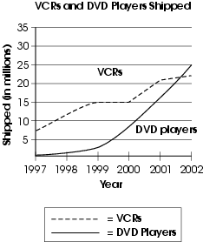

In what year did the number of DVD players shipped first exceed 10 million?

A. 1997
B. 1999
C. 2000
D. 2002

Commentary:
This multiple-choice question asks students to read a graph to answer a question related to the graph. Students read the graph to determine when the number of DVD players shipped first exceeds 10 million. The correct answer choice is C, the year 2000 is the first time DVD sales reached 10 million.

The complexity of this question is Low Complexity. The students are required to retrieve information from a graph to answer a question.

Performance Data:
The percent of public school students selecting answer choice C for question 3 on the March 2005 Grade 8 Achievement Test was 81%.

Keywords: data analysis, graph

BACK TO INDEX

Benchmark: H | Use counting techniques, such as permutations and combinations, to determine the total number of options and possible outcomes.
GLI: DAP 8.10 | Calculate the number of possible outcomes for a situation, recognizing and accounting for when items may occur more than once or when order is important.

Multiple Choice Question:

7. Sarah has five hats of different colors: red, blue, green, yellow, and orange.
How many different ways can Sarah arrange these hats next to each other on a shelf?
A. | 5
B. | 10
C. | 25
D. | 120

Commentary:
This multiple-choice question asks students to determine the number of permutations of five colored hats. Students may use a variety of strategies, including tree diagrams or the counting principle to determine the number of arrangements. There are 5 positions for the first color, 4 positions for the next color, 3 positions, 2 positions and 1 position for the final color, therefore 5 x 4 x 3 x 2 x1 = 120 different possibilities. So answer choice D is correct. Answer choice A represents the five positions or colors. Answer choice B is the result of adding the five colors to the five positions. Answer choice C is the result of multiplying the colors and the positions.

The level of complexity for this question is Moderate Complexity. The task requires students to use a strategy for determining the number of possible arrangements for the five hats.

Performance Data:
The percent of public school students selecting answer choice D for question 7 on the March 2005 Grade 8 Achievement Test was 30%.

Keywords: probability, permutation

BACK TO INDEX

Benchmark: F | Construct convincing arguments based on analysis of data and interpretation of graphs.
GLI: DAP 8.9 | Construct convincing arguments based on analysis of data and interpretation of graphs.

Multiple Choice Question:

13. The Hernandez family has a monthly income of $4,500. The Thomas family has a monthly income of $3,200. The two circle graphs show the monthly budgets of two families.

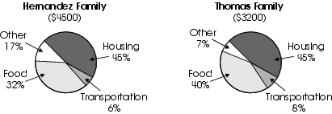

Which statement is supported by the data in the two graphs?
A. The Thomas family spends more dollars each month on transportation than the Hernandez family does.
B. The Hernandez family spends more dollars each month on food than the Thomas family does.
C. Both families spend more dollars on “other” than on transportation.
D. Both families spend the same amount of dollars each month on housing.

Commentary:
This multiple-choice question asks students to analyze information presented in the circle graphs. Students need to calculate the dollar amount spent for each category and use those values to make comparisons. The Hernandez family spends 32% of $4500 on food which is $1440, while the Thomas family spends 40% of 3200 on food or $1280. Therefore the statement “The Hernandez family spends more dollars each month on food than the Thomas family does” (Answer Choice B) is supported by the information in the graphs. The other answer choices are not supported by the information in the graphs.

The level of complexity for this question is Moderate Complexity. The task requires students to interpret a visual representation to solve a problem.

Performance Data:
The percent of public school students selecting answer choice B for question 13 on the March 2005 Grade 8 Achievement Test was 22%.

Keywords: data analysis, circle graphs, percents

BACK TO INDEX

Benchmark: A | Create, interpret and use graphical displays and statistical measures to describe data; e.g., box-and-whisker plots, histograms, scatter plots, measures of center and variability.
Benchmark: F | Construct convincing arguments based on analysis of data and interpretation of graphs.
GLI: DAP 8.1, DAP 8.6, DAP 8.9 | DAP 8.1: Use, create and interpret scatterplots and other types of graphs as appropriate.  DAP 8.6: Make conjectures about possible relationship in a scatterplot and approximate line of best fit.  DAP 8.9: Construct convincing arguments based on analysis of data and interpretation of graphs.

Extended Response Question:

26. There are 8 homes for sale near Bell Middle School. The chart below shows the square footage and cost of each house.
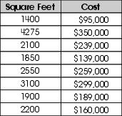
In your Answer Document , create a scatter plot that represents the data in the chart. Be sure to label your axes and create appropriate scales.
Use the scatter plot to explain the relationship that exists between the number of square feet and the cost of the 8 houses.
Use the data to predict the approximate cost of a house that has 6,000 square feet. Use mathematics to explain or support your prediction.

Commentary:
This extended-response question asks students to create a scatter plot from a table, identify the relationship between the square feet and the cost of the houses, and make a prediction based on the data. In the first task, students are asked to create a scatter plot. The graph should be labeled, the scale should be appropriate for the values given in the table, and the points should be plotted as discrete data points and not connected. The second task asks students to identify that as the number of square feet increases the cost of the house increases. In the final task students are to predict the cost of a 6,000 square foot house. This can be accomplished with several different methods, such as using a line of best fit or finding means. An answer within the range of $400,000 to $600,000 with supporting work or explanation was given credit for this part of the question.

The complexity of this question is High Complexity. The tasks require students to perform procedures having multiple steps, multiple decision points, and to generalize a pattern.

Performance Data:
The percent of public school students earning each score point for question 26 on the March 2005 Grade 8 Achievement Test:

Percent at Each Score Point
0 | 1 | 2 | 3 | 4
% | % | % | % | %

Scoring Guidelines:

4 point

Sample Correct Responses:

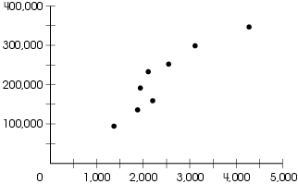

The bigger houses have higher prices. A 6,000-square-foot house would cost approximately $480,000.
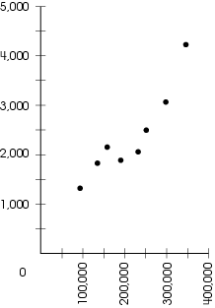

A bigger house would have a higher price. A 6,000-square-foot house would cost approximately $600,000.

The focus of this task is to construct a scatter plot and make conjectures about possible relationships in a scatter plot. The response correctly describes the increase in prices resulting from the increase in home size, as shown by the points on the graph. The response also predicts that a 6,000-square-foot house would cost between $400,000 and $600,000, and provides appropriate support.

3 point
The response provides evidence of constructing a scatter plot and making conjectures about possible relationships in a scatter plot; however, the solution may be incomplete or slightly flawed.

For example, the response may:
Include all three components (graph, description of the relationship between house size and cost, accurate prediction of larger house price with adequate support) but has one or two minor errors; e.g., lack of appropriate scale, omits graphing one or two points.

2 point
The response provides partial evidence of constructing a scatter plot and making conjectures about possible relationships in a scatter plot; however, the solution is incomplete and/or contains flaws.

For example, the response may:
Include only two of the three required components (graph, description of the relationship between house size and cost, accurate prediction of house price with adequate support).

1 point
The response provides minimal evidence of constructing a scatter plot and making conjectures about possible relationships in a scatter plot. The response has major flaws and errors in reasoning.

For example, the response may:
- Fail to provide a graph, or show an inaccurate graph, but give an accurate price prediction with adequate support.
- Show a graph that is somewhat accurate, but an explanation of the relationship between home size and cost and a predicted price are missing or inaccurate.

0 point
The response provides inadequate evidence of constructing a scatter plot and making conjectures about possible relationships in a scatter plot.

For example, the response may:
- Include no attempt to create a graph or create an inaccurate graph with no explanation or prediction.
- Offer explanations or predictions that are wholly inaccurate.
- Be blank or state unrelated statements.

Keywords: data analysis, scatter plots, prediction

BACK TO INDEX

Benchmark: J | Compute probabilities of compound events, independent events, and simple dependent events.
GLI: DAP 8.11 | Demonstrate an understanding that the probability of either of two disjoint events occurring can be found by adding the probabilities for each and that the probability of one independent event following another can be found by multiplying the probabilities.

Multiple Choice Question:

32. A bag contains 4 sour-apple candies and 3 watermelon candies. One piece of candy is chosen at random and returned to the bag. Then a second piece of candy is chosen at random.

What is the probability that both pieces of candy chosen will be sour-apple?

- $$\frac{1}{\text{16}}$$
- $$\frac{\text{12}}{\text{49}}$$
- $$\frac{\text{16}}{\text{49}}$$
- $\frac{8}{7}$

Commentary:
This multiple-choice question asks students to determine the probability of a compound event. Students need to determine the likelihood of choosing a sour-apple candy twice after returning the first selection. The probability of selecting one sour-apple candy is $\frac{4}{7}$. Because the candy is replaced, the probability of selecting the second sour-apple candy is also $\frac{4}{7}$ . So, the probability of selecting two sour-apple candies is $\frac{4}{7}$ x $\frac{4}{7}$ = $\frac{\text{16}}{\text{49}}$ (answer choice C). Answer choices A, B and D are the results of miscalculations and/or a misunderstanding of the situation.

The level of complexity for this question is Moderate Complexity. The task requires the students to solve a word problem that requires multiple steps.

Performance Data:
The percent of public school students selecting answer choice C for question 32 on the March 2005 Grade 8 Achievement Test was 31%.

Keywords: probability, compound events

BACK TO INDEX

Benchmark: A | Create, interpret and use graphical displays and statistical measures to describe data; e.g., box-and-whisker plots, histograms, scatterplots, measures of center and variability.
GLI: DAP 8.1 | Use, create and interpret scatterplots and other types of graphs as appropriate.

Benchmark: D | Find, use and interpret measures of center and spread, such as mean and quartiles, and use those measures to compare and draw conclusions about sets of data.
GLI: DAP 8.4 | Compare two sets of data using measures of center (mean, mode, median) and measures of spread (range, quartiles, interquartile range, percentiles).

Multiple Choice Question:

34. The box-and-whisker plots show the distribution of weight among dogs in two different pet stores.

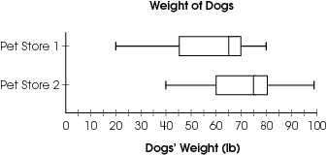

How much greater is the median weight of the dogs in Pet Store 2 than in Pet Store 1?

A. 5
B. 10
C. 15
D. 20

Commentary:
This multiple-choice question asks students to find the difference in the medians. Students need to read the box-and-whisker plots, identifying the median for each pet store. The median for Pet Store 1 is 65 and the median for Pet Store 2 is 75. The difference is 10, answer choice B. Answer choices A, C and D are the results of misreading or incorrectly interpreting the box-and-whisker plots.

The level of complexity for this question is Moderate Complexity. The task requires students to retrieve information from a graph and use it to solve a problem.

Performance Data:
The percent of public school students selecting answer choice B for question 34 on the March 2005 Grade 8 Achievement Test was 58%.

Keywords: data analysis, box-and-whisker plots, median

BACK TO INDEX

Benchmark: D | Find, use and interpret measures of center and spread, such as mean and quartiles, and use those measures to compare and draw conclusions about sets of data.
GLI: DAP 8.4 | Compare two sets of data using measures of center (mean, mode, median) and measures of spread (range, quartiles, interquartile range, percentiles).

Multiple Choice Question:

41. The data show the ages of 2 groups of grandparents.

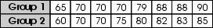

Which statistic has a greater value for Group 1 than Group 2?

A. the mean
B. the median
C. the mode
D. the range

Commentary:
This multiple-choice question asks students to compare measures of center and spread for two sets of data. Students need to find and compare the mean, median, mode and range for both sets of data and determine which measure will have a greater value for Group1.
 | Mean | Median | Mode | Range
Group 1 | 77.5 | 74.5 | 70 | 25
Group 2 | 75.625 | 78.5 | 70 | 25

The mean has a greater value for Group 1, answer choice A. Answer choice B is not correct because the median is greater for Group 2, and answer choices C and D are not correct because the mode and the range are equal for both groups.

The level of complexity for this question is Moderate Complexity. The task requires students to compare the values determined for the mean, median, mode and range.

Performance Data:
The percent of public school students selecting answer choice A for question 41 on the March 2005 Grade 8 Achievement Test was 44%.

Keywords: data analysis, measures of center, measures of spread

BACK TO INDEX

Benchmark: E | Evaluate the validity of claims and predictions that are based on data by examining the appropriateness of the data collection and analysis.
GLI: DAP 8.8 | Describe how the relative size of a sample compared to the target population affects the validity of predictions.

Mathematical Processes
Benchmark: G | Write clearly and coherently about mathematical thinking and ideas.

Short Answer Question:

16. There are 1000 students in grades 6, 7 and 8 at the Oak Lake Middle School. To determine which after-school activities are preferred by the students at the school, the student council decided to survey 20 eighth graders in a first period French class.
In your Answer Document, explain whether or not this is an appropriate sampling technique.

Commentary:
This short-answer question asks students to provide an explanation to the appropriateness of the sampling technique described in the question. Student need to have an understanding of why a sample represents or cannot represent the larger population. A response earning the maximum number of points (2 points) provides a rationale for why the sample of only surveying 20 eighth grade students in the first period French class is not a good representation of the
100 students in grades 6, 7 and 8.

The complexity level of this question is Moderate Complexity. This task asks students to interpret a simple argument.

Performance Data:
The percent of public school students earning each score point for question 16 on the March 2006 Grade 8 Achievement Test:
Percent at Each Score Point
0 | 1 | 2
24% | 17% | 56%

Scoring Guidelines:
Sample Correct Response(s):
- Selecting only 8th graders in a French class does not represent the student population.
- A sample of students in grades 6 and 7 also needs to be surveyed.
- Most students do not take French so you need to ask some students taking other classes.
Points | Student Response
2 | The focus of this task is to correctly apply representative sampling methods. A correct response will indicate that a random sampling of all students was not used in the survey.
1 | The response provides partial evidence of applying representative sampling methods; however, the explanation may be incomplete or slightly flawed.  For example, the response may:  - State that the sample was not appropriate because it should have asked 6th graders.  - State that 20 students is too small.
0 | The response provides inadequate evidence of an understanding of sample sizes and sampling methods. The response has major flaws or irrelevant information.  For example, the response may:  - State that this is an appropriate sampling method.  - Restate the information provided in the item.  - Be blank or provide irrelevant information.

Keywords: data analysis, random sample, survey

BACK TO INDEX

Benchmark: F | Construct convincing arguments based on analysis of data and interpretation of graphs.
GLI: DAP 8.6 | Make conjectures about possible relationship in a scatterplot and approximate line of best fit.

Multiple Choice Question:

19. The scatter plot and a line of best fit show the relationship between the capacity and the cost of eight refrigerators available at a local appliance store.
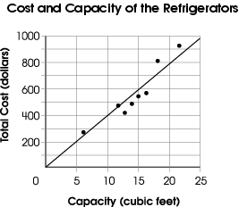
Which statement describes the relationship between the cost and the capacity of the refrigerators?
A. Refrigerators cost about $700.
B. Refrigerators cost about $40 per cubic foot.
C. Refrigerators cost less as their capacity increases.
D. Refrigerators that cost more than $800 have the smallest capacity.

Commentary:
This multiple-choice question asks students to identify a true statement that can be supported by the data in the graph. The line of best fit represents the relationship between the cost and the capacity. The cost increases about $40 for each cubic foot. This can be seen by examining several points to determine the relationship, ($\frac{\text{400}}{\text{10}} =\text{40}, \frac{\text{600}}{\text{15}} = \text{40}$).Choice B is the correct answer. Answer choice A does not describe the relationship between cost and capacity. Answer choices C and D describe an incorrect relationship and is not supported by the data.

The complexity level of this question is Moderate Complexity. The question asks student to interpret a visual representation and compare statements based on the interpretation.

Performance Data:
The percent of public school students selecting answer choice B for question 19 on the March 2006 Grade 8 Achievement Test was 70%.

Keywords: data analysis, scatterplot, line of best fit

BACK TO INDEX

Benchmark: C | Compare the characteristics of the mean, median and mode for a given set of data, and explain which measure of center best represents the data.
GLI: DAP 8.5 | Explain the mean's sensitivity to extremes and its use in comparison with the median and mode.

Multiple Choice Question:

30. The temperature of a community pool was measured each morning. The daily readings were 82°F, 79°F, 80°F, and 78°F. The temperature on the fifth day was 99°F.
Which statistic was affected the most by the 5th day’s temperature?
A. the lower quartile
B. the mean of the temperatures
C. the mode of the temperatures
D. the median of the temperatures

Commentary:
This multiple-choice question asks students to determine which measure if affected most by the addition of the fifth temperature. One method that can be used is to find each of the measures for the first four temperatures. Then find the measures again with the addition of the fifth temperature and identify the measure that was affect the most, has the greatest change.
Measures | First four temperatures | All five temperatures | Change in the measure
Lower quartile | 78.5° | 78.5° | No change
Mean | 79.75° | 83.6° | Change of 3.85°
Mode | No Mode | No mode | No change
Median | 79.5° | 80° | Change of 0.5°

The change of the mean was the greatest of the 4 measures identified. The other measures, lower quartile, mode and median, answer choices A, C and D do not change as much as the mean.

The complexity level of this question is Moderate Complexity. The question requires students to compare statements for a problem situation.

Performance Data:
The percent of public school students selecting answer choice B for question 30 on the March 2006 Grade 8 Achievement Test was 59%.

Keywords: data analysis, measures of center

BACK TO INDEX

Benchmark: I (5-7) | Describe the probability of an event using ratios, including fractional notation.
GLI: DAP 5.8 | Identify the probability of events within a simple experiment, such as three chances out of eight.

Multiple Choice Question:

35. The 2 on the spinner shown will be replaced with a 7.
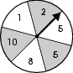
How does the probability of the spinner landing on an even number change?

A. It increases by$\frac{1}{6}$.
B. It decreases by$\frac{1}{6}$.
C. It increases by$\frac{1}{3}$.
D. It decreases by$\frac{1}{6}$.

Commentary:
This multiple-choice question asks students to identify the change in probability of obtaining an even number after a number on a spinner is replaced. The probability of spinning an even number on the current spinner is $\frac{1}{2}$or $\frac{3}{6}$. The probability with one fewer even number on the spinner would be $\frac{1}{3}$ or$\frac{2}{6}$. This is a decrease of$\frac{1}{6}$, answer choice B. Answer choices A and C state that there is an increase in the probability which is not supported by the information in the problem. Answer choice D identifies that it is decreasing; however, it also identifies the probability of obtaining an even number rather than the difference in the probabilities.

The complexity level of this question is Moderate Complexity. The question requires student to solve a problem requiring multiple step.

Performance Data:
The percent of public school students selecting answer choice B for question 35 on the March 2006 Grade 8 Achievement Test was 52%.

Keywords: data analysis, probability, spinner

BACK TO INDEX

Benchmark: A | Create, interpret and use graphical displays and statistical measures to describe data; e.g., box-and-whisker plots, histograms, scatterplots, measures of center and variability.
GLI: DAP 7.1, DAP 8.1 | DAP 7.1: Read, create and interpret box-and-whisker plots, stem-and-leaf plots, and other types of graphs, when appropriate.  DAP 8.1: Use, create and interpret scatterplots and other types of graphs as appropriate.

Multiple Choice Question:

4. Which box-and-whisker plot represents a situation where 75% of the data is 200 or less?

A. 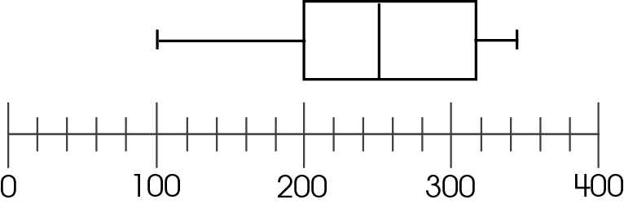

B. 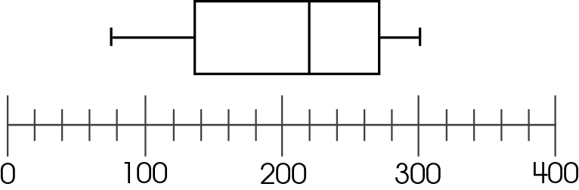

C. 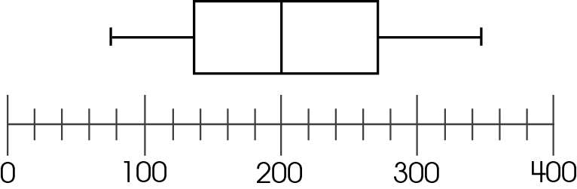

D. 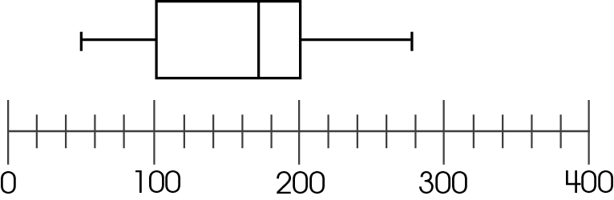

Commentary:
This multiple-choice question asks students to identify the box-and-whisker plot that contains 75% of the data at or below 200. Students must be able to read box-and-whisker plots and know what each of the key components of the graph represents. The key components of a box-and-whisker plot are maximum, minimum, median, first quartile, third quartile, range and interquartile range of a data set.

Maximum
Minimum
Median
First Quartile
Third Quartile
Range
Interquartile Range

Students must know that the third quartile represents the value where 75% of the data are below 200 and 25% of the data are above it. In this problem, answer choice D has a third quartile value of 200 and therefore 75% of the data are at 200 or below.
Students who selected answer choice A may have selected the graph where 75% of the data are above 200. Answer choice C, has a median of 200, which indicates the data are split 50% above and below this value. Answer choices B and C have a third quartile of approximately 275.

The complexity level of this question is Low Complexity. This task requires students to retrieve information from a graph.

Performance Data:
The percent of public school students selecting answer choice D for question 4 on the May 2007 Grade 8 Achievement Test was 69%.

Keywords: data analysis, box-and-whisker plot, graph, quartile

BACK TO INDEX

Benchmark: B | Evaluate different graphical representations of the same data to determine which is the most appropriate representation for an identified purpose.
GLI: DAP 8.2 | Evaluate different graphical representations of the same data to determine which is the most appropriate representation for an identified purpose; e.g., line graph for change over time, circle graph for part-to-whole comparison, scatterplot for relationship between two variants.

Multiple Choice Question:

14. The chart shows the number of cars sold per week at a car dealership during the month of June.
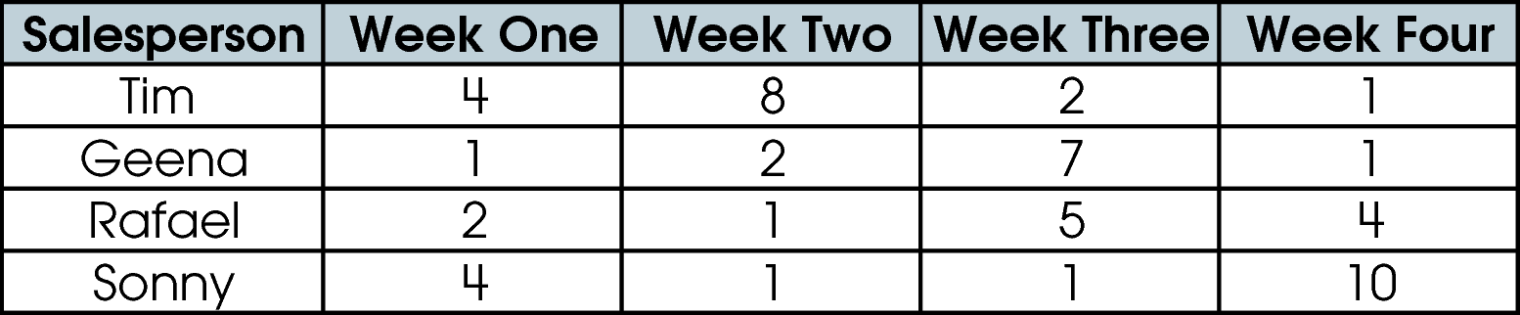
How should the data be displayed to make the most convincing argument that sales improved each week?
  - a bar graph of the total car sales per week
  - a box-and-whisker plot of Sonny’s sales per week
  - a line graph of each salesperson’s sales per week
  - a circle graph showing how many cars each person sold during the month

Commentary:
This multiple-choice question asks students to determine the appropriate representation of the given data to make the most convincing argument that sales improved each week. Students need to analyze the data provided and determine which type of graph could be used to best represent this data. The data in this table are categorical and would best be represented by a bar graph or a circle graph. The situation also requires the graph to show the weekly increase in car sales. Therefore, the graph must also look at the total sales for each week and not the sales of individual salespersons. Answer choice A, “a bar graph of the total car sales per week” is correct. The types of graphs in answer choices B, C and D are inappropriate for the data or do not address the requirements of the situation.

The complexity level of this question is Moderate Complexity. The task requires students to retrieve information from a table and use it to compare statements that describe graphical representations.

Performance Data:
The percent of public school students selecting answer choice A for question 14 on the May 2007 Grade 8 Achievement Test was 45%.

Keywords: data analysis, graph, bar graph, chart

BACK TO INDEX

Benchmark: D | Find, use and interpret measures of center and spread, such as mean and quartiles, and use those measures to compare and draw conclusions about sets of data.
GLI: DAP 8.4 | Compare two sets of data using measures of center (mean, mode, median) and measures of spread (range, quartiles, interquartile range, percentiles).

Multiple Choice Question:

- The daily noon temperatures for two cities were collected over a one-month period. The data were used to create the box-and-whisker plots shown.
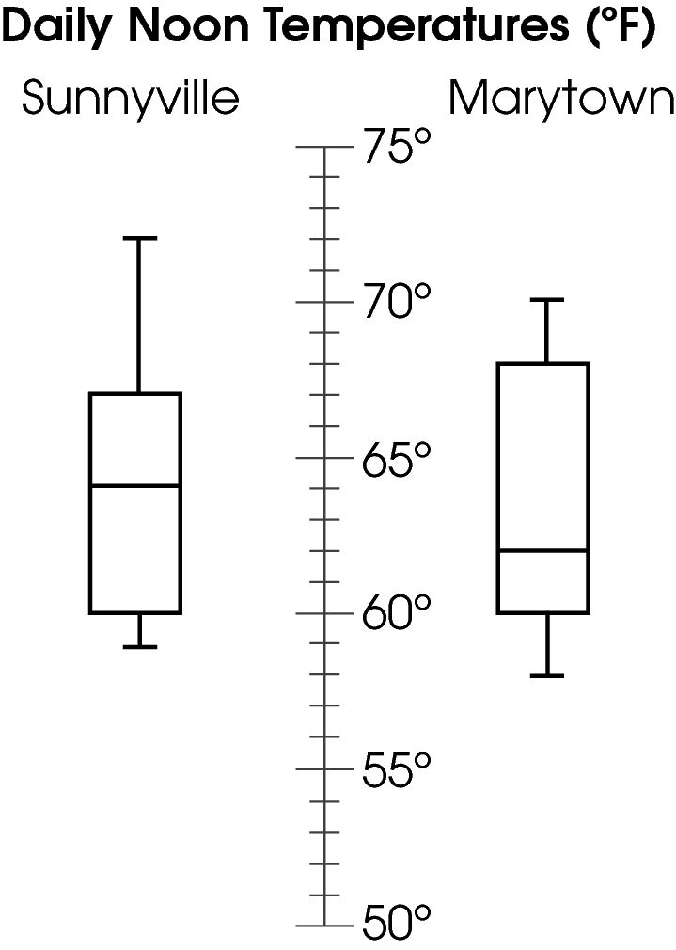

Which statement is supported by the data?

- Sunnyville has the lowest noon temperature.
- Marytown has a greater interquartile range.
- The median temperature is the same for both towns.
- Marytown has a greater range of noon temperatures.

Commentary:
This multiple-choice question asks students to use the data in the box-and-whisker plots to determine which statement provided is true. Students need to be able to identify the key components of a box-and-whisker plot. Key components include: maximum, minimum, median, first quartile, third quartile, range and interquartile range of a data set.

Maximum
Minimum
Median
First Quartile
Third Quartile

Range
Interquartile Range

The interquartile range for Sunnyville is 60 to 67 and the interquartile range for Marytown is 60 to 68. Therefore the statement “Marytown has a greater interquartile range” is supported by box-and-whisker plots. Answer choice B is correct.
Answer choices A, C and D are not supported by the box-and-whisker plots.

The complexity level of this question is Moderate Complexity. The question requires students to interpret a visual representation and compare statements.

Performance Data:
The percent of public school students selecting answer choice B for question 34 on the May 2007 Grade 8 Achievement Test was 52%.

Keywords: data analysis, representation, box-and-whisker plot, interquartile range

BACK TO INDEX

Benchmark: A | Create, interpret and use graphical displays and statistical measures to describe data; e.g., box-and-whisker plots, histograms, scatter plots, measures of center and variability.
Benchmark : F | Construct convincing arguments based on analysis of data and interpretation of graphs.
GLI: DAP 8.1, DAP 8.6 | DAP 8.1: Use, create and interpret scatterplots and other types of graphs as appropriate.  DAP 8.6: Make conjectures about possible relationship in a scatterplot and approximate line of best fit.

Short Answer Question:

6. A student in Cleveland, Ohio, recorded the sunset times in October. She plotted her data in the scatter plot shown.
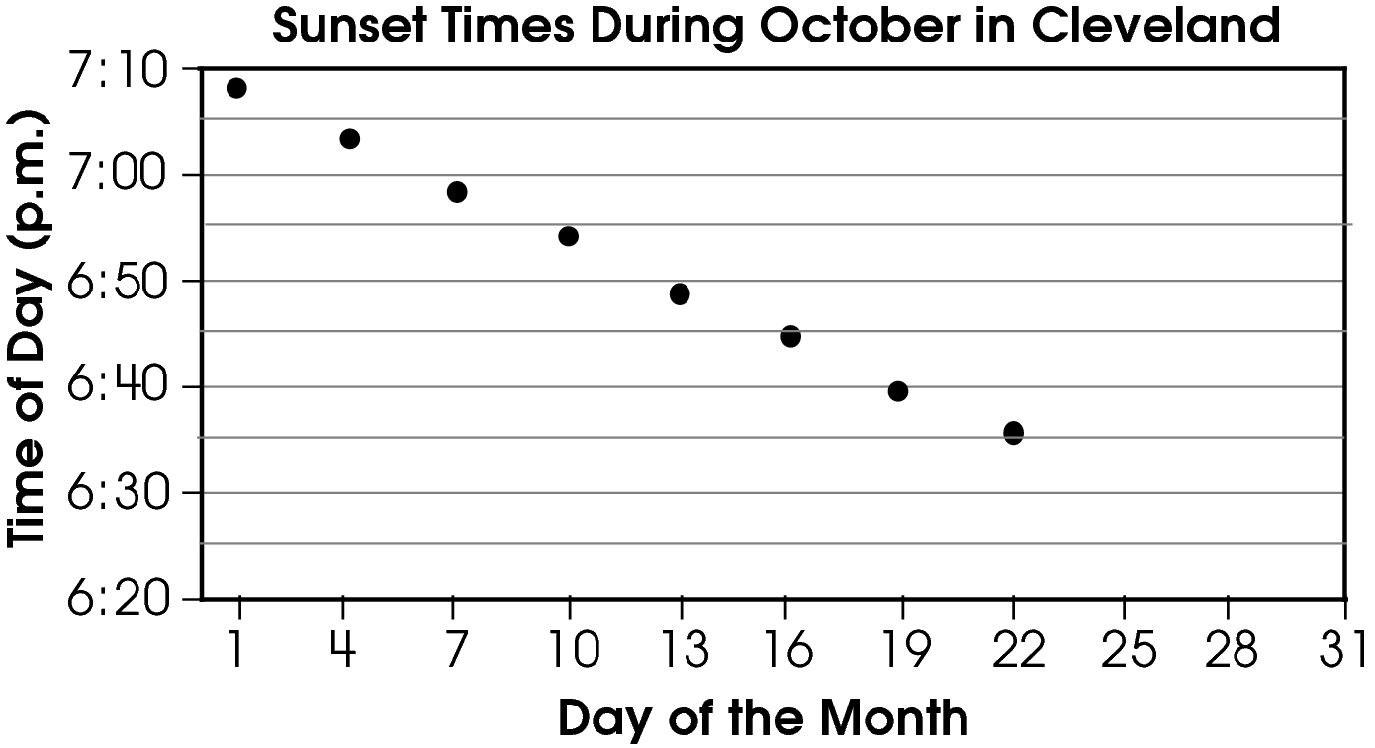
In your Answer Document, use the graph to predict what time the sun will set on October 28. Explain the strategy you used to make your prediction.

Commentary:
This short-answer question asks students to analyze the data in a scatter plot and make a prediction based on the analysis. Students should be able to draw an accurate conclusion using the scatter plot – a graph that relates data from the set that represents “Time of Day” and the set that represents “Day of the Month”. A response earning the maximum number of points (2 pts) provides a time of the sunset in the range of 6:24 PM to 6:30 PM and explains how the time was determined. One method students can use for determining the time is to notice that the sunset time decreases about 5 minutes every 3 days. The last data point is at about 6:36 PM on October 22. Then 6 days later, on October 28, the sunset time will be at about 6:26 PM.
Another method for determining the time of sunset is to observe that the points in the graph are close to a straight line. After the line is extended students can locate number 28 along the Day of the Month axis and move vertically upward until the line is reached. From this point on the line, students move horizontally to the left until the Time of Day axis is reached. Reading the number on the Time of Day axis, students find that the sunset time is about 6:27 PM on October 28.

The complexity level of this question is Moderate Complexity. This question requires students to retrieve information from a scatter plot and to provide a justification for a solution.

Performance Data:
The percent of public school students earning each score point for question 6 on the May 2008 Grade 8 Achievement Test:

Percent at Each Score Point
0 | 1 | 2
18% | 46% | 34%

Scoring Guidelines:
Exemplar Response:
- It looks like the time decreases about 5 minutes every 3 days. The last data point is at about 6:36 on Oct. 22. Then Oct. 28 is 6 days later, so the sun will set at about 6:26.
- I think the sun will set at 6:27. The points in the graph are close to a straight line so I extended the line and it looked like the sunset time would be about 6:27 on the 28th.
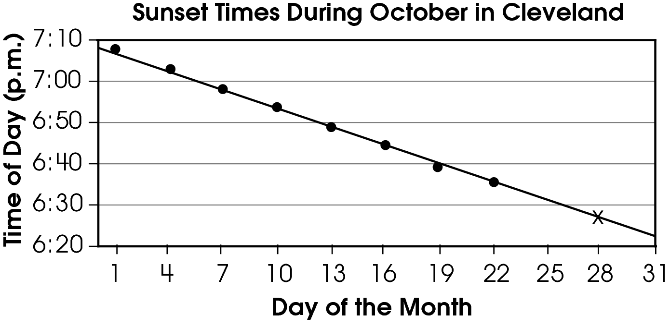

Points | Student Response
2 point text | The focus of this task is to analyze the data in a scatterplot, approximate the line of best fit and make a prediction based on the analysis. The response provides an appropriate time that the sun will set and explains the strategy used to determine the time for the sunset.  Note: A response in the range of 6:24 to 6:30 is acceptable, with appropriate justification.
1 point text | The response shows partial evidence of analyzing the data in a scatterplot, approximating the line of best fit and making a prediction based on the analysis; however, the response may be incomplete or slightly flawed.  For example, the response may:  - give an acceptable time only, with a missing or unclear explanation of strategy used.  - provide an appropriate explanation for determining the time but fail to state an appropriate time.
0 point text | The response provides inadequate evidence of analyzing the data in a scatterplot, approximating the line of best fit and making a prediction based on the analysis. The response provides an explanation with major flaws and errors of reasoning.  For example, the response may:  - state an inappropriate time only.  - restate the information provided in the item.  - be blank or give irrelevant information.

Keywords: data analysis, scatter plot, line of best fit

BACK TO INDEX

Benchmark: K | Make predictions based on theoretical probabilities and experimental results.
GLI: DAP 5.10 | Compare what should happen (theoretical/expected results) with what did happen (experimental/actual results) in a simple experiment.

Multiple Choice Question:

20. A class designed the spinner shown to award prizes at the school fair.
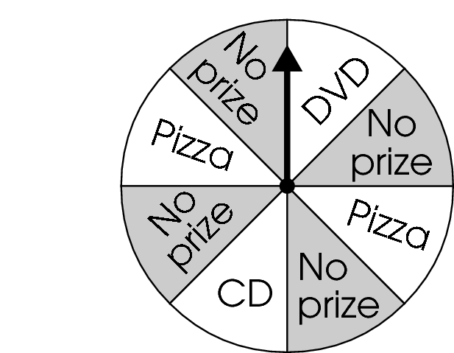
At the fair, 450 students spun the spinner. The class awarded 115 slices of pizza, 49 CDs and 78 DVDs.
How do the actual results differ from the expected results?

- The class awarded more CDs than expected.
- The class awarded fewer slices of pizza than expected.
- The class awarded more DVDs than expected.
- The actual results do not differ from the expected results.

Commentary:
This multiple-choice question asks students to compare the differences between actual results and expected results (predictions based on calculated probability) from an experiment. Since the class is awarded 78 DVDs in 450 spins, the experimental probability is $\frac{\text{78}}{\text{450}}$ = 0.173. On the spinner 1 out of 8 sections are labeled “DVD”, so the expected probability of winning a DVD is $\frac{1}{8}$ = 0.125. The experimental probability, 0.173, is greater than the theoretical probability, 0.125. Therefore, the class awarded more DVDs than expected. Answer choice C is correct.

If students choose answer choice A, they thought that the actual result, $\frac{\text{49}}{\text{450}}$= 0.108, are greater than the theoretical probability of winning a CD, $\frac{1}{8}$ = 0.125.
If students choose answer choice B, they thought that the actual result,
$\frac{\text{115}}{\text{450}}$= 0.255, are less than the theoretical probability of winning a CD, $\frac{2}{8}$ = 0.25.
If students choose answer choice D, they only compared the theoretical and the experimental probability of winning a pizza and assumed that since they were very close, the other results did not differ from the expected results.

The complexity level of this question is Moderate Complexity. The question requires student to retrieve information from a diagram and use it.

Performance Data:
The percent of public school students selecting answer choice C for question 20 on the May 2008 Grade 8 Achievement Test was 47%.

Keywords: data analysis, probability, theoretical probability, spinner

BACK TO INDEX

Benchmark: F (5-7) | Determine and use the range, mean, median and mode to analyze and compare data, and explain what each indicates about the data.
GLI: DAP 7.3 | Analyze a set of data by using and comparing combinations of measures of center (mean, mode, median) and measures of spread (range, quartile, interquartile range), and describe how the inclusion or exclusion of outliers affects those measures.

Multiple Choice Question:

25. The table shows the prices of 10 different brands of jeans.
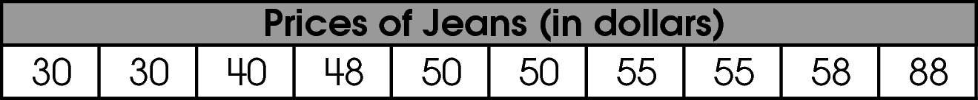
How will the mean price and median price change if the $88 brand is removed from the data set?

- Both the mean and the median will decrease.
- The mean will decrease and the median will not change.
- The mean will not change and the median will decrease.
- Both the mean and the median will not change.

Commentary:
This multiple-choice question asks students to interpret how the mean and median will change when an extreme value ($ 88) is removed from the set of data.
The problem can be solved by finding each of the measures of center for the set of data before and after an extreme value is removed from the set.
Students can calculate the original mean by adding together all prices of the jeans and then dividing by the number of prices in the data set:
$\frac{\text{30}+\text{30}+\text{40}+\text{48}+\text{50}+\text{50}+\text{55}+\text{55}+\text{58}+\text{88}}{\text{10}}$ = 50.4
If 88 is removed from the data set, the mean will decrease to 46.2 because
$\frac{\text{30}+\text{30}+\text{40}+\text{48}+\text{50}+\text{50}+\text{55}+\text{55}+\text{58}}{9}$ = 46.2
The median is the number in the middle of the data when the data is in order from least to greatest, such as $30, $30, $40, $48, $50, $50, $55, $55, $58, $88. Because there are two values of $50 in the middle, the median is the mean of those two values
$\frac{\text{50}+\text{50}}{2}$ = 50
If 88 is removed from the set, the median will be the middle number in the set of 9 numbers, which is still 50.
$30, $30, $40, $48, $50, $50, $55, $55, $58
The mean of the set decreases from 55.2 to 46.2, but the median does not change. Answer choice B is correct.

Answer choices A, C and D may be results of incorrect calculations of the measures of the center or student misconceptions.

The complexity level of this question is Low Complexity. This question requires students to recognize examples of concepts and perform specified procedures.

Performance Data:
The percent of public school students selecting answer choice B for question 25 on the May 2008 Grade 8 Achievement Test was 65%.

Keywords: data analysis, data set, mean, median

BACK TO INDEX

Benchmark: J | Compute probabilities of compound events, independent events, and simple dependent events.
GLI: DAP 8.10 | Calculate the number of possible outcomes for a situation, recognizing and accounting for when items may occur more than once or when order is important.

Multiple Choice Question:

38. Jerry has one red cube and one green cube. Each is numbered 1 through 6. He will roll both of them at the same time.
How many ways can the number on the red cube be exactly 2 greater than the number on the green cube?

- 1
- 2
- 4
- 9

Commentary:
This multiple-choice question asks students to determine the number of possible ways the number on the red cube will be exactly 2 greater than the number on the green cube. To solve this problem students need to understand that identical red and green number cubes are rolled at the same time.
The following is the list of desired outcomes:
The number on the green cube is 1 and the number on the red cube is 3
The number on the green cube is 2 and the number on the red cube is 4.
The number on the green cube is 3 and the number on the red cube is 5.
The number on the green cube is 4 and the number on the red cube is 6.
There are four ways the number on the red cube could be exactly 2 greater than the number on the green cube, answer choice C.

Answer choices A and B may have been results of miscalculations for the number of desired outcomes. Answer choice D is a result of finding the combinations of rolls that is at least 2 greater instead of exactly 2 greater.

The complexity level of this question is Moderate Complexity. This question requires students to formulate a routine problem with given conditions and solve it using several steps.
Performance Data:
The percent of public school students selecting answer choice C for question 38 on the May 2008 Grade 8 Achievement Test was 70%.

Keywords: data analysis, probability, outcomes

BACK TO INDEX

