Index to Questions

Question Number | Source | BM | GLI | Description
9 | OAT Mar 06 | D & E | DAP 6.2, DAP 6.3 | This multiple-choice question asks students to select the graph that best shows the fractional part of the total amount from a table.
17 | OAT Mar 06 | E & F | DAP 6.4, DAP 6.5 | This multiple-choice question asks students to determine a true statement about the mode of a data set in a frequency table.
22 | OAT Mar 06 | A | DAP 6.1 | This multiple-choice question asks students to use the data in the histogram to find the total number of runners who ran the distance in less than 7.0 seconds.
25 | OAT Mar 06 | A | DAP 6.1 | This multiple-choice question asks students to make a reasonable prediction from a chart.
33 | OAT Mar 06 | A | DAP 6.1 | This multiple-choice question asks students to find the number of votes Park received basked on a circle graph.
36 | OAT Mar 06 | D | DAP 6.3 | This short-answer question asks students to give one advantage of using the bar graph for displaying the given data and one advantage of using the circle graph for displaying the given data.
39 | OAT Mar 06 | K | DAP 6.7 | This multiple-choice question asks students to select an activity to test a prediction of selecting an object one-third of the time.
45 | OAT Mar 06 | B & G | DAP 6.5, DAP 6.6 | This multiple-choice question asks students to determine a reasonable prediction for the total enrollment at a middle school in 2010 using the data in the graph.
4 | OAT May 07 | E | DAP 6.2 | This multiple-choice question asks students to select the circle graph which appears to represent the data given in the table.
35 | OAT May 07 | F | DAP 6.4 | This multiple-choice question asks students to select the statement that explains what the range represents based on the given information.
39 | OAT May 07 | G | DAP 6.6 | This multiple-choice question asks students to make a reasonable prediction based on a line graph.
19 | OAT May 08 | A | DAP 6.1 | This multiple-choice question asks students to describe the overall change in sales from 1992 to 1994 on the given line graph.
44 | OAT May 08 | A | DAP 6.1 | This multiple-choice question asks students to estimate the amount of money a city spent on police using the information provided ($4 million is spent on garbage).

BACK TO INDEX

Benchmark: D  E | Compare increasingly complex displays of data, such as multiple sets of data on the same graph.  Collect, organize, display, and interpret data for a specific purpose or need.
GLI: DAP 6.2, DAP 6.3 | DAP 6.2: Select, create and use graphical representations that are appropriate for the type of data collected.  DAP 6.3: Compare representations of the same data in different types of graphs, such as a bar graph and circle graph.

Multiple Choice Question

9. The table shows the number of appliances in stock at King’s Appliance Store.
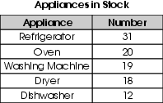
Which graph best shows the fractional part of the total number of appliances for each appliance in stock?
A. 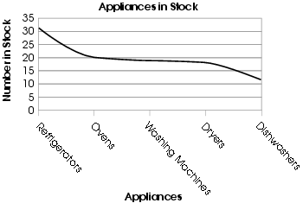
B. 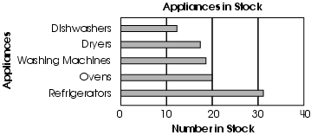
C. 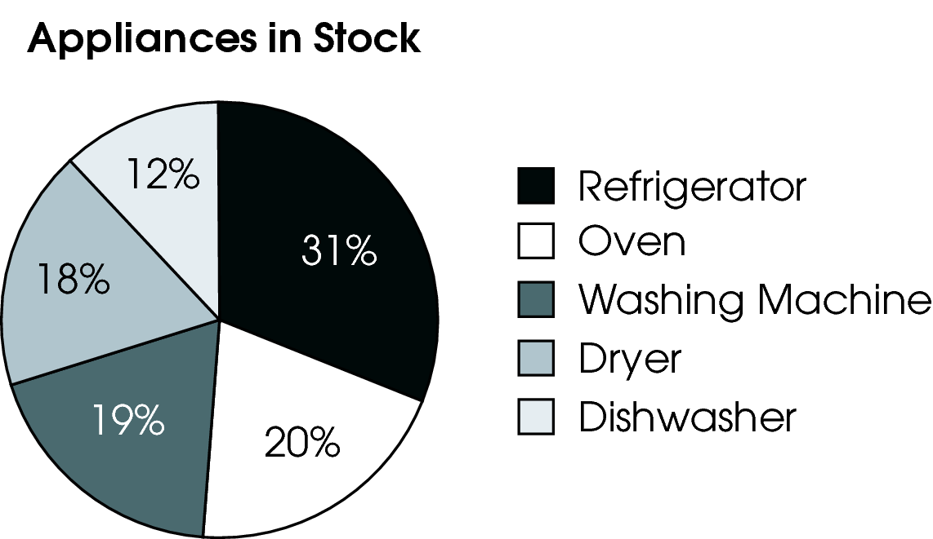
D. 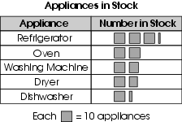

do not copy or distribute ID: 5847; Version: 7

Commentary:
This multiple-choice question asks students to select the graph that best shows the fractional part of the total amount from a table. A circle graph shows the fractional part of the total amount. The circle graph in answer choice C with the percentages for each appliance is the best representation of the fractional part of the total amount of 100 appliances. The line graph in answer choice A and the pictograph in answer choice D do not show the fractional part out of the total amount. The bar graph in answer choice B does not show the total of each appliance out of 100 appliances.

The complexity level of this question is Moderate Complexity. Students are required to interpret each graphical representation to determine whether the graph shows the fractional part of the total amount.

Performance Data:
The percent of public school students selecting answer choice C for question 9 on the March 2006 Grade 6 Achievement Test was 50%.

Keywords: data analysis, graphical representations

BACK TO INDEX

Benchmark: E  F | Collect, organize, display, and interpret data for a specific purpose or need.  Determine and use the range, mean, median and mode to analyze and compare data, and explain what each indicates about the data.
GLI: DAP 6.4, DAP 6.5 | DAP 6.4: Understand the different information provided by measures of center (mean, mode and median) and measures of spread (range).  DAP 6.5: Describe the frequency distribution of a set of data, as shown in a histogram or frequency table, by general appearance or shape; e.g., number of modes, middle of data and level of symmetry, outliers.

Multiple Choice Question:

17. The frequency table shows the number of cousins for 29 students.
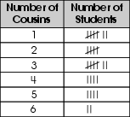
Which statement is true about these data?
A. There is no mode.
B. There is one mode.
C. There are two modes.
D. There are six modes.

do not copy or distribute ID: 6663; Version: 11

Commentary:
This multiple-choice question asks students to determine a true statement about the mode of a data set in a frequency table. Students need to know that the mode of a data set is the number of times a piece of data appears most frequently. In this question, students need to look for the number of cousins that have the most tally marks. In the table, students who had 1 cousin and students who had 3 cousins have the most tally marks. This means there are two modes, answer choice C.

The complexity level of this question is Moderate Complexity. This question requires students to retrieve information from a table and use the information to solve a problem.

Performance Data:
The percent of public school students selecting answer choice C for question 17 on the March 2006 Grade 6 Achievement Test was 69%.
Keywords: data analysis, mode, frequency table

BACK TO INDEX

Benchmark: A | Read, create and use line graphs, histograms, circle graphs, box-and-whisker plots, stem-and-leaf plots, and other representations when appropriate.
GLI: DAP 6.1 | Read, construct and interpret line graphs, circle graphs and histograms.

Multiple Choice Question:
22. The graph shows times for runners in the 50-yard dash.
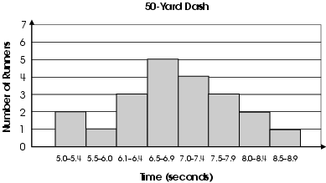
How many runners ran the distance in less than 7.0 seconds?
A. 4 runners
B. 5 runners
C. 11 runners
D. 21 runners

do not copy or distribute ID: 4235; Version: 16

do not copy or distribute ID: 4134; Version: 5

Commentary:
This multiple-choice question asks students to use the data in the histogram to find the total number of runners who ran the distance in less than 7.0 seconds. Students need to find the number of runners who ran the distance from 5.0 seconds to 6.9 seconds. There were 11 runners who ran the distance in less than 7.0 seconds (5 + 3 + 1 + 2 = 11 runners), answer choice C. Answer choice A is incorrect because it represents the number of runners who ran the distance in the interval for 7.0 seconds to 7.4 seconds. Answer choice B represents the number of runners who ran the distance in the interval for 6.5 seconds to 6.9 seconds, which is not the only interval that contains times less than 7.0 seconds. Answer choice D represents all of the runners who ran the distance from 5.0 seconds to 8.9 seconds, which includes all the intervals with times that are less than 7.0 seconds and greater than 7.0 seconds.

The complexity level of this question is Moderate Complexity. This question requires students to retrieve information from a graph and use it to solve a problem.

Performance Data:
The percent of public school students selecting answer choice C for question 22 on the March 2006 Grade 6 Achievement Test was 69%.

Keywords: data analysis, histogram

BACK TO INDEX

Benchmark: A | Read, create and use line graphs, histograms, circle graphs, box-and-whisker plots, stem-and–leaf plots, and other representations when appropriate.
GLI: DAP 6.1 | Read, construct and interpret line graphs, circle graphs and histograms.

Mathematical Processes
Benchmark: F | Use inductive thinking to generalize a pattern of observations for particular cases, make conjectures, and provide supporting arguments for conjectures.

Multiple Choice Question:

25. The chart shows winning times for the women’s 100-meter freestyle in every Olympic Games since 1960.
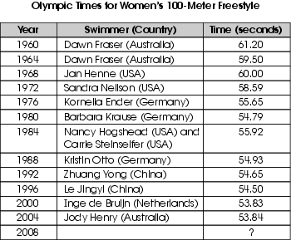
Which time is a reasonable prediction for the winning time in this race at the 2008 Olympic Games?
A. 61.50 seconds
B. 58.50 seconds
C. 53.50 seconds
D. 48.50 seconds

do not copy or distribute ID: 5911; Version: 9

Commentary:
This multiple-choice question asks students to make a reasonable prediction from a chart. Students should review the data in the chart and notice that generally the time is decreasing. Therefore, the time in 2008 would be a little less than 53.84 seconds. A reasonable prediction that is close to or a little less than 53.84 seconds is 53.50 seconds, answer choice C. This time is less than 53.84 seconds. Although 48.50 seconds, answer choice D, is less than 53.84 seconds, it is not a reasonable prediction because it is too great of a decrease. Answer choices A and B show a significant increase in the time and are not a reasonable prediction.

The complexity level of this question is Moderate Complexity. Students are retrieving information from a table to solve a problem.

Performance Data:
The percent of public school students selecting answer choice C for question 25 on the March 2006 Grade 6 Achievement Test was 64%.

Keywords: data analysis, prediction, table

BACK TO INDEX
Benchmark: A | Read, create and use line graphs, histograms, circle graphs, box-and whisker plots, stem-and-leaf plots, and other representations when appropriate.
GLI: DAP 6.1 | Read, construct and interpret line graphs, circle graphs and histograms.

Multiple Choice Question:

33. Eighty students voted in the election for the sixth-grade class president. The results are shown in the graph.
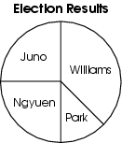
About how many votes did Park receive?
A. 4
B. 10
C. 20
D. 40

do not copy or distribute ID: 4134; Version: 5

Commentary:
This multiple-choice question asks students to find the number of votes Park received based on a circle graph. Students need to first determine what part of the circle graph represents Park’s results ($\frac{1}{8}$). Then students should determine $\frac{1}{8}$ of the total number of votes (80), which is 10 votes ($\frac{1}{8}$ × 80 = 10), answer choice B.

The complexity level of this question is Moderate Complexity. This question requires students to retrieve information from a graph and use it to solve a problem.

Performance Data:
The percent of public school students selecting answer choice B for question 33 on the March 2006 Grade 6 Achievement Test was 63%.

Keywords: data analysis, circle graph

BACK TO INDEX

Benchmark: D | Compare increasingly complex displays of data, such as multiple sets of data on the same graph.
GLI: DAP 6.3 | Compare representations of the same data in different types of graphs, such as a bar graph and circle graph.

Mathematical Processes
Benchmark: H | Use representations to organize and communicate mathematical thinking and problem solutions.

Short Answer Question:

36. The table shows the lunch choices of 155 students.
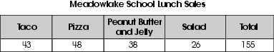
A circle graph and a bar graph are constructed to represent these data.
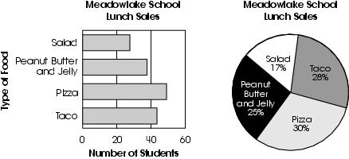
In your Answer Document, give one advantage of using the bar graph to display these data. Then give one advantage of using the circle graph to display these data.

Commentary:
This short-answer question asks students to give one advantage of using the bar graph for displaying the given data and one advantage of using the circle graph for displaying the given data. A response earning the maximum number of points (2 points) indicates that the bar graph shows the number of students who ate each type of food and that the circle graph shows the percent of students who ate each type of food.

The complexity level of this question is Moderate Complexity. This task asks students to identify the purpose for each given graphical display.

Performance Data:
The percent of public school students earning each score point for question 36 on the March 2006 Grade 6 Achievement Test:

Percent at Each Score Point
0 | 1 | 2
31% | 29% | 38%

Scoring Guidelines:
Sample Correct Response(s):
- State the circle graph makes it easier to see how the amount of students eating one type of food compares to all of the students. The bar graph makes it easier to see the number of students eating the different foods.
- State the bar graph shows the actual numbers and the circle graph shows the percents.
Points | Student Response
2 | The focus of this task is comparing representations of the same data in different types of graphs. The response provides adequate support that demonstrates an understanding of comparing the same data in a bar graph and circle graph.
1 | The response provides partial evidence of comparing representations of the same data in different types of graphs. The response provides a vague explanation with minor flaws.  For example, the response may:  - State an advantage of one type of graph but not the other.  - State that the circle graph conveys a part to whole relationship as compared to a bar graph that doesn’t.  - State that the bar graph conveys the number of students as compared to the circle graph that doesn’t.
0 | The response provides inadequate evidence of understanding of comparing representations of the same data in different types of graphs. The response will provide major flaws in explanations or irrelevant information  For example, the response may:  - Restate information that is already given, including data interpretation; e.g.; 30% of the students ate pizza.  - Be highly flawed, blank or states unrelated information.

Keywords: data analysis, bar graphs, circle graphs

BACK TO INDEX

Benchmark: K | Make and justify predictions based on experimental and theoretical probabilities.
GLI: DAP 6.7 | Design an experiment to test a theoretical probability and explain how the results may vary.

Multiple Choice Question:

39. Shawna has 36 Ping-Pong balls in a shoebox. She has 8 white balls, 12 orange balls and 16 green balls. She predicts that when she reaches into the box without looking, she will pull out an orange ball $\frac{1}{3}$of the time.
Which activity would best allow Shawna to test her prediction?
A. Measure the circumference of the Ping-Pong balls.
B. Randomly select a Ping-Pong ball and replace it. Repeat 100 times and see how close to 33 times the orange ball is selected.
C. Ask three different people to predict what color they think will be selected.
D. Randomly select a Ping-Pong ball and replace it. Repeat three times to see whether each color is chosen.

do not copy or distribute ID: 5925; Version: 6

Commentary:
This multiple-choice question asks students to select an activity to test a prediction of selecting an object one-third of the time. Students should select an activity that would have the expected probability of selecting an orange Ping Pong ball $\frac{1}{3}$ of the time. This expected probability is based on the theoretical probability of selecting one of the 12 orange Ping-Pong balls out of the total 36 Ping-Pong balls. The activity in answer choice B (Randomly select a Ping-Pong ball 100 times and seeing how close to 33 times is the orange ball is selected.) is the correct answer because 33 times out of 100 times is close to the theoretical probability of $\frac{1}{3}$. Measuring the circumference of the Ping-Pong ball (answer choice A), and asking three people to predict a color (answer choice C), do not have anything to do with finding the probability. Repeating the random selection of a Ping-Pong ball three times to see whether each color is chosen is not a sufficient number of times to test for a valid prediction.

The complexity level of this question is Moderate Complexity. This question requires students to formulate a routine problem given data and conditions.

Performance Data:
The percent of public school students selecting answer choice B for question 39 on the March 2006 Grade 6 Achievement Test was 52%.

Keywords: data analysis, experimental probability, theoretical probability, prediction

BACK TO INDEX

Benchmark: B  G | Interpret data by looking for patterns and relationships, draw and justify conclusions, and answer related questions.  Evaluate conjectures and predictions based upon data presented in tables and graphs, and identify misuses of statistical data and displays.
GLI: DAP 6.5, DAP 6.6 | DAP 6.5: Describe the frequency distribution of a set of data, as shown in a histogram or frequency table, by general appearance or shape; e.g., number of modes, middle of data and level of symmetry, outliers.  DAP 6.5: Make logical inferences from statistical data.

Multiple Choice Question:

45. The graph shows the total enrollment at a middle school over a 10-year period.
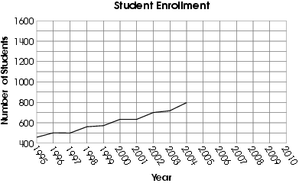
Which is a reasonable prediction for the total enrollment at the school in 2010?
A. 400
B. 700
C. 1,000
D. 1,600

Commentary:
This multiple-choice question asks students to determine a reasonable prediction for the total enrollment at a middle school in 2010 using the data in the graph. The graph provides data on the total enrollment at a middle school over a 10-year period from 1995 to 2004. Based on the data in the graph, students need to identify trends, such as how much the data is increasing. The data shows an increase for the majority of the 10-year period and the total enrollment should be expected to increase by 2010. The enrollment for 2010 should be greater than 800 students, which is the enrollment for 2004. Answer choices A and B show a total enrollment less than 800 students and should be eliminated. The enrollment during the 10-year period increased about 350 students. At this rate, the enrollment for the next six-year period is not expected to be more than 350 students. The total enrollment in answer choice C, 1000 is a reasonable prediction. The estimated prediction in answer choice D, 1,600 is not reasonable since the difference in 1,600 and 800 exceeds 350.
The complexity level of this question is Moderate Complexity. This question requires students to retrieve information from a graph and use it to solve a problem.

Performance Data:
The percent of public school students selecting answer choice C for question 45 on the March 2006 Grade 6 Achievement Test was 56%.

Keywords: data analysis, prediction

BACK TO INDEX

Benchmark: E | Collect, organize, display and interpret data for a specific purpose or need.
GLI: DAP 6.2 | Select, create and use graphical representations that are appropriate for the type of data collected.

Multiple Choice Question:

- Tara surveyed the 25 students in her class to determine each student’s favorite color. The results are shown.
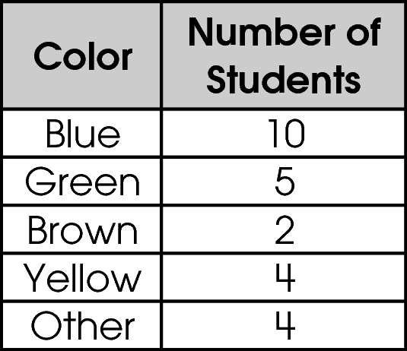
Which circle graph appears to represent these data?

- 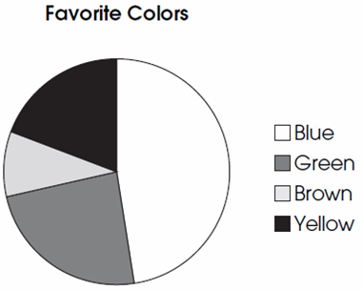

- 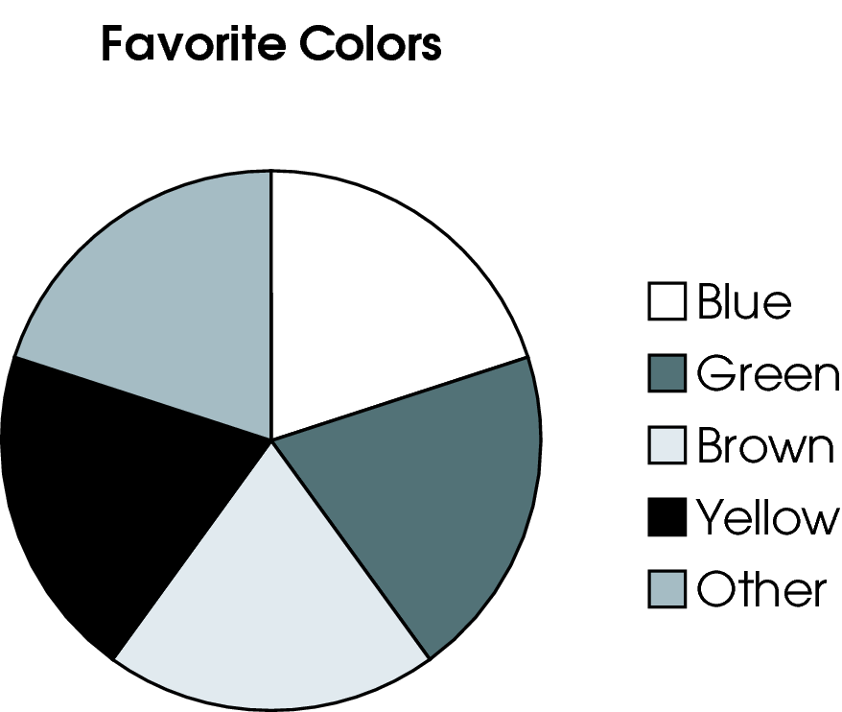
- 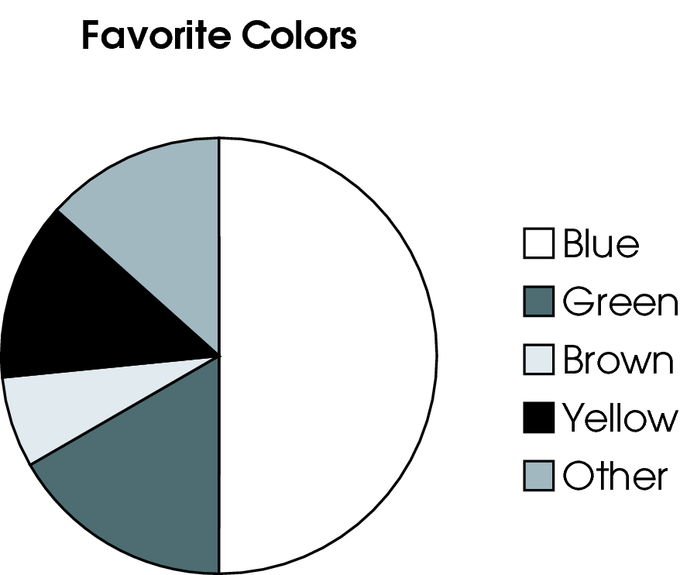
- 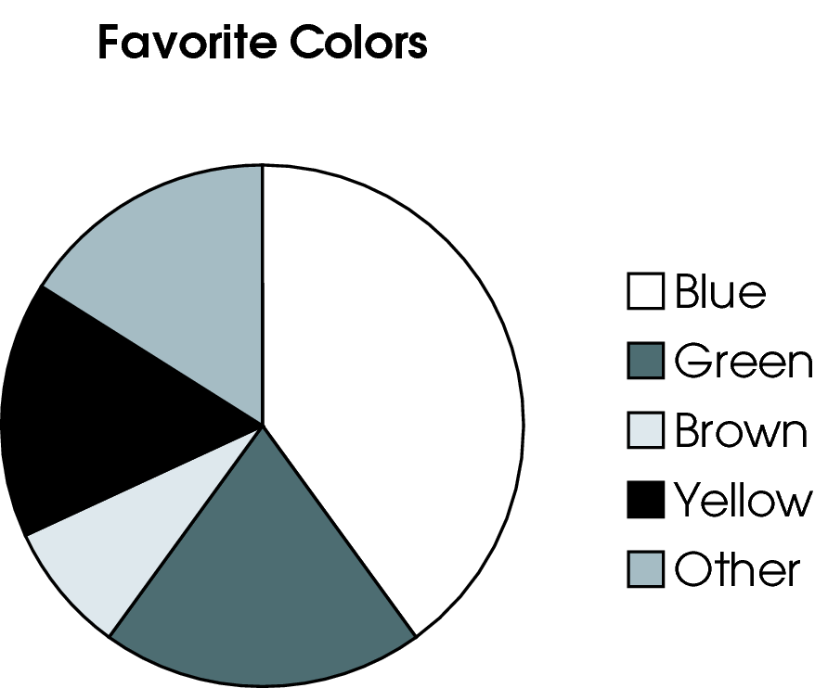

Commentary:
This multiple-choice question asks students to select the circle graph which appears to represent the data given in the table. Students need to determine what part of the class chose each color and relate it to the part of the circle representing the color. Since more students chose blue than any other color, the Blue section of the circle graph should be the largest. The sections for Yellow and Other should be the same size since they were chosen by the same number of students. The section for Green should be slightly larger than the sections for Yellow and Other, whereas the section for Brown should be the smallest section since the fewest number of students chose this color. The circle graph in answer choice D is correct since it appears to represent the data given in the table.

Answer choice A is incorrect since section for Other is not represented in the graph. Answer choice B is incorrect since the sections in this graph appear to be the same size which means that all colors were equally chosen by the students. The sections in this graph appear to be the same size. Answer choice C is incorrect since the section for Blue in this graph is half or 50% of the total number of students. Ten of the 25 students chose Blue, which is 40% or less than half of the class.

The complexity level of this question is Low Complexity. This question requires students to recognize an equivalent representation.

Performance Data:
The percent of public school students selecting answer choice D for question 4 on the May 2007 Grade 6 Achievement Test was 68%.

Keywords: data analysis, circle graph, table

BACK TO INDEX

Benchmark: F | Determine and use the range, mean, median and mode to analyze and compare data, and explain what each indicates about the data.
GLI: DAP 6.4 | Understand the different information provided by measures of center (mean, mode and median) and measures of spread (range).

Multiple Choice Question:

35. A school has 8 science classes. The range of the number of students in these classes is 7.
Which explains what the range represents?

A. There are 7 students in each class.
B. Half the classes have more than 7 students and half have fewer than 7 students.
C. The difference between the number of students in the largest class and the number of students in the smallest class is 7.
D. All the classes have more than 7 students.

Commentary:
This multiple-choice question asks students to select the statement that explains what the range represents based on the given information. The range of the number of students in the 8 science classes is 7. Students need to know that the range of a data set represents the difference between the largest and smallest values in the set. Answer choice C is correct.

The statement in answer choices A, B and D do not explain the meaning of range.

The complexity level of this question is Moderate Complexity. This question requires students to compare statements.

Performance Data:
The percent of public school students selecting answer choice C for question 35 on the May 2007 Grade 6 Achievement Test was 58%.

Keywords: data analysis, range

BACK TO INDEX

Benchmark: G | Evaluate conjectures and predictions based upon data presented in tables and graphs, and identify misuses of statistical data and displays.
GLI: DAP 6.6 | Make logical inferences from statistical data.

Multiple Choice Question:

39. The graph shows the total amount of money that Charlie has saved over time.
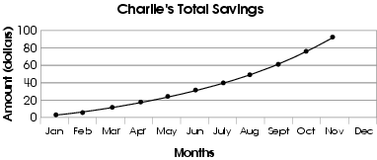
Which estimate is reasonable for the total amount of money that Charlie will save by the end of December?
A. $1.00
B. $10.00
C. $100.00
D. $1,000.00

Commentary:
This multiple-choice question asks students to make a reasonable prediction based on a line graph. Students need to determine an estimate of the total amount of money that will be saved by the end of December. The amount shown on the graph for November is about $90.00
Students should see that the total amount of money to be saved by the end of December should be about $100.00, answer choice C.

The total amounts identified in answer choices A ($1.00) and B ($10.00) are not reasonable estimates because they are too low. These values were surpassed in the first three months. The total amount identified in answer choice D, $1,000.00, is not a reasonable estimate because it is too high and would take multiple years to save at this rate.

The complexity level of this question is Low Complexity. This question requires students to interpret a visual representation.

Performance Data:
The percent of public school students selecting answer choice C for question 39 on the May 2007 Grade 6 Achievement Test was 84%.

Keywords: data analysis, prediction, line graph

BACK TO INDEX

Benchmark: A | Read, create and use line graphs, histograms, circle graphs, box-and whisker plots, stem-and-leaf plots, and other representations when appropriate.
GLI: DAP 6.1 | Read, construct and interpret line graphs, circle graphs and histograms.

Mathematical Processes
Benchmark: B | Apply and adapt problem-solving strategies to solve a variety of problems, including unfamiliar and non-routine problem situations.

Multiple Choice Question:

19. Ben’s Chocolate Shop recorded the total number of yearly sales for 1991 through 1996. The manager placed these data on the graph shown.
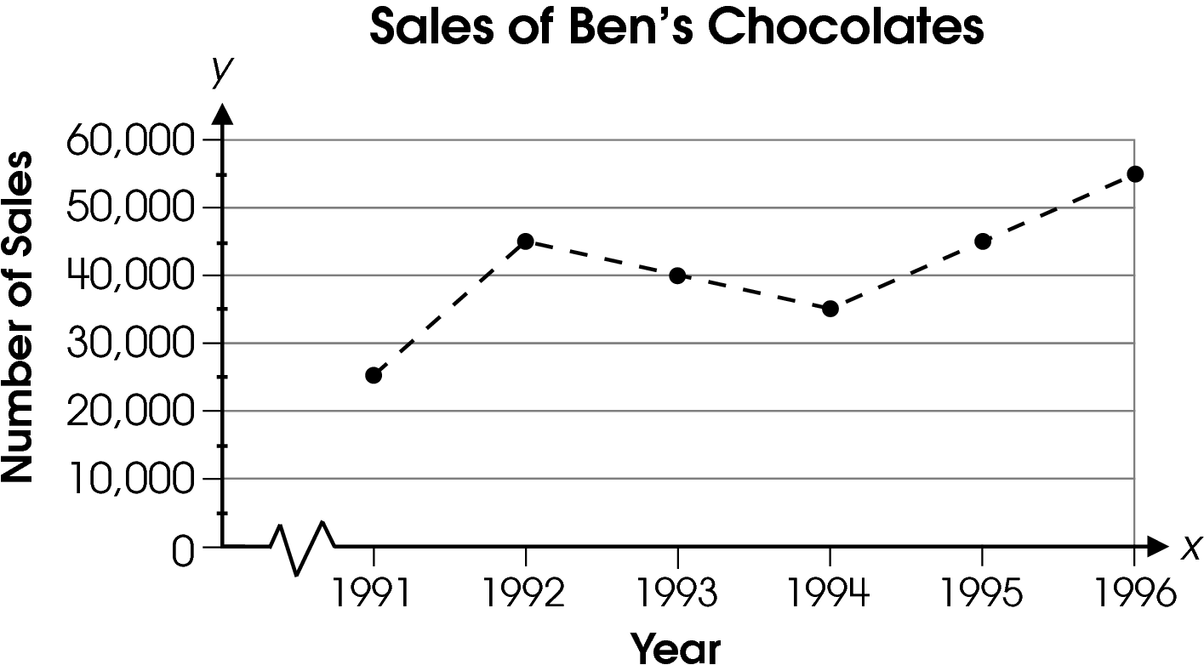
What was the overall change in sales from 1992 to 1994?

A. decrease of 10,000
B. decrease of 5,000
C. increase of 10,000
D. increase of 30,000

Commentary:
This multiple-choice question asks students to describe the overall change in sales from 1992 to 1994 on the given line graph. Students should notice that there is a decrease in sales from 1992 to 1994. This would eliminate answer choices C and D which refer to an increase in sales.

To determine the amount of decrease from the graph, students can estimate the decrease from 1992 to 1993 to be about $5,000 and from 1993 to 1994 as another $5,000 for a total decrease of about $10,000. Therefore, answer choice A is correct.

The amount of decrease in answer choice B is only from 1992 to 1993 or from 1993 to 1994; each a partial solution.

The complexity level of this question is Low Complexity. This question requires students to retrieve information from a graph.

Performance Data:
The percent of public school students selecting answer choice A for question 19 on the May 2008 Grade 6 Achievement Test was 68%.

Keywords: data analysis, line graph

BACK TO INDEX

Benchmark: A | Read, create and use line graphs, histograms, circle graphs, box-and-whisker plots, stem-and–leaf plots, and other representations when appropriate.
GLI: DAP 6.1 | Read, construct and interpret line graphs, circle graphs and histograms.

Multiple Choice Question:

44. The graph shows how the city budget is distributed among five departments.
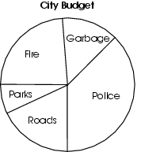
The city spends about $4 million on garbage.
About how much does the city spend on police?

A. $ 8 million
B. $12 million
C. $16 million
D. $20 million

Commentary:
This multiple-choice question asks students to estimate the amount of money a city spent on police using the information provided ($4 million is spent on garbage). The section representing garbage is approximately $\frac{1}{8}$ of the graph. This would make the section for police approximately $\frac{3}{8}$ of the graph. Therefore, the amount spent on police is about three times the amount spent on garbage (3 × $4 million). Therefore, the city would spend about $12 million on police, answer choice B.

Answer choices A, C and D are incorrect. Students selecting answer choice A think that the amount spent on police is twice the amount spent on garbage. Students selecting answer choice C added the cost they estimated to spend on police ($12 million), to the cost of garbage ($4million) for a total of $16 million. Students selecting answer choice D may have multiplied the cost of garbage by 5 since there are five sections in the circle graph.

The complexity level of this question is Moderate Complexity. This question requires students to retrieve information from a graph and use it to solve a problem.

Performance Data:
The percent of public school students selecting answer choice B for question 44 on the May 2008 Grade 6 Achievement Test was 49%.

Keywords: data analysis, circle graph

BACK TO INDEX

