Index to Questions

Question Number | Source | BM | GLI | Description
3 | OAT Mar 06 | F | DAP 5.6 | This multiple-choice question asks students to determine the mode of the given data set.
5 | OAT Mar 06 | H | DAP 5.7 | This short-answer question asks students to list the different shirt and pants combination from four different colored shirts and three different colored pants.
8 | OAT Mar 06 | F | DAP 5.6 | This multiple-choice question asks students to fine the greatest median in a group of numbers.
17 | OAT Mar 06 | J | DAP 5.10 | This multiple-choice question asks students to select the statement that explains the reasonableness of the results from a simple experiment.
22 | OAT Mar 06 | I | DAP 5.8 | This multiple-choice question asks students to determine the probability of selecting a card with a certain letter.
29 | OAT Mar 06 | A | DAP 5.1 | This short-answer question asks students to construct a frequency table to summarize the given data.
32 | OAT Mar 06 | E | DAP 5.4 | This multiple-choice question asks students to determine which phrase describing the data category will not be shown in a graph of desserts students like.
43 | OAT Mar 06 | F | DAP 5.6 | This multiple-choice question asks students to determine the range of the temperatures from the data presented in a bar graph.
3 | OAT May 07 | D | DAP 5.3 | This multiple-choice question asks students to interpret a double bar graph to answer a question.
6 | OAT May 07 | K | DAP 5.11 | This multiple-choice question asks students to determine the color of a button that is least likely to be picked from a bag based on the probabilities given in a table.
12 | OAT May 07 | A | DAP 5.1 | This multiple-choice question asks students to determine the type of music represented by the shaded area in a circle graph by using the data given in a table.
33 | OAT May 07 | A | DAP 5.1 | This extended-response question asks students to explain why a circle graph is not an appropriate way to display the heights of a maple tree for 5 years.
Question Number | Source | BM | GLI | Description
32 | OAT May 08 | I | DAP 5.8 | This multiple-choice question asks students to determine the probability of selecting a green or red marble from a bag of marbles.
36 | OAT May 08 | A | DAP 5.1 | This multiple-choice question asks students to select the statement which is true about the line graph showing height over time.
41 | OAT May 08 | J | DAP 5.10 | This multiple-choice question asks students to compare the number of times a coin landed on heads with the number of heads expected when a coin is tossed 16 times.

BACK TO INDEX

Benchmark: F | Determine and use the range, mean, median and mode to analyze and compare data, and explain what each indicates about the data.
GLI: DAP 5.6 | Determine and use the range, mean, median and mode, and explain what each does and does not indicate about the set of data.

Multiple Choice Question:

3. Ms. Benitez’s class recorded the temperature for several mornings at 9:00 a.m. The temperatures the class recorded are shown.
61°, 63°, 62°, 65°, 66°, 61°, 60°
What is the mode of the data the class collected?
A. 60°
B. 61°
C. 62°
D. 65°

do not copy or distribute ID: 10719; Version: 16

Commentary:
This multiple-choice question asks students to determine the mode of the given data set. Students should identify the temperature that appears most frequently. The temperature that most appears frequently is 61°, answer choice B. Answer choice A represents the lowest temperature. Answer choice C, 62° represents the median of the data set. Answer choice D, 65°, represents the middle temperature as presented in the data set.

The complexity level of this question is Low Complexity. This question requires students to perform a specified procedure.

Performance Data:
The percent of public school students selecting answer choice B for question 3 on the March 2006 Grade 5 Achievement Test was 74%.

Keywords: data analysis, mode

BACK TO INDEX

Benchmark: H | Find all possible outcomes of simple experiments or problem situations, using methods such as lists, arrays and tree diagrams.
GLI: DAP 5.7 | List and explain all possible outcomes in a given situation.

Mathematical Processes
Benchmark: F | Use inductive thinking to generalize a pattern of observations for particular cases, make conjectures, and provide supporting arguments for conjectures.

Short Answer Question:

5. Gregg has four shirts and three pairs of pants. His shirts are red, green, white, and yellow. His pants are navy, black and tan.
In your Answer Document, list all the different shirt and pants combinations that Gregg can wear. (2 points)

Commentary:
This short-answer question asks students to list the different shirt and pants combinations from four different colored shirts and three different colored pants. The response earning the maximum number of points (2 points) provides a list with 12 combinations. For example,

Red shirt and navy pants, red shirt and black pants, red shirt and tan pants
Green shirt and navy pants, green shirt and black pants, green shirt and tan pants
White shirt and navy pants, white shirt and black pants, white shirt and tan pants
Yellow shirt and navy pants, yellow shirt and black pants, yellow shirt and tan pants

The complexity level of this question is Moderate Complexity. This task requires students to solve a word problem requiring multiple steps.

Performance Data:
The percent of public school students earning each score point for question 5 on the March 2006 Grade 5 Achievement Test:

Percent at Each Score Point
0 | 1 | 2
22% | 19% | 58%

Scoring Guidelines:
Sample Correct Response(s):
- Red, navy; Red, black; Red, tan; Green, navy; Green, black; Green, tan; White, navy; White, black; White, tan; Yellow, navy; Yellow, black; Yellow, tan
- Tree diagram showing all the possible combinations
- Drawing of all the combinations.
Points | Student Response
2 | The focus of this task is finding and listing all possible outcomes of a problem situation. The response provides all possible combinations in a list, tree diagram or pictures.
1 | The response provides partial evidence of finding and listing all possible outcomes of a problem situation; however, the solution may be incomplete or slightly flawed.  For example, the response may:  - Provide at least 6 correct combinations.  - State that there are 12 combinations, but fail to list them.  - Provide a tree diagram with omissions.
0 | The response provides inadequate evidence of finding and listing all possible outcomes of a problem situation. The response provides major flaws in reasoning or irrelevant information.  For example, the response may:  - Provide a random list of a few combinations.  - Be blank or provide unrelated statements.  - Recopy information from the stem.

Keywords: data analysis, combinations

BACK TO INDEX

Benchmark: F | Determine and use the range, mean, median and mode to analyze and compare data, and explain what each indicates about the data.
GLI: DAP 5.6 | Determine and use the range, mean, median and mode, and explain what each does and does not indicate about the set of data.

Multiple Choice Question:

8. Which group of numbers has the greatest median?

A. 2, 5, 5, 5, 6
B. 2, 3, 7, 9, 10
C. 4, 4, 6, 6, 7
D. 3, 5, 8, 9, 9

do not copy or distribute ID: 10708; Version: 8

Commentary:
This multiple-choice question asks students to find the greatest median in a group of numbers. Students need to recall that the median is the number in the middle of a group of numbers arranged in order from the smallest to the largest. Answer choice D is the group of numbers that contains the greatest median (8). The medians in the group of numbers in answer choices A, B and C are less than 8.

The complexity level of this question is Low Complexity. This question requires students to perform a specified procedure.

Performance Data:
The percent of public school students selecting answer choice D for question 8 on the March 2006 Grade 5 Achievement Test was 73%.

Keywords: data analysis, median

BACK TO INDEX

Benchmark: J | Compare experimental and theoretical results for a variety of simple experiments.
GLI: DAP 5.10 | Compare what should happen (theoretical/expected results) with what did happen (experimental/actual results) in a simple experiment.

Multiple Choice Question:

17. Janet has a box of 30 cards. There are 15 blue cards and 15 green cards in the box. Janet pulls out a card, records the color and returns the card to the box. After pulling 10 times, she has recorded 6 blue cards and 4 green cards.
Which statement describes whether this result is reasonable?
A. It is reasonable because both 6 and 4 are close to 5.
B. It is reasonable because 6 is more than 4.
C. It is not reasonable because she will always get 5 blue cards and 5 green cards.
D. It is not reasonable because she did not pick enough cards.

do not copy or distribute ID: 10764; Version: 5

Commentary:
This multiple-choice question asks students to select the statement that explains the reasonableness of the results from a simple experiment. Since there are an equal number of blue and green cards in the box, each card is expected to be pulled about half the time. Therefore, when pulling 10 cards, each color is expected to be pulled about 5 times. Answer choice A is a reasonable explanation because 6 and 4 are both close to 5. Answer choices B, C and D do not support the reasonableness of the statement.

The complexity level of this question is High Complexity. This question requires students to analyze the assumption made in a mathematical model.

Performance Data:
The percent of public school students selecting answer choice A for question 17 on the March 2006 Grade 5 Achievement Test was 54%.

Keywords: data analysis, experimental probability, theoretical probability

BACK TO INDEX

Benchmark: I | Describe the probability of an event using ratios, including fractional notation.
GLI: DAP 5.8 | Identify the probability of events within a simple experiment, such as three chances out of eight.

Multiple Choice Question:

- Beverly writes each letter of her name on a separate index card, as shown.

She puts all the cards in a bag. She randomly pulls out one card.
What is the probability that the card is an “E”?
A. $\frac{1}{2}$
B. $\frac{2}{5}$
C. $\frac{1}{7}$
D. $\frac{2}{7}$

do not copy or distribute ID: 10736; Version: 11

Commentary:
This multiple-choice question asks students to determine the probability of selecting a card with a certain letter. Students need to determine the number of letters in the name (7) and the number of times the letter E appears in the name (2). Each of the 7 letters is placed on its own card and there will be two cards with the letter E. Therefore, the probability of pulling the card with the letter E out of a bag is$\frac{2}{7}$, answer choice D. Answer choice A may have been chosen if the student was thinking the probability is $\frac{1}{2}$because of pulling one card with the letter E out of two cards with the letter E. Answer choice B may have been chosen because there are 2 cards with the letter E and there are 5 cards remaining. Answer choice C may have been chosen because pulling a card with the letter E may be thought of as pulling one card out of the 7 cards.
The complexity level of this question is Moderate Complexity. This question requires students to retrieve information from a figure and use it to solve a problem.

Performance Data:
The percent of public school students selecting answer choice D for question 22 on the March 2006 Grade 5 Achievement Test was 78%.

Keywords: data analysis, probability

BACK TO INDEX

Benchmark: A | Read, create and use line graphs, histograms, circle graphs, box-and-whisker plots, stem-and leaf plots, and other representations when appropriate.
GLI: DAP 5.1 | Read, construct and interpret frequency tables, circle graphs and line graphs.

Mathematical Processes
Benchmark: J | Communicate mathematical thinking to others and analyze the mathematical thinking and strategies of others.

Short Answer Question:

- Mike surveys his class to find each student’s favorite dessert and records his data as shown.
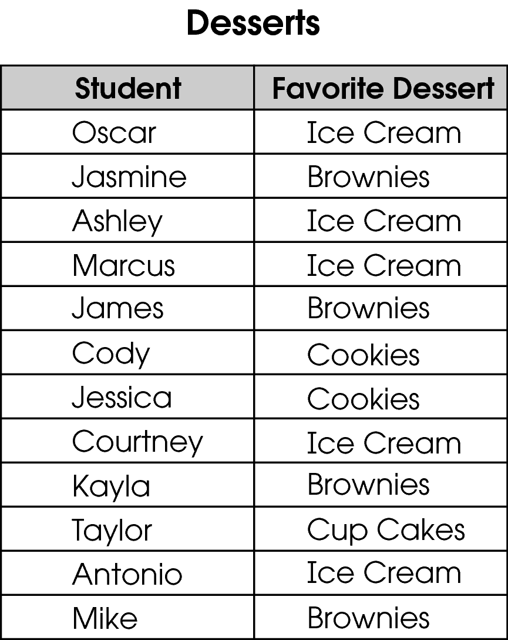
In your Answer Document, construct a frequency table to summarize the data. Be sure to include labels.

Commentary:
This short-answer question asks students to construct a frequency table to summarize the given data. The response earning the maximum number of points (2 points) provides a correct frequency table with appropriate labels. For example,

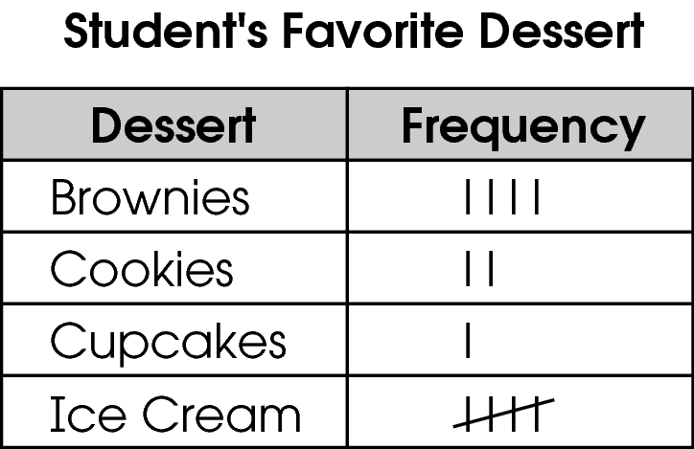

The complexity level of this question is Moderate Complexity. This task requires students to use a different representation.

Performance Data:
The percent of public school students earning each score point for question 29 on the March 2006 Grade 5 Achievement Test:

Percent at Each Score Point
0 | 1 | 2
66% | 16% | 16%

Scoring Guidelines:
Sample Correct Response(s):
- 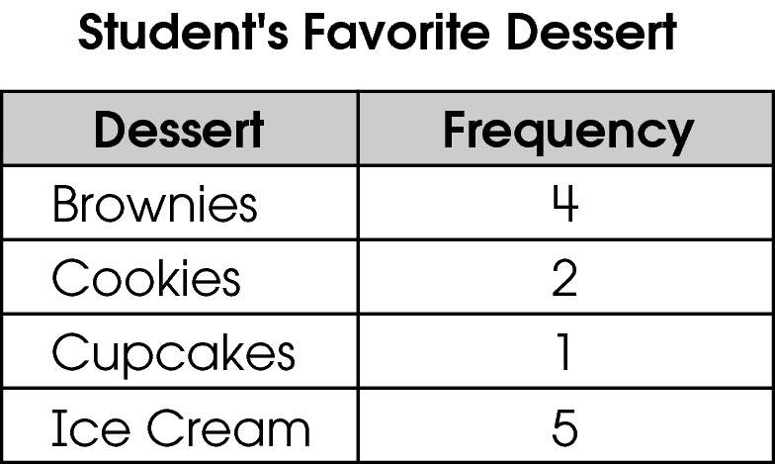
Points | Student Response
2 | The focus of this task is constructing a frequency table. The response includes an accurate frequency table that is labeled.
1 | The response provides partial evidence of constructing a frequency table; however the solution may be incomplete or slightly flawed.  For example, the response may:  - Provide a frequency table that does not accurately list the data shown in the table.  - Provide a correct frequency table with missing or flawed labels.
0 | The response provides inadequate evidence of constructing a frequency table. The response provides major flaws in reasoning or irrelevant information.  For example, the response may:  - Provide representation that does not meet the criteria of the task such as a graph.  - Be blank or state unrelated statements.  - Recopy information from the stem.
Keywords: data analysis, frequency table

BACK TO INDEX

Benchmark: E | Collect, organize, display, and interpret data for a specific purpose or need.
GLI: DAP 5.4 | Determine appropriate data to be collected to answer questions posed by students or teacher, collect and display data, and clearly communicate findings.

Multiple Choice Question:

32. Mr. Reid wants to know which dessert the students in his class like best.
Which data would not be shown in a graph of desserts the students like?
A. the price of the desserts
B. the dessert students like best
C. the number of students surveyed
D. the dessert students like second best

do not copy or distribute ID: 11289; Version: 8

Commentary:
This multiple-choice question asks students to determine which phrase describing the data category will not be shown in a graph of desserts student like. The data showing the price of the desserts, answer choice A, will not be shown in the graph about desserts students like best because the price would not necessarily determine whether students liked the dessert or not. The data from answer choices B, C and D would be shown in a graph about desserts students like best.

The complexity level of this question is Low Complexity. This question requires students to recognize an example of a concept.

Performance Data:
The percent of public school students selecting answer choice A for question 32 on the March 2006 Grade 5 Achievement Test was 76%.

Keywords: data analysis, graphical interpretation

BACK TO INDEX

Benchmark: F | Determine and use the range, mean, median and mode to analyze and compare data, and explain what each indicates about the data.
GLI: DAP 5.6 | Determine and use the range, mean, median and mode, and explain what each does and does not indicate about the set of data.

Multiple Choice Question:

43. This graph shows the high temperatures over five days in one week.
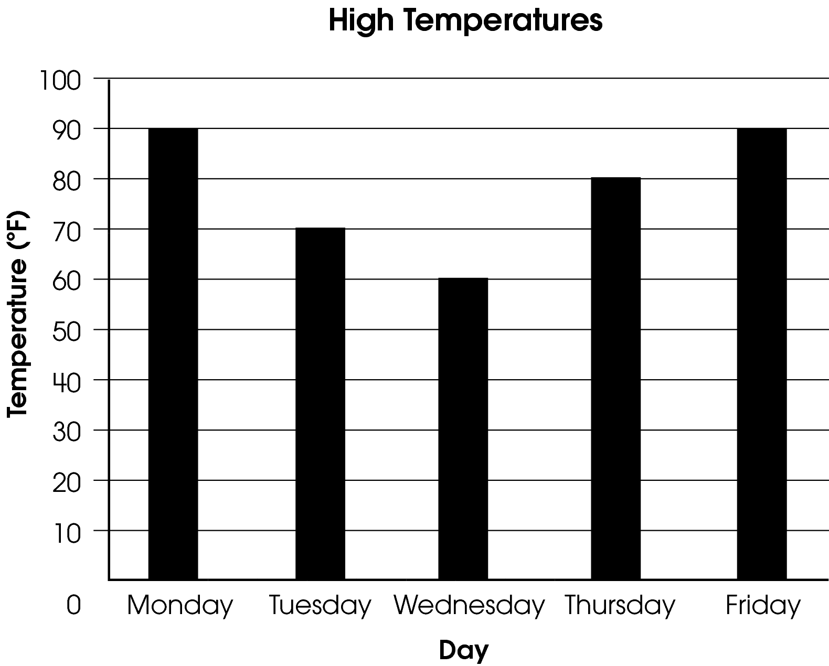
What is the range of the temperatures?
A. 0 degrees
B. 20 degrees
C. 30 degrees
D. 90 degrees

Commentary:
This multiple-choice question asks students to determine the range of the temperatures from the data presented in a bar graph. Students need to know that the range is the difference between the highest and lowest temperatures. The highest temperature is 90° and the lowest temperature is 60°. The difference between the temperatures is 30° (90° - 60° = 30°), answer choice C. Answer choices A, B and D are incorrect because they do not represent the difference between the highest and lowest temperatures. Answer choice A is the difference in the temperatures for Monday and Friday. In answer choice B, 20 degrees is the difference in the temperatures for Monday and Tuesday. Choice D is the mode because Monday and Friday both have high temperatures of 90°.

The complexity level of this question is Moderate Complexity. This question requires students to retrieve information from a graph and use it to solve a problem.

Performance Data:
The percent of public school students selecting answer choice C for question 43 on the March 2006 Grade 5 Achievement Test was 53%.

Keywords: data analysis, range

BACK TO INDEX

Benchmark: D | Compare increasingly complex displays of data, such as multiple sets of data on the same graph.
GLI: DAP 5.3 | Read and interpret increasingly complex displays of data, such as double bar graphs.

Multiple Choice Question:

3. Shelly recorded the amount of time she spent waiting at the bus stop on several days over two weeks.
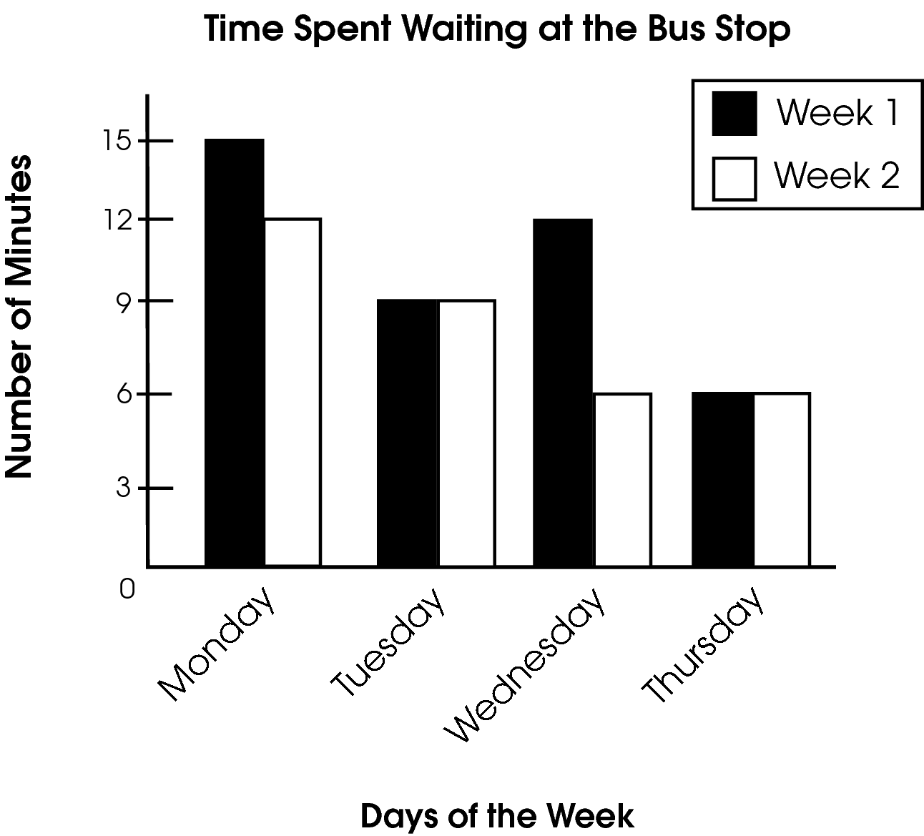
How much more time did Shelly spend waiting at the bus stop during Week 1 than Week 2?

A. Shelly waited the same amount of time in both weeks.
B. Shelly waited 3 more minutes in Week 1.
C. Shelly waited 6 more minutes in Week 1.
D. Shelly waited 9 more minutes in Week 1.

Commentary:
This multiple-choice question asks students to interpret a double bar graph to answer a question. Students need to analyze the information provided in the graph and compare the differences in time between waiting at the bus stop in Week 1 and Week 2. Students can solve this problem in various ways. First, students need to find the total time spent waiting at the bus stop for Week 1, 42 minutes (15 + 9 + 12 + 6) and for Week 2, 33 minutes (12 + 9 + 6 + 6). Then, they should subtract the times to compare Week 1 and Week 2. Students should find that 9 more minutes (42 – 33) was spent waiting for the bus in Week 1 than in Week 2. Therefore, answer choice D is correct.

Students can also determine from the graph that the times waiting for the bus on Tuesday and Wednesday in Week 1 and Week 2 stayed the same. They can then determine the difference in the time for Monday and Wednesday in Week 1 and Week 2. The difference for Monday is 3 minutes (15 minutes – 12 minutes = 3 minutes). The difference for Wednesday is 6 minutes (12 minutes – 6 minutes = 6 minutes). The total time in waiting for the bus on Monday and Wednesday is 9 minutes (3 minutes + 6 minutes – 9 minutes).

Answer choices A, B and C are incorrect since all of the days in the graph may not have been used to make the comparison, or they may have only looked at the difference in time spent for one of the days.

The complexity level of this question is Moderate Complexity. This question requires students to retrieve information from a graph and use it to solve a problem requiring multiple steps.

Performance Data:
The percent of public school students selecting answer choice D for question 3 on the May 2007 Grade 5 Achievement Test was 62%.

Keywords: data analysis, double bar graph

BACK TO INDEX

Benchmark: K | Make and justify predictions based on experimental and theoretical probabilities.
GLI: DAP 5.11 | Make predictions based on experimental and theoretical probabilities.

Multiple Choice Question:

6. Samantha has different-colored buttons in a bag. The probabilities of picking each color are shown in the table.
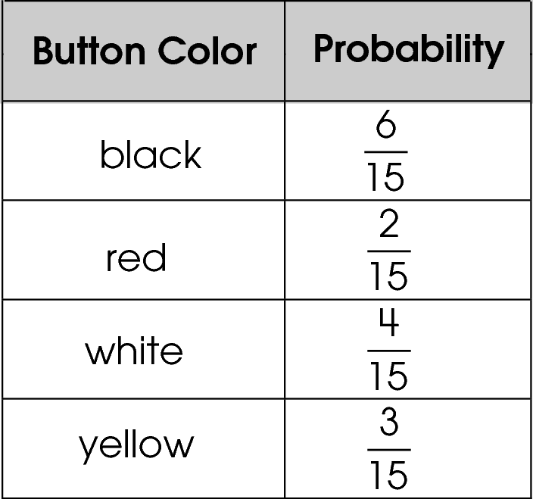
Samantha picks a button without looking in the bag.
Which color is she least likely to pick from the bag?

A. black
B. red
C. white
D. yellow

Commentary:
This multiple-choice question asks students to determine the color of a button that is least likely to be picked from a bag based on the probabilities given in a table. Students need to associate the probability of the outcome of an event with the likelihood of the outcome. The likelihood of an event least likely to happen will have the least probability. In the table, picking a red button has the least probability, which is$\frac{2}{\text{15}}$. Therefore, answer choice B is correct.
Answer choices A, C and D are incorrect because the probability for picking a button for those colors is greater than the probability of picking a red button.
The complexity level of this question is Moderate Complexity. This question requires students to retrieve information from a table and use it to solve a problem.

Performance Data:
The percent of public school students selecting answer choice B for question 6 on the May 2007 Grade 5 Achievement Test was 81%.

Keywords: probability, likelihood

BACK TO INDEX

Benchmark: A | Read, create and use line graphs, histograms, circle graphs, box-and-whisker plots, stem-and–leaf plots, and other representations when appropriate.
GLI: DAP 5.1 | Read, construct and interpret frequency tables, circle graphs and line graphs.

Multiple Choice Question:

12. Jim created a table of the different types of music in his CD collection.
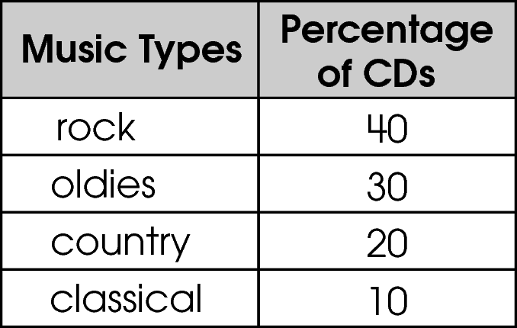

He started to create the circle graph shown to represent these data.
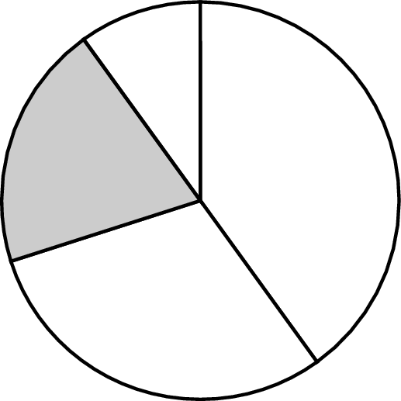
What type of music does the shaded section represent?

A. rock
B. oldies
C. country
D. classical

Commentary:
This multiple-choice question asks students to determine the type of music represented by the shaded area in a circle graph by using the data given in a table. Students need to relate the area of the parts in the circle graph to the percentage of CDs of the CD collection. Students should examine the circle graph and recognize that the shaded region is the third largest section.

Rock music, answer choice A, is represented by the largest area in the circle graph since 40% is the largest percentage of the CD collection. Answer choice D, classical music, represents 10% of the collection and is the smallest section of the circle graph. The area for the oldies, represented by 30%, answer choice B, is smaller than the area for rock music, but larger than the area for classical music. Therefore, the shaded section of the circle graph representing country music (20%), answer choice C, is correct.

classical
classical

rock
country

oldies

The complexity level of this question is Moderate Complexity. This question requires students to interpret a visual representation.

Performance Data:
The percent of public school students selecting answer choice C for question 12 on the May 2007 Grade 5 Achievement Test was 88%.

Keywords: data analysis, circle graphs, percents

BACK TO INDEX

Benchmark: A | Read, create and use line graphs, histograms, circle graphs, box-and-whisker plots, stem-and leaf plots, and other representations when appropriate.
GLI: DAP 5.1 | Read, construct and interpret frequency tables, circle graphs and line graphs.

Extended Response Question:

33. The height of a maple tree is recorded for each of 5 years in the table shown.
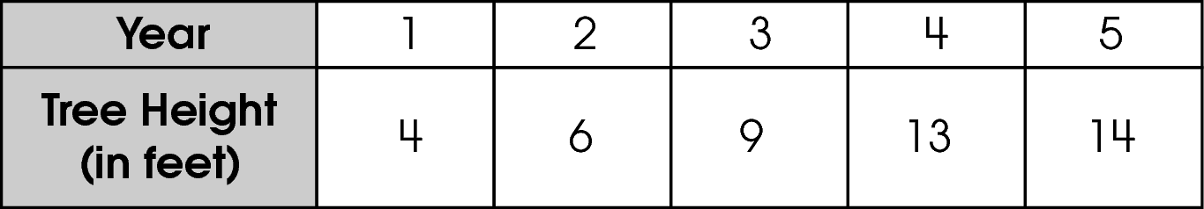
Chris displays the data in the circle graph shown.
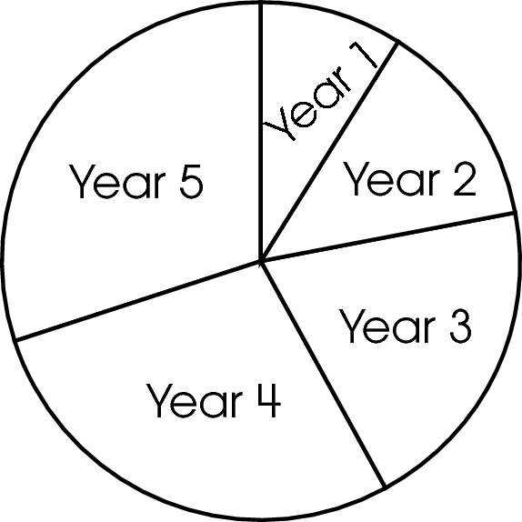
In your Answer Document, explain why Chris’ circle graph is not an appropriate way to display the data.
Create an appropriate graph to display the data shown in the table. Be sure to give your graph a title, labels and a scale.
Explain why your graph is a better way to display the data. (4 points)

Commentary:
This extended-response question asks students to explain why a circle graph is not an appropriate way to display the heights of a maple tree for 5 years. Students are also asked to create an appropriate graph to display the data and to explain why their graph is a better way to display the heights of the maple tree for 5 years. The response earning the maximum number of points (4 points) provides an adequate explanation as to why a circle graph is an inappropriate way to display the heights of a maple tree for 5 years; such as, a circle graph does not show the tree’s growth over time. The response also provides an accurate line graph displaying the given data, complete with a title, labels and a scale, as well as an adequate explanation of why the line graph is a better way to display the data; such as, the line graph shows the tree’s growth over time.

A circle graph shows a comparison of parts to the whole. The best way to show the growth of a maple tree is to use a line graph. A line graph shows change over time.
A line graph should include: a title (“Maple Tree Growth”), labels on the horizontal axis (“Year”), and the vertical axis (“Height in Feet”). The scale (the numbers that describe the intervals on the horizontal and vertical axes) should start at 0, and each line on the graph represents an interval. The numbers used for each interval should be placed on the graph lines, not between the lines. The scale for the number of years starts at 0 and increases to 5 since the data for the years are for years 1 through 5. Also, the height of the trees ranged from 4 feet to 14 feet; therefore, the numbers for the height should start at 0 and increase to at least 14. So, the scale should start with 0 and each interval should increase by 1, 2 or 4. In the exemplar graphic, the intervals for “Year” increases by 1s and the “Height” in feet increases by 2s.

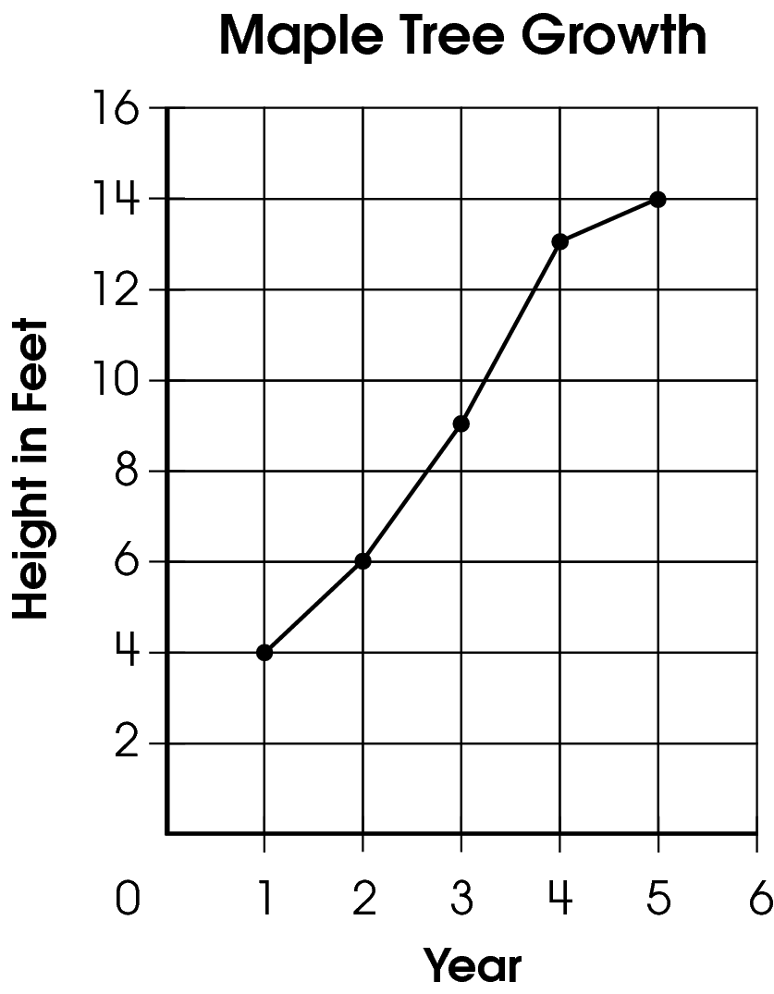

The complexity level of this question is Moderate Complexity. This task requires students to provide a justification for a situation and to use different representations depending on the situation.

Performance Data:
The percent of public school students earning each score point for question 33 on the May 2007 Grade 5 Achievement Test:

Percent at Each Score Point
0 | 1 | 2 | 3 | 4
43% | 30% | 16% | 7% | 4%

Scoring Guidelines:
Exemplar Response:

- Chris’ circle graph is not appropriate since there is no part to whole relationship with the maple tree data. The line graph is better since it shows growth over time.
Other Correct Response(s):

Points | Student Response
4 point text | The focus of this task is explaining why a circle graph is not an appropriate graph to display the given data and creating a graph that is appropriate for the type of data to be displayed. The response provides an adequate explanation for why Chris’ circle graph is not an appropriate way to display the data. The response also provides an accurate line graph displaying the data in the table complete with a title, labels and a scale, as well as an adequate explanation of why the line graph is a better way to display the data.  NOTE: An acceptable reason for why Chris’ graph is not appropriate is that there are no percents used in the data.
3 point text | The response provides evidence of explaining why a circle graph is not an appropriate graph to display the given data and creating a graph that is appropriate for the type of data to be displayed; however, the solution may contain a slight error, a flaw or a vague explanation.
3 point text | 3 point sample answer:  For example, the response may:  - Provide an accurate line graph with an adequate explanation of why this is a good way to represent this data. Chris’ graph is addressed inappropriately.  - State an adequate reason why Chris’ graph is inappropriate and state an adequate reason why a line graph is better. The line graph may be missing labels, a title and/or have only 4 data points correctly plotted (minor errors).
2 point text | The response provides partial evidence of explaining why a circle graph is not an appropriate graph to display the given data and creating a graph that is appropriate for the type of data to be displayed; however, the solution is incomplete and/or contains minor flaws.
2 point text | 2 point sample answer:  For example, the response may:  - Provide an adequate reason why Chris’ graph is inappropriate and state an adequate reason why a line graph is better but have a line graph with multiple errors, such as plotting the data.  - Provide an accurate line graph with an inadequate or missing explanation of why this is a good way to represent these data. Chris’s graph is not addressed or is incorrectly addressed.
1 point text | The response provides minimal evidence of explaining why a circle graph is not an appropriate graph to display the given data and creating a graph that is appropriate for the type of data to be displayed. The response has major flaws and errors in reasoning.
1 point text | 1 point sample answer:  For example, the response may:  - Provide a line graph that has multiple errors such as errors in plotting the data and does not address Chris’ graph or why the line graph is a better way to display the data.  - Provide an adequate reason why Chris’ graph is inappropriate.  - Provide an adequate reason why a line graph is a better graph to be used with this data.
0 point text | The response provides inadequate evidence of explaining why a circle graph is not an appropriate graph to display the given data and creating a graph that is appropriate for the type of data to be displayed. The response provides major flaws in explanations or irrelevant information.
0 point text | 0 point sample answer:  For example, the response may:  - Provide an inappropriate graph, such as a bar graph.  - Provide an inadequate reason such as, “Chris’ graph is a great graph for these data.”  - Restate the information provided in the item.  - Be blank or state irrelevant information.

Keywords: data analysis, circle graph, line graph

BACK TO INDEX

Benchmark: I | Describe the probability of an event using ratios, including fractional notation.
GLI: DAP 5.8 | Identify the probability of events within a simple experiment, such as three chances out of eight.

Multiple Choice Question:

32. Margo has 3 blue marbles, 4 green marbles and 5 red marbles in a bag. She randomly selects 1 marble.
What is the probability that the marble is green or red?

A. $\frac{1}{\text{12}}$
B. $\frac{4}{\text{12}}$
C. $\frac{5}{\text{12}}$
D. $\frac{9}{\text{12}}$
Commentary:
This multiple-choice question asks students to determine the probability of selecting a green or red marble from a bag of marbles. Students need to determine the total number of marbles in the bag and also the number of green or red marbles in the bag. There are 12 marbles in the bag and 9 of these marbles are green (4) or red (5). Therefore, the probability of selecting 1 marble that is green or red would be 9 out of 12. The probability can be written as $\frac{9}{\text{12}}$, answer choice D.

Answer choices A, B and C are incorrect. Answer choice A is the probability of selecting 1 particular marble out of the 12 marbles. Answer choice B is the probability of selecting a green marble. Answer choice C is the probability of selecting a red marble.

The complexity level of this question is Moderate Complexity. The question requires students to solve a word problem requiring multiple steps.

Performance Data:
The percent of public school students selecting answer choice D for question 32 on the May 2008 Grade 5 Achievement Test was 69%.

Keywords: probability

BACK TO INDEX

Benchmark: A | Read, create and use line graphs, histograms, circle graphs, box-and-whisker plots, stem-and leaf plots, and other representations when appropriate.
GLI: DAP 5.1 | Read, construct and interpret frequency tables, circle graphs and line graphs.

Multiple Choice Question:

36. John created the graph shown to represent his height over time.
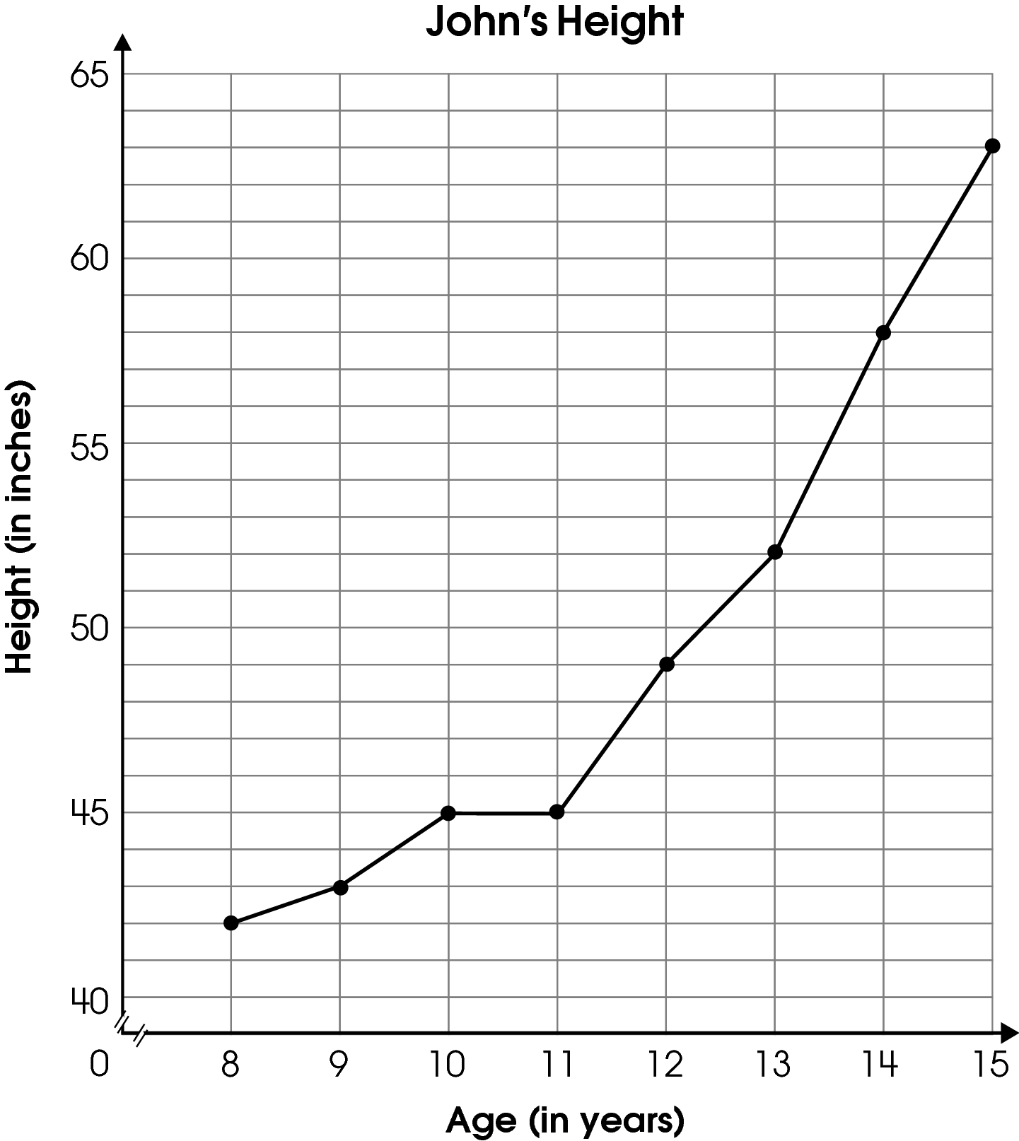

Which statement is true about the graph?

A. John grew the most between ages 12 and 13.
B. John grew the most between ages 13 and 14.
C. John grew the least between ages 14 and 15.
D. John did not grow at all between ages 9 and 10.

Commentary:
This multiple-choice question asks students to select the statement which is true about the line graph showing height over time. Students need to determine how much John grew between two ages. Answer choice B is correct because John grew 6 inches (58 inches – 52 inches ) between ages 13 and 14. John’s growth of 6 inches between ages 13 and 14 is the greatest growth which makes this statement true.

Answer choice A is not a true statement because John only grew 3 inches which is less than 6 inches. Answer choice C is not a true statement because John grew 5 inches between ages 14 and 15 and he grew only 1 inch between ages 8 and 9 which is the least growth. Answer choice D is not a true statement because there was growth between the ages of 9 and 10, but not between the ages of 10 and 11.

The complexity level of this question is Moderate Complexity. The question requires students to interpret a visual representation.

Performance Data:
The percent of public school students selecting answer choice B for question 36 on the May 2008 Grade 5 Achievement Test was 74%.

Keywords: data analysis, line graph

BACK TO INDEX

Benchmark: J | Compare experimental and theoretical results for a variety of simple experiments.
GLI: DAP 5.10 | Compare what should happen (theoretical/expected results) with what did happen (experimental/actual results) in a simple experiment.

Multiple Choice Question:

41. Craig tossed a coin 16 times. The coin landed on heads 6 times.
How does the number of heads Craig obtained compare with the number of heads expected?

A. 1 fewer head than expected
B. 2 fewer heads than expected
C. 10 fewer heads than expected
D. exact amount

Commentary:
This multiple-choice question asks students to compare the number of times a coin landed on heads with the number of heads expected when a coin is tossed 16 times. Students should know that half of the time a coin will land on heads and half of the time it will land on tails. Since the coin was tossed 16 times, it should be expected to land on heads half of the time or 8 times. The coin landed two fewer times than expected (8 – 6 = 2). Answer choice B is correct.

Answer choices A, C and D are incorrect. The comparisons do not reflect what happened when the coin landed on heads 6 times and the number of times the coin was expected to land on heads. Answer choice A is the result of expecting 7 to be the number of times the coin landed on heads is 7. Answer choice B is the result of subtracting the number of times the coin landed on heads from the number of times the coin was tossed (16 – 6 = 10). Answer choice D is the result of students thinking the number of times the coin landed on heads is the number of times the coin is expected to land on heads.

The complexity level of this question is Moderate Complexity. The question requires students to compare statements.

Performance Data:
The percent of public school students selecting answer choice B for question 41 on the May 2008 Grade 5 Achievement Test was 47%.

Keywords: probability, experimental probability, theoretical probability

BACK TO INDEX

