Index to Questions

Question Number | Source | BM | GLI | Description
2 | OAT Mar 06 | A | DAP 4.1 | This multiple-choice question asks students to select the first phase of a data collection plan.
8 | OAT Mar 06 | H | DAP 4.11 | This multiple-choice question asks students to select the spinner that has a probability of 0 for landing on a star.
20 | OAT Mar 06 | E | DAP 4.8 | This extended-response question asks students to calculate the range, the median and the mode for the height of the boys and the height of the girls, and to make a comparison using one of the measures.
27 | OAT Mar 06 | D | DAP 4.2 | This multiple-choice question asks students to interpret a bar graph to find how many more people visited the first-aid station in July than in May.
30 | OAT Mar 06 | F | DAP 4.9 | This multiple-choice question asks students to select the colors listed in order from the least likely picked to the most likely picked.
37 | OAT Mar 06 | E | DAP 4.6 | This multiple-choice question asks students to find the true statement by interpreting the data shown on the line plot.
46 | OAT Mar 06 | G | DAP 3.10 | This multiple-choice question asks students to select all of the different combinations of one flower and one vegetable from two flowers and two vegetables.
8 | OAT May 07 | E | DAP 4.6 | This multiple-choice question asks students to define the range of a set of data. The range is the difference between the greatest and the smallest numbers in a set of data.
15 | OAT May 07 | G | DAP 4.13 | This short-answer question asks students to create a list of all possible combinations of one notebook and one color pen that Raymond could take from his backpack.
28 | OAT May 07 | B | DAP 4.2, DAP 4.4 | This multiple-choice question asks students to compare two different graphical representations.
35 | OAT May 07 | C | DAP 4.3 | This multiple-choice question asks students to select the Venn diagram that represents the given information.
4 | OAT May 08 | G | DAP 4.13 | This multiple-choice question asks students to identify a combination of ingredients for a sandwich using the choices for bread, meat and cheese, and a preference for a sandwich without chicken or cheddar cheese.
Question Number | Source | BM | GLI | Description
7 | OAT May 08 | B | DAP 4.2 | This multiple-choice question asks students to select the table that represents the data in the given line graph.
12 | OAT May 08 | F | DAP 4.10 | This multiple-choice question asks students to choose the likelihood of this event: a penny is tossed five times and lands on heads all 5 times.
26 | OAT May 08 | F | DAP 4.10 | This multiple-choice question asks students to determine the likelihood of a spinner landing on different sections of a circular spinner.

BACK TO INDEX

Benchmark: A | Gather and organize data from surveys and classroom experiments, including data collected over a period of time.
GLI: DAP 4.1 | Create a plan for collecting data for a specific purpose.

Multiple Choice Question:

2. Alan will be gathering data about the temperature.
Which part of Alan’s data collection plan should come first?
A. create a graph to display the data
B. record the data
C. choose a place and time to collect the data each day
D. interpret the data

do not copy or distribute ID: 10043; Version: 17

Commentary:
This multiple-choice question asks students to select the first phase of a data collection plan. Choosing a place and time when collecting data is the first stage of the process, therefore answer choice C is the correct answer. Answer choices A, B and D can be eliminated because phases such as recording the data, creating a graph to display the data and interpreting the data come after collecting the data.

The complexity level of this question is Low Complexity. This question requires students to recognize a process for collecting data.

Performance Data:
The percent of public school students selecting answer choice C for question 2 on the March 2006 Grade 4 Achievement Test was 52%.

Keywords: data analysis, data collection plan

BACK TO INDEX

Benchmark: H | Use the set of possible outcomes to describe and predict events.
GLI: DAP 4.11 | Relate the concepts of impossible and certain-to-happen events to the numerical values of 0 (impossible) and 1 (certain).

Multiple Choice Question:

8. Which spinner has a probability of 0 for landing on a star, ?
A. 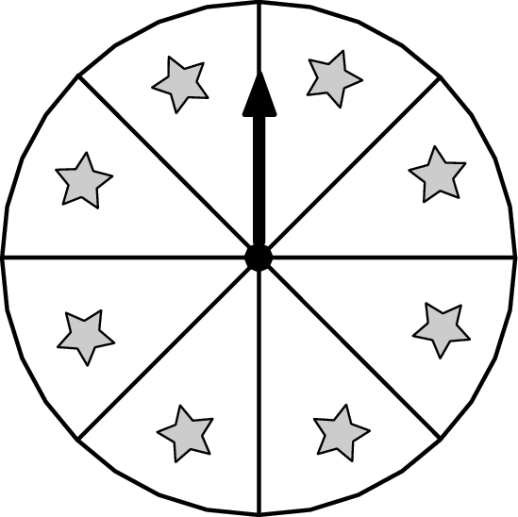
B. 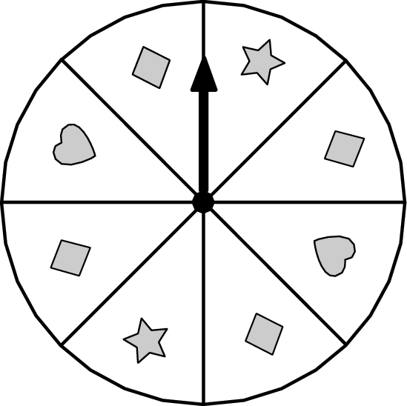
C. 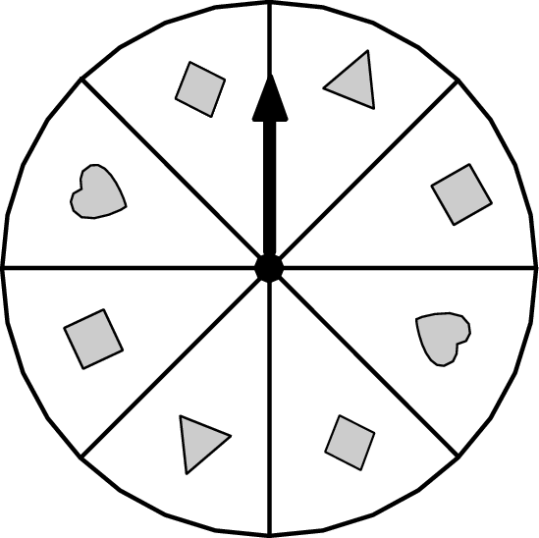
D. 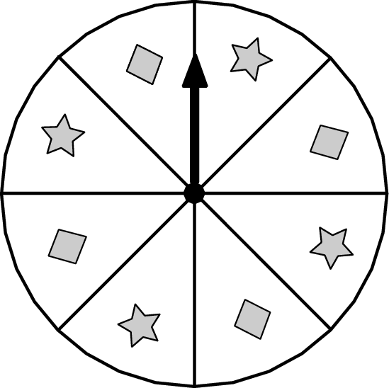
Commentary:
This multiple-choice question asks students to select the spinner that has a probability of 0 for landing on a star, . The correct answer is choice C because this spinner has no stars () on it. Therefore, the probability for landing on a star on this spinner equals to 0.
All of the other spinners in answer choices A, B and D have stars (), so the probability for landing on stars () is not equal to 0. Therefore, answer choices A, B and D are incorrect.

The complexity level of this question is Moderate Complexity. This question requires students to compare and interpret visual representations.

Performance Data:
The percent of public school students selecting answer choice C for question 8 on the March 2006 Grade 4 Achievement Test was 87%.

Keywords: data analysis, probability, spinner

BACK TO INDEX

Benchmark: E | Describe data using mode, median and range.
GLI: DAP 4.8 | Use range, median and mode to make comparisons among related sets of data.

Extended Response Question:

- Reuben recorded the heights of 7 boys and 7 girls in his class in the table shown.

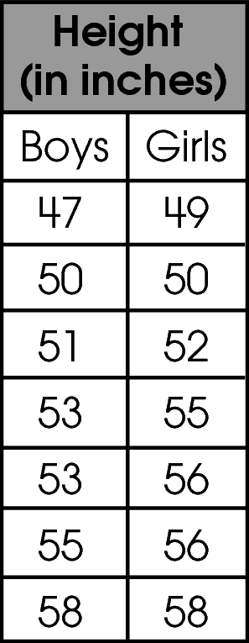
Calculate the range, the median and the mode for the height of the boys and for the height of the girls.
Range:
Boys________________________________________________
Girls_________________________________________________
Median:
Boys________________________________________________
Girls_________________________________________________
Mode:
Boys________________________________________________
Girls_________________________________________________

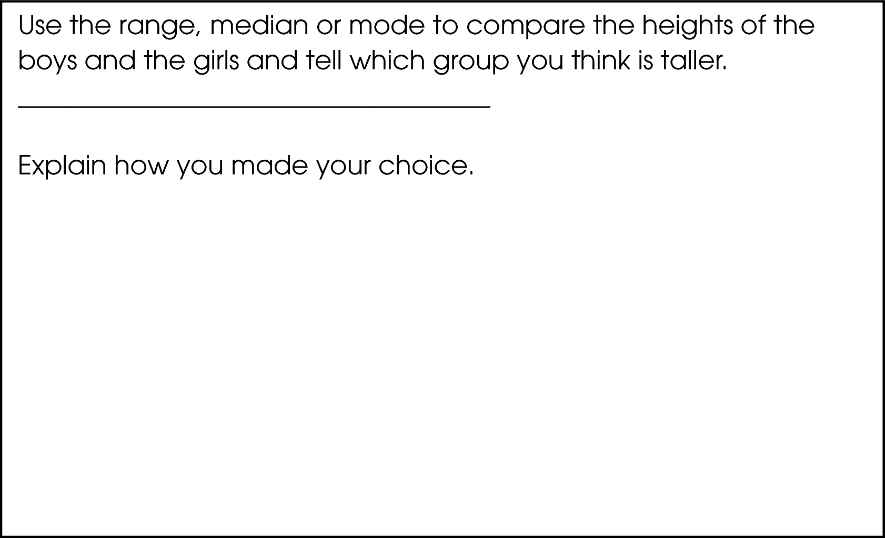

Commentary:
This extended-response question asks students to calculate the range, the median and the mode for the height of the boys and the height of the girls, and to make a comparison using one of the measures. A response earning the maximum number of points (4 points) shows the correct range, median and mode for the girls and the boys, and an adequate explanation of which group of students is taller. Students are provided with the heights of 7 boys and 7 girls in a table. The range of the boys’ data is 11 inches (58 – 47 = 11) and the range of the girls’ data is 9 inches (58 – 49 = 9). The median of the boys’ data is 53 inches and the median of the girls’ data is 55 inches. The mode of the boys’ data is 53 inches and the mode of the girls’ data is 56 inches. One way to compare the girls’ height is to state that the girls are taller because the tallest girl is just as tall as the tallest boy and the range is smaller for the girls. The other possible way to compare the girls’ height is to state the median height of the girls is higher, so half of the girls are taller than 55 inches and half of the boys are taller than 53 inches.

The complexity level of this question is High Complexity. The task requires students to provide a mathematical justification and make an adequate comparison about the data.

Performance Data:
The percent of public school students earning each score point for question 20 on the March 2006 Grade 4 Achievement Test:

Percent at Each Score Point
0 | 1 | 2 | 3 | 4
19% | 16% | 19% | 30% | 15%

Scoring Guidelines:
Sample Correct Response(s):
- Range: boys 58 – 47 = 11, girls 58 – 49 = 9
Median: boys = 53, girls = 55
Mode: boys = 53, girls = 56
The girls are taller because the tallest girl is just as tall as the tallest boy and the range is smaller for the girls. OR The median height of the girls is higher, so half of the girls are taller than 55 inches and half of the boys are taller than 53 inches.
Points | Student Response
4 | The focus of the task is calculating relevant statistics for two sets of data and making and explaining a conclusion based on the statistics. The response provides a correct range for the girls and the boys, a correct median for the girls and the boys, a correct mode for the girls and the boys, and an accurate explanation of which group is taller.
3 | The response provides evidence of calculating relevant statistics for two sets of data and making and explaining a conclusion based on the statistics; however, the solution may contain a slight error, a flaw or a vague explanation.  For example, the response may:  - Provide two out of the three correct statistics and provide an accurate explanation of the tallest group based on the statistics as provided.  - The response correctly determines the range, median, and mode, but does not give an explanation, or uses a flawed reasoning to explain which group is taller.
2 | The response provides partial evidence of calculating relevant statistics for two sets of data and making and explaining a conclusion based on the statistics; however, the solution is incomplete and/or contains minor flaws.  For example, the response may:  - Incorrectly determine two of the statistics but provides a reasonable explanation for which group is taller.  - Have multiple calculation errors in determining the range, median and mode but includes an explanation that uses only slightly flawed reasoning.
1 | The response provides minimal evidence of calculating relevant statistics for two sets of data and making and explaining a conclusion based on the statistics. The response has major flaws and errors in reasoning.  For example, the response may:  - Incorrectly determine 2 out of the 3 statistics and provide an explanation based on flawed reasoning or omit an explanation.
0 | The response provides inadequate evidence of calculating relevant statistics for two sets of data and making and explaining a conclusion based on the statistics.  For example, the response may:  - Incorrectly determine all of the statistics OR make multiple errors and provide a completely flawed or unrelated explanation.  - Provide unrelated statements.

Keywords: data analysis, range, median, mode

BACK TO INDEX

Benchmark: D | Read, interpret and construct graphs in which icons represent more than a single unit or intervals greater than one.
GLI: DAP 4.2 | Represent and interpret data using tables, bar graphs, line plots and line graphs.

Multiple Choice Question:

- The bar graph shows the number of people who visited the first-aid station at Holden Creek State Park each month last summer.
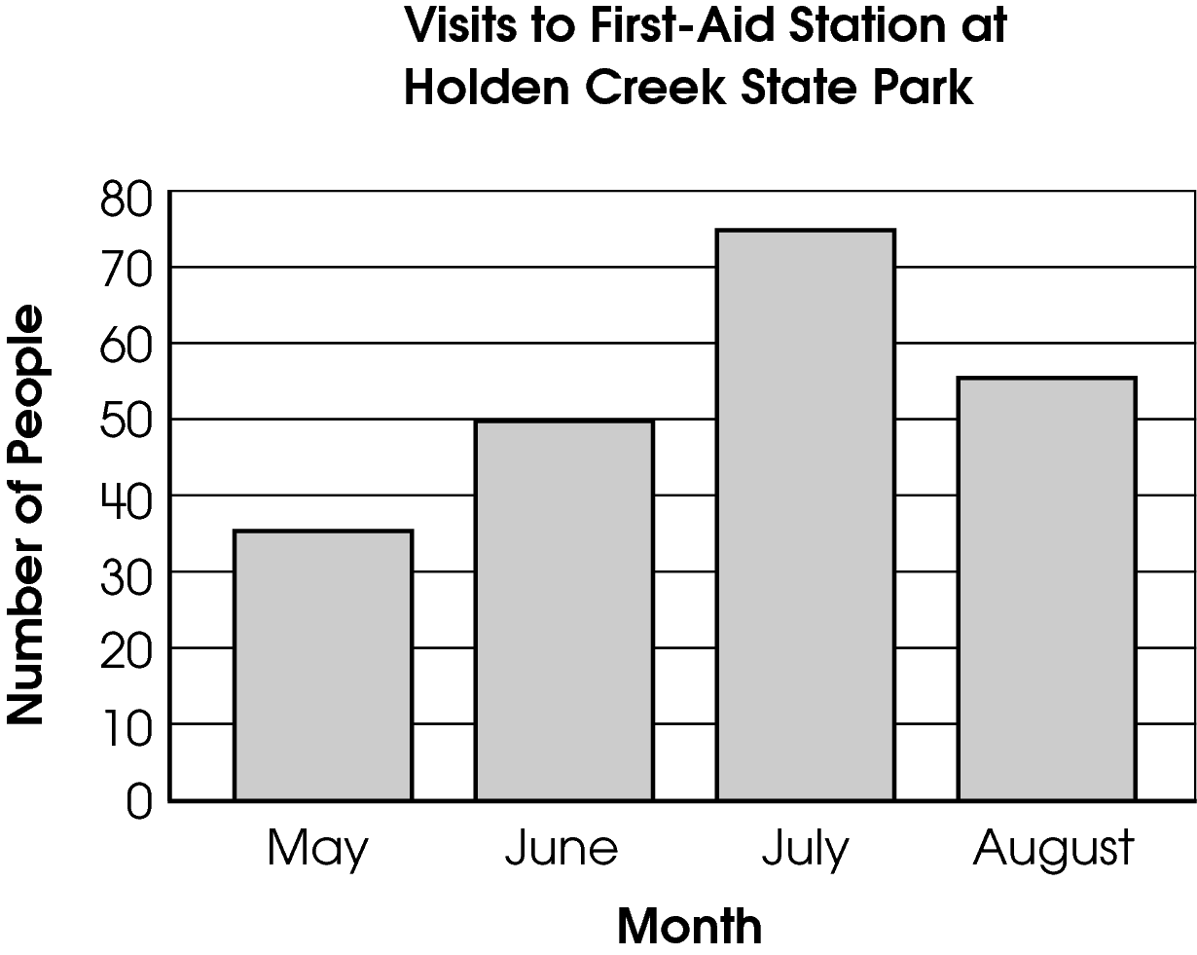
How many more people visited the first-aid station in July than in May?
A. 15 people
B. 20 people
C. 40 people
D. 110 people

Commentary:
This multiple-choice question asks students to interpret a bar graph to find how many more people visited the first-aid station in July than in May. The bar for July indicates that the number of visitors is about 75 people and the bar for May indicates that the number of visitors is about 35 people. To find how many more people visited the first-aid station in July then in May students have to subtract 35 from 75 (75 – 35 = 40). The correct answer choice is C. Answer choices A, B and D are incorrect. Answer choice A represents the difference between the number of visitors in May and June, answer choice B represents the difference between the number of visitors in May and August, and answer choice D represents the difference between the number of visitors in May and July.

The complexity level of this question is Moderate Complexity. The question requires students to retrieve information from a graph and use it to solve a problem.

Performance Data:
The percent of public school students selecting answer choice C for question 27 on the March 2006 Grade 4 Achievement Test was 78%.

Keywords: data analysis, bar graph

BACK TO INDEX

Benchmark: F | Conduct a simple probability experiment and draw conclusions about the likelihood of possible outcomes.
GLI: DAP 4.9 | Conduct simple probability experiments and draw conclusions from the results; e.g., rolling number cubes or drawing marbles from a bag.

Multiple Choice Question:

30. The table shows the number of different-colored tiles Anita placed in a bag.
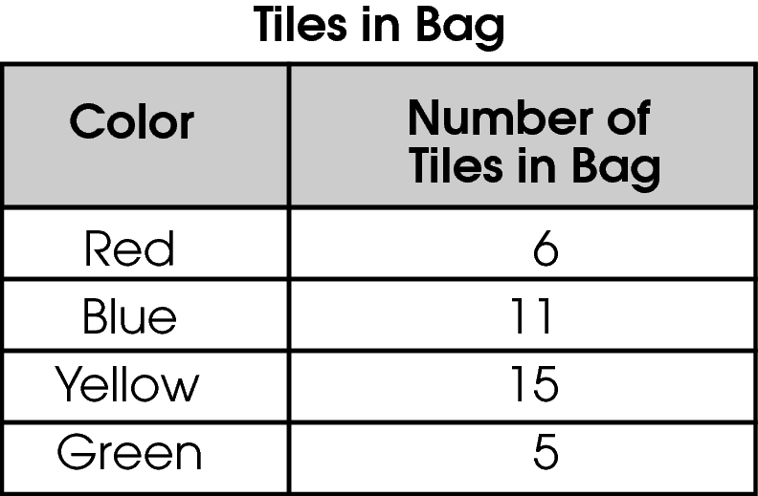
Anita picked one tile from the bag without looking.
Which shows the colors listed in order from the least likely to be picked to the most likely?
A. green, red, yellow, blue
B. green, red, blue, yellow
C. yellow, blue, green, red
D. red, blue, yellow, green

do not copy or distribute ID: 9668; Version: 6

Commentary:
This multiple-choice question asks students to select the colors listed in order from the least likely picked to the most likely picked. Answer choice B is the correct answer because the likelihood of selecting a color can be determined by arranging the color of the tiles from the least number to the greatest. This order goes from 5 green tiles to 6 red tiles, then to 11 blue tiles, and ends with 15 yellow tiles. Answer choices A, C and D can be eliminated because they do not list the colors in order from the least number of tiles to the greatest number of tiles.

The level of complexity for this question is Moderate Complexity. The question requires students to retrieve information from the table and use it to solve a problem.

Performance Data:
The percent of public school students selecting answer choice B for question 30 on the March 2006 Grade 4 Achievement Test was 82%.
Keywords: data analysis, likelihood, probability

BACK TO INDEX

Benchmark: E | Describe data using mode, median and range.
GLI: DAP 4.6 | Describe the characteristics of a set of data based on a graphical representation, such as range of the data, clumps of data, and holes in the data.

Multiple Choice Question:

37. Andrea made a line plot of the ages of children at summer camp.
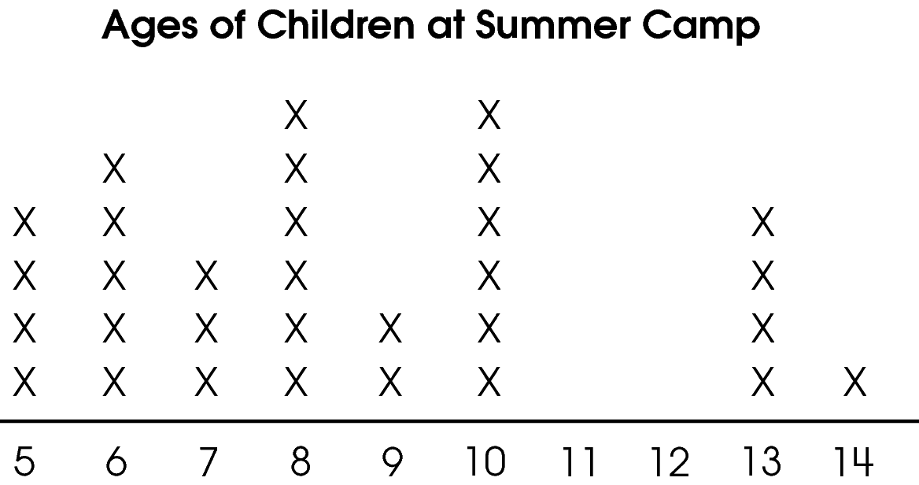
Which is true about the data in the line plot?

A. The data are spread out evenly.
B. The data have a hole between 10 and 13.
C. There is a clump of data between 10 and 13.
D. The range and the median are the same.

do not copy or distribute ID: 10296; Version: 6

Commentary:
This multiple-choice question asks students to find the true statement by interpreting the data shown on the line plot. The correct answer is answer choice B. Students may look across the number line, notice the absence of (x’s) above numbers 11 and 12, and then find a match for it in answer choice B. Answer choice A can be eliminated because if the data are spread out evenly there would be the same number of (x’s) above each number on the line plot. Answer choice C is incorrect because students confused clump and hole. Answer choice D is also incorrect because the range of the data is 9 (14 – 5 = 9) and the median of the data is 8 (the middle number from the list of all numbers)

The complexity level of this question is Moderate Complexity. This question requires students to interpret a visual representation.

Performance Data:
The percent of public school students selecting answer choice B for question 37 on the March 2006 Grade 4 Achievement Test was 62%.

Keywords: data analysis, line plot, hole in the data, clumps of data

BACK TO INDEX

Benchmark: G | Identify and represent possible outcomes, such as arrangements of a set of up to four members and possible combinations from several sets, each containing 2 or 3 members.
GLI: DAP 3.10 | Use physical models, pictures, diagrams and lists to solve problems involving possible arrangements or combinations of two to four objects.

Multiple Choice Question:

46. Calvin plans to plant one type of flower and one type of vegetable in his garden. He chooses the plants from the table shown.
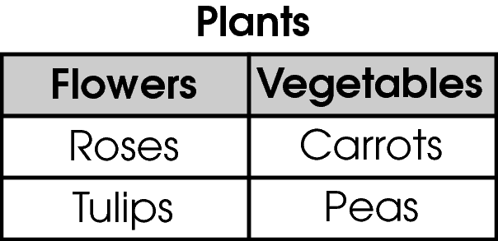
Which list shows all the different combinations of one flower and one vegetable that Calvin can plant?
A. roses and carrots, roses and peas
B. roses and carrots, roses and peas, tulips and carrots, tulips and peas
C. roses and carrots, tulips and peas, roses and tulips, carrots and peas
D. roses and carrots, roses and peas, roses and tulips, tulips and carrots, tulips and peas, carrots and peas

do not copy or distribute ID: 9478; Version: 9

Commentary:
This multiple-choice question asks students to select all of the different combinations of one flower and one vegetable from two flowers and two vegetables. Students may approach the problem by listing all of the possible combinations of one flower and one vegetable (roses and carrots, roses and pears, tulips and carrots, tulips and pears). Therefore, the correct answer is B because it has the four different combinations of one flower and one vegetable. Answer choice A is incorrect because it is incomplete and consists only of two combinations out of four possible combinations. Answer choices C and D are also incorrect because they both include combinations of two flowers and two vegetables instead of one flower and one vegetable.

The level of complexity for this question is Moderate Complexity. The task asks students to retrieve information from a table and use it to solve a problem.

Performance Data:
The percent of public school students selecting answer choice B for question 48 on the March 2006 Grade 4 Achievement Test was 65%.
Keywords: data analysis, combinations

BACK TO INDEX

Benchmark: E | Describe data using mode, median and range.
GLI: DAP 4.6 | Describe the characteristics of a set of data based on a graphical representation, such as range of the data, clumps of data, and holes in the data.

Multiple Choice Question:

8. Fred recorded the heights, in inches, of the students in his class. The range of the data was 15.
Which statement is true about Fred’s data?

A. Fred found that 15 students are all the same height.
B. The height of the shortest student is 15 inches.
C. Fred recorded the heights of 15 students in his class.
D. The tallest student is 15 inches taller than the shortest student.

Commentary:
This multiple-choice question asks students to define the range of a set of data. The range is the difference between the greatest and the smallest numbers in a set of data. The range of the data is 15 and the difference between the height of the tallest student and the height of shortest student is 15 inches. Therefore, answer choice D is correct.

Students, who chose answer choice A, may have confused the range of a set of data with the number of times the same height appears in a set of data. Students, who chose answer choice B, may have thought that the range is the smallest number in the data set. Students, who chose answer choice C, may have thought that the range is the number of students in the data set.

The complexity level of this question is Moderate Complexity. This question asks students to compare statements.

Performance Data:
The percent of public school students selecting answer choice D for question 8 on the May 2007 Grade 4 Achievement Test was 47%.

Keywords: data analysis, range

BACK TO INDEX

Benchmark: G | Identify and represent possible outcomes, such as arrangements of a set of up to four members and possible combinations from several sets, each containing 2 or 3 members.
GLI: DAP 4.13 | List and count all possible combinations using one member from each of several sets, each containing 2 or 3 members; e.g., the number of possible outfits from 3 shirts, 2 shorts and 2 pairs of shoes.

Short Answer Question:

15. Raymond has these notebooks and pens in his backpack.
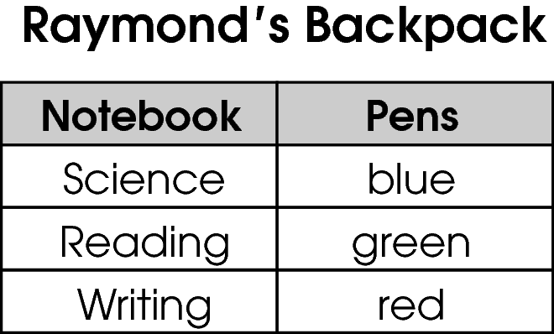
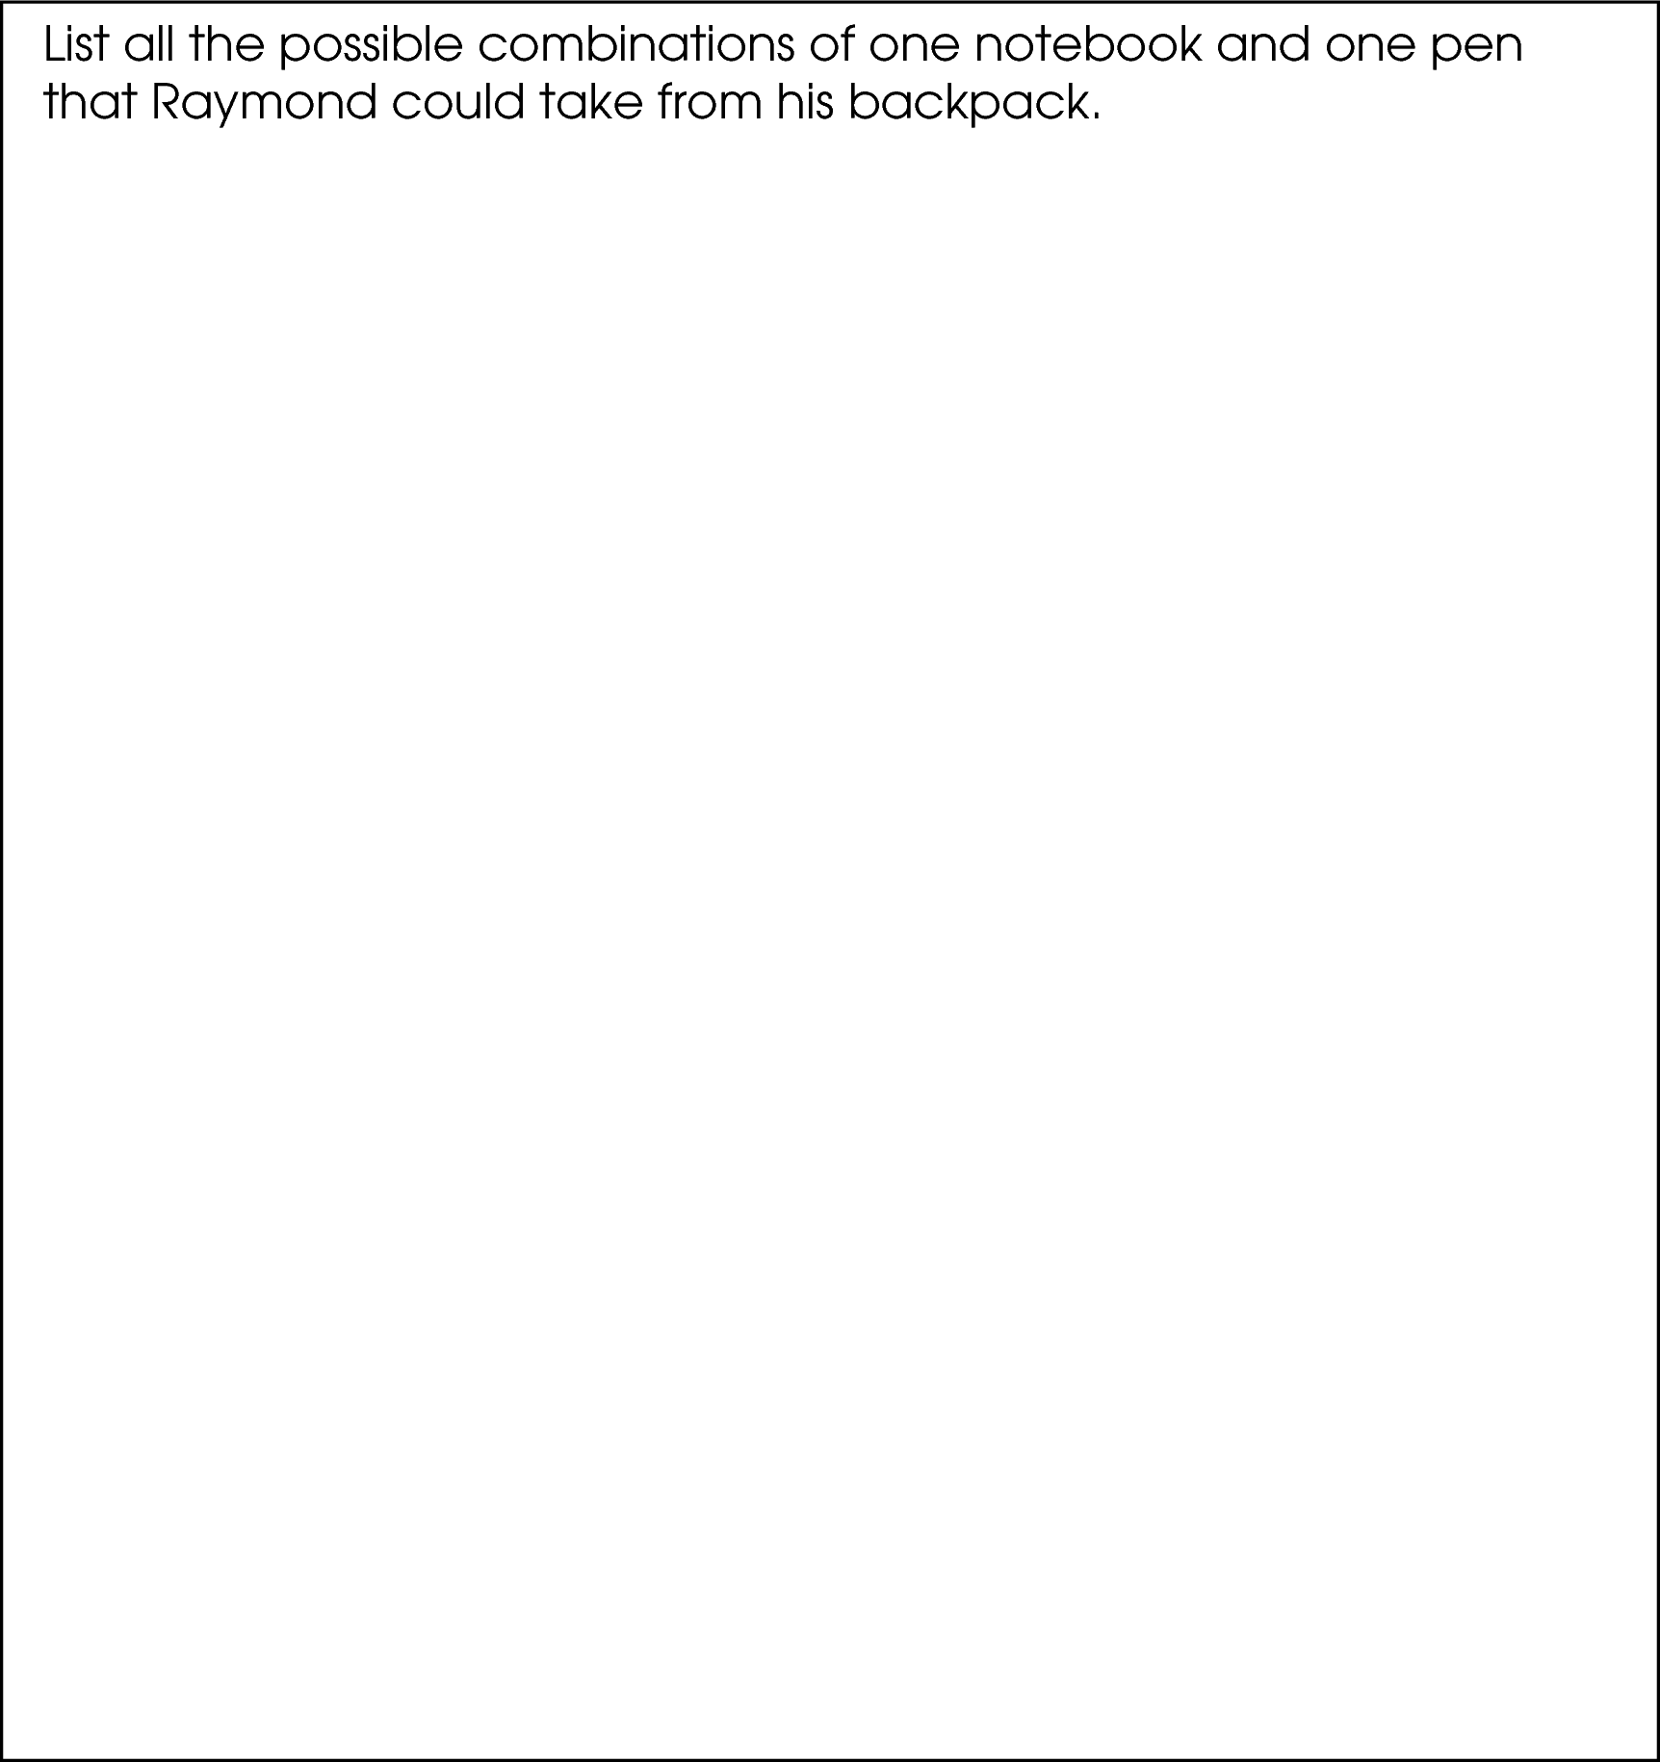

Commentary:
This short-answer question asks students to create a list of all possible combinations of one notebook and one color pen that Raymond could take from his backpack. The response earning the maximum number of points (2 points) provides a list of all nine correct combinations of one notebook and one pen.
Students should select one notebook in the first set and match it with one pen in the other set. A Science notebook can be matched with the blue, green or red pen (3 combinations: Science notebook – blue, Science notebook – green, Science notebook – red). The Reading notebook can be matched with the blue, green or red pen (3 combinations: Reading notebook – blue, Reading notebook – green, Reading notebook – red ) and the Writing notebook also can be matched with the blue, green or red pen (3 combinations: Reading notebook – blue, Reading notebook – green, Reading notebook – red ). All together there are 9 different combinations of one notebook and one pen.

The complexity level of this question is Moderate Complexity. This task requires students to retrieve information from a chart and use it to solve problem.

Performance Data:
The percent of public school students earning each score point for question 15 on the May 2007 Grade 4 Achievement Test:

Percent at Each Score Point
0 | 1 | 2
18% | 6% | 76%

Scoring Guidelines:
Exemplar Response:

- Science and blue, Science and green, Science and red, Reading and blue, Reading and green, Reading and red, Writing and blue, Writing and green, Writing and red
Other Correct Response(s):

Points | Student Response
2 point text | The focus of this task is to show all possible outcomes using one member from each of two sets; each set contains three members. The response includes a list of all 9 combinations of one notebook and one pen with no incorrect combinations.  Note – Letters or symbols may be used to represent colors, i.e., b – blue. Tables with outcomes are also acceptable.
1 point text | The response provides partial evidence of understanding how to list all possible combinations using one member from each of two sets; however, the response is incomplete or slightly flawed.
1 point text | 1 point sample answer:  For example, the response may:  - Include 5, 6, 7 or 8 correct combinations and may include additional incorrect combinations.  - Include at least five correct combinations.
0 point text | The response provides evidence of inadequate understanding of listing possible outcomes. The response will provide major flaws in explanations or irrelevant information.
0 point text | 0 point sample answer:  For example, the response may:  - Include 4 or fewer correct combinations.  - Only list the combinations shown adjacent on the chart.  - Be blank or state unrelated statements.  - Recopy information from the stem.
Keywords: data analysis, probability, combinations

BACK TO INDEX

Benchmark: B | Read and interpret tables, charts, graphs (bar, picture, line, line plot), and timelines as sources of information, identify main idea, draw conclusions, and make predictions.
GLI: DAP 4.2, DAP 4.4 | DAP 4.2: Represent and interpret data using tables, bar graphs, line plots and line graphs.  DAP 4.4: Compare different representations of the same data to evaluate how well each representation shows important aspects of the data, and identify appropriate ways to display the data.

Multiple Choice Question:

28. Ken goes grocery shopping once a week and keeps track of how much money he spends. He made a bar graph and a line plot to display these data.
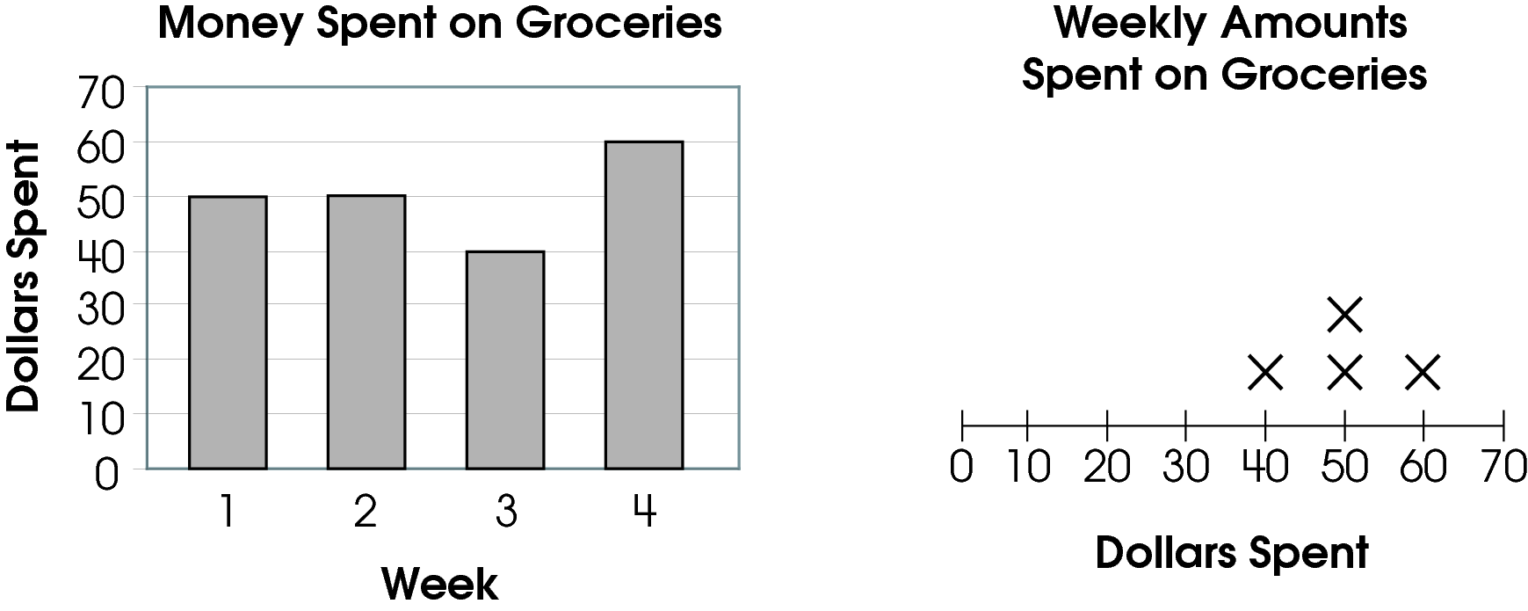
What information can be found only on the bar graph?

A. the number of weeks he shopped
B. the week he spent the least money
C. the most money he spent in one week
D. the least money he spent in one week

Commentary:
This multiple-choice question asks students to compare two different graphical representations.
Given a bar graph and a line plot that represents the same data. Students need to identify information that can only be found on the bar graph.
The bar graph shows not only the amount of money spent but also gives information about when this amount was spent. This bar graph shows that Ken spent $40, the least amount of money, in week three.
The line plot shows the amount of money spent and the number of times each amount was spent, but it does not indicate the week this amount was spent. The given line plot shows the least amount of money, $40, Ken spent only in one week (one X above 40), but it does not indicate which week he spent this amount. This makes answer choice B, the week Ken spent the least amount of money, the correct answer.

Answer choices A, B, or D are incorrect answers. They reflect common information about the data that can be found in both the given bar graph and the line plot.

The complexity level of this question is High Complexity. This question requires students to analyze similarities and differences between representations.

Performance Data:
The percent of public school students selecting answer choice B for question 28 on the May 2007 Grade 4 Achievement Test was 23%.

Keywords: data analysis, data, bar graph, line plot

BACK TO INDEX

Benchmark: C | Construct charts, tables and graphs to represent data, including picture graphs, bar graphs, line graphs, line plots and Venn diagrams.
GLI: DAP 4.3 | Interpret and construct Venn diagrams to sort and describe data.

Multiple Choice Question:

35. Mrs. Allen has 15 students. Eight students belong to the drama club and 10 students belong to the computer club. Some students belong to both clubs.
Which Venn diagram represents these data?

A. 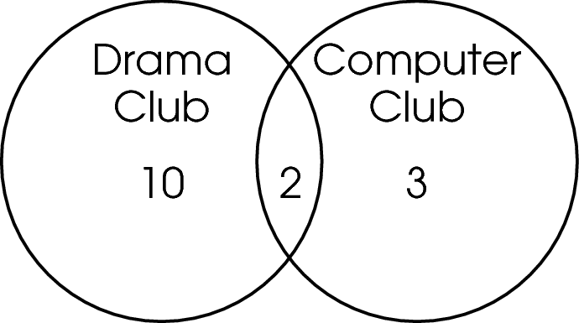
B. 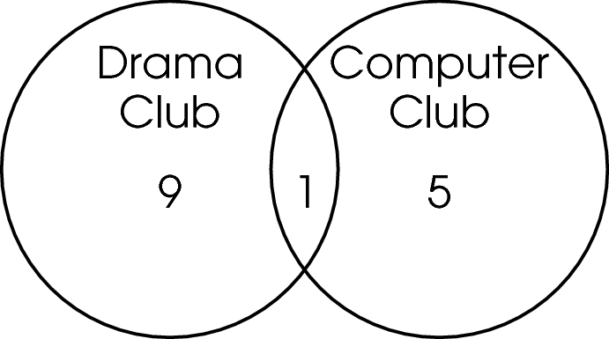
C. 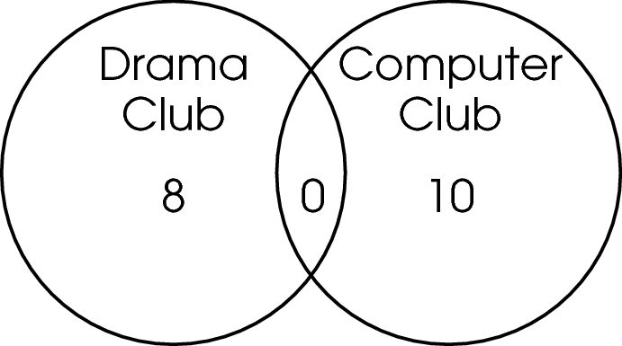
D. 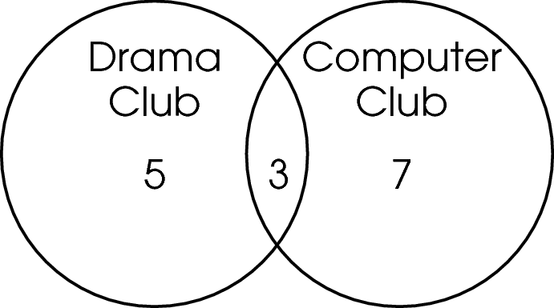

Commentary:
This multiple-choice question asks students to select the Venn diagram that represents the given information. A Venn diagram is a drawing, in which circular areas represent groups of items sharing common properties.
In this problem, the Venn diagram uses overlapping circles to represent the number of students belonging to both clubs. Answer choices C and D correctly represent the data in the problem, 8 and 10 students in each club; however, answer choice C has 0 students in both clubs (overlapping region) which makes this answer choice incorrect. Therefore, answer choice D is correct because the overlapping region of this Venn diagram represents the number of students belonging to both clubs.

Answer choice A and B have the number of students in the drama and computer clubs different than 8 and 10.Therefore, answer choices A and B are incorrect.

The complexity level of this question is Moderate Complexity. This question requires students to interpret a visual representation.

Performance Data:
The percent of public school students selecting answer choice D for question 35 on the May 2007 Grade 4 Achievement Test was 45%.

Keywords: data analysis, Venn diagram

BACK TO INDEX

Benchmark: G | Identify and represent possible outcomes, such as arrangements of a set of up to four members and possible combinations from several sets, each containing 2 or 3 members.
GLI: DAP 4.13 | List and count all possible combinations using one member from each of several sets, each containing 2 or 3 members; e.g., the number of possible outfits from 3 shirts, 2 shorts and 2 pairs of shoes.

Multiple Choice Question:

4. Megan uses the sign shown to order a sandwich.
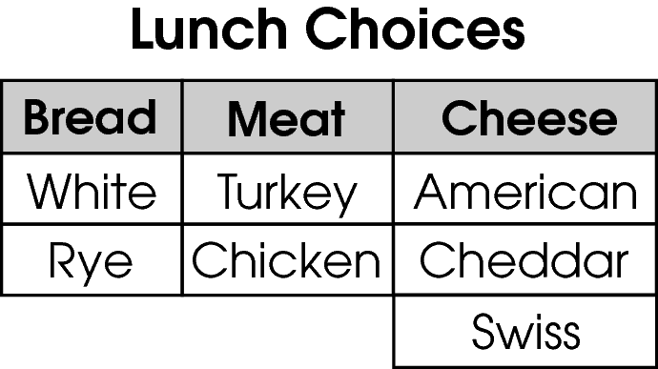
What type of sandwich might she order if she does not like chicken and she does not like cheddar cheese?

- white bread, chicken, Swiss cheese
- rye bread, turkey, cheddar cheese
- white bread, turkey, American cheese
- rye bread, chicken, American cheese
Commentary:
This multiple-choice question asks students to identify a combination of ingredients for a sandwich using the choices for bread, meat and cheese, and a preference for a sandwich without chicken or cheddar cheese. Students need to understand how to make combinations from items listed for each of the separate categories. For example, one of the sandwiches could be created by using the first choice given for bread, meat and cheese: a turkey sandwich with American cheese on white bread. Answer choice C is the correct answer since a turkey sandwich with American cheese on white bread is one combination that avoids chicken and cheddar cheese.

The chicken sandwich with Swiss cheese on white bread, answer choice A, is incorrect because it contains chicken. Answer choice B is incorrect because the turkey sandwich with cheddar cheese on rye bread contains cheddar cheese. The chicken sandwich with American cheese on rye bread, answer choice D, is incorrect because it contains chicken.

The complexity level of this question is Low Complexity. Students are asked to perform a procedure for finding combinations.

Performance Data:
The percent of public school students selecting answer choice C for question 4 on the May 2007 Grade 4 Achievement Test was 94%.

Keywords: data analysis, probability, combinations

BACK TO INDEX

Benchmark: B | Read and interpret tables, charts, graphs (bar, picture, line, line plot), and timelines as sources of information, identify main idea, draw conclusions, and make predictions.
GLI: DAP 4.2 | Represent and interpret data using tables, bar graphs, line plots and line graphs.

Multiple Choice Question:

7. The line graph shows the height of a puppy as it gets older.
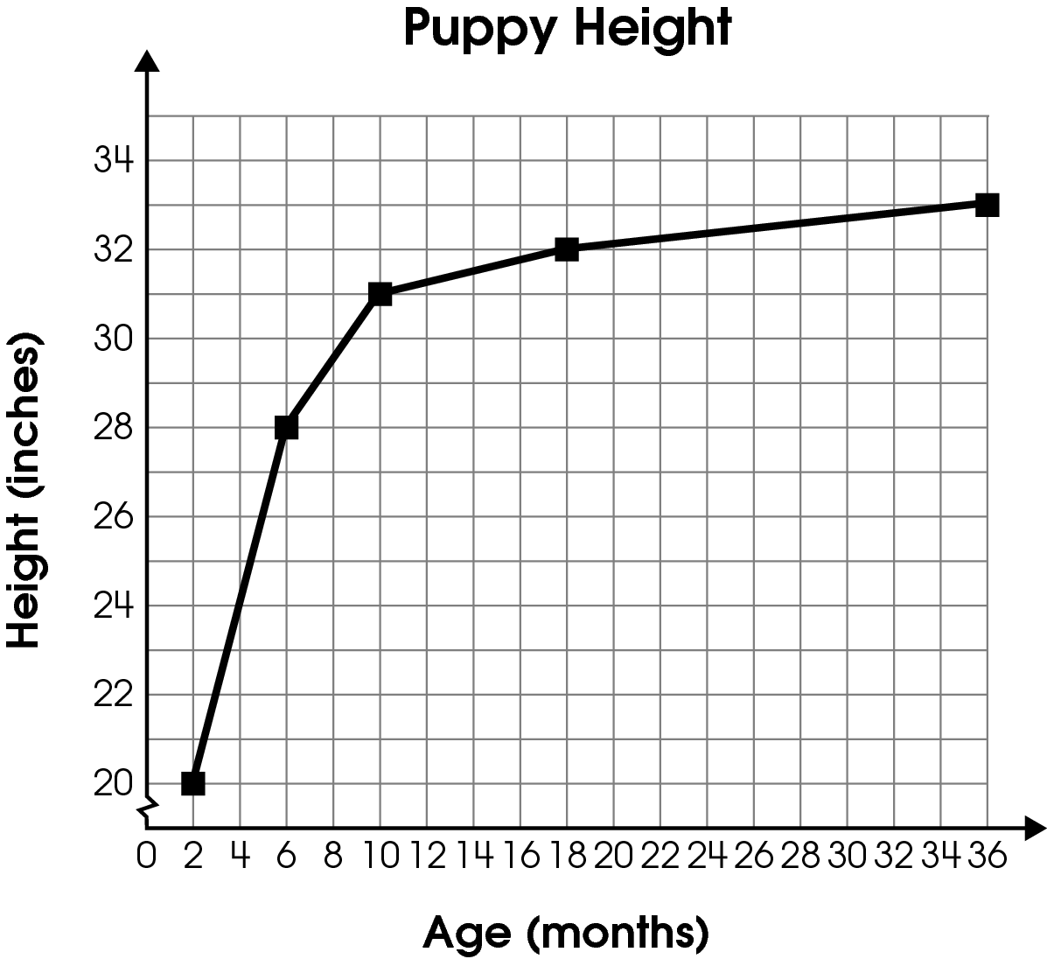
Which table represents these data?

A.

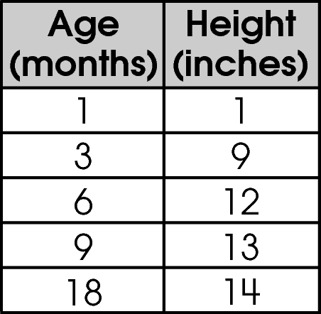

B.
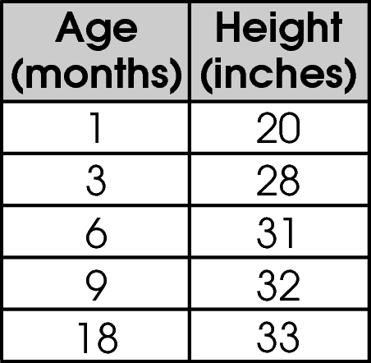

C.
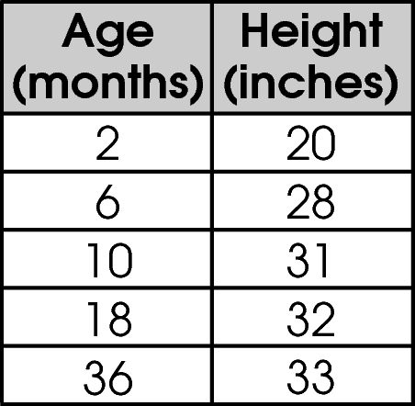

D.
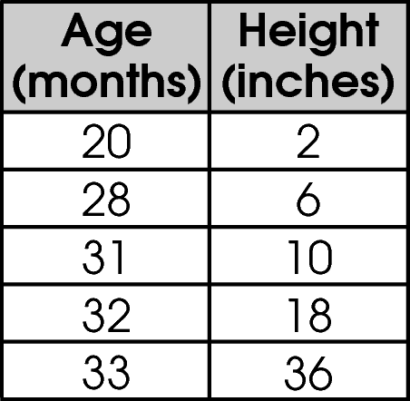

Commentary:
This multiple-choice question asks students to select the table that represents the data in the given line graph. Students need to understand the scales on the vertical and horizontal axes of this coordinate grid and the meaning of the data points (squares) on the line graph. Students should know that the data points on the graph show a relationship between Age and Height and can be represented in a table. For example, at age 2 months, the height of a puppy was 20 inches. At 6 months old, the puppy’s height was 28 inches. The coordinates for the points can represent the relationship between Age and Height (Age, Height). The data points (squares) on the line graph are: (2, 20), (6, 28), (10, 31), (18, 32), and (36, 33). These same points are listed in the table in choice C, the correct answer.

Answer choice A is incorrect since individual grid lines were used to determine the data points instead of the scale. Answer choice B is incorrect because the scale for Age was ignored. The table in choice D shows values that have been misplaced: values for Height are shown in the Age column and values for Age are listed in the Height column. Therefore, answer choice D is incorrect.

The complexity level of this question is Low Complexity. Students are asked to recognize an equivalent representation of data.

Performance Data:
The percent of public school students selecting answer choice C for question 7 on the May 2008 Grade 4 Achievement Test was 85%.

Keywords: data analysis, line graph, coordinate grid, table

BACK TO INDEX

Benchmark: F | Conduct a simple probability experiment and draw conclusions about the likelihood of possible outcomes.
GLI: DAP 4.10 | Represent the likelihood of possible outcomes for chance situations; e.g., probability of selecting a red marble from a bag containing 3 red and 5 white marbles.

Multiple Choice Question:

12. Jerry tossed a penny 5 times.
What is the likelihood that the penny landed on heads all 5 times?

- certain
- impossible
- possible and likely
- possible but unlikely

Commentary:
This multiple-choice question asks students to choose the likelihood of this event: a penny is tossed five times and lands on heads all 5 times. Students should understand the meanings for the different likelihoods: certain; impossible; possible; likely; unlikely; possible and likely; and possible but unlikely. They should also know that the likelihood of a penny landing on heads is the same as the likelihood of a penny landing on tails. Therefore, it is possible but unlikely for a penny to land on heads for all 5 tosses. So, answer choice D is correct.

Answer choice A is the incorrect answer because a likelihood of “certain” means that the event must happen, not that it could happen. A likelihood of “impossible” is also incorrect since impossible means that the event definitely will not happen, but this event could happen. Answer choice C is incorrect because the event could happen but it is not very likely to happen.

The complexity level of this question is Moderate Complexity. Students are asked to compare statements about the likelihoods of an event.

Performance Data:
The percent of public school students selecting answer choice D for question 12 on the May 2008 Grade 4 Achievement Test was 66%.

Keywords: data analysis, probability, likelihood

BACK TO INDEX

Benchmark: F | Conduct a simple probability experiment and draw conclusions about the likelihood of possible outcomes.
GLI: DAP 4.10 | Represent the likelihood of possible outcomes for chance situations; e.g., probability of selecting a red marble from a bag containing 3 red and 5 white marbles.

Multiple Choice Question:

26. Zach has the spinner shown.
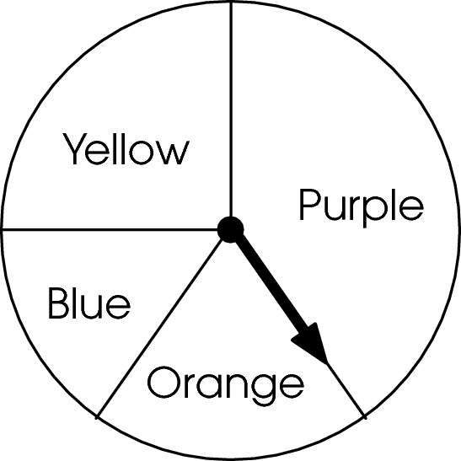
Which statement is true about the spinner?

- The spinner is equally likely to land on purple and yellow.
- The spinner is more likely to land on orange than purple.
- The spinner is less likely to land on yellow than blue.
- The spinner is more likely to land on purple than on yellow.

Commentary:
This multiple-choice question asks students to determine the likelihood of a spinner landing on different sections of a circular spinner. Students need to know that the size of a section is directly related to the likelihood of the spinner landing in that section. The larger the section, the more likely the spinner is to land in that section. Since the purple section is larger than the yellow section, the spinner is more likely to land on purple. So, choice D is the correct answer.

Answer choice A is incorrect because the purple section is larger than the yellow section, so the likelihood of landing on purple is greater than the likelihood of landing on yellow. Answer choice B is incorrect because the orange section is smaller than the purple section so the spinner is more likely to land on purple. The blue section is smaller than the yellow section, so the spinner is less likely to land on blue, so answer choice C is incorrect.

The complexity level of this question is Moderate Complexity. Students are asked to interpret a visual representation.

Performance Data:
The percent of public school students selecting answer choice D for question 26 on the May 2008 Grade 4 Achievement Test was 83%.

Keywords: data analysis, probability, likelihood

BACK TO INDEX

