Index to Questions

Question Number | Source | BM | GLI | Description
3 | OAT March 05 | E | DAP 3.8 | This multiple-choice question asks students to recognize an example of mode.
12 | OAT March 05 | D  K-2 | DAP 2.7 | This multiple-choice question asks students to consider the likelihood of selecting a given color.
20 | OAT March 05 | G | DAP 3.10 | This short-answer question asks students to list all the possible combinations of three different shirts with two different hats.
26 | OAT March 05 | B | DAP 3.4 | This multiple-choice question asks students to read and interpret information in a table.
30 | OAT March 05 | B & D | DAP 3.3, DAP 3.4, DAP 3.6 | This extended-response question asks students to create a bar graph and state facts about the information in the graph.
21 | OAT March 06 | F | DAP 3.9 | This multiple-choice question asks students to consider the likelihood of a spinner landing on a shaded space.
24 | OAT March 06 | E | DAP 3.8 | This multiple-choice question asks students to identify the mode of shoe sizes of nine students’ fathers.
39 | OAT March 06 | B | DAP 3.5 | This multiple-choice question asks students to identify the line plot that correctly represents the information on the list.
44 | OAT March 06 | C | DAP 3.6 | This multiple-choice question asks students to choose the bar graph that represents the information in the chart.
8 | OAT May 07 | C | DAP 3.6 | This multiple-choice question asks students to select a set of data that represents information recorded in the graph.
36 | OAT May 07 | D  K-2 | DAP 1.8 | This multiple-choice question asks students to predict the likelihood that the sum of the two numbers on two different spinners will be odd.
41 | OAT May 07 | D | DAP 3.2 | This multiple-choice question asks students to read and interpret the meaning of a picture graph in which each symbol represents more than one unit.
5 | OAT May 08 | D | DAP 3.2 | This short-answer question asks students to read, interpret and complete a pictograph where the icon in the key represents more than one object or event.
Question Number | Source | BM | GLI | Description
11 | OAT May 08 | F | DAP 3.9, DAP 4.12 | This multiple-choice question asks students to identify the number on the spinner that is likely to be selected the fewest number of times.
21 | OAT May 08 | B | DAP 3.5 | This multiple-choice question asks students to read and interpret the data in a table and to match this data with the correct line graph.

Benchmark:  E | Describe data using mode, median and range.
GLI: DAP 3.8 | Identify the mode of a data set and describe the information it gives about a data set.

Multiple Choice Question:
3. | Johnny asked his classmates to name their favorite food. The mode of this data was pizza. Which statement tells what the mode means?

A. | The greatest number of students said pizza.
B. | The least number of students said pizza.
C. | None of the students said pizza.
Commentary:
This multiple-choice question asks students to recognize and example of mode. The question describes a student asking peers about their favorite food and states that pizza was the mode. Answer choice A is the correct answer. Identifying pizza as the mode means that pizza was stated as the favorite food more times than any other food. Answer choices B and C demonstrate misunderstandings about the meaning of mode.

The complexity level of this question is Low Complexity. Students are asked to recognize an example of mode when selecting from the answer choices.
Performance Data:
The percent of public school students selecting answer choice A for question 3 on the March 2005 Grade 3 Achievement Test was 93%.

Keywords: data analysis, mode

BACK TO INDEX
Benchmark:  D (K-2) | Describe the probability of chance events as more, less or equally likely to occur.
GLI:  DAP 2.7 | List some of the possible outcomes of a simple experiment, and predict whether given outcomes are more, less or equally likely to occur.

Multiple Choice Question:

12. Monica pulls one block from each bag. Which bag is the least likely to have a white block pulled from it?
A.


B.
C.



Commentary:
This multiple-choice question asks students to consider the likelihood of selecting a given color. Several bags with different numbers of blocks are displayed. Answer choice B is the correct answer because this bag has only 1 white block out of 7 total blocks. Answer choice C can be eliminated because more than half of the blocks are white, making the white blocks more likely to be selected. Answer choice A has only one white block, as does the correct answer. However, in answer choice A, there are only 2 dark blocks while answer choice B has 6 dark blocks. The level of complexity for this question is Moderate Complexity. Students must compare figures (the bags of blocks).

Performance Data:
The percent of public school students selecting answer choice B for question 12 on the March 2005 Grade 3 Achievement Test was 57%.

Keywords: probability, likelihood

BACK TO INDEX

Benchmark:  G | Identify and represent possible outcomes, such as arrangements of a set of up to four members and possible combinations from several sets, each containing 2 or 3 members.
GLI:  DAP 3.10 | Use physical models, pictures, diagrams and lists to solve problems involving possible arrangements or combinations of two to four objects.

Short Answer Question:
20. | José has a red shirt, a blue shirt and a white shirt. He also has an orange hat and a green hat.  Use words or pictures to show all the different ways José can wear one shirt and one hat

Commentary:
This short-answer question asks students to list all the possible combinations of three different shirts with two different hats. Students may approach the problem in several different ways. One method is to make a list of the possible combinations (red shirt & orange hat, red shirt & green hat, blue shirt & orange hat, blue shirt & green hat, white shirt & orange hat, white shirt & green hat) to find all 6 possible combinations. Students may also draw pictures or make tree diagrams to organize their thinking about the possible combinations. A response earning the maximum number of points (2 points) provides all six combinations and no incorrect combinations.

The level of complexity for this question is Moderate Complexity. The task asks students to represent the possible combinations.

Performance Data:
The percent of public school students earning each score point for question 20 on the March 2005 Grade 3 Achievement Test:

Percent at Each Score Point
0 | 1 | 2
23% | 40% | 36%

Scoring Guidelines:
Points | Student Response
2 | The response shows six different combinations of shirts and hats using pictures or words.  Examples of correct responses:
  red shirt – orange hat  red shirt – green hat  blue shirt – orange hat OR  blue shirt – green hat  white shirt – orange hat  white shirt – green hat | G and W  G and R  G and B  O and W  O and R  O and B
1 | The response shows one to five correct combinations of shirts and hats.
0 | The response indicates no understanding of the task or the underlying skills, concepts tasks or processes.

Keywords: data analysis, combinations

BACK TO INDEX

Benchmark:  B | Read and interpret tables, charts, graphs (bar, picture, line, line plot), and timelines as sources of information, identify main idea, draw conclusions, and make predictions.
GLI:  DAP 3.4 | Support a conclusion or prediction orally and in writing, using information in a table or graph.

Multiple Choice Question:
26. | How many goldfish are there?
  Aquarium Fish
  Type |  | Large Fish | Small Fish
  Guppies |  | 12 | 27
  Goldfish |  | 12 | 6
  A. | 12
  B. | 18
  C. | 24

Commentary:
This multiple-choice question asks students to read and interpret information in a table. The correct answer is choice B. Students look across the bottom row of the table to add the number of large goldfish (12) to the number of small goldfish (6) to find a total of 18. Answer choices A and C may indicate that students either only identified part of the goldfish (the large goldfish only) or found the total number of large fish.

The level of complexity for this question is Moderate Complexity. This question requires students to retrieve information from a table and use the information to answer a question.

Performance Data:
The percent of public school students selecting answer choice B for question 26 on the March 2005 Grade 3 Achievement Test was 78%.

Keywords: data, tables

BACK TO INDEX

Benchmark:  B & D | Read and interpret tables, charts, graphs (bar, picture, line, line plot), and timelines as sources of information, identify main idea, draw conclusions, and make predictions.  Read, interpret and construct graphs in which icons represent more than a single unit or intervals greater than one; e.g., each  = 10 bicycles or the intervals on an axis are multiples of 10.
GLI: DAP 3.3,  DAP 3.4,  DAP 3.6 | DAP 3.3: Read, interpret and construct bar graphs with intervals greater than one.  DAP 3.4: Support a conclusion or prediction orally and in writing, using information in a table or graph.  DAP 3.6: Translate information freely among charts, tables, line plots, picture graphs and bar graphs; e.g., create a bar graph from the information in a chart.

Extended Response Question:
30. | This table shows the number of students in four classes.  Directions:  Use the grid on the next page to create a bar graph to show the data in the table.  Be sure to show a scale for your graph.  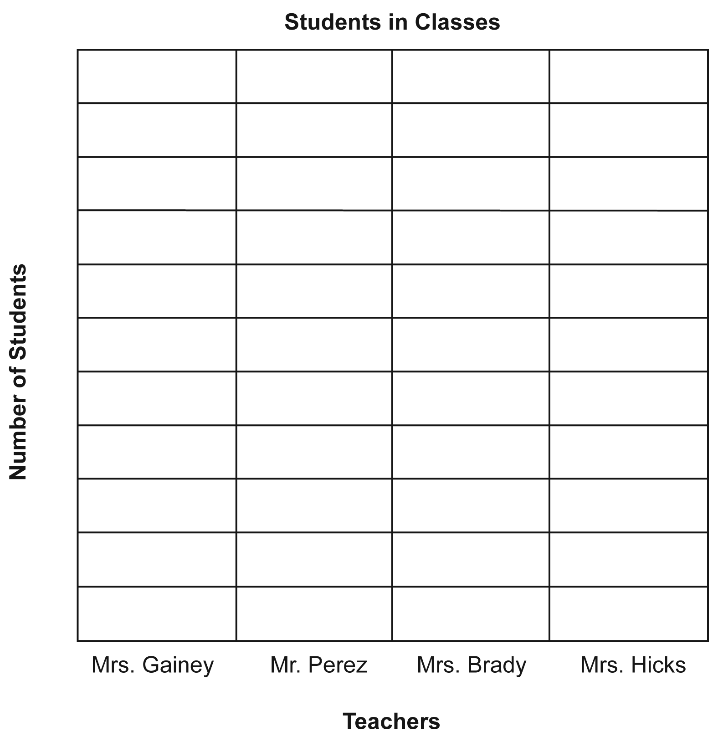  Write two different facts about the information in the graph.  a.  b.
Commentary:
This extended-response question asks students to create a bar graph and state facts about the information in the graph. Students are given information in a table and asked to make a bar graph on the grid provided. The title and labels are already provided on the grid, requiring students to make a vertical bar graph. Appropriate graphs use reasonable intervals on the horizontal axis (e.g., counting by 2’s or 3’s), indicate where zero lies on the horizontal axis and have bars that align correctly with the marks on the horizontal axis. The facts about the graph might indicate that the bar for Mr. Perez is taller than all the other bars, or that two of the bars are the same height.
The level of complexity for this question is Moderate Complexity. When writing two different facts about the information in the graph, students are interpreting a visual representation of the data given in the table.

Performance Data:
The percent of public school students earning each score point for question 30 on the March 2005 Grade 3 Achievement Test:

Percent at Each Score Point
0 | 1 | 2 | 3 | 4
14% | 18% | 24% | 23% | 21%

Scoring Guidelines:
Points | Student Response
4 | The response creates the bar graph with a correct scale and bar heights and writes two different, correct facts based on the table or graph.  For example:  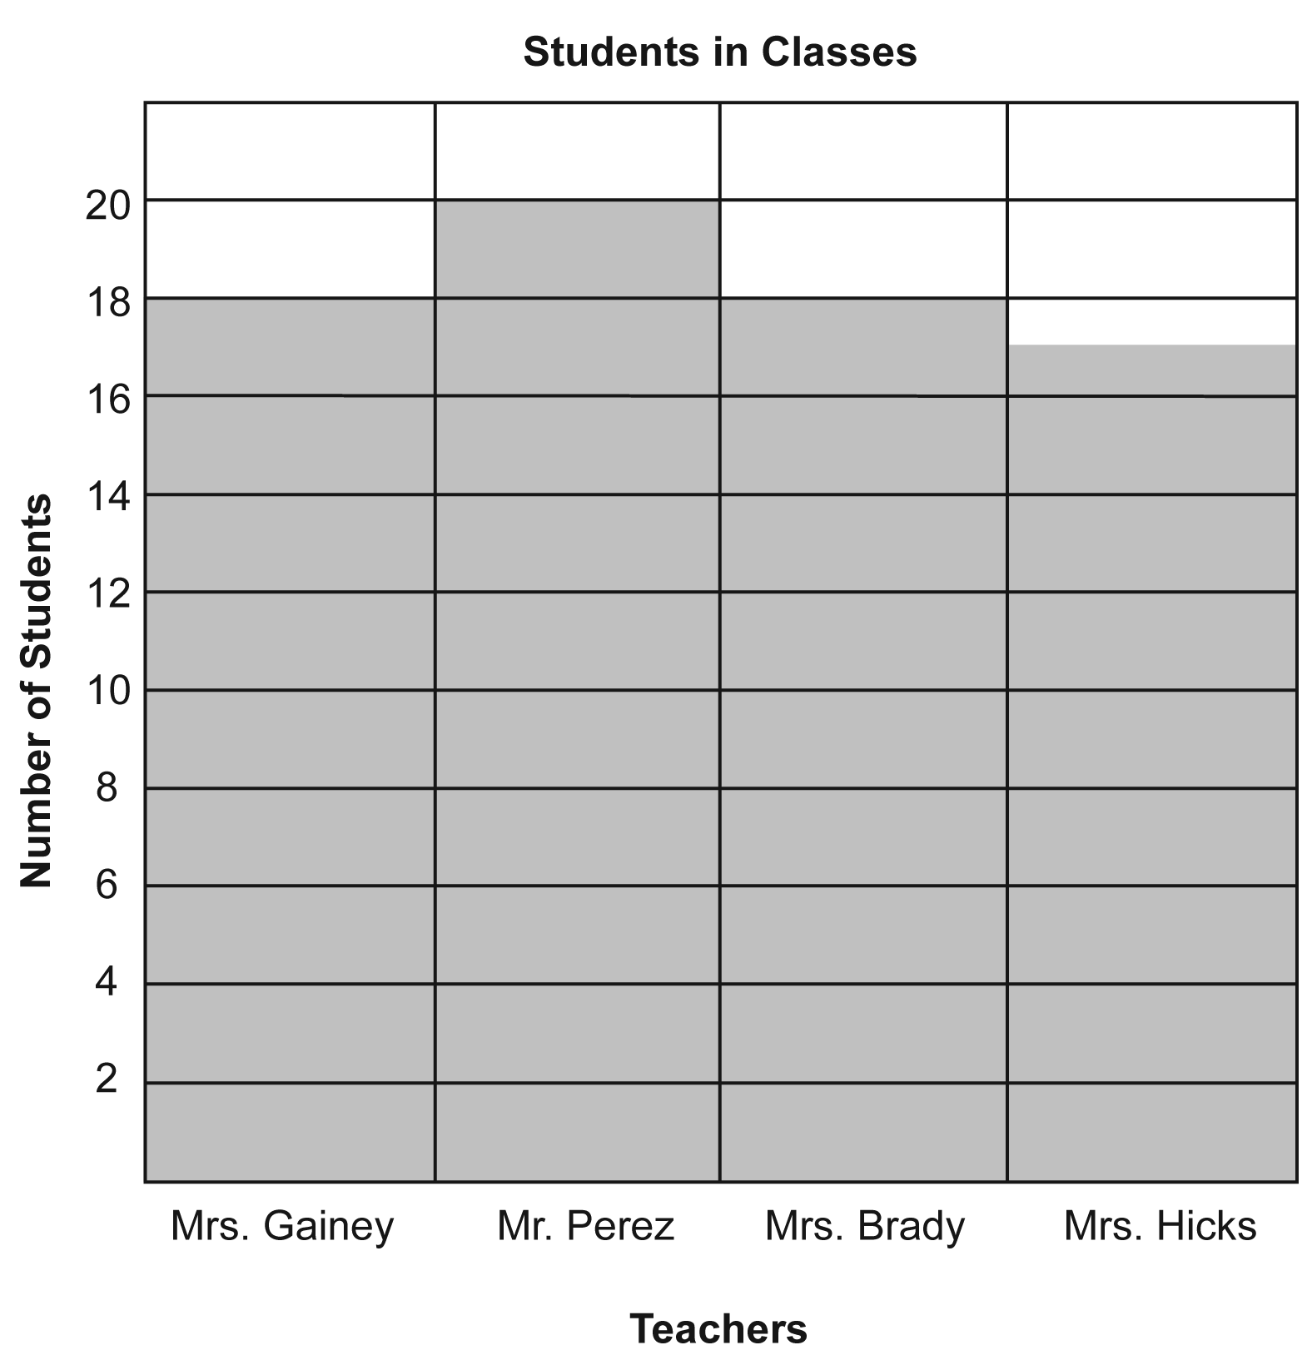  Acceptable facts:  - Any reference to the bar heights or numbers used in the table are ok  - Repetition of the information in the table is not correct

Points | Student Response
3 | The response creates the bar graph with a correct scale and bar heights and writes one correct fact based on the table or graph.  OR  The response creates the bar graph with no more than two errors (scale and/or bar height(s)), and writes two different, correct facts based on the table or graph.  NOTE:  Multiple unrelated bar height errors = # of errors  One error in bar heights that is consistently carried through = 1 error  Scale and bar height error = 2 errors
2 | The response creates the bar graph with a correct scale and bar heights OR writes two different, correct facts based on the table or graph.  OR  The response creates the bar graph with no more than two errors (scale and/or bar heights) AND writes one correct fact based on the table or graph.
1 | The response creates the bar graph with no more than two errors (scale and/or bar heights) OR writes one correct fact based on the table or graph.
0 | The response indicates no understanding of the task or the underlying skills, concepts or processes.

Keywords: data, analysis, bar graph

BACK TO INDEX

Benchmark:  F | Conduct a simple probability experiment and draw conclusions about the likelihood of possible outcomes.
GLI:  DAP 3.9 | Conduct a simple experiment or simulation of a simple event, record the results in a chart, table or graph, and use the results to draw conclusions about the likelihood of possible outcomes.

Multiple Choice Question:

21. Which spinner has the best chance of landing on a shaded space?
A. 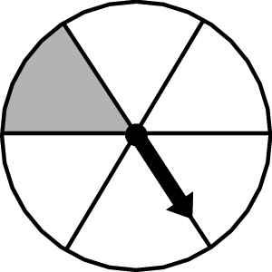
B. 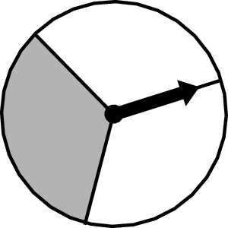
C. 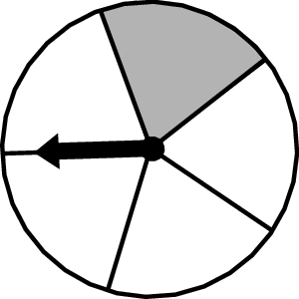

Commentary:
This multiple-choice question asks students to consider the likelihood of a spinner landing on a shaded space. Three spinners with different shaded areas are shown. Answer choice B is the correct answer because this spinner has the largest shaded area of the three spinners. Therefore, this spinner is more likely to land on a shaded space. Answer choices A and C can be eliminated because their shaded areas are smaller than the shaded area in answer choice B.

The complexity level of this question is Moderate Complexity. Student must compare spinners and interpret visual representations.

Performance Data:
The percent of public school students selecting answer choice B for question 21 on the March 2006 Grade 3 Achievement Test was 79%.

Keywords: probability, spinner, likelihood

BACK TO INDEX

Benchmark:  E | Describe data using mode, median and range.
GLI:  DAP 3.8 | Identify the mode of a data set and describe the information it gives about a data set.

Multiple Choice Question:

24. Nine students gathered data about their fathers’ shoe sizes.
What is the mode for the data they collected?
- size 8
- size 9
- size 10

Commentary:
This multiple-choice question asks students to identify the mode of shoe sizes of nine students’ fathers. Identifying the mode for a data set means finding the number that is represented more times than any other number on the list. Answer choice B is the correct answer choice. Answer choices A and C demonstrate misunderstanding about the meaning of mode. Students may have chosen answer choices A or C because 8 is the first on the list and 10 is the largest number on the list.

The complexity level of this question is Low Complexity. Students are asked to recognize an example of a concept.

Performance Data:
The percent of public school students selecting answer choice B for question 24 on the March 2006 Grade 3 Achievement Test was 83%.

Keywords: data analysis, mode

BACK TO INDEX

Benchmark:  B | Read and interpret tables, charts, graphs (bar, picture, line, line plot), and timelines as sources of information, identify main idea, draw conclusions, and make predictions.
GLI:  DAP 3.5 | Match a set of data with a graphical representation of the data.

Multiple Choice Question:

39. The list shows the ages of all the players on Miguel’s baseball team.

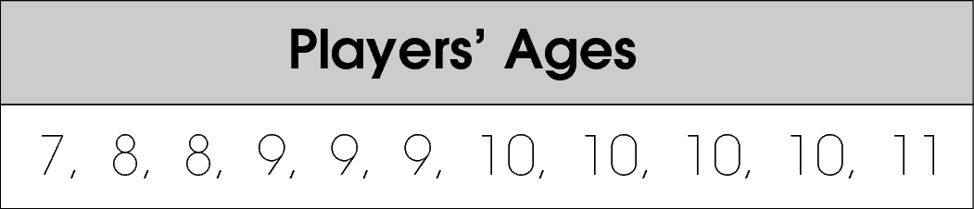
Which line plot shows this information correctly?
A. 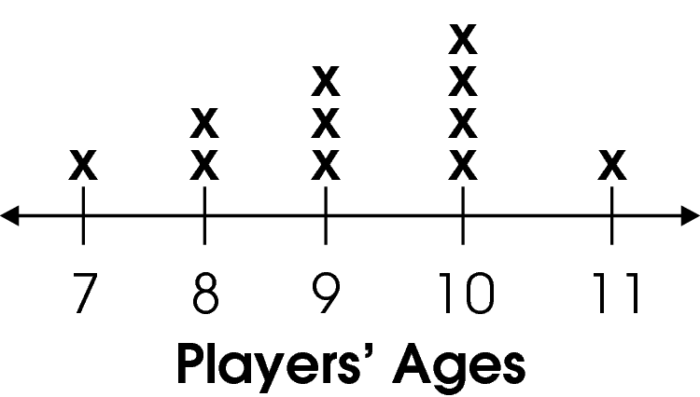

B. 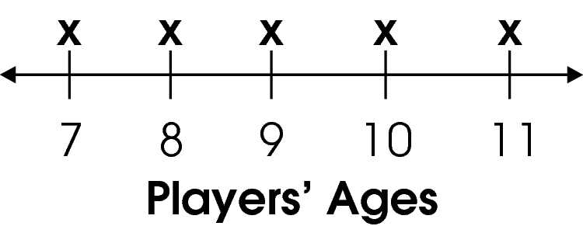

C. 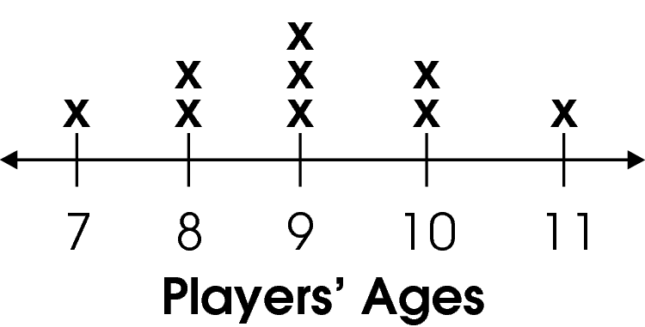

Commentary:
This multiple-choice question asks students to identify the line plot that correctly represents the information on the list. The correct answer choice is A. Students should look across the numbers in the list, count how many times each number repeats itself and match it with the line plot. Answer choices B and C are incorrect. Students may have noted the presence of all the numbers on the list or counted them incorrectly.

The complexity level of this question is Low Complexity. The question requires students to recognize an equivalent representation..

Performance Data:
The percent of public school students selecting answer choice A for question 39 on the March 2006 Grade 3 Achievement Test was 93%.

Keywords: data, line plot

BACK TO INDEX

Benchmark:  C | Construct charts, tables and graphs to represent data, including picture graphs, bar graphs, line graphs, line plots and Venn diagrams.
GLI:  DAP 3.6 | Translate information freely among charts, tables, line plots, picture graphs and bar graphs; e.g., create a bar graph from the information in a chart.

Multiple Choice Question:

44. The chart below shows the kinds of pets owned by students in Mr. Grady’s class.
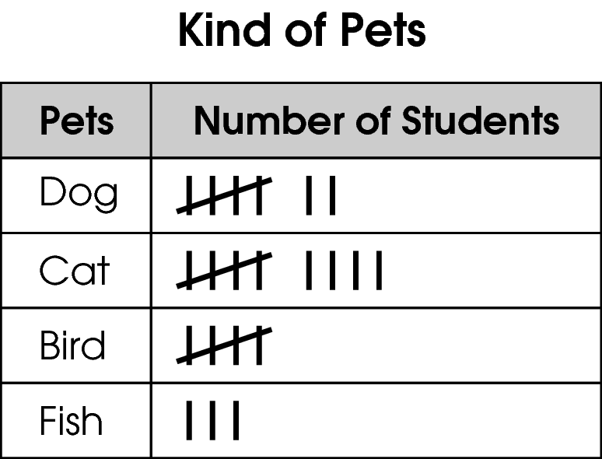
Which graph shows these data?
A. 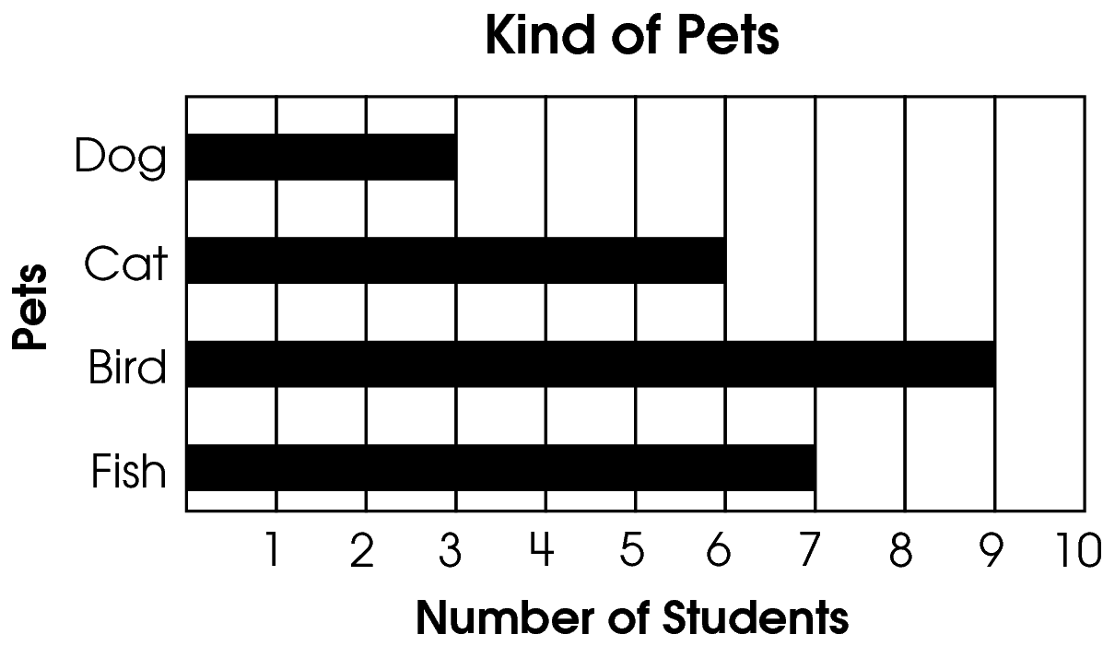
B. 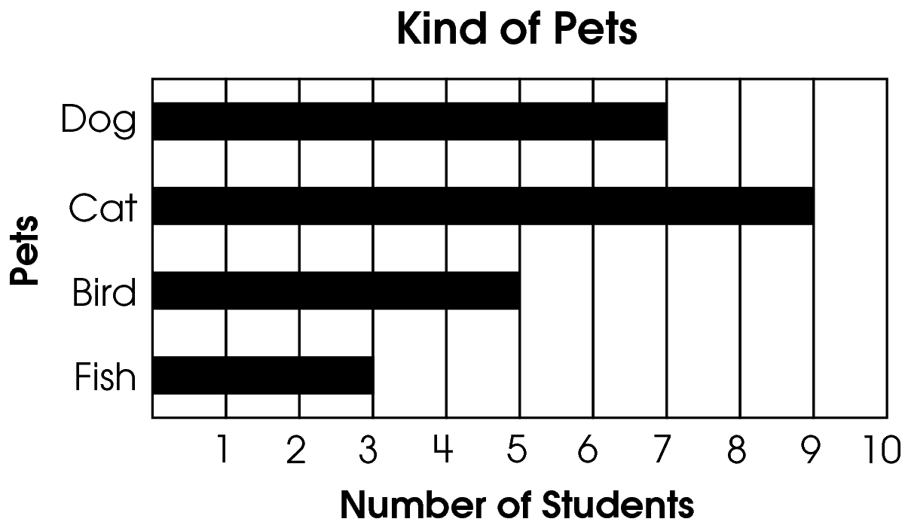
C. 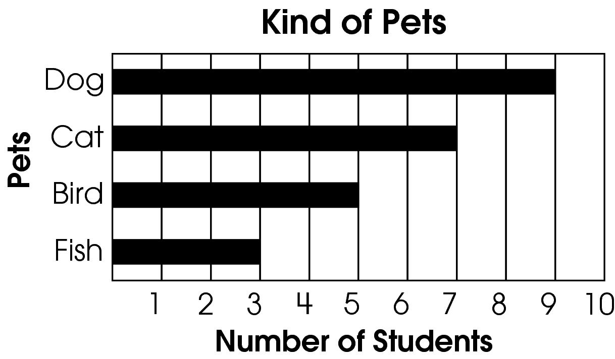

Commentary:
This multiple-choice question asks students to choose the bar graph that represents the information in the chart. The correct answer choice is B. The number of parts in each bar of answer choice B equals the number of students who own that kind of pet. Answer choices A and C can be eliminated because they do not represent the chart correctly.

The complexity level of this question is Moderate Complexity. This question requires students to recognize an equivalent representation.

Performance Data:
The percent of public school students selecting answer choice B for question 44 on the March 2006 Grade 3 Achievement Test was 94%.

Keywords: data analysis, bar graph, chart

BACK TO INDEX

Benchmark: C | Construct charts, tables and graphs to represent data, including picture graphs, bar graphs, line graphs, line plots and Venn diagrams.
GLI: | Translate information freely among charts, tables, line plots, picture graphs and bar graphs; e.g., create a bar graph from the information in a chart.

Multiple Choice Question:

8. Sam was heating a pot of water. He recorded the temperature of the water every minute in the graph shown.
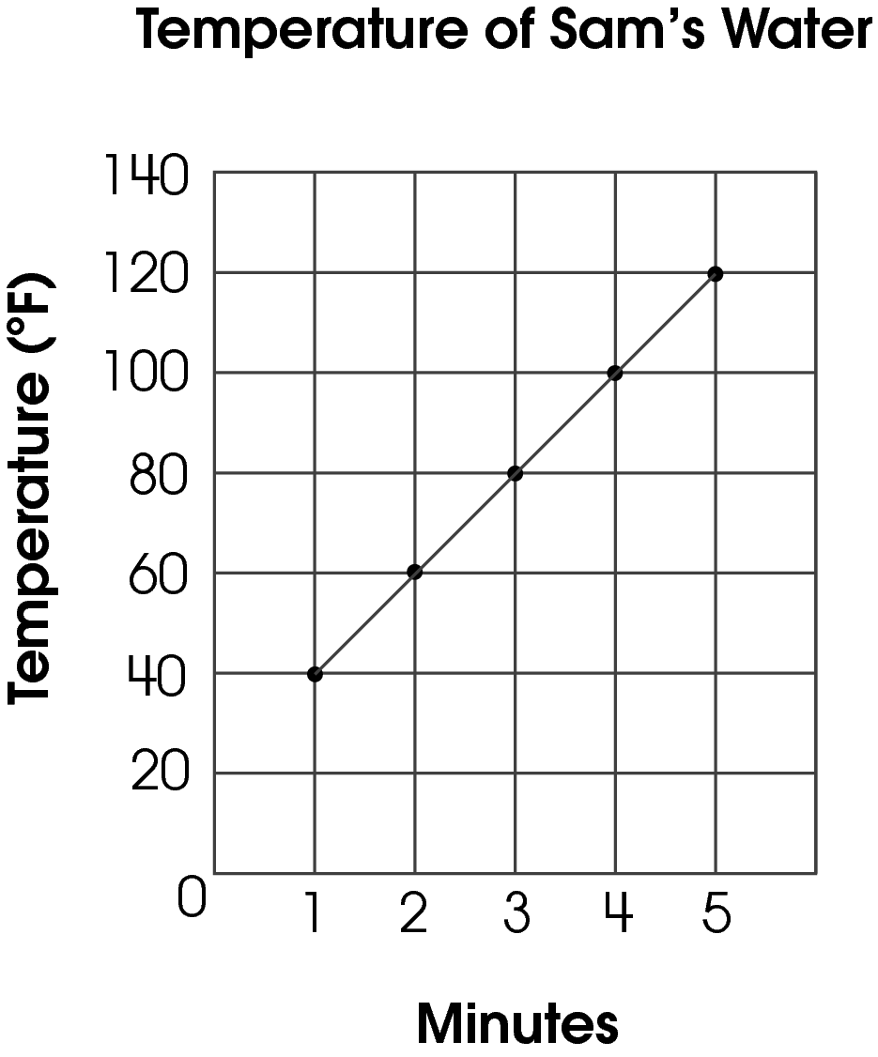
Which set of data is shown on the graph?
A. 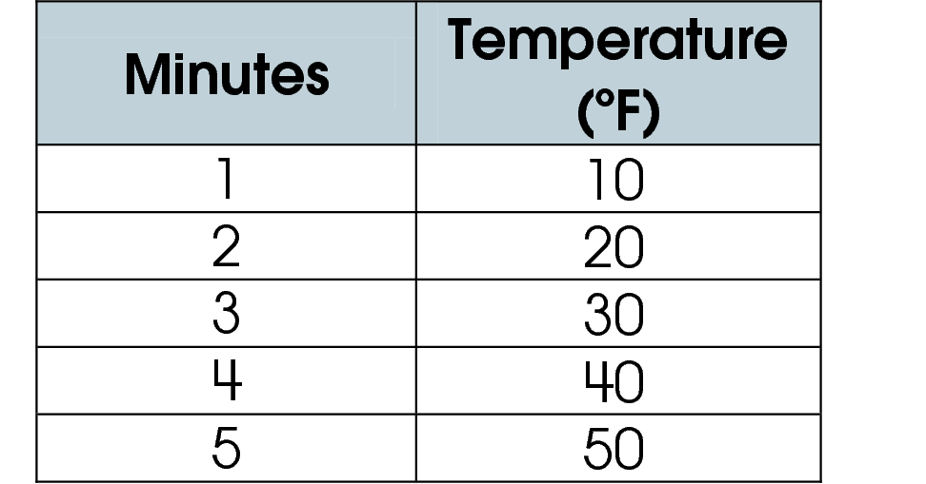
B. 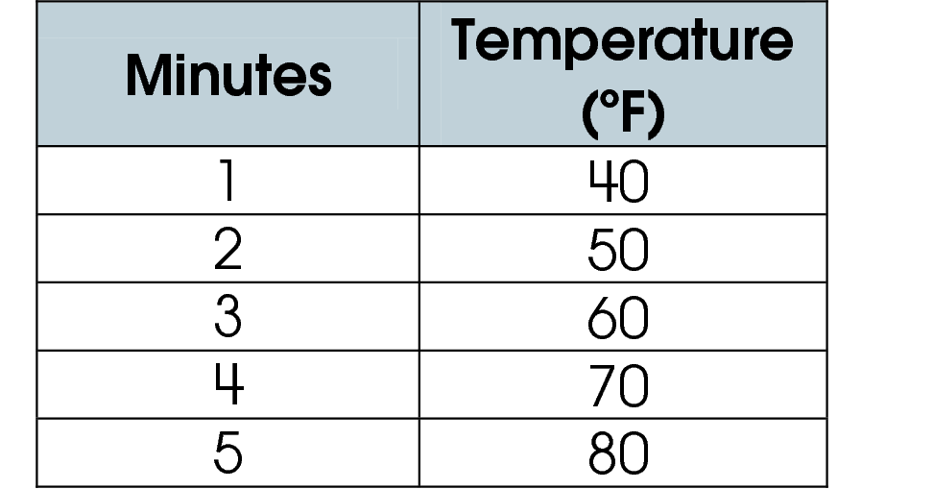
C. 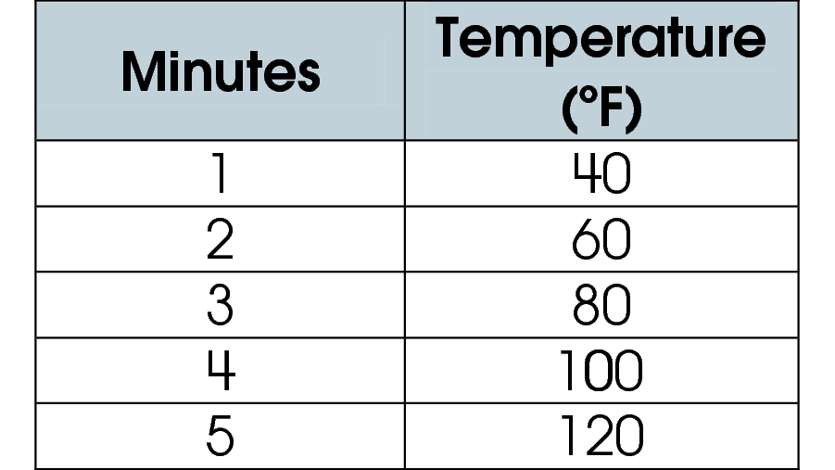

Commentary:
This multiple-choice question asks students to select a set of data that represents information recorded in the graph. Students, first, may have to find the coordinates of all five points indicated on a graph ((1; 40), (2; 60), (3; 80), (4; 100), (5; 120)). The first coordinates in ordered pairs represent the number of minutes the water was boiled and are listed in the left column of the data sets. The second coordinates in ordered pairs represent the temperature of the water at a given minute and are listed in the right column of the data sets.
Students look at the numbers in the data sets and notice that, if time is read first and the temperature is read second, then each line of data set in answer choice C matches with one out of five ordered pairs. So, the correct answer choice is C.

Answer choices A and B are incorrect. Students may have found the coordinates of points in the graph incorrectly.

The complexity level of this question is Low Complexity. The question requires students to recognize an equivalent representation.

Performance Data:
The percent of public school students selecting answer choice C for question on the May 2007 Grade 3 Achievement Test was %.

Keywords: data analysis, graph, data set

BACK TO INDEX

Benchmark:  D | Describe the probability of chance events as more, less or equally likely to occur.
GLI:  DAP 1.8 | Describe the likelihood of simple events as possible/impossible and more likely/less likely; e.g., when using spinners or number cubes in classroom activities.

Multiple Choice Question:

36. Morgan spins both spinners shown.
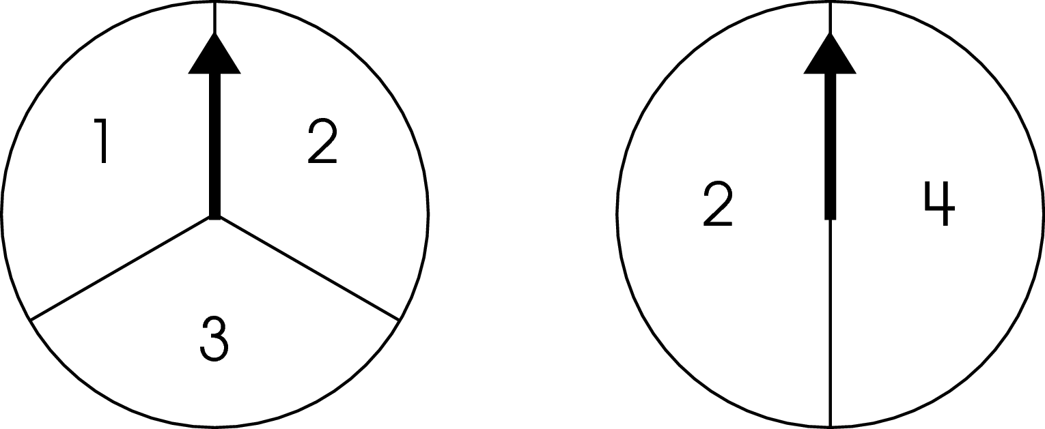
He adds the two numbers on which the spinners land.
How likely it is that Morgan’s sum will be an odd number?

- possible but not certain
- impossible
- certain

Commentary:
This multiple-choice question asks students to predict the likelihood that the sum of the two numbers on two different spinners will be odd. Students need to use the combinations of outcomes from the spinners to make a prediction.
There are six possible outcomes for the sums: 1+ 2 = 3, 1 + 4 = 5, 2 + 2 = 4, 2 + 4 = 6, 3 + 2 = 5, and 3 + 4 = 7. Among the listed sums there are four odd sums (3, 5, 5, and 7) and two even sums (4, 6). Since four sums are odd and two sums are even, it is possible but not certain to get an odd sum. The correct answer choice is A.

Since some of the sums are odd, it is not impossible to get an odd sum, answer choice B is incorrect. Since some of the sums are even, it is not certain to get odd sum. Answer choice C is also incorrect.

The complexity level of this question is Moderate Complexity. This question requires students to interpret a visual representation.

Performance Data:
The percent of public school students selecting answer choice A for question 36 on the May 2007 Grade 3 Achievement Test was 64%.

Keywords: probability, likelihood, outcome, even number, odd number

BACK TO INDEX

Benchmark:  D | Read, interpret and construct graphs in which icons represent more than a single unit or intervals greater than one.
GLI:  DAP 3.2 | Draw and interpret picture graphs in which a symbol or picture represents more than one object.

Multiple Choice Question:

41. Mrs. Jones’ students made a picture graph of their favorite ice cream cones.
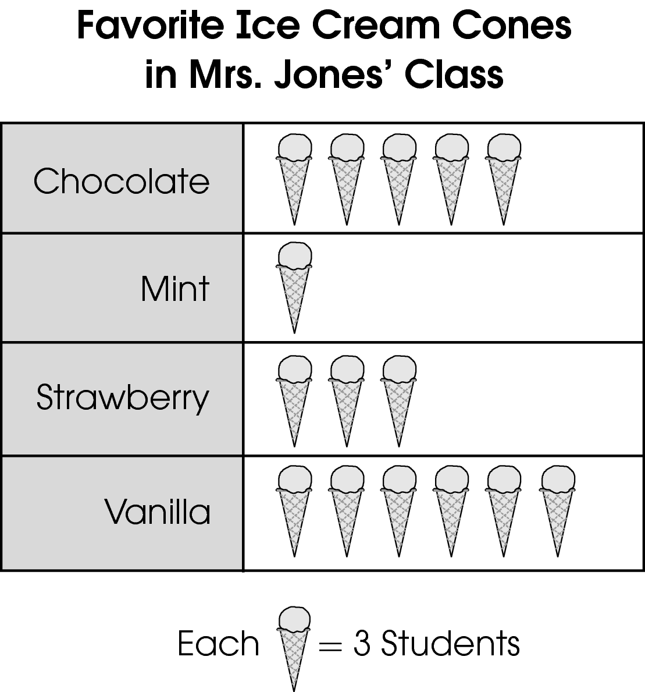
How many children chose vanilla ice cream cones as their favorite?

- 3
- 6
- 18

Commentary:
This multiple-choice question asks students to read and interpret the meaning of a picture graph in which each symbol represents more than one unit. One method students can use for solving this problem is to eliminate incorrect answers. Students need to realize that each ice-cream cone represents 3 students.
Answer choice A is incorrect answer. Students may have thought that only three students like vanilla ice-cream because one cone represents 3 students. Answer choice B is also an incorrect answer because students may have thought that the number of students who favored vanilla ice-cream equals the number of cones in the chart. Therefore, the correct answer choice is C (3 students x 6 cones = 18 students)

The complexity level of this question is Low Complexity. This question requires students to retrieve information from a chart.

Performance Data:
The percent of public school students selecting answer choice C for question 41 on the May 2007 Grade 3 Achievement Test was 86%.

Keywords: data analysis, picture graph, data

BACK TO INDEX

Benchmark:  D | Read, interpret and construct graphs in which icons represent more than a single unit or intervals greater than one.
GLI:  DAP 3.2 | Draw and interpret picture graphs in which a symbol or picture represents more than one object.

Short Answer Question:

5. This pictograph shows the number of rainy days in June, July and August.
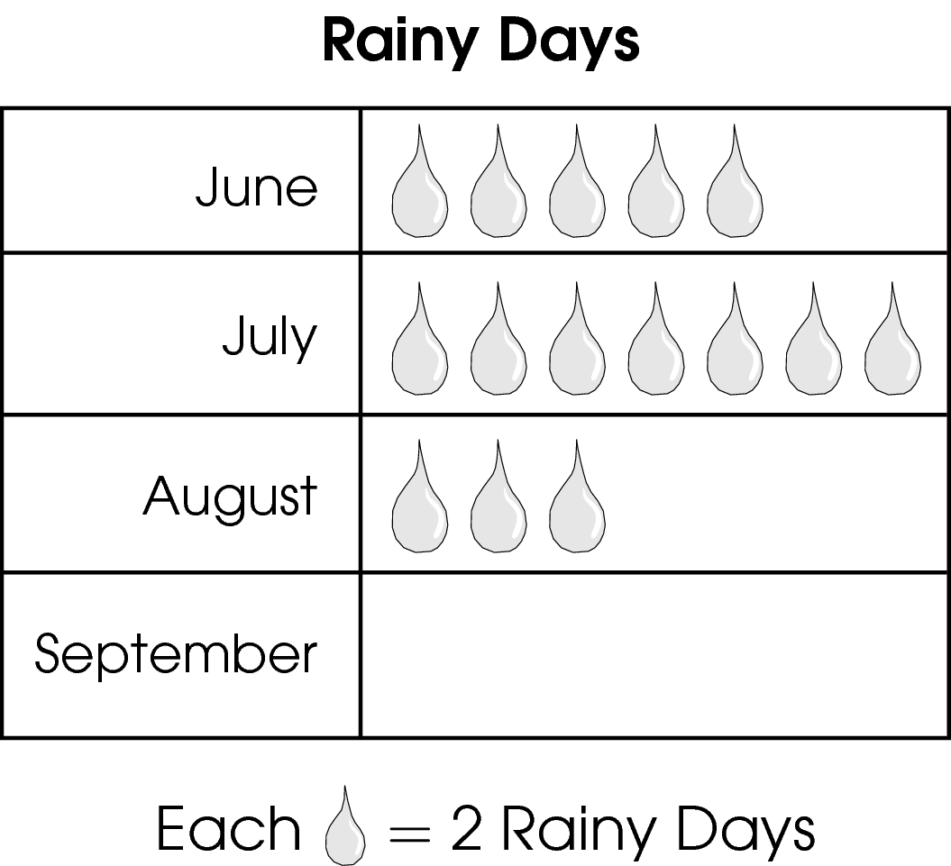
It rained four days in September. Draw the number of raindrops to complete the pictograph for September.

Commentary:
This short-answer question asks students to read, interpret and complete a pictograph where the icon in the key represents more than one object or event. The key for this pictograph states that each raindrop icon represents 2 rainy days. A response earning the maximum number of points (2 points) shows an understanding of using 1 raindrop icon to represent 2 rainy days. Students should draw 2 raindrops in the pictograph to represent the 4 rainy days in September.

The complexity level of this question is Moderate Complexity. This task requires students to interpret an incomplete pictograph and then use the information to complete it.

Performance Data:
The percent of public school students earning each score point for question 5 on the May 2008 Grade 3 Achievement Test:

Percent at Each Score Point
0 | 1 | 2
7% | 16% | 76%

Scoring Guidelines:
Points | Student Response
2 | The response correctly completes the graph with 2 raindrops or marks for September.  Example: 2 = 4 rainy days
1 | The response completes the graph with four raindrops or marks for September.
0 | The response indicates anything other than 2 or 4 raindrops or marks.

Keywords: data analysis, pictograph, key

BACK TO INDEX
Benchmark: F | Conduct a simple probability experiment and draw conclusions about the likelihood of possible outcomes.
GLI: DAP 3.9, DAP 4.12 | DAP 3.9: Conduct a simple experiment or simulation of a simple event, record the results in a chart, table or graph, and use the results to draw conclusions about the likelihood of possible outcomes.  DAP 4.12: Place events in order of likelihood and use a diagram or appropriate language to compare the chance of each event occurring; e.g., impossible, unlikely, equal, likely, certain.

Multiple Choice Question:

11. Mike spins a spinner, like the one shown, 20 times and records the results.
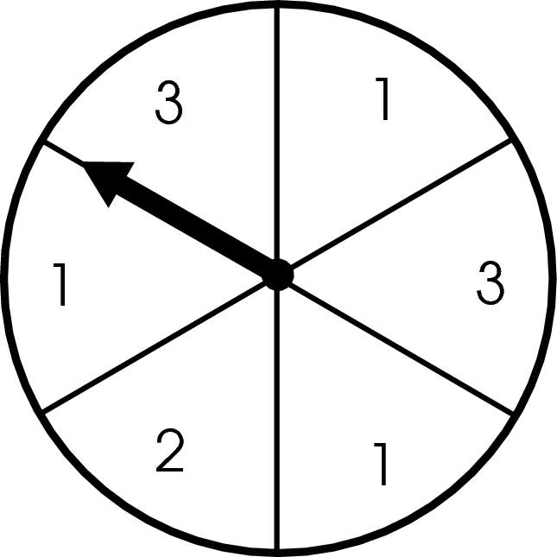
Which number is Mike likely to spin the fewest number of times?

A. 1
B. 2
C. 3

Commentary:
This multiple-choice question asks students to identify the number on the spinner that is likely to be selected the fewest number of times. The spinner is divided into six equal sections, each labeled with a number: the number 1 in three sections, the number 3 in two sections, and the number 2 in one section. Since 2 appears in only one of the six sections, it would be the least likely outcome for any number of spins, so answer choice B is correct.

Answer choice A is incorrect because 1 is the most likely outcome for any number of spins since it appears in one-half or three of the six sections. Answer choice C is incorrect because the number 3 appears in one-third or two of the six sections.

The complexity level of this question is Low Complexity. This question asks students to retrieve information from a figure.

Performance Data:
The percent of public school students selecting answer choice B for question 11 on the May 2008 Grade 3 Achievement Test was 70%.

Keywords: data analysis, probability, spinner, likelihood

BACK TO INDEX

Benchmark: B | Read and interpret tables, charts, graphs (bar, picture, line, line plot), and timelines as sources of information, identify main idea, draw conclusions, and make predictions.
GLI:  DAP 3.5 | Match a set of data with a graphical representation of the data.

Multiple Choice Question:

21. Dina checked the temperature on the school playground each morning for five days. She wrote the temperatures in a list.
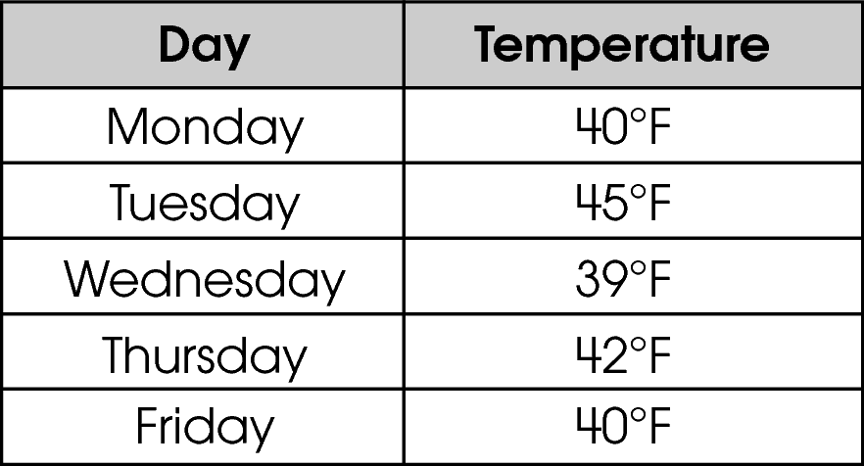
Which line graph shows these data?

A.
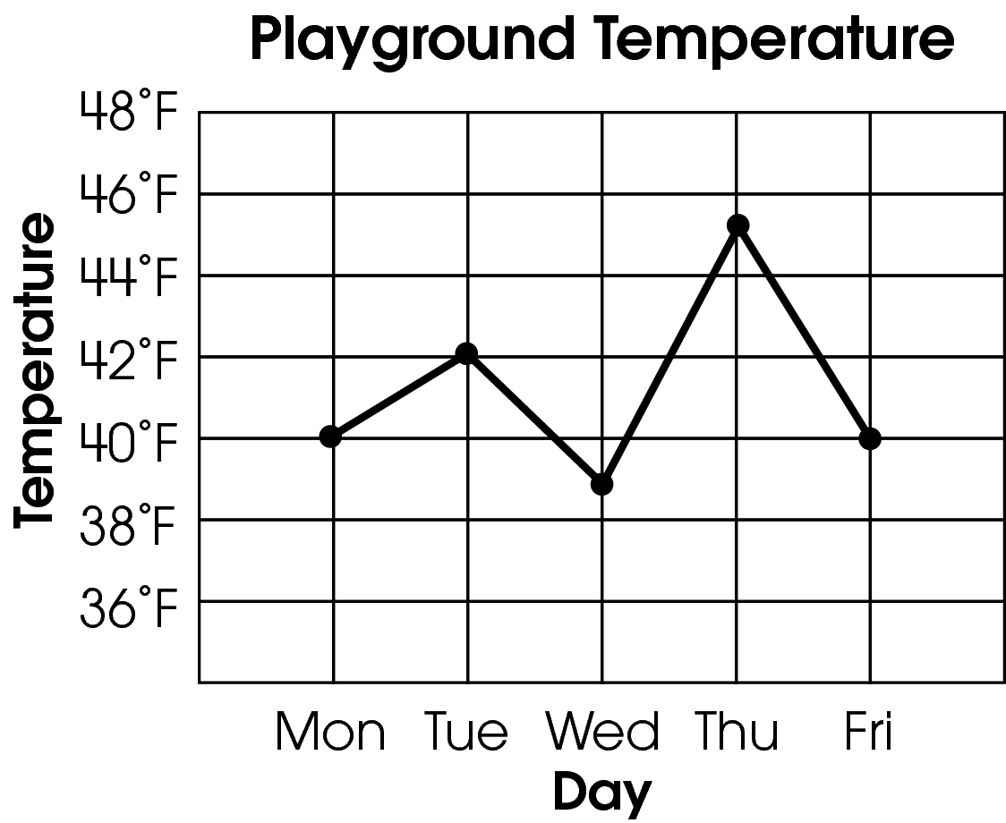

B.
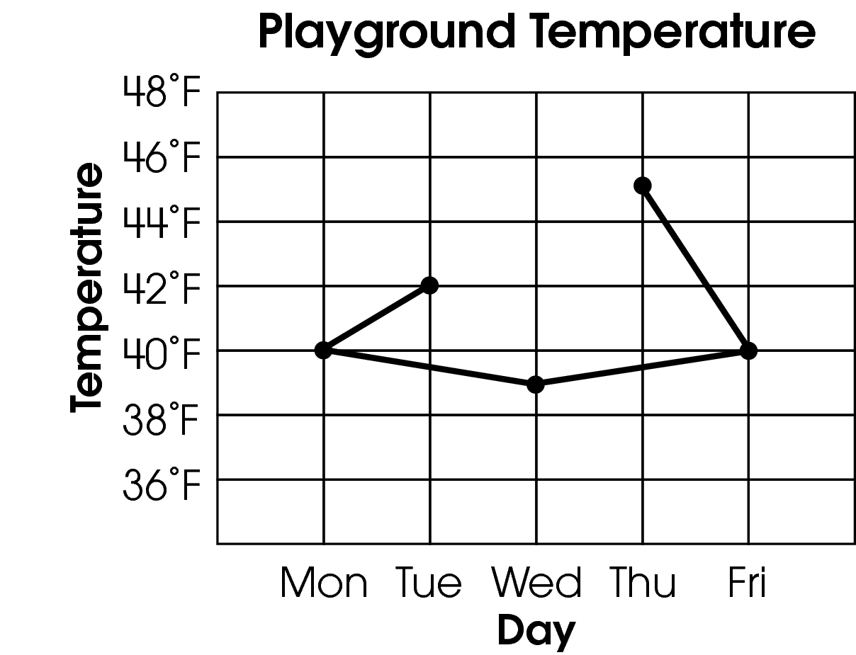

C.
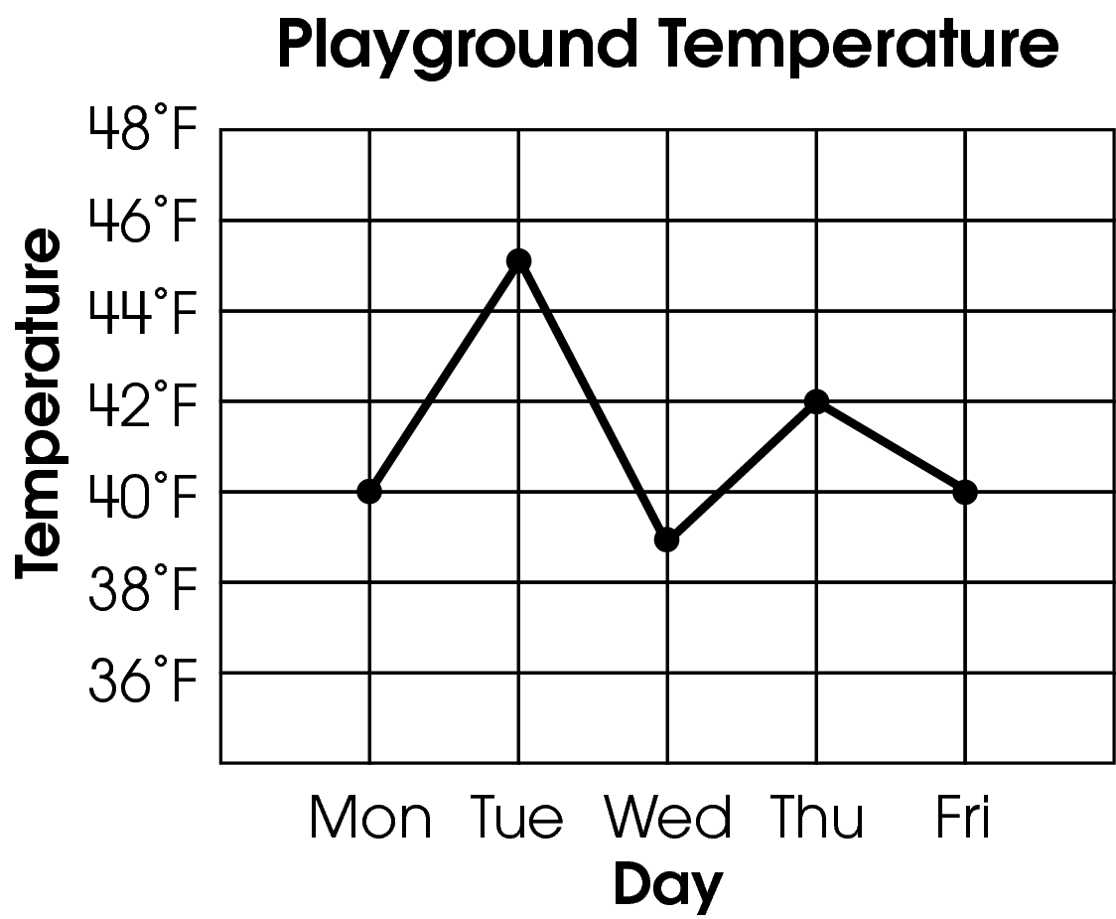

Commentary:
This multiple-choice question asks students to read and interpret the data in a table and to match this data with the correct line graph. Students need to be able to correctly translate the information in the table to the parts of a line graph. The days listed in the Day column form the scale for the horizontal axes in the line graphs shown. The temperatures in the Temperature column would then be represented on the vertical axes. Students need to recognize that the vertical scales in the line graphs shown list even-numbered temperatures starting with 36° F and ending at 48° F, so odd numbered temperatures from the table should be shown half-way between the grid lines for these even-numbered temperatures. The line graph in answer choice C correctly represents the data in the table. It shows that Monday’s temperature was 40° F, it rose to 45° F on Tuesday, dropped to 39° F on Wednesday, rose to 42° F on Thursday, then dropped to 40° F on Friday.

Answer choice A is incorrect since it represents the temperatures in the table translated to the line graph in reverse order of the days of the week. This same mistake is shown in answer choice B, which also shows the points connected incorrectly. The points on the graph should be connected sequentially from left to right with line segments.

The complexity level of this question is Moderate Complexity. Students are required to interpret a line graph representing the data in a table.

Performance Data:
The percent of public school students selecting answer choice C for question 21 on the May 2008 Grade 3 Achievement Test was 85%.

Keywords: data analysis, line graph

BACK TO INDEX

