Acquisition of Vocabulary

Code | Grade Level Indicator | Ques #  w/  Answer | Question | State  %  Correct | District  %  Correct | Building  %  Correct
AV 3.1 | Determine the meaning of unknown words using a variety of context clues, including word, sentence and paragraph clues. | 8  B  FIC | 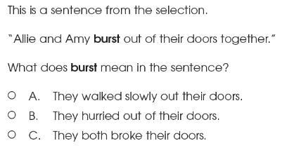 | 88%
AV 3.1 |  | 20  C  NF--SCI | 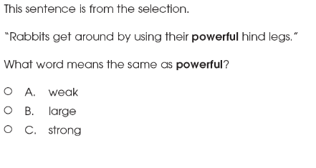 | 90%
AV 3.1 |  | 21  B  FIC | 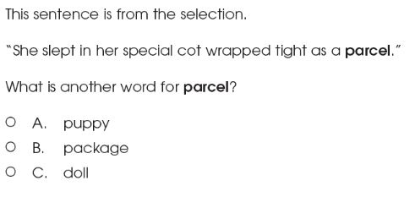 | 74%
AV 3.1 |  | 31  A  NF--SCI | 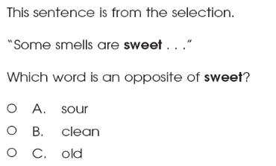  Opposite | 72%
Acquisition of Vocabulary

Code | Grade Level Indicator | Ques #  w/  Answer | Question | State  %  Correct | District  %  Correct | Building  %  Correct
AV 3.2  AV 3.9 | Use context clues to determine the meaning of homophones, homonyms and homographs.  Determine the meanings and pronunciations of unknown words by using dictionaries, glossaries, technology and textual features, such as definitional footnotes or sidebars. | 5  A | 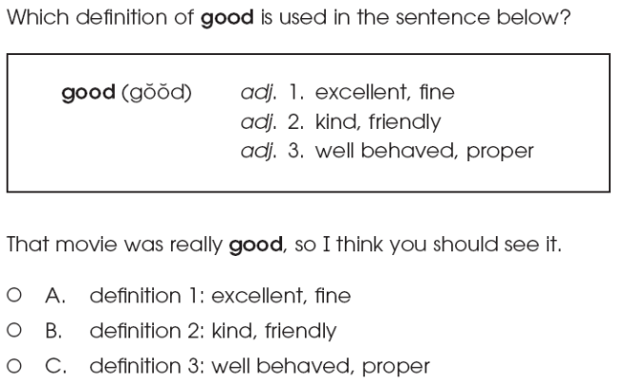 | 63%  B= 14%  C= 21%
AV 3.3 | Apply the meaning of the terms synonyms and antonyms. | 3  B | 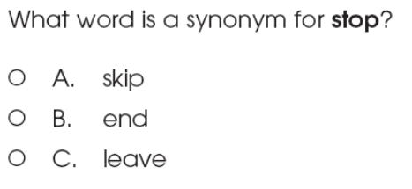 | 82%
AV 3.3 | Apply the meaning of the terms synonyms and antonyms. | 4  C | 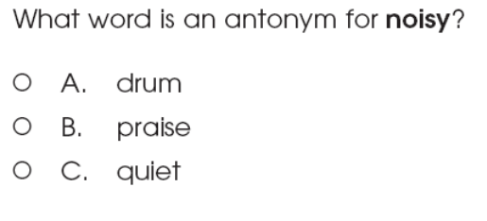 | 74%
Acquisition of Vocabulary

Code | Grade Level Indicator | Ques #  w/  Answer | Question | State  %  Correct | District  %  Correct | Building  %  Correct
AV 3.6 | Use knowledge of contractions and common abbreviations to identify whole words. | 1  B | 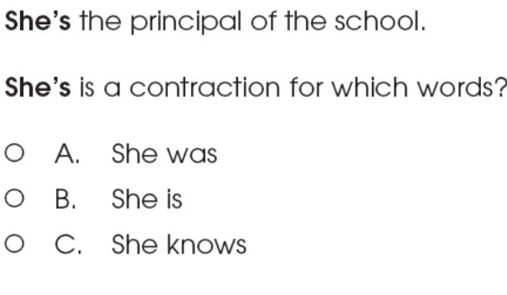 | 89%
AV 3.7  AV 3.1 | Apply knowledge of prefixes, including un-, re-, pre- and suffixes, including -er, -est, -ful and -less to determine meaning of words.  Determine the meaning of unknown words using a variety of context clues, including word, sentence and paragraph clues | 2  B | 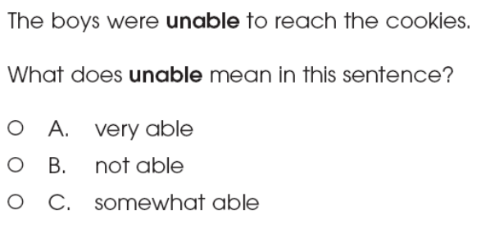 | 89%

Reading Processes: Concepts of Print, Comprehension Strategies and Self-Monitoring Strategies

Code | Grade Level Indicator | Ques #  w/  Answer | Question | State  %  Correct | District  %  Correct | Building  %  Correct
RP 3.1 | Establish a purpose for reading (e.g., to be informed, to follow directions or to be entertained). | 12  C  NF--SCI | 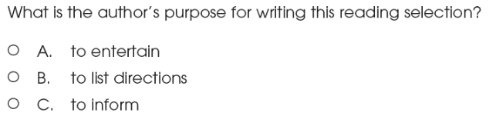  Purpose for Reading vs Purpose for Writing | 53%  A=27%  B=20%
RP 3.2 | Predict content, events and outcomes by using chapter titles, section headers, illustrations and story topics, and support those predictions with examples from the text. | 9  ER  FIC | 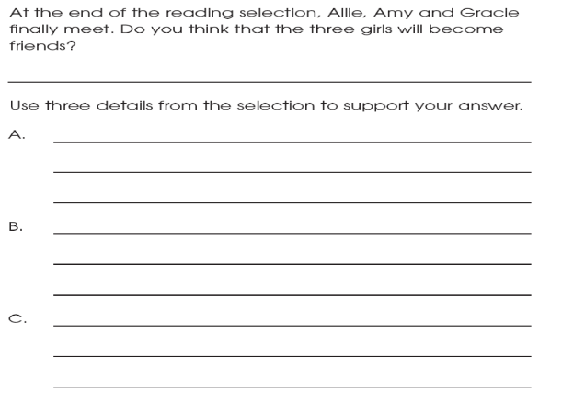 | 4pt=16%  3pt=35%  2ps=27%  1pt=21%  0pt=10%  NR=1%
RP 3.2 |  | 29  C  FIC | 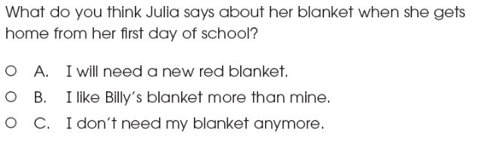 | 67%  A=22%  B= 8%
Reading Processes: Concepts of Print, Comprehension Strategies and Self-Monitoring Strategies

Code | Grade Level Indicator | Ques #  w/  Answer | Question | State  %  Correct | District  %  Correct | Building  %  Correct
RP 3.4 | Summarize texts, sequencing information accurately and include main ideas and details as appropriate. | 14  SA  NF--SCI | 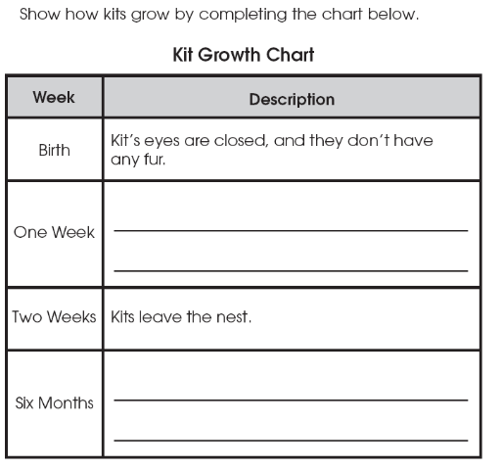 | 2pt=58%  1pt=26%  0pt=14%  NR=2%
RP 3.5 | Make inferences regarding events and possible outcomes from information in text. | 6  B  FIC | 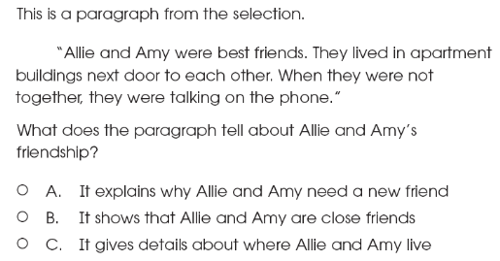 | 72%
RP 3.5 |  | 7  C  FIC | 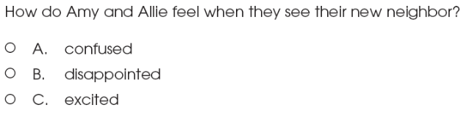 | 85%
Reading Processes: Concepts of Print, Comprehension Strategies and Self-Monitoring Strategies

Code | Grade Level Indicator | Ques #  w/  Answer | Question | State  %  Correct | District  %  Correct | Building  %  Correct
RP 3.7 | Answer literal, inferential and evaluative questions to demonstrate comprehension of grade-appropriate print texts and electronic and visual media. | 13  A  NF--SCI | 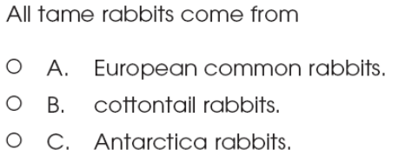  Literal—glossary word “descendants” | 64%  B=21%  C=14%
RP 3.7 |  | 15  A  NF--SCI | 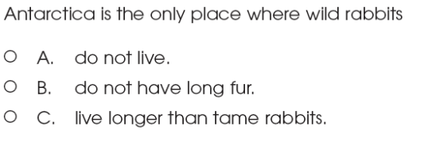  Literal | 65%  B=10%  C=25%
RP 3.7 |  | 17  B  NF--SCI | 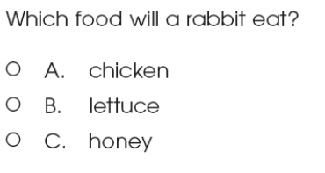  Inferential—prior knowledge | 92%
RP 3.7 |  | 22  SA  FIC | 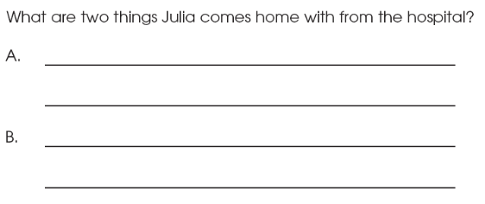  Literal | 2pt=54%  1pt=28%  0=16%  NR=2%
Reading Processes: Concepts of Print, Comprehension Strategies and Self-Monitoring Strategies

Code | Grade Level Indicator | Ques #  w/  Answer | Question | State  %  Correct | District  %  Correct | Building  %  Correct
RP 3.7 | Answer literal, inferential and evaluative questions to demonstrate comprehension of grade-appropriate print texts and electronic and visual media. | 24  C  FIC | 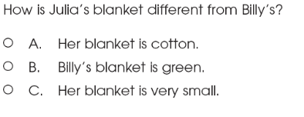  Inferential | 73%
RP 3.7 |  | 28  B  FIC | 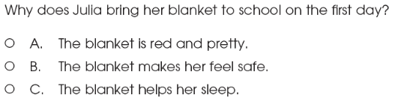  Inferential | 74%
RP 3.7 |  | 30  A  NF--SCI | 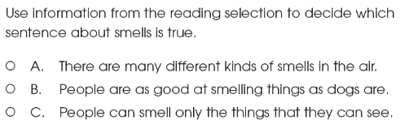  Literal | 81%
RP 3.7 |  | 34  B  NF--SCI | 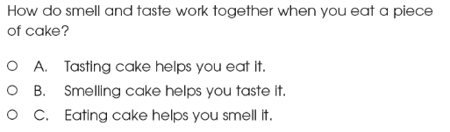  Inferential | 57%  A=20%  C=21%
RP 3.7 |  | 36  SA  NF--SCI | 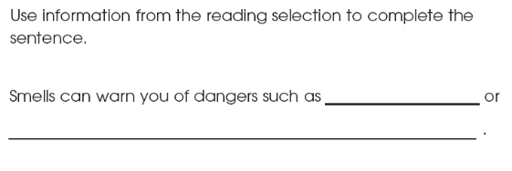  Literal—question format? | 2pt=32%  1pt=23%  0pt=41%  NR=4%
Reading Applications: Informational, Technical, and Persuasive Text

Code | Grade Level Indicator | Ques #  w/  Answer | Question | State  %  Correct | District  %  Correct | Building  %  Correct
IT 3.2 | List questions about essential elements (e.g., why, who, where, what, when and how) from informational text and identify answers. | 16  B  NF--SCI | 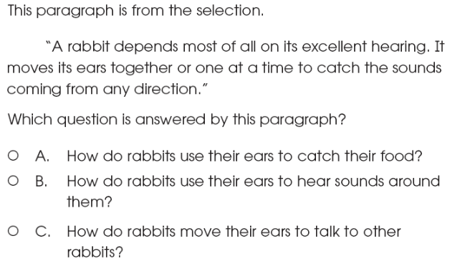 | 78%
IT 3.2 |  | 35  A  NF--SCI | 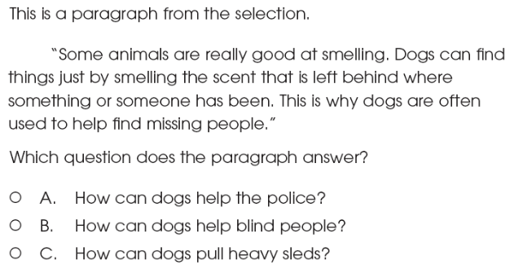 | 67%  B=24%  C=7%
Reading Applications: Informational, Technical, and Persuasive Text

Code | Grade Level Indicator | Ques #  w/  Answer | Question | State  %  Correct | District  %  Correct | Building  %  Correct
IT 3.3 | Identify and list the important central ideas and supporting details of informational text. | 18  ER  NF--SCI | 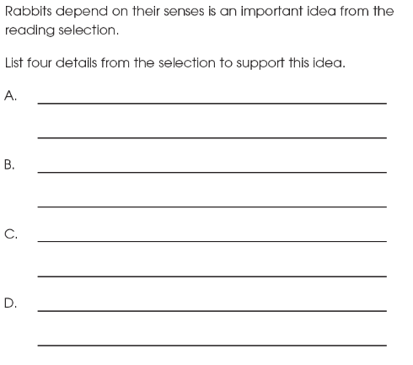 | 4pt=2%  3pt=6%  2pt=10%  1pt=19%  0pt=59%  NR=1%
IT 3.3 |  | 19  B  NF--SCI | 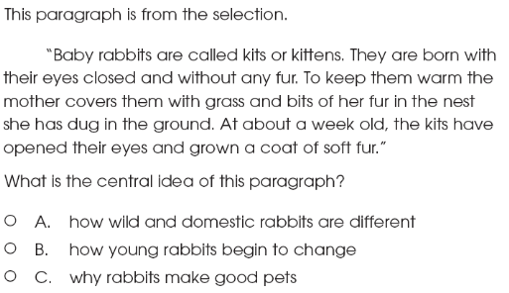 | 77%
IT 3.3 |  | 33  B  NF--SCI | 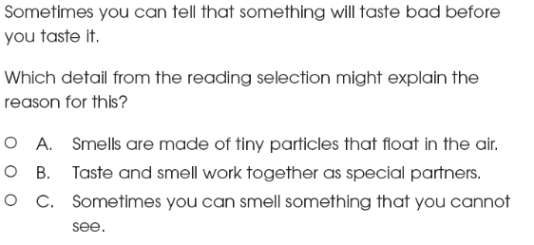 | 42%  A=28%  C=28%
Reading Applications: Informational, Technical, and Persuasive Text

Code | Grade Level Indicator | Ques #  w/  Answer | Question | State  %  Correct | District  %  Correct | Building  %  Correct
IT 3.5 | Analyze a set of directions for proper sequencing, clarity and completeness. | 32  SA  NF--SCI | 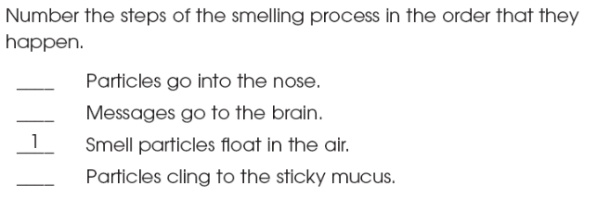 | 2pt=52%  1pt=32%  0pt=13%  NR=4%
Reading Applications: Literary Text

Code | Grade Level Indicator | Ques #  w/  Answer | Question | State  %  Correct | District  %  Correct | Building  %  Correct
LT 3.2 | Use concrete details from the text to describe characters and setting. | 11  C  FIC | 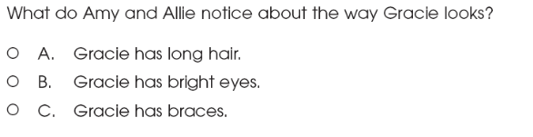 | 82%
LT 3.2 |  | 23  C  FIC | 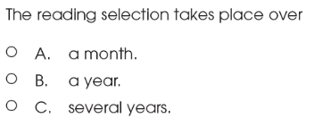 | 44%  A=28%  B=25%
LT 3.2 |  | 27  C  FIC | 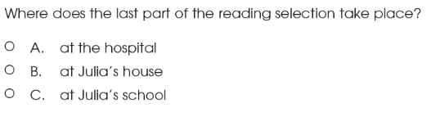 | 70%
Reading Applications: Literary Text

Code | Grade Level Indicator | Ques #  w/  Answer | Question | State  %  Correct | District  %  Correct | Building  %  Correct
LT 3.3 | Retell the plot sequence. | 26  ER  FIC | 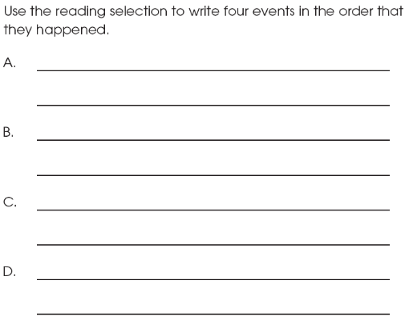 | 4pt=32%  3pt=24%  2pt=17%  1pt=12%  0pt=10%  NR=4%
LT 3.7 | Describe methods authors use to influence readers’ feelings and attitudes (e.g., appeal of characters in a picture book; use of figurative language). | 10  B  FIC | 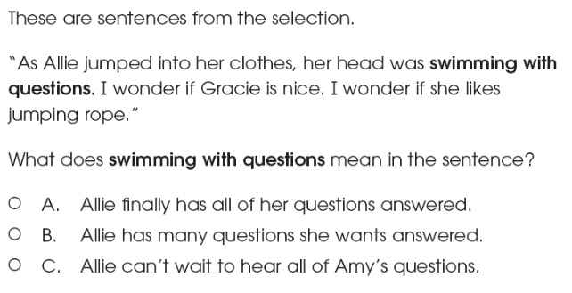 | 79%
LT 3.7 |  | 25  B  FIC | 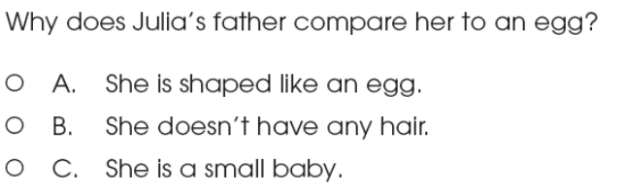 | 48%  A=15%  C=36%

