Index to Questions

Question Number | Source | BM | GLI | Description
1 | OAT Mar 06 | I | NNS 4.14 | This multiple-choice question asks students to find the number of strawberry plants in Ruth’s garden.
6 | OAT Mar 06 | M | NNS 4.10 | This multiple-choice question asks students to add fractions that represent the total growth of a puppy in two months.
10 | OAT Mar 06 | B | NNS 4.1b | This short-answer question asks students to write a fraction that equals to one and to provide an explanation of why their fraction is equal to one.
17 | OAT Mar 06 | A | NNS 4.2 | This multiple-choice question asks students to recognize an equivalent representation for the number 480072 using a place-value structure.
23 | OAT Mar 06 | J | NNS 4.9 | This multiple-choice question asks students to select the estimate for the distance from Kellogg to Fairfield.
28 | OAT Mar 06 | F | NNS 4.8 | This multiple-choice question asks students to find the price of a pair of jeans using the amount of money given by Mrs. Thomas to the store clerk and the amount of change she received.
33 | OAT Mar 06 | K | NNS 4.12 | This extended-response question asks students to solve a multi-step problem.
36 | OAT Mar 06 | A | NNS 4.4 | This multiple-choice question asks students to select a prime number between 20 and 30 from the list of four numbers.
39 | OAT Mar 06 | D | NNS 4.5 | This multiple-choice question asks students to identify the greatest fraction from fraction models representing the shaded part of squares.
42 | OAT Mar 06 | F | NNS 4.8 | This short-answer question asks students to solve a problem involving money by finding the amount of change.
45 | OAT Mar 06 | A | NNS 4.3 | This multiple-choice question asks students to round a whole number to the nearest hundred.
6 | OAT May 07 | K | NNS 4.7 | This multiple-choice question asks students to find the number of models Aaron can buy for $60 if the cost of each model is $7.
10 | OAT May 07 | B | NNS 4.1a | This short-answer question asks students to represent the number of students wearing hats as a fraction and generate its equivalent (equal in value) decimal form.
Question Number | Source | BM | GLI | Description
16 | OAT May 07 | E | NNS 4.4 | This multiple-choice question asks students to select a class that can be divided into equal- sized groups with more than one student.
31 | OAT May 07 | F | NNS 4.8 | This multiple-choice question asks students to find the total amount of money earned for walking a dog for each of six days.
36 | OAT May 07 | J | NNS 4.3 | This multiple-choice question asks students to round a whole number to the nearest thousand.
40 | OAT May 07 | A | NNS 4.2 | This multiple-choice question asks students to compare whole numbers from the table and then select a number larger than 109,026.
46 | OAT May 07 | A | NNS 4.14 | This multiple-choice question asks students to select a number that represents the total number of people who went to the movie theatre on Saturday and Sunday.
2 | OAT May 08 | E | NNS 4.4 | This multiple-choice question asks students to identify a common multiple for two different numbers.
6 | OAT May 08 | A | NNS 4.2 | This multiple-choice question asks students to compare decimals to the thousandths place to find a measurement greater than 0.125 centimeters.
11 | OAT May 08 | F | NNS 4.8 | This multiple-choice question asks students to determine the change in both coins and paper bills for a $12.58 bag of seed purchased with two $10.00 bills.
35 | OAT May 08 | K | NNS 4.12 | This multiple-choice question asks students to use the number of envelopes in one box of small, one box of medium and one box of large envelopes to find the total number of envelopes in 2 small, 3 medium, and 1 large box of envelopes.
38 | OAT May 08 | J | NNS 2.13, NNS 4.9 | This short-answer question asks student to determine whether an estimated number of books sold at a book fair is reasonable based on the data in a table.
46 | OAT May 08 | M | NNS 4.2, NNS 4.10 | This multiple-choice question asks students to find the time it took a runner to complete a race when his time is one hundredth of a second longer than 27.34 seconds.

BACK TO INDEX

Benchmark: I | Demonstrate fluency in multiplication facts with factors through 10 and corresponding divisions.
GLI: NNS 4.14 | Demonstrate fluency in adding and subtracting whole numbers and in multiplying and dividing whole numbers by 1- and 2-digit numbers and multiples of ten.

Multiple Choice Question:

1. Ruth’s garden has 6 rows of strawberry plants. There are 20 strawberry plants in each row.
How many strawberry plants are in Ruth’s garden?
A. 12
B. 26
C. 80
D. 120

Commentary:
This multiple-choice question asks students to find the number of strawberry plants in Ruth’s garden. Students may find it using either multiplication (6 x 20 = 120) or repeated addition
(20 + 20 + 20 + 20 + 20 + 20 = 120). Therefore, answer choice D is the correct answer. Answer choice A is incorrect because students may have multiplied 6 x 2 = 12. Answer choice B is also incorrect because students found 20 + 6 = 26. Answer choice C is incorrect because students may have multiplied 20 x 6 but used 6 + 2 = 8 instead of 6 x 2 = 12.

The complexity level of this question is Low Complexity. This question requires students to recognize an example of the concept of multiplication and then to compute the product or sum.

Performance Data:
The percent of public school students selecting answer choice D for question 1 on the March 2006 Grade 4 Achievement Test was 85%.

Keywords: number, operation, multiplication

BACK TO INDEX

Benchmark: M | Add and subtract commonly used fractions with like denominators and decimals, using models and paper and pencil.
GLI: NNS 4.10 | Use physical models, visual representations, and paper and pencil to add and subtract decimals and commonly used fractions with like denominators.

Multiple Choice Question:
6. One month Tony’s puppy grew 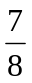of an inch. The next month his puppy grew of an inch.
How many inches did Tony’s puppy grow in two months?
A. 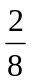
B. 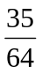
C. 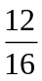
D. 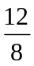

Commentary:
This multiple-choice question asks students to add fractions that represent the total growth of a puppy in two months. Answer choice D is the correct answer because if the denominators are alike (8) in both of the original fractions, students should add only the numerators (7 + 5 =12) of both original fractions and the denominator of the fractions will remain the same (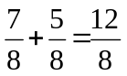). Answer choices A, B and C are incorrect because students may have used incorrect operations, e.g., subtracting the numerators instead of adding the numerators for answer choice A; multiplying the fractions for answer choice B; and adding both numerators and both denominators for answer choice C.

The complexity level of this question is Low Complexity because it requires students to solve a one-step word problem.

Performance Data:
The percent of public school students selecting answer choice D for question 6 on the March 2006 Grade 4 Achievement Test was 56%.

Keywords: number, fraction, addition

BACK TO INDEX

Benchmark: B | Recognize and generate equivalent representations for whole numbers, fractions and decimals.
GLI: NNS 4.1b | Identify and generate equivalent forms of fractions and decimals. For example:  - Understand and explain that ten tenths is the same as one whole in both fraction and decimal form.

Short Answer Question:

10. Some fractions are less than one. Some fractions are equal to one. Some fractions are greater than one.
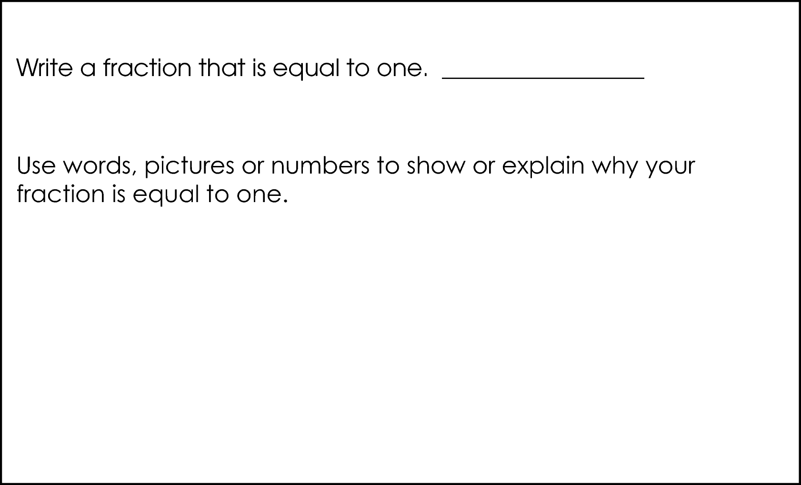

Commentary:
This short-answer question asks students to write a fraction that equals to one and to provide an explanation of why their fraction is equal to one. A response earning the maximum number of points (2 points) provides a fraction that has the same numerator and denominator, such as, and provides a mathematically relevant explanation or a picture that explains why this fraction is equal to one. For example, a student may choose to show the fraction as a circle or rectangle that is divided equally into five (5) fully shaded segments. This picture will represent a fraction that equals to one (1) because it has five shaded segments (the numerator of a fraction) out of the five segments the circle or rectangle is divided into (the denominator of a fraction).

The complexity level of this question is Moderate Complexity because it requires students to provide a representation of a number with justification.

Performance Data:
The percent of public school students earning each score point for question 10 on the March 2006 Grade 4 Achievement Test:

Percent at Each Score Point
0 | 1 | 2
33% | 16% | 49%

Scoring Guidelines:
Sample Correct Response(s):
- It is equal to one because the numerator is the number of parts and the denominator is the number of parts in all. Since they are both 4 it means you have 4 parts and there are 4 parts in all, so it’s equal to one.

- 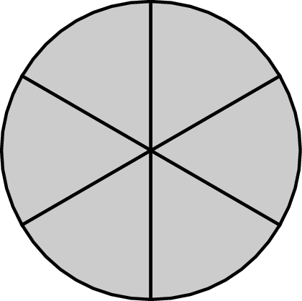

Points | Student Response
2 | The focus of this task is identifying and describing equivalent forms of fractions that are equal to one. The response provides a fraction equal to one and provides adequate support to show or explain why the fraction is equal to one.
1 | The response shows partial evidence of identifying and describing equivalent forms of fractions that are equal to one; however, the solution is incomplete or slightly flawed.  For example, the response may:  - Provide a fraction equal to one, but give no or a flawed explanation of why it is equal to one.  - State an appropriate explanation but does not indicate a fraction. E.g., a fraction is equal to one when the numerator is equal to the denominator.
0 | The response provides inadequate evidence of an understanding of identifying and describing equivalent forms of fractions that are equal to one. The response provides an explanation with major flaws and errors of reasoning.  For example, the response may:  - State a fraction that is not equal to one and does not provide an adequate explanation. E.g.  - Be blank or state unrelated statements.  - Recopy information from the stem.

do not copy or distribute ID: 10104; Version: 6

Keywords: number, fraction

BACK TO INDEX

Benchmark: A | Use place value structure of the base-ten number system to read, write, represent and compare whole numbers and decimals.
GLI: NNS 4.2 | Use place value structure of the base-ten number system to read, write, represent and compare whole numbers through millions and decimals through thousandths.

Multiple Choice Question:

17. Which is the same as 480,072?
A. 400 + 80 + 70 + 2
B. 4,000 + 80 + 700 + 2
C. 40,000 + 80,000 + 70 + 2
D. 400,000 + 80,000 + 70 + 2
Commentary:
This multiple-choice question asks students to recognize an equivalent representation for the number 480,072 using a place-value structure. The correct answer is answer choice D. Answer choices A, B and C are incorrect because students may have incorrectly identified the place value of one of the digits.

The complexity level of this question is Low Complexity because it requires recognizing an equivalent representation of a number.

Performance Data:
The percent of public school students selecting answer choice D for question 17 on the March 2006 Grade 4 Achievement Test was 69%.

Keywords: number, place-value

BACK TO INDEX

Benchmark: J | Estimate the results of whole number computations using a variety of strategies, and judge the reasonableness.
GLI: NNS 4.9 | Estimate the results of computations involving whole numbers, fractions and decimals, using a variety of strategies.

Multiple Choice Question:

23. The distance between three towns is shown.
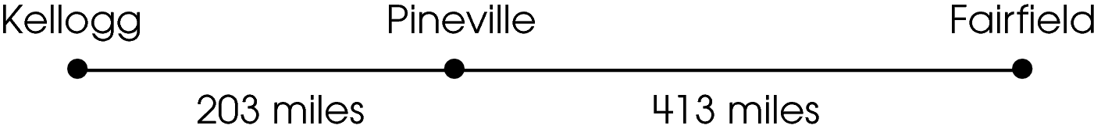
Estimate the distance from Kellogg to Fairfield.
A. 500 miles
B. 600 miles
C. 700 miles
D. 800 miles

do not copy or distribute ID: 10023; Version: 7

Commentary:
This multiple-choice question asks students to select the estimate for the distance from Kellogg to Fairfield. Students have to estimate the total of 203 and 413. For example, 203 is closer to 200 than it is to 300 and 413 is closer to 400 than it is to 500. Therefore, 600 miles
(200 + 400 = 600), answer choice B, is the best estimate for the distance.

The complexity level of this question is Low Complexity. This question requires students to perform a specified procedure (estimate the total).

Performance Data:
The percent of public school students selecting answer choice B for question 23 on the March 2006 Grade 4 Achievement Test was 82%.

Keywords: number sense, estimation, whole numbers

BACK TO INDEX

Benchmark: F | Count money and make change using both coins and paper bills.
GLI: NNS 4.8 | Solve problems involving counting money and making change, using both coins and paper bills.

Multiple Choice Question:

28. Mrs. Thomas gave the store clerk $25.00 for a pair of jeans. She received $2.88 back in change.
What was the price of the jeans?
A. $21.12
B. $22.12
C. $22.22
D. $23.22

Commentary:
This multiple-choice question asks students to find the price of a pair of jeans using the amount of money given by Mrs. Thomas to the store clerk and the amount of change she received. Students can solve this problem by finding the difference between $25.00 and $2.88. One method is to use mental math. First, students may subtract $2 from $25 (25 – 2 = 23), then they can take one dollar ($1) out of the $23 to subtract the $0.88 from or they can count up from $0.88 to a dollar to get $0.12 difference. Then students may add $0.12 and remaining $22 to find the cost of the jeans ($23 – $0.88 = $22.12 or $22 + $0.12 = $22.12). Answer choice B is the correct answer. Another method for finding the difference is to use the subtraction algorithm.

The complexity level of this question is Low Complexity. This question requires students to solve a one-step word problem.

Performance Data:
The percent of public school students selecting answer choice B for question 28 on the March 2006 Grade 4 Achievement Test was 65%.

Keywords: number, subtraction, money

BACK TO INDEX

Benchmark: K | Analyze and solve multi-step problems involving addition, subtraction, multiplication and division of whole numbers.
GLI: NNS 4.12 | Analyze and solve multi-step problems involving addition, subtraction, multiplication and division using an organized approach, and verify and interpret results with respect to the original problem.

Extended Response Question:

33. A store sells rice in 3-pound and 5-pound bags. Jennie is responsible for packing 60 pounds of rice into the 3-pound bags, 5-pound bags or a combination of 3-pound and 5-pound bags. She needs to pack all 60 pounds of rice.
The prices for the bags of rice are shown in the chart.
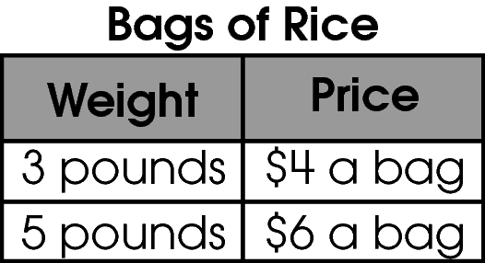
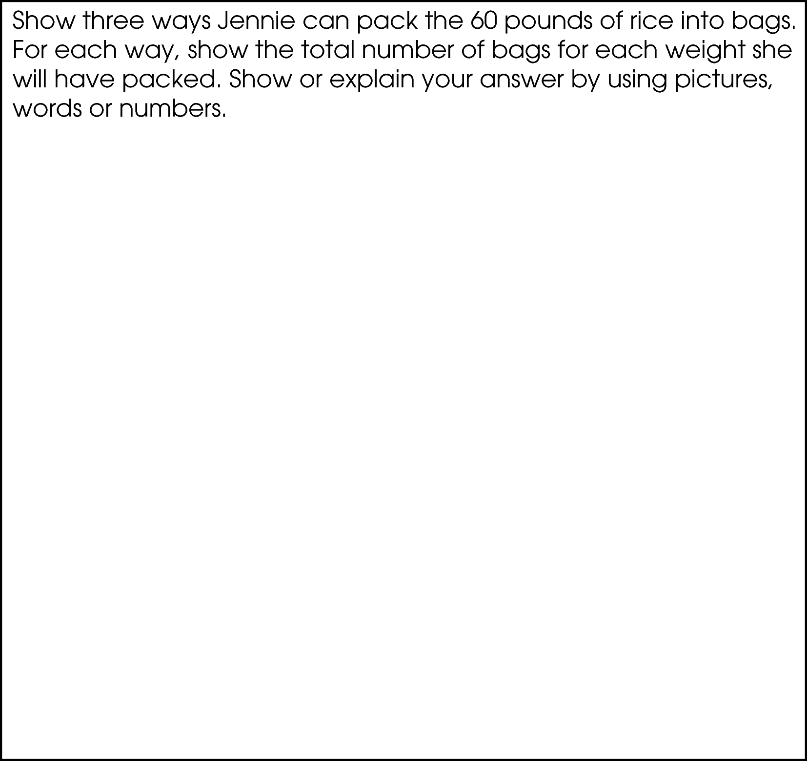

Commentary:
This extended-response question asks students to solve a multi-step problem. A response earning the maximum number of points (4 points) provides three correct combinations of 5- and 3- pound bags that result in a total of 60 pounds and provides an adequate explanation of which packaging combination makes the most money. For example, 60 lb of rice can be packed into 20 3-pound bags (60 = 3 x 20) and costs $80 (20 x 4 = 80). 60 lb of rice can be packed into 12 5-pound bags (60 = 5 x 12) and costs $72 (12 x 6 = 72). 60 lb of rice can also be packed into 10 3-pound (30 = 10 x 3) bags and 6 5-pound bags (30 = 6 x 5) and it can be sold for $40 (10 x 4 = 40) and for $36 (6 x 6 = 36) respectively which totals to $76. The combination that will make the most money is 20 3-pound bags.

The complexity level of this question is High Complexity. The question requires students to perform a procedure having multiple steps and multiple decision points.

Performance Data:
The percent of public school students earning each score point for question 33 on the March 2006 Grade 4 Achievement Test:

Percent at Each Score Point
0 | 1 | 2 | 3 | 4
51% | 15% | 6% | 16% | 10%

Scoring Guidelines:
Sample Correct Response(s):
- She can pack:
20 3-pound bags because 3 × 20 = 60 OR

12 5-pound bags because 5 × 12 = 60 OR

10 3-pound bags and 6 5-pound bags because 10 × 3 plus 6 × 5 = 60.

She makes the most money when she puts all the rice into the 3 pound bags since that combination has a value of $80 and the other two combinations have a value of $72 and $76.

- See table below for other possible combinations and costs.

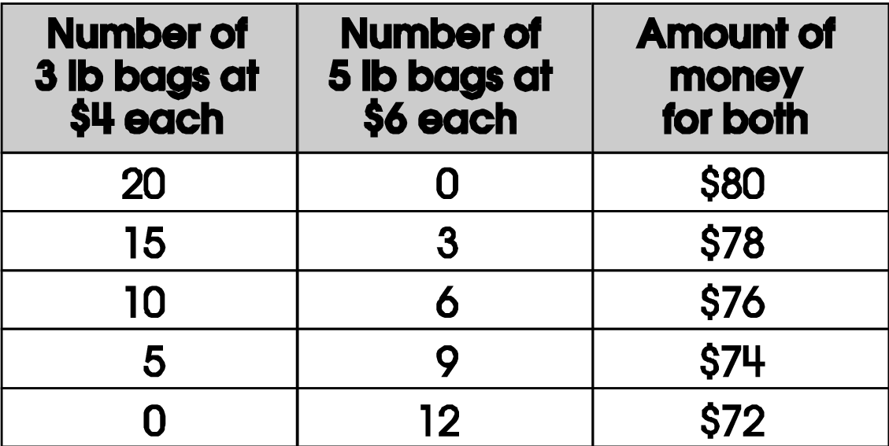

Points | Student Response
4 | The focus of the task is using appropriate operations with whole numbers to solve a multi-step problem and showing three different solutions. The response provides three correct combinations of 3 and 5 pound bags that result in a total of 60 pounds AND shows which combination makes the most money with a correct strategy or work.
3 | The response provides evidence of using appropriate operations with whole numbers to solve a multi-step problem and showing three different solutions; however, the solution may contain a slight error, a flaw or a vague explanation.  For example, the response may:  - Show three correct combinations of bags, but incorrectly identifies the one of greatest value due to a minor calculation error.  - Show three combinations, one of which is incorrect, but correctly finds the one that makes the most based on their combinations.
2 | The response provides partial evidence of using appropriate operations with whole numbers to solve a multi-step problem and showing three different solutions; however, the solution is incomplete and/or contains minor flaws.  For example, the response may:  - Only show two correct combinations and show a strategy for finding which has the greatest value with minor flaws or errors.
1 | The response provides minimal evidence of using appropriate operations with whole numbers to solve a multi-step problem and showing three different solutions. The response has major flaws and errors in reasoning.  For example, the response may:  - State that the most expensive bag would be $80.  - State at least two combinations of bags equaling 60 pounds correctly.
0 | The response provides inadequate evidence of using appropriate operations with whole numbers to solve a multi-step problem and showing three different solutions.  For example, the response may:  - Show one correct combination.  - State that the bags will cost any correct amount without showing work or stating if it is the most expensive or not.  - Be blank or make unrelated statements.  - Recopy information given in the stem.

do not copy or distribute ID: 10934; Version: 20

Keywords: number sense, money, operation

BACK TO INDEX

Benchmark: A | Use place value structure of the base-ten number system to read, write, represent and compare whole numbers and decimals.
GLI: NNS 4.4 | Identify and represent factors and multiples of whole numbers through 100, and classify numbers as prime or composite.

Multiple Choice Question:

36. Which is a prime number between 20 and 30?
A. 21
B. 23
C. 25
D. 27

Commentary:
This multiple-choice question asks students to select a prime number between 20 and 30 from the list of four numbers. A prime number is a number that has no factors beside one and itself. The correct answer choice is B because the only factors of 23 are 1 and 23. Numbers 21, 25 and 27 are not prime numbers. They all can be written as the product of factors other then 1 and itself, such as 21 = 3 x 7, 25 = 5 x 5, and 27 = 3 x 9. Therefore, answer choices A, C and D are incorrect.

The complexity level of this question is Low Complexity. The question requires students to recognize an example of a concept.

Performance Data:
The percent of public school students selecting answer choice B for question 36 on the March 2006 Grade 4 Achievement Test was 45%.

Keywords: number, prime number, factor

BACK TO INDEX

Benchmark: D | Use models, points of reference and equivalent forms of commonly used fractions to judge the size of fractions and to compare, describe and order them.
GLI: NNS 4.5 | Use models and points of reference to compare commonly used fractions.

Multiple Choice Question:

39.

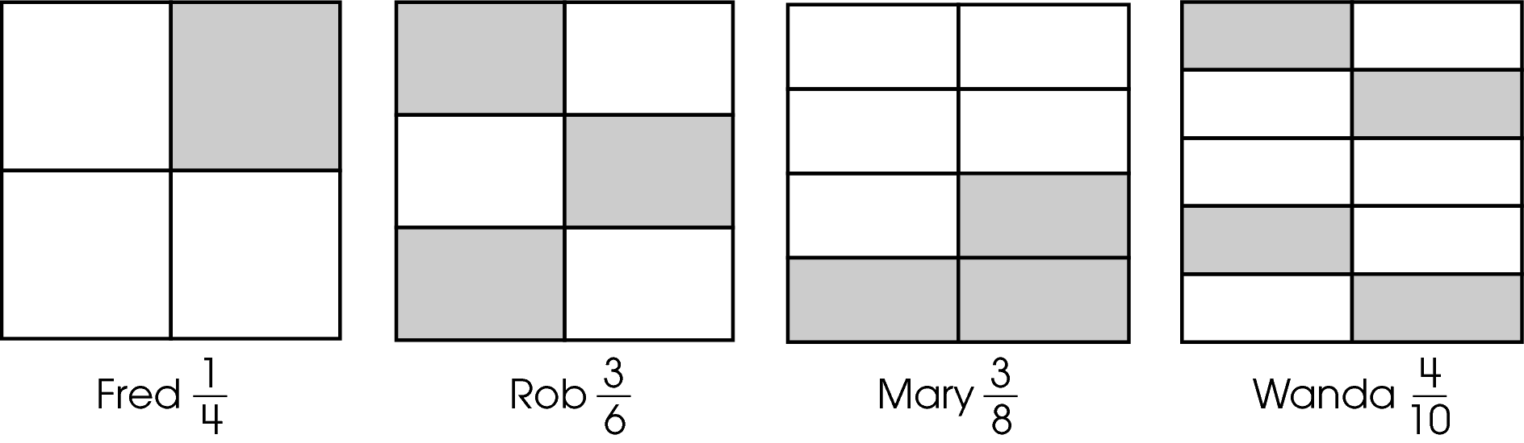
Which fraction is greatest?
A. 
B. 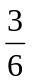
C.
D. 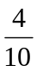

Commentary:
This multiple-choice question asks students to identify the greatest fraction from fraction models representing the shaded part of squares. Fractions are often referred to as measuring part of the whole. In this problem, each square represents one whole and the shaded sections represent the parts of the whole. If all of the shaded parts in each square are moved next to each other, half of the Rob’s square would be shaded. The shaded part of Mary’s square is smaller than a half and the shaded part of Wanda’s square is also smaller than a half. Therefore, the correct answer is B. The fractions in answer choices A, C and D are incorrect because they represent numbers that are smaller than or.

The complexity level of this question is Moderate Complexity. This question requires students to use different representations of fractions and interpret the visual representations.

Performance Data:
The percent of public school students selecting answer choice B for question 39 on the March 2006 Grade 4 Achievement Test was 47%.

Keywords: number sense, fraction

BACK TO INDEX

Benchmark: F | Count money and make change using both coins and paper bills.
GLI: NNS 4.8 | Solve problems involving counting money and making change, using both coins and paper bills.

Short Answer Question:

42. Gavin bought a puzzle that costs $6.35. He gave the clerk a $10 bill.
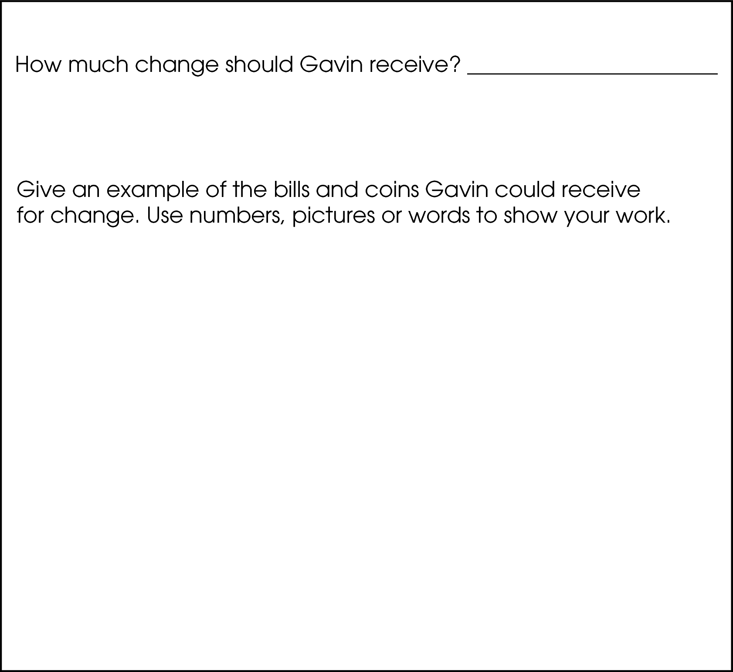

Commentary:
This short-answer question asks students to solve a problem involving money by finding the amount of change. A response earning the maximum number of points (2 points) provides the correct amount of change ($3.65 = $10 - $6.35) and gives an example of the change received in bills and coins. For example, Gavin receives $3.65 in three $1 bills, two quarters, one dime and one nickel or he receives three $1 bills, six dimes and one nickel.

The complexity level of this question is Moderate Complexity. The task requires students to represent a mathematical situation in more than one way.

Performance Data:
The percent of public school students earning each score point for question 42 on the March 2006 Grade 4 Achievement Test:

Percent at Each Score Point
0 | 1 | 2
20% | 35% | 44%

Scoring Guidelines:
Sample Correct Response(s):
- Gavin gets back $3.65. He receives three $1 bills, two quarters, one dime and one nickel, and 10 – 6.35 = 3.65.
- $10 - $6.35 = 3.65 is the change that Gavin gets. Gavin gets back three $1 bills, six dimes and one nickel because this makes $3.65.
- $3.65 is the change
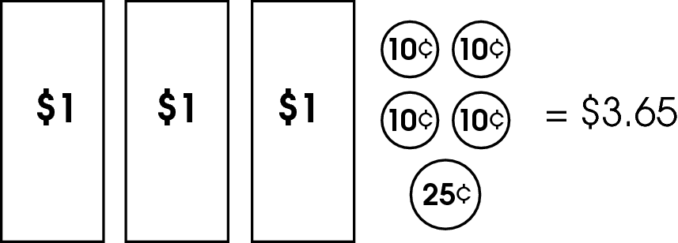

Points | Student Response
2 | The focus of the task is solving problems involving counting money and making change. The response provides the amount of change AND provides a correct list of bills and coins with an adequate explanation or work.
1 | The response shows partial evidence of solving problems involving counting money and making change; however, the solution may be incomplete or slightly flawed.  For example, the response may:  - State a correct amount of change, but not list a correct example of the bills and coins he could receive as change.  - State an incorrect amount of change, but correctly list a combination of bills and coins that total the given amount of change.
0 | The response provides inadequate evidence of solving problems involving counting money and making change. The response provides an explanation with major flaws and errors of reasoning.  For example, the response may:  - State an incorrect amount of change and show an incorrect amount of bills and coins he could receive as change.  - Be blank or state unrelated statements.  - Recopy information from the stem.

do not copy or distribute ID: 9403; Version: 8

Keywords: number, money

BACK TO INDEX

Benchmark: A | Use place value structure of the base-ten number system to read, write, represent and compare whole numbers and decimals.
GLI: NNS 4.3 | Round whole numbers to a given place value.

Multiple Choice Question:

45. The elevation of Campbell Hill is 1,565 feet.
What is this number rounded to the nearest hundred?
A. 1,500 feet
B. 1,550 feet
C. 1,600 feet
D. 2,000 feet

do not copy or distribute ID: 9802; Version: 24

Commentary:
This multiple-choice question asks students to round a whole number to the nearest hundred. Students need to round 1,565 to the nearest hundred using an appropriate strategy. For example, 1,565 is between 1,500 and 1,600 but it is closer to 1,600. Therefore, the correct answer is 1600, answer choice C. Answer choice A is incorrect because students may have rounded the number down. Answer choice B is also incorrect because students may have rounded 1,565 to the nearest fifty. Answer choice D is incorrect because 1,565 was rounded to the nearest thousand instead of the nearest hundred.

The complexity level of this question is Low Complexity. The question requires students to perform a specified procedure.

Performance Data:
The percent of public school students selecting answer choice C for question 45 on the March 2006 Grade 4 Achievement Test was 75%.

Keywords: number sense, estimation, rounding

BACK TO INDEX

Benchmark: K | Analyze and solve multi-step problems involving addition, subtraction, multiplication and division of whole numbers.
GLI: NNS 4.7 | Recognize that division may be used to solve different types of problem situations and interpret the meaning of remainders; e.g., situations involving measurement, money.

Multiple Choice Question:

6. Aaron saved $60 to buy airplane models for his collection. The cost of each model with tax included is $7.
How many models can he buy?

A. 4
B. 8
C. 9
D. 12

Commentary:
This multiple-choice question asks students to find the number of models Aaron can buy for
$60 if the cost of each model is $7. One strategy students can use to solve this problem is to divide 60 by 7 and, as a result, get 8 with a remainder of 4. The quotient (8) represents the number of models Aaron can buy with $ 60 and the remainder (4) represents the money left over after 8 models are purchased. The correct answer is B.

Students choosing answer choice A used the amount of money left for the number of models purchased. Students choosing answer choice C may have made a rounding error and used the remaining 4 dollars toward purchasing the ninth model. Answer choice D is the result of adding the number of models that Aaron can purchase (8) with the remaining money (4), 8 + 4 = 12.

The complexity level of this question is Moderate Complexity. This question asks students to represent a situation mathematically.

Performance Data:
The percent of public school students selecting answer choice B for question 6 on the May 2007 Grade 4 Achievement Test was 67%.

Keywords: number, division, quotient, remainder

BACK TO INDEX

Benchmark: B | Recognize and generate equivalent representations for whole numbers, fractions and decimals.
GLI: NNS 4.1a | Identify and generate equivalent forms of fractions and decimals. For example:  a. Connect physical, verbal and symbolic representations of  fractions, decimals and whole numbers; e.g., ,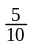 , “five  tenths,” 0.5, shaded rectangles with half, and five tenths.

Short Answer Question:

10. Eight students are shown.

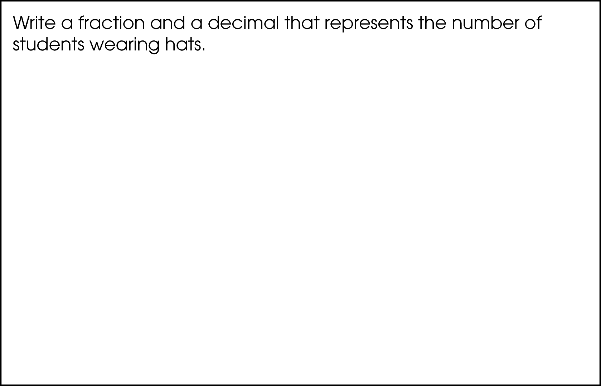

Commentary:
This short-answer question asks students to represent the number of students wearing hats as a fraction and generate its equivalent (equal in value) decimal form. A response earning the maximum number of points (2 points) provides a fraction and a decimal that represent the number of students wearing hats out of the total number of students.
Fractions are used to represent part of a whole. The picture shows 6 out of 8 students wearing hats. This can be represented by the fraction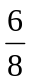, which is equivalent to  ,because both fractions have the same value. A decimal is another way of writing a fraction using denominators such as 10, 100, 1,000, and so on. The fraction is equivalent to 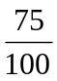 and the fraction in decimal form is 0.75.

The complexity level of this question is Low Complexity. This task asks students to generate an equivalent decimal form for a fraction.

Performance Data:
The percent of public school students earning each score point for question 10 on the May 2007 Grade 4 Achievement Test:

Percent at Each Score Point
0 | 1 | 2
24% | 70% | 5%

Scoring Guidelines:
Exemplar Response:

- 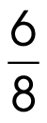 , 0.75
- 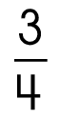, 0.75
Other Correct Response(s):

Points | Student Response
2 point text | The focus of this task is generating equivalent forms of fractions and decimals. The response provides a fraction and a decimal that represent the number of students wearing hats.
1 point text | The response shows evidence of generating equivalent forms of fractions and decimals; however, the response may be incomplete or slightly flawed.
1 point text | 1 point sample answer:  For example, the response may:  - Provide a correct fraction but fail to provide an appropriate decimal.  - Provide a correct decimal but fail to provide an appropriate fraction.
0 point text | The response provides inadequate evidence of generating equivalent forms of fractions and decimals. The response may have major flaws or errors in reasoning.
0 point text | 0 point sample answer:  For example, the response may:  - State that 0.6 of the students are wearing hats and fail to provide an appropriate fraction.  - Be blank or give irrelevant information.  - Restate information given in the stem.

Keywords: number, fraction, decimal, equivalent

BACK TO INDEX

Benchmark: E | Recognize and classify numbers as prime or composite and list factors.
GLI: NNS 4.4 | Identify and represent factors and multiples of whole numbers through 100, and classify numbers as prime or composite.

Multiple Choice Question:

16. The numbers of students in four classes are shown in the table.
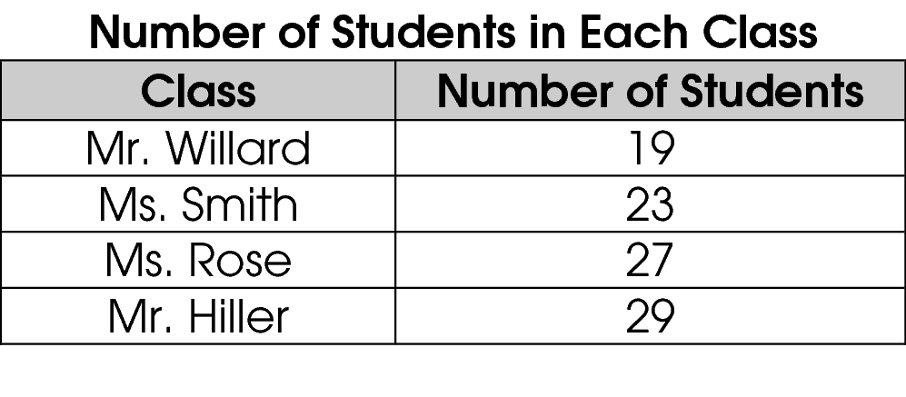
Which class can be divided into equal-sized groups that contain more than one student?

A. Mr. Willard’s class
B. Ms. Smith’s class
C. Ms. Rose’s class
D. Mr. Hiller’s class

Commentary:
This multiple-choice question asks students to select a class that can be divided into equal- sized groups with more than one student. Students need to have understanding of prime and composite numbers. A composite number is a number that can be divided by natural (counting) number(s) other than 1 and itself. Therefore, composite numbers can be divided into equal groups. Ms. Rose’s class is the only class that has a composite number of students because 27 can be divided into 9 groups of 3 or 3 groups of 9. Answer choice C is correct.

All of the other classes have a prime number of students (numbers that can be divided by 1 and itself only) which makes answer choices A, B and D incorrect.

The complexity level of this question is Moderate Complexity. This problem requires students to compare statements.

Performance Data:
The percent of public school students selecting answer choice C for question 16 on the May 2007 Grade 4 Achievement Test was 52%.

Keywords: number, composite number, prime number

BACK TO INDEX

Benchmark: F | Count money and make change using both coins and paper bills.
GLI: NNS 4.8 | Solve problems involving counting money and making change, using both coins and paper bills.

Multiple Choice Question:

31. Erik walked Mrs. Johnson’s dog each day for six days. He earned $1.25 each day.
How much money did Erik earn?

A. $4.75
B. $6.25
C. $7.25
D. $7.50

Commentary:
This multiple-choice question asks students to find the total amount of money earned for walking a dog for each of six days. Students may find the total amount by using repeated addition ($1.25 + $1.25 + $1.25 + $1.25 + $1.25 + $1.25 = $7.50). Students may also use a counting strategy by breaking $1.25 into $1 and 25 cents. They can count the dollar bills ($ 6) separately from the six quarters ($1.50) and then add the two amounts together ($6.00 + $1.50 = $7.50). Answer choice D is the correct answer.

Answer choice A is incorrect because students may have subtracted the money earned each day from the number of days (6 – $1.25 = $4.75). Answer choice B would have been the correct amount for 5 days, miscounting the repeated addition process. Answer choice C is incorrect as well because students may have added the number of days and the money earned each day (6 + $1.25 = $7.25).

The complexity level of this question is Low Complexity. This question requires students to compute a sum of repeated numbers.
Performance Data:
The percent of public school students selecting answer choice D for question 31 on the May 2007 Grade 4 Achievement Test was 81%.
Keywords: number, operation, addition

BACK TO INDEX

Benchmark: J | Estimate the results of whole number computations using a variety of strategies, and judge the reasonableness.
GLI: NNS 4.3 | Round whole numbers to a given place value.

Multiple Choice Question:

36. There are about 525,600 minutes in a year.
What is this number rounded to the nearest thousand?

A. 500,000
B. 525,000
C. 526,000
D. 530,000

Commentary:
This multiple-choice question asks students to round a whole number to the nearest thousand.
Students need to have understanding of place value and rounding numbers. Students have to look at the value that is in the thousands’ place (the fourth from the right). The number 525,600 is between 525,000 and 526,000, but it is closer to 526,000. Therefore, the correct number is 526,000; answer choice C.

Answer choice A is incorrect because 500,000 is rounded to the nearest hundred thousand. Answer choice B is also incorrect because 525,600 is rounded down or truncated to the nearest thousand. Answer choice D is incorrect as well because 526,600 is rounded to the nearest ten thousand.

The complexity level of this question is Low Complexity. This question requires students to perform a specified procedure.

Performance Data:
The percent of public school students selecting answer choice C for question 36 on the May 2007 Grade 4 Achievement Test was 58%.

Keywords: number, estimation, rounding.

BACK TO INDEX

Benchmark: A | Use place value structure of the base-ten number system to read, write, represent and compare whole numbers and decimals.
GLI: NNS 4.2 | Use place value structure of the base-ten number system to read, write, represent and compare whole numbers through millions and decimals through thousandths.

Multiple Choice Question:

40. Calvin gathered data on the number of people who live in five cities.
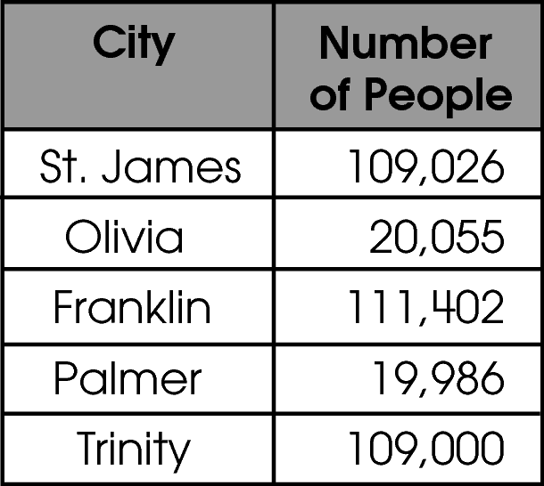
Which city has more people than St. James?

A. Olivia
B. Franklin
C. Palmer
D. Trinity

Commentary:
This multiple-choice question asks students to compare whole numbers from the table and then select a number larger than 109,026. To compare numbers students need to use their understanding of place value. Students need to look at the digit in the hundred thousands place and then at each place value to the right. Answer choice B is the correct answer.

Franklin (111,402), Trinity (109,000) and St. James (109, 026) have the same digit 1 in the hundred thousands place, so the focus is then on the ten thousands place. In the ten thousands place Franklin has 1 and both St. James and Trinity have 0. Since 1 is greater than 0, then 111, 402 is greater than 109,000 and 109,026. There are more people who live in Franklin than in St. James. Both answer choices A and C are incorrect. The number of people living in both Olivia and Palmer is smaller than the number of people who live in Trinity, 109,000; because their population is less than one hundred thousand and the Trinity population is larger than one hundred thousand.

The complexity level of this question is Moderate Complexity. This question asks students to retrieve information from the graph or table and use it to compare numbers.

Performance Data:
The percent of public school students selecting answer choice B for question 40 on the May 2007 Grade 4 Achievement Test was 94%.

Keywords: number, place value

BACK TO INDEX

Benchmark: A | Use place value structure of the base-ten number system to read, write, represent and compare whole numbers and decimals.
GLI: NNS 4.14 | Demonstrate fluency in adding and subtracting whole numbers and in multiplying and dividing whole numbers by 1- and 2-digit numbers and multiples of ten.

Multiple Choice Question:

46. There were 1,479 people at the movie theater on Saturday and 1,753 people on Sunday.
How many people went to the movie theater on Saturday and Sunday?

A. 2,232
B. 3,132
C. 3,222
D. 3,232

Commentary:
This multiple-choice question asks students to select a number that represents the total number of people who went to the movie theatre on Saturday and Sunday. To solve this problem students need to add the number of people who went to the theatre both days (1,479 and 1,753) using place value structure of the base-ten number system or a regrouping strategy.

1 11
1,479
+1,753
3,232

First, students need to line up both numbers at ones place. Then, they have add the ones,
9 ones + 3 ones = 12 ones. Since 12 ones is 1 ten and 2 ones, students will write 2 in the ones place and 1 as a new addend in the tens place.
Secondly, students need to add the tens, 1 ten + 7 tens + 5 tens = 13 tens. Since 13 tens is 1 hundred + 3 tens, students will write 3 in the tens place and 1 as a new extra addend in the hundreds place.

Next, students need to add hundreds, 1 hundred + 4 hundreds + 7 hundreds =12 hundreds.
Since 12 hundreds is 1 thousand + 2 hundreds, students will write 2 in the hundreds place and 1 as an extra addend in the thousands place. Lastly, students need to add thousands, 1 thousand + 1 thousand + 1 thousand = 3 thousands. Answer choice D is the correct answer. Answer choices A, B or C are incorrect because students did not correctly regroup in the thousands, in the hundreds or in the tens columns, respectively.

Performance Data:
The percent of public school students selecting answer choice D for question 46 on the May 2007 Grade 4 Achievement Test was 79%.
Keywords: number, regrouping, place value

BACK TO INDEX

Benchmark: E | Recognize and classify numbers as prime or composite and list factors.
GLI: NNS 4.4 | Identify and represent factors and multiples of whole numbers through 100, and classify numbers as prime or composite.

Multiple Choice Question:

2. Which is a multiple of both 4 and 5?

A. 9
B. 10
C. 20
D. 28
Commentary:
This multiple-choice question asks students to identify a common multiple for two different numbers. Students need to know that multiples of a number are products that result from multiplying the given number by other numbers. For example, some multiples of 4 are: 4
(4 x 1), 8 (4 x 2), 12 (3 x 4), 16 (4 x 4), 20 (4 x 5), 24 (4 x 6), 28 (4 x 7) and so on. Similarly, some multiples of 5 are: 5 (1 x 5), 10 (2 x 5), 15 (3 x 5), 20 (5 x 5), 25 (5 x 5), 30 (6 x 5) and so on. Answer choice C is correct because 20 appears in the lists of multiples of both 4 and 5.

Answer choice A is incorrect since 9 does not appear in the lists of multiples for either 4 or 5. Since 10 is not a multiple of 4 but is a multiple of 5, answer choice B is incorrect. Answer choice D is incorrect since 28, is a multiple of 4 but not a multiple of 5.

The complexity level of this question is Low Complexity. Students are asked to recall the term “multiple” and perform a procedure or recognize and example of a concept.

Performance Data:
The percent of public school students selecting answer choice C for question 2 on the May 2007 Grade 4 Achievement Test was 84%.

Keywords: number, multiples

BACK TO INDEX

Benchmark: A | Use place value structure of the base-ten number system to read, write, represent and compare whole numbers and decimals.
GLI: NNS 4.2 | Use place value structure of the base-ten number system to read, write, represent and compare whole numbers through millions and decimals through thousandths.

Multiple Choice Question:

6. Michael needs a sheet of paper that is greater than 0.125 cm thick for a poster.
Which thickness is greater than 0.125 cm?

A. 0.078 cm
B. 0.150 cm
C. 0.116 cm
D. 0.055 cm

Commentary:
This multiple-choice question asks students to compare decimals to the thousandths place to find a measurement greater than 0.125 centimeters. Students need to know that the digits in the tenths, hundredths, and thousandths place need to be compared in that order. If students start by comparing 0.150 and 0.125 they will notice that both numbers have a “1 tenth”, so they can not determine which is greater and must now compare the digits in the hundredths place. Here they should see that the “5 hundredth” in 0.150 cm is greater than the “2 hundredth” in 0.125 cm. Therefore, 0.150 cm is greater than 0.125 cm, answer choice B.

Answer choice A is incorrect since the “1 tenth” in 0.125 cm is greater than the “0 tenth” in 0.078 cm. Answer choice C is incorrect because both numbers have a “1 tenth” but 0.125 cm has a “2 hundredth” which is greater than the “1 hundredth” in 0.116 cm. Answer choice D is incorrect since the “1 tenth” in 0.125 cm is greater than the “0 tenth” in 0.055 cm.

The complexity level of this question is Moderate Complexity. Students are asked to compare decimals.

Performance Data:
The percent of public school students selecting answer choice B for question 6 on the May 2008 Grade 4 Achievement Test was 88%.

Keywords: number sense, decimals, place value

BACK TO INDEX

Benchmark: F | Count money and make change using both coins and paper bills.
GLI: NNS 4.8 | Solve problems involving counting money and making change, using both coins and paper bills.

Multiple Choice Question:

11. Maya bought a bag of bird seed that cost $12.58. She paid with two $10.00 bills.
How much money should Maya get back?

A.
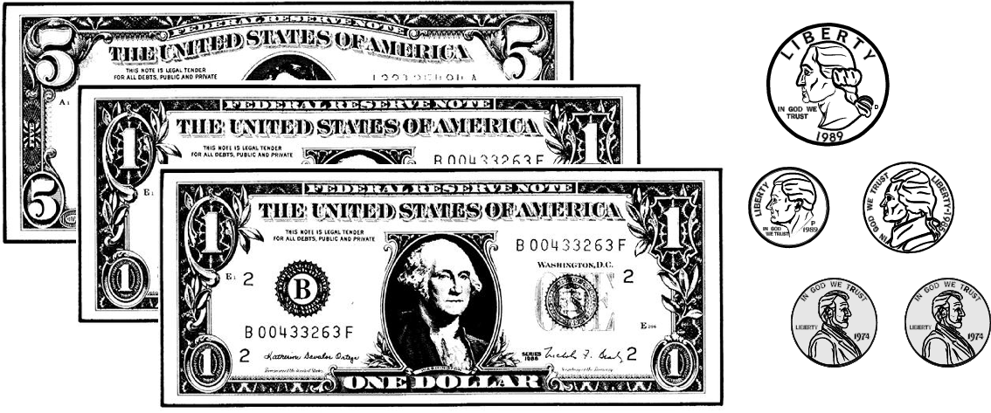

B.
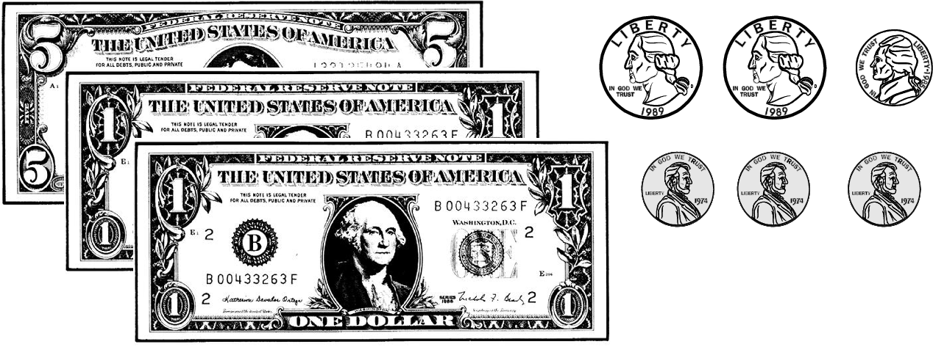

C.
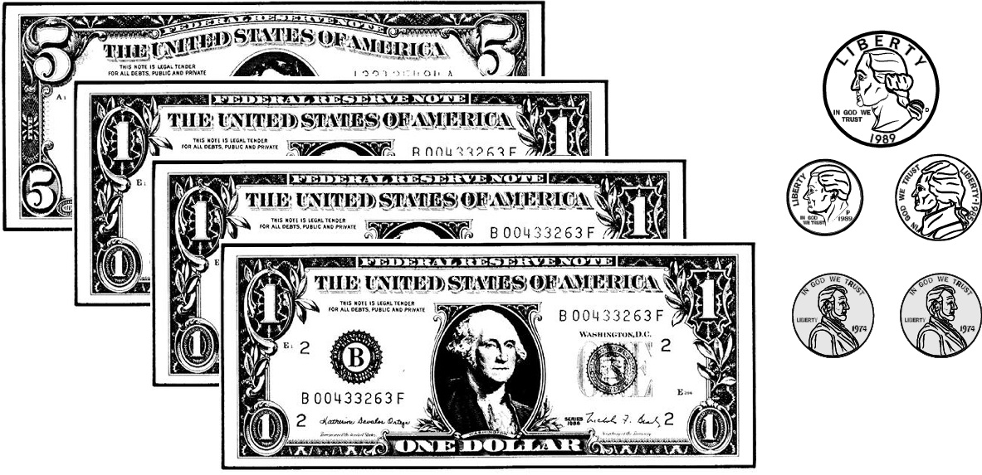

D.
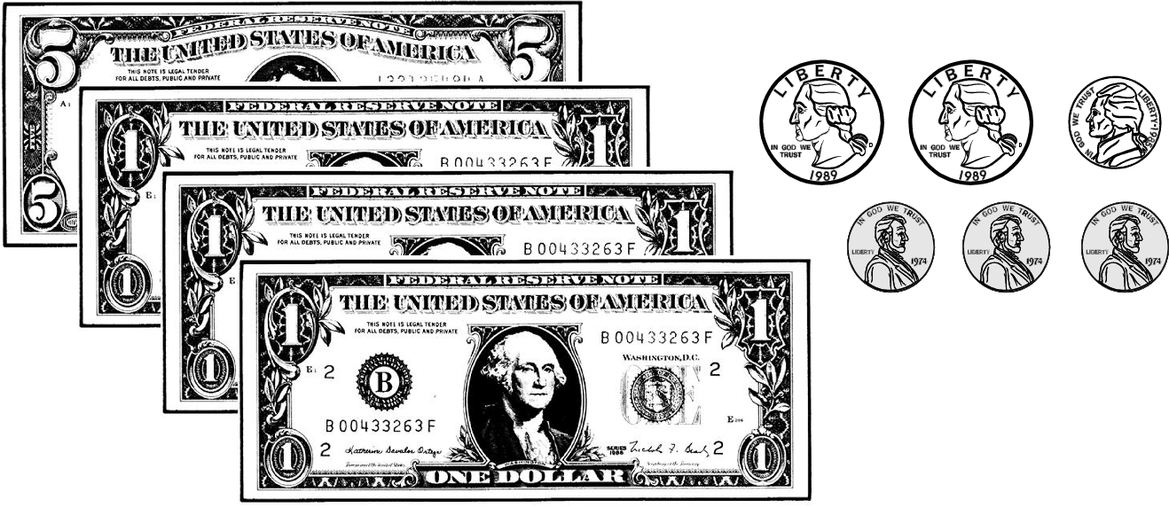

Commentary:
This multiple-choice question asks students to determine the change in both coins and paper bills for a $12.58 bag of seed purchased with two $10.00 bills. Students need to know the values of coins and paper bills and strategies for making change after a purchase. One strategy for making change is to multiply the value of a $10.00 bill by 2 to get $20.00 then subtract $12.58 from $20.00. The result would be $7.42, or one $5.00 bill, two $1.00 bills, one quarter, one dime, one nickel, and two pennies, as shown correctly in answer choice A. A more common strategy for making change is to count up from $12.58 to $20.00: start with the cost of $12.58, add two pennies to make $12.60, add one dime to make $12.70, add one nickel to make $12.75, add one quarter to make $13.00, add two one-dollar bills to make $15.00 and finally add one five-dollar bill to make $20.00.

The change in coins in answer choice B is incorrect because it was found without the necessary regrouping in the hundredths and tenths places. The dollar amount of $8.00 in answer choice C is incorrect since $12.58 was subtracted from $20.00 without the necessary regrouping in the tens and ones places. Answer choice D is incorrect because the dollar amount of $8.00 was found without the necessary regrouping and the change was found by subtracting $.00 from $0.58.

The complexity level of this question is Low Complexity. Students are asked to perform a procedure for making change.

Performance Data:
The percent of public school students selecting answer choice A for question 11 on the May 2008 Grade 4 Achievement Test was 70%.

Keywords: number, money, change

BACK TO INDEX

Benchmark: K | Analyze and solve multi-step problems involving addition, subtraction, multiplication and division using whole numbers.
GLI: NNS 4.12 | Analyze and solve multi-step problems involving addition, subtraction, multiplication and division using an organized approach, and verify and interpret results with respect to the original problem.

Mathematical Processes
Benchmark: B | Use an organized approach and appropriate strategies to solve multi-step problems.

Multiple Choice Question:

35. The table shows how many envelopes are in a box.
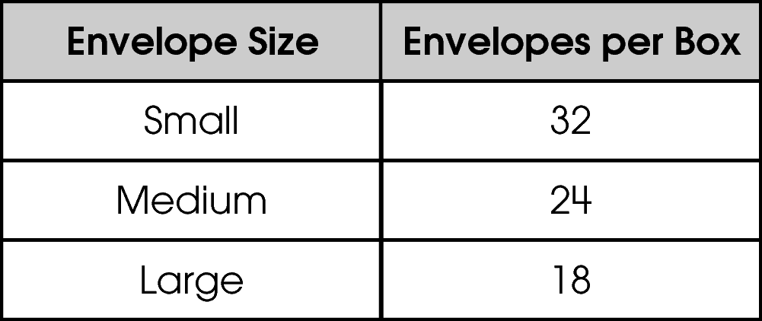
Denise bought 2 small boxes, 3 medium boxes and 1 large box of envelopes.
How many envelopes did she buy?

A. 6
B. 74
C. 144
D. 154

Commentary:
This multiple-choice question asks students to use the number of envelopes in one box of small, one box of medium and one box of large envelopes to find the total number of envelopes in 2 small, 3 medium, and 1 large box of envelopes. Students need to be able to interpret and analyze a multi-step problem to develop an organized approach to solving the problem using addition and multiplication.

Students could multiply the number of boxes for each type of envelope by the number of envelopes per box, then add these three products to find the total number of envelopes:

2 x 32 = 64 small envelopes

3 x 24 = 72 medium envelopes

1 x 18 = 18 large envelopes

64 small envelopes + 72 medium envelopes + 18 large envelopes = 154 total envelopes

So, answer choice D is correct.

Answer choice A is incorrect because 6 is the total number of boxes given in the problem
(2 + 3 + 1 = 6) not the total number of envelopes in the 6 boxes purchased. Answer choice B is incorrect since 74 is the total number of envelopes given in the table (32 + 24 + 18 = 74), not the total number of envelopes in the 6 boxes purchased. Answer choice C is incorrect because 62, instead of 72, is incorrectly used as the number of medium envelopes (64 + 62 + 18 = 144).

The complexity level of this question is Moderate Complexity. Students are asked to solve a word problem requiring multiple steps.

Performance Data:
The percent of public school students selecting answer choice D for question 35 on the May 2008 Grade 4 Achievement Test was 60%.

Keywords: number, addition, multiplication

BACK TO INDEX

Benchmark: J | Estimate the results of whole number computations using a variety of strategies, and judge the reasonableness.
GLI: NNS 2.13, NNS 4.9 | NNS 2.13: Estimate the results of whole number addition and subtraction problems using front-end estimation, and judge the reasonableness of the answers.  NNS 4.9: Estimate the results of computations involving whole numbers, fractions and decimals, using a variety of strategies.

Mathematical Processes
Benchmark: G | Use reasoning skills to determine and explain the reasonableness of a solution with respect to the problem situation.

Short Answer Question:

38. The table shows the number of books sold at the book fair.
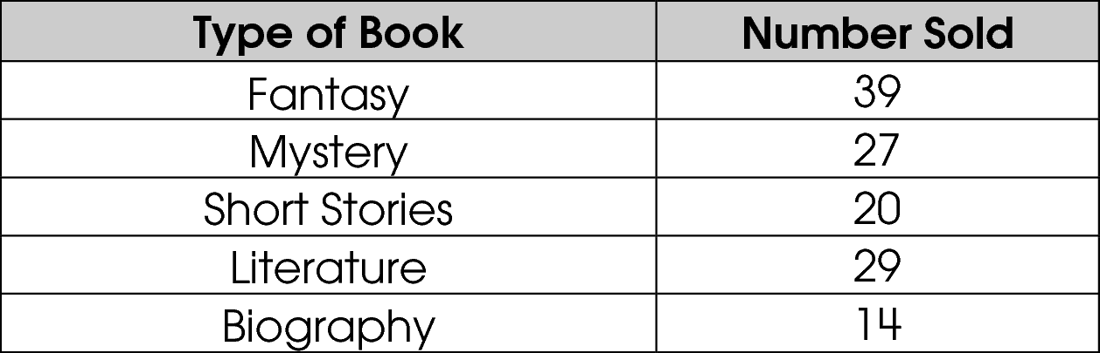
It was estimated that about 200 books were sold.
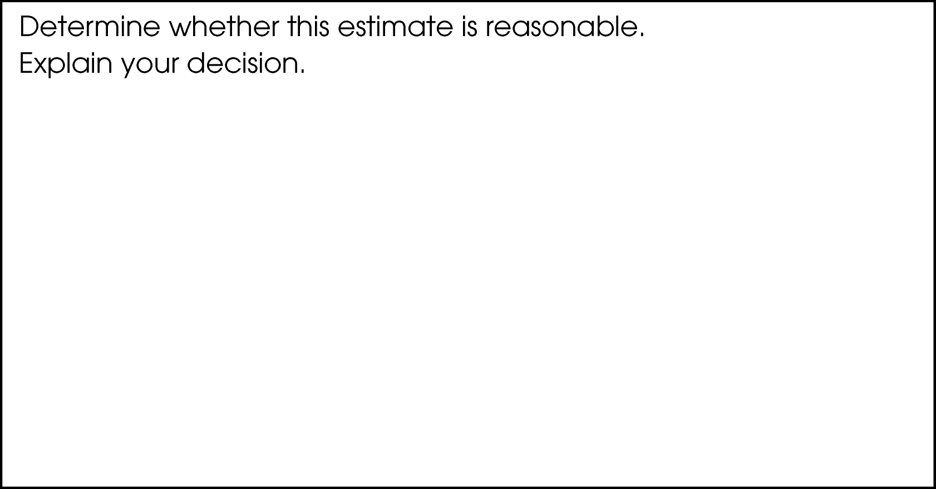

Commentary:
This short-answer question asks student to determine whether an estimated number of books sold at a book fair is reasonable based on the data in a table. A response earning the maximum number of points (2 points) states that the estimate is not reasonable and provides an adequate explanation.

Students need to be able to interpret the data in the given table to use in an appropriate estimation strategy for estimating the total number of books sold at the book fair. For example, students could first round the Number Sold for each Type of Book to the nearest number of 10 books (10 books, 20 books, 30 books and so on). These rounded numbers could then be added together to estimate the total number of books sold at the book fair:

Number of Fantasy Books Sold Round 39 to 40
Number of Mystery Books Sold Round 27 to 30
Number of Short Stories Sold 20 is already to the nearest 10 books
Number of Literature Books Sold Round 29 to 30
Number of Biographies Sold Round 14 to 10

40 + 30 + 20 + 30 + 10 = 130

Students need to understand that the estimate of 200 books sold is not reasonable since 130 is much less than 200.

The complexity level of this question is Moderate Complexity. Students are asked to retrieve information form a table and use it to solve a problem requiring multiple steps.

Performance Data:
The percent of public school students earning each score point for question 38 on the May 2008 Grade 4 Achievement Test:

Percent at Each Score Point
0 | 1 | 2
32% | 24% | 43%

Scoring Guidelines:
Exemplar Response:
- No, it’s not a reasonable estimate because I estimated and added
30 + 20 + 20 + 20 + 10, and it only comes to 100 books sold.
- No, the estimate is not reasonable. I rounded the numbers to
40 + 30 + 20 + 30 + 10 = 130, this is much less than 200.
Points | Student Response
2 | The focus of this task is determining the reasonableness of results found from estimates of computations involving whole numbers. The response provides the reasonableness of the estimate with an adequate explanation.  NOTE: Adding the number of books sold as an explanation is acceptable.
1 | The response shows partial evidence of determining the reasonableness of results found from estimates of computations involving whole numbers; however, the solution may be incomplete or slightly flawed.  For example, the response may:  - State that the estimate is not reasonable and provide an incomplete or slightly flawed explanation.  - Show how they estimated the number of books sold, but make no claim as to whether or not the estimate is reasonable.
0 | The response provides inadequate evidence of determining the reasonableness of results found from estimates of computations involving whole numbers. The response provides an explanation with major flaws and errors of reasoning.  For example, the response may:  - State that the estimate is or is not reasonable and provide no explanation or work.  - Restate the information provided in the item.  - Be blank or give irrelevant information.

Keywords: number sense, estimation

BACK TO INDEX

Benchmark: M | Add and subtract commonly used fractions with like denominators and decimals, using models and paper and pencil.
GLI: NNS 4.2, NNS 4.10 | NNS 4.2: Use place value structure of the base-ten number system to read, write, represent and compare whole numbers through millions and decimals through thousandths.  NNS 4.10: Use physical models, visual representations, and paper and pencil to add and subtract decimals and commonly used fractions with like denominators.

Multiple Choice Question:

46. Tom ran a race in 27.34 seconds. It took Barry one hundredth of a second longer to run the race.
How long did it take Barry to run the race?

- 27.341
- 27.35
- 27.44
- 28.340

Commentary:
This multiple-choice question asks students to find the time it took a runner to complete a race when his time is one hundredth of a second longer than 27.34 seconds. Students should understand place value concepts to the right of the ones place such as decimal point, tenths, hundredths and thousandths. They also need to know how to represent decimal fractions using both words and numbers. Finally, students need to be able to choose an appropriate operation and add two decimal fractions, making sure that they align the decimal points in their computation.

The correct answer is choice B. Students should represent “one hundredth” as 0.01 since the second place to the right of the decimal point represents hundredths and the 1 represents the number of hundredths. Since it took Barry 0.01 seconds longer than 27.34 seconds to run the race, 0.01 should be added to 27.34. Students should align or “line up” the decimal points in the addends and sum:

27.34
+ 0.01
27.35 seconds

Answer choice A is incorrect since one thousandth of a second or 0.001 was added to 27.34 seconds. Answer choice B is incorrect since one tenth of a second or 0.1 was added to 27.34 seconds. Because one second or 1 was added to 27.34 and 0 was added to represent 0 thousandths of a second, answer choice D is incorrect.

The complexity level of this question is Moderate Complexity. Students are asked to represent a decimal in more than one way.

Performance Data:
The percent of public school students selecting answer choice B for question 46 on the May 2008 Grade 4 Achievement Test was 46%.

Keywords: number, decimal, fraction, addition

BACK TO INDEX

